**Kitchen Story**

The code for this project is hosted at <https://github.com/VijayMoirangthem/KitchenStory.git>

The project is developed by Vijay Moirangthem

Screenshots :

# Fig 1.1 Login Page

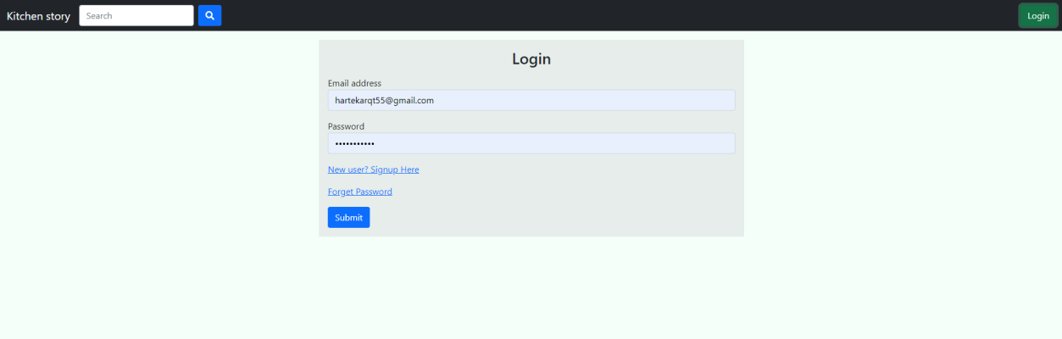

Fig 1.2 Signup page

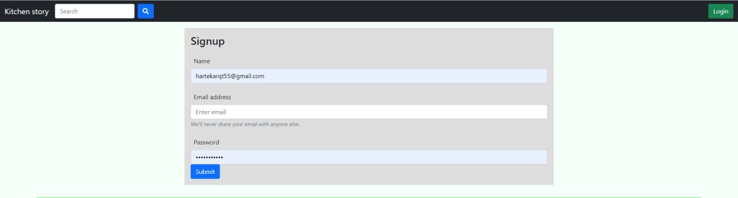

Fig 1.3Home page

Fig 1.4 Product Detail Page

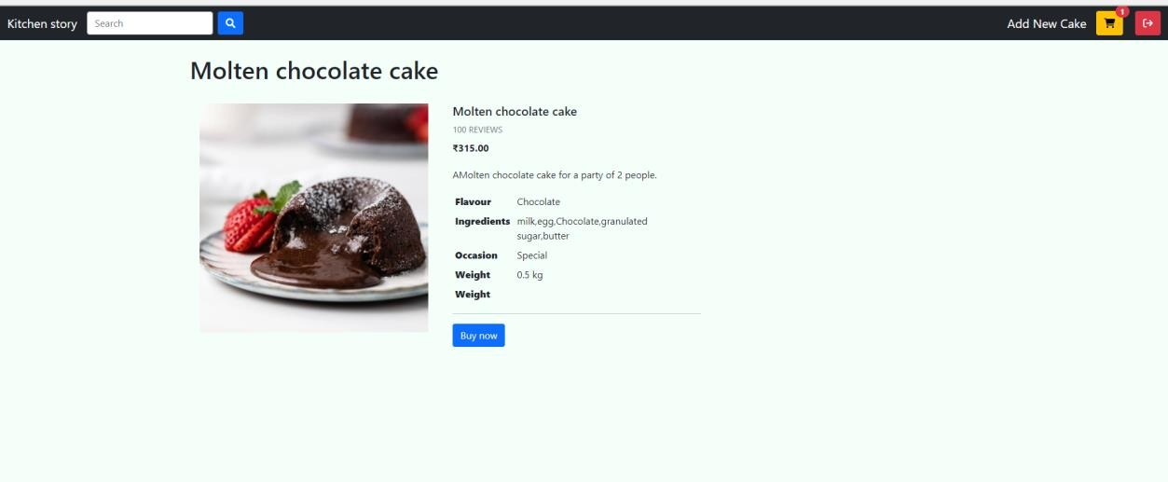

Fig 1.5 Cart Page

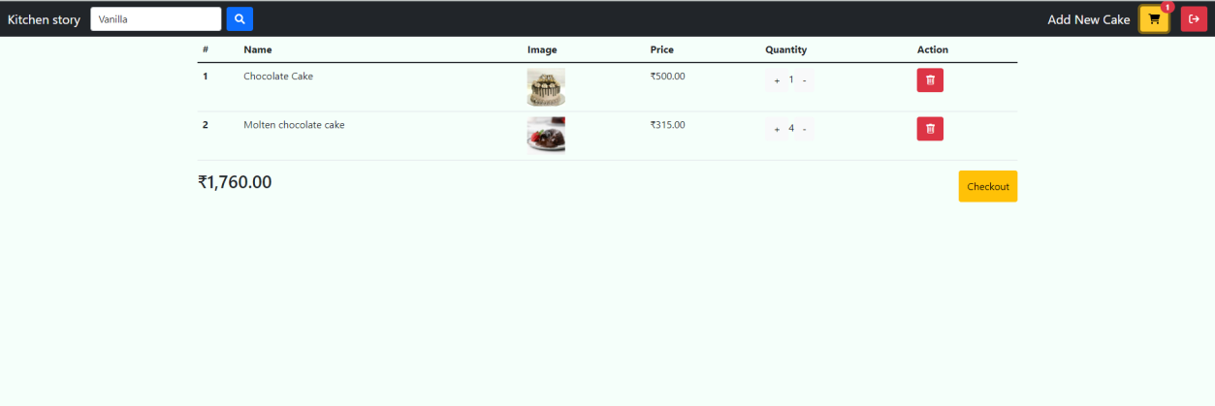

Fig 1.6 Checkout page Address form page

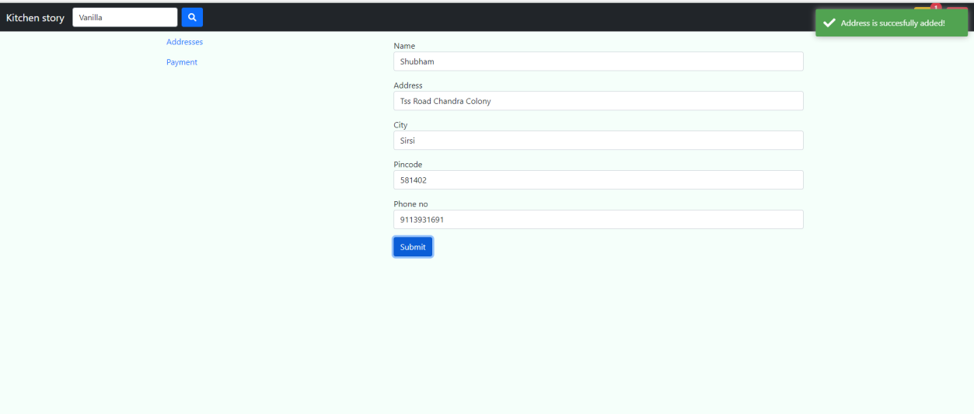

Fig 1.7 Checkout Payment Page

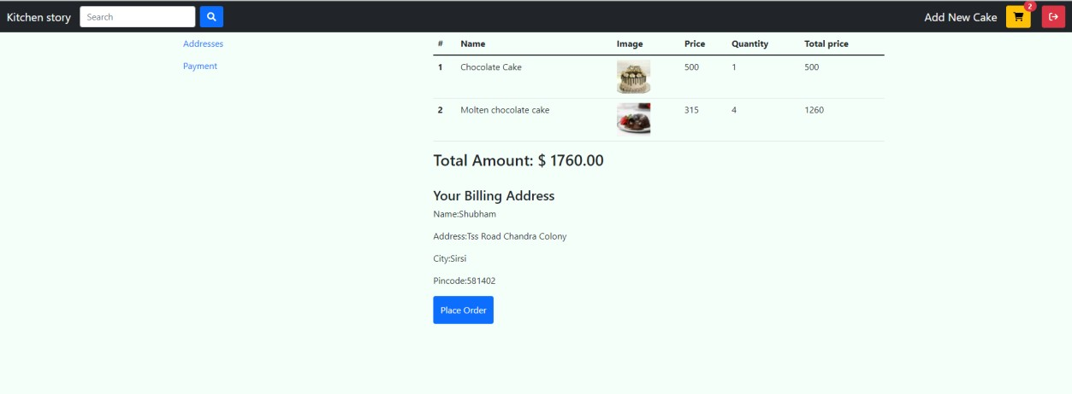

Fig 1.8 Add Product Page

