S_P_Timeseries

Vijay Mudivedu

6/6/2018

# Time Series Analysis of S&P 500

### Business Understandading

Business objective:

Please apply any machine learning algorithm you are comfortable with for predicting this time series

The results would be measured on:

1. Accuracy - How good are predictions
2. Visualization - How well are you able to convey your idea graphically
3. Code Cleanliness - How well have you documented your code in an easy language to understand. No need for excess code

Read Data from the CSV

## [1] 643 12

## symbol date_txn open low high close_price volume lead_1  
## 1 SPY 11/10/2015 207.51 207.19 208.60 208.55 71844000 207.67  
## 2 SPY 11/11/2015 208.88 207.66 208.94 207.67 67251000 204.84  
## 3 SPY 11/12/2015 206.50 204.82 207.06 204.84 118209400 202.54  
## 4 SPY 11/13/2015 204.35 202.44 204.67 202.54 145494400 205.62  
## 5 SPY 11/16/2015 202.32 202.18 205.69 205.62 112996000 205.47  
## 6 SPY 11/17/2015 205.99 204.88 207.04 205.47 113429400 208.73  
## lead_5 lead_10 name class_type_of  
## 1 205.47 209.35 SPDR S&P500 S_P_500  
## 2 208.73 209.32 SPDR S&P500 S_P_500  
## 3 208.55 209.56 SPDR S&P500 S_P_500  
## 4 209.31 208.69 SPDR S&P500 S_P_500  
## 5 209.07 210.68 SPDR S&P500 S_P_500  
## 6 209.35 208.53 SPDR S&P500 S_P_500

## 'data.frame': 643 obs. of 12 variables:  
## $ symbol : Factor w/ 1 level "SPY": 1 1 1 1 1 1 1 1 1 1 ...  
## $ date_txn : Factor w/ 643 levels "1/10/2017","1/10/2018",..: 106 109 111 112 118 121 124 126 129 135 ...  
## $ open : num 208 209 206 204 202 ...  
## $ low : num 207 208 205 202 202 ...  
## $ high : num 209 209 207 205 206 ...  
## $ close_price : num 209 208 205 203 206 ...  
## $ volume : int 71844000 67251000 118209400 145494400 112996000 113429400 113064100 81363500 89556300 63829000 ...  
## $ lead_1 : num 208 205 203 206 205 ...  
## $ lead_5 : num 205 209 209 209 209 ...  
## $ lead_10 : num 209 209 210 209 211 ...  
## $ name : Factor w/ 1 level "SPDR S&P500": 1 1 1 1 1 1 1 1 1 1 ...  
## $ class_type_of: Factor w/ 1 level "S_P_500": 1 1 1 1 1 1 1 1 1 1 ...

### Data Understanding

#### Data Preparation

* Remove Unwanted Columns

Remove the redundant columns symbol, name, class_type_of “SPY”, “SPDR S&P500”, “S_P_500”

## date_txn open low high close_price volume lead_1 lead_5  
## 1 11/10/2015 207.51 207.19 208.60 208.55 71844000 207.67 205.47  
## 2 11/11/2015 208.88 207.66 208.94 207.67 67251000 204.84 208.73  
## 3 11/12/2015 206.50 204.82 207.06 204.84 118209400 202.54 208.55  
## 4 11/13/2015 204.35 202.44 204.67 202.54 145494400 205.62 209.31  
## 5 11/16/2015 202.32 202.18 205.69 205.62 112996000 205.47 209.07  
## 6 11/17/2015 205.99 204.88 207.04 205.47 113429400 208.73 209.35  
## lead_10  
## 1 209.35  
## 2 209.32  
## 3 209.56  
## 4 208.69  
## 5 210.68  
## 6 208.53

* Check for NAs

## date_txn open low high close_price volume   
## 0 0 0 0 0 0   
## lead_1 lead_5 lead_10   
## 2 6 11

*Comments*: NAs found in Lead_1, Lead_2 and Lead_10

* Query to find NAs

## [1] 643 9

*Comments*: NAs were identified in lead_1, lead_5, lead_10

* NAs in Lead_1, Lead_5, Lead_10 are:

## $lead_1  
## [1] 590 643  
##   
## $lead_5  
## [1] 586 639 640 641 642 643  
##   
## $lead_10  
## [1] 581 634 635 636 637 638 639 640 641 642 643

* Remove NAs from lead_10

## [1] 632 9

* NAs in lead_1 and lead_5 are:

## $lead_1  
## [1] 589  
##   
## $lead_5  
## [1] 585  
##   
## $lead_10  
## integer(0)

* Removing the NAs from lead_1 remaining the rows and columns are

## [1] 631 9

* NAs in Lead 5 are:

## $lead_1  
## integer(0)  
##   
## $lead_5  
## [1] 585  
##   
## $lead_10  
## integer(0)

* Removing the NAs from lead_5, remaining the rows and columns are:

## [1] 630 9

## date_txn open low high close_price volume lead_1 lead_5  
## 1 11/10/2015 207.51 207.19 208.60 208.55 71844000 207.67 205.47  
## 2 11/11/2015 208.88 207.66 208.94 207.67 67251000 204.84 208.73  
## 3 11/12/2015 206.50 204.82 207.06 204.84 118209400 202.54 208.55  
## 4 11/13/2015 204.35 202.44 204.67 202.54 145494400 205.62 209.31  
## 5 11/16/2015 202.32 202.18 205.69 205.62 112996000 205.47 209.07  
## 6 11/17/2015 205.99 204.88 207.04 205.47 113429400 208.73 209.35  
## lead_10  
## 1 209.35  
## 2 209.32  
## 3 209.56  
## 4 208.69  
## 5 210.68  
## 6 208.53

* check for outliers in close_price 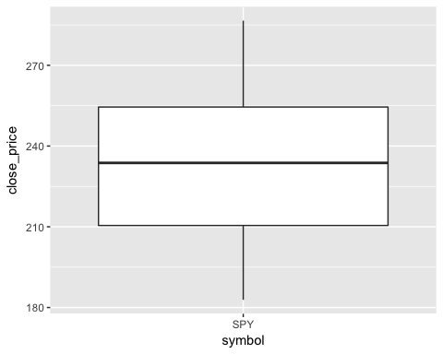 *Comments*: No outliers found
* Convert the date to R date format

## [1] "2015-11-10" "2015-11-11" "2015-11-12" "2015-11-13" "2015-11-16"  
## [6] "2015-11-17"

* Check for uniuqes and duplicates

## [1] 0

*Comments*: No duplicates found

* Check for invalid valid data - checking for minimum dips

## open low high close_price volume lead_1   
## 382 382 382 64 484 63   
## lead_5 lead_10   
## 377 54

*Comments* : There is bad data in variables open, low, high, lead_1, thus considering the “close_price”

#### Exploratory Data Analyis

* Plotting the datasets

## date_txn open low high close_price volume   
## 0 0 0 0 0 0   
## lead_1 lead_5 lead_10   
## 0 0 0

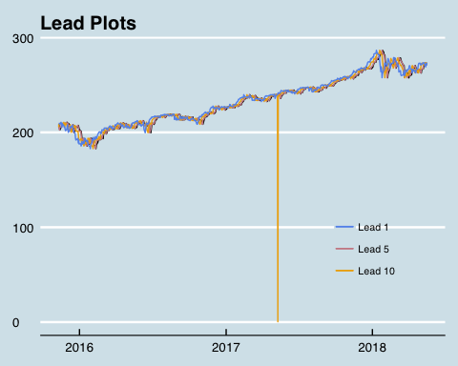

*Comments*: Thus considering the close_price as the lead_prices do not convey much information

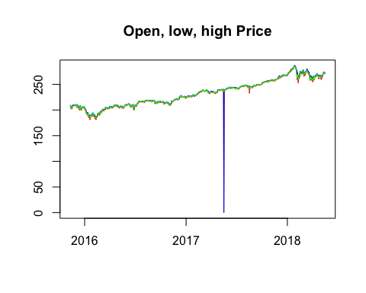

* Univariate analysis

## `stat_bin()` using `bins = 30`. Pick better value with `binwidth`.

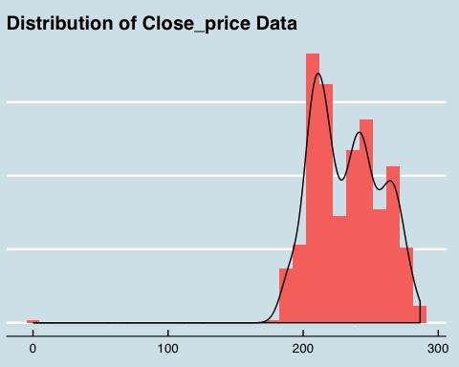 *Comments*: Most of the Pricing data is concentrated around 200 - 240

#### Time Series Object: Creating a time series object of “sp_historical_cleaned”

## open low high close_price volume lead_1 lead_5  
## 2015-11-10 207.51 207.19 208.60 208.55 71844000 207.67 205.47  
## 2015-11-11 208.88 207.66 208.94 207.67 67251000 204.84 208.73  
## 2015-11-12 206.50 204.82 207.06 204.84 118209400 202.54 208.55  
## 2015-11-13 204.35 202.44 204.67 202.54 145494400 205.62 209.31  
## 2015-11-16 202.32 202.18 205.69 205.62 112996000 205.47 209.07  
## 2015-11-17 205.99 204.88 207.04 205.47 113429400 208.73 209.35  
## lead_10  
## 2015-11-10 209.35  
## 2015-11-11 209.32  
## 2015-11-12 209.56  
## 2015-11-13 208.69  
## 2015-11-16 210.68  
## 2015-11-17 208.53

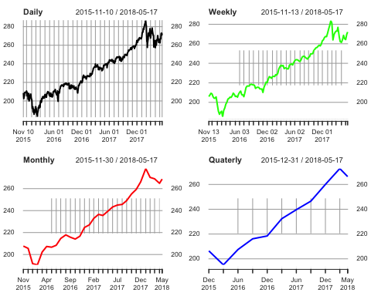

#### Training and Validation datasets

## date_txn open low high close_price volume lead_1 lead_5  
## 598 2018-03-28 260.75 258.58 262.64 259.83 146088900 263.15 265.64  
## 599 2018-03-29 261.12 259.84 265.26 263.15 123162700 257.47 259.72  
## 600 2018-04-02 262.55 254.67 263.13 257.47 184710400 260.77 261.00  
## 601 2018-04-03 258.87 256.84 261.31 260.77 119492300 263.56 265.15  
## 602 2018-04-04 256.75 256.60 264.36 263.56 123193700 265.64 263.76  
## 603 2018-04-05 265.55 264.32 266.64 265.64 80980400 259.72 265.93  
## lead_10  
## 598 265.93  
## 599 265.15  
## 600 267.33  
## 601 270.19  
## 602 270.39  
## 603 268.89

## date_txn open low high close_price volume lead_1 lead_5  
## 604 2018-04-06 263.42 258.00 265.11 259.72 182029210 261.00 265.15  
## 605 2018-04-09 261.37 259.94 264.84 261.00 104745500 265.15 267.33  
## 606 2018-04-10 264.27 262.98 266.04 265.15 104375800 263.76 270.19  
## 607 2018-04-11 263.47 263.39 265.64 263.76 90886300 265.93 270.39  
## 608 2018-04-12 265.26 265.06 267.00 265.93 68138500 265.15 268.89  
## 609 2018-04-13 267.41 264.01 267.54 265.15 84647281 267.33 266.61  
## lead_10  
## 604 266.61  
## 605 266.57  
## 606 262.98  
## 607 263.63  
## 608 266.31  
## 609 266.56

## [1] 600 9

## [1] 30 9

### Smoothing

#### Smoothing using Classical Decomposition

* window width

## [1] 9

* Printing the smooted moving average:

## Time Series:  
## Start = 1   
## End = 20   
## Frequency = 1   
## [1] NA NA NA NA NA NA NA  
## [8] NA NA 207.8979 207.8137 207.6911 207.7453 207.7058  
## [15] 207.5626 207.5395 207.5026 207.3084 206.8195 206.4300

* Replacing the induced NAs as result of smoothing

## [1] -0.08421053

## [1] 0.2178947

* Replacing the lagging NAs are a result of windowing of moving average

## Time Series:  
## Start = 1   
## End = 20   
## Frequency = 1   
## [1] 208.6558 208.5716 208.4874 208.4032 208.3189 208.2347 208.1505  
## [8] 208.0663 207.9821 207.8979 207.8137 207.6911 207.7453 207.7058  
## [15] 207.5626 207.5395 207.5026 207.3084 206.8195 206.4300

* Replacing the smoothed leading NAs

## Time Series:  
## Start = 581   
## End = 600   
## Frequency = 1   
## [1] 272.9321 272.4353 271.7326 271.4726 270.9568 270.1737 269.3974  
## [8] 268.5047 267.9321 268.1500 268.3679 268.5858 268.8037 269.0216  
## [15] 269.2395 269.4574 269.6753 269.8932 270.1111 270.3289

* Plotting the Smoothed Close Price 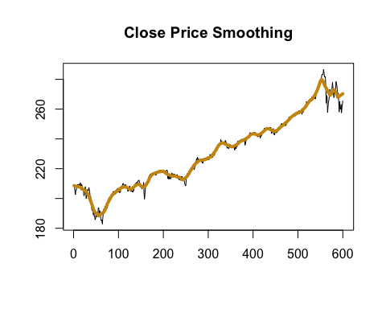

#### Smoothing using Holts method

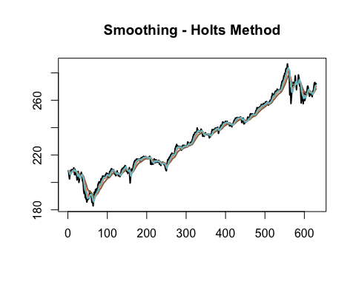 *Comments*: Clearly, from Holts Method best smoothing happens when alpha is ~ 0.1

* Holts smoothed series Plot

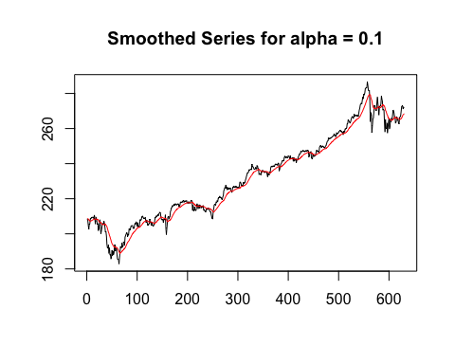

* Creating a new dat frame for close_price and dates

## months_smoothed smoothed_close_price  
## 1 1 208.6558  
## 2 2 208.5716  
## 3 3 208.4874  
## 4 4 208.4032  
## 5 5 208.3189  
## 6 6 208.2347

### Model Building

##   
## Call:  
## lm(formula = smoothed_close_price ~ cos(0.05 * months_smoothed) *   
## poly(months_smoothed, 1) + sin(0.05 * months_smoothed) *   
## poly(months_smoothed, 1), data = smoothed_df)  
##   
## Residuals:  
## Min 1Q Median 3Q Max   
## -10.3422 -4.0300 -0.1904 3.7777 12.2405   
##   
## Coefficients:  
## Estimate Std. Error  
## (Intercept) 230.23069 0.19667  
## cos(0.05 * months_smoothed) -0.02158 0.27776  
## poly(months_smoothed, 1) 567.96883 4.87636  
## sin(0.05 * months_smoothed) 1.85678 0.27629  
## cos(0.05 * months_smoothed):poly(months_smoothed, 1) -88.38120 6.92574  
## poly(months_smoothed, 1):sin(0.05 * months_smoothed) 6.63155 6.78174  
## t value Pr(>|t|)   
## (Intercept) 1170.650 < 2e-16 ***  
## cos(0.05 * months_smoothed) -0.078 0.938   
## poly(months_smoothed, 1) 116.474 < 2e-16 ***  
## sin(0.05 * months_smoothed) 6.720 4.25e-11 ***  
## cos(0.05 * months_smoothed):poly(months_smoothed, 1) -12.761 < 2e-16 ***  
## poly(months_smoothed, 1):sin(0.05 * months_smoothed) 0.978 0.329   
## ---  
## Signif. codes: 0 '***' 0.001 '**' 0.01 '*' 0.05 '.' 0.1 ' ' 1  
##   
## Residual standard error: 4.77 on 594 degrees of freedom  
## Multiple R-squared: 0.961, Adjusted R-squared: 0.9606   
## F-statistic: 2925 on 5 and 594 DF, p-value: < 2.2e-16

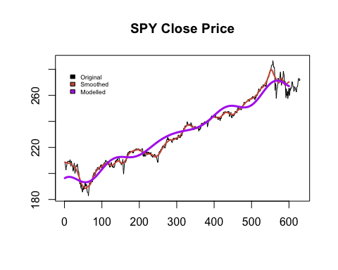 *Comments*: With adjusted R-Squared with accuracy of 96.2% is the best fit curve and it has also generated the least MAPE error of 1%.

* Stationarity tests on the residual time series:

## 1 2 3 4 5 6   
## 12.134755 11.095516 8.121673 5.693146 8.659823 8.411551

* adf test and kpss test for stationarity:

## Warning in adf.test(x = resi_close_price, alternative = "stationary"): p-  
## value smaller than printed p-value

##   
## Augmented Dickey-Fuller Test  
##   
## data: resi_close_price  
## Dickey-Fuller = -4.0685, Lag order = 8, p-value = 0.01  
## alternative hypothesis: stationary

##   
## KPSS Test for Level Stationarity  
##   
## data: resi_close_price  
## KPSS Level = 0.6319, Truncation lag parameter = 5, p-value =  
## 0.01974

*Comments*: From these tests it can be inferred that there is enough evidence to prove that the “resi_close_price”" is Stationary.

* ACF and PACF Plots are:

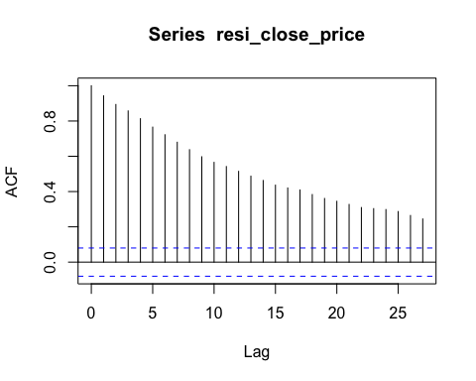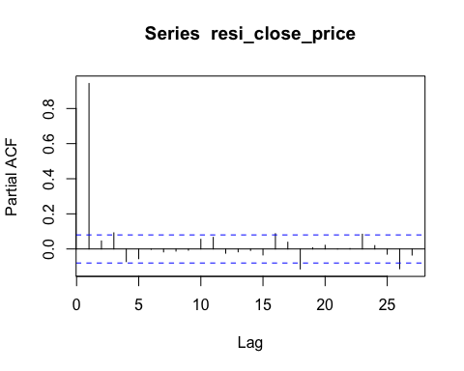

## Series: resi_close_price   
## ARIMA(0,0,0) with non-zero mean   
##   
## Coefficients:  
## mean  
## -0.0961  
## s.e. 0.2227  
##   
## sigma^2 estimated as 29.81: log likelihood=-1869.27  
## AIC=3742.55 AICc=3742.57 BIC=3751.34

*Comments*: This has a very small sigma square, with a very high log likelihood. In addition to this this is AR(0) and MA(0) time series

* checking the noise and stationarity of the time series using the box-Ljung test

##   
## Box-Ljung test  
##   
## data: resi_close_price  
## X-squared = 535.84, df = 1, p-value < 2.2e-16

*Comments*: thus the p-value of the time-series is very low making it a good fit to call it a Strictly Stationary time series.

* QQPlot of the residual timeseries

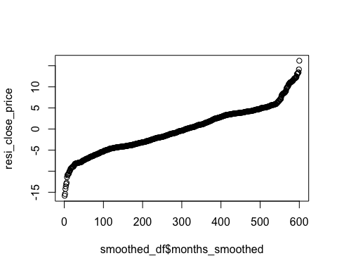 *Comments*: QQ plot suggests that Close_price time-series is stationary

* Plotting the histogram of the residual time-series represents a Gaussian Curve

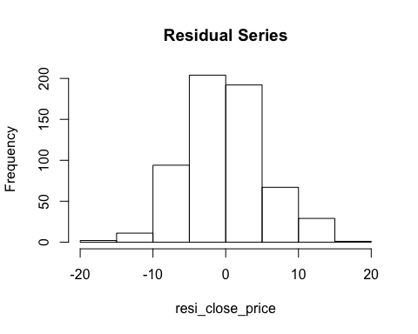

* Checking the properities of Residual time-series by inspection

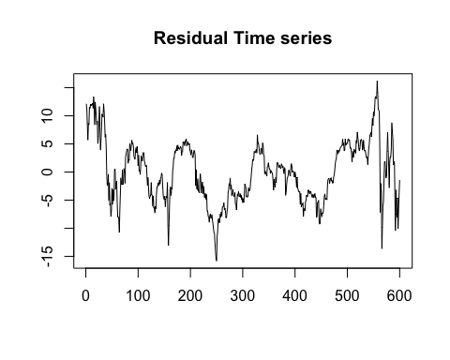 *Comments*: Thus, it is also clear from the plots ARIMA, ADF test, KPSS test the that the time series is stationary

### Model Evaluation

* Predicting the values fitted model from the vadlidation dataset

## months_smoothed  
## 1 601  
## 2 602  
## 3 603  
## 4 604  
## 5 605  
## 6 606

* MAPE Error - Accuracy Calculation

## [1] 1.026822

*Comments*: Thus with a MAPE error of just 1.0268, model is apparently a very good fit.

* Combining the predicted values train and test data
* Plottig the actual vs the predicted data, using classical decomposition

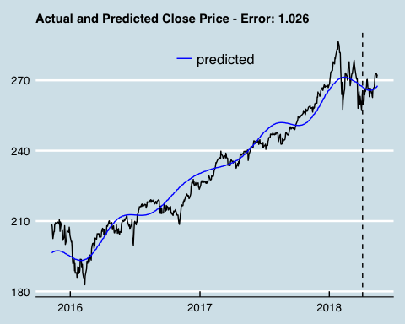

### PREDICTION ANALYSIS USING AUTO.ARIMA

#### Modelling auto arima

## Series: sp_train$close_price   
## ARIMA(4,1,0)   
##   
## Coefficients:  
## ar1 ar2 ar3 ar4  
## -0.0655 -0.0858 0.0847 0.0362  
## s.e. 0.0409 0.0410 0.0411 0.0416  
##   
## sigma^2 estimated as 3.148: log likelihood=-1191.36  
## AIC=2392.73 AICc=2392.83 BIC=2414.7  
##   
## Training set error measures:  
## ME RMSE MAE MPE MAPE MASE  
## Training set 0.09879535 1.766713 1.188871 0.03878482 0.5244785 0.999416  
## ACF1  
## Training set -0.002495871

* Predicting the Validation dataset

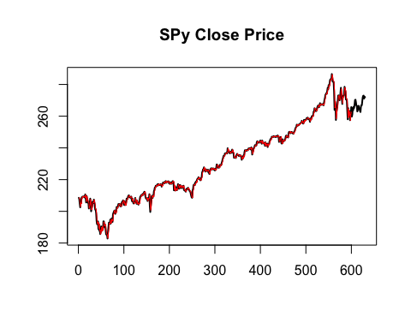

* MAPE of Close Price Using Auto Arima.

## [1] 1.079454

* Combining the predicted training and testing to plot
* Combined plot of Arima

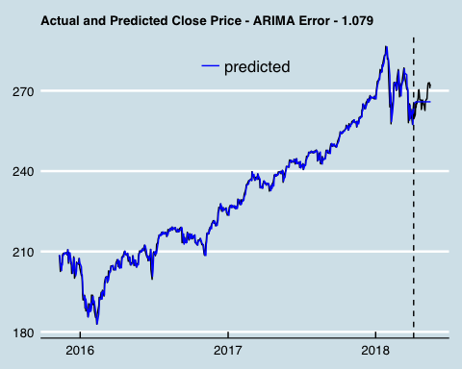

### Conclusion

* Thus the Accuracy result using the MAPE using Classicial Decomposition is 1.03 which is less than Auto.Arima Modelling 1.08 and Classical Decompsition has had higher accuracy*