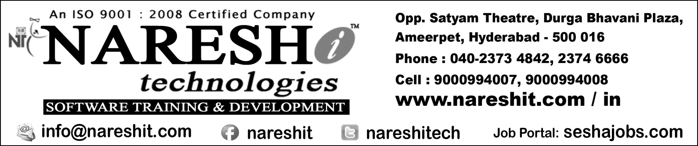

Advanced Java

**JDBC 4.X**

* Introduction to JDBC
* The DriverManager class
* Procedure to develop applications in Eclipse IDE
* Applets
* Architecture Diagrams of All Types of JDBC Drivers
* Types of JDBC Statement Objects
* Working with Conventional &Non-Conventional Database Softwares
* Working with Date values
* Working with Large Objects
* Working with Callable Statement
* Procedure to Develop Desktop icon
* Understanding Different Types of ResultSets
* Understanding JDBC MetaData
* Batch Updation/Batch Processing
* Working With Properties Files
* JDBC Versions & Features
* Working With JDBC Connection pool
* Save Point
* RowSets & Types of RowSets
* Type 5 JDBC Driver
* Type 3 JDBC Driver

**Servlet 4.x**

* Need of Web applications
* Need of Web Server
* Web application development setup
* Tomcat Server Basics
* Basics of web Server and Servlet Container
* javax.servlet package
* First Java web application
* development
* Html to Servlet Communication
* Form validations
* Different types of form components
* Working with multiple Hyperlinks
* Working with multiple Submit Buttons
* GET Vs POST
* Servlet Life Cycle
* javax.servlet.http package
* War file creation
* War Vs jar
* Working with Application Servers
* Servlet to DataBase Software Communication
* Servlet Config Vs Servlet Content
* Working with init params and context params
* Working with Server Managed JDBC connection pool
* Java Bean
* Servlet Communication
* Forward and Include Mechanisms
* Send Re-direction
* Servlet Attributes
* File Uploading & File Downloading
* Annotation based servlet programming
* Security in Web application
* Session Tracking
* Servlet Listeners
* Thread safety in servlet programming
* Understanding protocol http
* Servlet Filters
* Servlet Wrappers
* Different types of url patterns
* Dynamic Registration of servlet

**JSP 2.x**

* Disadvantages of Servlets
* Introduction to JSP
* Creating dynamic Web component with JSP
* Phases Of JSP Execution
* JSP Life Cycle
* Scripting elements
* Scriplet
* Declaration
* Expression
* XML syntax for JSP elements
* JSP to DataBase communication
* JSP directives page, include and taglib
* JSP implicit objects
* JSP scopes
* JSP Action Tags
* Include and forward mechanism
* Using a Java bean in a jsp
* JSP Model 1 architecture
* JSP Model 2 (MVC) architecture
* Mini Projects Discussion
* Custom Tag Development
* Classic Tags, Simple Tags
* Error Handling in a jsp
* JSTL
* Expression Language
* Processing XML in a jsp