**PHASE 4 – PROJECT SUBMISSION**

**PRODUCT SALES ANALYSIS**

**i)Pre-Visualisation Steps:**

* The process begins by parsing the date column to extract the month component.
* This is done for each row in the dataset.
* Next, the sales for each product are grouped by their respective months, and a count of sales for that month is maintained.
* Simultaneously, a counter for each month is incremented to keep track of how many years of data contain sales for that specific month.
* To calculate the average sales for each month, the total sales for that month is divided by the number of years for which sales data is available.
* This provides a fair comparison of monthly sales performance.
* And also sub-datasets are constructed for each product with months as x-attributes and sales as y-attributes.

**ii)Visualisation:**

* IBM provides various data visualization and business intelligence solutions that empower organizations to turn their data into actionable insights.
* Here's an introduction to IBM's data visualization tools and how they can benefit your data-driven initiatives:
* IBM offers a suite of data visualization tools that cater to different business needs, including IBM Cognos Analytics. These tools enabled us

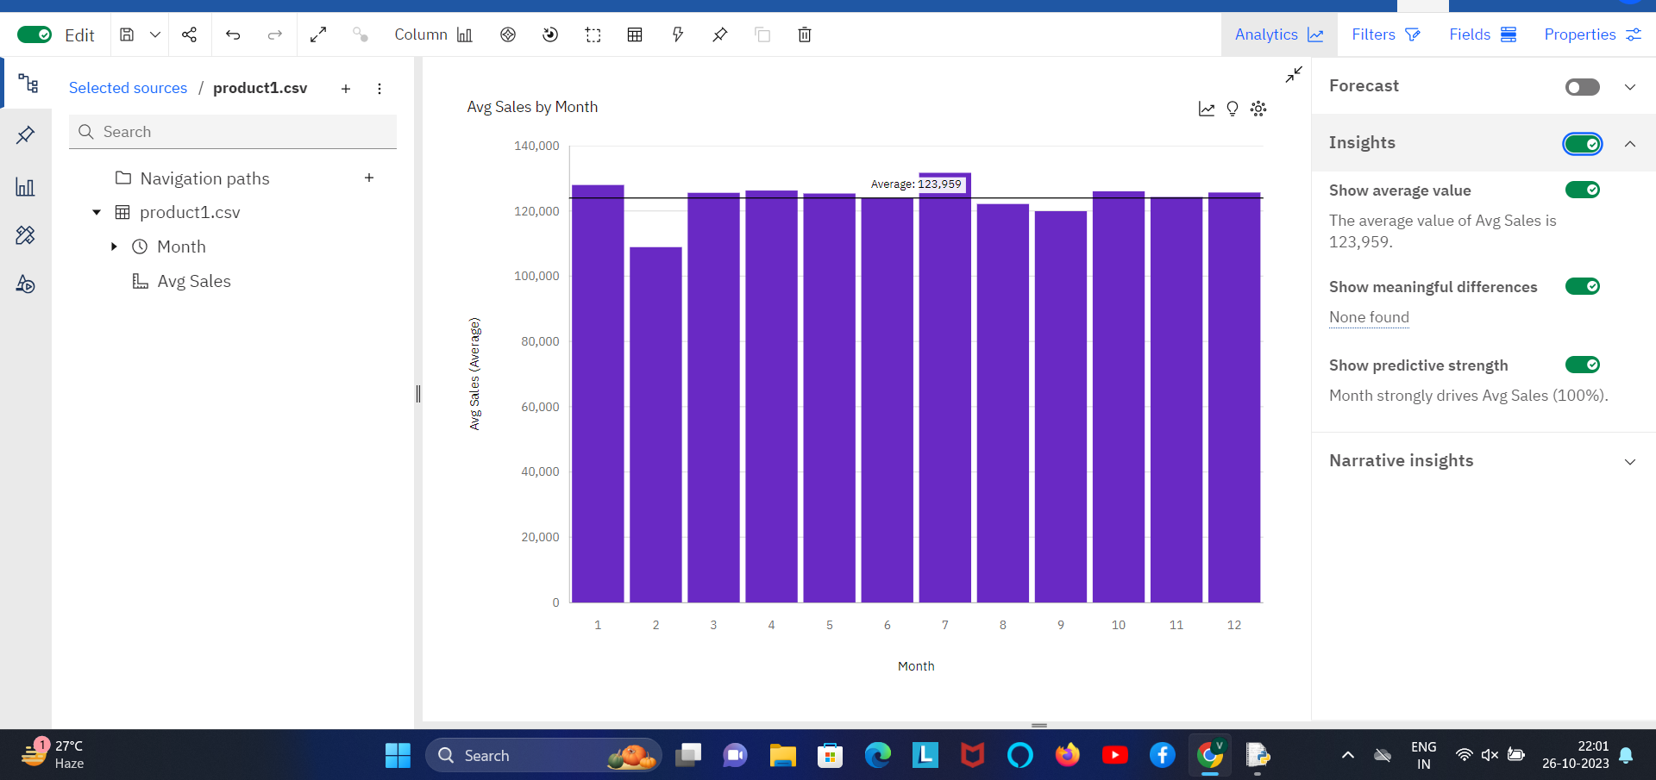

(fig-1:Verical Bar Chart – Average Sales vs Months for Product-1)

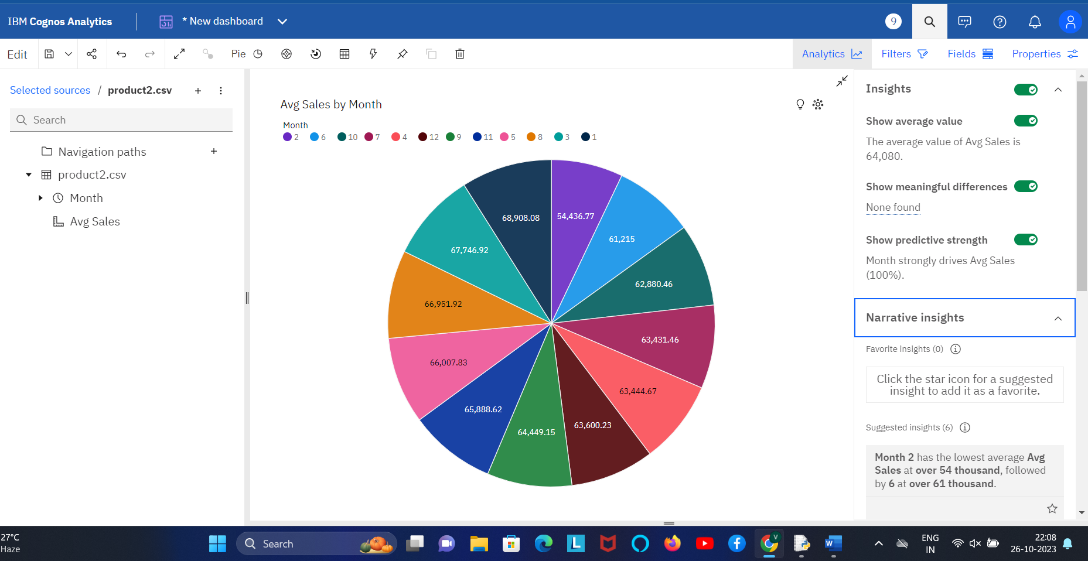

(fig-2 : Pie-Chart describing the distribution of sales of product -2 in various months)

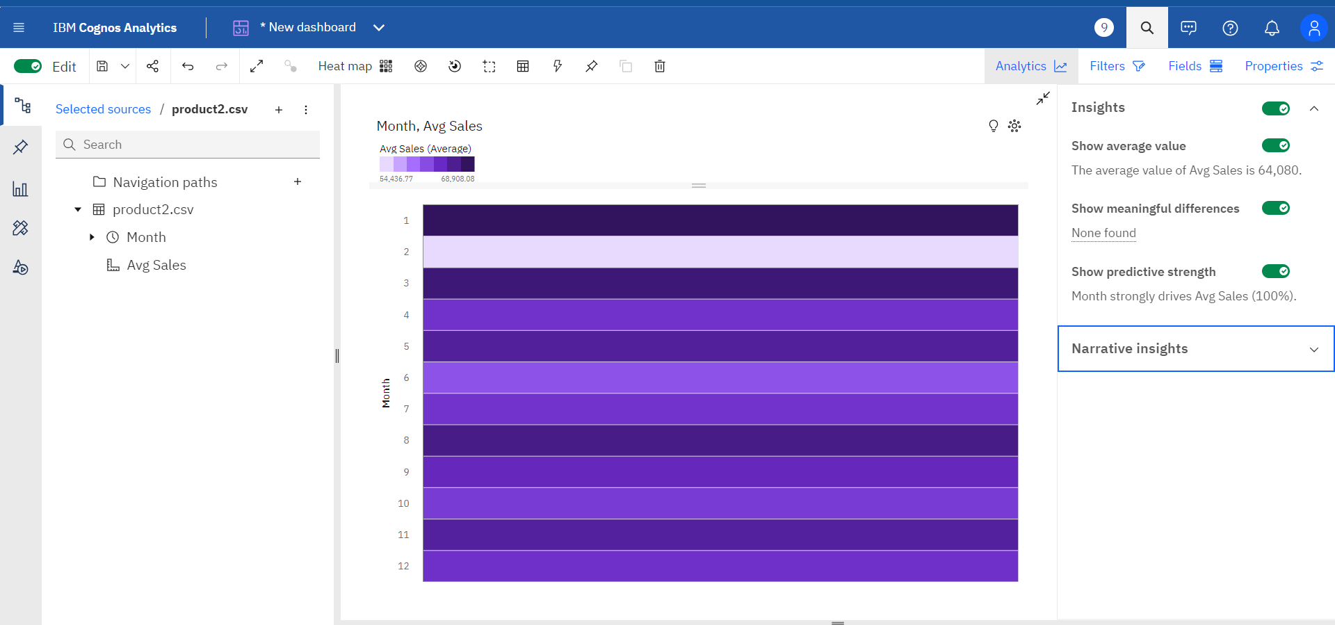

(fig-3: Heat-Map denoting the intensity of sales of product-2 at different months )

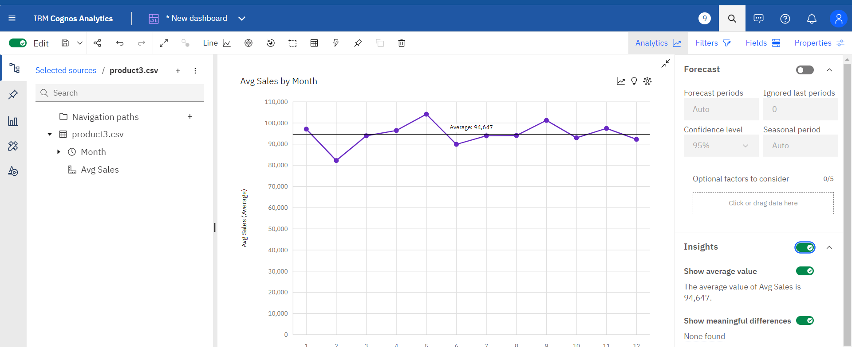

(fig -4: LinePlot describing continuity and clear increase and decrease of sales of product-3 between months )

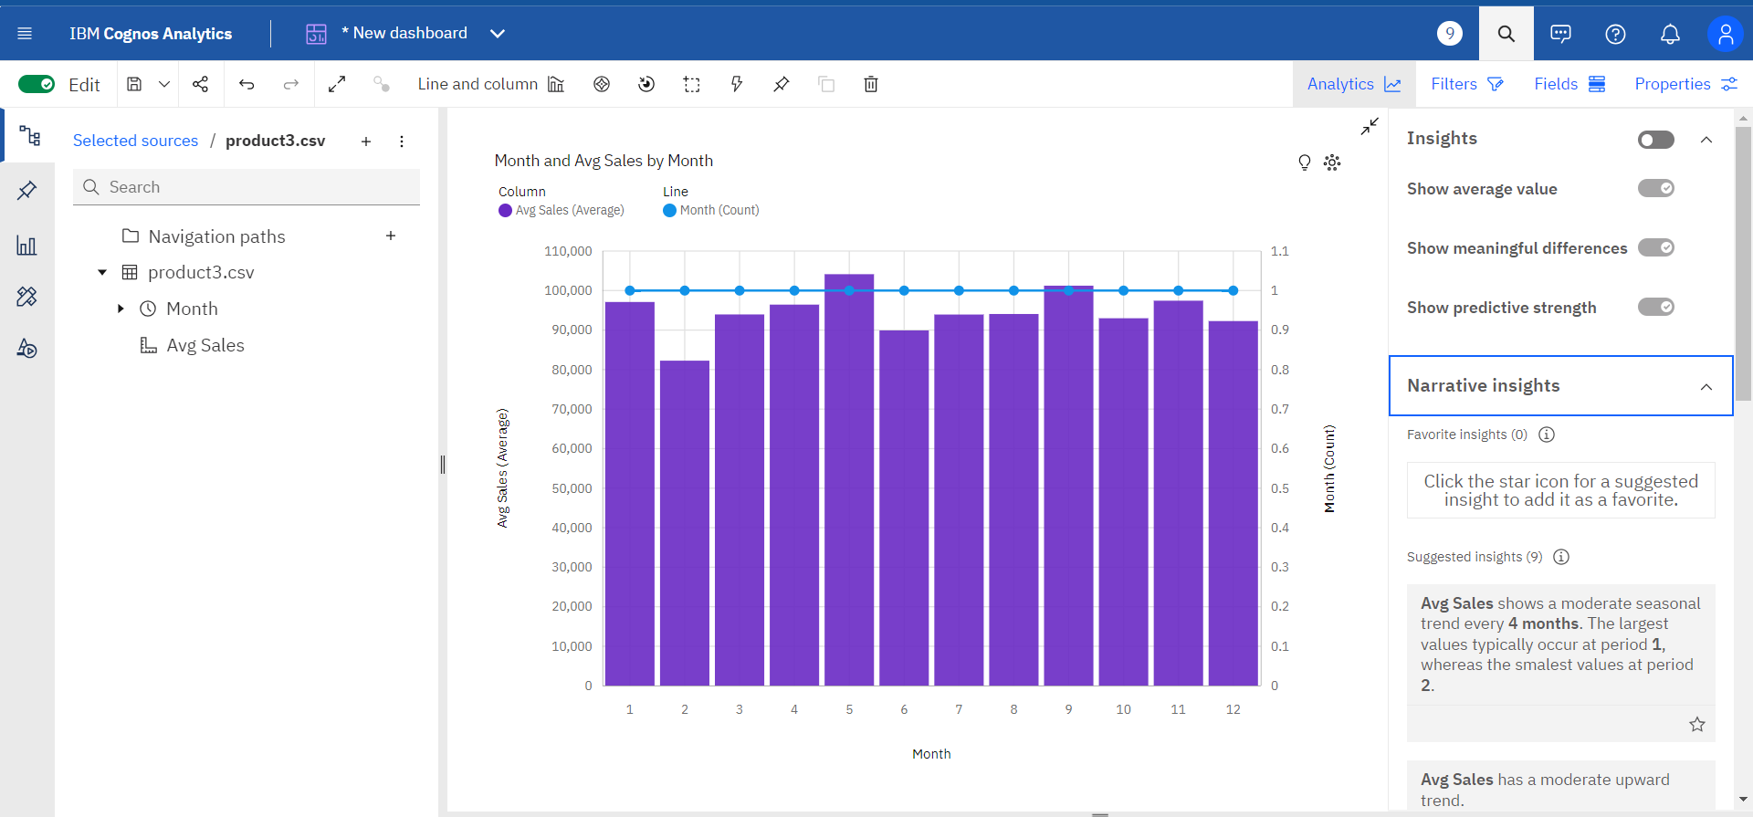

(fig -5 : Barplot with column denoting average sales and line denoting the month)

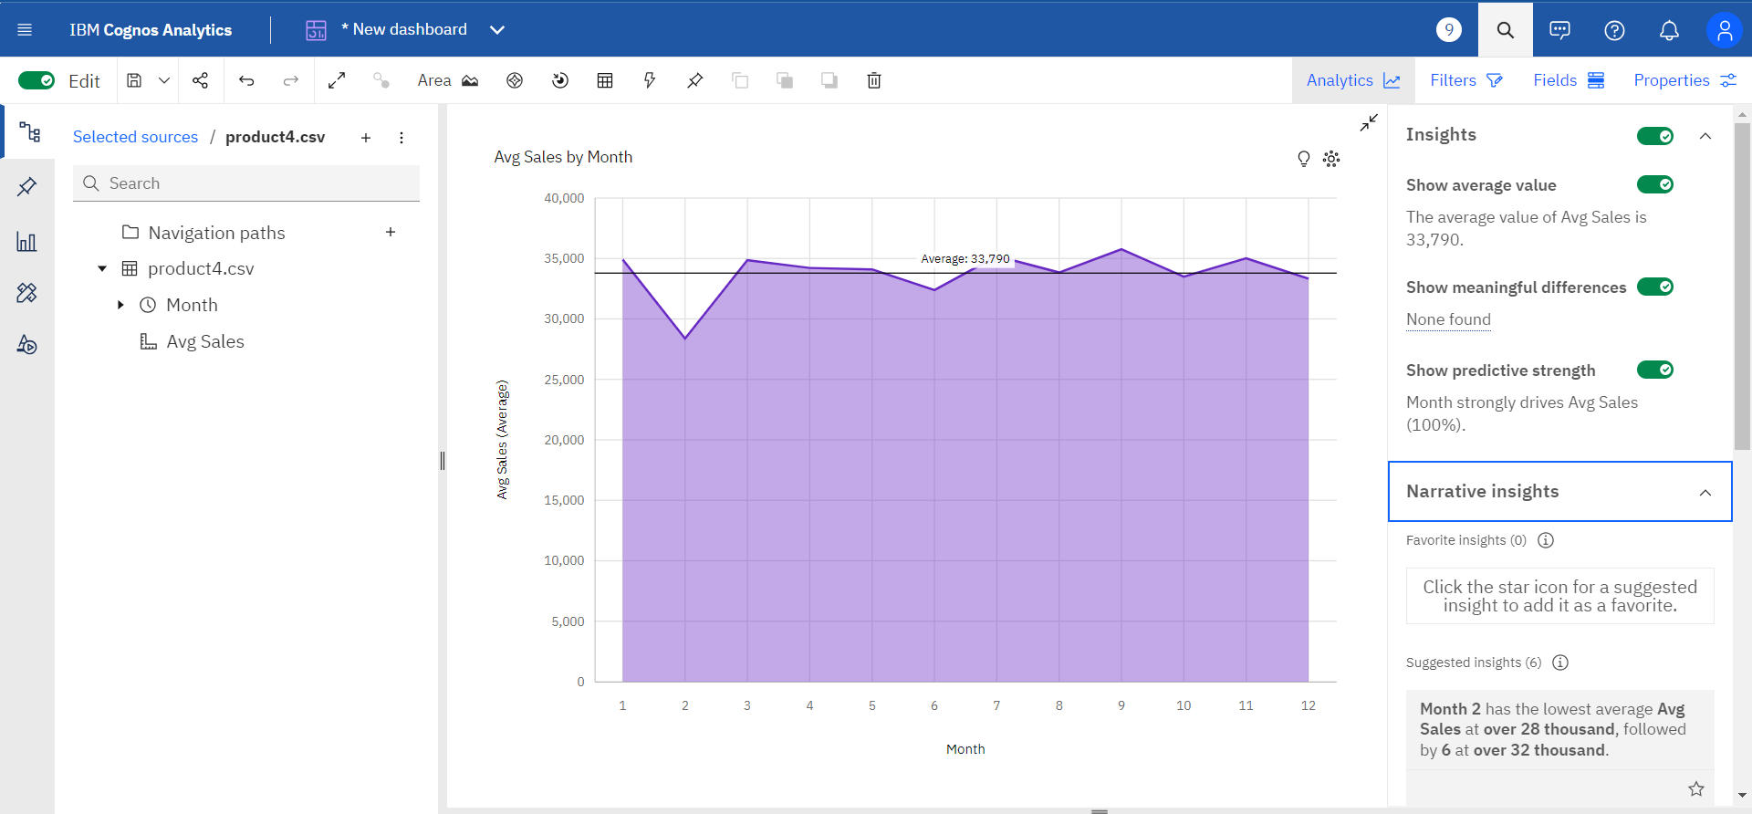

(fig -6 : Areaplot for product-4 where column denoting average sales and line describes the average sales)

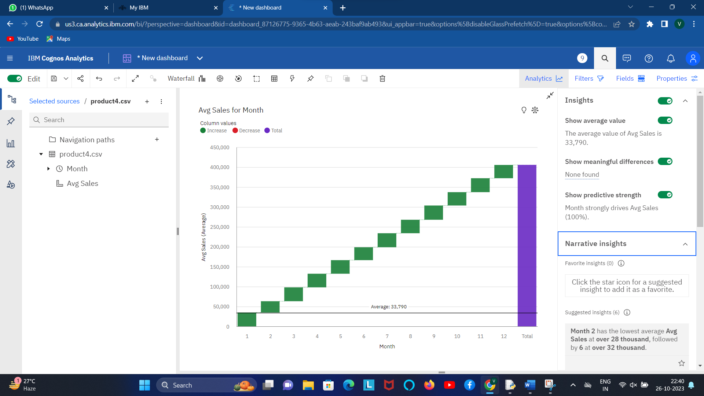

(fig-7: Waterfall plot for product 4 where column describing the average sales for a month)

**iii) Insights obtained from the visualizations:**

* The insights obtained from data visualizations can be highly valuable for organizations across various domains. Here are some common insights that can be derived from data visualizations:

**PRODUCT -4:**

* Month 2 has the lowest average Avg Sales at over 28 thousand, followed by 6 at over 32 thousand.
* Month 9 has the highest average Avg Sales at almost 36 thousand, followed by 7 at over 35 thousand.
* Based on the current forecasting, Avg Sales may reach over 35 thousand by Month 15.
* Month strongly affects Avg Sales (100%).Over all months, the average of Avg Sales is almost 34 thousand.
* The average values of Avg Sales range from over 28 thousand, occurring when Month is 2, to almost 36 thousand, when Month is 9.

**PRODUCT – 3:**

* Average Sales shows a moderate seasonal trend every 4 months. The largest values typically occur at period 1, whereas the smalest values at period 2.Avg Sales has a moderate upward trend.
* Month 2 has the lowest average Avg Sales at over 82 thousand, followed by 6 at almost 90 thousand.Month 5 has the highest average Avg Sales at over 104 thousand, followed by 9 at over 101 thousand.
* Based on the current forecasting, Avg Sales may reach over 95 thousand by Month 15.Month strongly affects Avg Sales (100%).Over all months, the average of Avg Sales is almost 95 thousand.
* The average values of Avg Sales range from over 82 thousand, occurring when Month is 2, to over 104 thousand, when Month is 5.The total number of results for Month, across all months, is 12.

**PRODUCT 2:**

* Month 2 has the lowest average Avg Sales at over 54 thousand, followed by 6 at over 61 thousand.
* Month 1 has the highest average Avg Sales at almost 69 thousand, followed by 3 at almost 68 thousand.
* Based on the current forecasting, Avg Sales may reach over 64 thousand by Month 15Month strongly affects Avg Sales (100%).Across all months, the average of Avg Sales is over 64 thousand.
* The average values of Avg Sales range from over 54 thousand, occurring when Month is 2, to almost 69 thousand, when Month is 1.

**PRODUCT 1:**

* Month 2 has the lowest average Avg Sales at nearly 109 thousand, followed by 9 at nearly 120 thousand.
* Month 7 has the highest average Avg Sales at nearly 132 thousand, followed by 1 at almost 128 thousand.Based on the current forecasting.
* Avg Sales may reach over 126 thousand by Month 15.Month strongly affects Avg Sales (100%).
* Over all months, the average of Avg Sales is nearly 124 thousand.The average values of Avg Sales range from nearly 109 thousand, occurring when Month is 2, to nearly 132 thousand, when Month is 7.