**Assignment-1**

**Task Description:**

1. Create a directory called ""my_folder"", navigate into it, and create a file named ""my_file.txt"" with some text. Then, create another file named ""another_file.txt"" with some text. Concatenate the content of ""another_file.txt"" to ""my_file.txt"" and display the updated content. Finally, list all files and directories in the current directory.

**Solution:-**

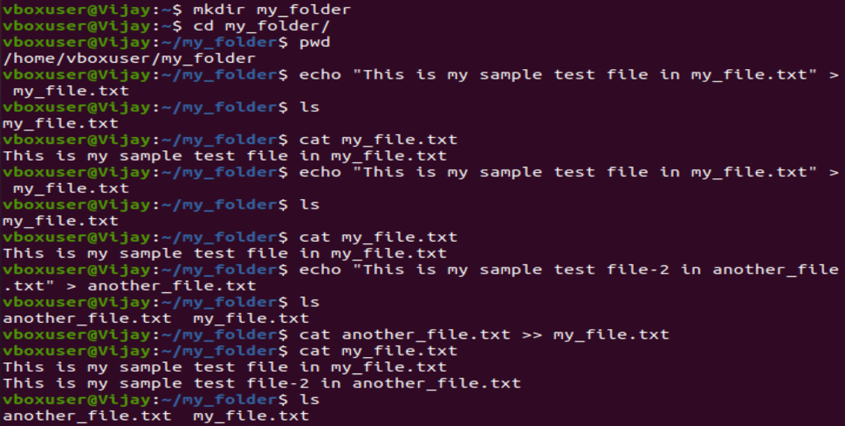

1. Create 20 files with .txt extensions and rename the first 5 files to .yml extension and Print the latest created top 5 files among the total no of files".

**Solution:-**

1. Created 20 text files



1. Rename of first 5 filename from .txt to .yml

1. Print the latest created top 5 files Output.

