EX NO: 7

09/12/2021

**BROADCAST APPLICATION**

**AIM:**

To create a UDP program to develop a UDP Broadcast server for broadcasting the details of “Opportunities available for a student with GATE score”.

**ALGORITHM:**

**SERVER:**

1. Include header files, initialize the required variables and specify the family, protocol, IP address and port number.
2. Create a socket using socket() function.
3. Bind the IP address and port number.
4. Send the broadcast message to the different clients.
5. Close the socket.

**CLIENT:**

1. Include header files, initialize the required variables and specify the family, protocol, IP address and port number.
2. Create a socket using socket() function.
3. Call the setsocketopt() function.
4. Display the opportunities available for respective GATE scores as received from the client.
5. Close the socket.

**PROGRAM:**

**SERVER:**

#include <stdio.h>

#include <stdlib.h>

#include <unistd.h>

#include <string.h>

#include <sys/types.h>

#include <sys/socket.h>

#include <arpa/inet.h>

#include <netinet/in.h>

#define PORT 8080

#define MAXLINE 1024

struct st{

int min;

int max;

char message[100];

}arr[4];

int main(){

int s,len,on=1;

strcpy(arr[0].message,"Eligible for Public Service Undertakings");

arr[0].max=100;

arr[0].min=80;

strcpy(arr[1].message,"Eligible for Indian Institute of Technology");

arr[1].max=79;

arr[1].min=60;

strcpy(arr[2].message,"Eligible for Private Colleges");

arr[2].max=59;

arr[2].min=30;

strcpy(arr[3].message,"Sorry!! Low scores; Better Luck next time");

arr[3].max=29;

arr[3].min=0;

struct sockaddr_in servaddr, cliaddr,baddr;

s=socket(PF_INET, SOCK_DGRAM,0);

printf("\nSocket connected successfully...");

setsockopt(s,SOL SOCKET,SO_BROADCAST,&on,sizeof(on));

bzero((void *)&servaddr, sizeof(servaddr));

servaddr.sin_port=htons(4040);

servaddr.sin_family=AF_INET;

servaddr.sin_addr.s_addr=INADDR_ANY;

len=sizeof(struct sockaddr);

bind(s,(struct sockaddr* )&servaddr,sizeof(struct sockaddr));

printf("\nBinded successfully...\n");

baddr.sin_family=AF_INET;

baddr.sin_port=htons(5000);

inet_pton(AF_INET,"255.255.255.255",(void *)&baddr.sin_addr);

for(int i=0;i<4;i++){

sendto(s,&arr[i],sizeof(arr),0,(struct sockaddr *) & baddr, sizeof(baddr));

fflush(NULL);

}

printf("\nStatus: Opportunity Details for GATE exam Scores Broadcasted Successfully...\n");

close(s);

}

**CLIENT:**

#include <stdio.h>

#include <stdlib.h>

#include <unistd.h>

#include <string.h>

#include <sys/types.h>

#include <sys/socket.h>

#include <arpa/inet.h>

#include <netinet/in.h>

#define PORT 8080

#define MAXLINE 1024

struct st{

int min;

int max;

char message[50];

}arr1;

int main(){

int s,len,on=1;

struct sockaddr_in servaddr,cliaddr;

s=socket(PF_INET,SOCK_DGRAM,0);

printf("\nSocket connected successfully...");

setsockopt(s,SOL_SOCKET,SO_REUSEADDR,&on,sizeof(on));

bzero((void *)&servaddr,sizeof(servaddr));

cliaddr.sin_port=htons(5000);

cliaddr.sin_family=AF_INET;

cliaddr.sin_addr.s_addr=INADDR_ANY;

len=sizeof(struct sockaddr_in);

bind(s,(struct sockaddr* )&cliaddr, sizeof(struct sockaddr));

printf("\nBinded successfully...\n");

printf("\nGATE score range and respective opportunities details:\n");

for(int i=0;i<4;i++){

recvfrom(s,&arr1,sizeof(arr1),0,(struct sockaddr *) & servaddr, &len);

printf("Marks:- minimum: %d maximum: %d Opportunity: %s\n",arr1.min,arr1.max,arr1.message);

}

close(s);

}

**SAMPLE OUTPUT:**

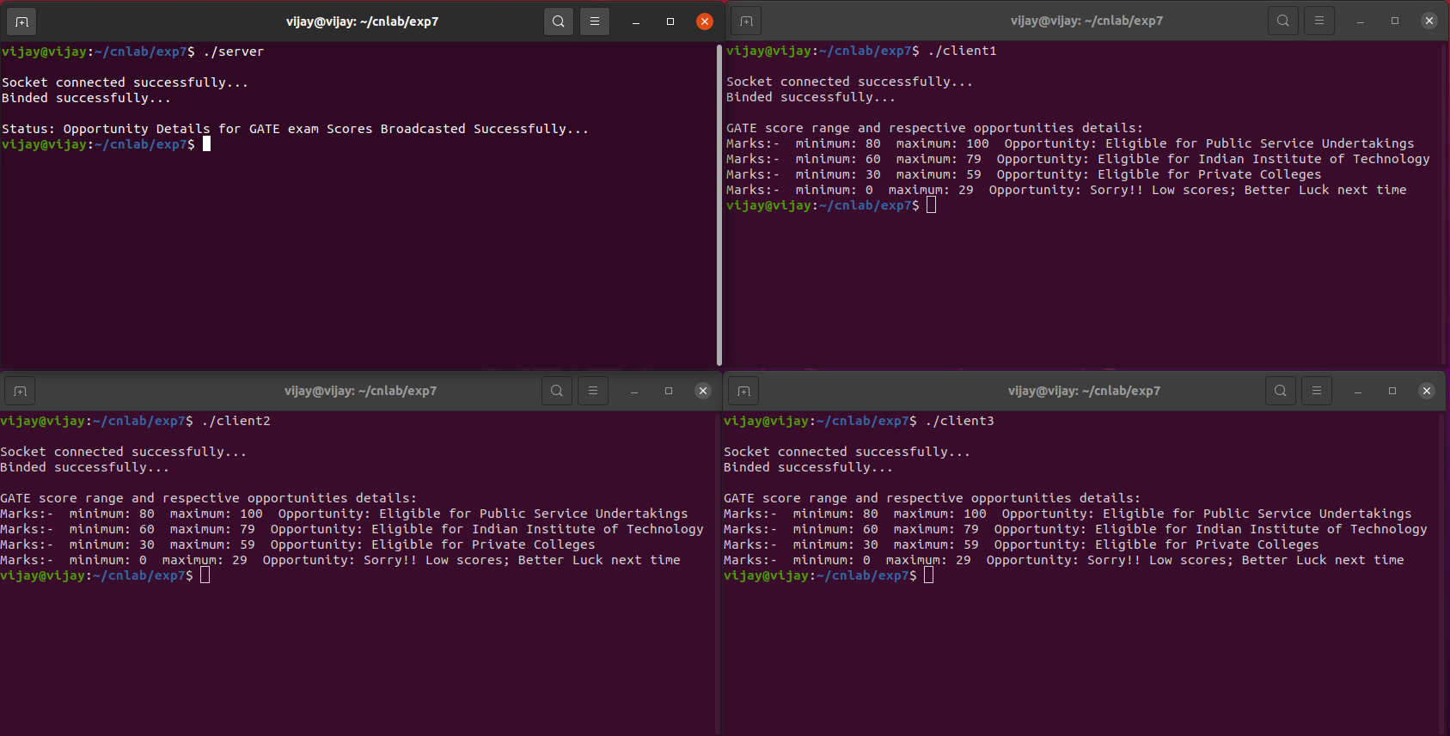

**RESULT:**

Hence the UDP Broadcast server for broadcasting the details of “Opportunities available for a student with GATE score” has been created and the output has been verified.