EX NO: 2

23/08/2021

**TCP CLIENT – SERVER PROGRAM TO CONVERT**

**RUPEES TO DOLLARS**

**AIM:**

To create a socket programming to implement TCP/IP client server application to convert rupees to dollars.

**ALGORITHM:**

**SERVER:**

1. Include header files, initialize the required variables and specify the family, protocol, IP address and port number.
2. Create a socket using socket() function.
3. Bind the IP address and port number and listen to the client’s request for connection.
4. Read the client’s message as an integer.
5. Perform the conversion of rupees to dollars and send the converted value to the client.
6. Close the socket.

**CLIENT:**

1. Include header files, initialize the required variables and specify the family, protocol, IP address and port number.
2. Create a socket using socket() function.
3. Call the connect() function and scan the input message.
4. Send the integer value to the server.
5. Display the converted integer value received from server.
6. Close the socket.

**PROGRAM:**

**SERVER:**

#include <netdb.h>

#include <stdio.h>

#include <stdlib.h>

#include <string.h>

#include <sys/socket.h>

#define PORT 8080

#define SA struct sockaddr

void func(int client_socket){

int amount;

float result;

read(client_socket,&amount,sizeof(amount));

printf("Amount received from client: Rs.%d",amount);

result = amount/72.99;

printf("\nUS dollar: $%.2f\n",result);

write(client_socket,&result,sizeof(result));

}

int main(){

int server_socket, client_socket, len;

struct sockaddr_in server_addr, client_addr;

server_socket = socket(AF_INET, SOCK_STREAM, 0);

if (server_socket == -1) {

printf("socket creation failed...\n");

exit(0);

}

printf("Socket created successfully...\n");

bzero(&server_addr, sizeof(server_addr));

server_addr.sin_family = AF_INET;

server_addr.sin_addr.s_addr = htonl(INADDR_ANY);

server_addr.sin_port = htons(PORT);

if ((bind(server_socket, (SA*)&server_addr, sizeof(server_addr))) != 0) {

printf("socket bind failed...\n");

exit(0);

}

printf("Socket bind successfull...\n");

if ((listen(server_socket, 5)) != 0) {

printf("Listen failed...\n");

exit(0);

}

len = sizeof(client_addr);

client_socket = accept(server_socket, (SA*)&client_addr, &len);

if (client_socket < 0) {

printf("server acccept failed...\n");

exit(0);

}

printf("Server accepted the client...\n");

func(client_socket);

printf("Server exit...\n");

close(server_socket);

}

**CLIENT:**

#include <netdb.h>

#include <stdio.h>

#include <stdlib.h>

#include <string.h>

#include <sys/socket.h>

#define PORT 8080

#define SA struct sockaddr

void func(int server_socket){

int amount;

float result;

printf("Enter the amount to be converted: Rs.");

scanf("%d",&amount);

write(server_socket,&amount,sizeof(amount));

read(server_socket,&result,sizeof(result));

printf("US dollar: $%.2f\n",result);

}

int main(){

int server_socket, client_socket;

struct sockaddr_in server_addr, client_addr;

server_socket = socket(AF_INET, SOCK_STREAM, 0);

if (server_socket == -1) {

printf("socket creation failed...\n");

exit(0);

}

printf("Socket created successfully...\n");

bzero(&server_addr, sizeof(server_addr));

server_addr.sin_family = AF_INET;

server_addr.sin_addr.s_addr = inet_addr("127.0.0.1");

server_addr.sin_port = htons(PORT);

if (connect(server_socket , (SA*)&server_addr, sizeof(server_addr)) != 0) {

printf("connection with the server failed...\n");

exit(0);

}

printf("Successfully connected with the server...\n");

func(server_socket);

printf("Client exit...\n");

close(server_socket);

}

**SAMPLE OUTPUT:**

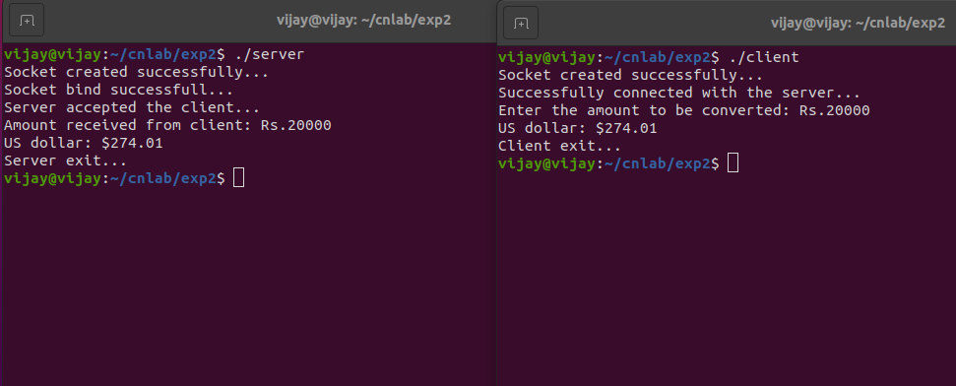

**RESULT:**

Hence the TCP/IP client server application was created to convert rupees to dollars and the output was verified.