EX NO: 4

01/09/2021

**SIMULATION OF WC COMMAND**

**USING SHELL SCRIPTING**

**AIM:**

To write a shell program to simulate WC command to print number of lines, words, characters and length of longest line in a file without using inbuilt functions.

**PROGRAM:**

**Source Code:**

#!/bin/bash

path="/home/vijay/oslab/exp4/file.txt"

exec < $path

lines=0

words=0

characters=0

length=0

longest=0

while read line

do

lines=$((lines + 1))

set $line

words=$((words + $#))

length=$(( 0 + ${#line}))

if [ $length -gt $longest ]

then

longest=$length

fi

done

while read -n1 character

do

characters=$((characters + 1))

done <$path

echo "Number of lines: $lines"

echo "Number of words: $words"

echo "Number of characters: $characters"

echo "Length of longest line: $longest"

**Text file content:**

The given program today is

to count number of words lines characters and longest line

in a file

**Output:**

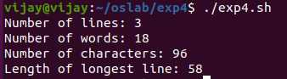

**RESULT:**

Hence a shell program to simulate WC command to print number of lines, words, characters and find length of longest line in a file without using inbuilt functions is created and the output has been verified.