1.After building every time using POM.xml file used to get below jar

com.google.code.google-collections🡪google-collect-snapshot-20080530.jar

2.If I run tests with this jar used to get Error as NOSuchMethod Error

“com.google.common.collect.ImmutableSet.of(Ljava/lang/Object;Ljava/lang/Object;Ljava”

This Error was because same method(ImmutableSet.of) was available at 2 places so there was ambiguity which one to choose, so omitted the used jar by following 3 & 4 points.

3. To fix above issue of point 2 open pom.xml file

Under dependency Hierarchy TAB

Right click on the jar you want to exclude downloading while building & choose option

“Exclude Maven Artifact…”

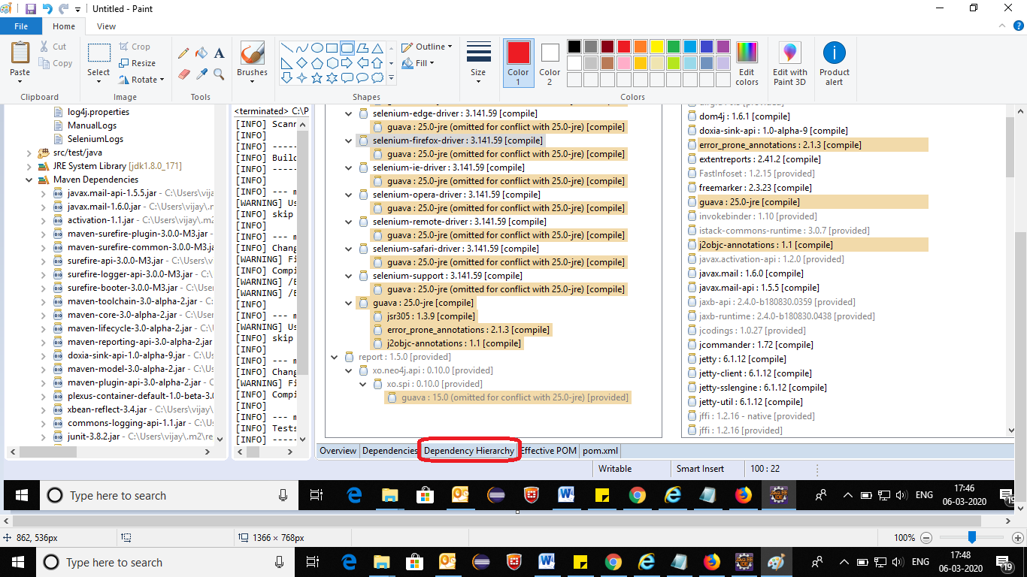

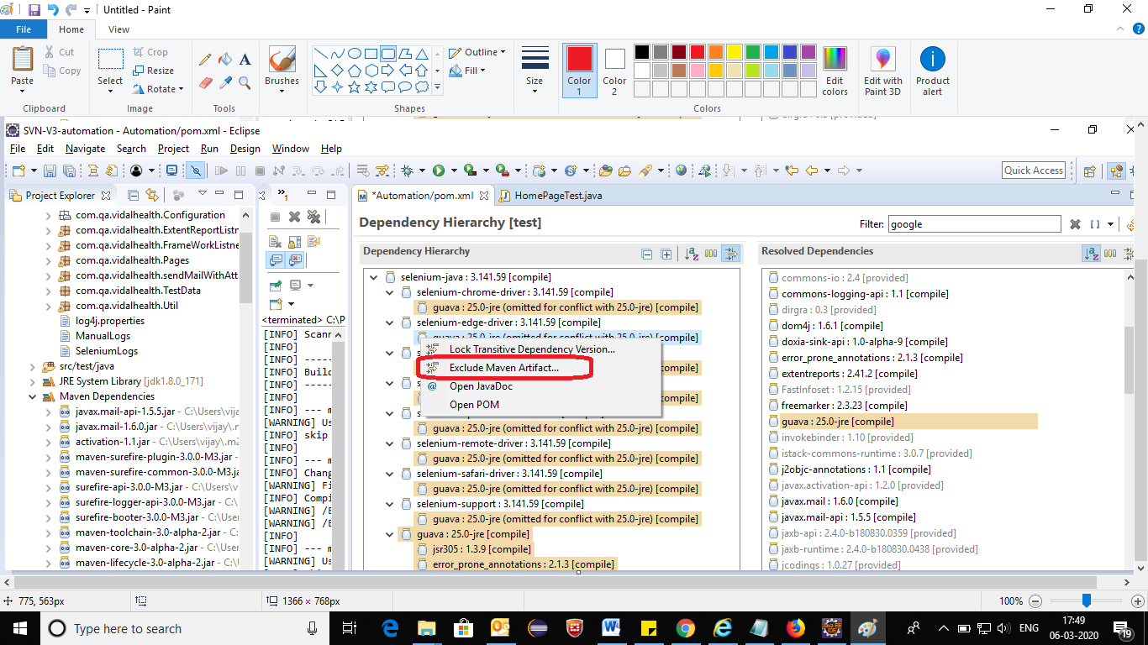

4.Now build again that excluded jar file will not download