* Download latest Jenkins version from <https://updates.jenkins-ci.org/download/war/>
* Run the war file from cmd, command ‘java -jar Jenkins.war’
* After successfully running jenkin.war, in cmd below output will be generated.

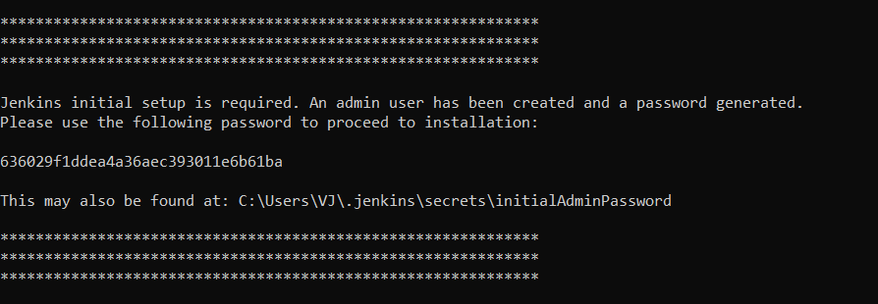

OR

* Simply install the installer zip from <https://www.jenkins.io/download/thank-you-downloading-windows-installer/>

Refer 🡪 <https://www.youtube.com/watch?v=gT9qnZi3f74>

* Now open enter ‘localhost:8080’ in any browser, Jenkins sign in page will appear.
* Copy and paste above generated password.
* Click on ‘Install Suggested Plugin’. It will take some time to install all the plugins.
* After that ‘Admin User’ Creation window will appear. (vijay004 / rahul004)

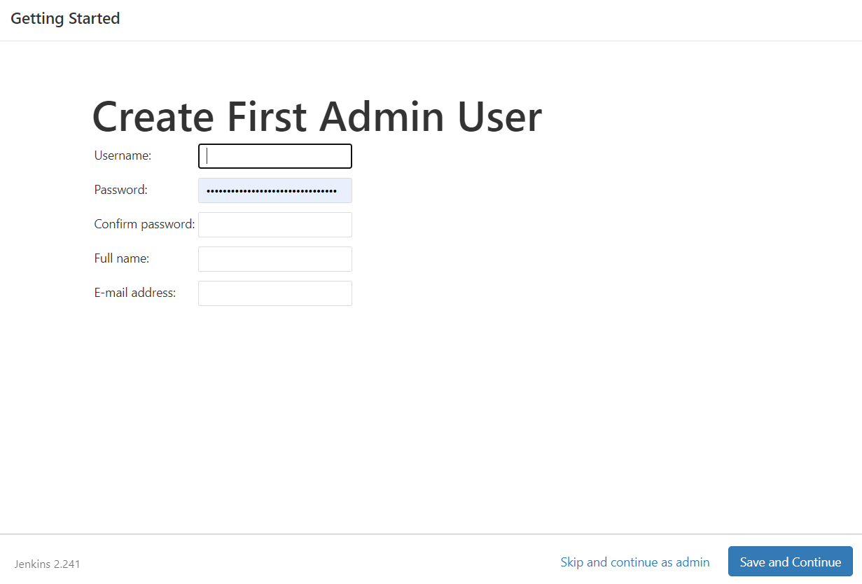

* After login, it will take to Jenkins home page.

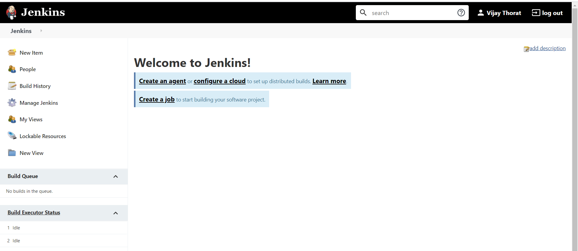

* Now we need to config JAVA and Maven in the project. It’s a one time activity.
* Go to Manage Jenkins -> Global Tool Configuration

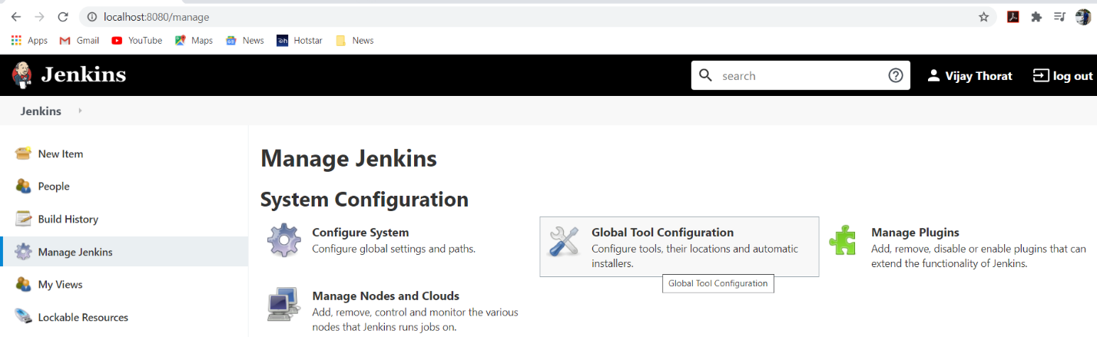

* Click on Add JDK, uncheck ‘install automatically’ option.
* Provide name as ‘JAVA_HOME’ and provide system path of JDK.

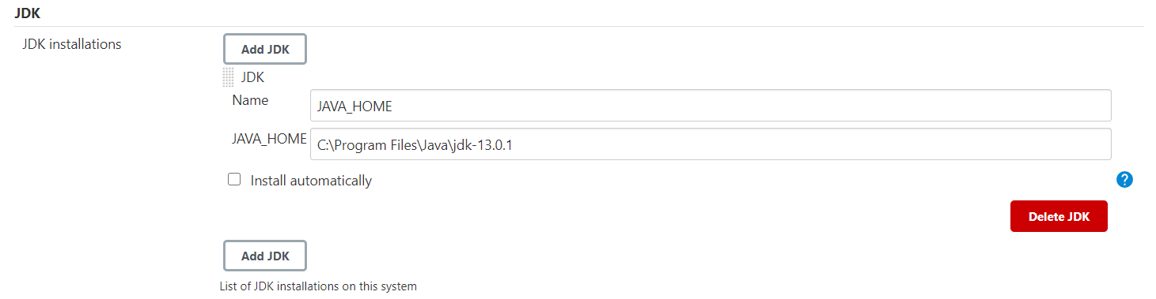

* Now in same way configure Maven as well.
* Maven path can be found out from system environment variable.

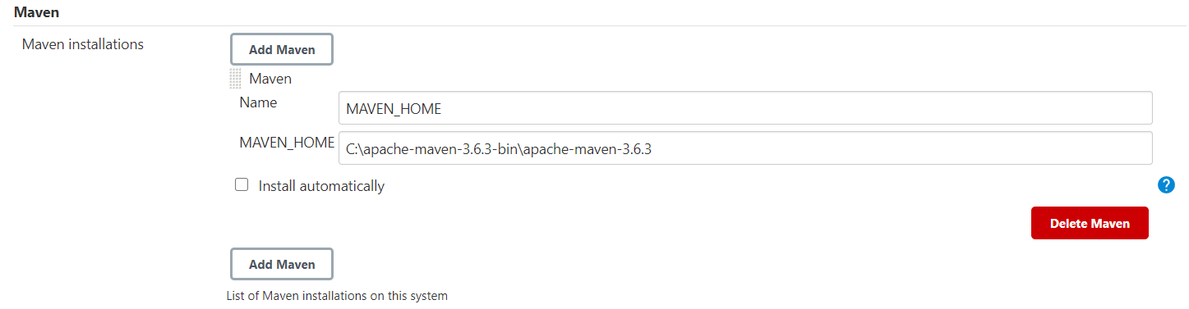

* Click Save at the bottom of the form.
* From Manage Jenkins -> Manage Plugins, install ‘Maven Integration Plugin’.

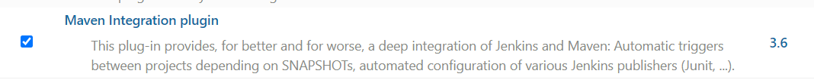

* Now from Jenkins home page, click on New Item and create new Maven project and click OK.

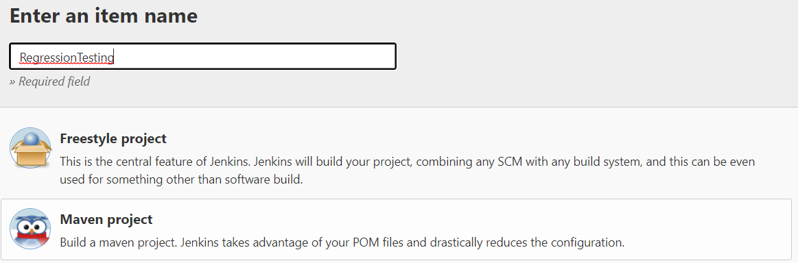

* In the ‘Source Code Management’ option select Git.
* Copy past GitHub repository URL and enter github credentials to access it.

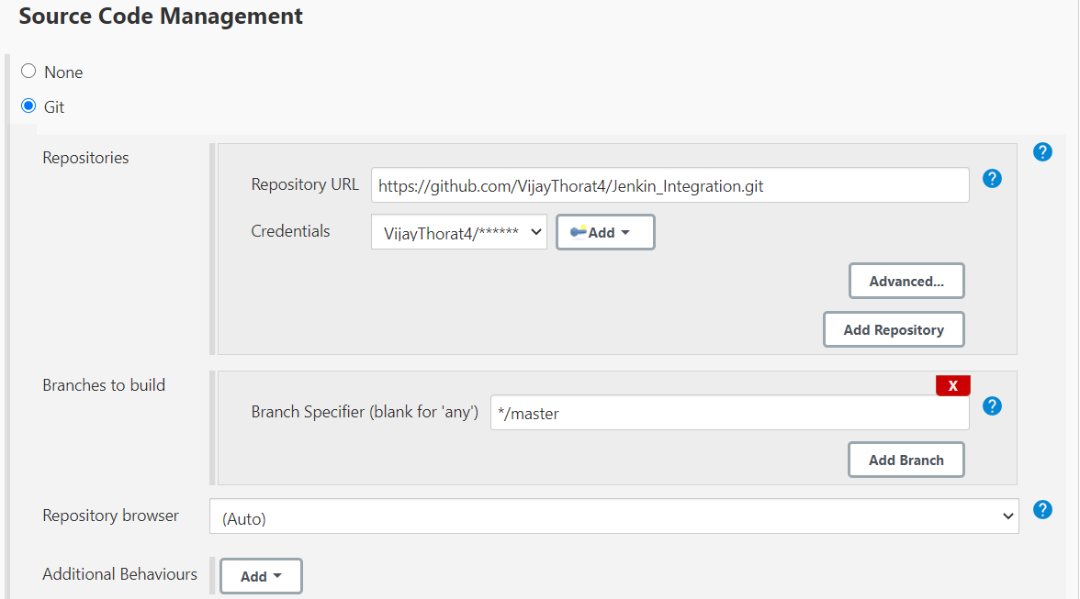

* In the Build option, provide path of pom.xml and goals.

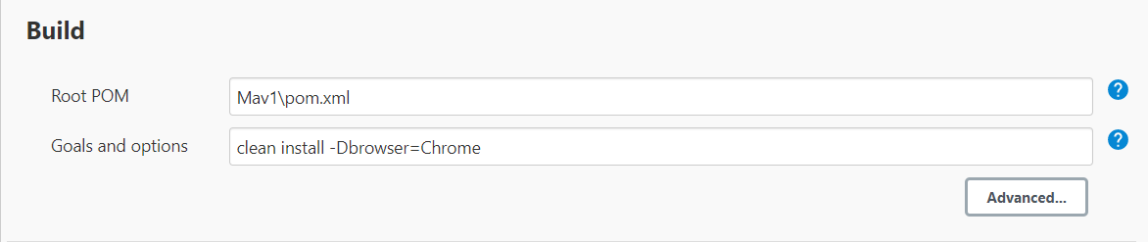

* Click on Save, project gets created.
* To start the job, click on build now.

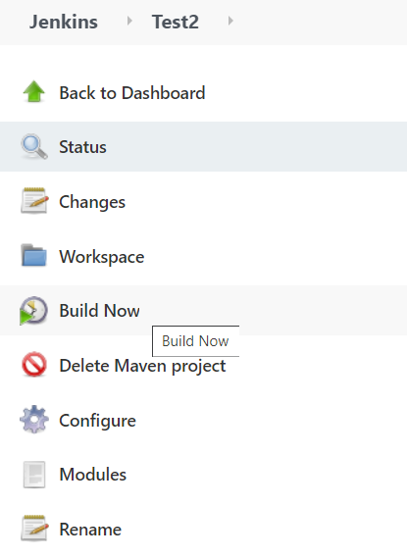

Jenkins scheduling Build Periodically format 🡪

By setting the schedule period to 15 13 * * * you tell Jenkins to schedule the build every day of every month of every year at the 15th minute of the 13th hour of the day.

Jenkins used a **Cron expression**, and the different fields are:

MINUTES Minutes in one hour (0-59)

HOURS Hours in one day (0-23)

DAYMONTH Day in a month (1-31)

MONTH Month in a year (1-12)

DAYWEEK Day of the week (0-7) where 0 and 7 are Sunday