**Download jars**

From <https://selenium.dev/downloads/>, download Selenium server and client jar.

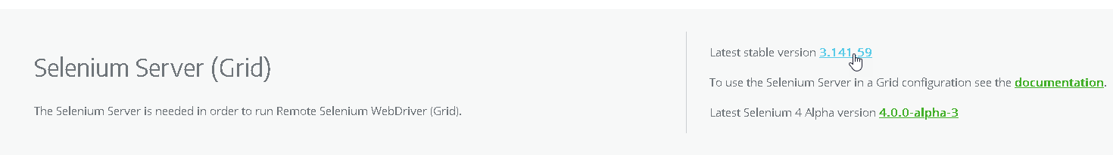

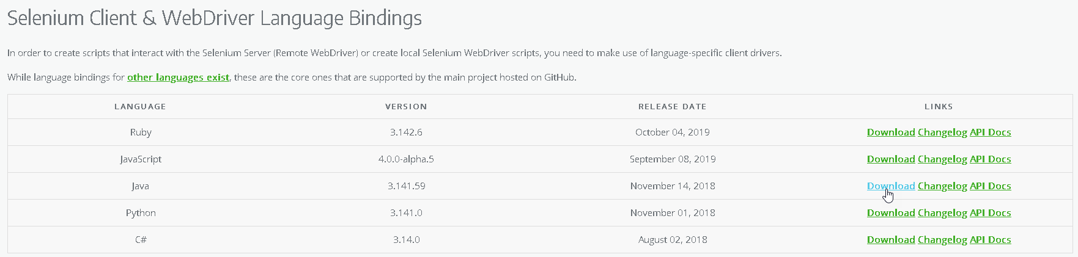

Extract ‘selenium-java-3.141.59.zip’ file.

**Configuring Eclipse**

* Open eclipse, create Java project.
* Create new folder inside java project as ‘lib’.
* Drag drop separately downloaded ‘selenium-server-standalone-3.141.59.jar’ and extracted ‘client-combined-3.141.59.jar’ into the lib folder. During drag drop, choose copy file option.
* Select both the jar files from lib folder, right click select ‘Build Path’ and choose ‘Add to Build Path’.
* ‘Referenced Libraries’ folder gets created above it.