**Virtualization** - Virtualization means creating virtual version of a device or resource such as server, storage device, network, operating system etc by dividing the resource into more execution environments.

**Cloud Computing** – It is on demand availability of computer system for multiple purposes like data storage, load balancing etc .

**Types of Virtualization & computing technologies 🡪**

* Operating System – One hardware with multiple operating systems.
* Application Server – Used for load balancing between applications & servers.
* Application – Running OS on some server feels like it is running on your system.
* Administrative – In Data centers giving different access like read write etc.
* Network – Network access & handling multiple IPs.
* Hardware – Specific chunk of hardware dedicated to specific tasks.
* Storage – Storage divided into parts & monitor manages stored data.

**Hypervisor** – It is nothing but virtual machine monitor which carries out the virtualization like vSphere. A computer on which hypervisor runs multiple VMs is called Host machine & each VM is called guest machine.

**Types of Hypervisor 🡪**

Type 1 (Bare Metal Hypervisor) – It runs directly on hardware like ESXi.

Type 2 (Host OS Hypervisor) – It allows multiple OS on same system like Virtual Box.

**VMware**

**VMware** – It is a platform that provides virtualization softwares and services for cloud computing.

**ESXi** – It is noting but an image like any OS that is installed on a hardware. In technical word it is called as ‘Host’. We can divide this ESXi installed machine in number of VMs as per our requirement specification.

**vSphere** - We can access ESXi web management console by entering its IP which is noting but vSphere. In technical words vSphere is an ‘Hypervisor’. vSphere is management interface for single ESXi host.

**vCenter** - To manage one host at a time, we use VSphere. But to manage multiple ESXi hosts, we need to use vCenter. vCenter is used to manage VMs between hosts if we have more EXSi hosts between the networks. VCenter is deployed on top of ESXi host. It provides center management interface to manage multiple ESXi and their VMs.

vCenter can be accessed from two consoles. One is Flash console & latest is web based HTML based interface. vCenter provides number of features like Load balancing across VMs between multiple hosts, VM cloning, DRS (Distributed Resource Scheduling), Fault tolerance etc

**Architecture of vCenter 🡪**

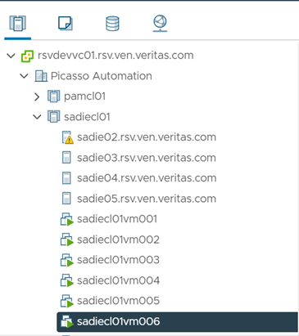

vCenter Server

              Datacenter (Picasso Automation)

                             Cluster (sadiecl01)

                                           Host / ESXi ([sadie04.rsv.ven.veritas.com](http://sadie04.rsv.ven.veritas.com/))

                                                          Node / VM (sadiecl0101vm72)

