Machine Learning Operations (AIMLCZG523) — Assignment 1
Heart Disease Risk Prediction: An End-to-End MLOps Pipeline

STUDENT NAME: YELDONA DESAI V VITTAL
STUDENT ID: 2025AE05316

2026-10-16
2025AE05316_MLOps_Assignment1_GitHub_Link
Demo video (embedded): 2025AE05316_MLOps_Assignment1_Video.mp4
Double-click the thumbnail in Microsoft Word (desktop) to open and play the video.

Online Drive Link or GitHub Video Link

Table of Contents
Table of Contents 2
1. Introduction and Problem Statement 3
2. Setup and Installation Instructions 3
3. Data Acquisition and Exploratory Data Analysis 3
4. Feature Engineering and Modelling 4
Leave-one-site-out generalisation 5
5. Experiment Tracking 6
6. Model Packaging and Reproducibility 6
7. CI/CD Pipeline and Automated Testing 7
8. Containerisation and API Design 7
9. Kubernetes Deployment 7
10. Monitoring and Logging 8
11. Architecture Diagram 9
12. Limitations, Ethical Considerations, and Future Work 9
13. References 9

1. Introduction and Problem Statement
This project builds a binary classifier that predicts the presence of heart disease from thirteen clinical attributes, and ships it as a containerised, monitored, Kubernetes-deployed API with a full CI/CD pipeline and experiment tracking. Rather than the common 303-row Cleveland-only subset, it combines all four original UCI sites (Cleveland, Hungarian, Switzerland, VA Long Beach; 918 rows after cleaning) — the four sites differ substantially in missingness and disease prevalence, so a leave-one-site-out evaluation is used throughout, alongside standard cross-validation, to make that generalisation risk visible rather than hidden.
Every non-obvious design decision in this project is logged with its rationale and alternatives considered in docs/DECISIONS.md, referenced throughout this report by decision ID (e.g. D3.1).

2. Setup and Installation Instructions
The project targets two environments: macOS (Python 3.13.x, development) and a Linux lab (Python 3.12.9, verification). scripts/setup_venv.sh resolves the correct pinned interpreter per OS rather than trusting whatever python3 is first on $PATH, since the two can silently differ (docs/DECISIONS.md D0.3).
bash scripts/check_env.sh
bash scripts/setup_venv.sh && source .venv/bin/activate
make data && make train
SETUP_GUIDE.md / LAB_RUNBOOK.md give the full copy-paste sequence — clone, preflight, venv, data, training, tests, Docker, Kubernetes deploy/verify/load-test/teardown, and troubleshooting — verified by an actual fresh-clone dry run before being trusted (docs/DECISIONS.md D8.2). No step anywhere requires sudo.

3. Data Acquisition and Exploratory Data Analysis
download.py downloads the four UCI site files with SHA-256 checksum verification and an automatic fallback if a primary URL is unreachable. clean.py converts '?' tokens and physiologically impossible zero values (chol == 0 in all 123 Switzerland rows and 49 VA rows; trestbps == 0 in one VA row) to missing, removes two exact duplicates, and binarises the target. The cleaned file keeps every missing value — imputation happens only inside the model pipeline, fit on training folds only, so no information leaks from validation or test rows.
Site | Rows | trestbps % missing | chol % missing | slope % missing | ca % missing | thal % missing | Disease %
cleveland | 303 | 0.0 | 0.0 | 0.0 | 1.3 | 0.7 | 45.9
hungarian | 293 | 0.3 | 7.5 | 64.5 | 99.0 | 90.4 | 36.2
switzerland | 123 | 1.6 | 100.0 | 13.8 | 95.9 | 42.3 | 93.5
va | 199 | 28.6 | 28.1 | 50.8 | 99.0 | 82.9 | 74.4
ALL | 918 | 6.5 | 21.9 | 33.4 | 66.3 | 52.7 | 55.3
Table 1: Rows, missing data (%) for the columns most affected, and disease prevalence (%), by site. Full per-column breakdown in data/processed/data_quality_summary.csv.
ca, thal and slope are missing in 60-99% of rows outside Cleveland, and disease prevalence swings from 36.2% (Hungarian) to 93.5% (Switzerland) — both motivate the site-aware modelling choices in Section 4.
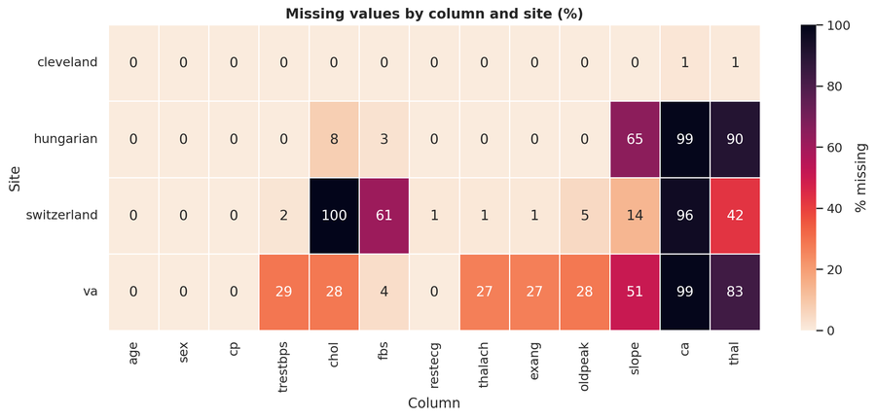  Figure 1: Missing values by column/site. | 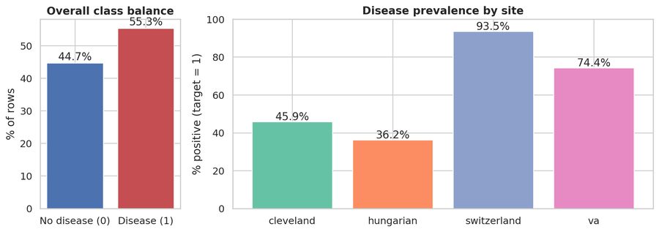  Figure 2: Overall and per-site class balance. | 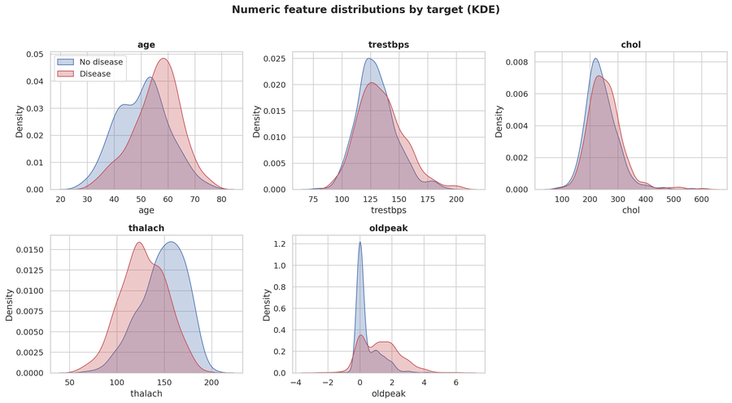  Figure 3: Numeric feature distributions by target (KDE).
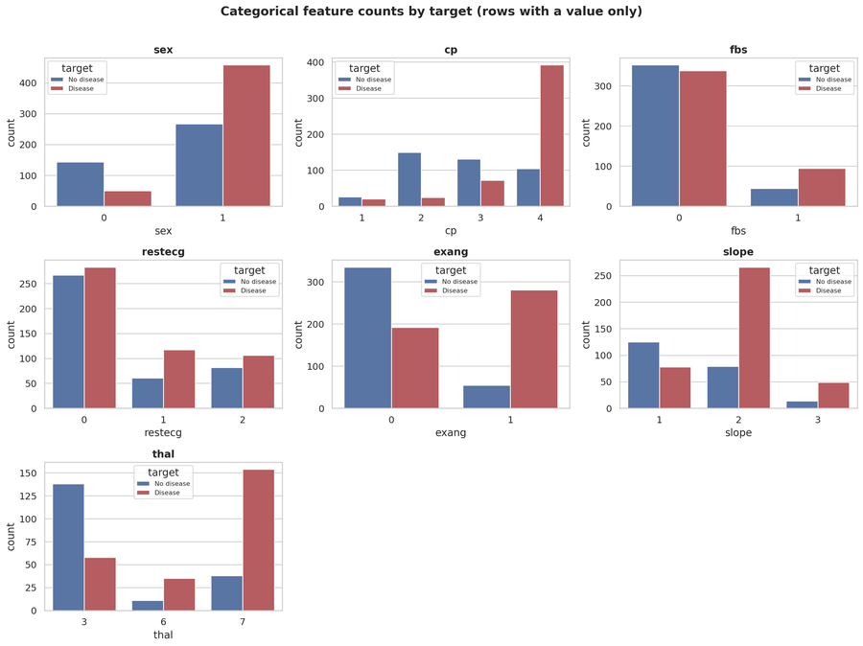  Figure 4: Categorical feature counts by target. | 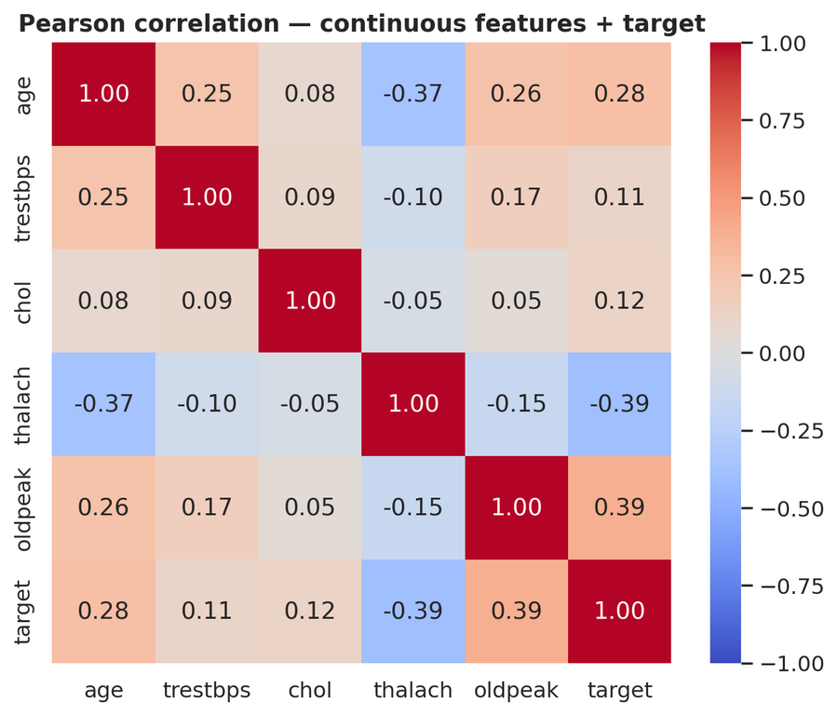  Figure 5: Pearson correlation, features and target. | 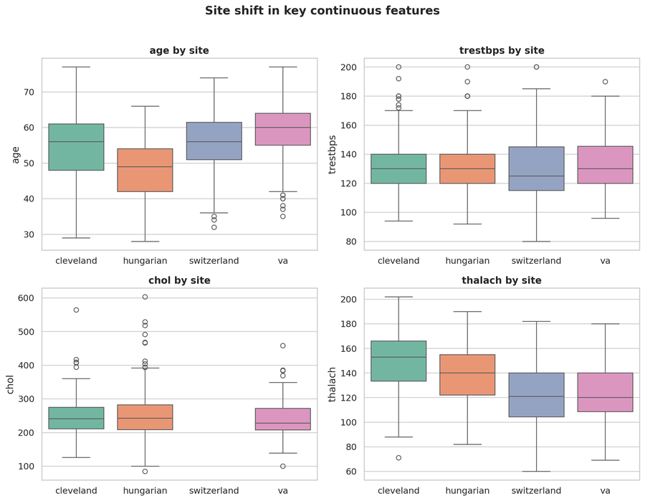  Figure 6: Site shift in key features.

4. Feature Engineering and Modelling
Three models were tuned with RandomizedSearchCV under 5-fold stratified cross-validation: Logistic Regression, Random Forest, and HistGradientBoostingClassifier — the last included specifically because it handles missing values and categorical columns natively, receiving no imputation at all (the other two share a ColumnTransformer: median imputation with missing-indicator flags and scaling for numeric columns, constant-sentinel imputation plus one-hot encoding for categorical columns).
The model-selection rule was committed before any hold-out result was looked at (docs/DECISIONS.md D3.1): highest mean cross-validated ROC-AUC wins, ties within 0.005 broken by preferring the simpler model. ROC-AUC is the tuning objective since the operating threshold is chosen separately afterwards.
model | CV ROC-AUC | CV std | Accuracy | Precision | Recall | F1 | ROC-AUC | PR-AUC | Brier | Threshold
logreg | 0.905 | 0.011 | 0.804 | 0.754 | 0.961 | 0.845 | 0.904 | 0.915 | 0.120 | 0.242
random_forest | 0.899 | 0.019 | 0.793 | 0.750 | 0.941 | 0.835 | 0.890 | 0.885 | 0.132 | 0.356
hist_gb | 0.894 | 0.017 | 0.810 | 0.760 | 0.961 | 0.848 | 0.898 | 0.906 | 0.122 | 0.260
Table 2: Cross-validated and hold-out metrics for all three tuned models.
Logistic Regression was selected (highest CV ROC-AUC, 0.9055). The operating threshold (0.2419) was chosen from out-of-fold probabilities to meet a 0.95 recall target, since missed disease cases are costlier than false alarms in a screening context. Its coefficients also give an interpretable check against the site-leakage risk flagged during EDA: 'ca is missing' carries an odds ratio of approximately 1 (no effect), while 'ca = 0' carries the single largest coefficient — evidence ca is used for genuine clinical signal, not as a hospital shortcut.
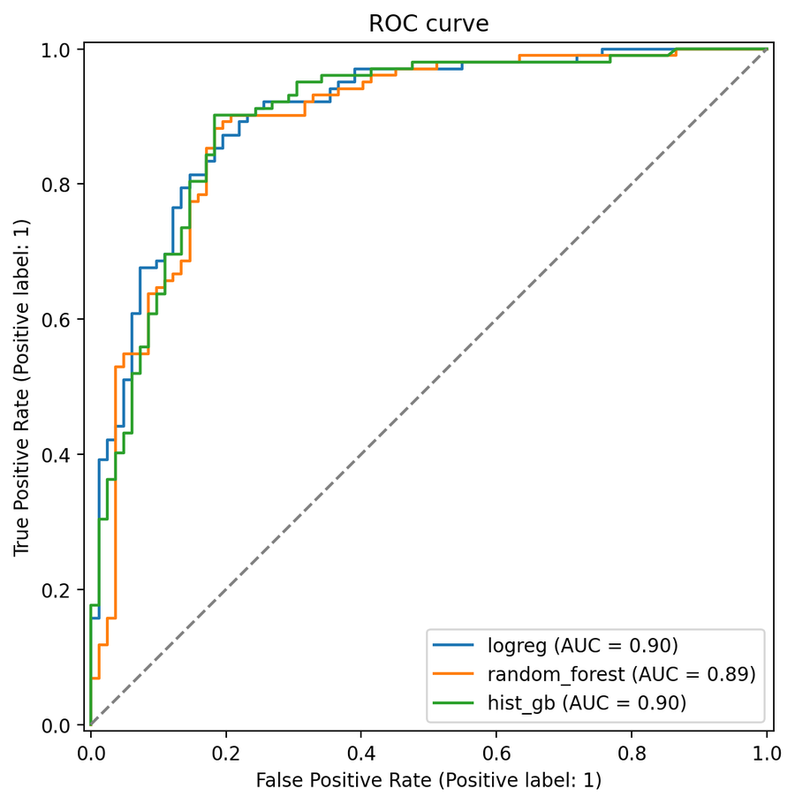  Figure 7: ROC curves, all three models. | 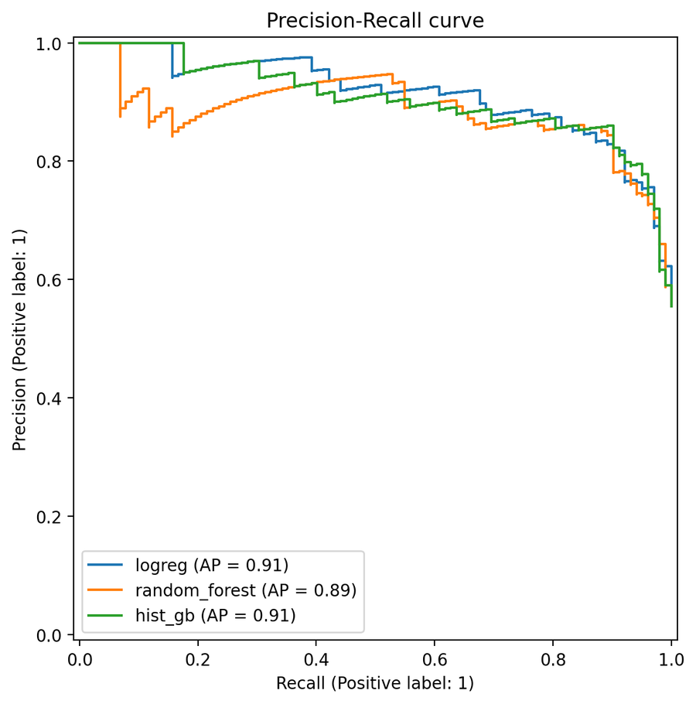  Figure 8: Precision-Recall curves, all three. | 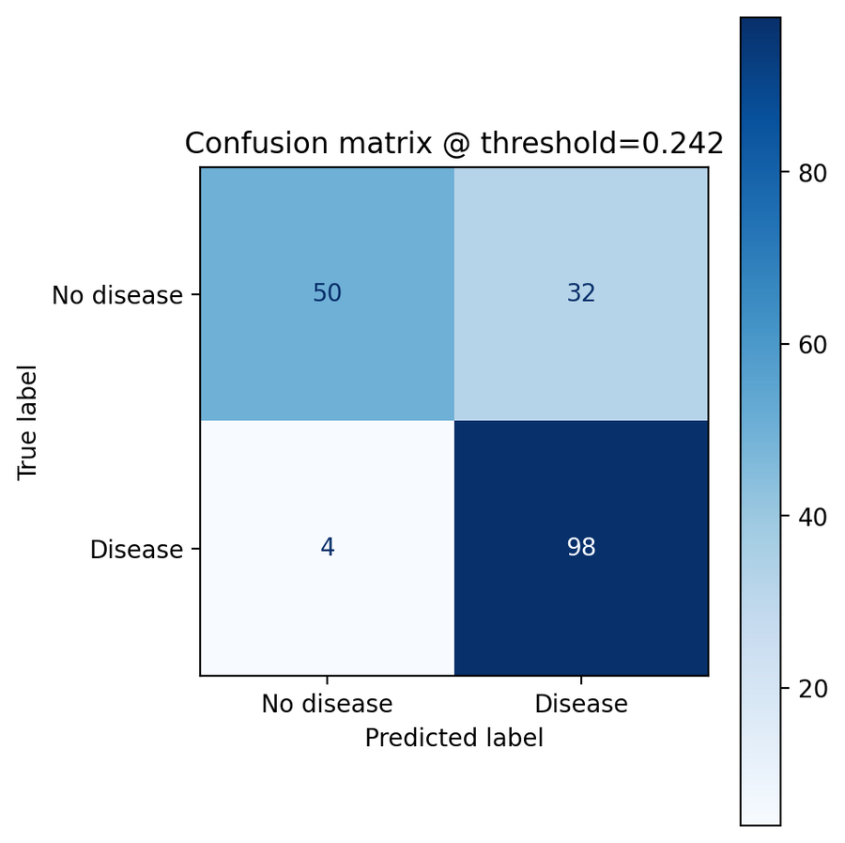  Figure 9: Confusion matrix, selected model.
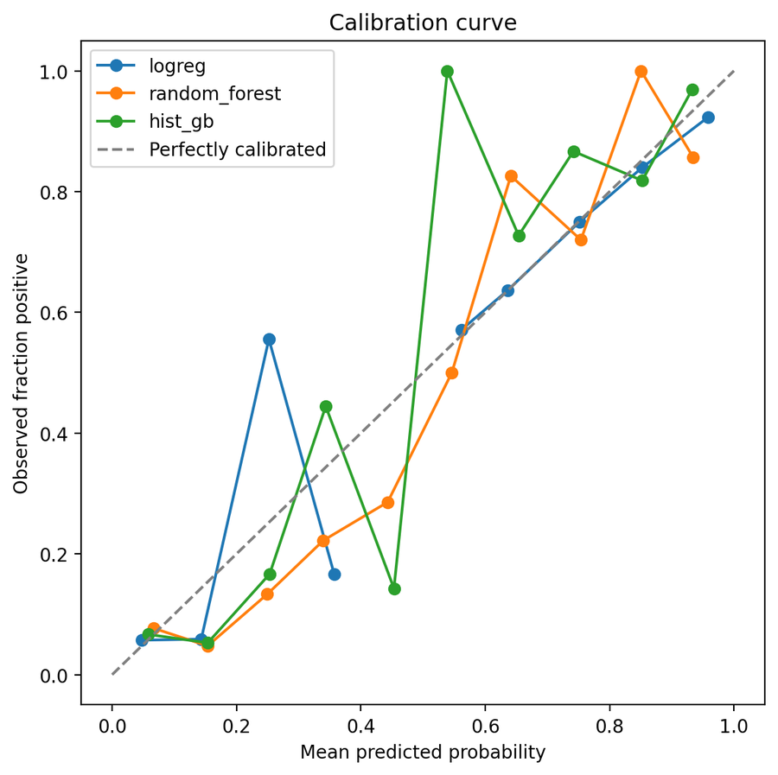  Figure 10: Calibration curves, all three. | 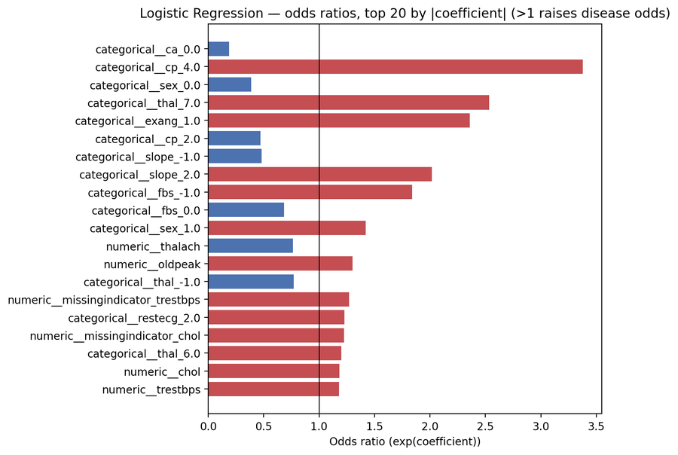  Figure 11: LogReg odds ratios (top 20 by |coef|). | 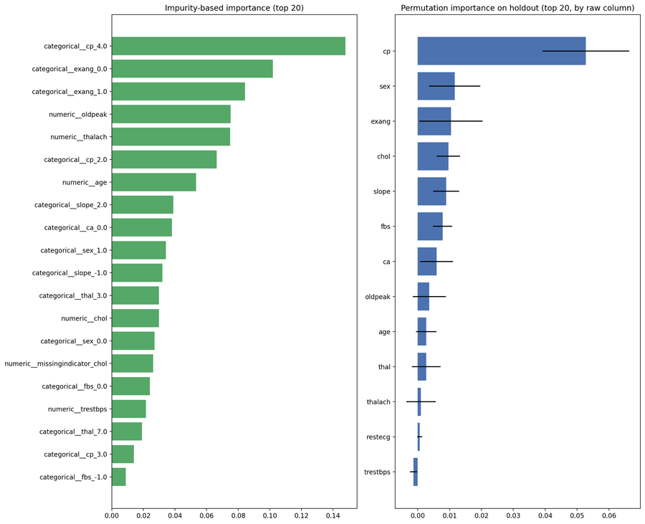  Figure 12: Random Forest importance (impurity + permutation).

Leave-one-site-out generalisation
This evaluation trains on three of the four sites and tests entirely on the fourth, in turn, using the single globally-selected threshold throughout (a deployed model does not re-tune itself per incoming hospital).
Held-out site | Train rows | Test rows | Accuracy | Precision | Recall | F1 | ROC-AUC | PR-AUC | Brier | Threshold
cleveland | 615 | 303 | 0.723 | 0.642 | 0.892 | 0.747 | 0.868 | 0.863 | 0.145 | 0.242
hungarian | 625 | 293 | 0.662 | 0.518 | 0.953 | 0.671 | 0.903 | 0.865 | 0.134 | 0.242
switzerland | 795 | 123 | 0.919 | 0.965 | 0.948 | 0.956 | 0.726 | 0.972 | 0.151 | 0.242
va | 719 | 199 | 0.744 | 0.774 | 0.926 | 0.843 | 0.736 | 0.869 | 0.179 | 0.242
Table 3: Leave-one-site-out metrics, one row per held-out site.
Recall holds at or above the 0.95 target for three of the four sites; Cleveland (0.89) is the exception, likely because it is the only site with near-complete ca/thal/slope data. ROC-AUC drops noticeably for Switzerland and VA, consistent with the site-shift seen in Section 3. Hungarian's precision is low (0.52) when held out, since it has the lowest disease prevalence of the four — a threshold tuned on the pooled mix produces more false positives there. This base-rate-shift effect would be invisible in a single pooled k-fold evaluation, which is the entire reason this evaluation exists.
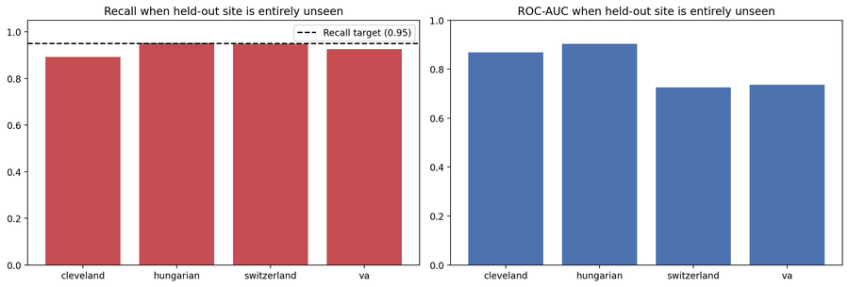
Figure 13: Recall and ROC-AUC by held-out site.
Calibration was checked, but CalibratedClassifierCV changed the Brier score by under 0.001 — not distinguishable from noise at this hold-out size — so the selected model's own predict_proba output ships directly as the API's confidence score.

5. Experiment Tracking
Every training run logs to a single MLflow experiment (heart-disease-4site) as one parent run with one nested child run per model. Each child run records hyperparameters, preprocessing choices, cross-validated and hold-out metrics, the cv_results table, a classification report, and a confusion matrix; the selected model's run additionally gets a feature-importance plot and the logged sklearn model with an inferred signature. Parent-run artifacts include the comparison table, ROC/PR/calibration plots, and the model card.
The selected model is registered as heart_disease_classifier, aliased 'champion' (version 2 at writing) rather than MLflow's deprecated Staging/Production stages. Serving code resolves the model by alias, never a hardcoded version, so promoting a new champion never requires a code change — verified by running training twice and confirming the alias moved automatically, with the old version left unaliased for audit and rollback.
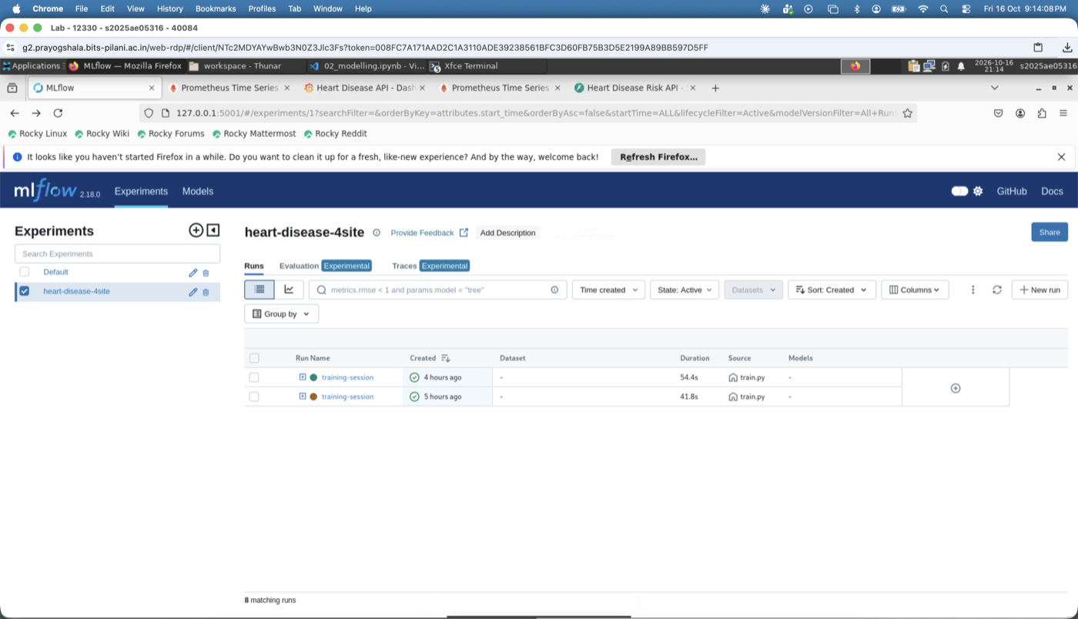  Figure 14: MLflow experiment runs list | 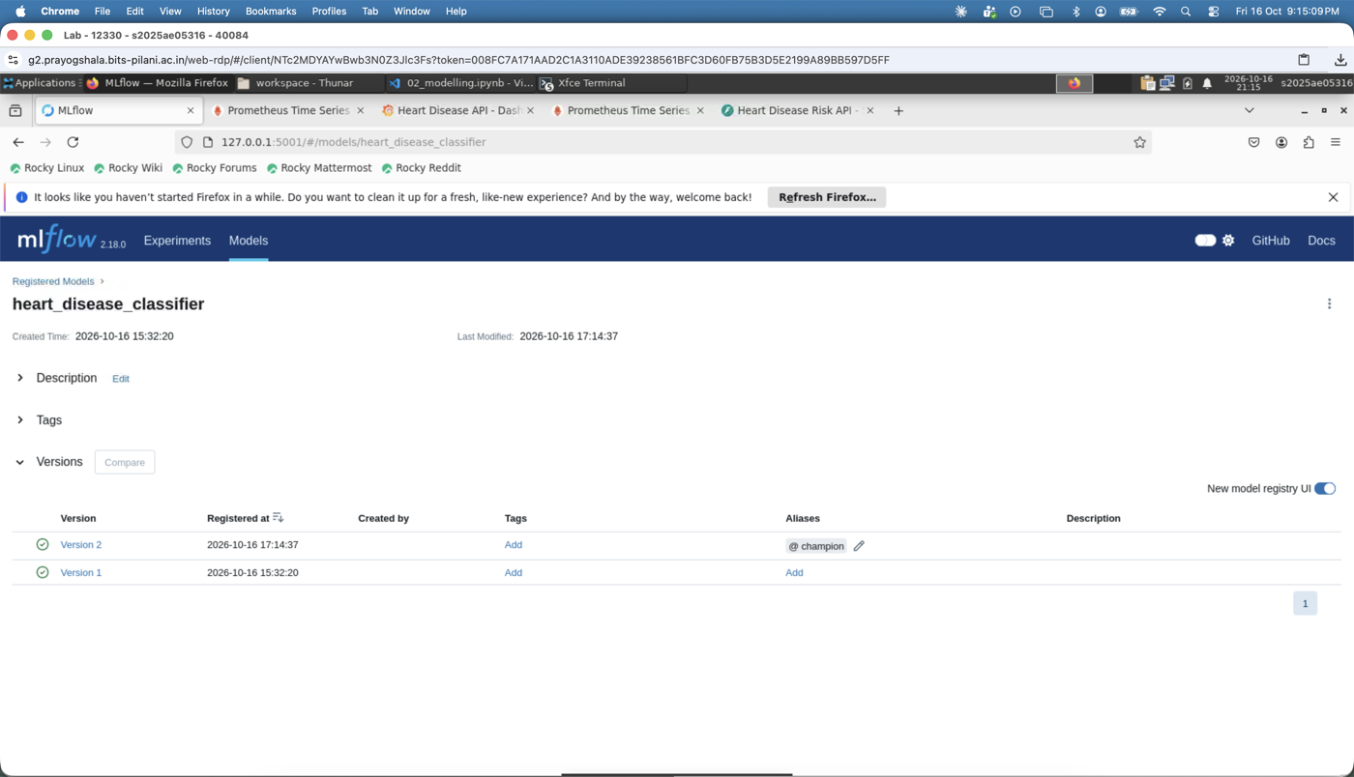  Figure 15: MLflow run detail, registered model

6. Model Packaging and Reproducibility
The trained pipeline is persisted twice: in the MLflow model format, and as models/heart_model.joblib plus models/model_metadata.json. Both are deliberately the exact same fitted pipeline, not independently retrained — the joblib artifact is byte-for-byte the same object passed to mlflow.sklearn.log_model — so the hold-out metrics in the metadata genuinely describe the model being shipped. The API loads the joblib/metadata pair directly, with no MLflow server needed at serving time, since the model is already fully trained by the time it needs to serve traffic.
Field | Value
Model | logreg
Registry version | 2
Threshold | 0.2419
scikit-learn version | 1.5.2
Training data SHA-256 | c1bdd6e8cfc99804…
Git commit | fcd0044439a0
Packaged at (UTC) | 2026-10-16T11:44:37.544396+00:00
Table 4: Packaged model artifact metadata (models/model_metadata.json).
A reproducibility test reads the packaged model's own tuned hyperparameters and fits two fresh pipeline instances, asserting their predictions match to floating-point tolerance — proving determinism without re-running the full ~6-minute search inside a test. notebooks/03_inference_demo.ipynb loads this exact joblib artifact and runs single-record and batch inference standalone, with no API server needed, demonstrating the packaged model is directly usable on its own.

7. CI/CD Pipeline and Automated Testing
68 pytest tests cover data cleaning/download (network calls mocked), the preprocessing pipelines (shape, no-NaN-after-transform, fit-on-train-only), the model/evaluation/registry code (including one fast end-to-end run of the real training+MLflow path against a tiny fixture), and the FastAPI app (health/readiness, prediction and batch-prediction paths, six validation-error cases, /metrics, and a check that raw patient values never appear in logs). Coverage is 93% against a 90% floor.
.github/workflows/ci.yml runs on every push/PR to main: lint, test (Python 3.12.9 and 3.13.5, mirroring the lab and dev machine), train (fresh data with a fallback to the committed CSV if UCI is unreachable), docker (builds from the committed model artifact and runs the same smoke-test script a developer runs locally), and, on main only once the smoke test passes, a push of the image to GitHub Container Registry.
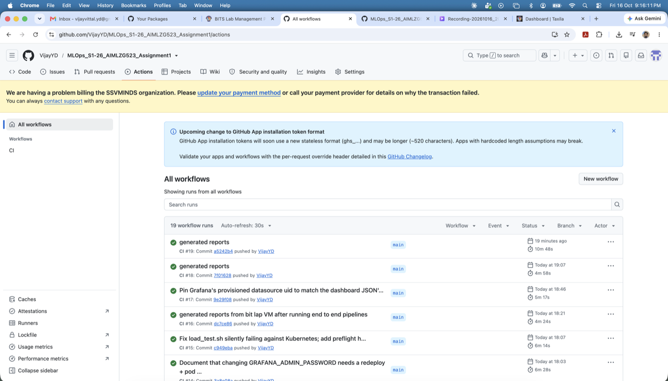  Figure 16: GitHub Actions, all jobs green | 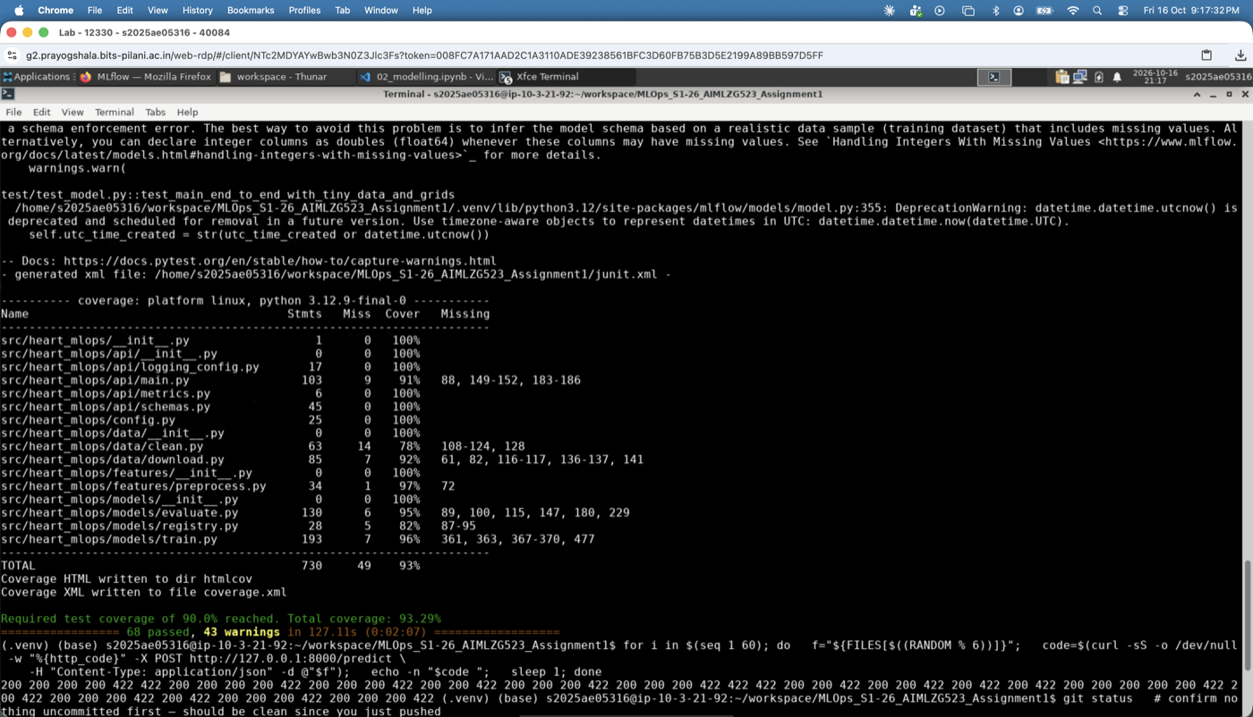  Figure 17: pytest coverage summary

8. Containerisation and API Design
docker/Dockerfile is a multi-stage build on python:3.12.9-slim (matching the lab), built for linux/amd64, running as a non-root user with only runtime dependencies installed, a HEALTHCHECK using the standard library's urllib, a configurable worker count, and OCI labels carrying the build version and git SHA.
The FastAPI app exposes GET /health, GET /ready (only once the model has loaded), GET /model-info, POST /predict, POST /predict/batch (up to 100 records, one vectorised call), GET /metrics (Prometheus format), and OpenAPI docs at /docs. All thirteen request fields are required, with evidence-based clinical range validation from the observed min/max in training data — out-of-range or missing values return HTTP 422, never a 500 or a silent bad prediction. Request logs are structured JSON and deliberately never include raw patient feature values.
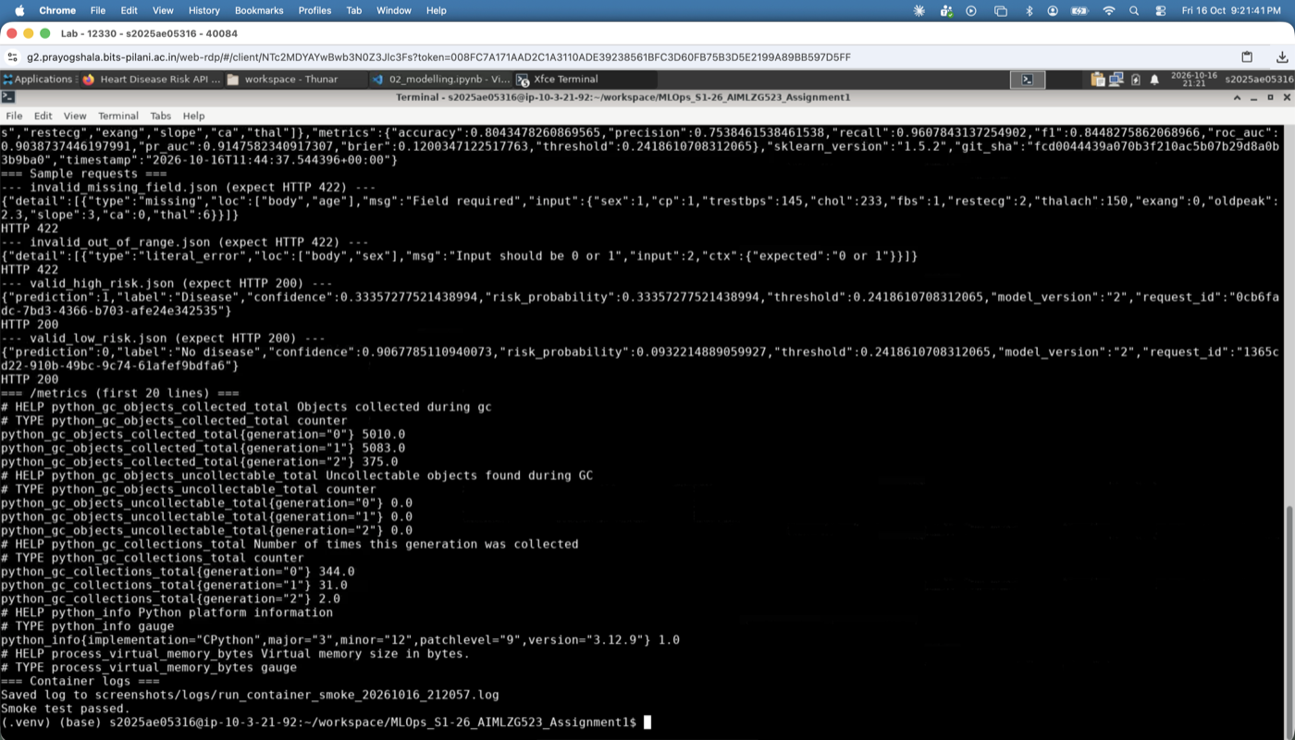  Figure 18: Docker build + container smoke test | 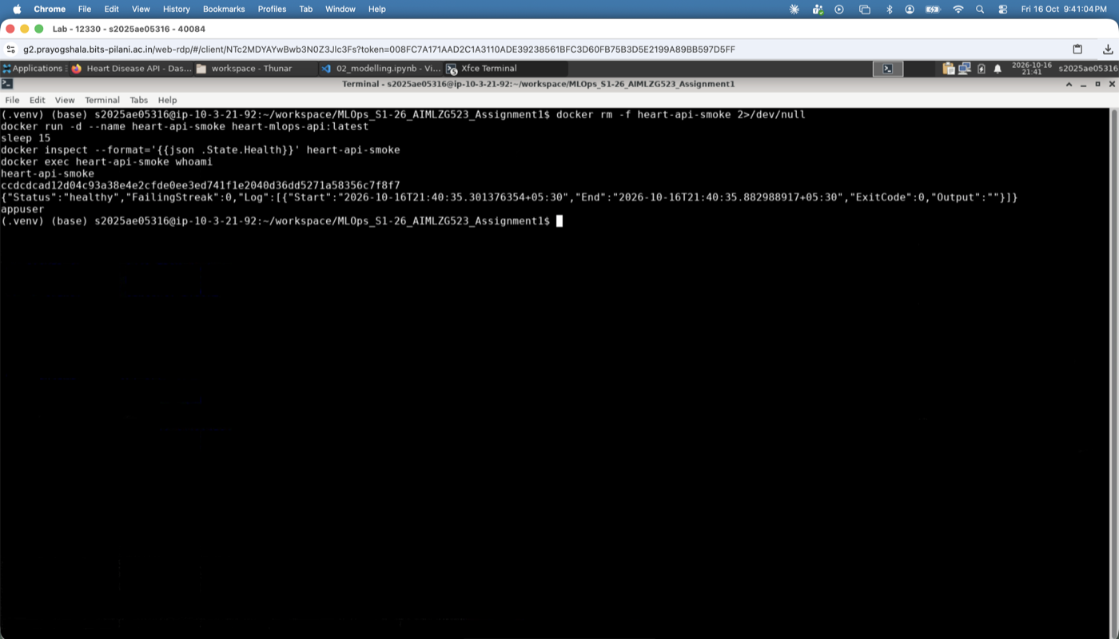  Figure 19: Non-root user, healthy container | 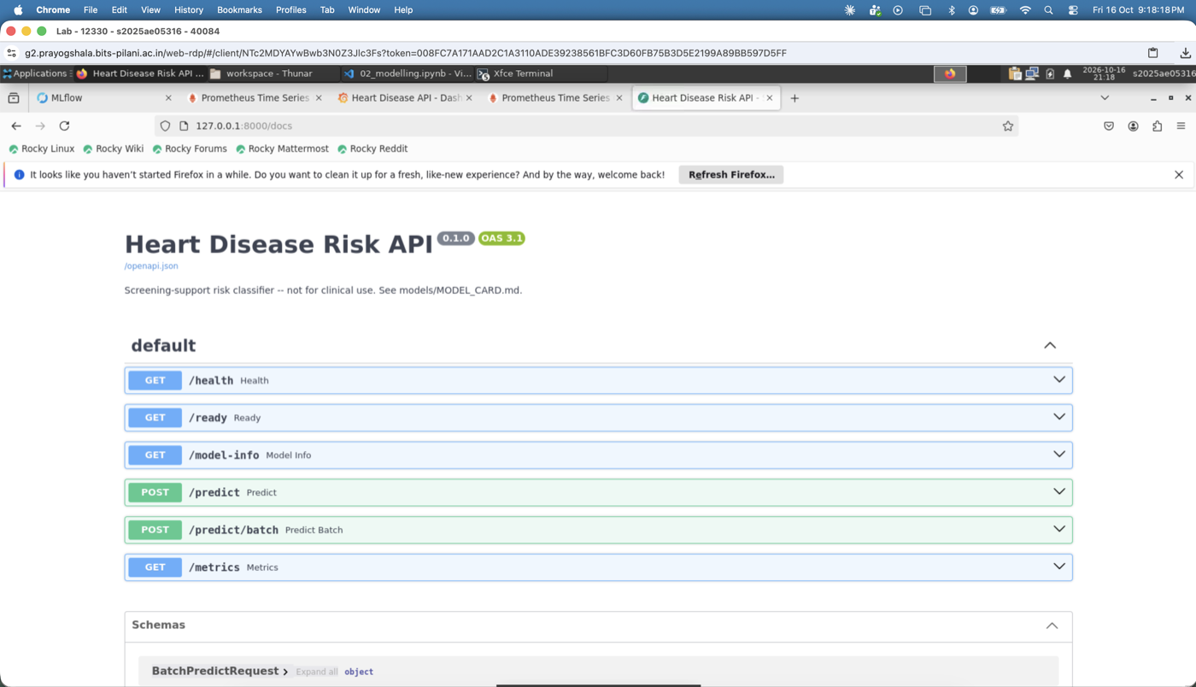  Figure 20: Swagger / OpenAPI documentation

9. Kubernetes Deployment
Manifests are organised with Kustomize: k8s/base/ (namespace, ConfigMap carrying LOG_LEVEL and an optional PREDICTION_THRESHOLD override that the app actually reads, a 2-replica Deployment with liveness/readiness probes and a non-root securityContext, a ClusterIP Service, a LoadBalancer Service, an Ingress at heart-api.local, and a CPU-based HPA scaling 2-5 replicas) and k8s/monitoring/ (Prometheus and Grafana, Section 10), composed by k8s/overlays/minikube/.
scripts/k8s_deploy.sh starts Minikube if needed, enables the ingress and metrics-server addons, builds the image inside Minikube's own Docker daemon, applies the overlay, and waits for rollout. scripts/k8s_verify.sh then checks pod/service/ingress/HPA state and calls /health and /predict through both the Ingress and the LoadBalancer Service. The Ingress is reachable directly at minikube ip on Linux; macOS falls back to kubectl port-forward (Ingress's privileged ports need an interactive sudo password an unattended script cannot supply, and the lab disallows sudo). The LoadBalancer Service only gets a real external IP once minikube tunnel is running — on every OS, not just macOS — so the script checks for an assigned IP first and falls back to port-forward if there isn't one.
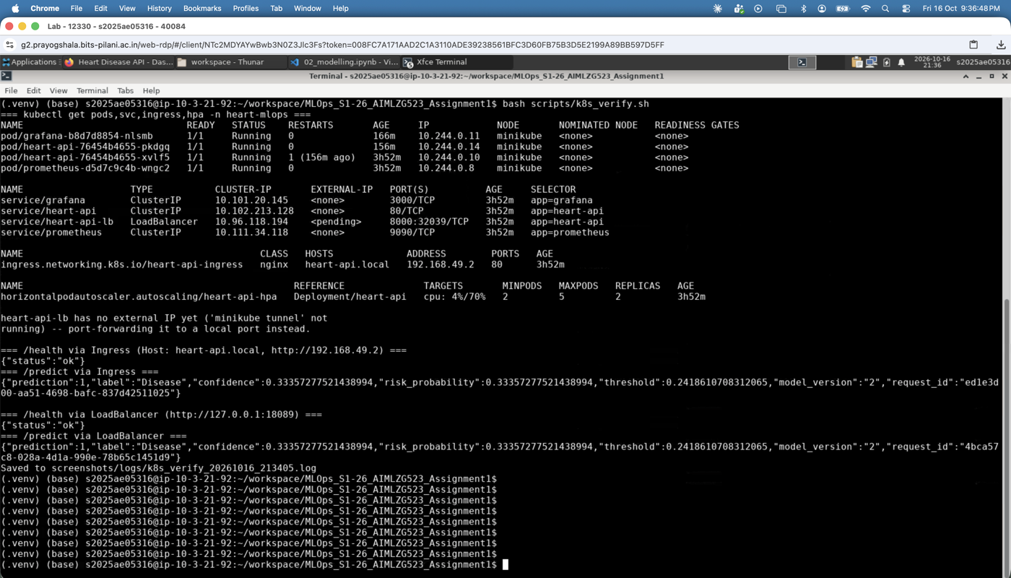
Figure 21: kubectl get pods, services, ingress, HPA, and /predict verified through both the Ingress and the LoadBalancer

10. Monitoring and Logging
The API exposes custom Prometheus metrics: request count by endpoint/status, a latency histogram, prediction count by class, a risk-probability histogram (a drift signal), and an inference-error counter. In Kubernetes, Prometheus discovers API pods via the Kubernetes API rather than a static target, since pod IPs are not stable. Grafana's datasource and a five-panel dashboard (request rate, p95 latency, predictions by class, drift signal, error rate) are both provisioned as code. Both were verified against their real HTTP APIs, not just "the containers are up": the Prometheus target reports healthy, and a live query returns real prediction counts after a load test.
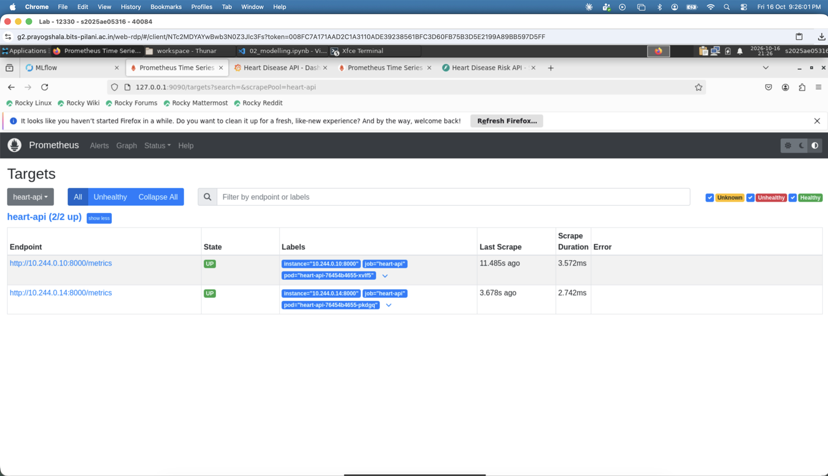  Figure 22: Prometheus targets page | 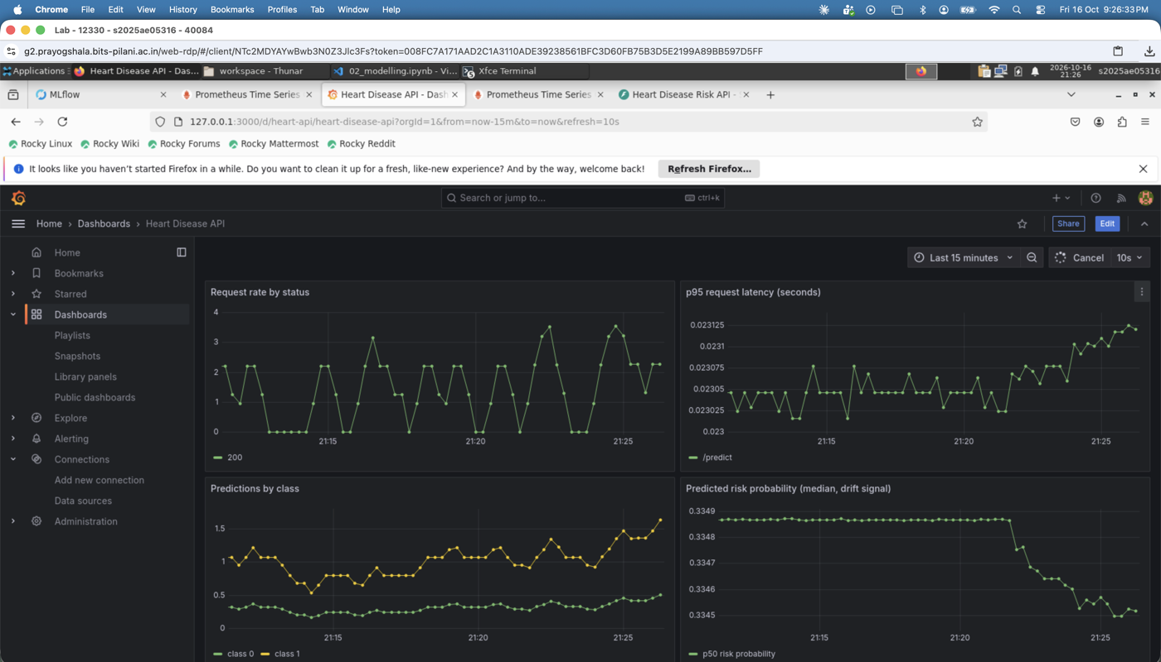  Figure 23: Grafana dashboard, live data

11. Architecture Diagram
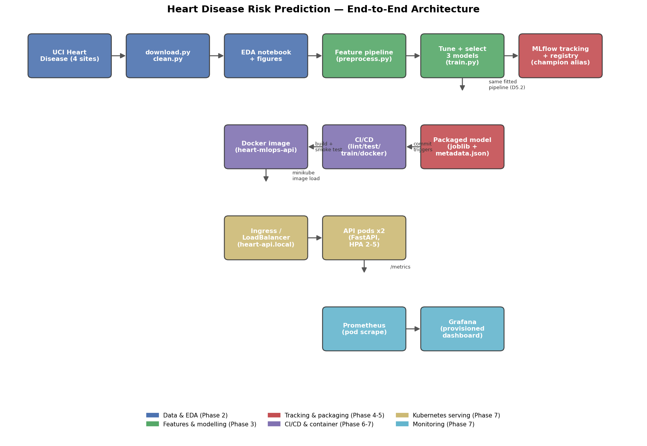
Figure 24: End-to-end architecture, from data acquisition to monitoring.
The full written walk-through of this diagram is in docs/ARCHITECTURE.md.

12. Limitations, Ethical Considerations, and Future Work
This model is a course project artefact, not a validated medical device, and must not be used to make or inform real patient-care decisions (models/MODEL_CARD.md has the full statement). The training data is small (918 rows) and decades old; ca and thal are over 60% missing outside Cleveland, and Section 4's leave-one-site-out results show behaviour on a genuinely unseen hospital is not uniform across sites. The 0.95 recall target was not validated against a real clinical cost-benefit analysis, and no subgroup fairness analysis beyond Section 3's EDA has been performed.
The training data's site of origin correlates with factors (era, region, equipment) that could encode bias unrelated to clinical presentation; site is excluded as a model feature specifically to reduce, though not eliminate, this risk. This model must not be used for insurance, employment, or any decision with legal or financial consequences for a person.
Future work: a prospective validation study, a fairness audit across demographic subgroups, a genuinely held-out fifth site, and investigating calibration on a larger hold-out set than the one available here.

13. References
- Janosi, A., Steinbrunn, W., Pfisterer, M., & Detrano, R. (1988). Heart Disease [Dataset]. UCI Machine Learning Repository. https://doi.org/10.24432/C52P4X
- Pedregosa, F. et al. (2011). Scikit-learn: Machine Learning in Python. Journal of Machine Learning Research, 12, 2825-2830.
- MLflow Documentation. https://mlflow.org/docs/latest/index.html
- FastAPI Documentation. https://fastapi.tiangolo.com/
- Kubernetes Documentation. https://kubernetes.io/docs/home/
- Prometheus Documentation. https://prometheus.io/docs/introduction/overview/
- Grafana Documentation. https://grafana.com/docs/grafana/latest/

