EXPERIMENT NO:1
Exp No:1.a
Analyze the trend of data science job postings over the last
Decade
AIM:
To analyze the trend of data science job postings over the last
Decade.
Program code:
import pandas as pd
import matplotlib.pyplot as plt

data = {'Year': list(range(2015, 2026)),
'Job Postings': [200, 350, 700, 750, 1000, 1400, 1900, 2500, 3200, 4000, 5000]}

df = pd.DataFrame(data)

plt.plot(df['Year'], df['Job Postings'], marker='o')
plt.title('Trend of Data Science Job Postings')
plt.xlabel('Year')
plt.ylabel('Number of Job Postings')
plt.show()
Output:
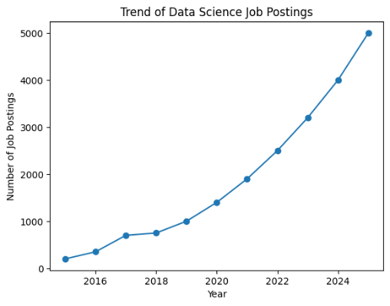

Result:
Thus, the trend of Data Science job postings from 2015 to 2025 was successfully analyzed and visualized using a line plot.
Exp No:1.b
Analyze and visualize the distribution of various data science roles (Data
Analyst, Data Engineer, Data Scientist, etc.) from a dataset
Aim:
To Analyze and visualize the distribution of various data science roles (Data
Analyst, Data Engineer, Data Scientist, etc.) from a dataset
Program code:
import matplotlib.pyplot as plt

roles = ['Data Analyst', 'Data Engineer', 'Data Scientist',
'ML Engineer', 'Business Analyst']

counts = [1400, 600, 300, 250, 250]

plt.bar(roles, counts)
plt.title('Distribution of Data Science Roles')
plt.xlabel('Role')
plt.ylabel('Count')
plt.show()
Output:
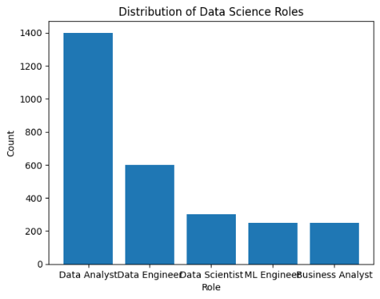
Result:
Thus, the distribution of different Data Science roles was successfully analyzed and visualized using a bar chart.
Exp No:1.c Conduct an experiment to differentiate Structured , Un-structured and Semi
structured data based on data sets given.
Aim:
To conduct an experiment to differentiate Structured , Un-structured and Semi
structured data based on data sets given.
Program code:
import pandas as pd
structured_data = pd.DataFrame({
'ID': [101, 102, 103],
'Name': ['David', 'Emma', 'John'],
'Age': [28, 32, 27]
})
print("Structured Data:\n", structured_data)
unstructured_data = "This is a sample document containing text, images and video content."
print("In Unstructured Data:\n", unstructured_data)
semi_structured_data = {
'ID': 101,
'Name': 'David',
'Attributes': {
'Height': 170,
'Weight': 65
}
}

print("In Semi-structured Data:\n", semi_structured_data)
Output:
Structured Data:
ID Name Age
0 101 David 28
1 102 Emma 32
2 103 John 27
In Unstructured Data:
This is a sample document containing text, images and video content.
In Semi-structured Data:
{'ID': 101, 'Name': 'David', 'Attributes': {'Height': 170, 'Weight': 65}}
Result:
Thus, the given data was successfully classified into structured, unstructured, and semi-structured data.

Exp No:1.d Conduct an experiment to encrypt and decrypt given sensitive data.
Aim:
To conduct an experiment to encrypt and decrypt given sensitive data.
Program code:
from cryptography.fernet import Fernet
key = Fernet.generate_key()
cipher_suite = Fernet(key)
plain_text = b"Computer Science Engineering"
cipher_text = cipher_suite.encrypt(plain_text)
decrypted_text = cipher_suite.decrypt(cipher_text)
print("Original Data:", plain_text)
print("Encrypted Data:", cipher_text)
print("Decrypted Data:", decrypted_text)
Output:
Original Data: b'Computer Science Engineering'
Encrypted Data: b'gAAAAABqfAgZMLf7ngrhpWlRD7Yv95Q-OExrIRSxq8dx-BpP36fB_8_X1JT8jynGL7CO4Q8xBTZMtke4q3lBzrAaXKvfBk11EUUiDgtMtkemVrZnmLwZyT0='
Decrypted Data: b'Computer Science Engineering'
Result:
Thus, the given data was successfully encrypted and decrypted using the Fernet encryption technique.

