EXPERIMENT NO:2
Upload and Analyze the data set given in csv format and perform data
preprocessing and visualization.
Aim:
To Upload and Analyze the data set given in csv format and perform data
preprocessing and visualization.
Program code:
import pandas as pd
import numpy as np
import matplotlib.pyplot as plt
file_path='C:\market_data.csv'
df = pd.read_csv(file_path)
print(df.head())
print(df.isnull().sum())
df['Sales'].fillna(df['Sales'].mean(), inplace=True)
df.dropna(subset=['Product', 'Quantity', 'Region'], inplace=True)
print(df.describe())
product_summary = df.groupby('Product').agg({
'Sales':'sum',
'Quantity':'sum'
}).reset_index()

print(product_summary)
plt.figure(figsize=(10,6))
plt.bar(product_summary['Product'], product_summary['Sales'])
plt.xlabel('Product')
plt.ylabel('Total Sales')
plt.title('Total Sales by Product')
plt.show()
df['Date'] = pd.to_datetime(df['Date'])
sales_over_time = df.groupby('Date').agg({'Sales':'sum'}).reset_index()
plt.figure(figsize=(10,6))
plt.plot(sales_over_time['Date'], sales_over_time['Sales'])
plt.xlabel('Date')
plt.ylabel('Total Sales')
plt.title('Sales Over Time')
plt.show()
pivot_table = df.pivot_table(values='Sales', index='Region', columns='Product', aggfunc=sum, fill_value=0)
print(pivot_table)
correlation_matrix = df.corr()
print(correlation_matrix)
import seaborn as sns
plt.figure(figsize=(8,6))
sns.heatmap(correlation_matrix, annot=True, cmap='coolwarm')
plt.title('Correlation Matrix')
plt.show()
Output:
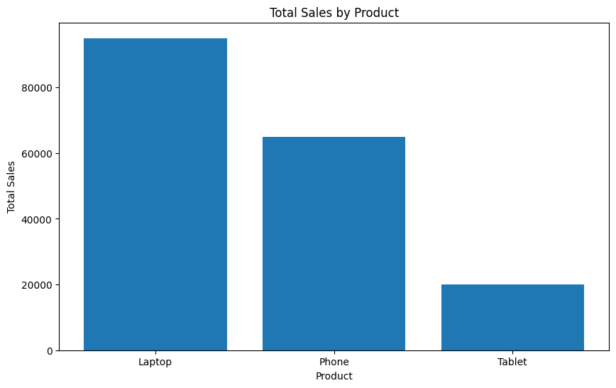

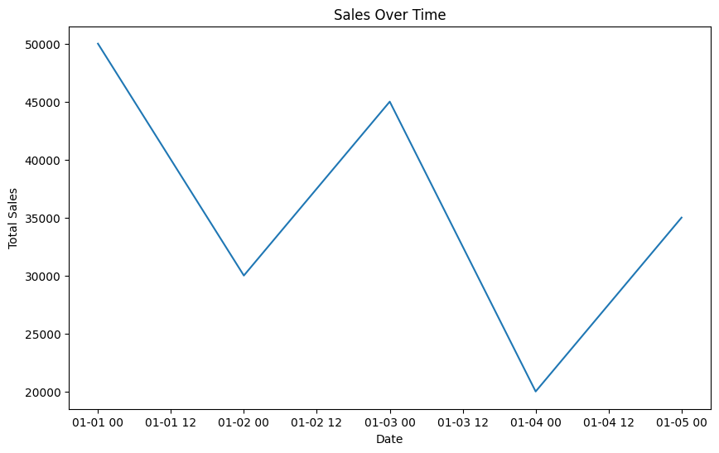
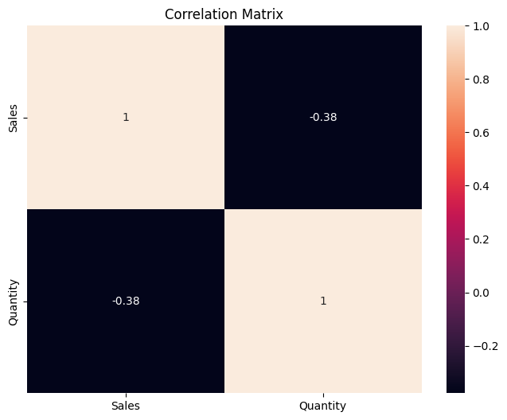
Result:
Thus, the given CSV dataset was successfully uploaded, preprocessed, analyzed, and visualized using Python.

