Exp No: 5 — Data Collection and Initial Exploration
Aim
To collect, load, and perform initial exploration of the diabetes dataset.
Description
The diabetes dataset is loaded using Pandas. The dataset is explored using head(), info() and describe(). Histograms are used to visualize the distribution of each feature and a pair plot is used to visualize relationships between the features.
Code
import pandas as pd
import numpy as np
import matplotlib.pyplot as plt
import seaborn as sns

url = "https://raw.githubusercontent.com/jbrownlee/Datasets/master/pima-indians-diabetes.data.csv"

columns = ['Pregnancies','Glucose','BloodPressure','SkinThickness',
'Insulin','BMI','DiabetesPedigreeFunction','Age','Outcome']

db = pd.read_csv(url, names=columns)

print(db.head())

print(db.info())
print(db.describe())

db.hist(bins=50, figsize=(20,15))
plt.show()

sns.pairplot(db)
plt.show()
Output:
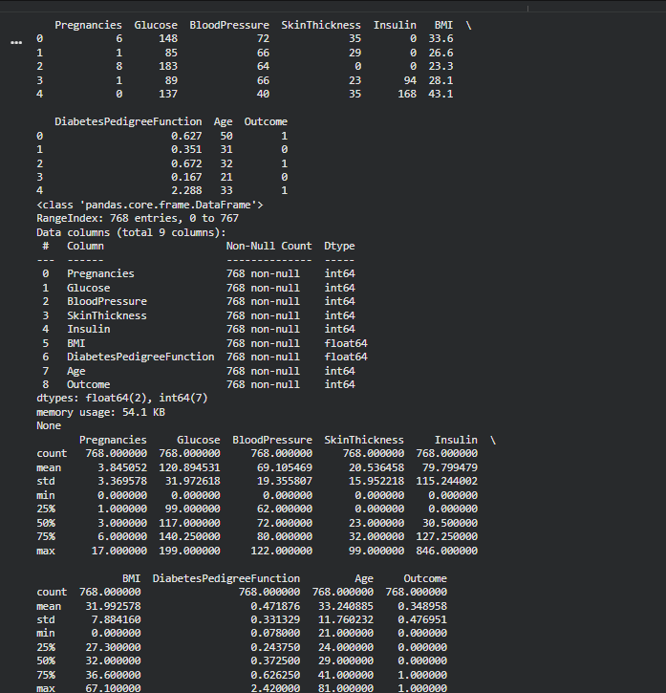
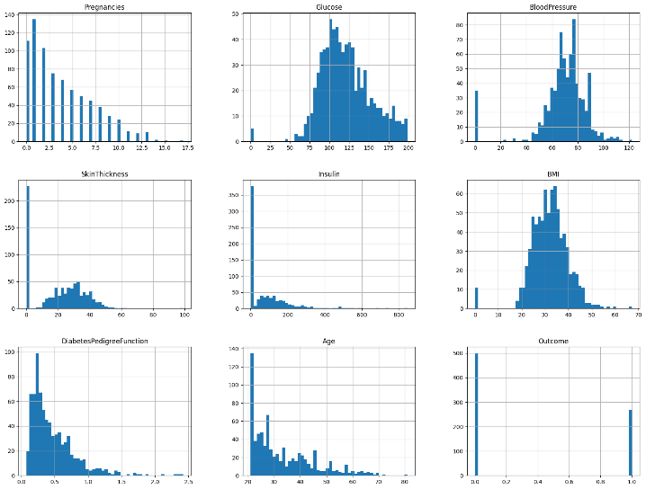
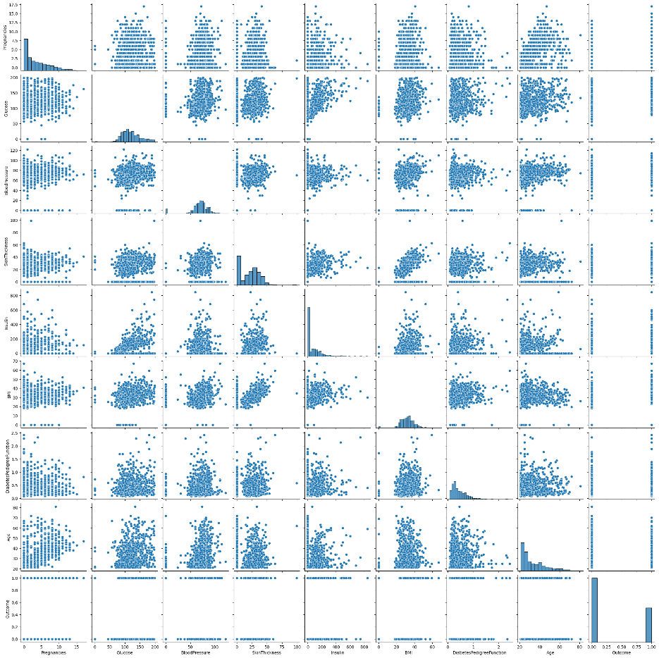

Result
The diabetes dataset was successfully loaded and initially explored. The first few records, dataset structure and summary statistics were displayed. Histograms showed the distribution of each feature, and the pair plot showed the relationships between the variables.

