EXPERIMENT NO:3
3.a)
Conduct an experiment to show data visualization using line plot
Description:
Take any sample data either through csv file or data fetched directly through
code.

Program:
import matplotlib.pyplot as cricket

Overs=list(range(5,51,5))
Australia_Score=[40,65,100,135,170,205,240,275,315,360]
England_Score=[30,55,85,115,145,175,205,235,265,295]

cricket.plot(Overs,Australia_Score)
cricket.plot(Overs,England_Score)
cricket.show()
cricket.title("AUSTRALIA VS ENGLAND")
cricket.xlabel("Overs")
cricket.ylabel("Score")
cricket.legend()
cricket.plot(Overs,Australia_Score,color="green",label="AUSTRALIA")
cricket.plot(Overs,England_Score,color="red",label="ENGLAND")
cricket.legend(loc="center right")
Output:
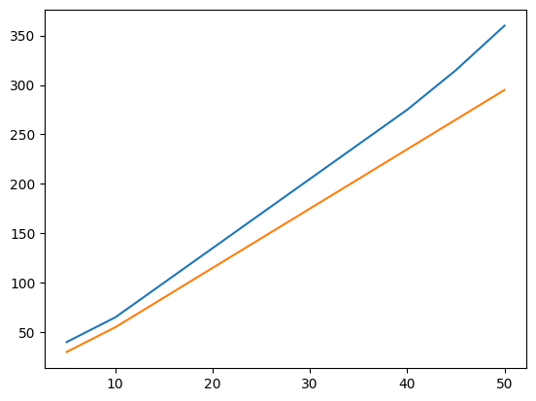
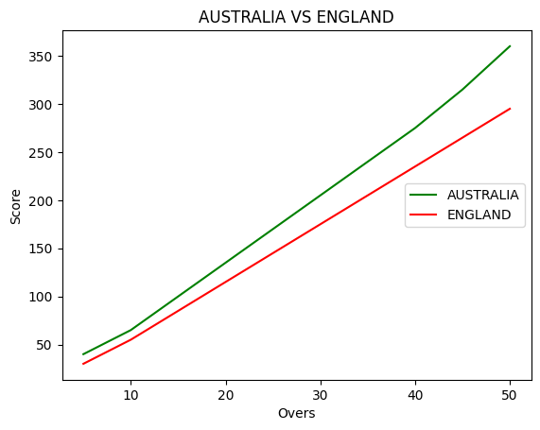
Result:
Thus, the cricket data was successfully visualized using the chart.
3.b)
Conduct an experiment to show data visualization using bar chart
Description: Take any sample data either through csv file or data fetched directly through code.
Program:
import matplotlib.pyplot as hsemark
import numpy as np

Names = ['ARUN','BALA','CHARAN','DIVYA','KAVYA','MANOJ']
xaxis = np.arange(len(Names))
Percentage_hsc = [88,76,95,82,69,91]

hsemark.bar(Names, Percentage_hsc)
hsemark.xticks(xaxis, Names, rotation=45)
hsemark.xlabel('Names of Pupil')
hsemark.ylabel('Percentage')
hsemark.title('Comparison of HSC Percentage', fontsize=20, color='green')
hsemark.show()
Output:
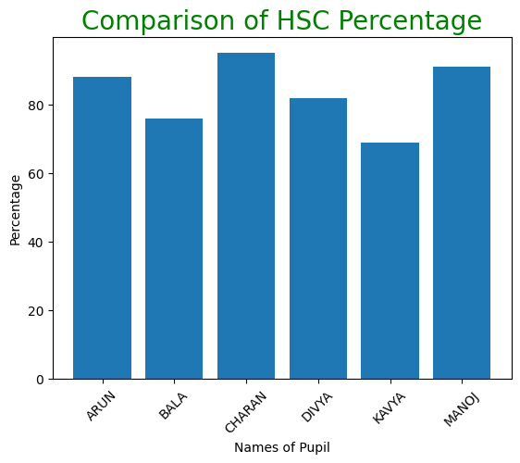
Result:
Thus, the bar chart was successfully created to compare the HSC percentages of different pupils.
3.c)
Conduct an experiment to show data visualization using pie chart
Description:
Take any sample data either through csv file or data fetched directly through code.
Program:
import matplotlib.pyplot as election
labels = ['CANDIDATE A','CANDIDATE B','CANDIDATE C','CANDIDATE D']
Votes = [280,175,220,260]
colors = ['blue','yellow','red','orange']
explode = (0,0.2,0,0)
election.pie(Votes, labels=labels, colors=colors, explode=explode, autopct='%0.2f%%')
election.title('Election Results')
election.show()
Output:
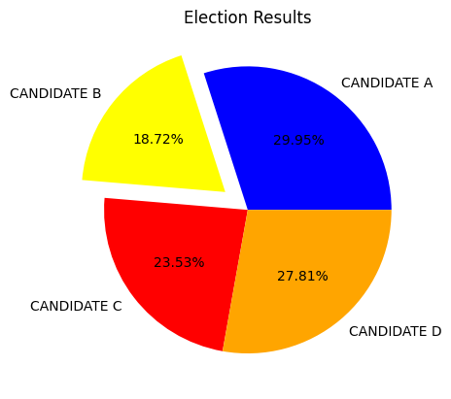
Result:
Thus, the pie chart was successfully created to represent the election results of different candidates.

