CLOUDPATH AI
AI-Based Cloud Movement Tracking and Rainfall Prediction System
A PROJECT REPORT
Submitted in partial fulfillment of the requirements
for the award of the degree of
BACHELOR OF TECHNOLOGY
IN
COMPUTER SCIENCE AND ENGINEERING
Submitted by:
FINAL YEAR PROJECT TEAM
Department of Computer Science and Engineering
Under the Guidance of:
PROJECT GUIDE & FACULTY ADVISOR
DEPARTMENT OF COMPUTER SCIENCE AND ENGINEERING
BENGALURU URBAN REGION, KARNATAKA, INDIA
ACADEMIC YEAR 2025 – 2026

CERTIFICATE
This is to certify that the project report entitled 'CloudPath AI: AI-Based Cloud Movement Tracking and Rainfall Prediction System' is a bonafide work carried out by the final-year B.Tech Computer Science and Engineering project team in partial fulfillment of the requirements for the award of the degree of Bachelor of Technology in Computer Science and Engineering during the academic year 2025–2026.
The project report has been examined and approved for submission. It satisfies the academic requirements prescribed for the Bachelor of Technology degree examination.
____________________  Internal Guide  Assistant Professor, CSE | ____________________  Head of Department  Department of CSE | ____________________  External Examiner  Examiner Signature

DECLARATION
We hereby declare that the work presented in this project report entitled 'CloudPath AI: AI-Based Cloud Movement Tracking and Rainfall Prediction System' submitted to the Department of Computer Science and Engineering is an authentic record of our own original work conducted under the supervision and guidance of our faculty advisor.
We further confirm that this work has not been submitted previously in part or in full to any other university or institute for the award of any degree, diploma, or academic distinction.
Date: November 11, 2026
Place: Bengaluru, Karnataka, India
__________________________________
Project Student Candidate Signature

ACKNOWLEDGEMENTS
We express our profound gratitude to our esteemed Project Guide for their continuous encouragement, technical guidance, and invaluable feedback throughout the design and implementation of the CloudPath AI project.
We extend our sincere thanks to the Head of the Department of Computer Science and Engineering and the Principal for providing the computational laboratory facilities and resources required to carry out this investigation.
We are deeply grateful to the Indian Space Research Organisation (ISRO) and the Meteorological and Oceanographic Satellite Data Archival Centre (MOSDAC) for making high-resolution INSAT-3DS Level-2B products publicly accessible for scientific research. We also acknowledge the India Meteorological Department (IMD) and Open-Meteo for archival meteorological datasets.
Finally, we thank our parents, faculty members, and peers whose encouragement made the completion of this research possible.

TABLE OF CONTENTS
The structural organization of this project report is summarized below:
Section / Chapter Title | Page No.
Certificate | ii
Declaration | iii
Acknowledgements | iv
Abstract | v
List of Figures | vi
List of Tables | vii
CHAPTER 1: ABSTRACT | 1
CHAPTER 2: INTRODUCTION | 2
2.1 General Introduction | 2
2.2 Background of the Study | 3
2.3 Problem Statement | 3
2.4 Project Objectives | 4
2.5 Proposed System | 4
2.6 Scope of the Project | 5
2.7 Existing Systems in Operation | 5
2.8 Limitations of Existing Systems | 6
CHAPTER 3: LITERATURE REVIEW | 7
3.1 Overview of Meteorological Nowcasting | 7
3.2 Numerical Weather Prediction (NWP) Models | 7
3.3 Geostationary Remote Sensing (INSAT Series) | 8
3.4 INSAT-3DS Cloud Cover Products | 8
3.5 Machine Learning in Precipitation Forecasting | 9
3.6 Gradient Tree Boosting and XGBoost Architecture | 9
3.7 Computer Vision in Cloud Segmentation | 10
3.8 Spatiotemporal Object Tracking and Centroid Modeling | 10
3.9 The Hungarian Assignment Algorithm (Kuhn-Munkres) | 11
3.10 Research Gap and Comparative Analysis | 11
CHAPTER 4: SYSTEM DESIGN AND METHODOLOGY | 13
4.1 System Overview | 13
4.2 System Architecture | 13
4.3 Data Flow Modeling (Level 0 and Level 1 DFD) | 15
4.4 Satellite Data Processing Pipeline | 17
4.5 Machine Learning Methodology for Rainfall Prediction | 18
4.6 Spatiotemporal Cloud Motion Tracking Pipeline | 20
4.7 Mathematical Formulation and Hungarian Optimization | 21
4.8 UML System Modeling (Use Case, Activity, Sequence) | 23
4.9 System Dashboard Architecture and Interface Design | 26
4.10 Hardware and Software Requirements | 27
CHAPTER 5: RESULTS AND DISCUSSION | 28
5.1 Experimental Setup and Dataset Description | 28
5.2 Rainfall Classification Model Evaluation | 29
5.3 Rainfall Regression Model Evaluation | 30
5.4 INSAT-3DS July 2025 Satellite Tracking Results | 31
5.5 Discussion on Operational Reliability | 32
CHAPTER 6: CONCLUSION AND FUTURE SCOPE | 33
6.1 Summary of the Project | 33
6.2 Key Achievements | 33
6.3 Limitations of Current Implementation | 34
6.4 Future Enhancements and Research Directions | 34
REFERENCES | 35

LIST OF FIGURES
List of technical architectural and algorithmic figures included in this report:
Figure Caption and Description | Page No.
Figure 4.1: Overall System Architecture of CloudPath AI | 14
Figure 4.2: Level 0 Data Flow Diagram (Context Diagram) | 15
Figure 4.3: Level 1 Data Flow Diagram (Decomposed Pipeline) | 16
Figure 4.4: INSAT-3DS Satellite Image Preprocessing and Extraction Flowchart | 17
Figure 4.5: Dual-Stage XGBoost Rainfall Prediction Workflow | 19
Figure 4.6: Connected Component Analysis and Spatiotemporal Cloud Tracking Workflow | 20
Figure 4.7: Hungarian (Kuhn-Munkres) Optimal Assignment Algorithm Execution Flowchart | 22
Figure 4.8: UML Use Case Diagram for CloudPath AI System | 24
Figure 4.9: UML Activity Diagram Depicting Operational Pipeline Execution | 25
Figure 4.10: UML Sequence Diagram for Interactive Timeline Query and Prediction Service | 26

LIST OF TABLES
List of comparative and evaluation tables presented in this report:
Table Caption and Description | Page No.
Table 3.1: Comparative Analysis of Meteorological Forecasting Approaches | 12
Table 4.1: Atmospheric Feature Space Employed in ML Rainfall Prediction Pipeline | 18
Table 4.2: Hardware Specifications and Computational Infrastructure | 27
Table 4.3: Software Stack and Core Library Dependencies | 27
Table 5.1: Rainfall Classification Performance Metrics on 20% Holdout Test Partition | 29
Table 5.2: Quantitative Rainfall Regression Model Evaluation Metrics | 30
Table 5.3: Summary Statistics of INSAT-3DS July 2025 Cloud Tracking Execution | 31

CHAPTER 1: ABSTRACT
Precipitation forecasting and localized convective cloud monitoring represent critical challenges in modern operational meteorology, urban disaster management, and environmental monitoring. Traditional Numerical Weather Prediction (NWP) frameworks struggle to deliver high-resolution, low-latency nowcasts for rapidly evolving convective storm events over complex tropical urban microclimates such as the Bengaluru Urban Region (12.9716° N, 77.5946° E). This project presents CloudPath AI, an end-to-end, dual-pipeline meteorological intelligence framework combining high-resolution geostationary satellite image processing with machine-learning-driven quantitative precipitation estimation. The first pipeline ingests Level-2B Cloud Cover NetCDF-4 imagery from ISRO's state-of-the-art INSAT-3DS geostationary satellite (spanning the entire active month of July 2025 across 1,448 observations) cropped to a 162 x 159 pixel spatial domain (~650 km x 650 km). Using Otsu adaptive thresholding, 8-connectivity Connected Component Analysis (CCA), and the Hungarian (Kuhn-Munkres) global optimization algorithm, the system detects 16,321 discrete cloud formations, resolves spatial correspondences across successive 30-minute frames, and constructs 2,831 persistent motion tracks, capturing cloud kinematics, mean speeds of 70.1 km/h, and directional heading vectors. The second pipeline features a dual-stage machine learning inference engine utilizing tuned Extreme Gradient Boosting (XGBoost) models trained on 96,431 hourly surface meteorological records (2009–2020) encompassing 25 atmospheric features. The classification stage identifies rain occurrence with 94.13% accuracy, an F1-score of 0.8349, and an ROC-AUC of 0.9753, while the quantitative regression stage predicts precipitation depth with a Mean Absolute Error (MAE) of 0.0597 mm and an R² of 0.7598. An interactive, dark-themed operational web dashboard integrates both pipelines to provide simultaneous spatial tracking and real-time precipitation nowcasting, demonstrating a scalable, production-ready framework for urban meteorological decision support.
Keywords: INSAT-3DS; Cloud Tracking; Hungarian Algorithm; Extreme Gradient Boosting (XGBoost); Precipitation Nowcasting; Connected Component Analysis; Satellite Remote Sensing; Urban Hydrometeorology.

CHAPTER 2: INTRODUCTION
2.1 General Introduction
Precipitation forecasting and convective storm tracking are foundational pillars of operational meteorology, urban flood risk mitigation, and aviation safety. In urbanized tropical centers such as the Bengaluru Urban Region (Karnataka, India; 12.9716° N, 77.5946° E), high-intensity localized convective rainfall events frequently induce severe flash floods, disrupt transportation arteries, overwhelm storm-water drainage networks, and jeopardize civic infrastructure. Traditional forecasting methodologies have historically depended on large-scale Numerical Weather Prediction (NWP) atmospheric physics models and ground-based Doppler Weather Radars (DWR). However, NWP frameworks suffer from prolonged computational runtimes (often requiring 3 to 6 hours per assimilation cycle), while ground radar networks face severe line-of-sight topographical attenuation, spatial blind spots, and exorbitant capital and maintenance expenditures. To overcome these limitations, CloudPath AI introduces a novel, dual-pipeline computational framework that marries state-of-the-art spaceborne geostationary remote sensing with advanced gradient-boosted machine learning to provide high-resolution, low-latency meteorological situational awareness.
2.2 Background of the Study
The Bengaluru metropolitan region is situated on the Deccan Plateau at an average altitude of approximately 920 meters above mean sea level. This unique orographic elevation, coupled with rapid urbanization, extensive concrete paving, and the proliferation of Urban Heat Islands (UHIs), creates sharp localized thermodynamic gradients. During the South-West Monsoon (June to September), moist air masses converging from the Arabian Sea interact with urban thermal plumes, triggering rapid, localized convective cell genesis. These microscale thunderstorms can evolve from benign cumulus clouds into torrential cumulonimbus cloud towers within 30 to 60 minutes. Capturing such dynamic phenomena necessitates continuous observation with high spatial granularity and rapid temporal refresh rates, a capability natively offered by geostationary meteorological satellites.
2.3 Problem Statement
The core problem addressed in this investigation is the acute latency-resolution trade-off inherent in conventional precipitation nowcasting systems. Current operational meteorological pipelines fail to synthesize high-frequency spaceborne imagery with ground-level atmospheric thermodynamic variables in real-time. Specifically: (1) Synoptic NWP forecasts lack the sub-kilometer and sub-hourly resolution required to track localized convective cloud cells across urban sub-regions; (2) Ground Doppler radar coverage over the Deccan Plateau exhibits significant blind zones and clutter artifacts; (3) Conventional computer vision techniques such as optical flow degrade rapidly when tracking non-rigid, morphologically deforming cloud structures; and (4) Standard statistical rain forecasts fail to model non-linear interactions across atmospheric thermodynamic parameters (e.g., surface pressure, dew point depressions, and multi-layer cloud fractions). Consequently, municipal authorities and disaster response teams remain blind to rapid storm developments until precipitation has already initiated.
2.4 Project Objectives
The primary technical objectives of this B.Tech final-year research project are defined as follows:
1. Develop an automated ingestion and spatial extraction pipeline for Level-2B Cloud Cover NetCDF-4 imagery from ISRO's INSAT-3DS geostationary satellite, standardizing raw radiances into calibrated 162 x 159 pixel matrices centered over Bengaluru.
2. Implement an adaptive morphological image segmentation algorithm utilizing Otsu thresholding and 8-connectivity Connected Component Analysis (CCA) to isolate discrete convective cloud entities and extract their geometric centroids and spatial boundaries.
3. Formulate a robust spatiotemporal tracking engine using the Kuhn-Munkres Hungarian global optimization algorithm to associate cloud objects across successive 30-minute frames, accurately estimating instantaneous velocity vectors, speed, and directional heading.
4. Engineer an end-to-end, dual-stage machine learning inference architecture utilizing tuned Extreme Gradient Boosting (XGBoost) to predict rain occurrence (classification) and quantitative rainfall accumulation (regression) from 25 synoptic weather parameters.
5. Architect an interactive, professional Midnight Navy and Electric Cyan web dashboard delivering real-time spatio-temporal cloud trajectory visualization alongside synchronized quantitative rainfall predictions to support civic decision-making.
2.5 Proposed System
The proposed CloudPath AI system establishes an end-to-end meteorological intelligence platform designed as two parallel, complementary analytical pipelines. Pipeline 1 operates on geostationary satellite imagery acquired from ISRO's INSAT-3DS satellite (covering the complete active month of July 2025 across 1,448 observations). It extracts a 162 x 159 pixel sub-grid centered on Bengaluru, applies Otsu thresholding and morphological filtering, extracts spatial centroids using Connected Component Analysis, and tracks motion trajectories using the Hungarian algorithm. Pipeline 2 operates on surface meteorological telemetry (spanning 96,431 records from 2009 to 2020), utilizing a two-stage tuned XGBoost model. Stage 1 executes binary classification to establish whether rain will occur; if positive, Stage 2 triggers an XGBoost regressor to compute exact precipitation depth in millimeters. Both pipelines feed into an integrated operational dashboard providing instantaneous spatial situational awareness and quantitative nowcasting.
2.6 Scope of the Project
The scope of this project encompasses the Bengaluru Urban Region within spatial coordinates approximately bounded by 12.0° N to 13.8° N latitude and 76.8° E to 78.4° E longitude (~650 km x 650 km). Temporally, the satellite tracking module is validated against the complete, real-world archive of INSAT-3DS Level-2B Cloud Cover observations for July 1 to July 31, 2025 (1,448 observations at ~30-minute cadence). The machine learning precipitation prediction models are trained and validated against a rigorously audited 12-year surface meteorological dataset (2009–2020) comprising 96,431 hourly records across 25 atmospheric variables. It is explicitly noted that these two datasets operate in parallel as complementary situational awareness modules within the unified dashboard architecture.
2.7 Existing Systems in Operation
Currently operational weather prediction systems primarily rely on three main paradigms:
1. Global and Regional NWP Models: Systems such as the Global Forecast System (GFS) and Weather Research and Forecasting (WRF) solve hydrodynamic and thermodynamic primitive equations on discretized 3D atmospheric grids. While indispensable for multi-day synoptic forecasts, their assimilation cycles (3 to 6 hours) render them unsuitable for sub-hourly localized nowcasting.
2. Ground-Based Doppler Weather Radars (DWR): Deployed by the India Meteorological Department (IMD), these systems emit microwave pulses to measure precipitation hydrometeor reflectivity (dBZ) and radial velocity. However, Bengaluru's radar coverage is subject to beam-blocking, anomalous propagation, and limited effective radius (~250 km).
3. Conventional Optical Flow Satellite Trackers: Algorithmic implementations such as Horn-Schunck and Farneback estimate dense velocity vectors between image pairs but assume brightness constancy and rigid motion, failing completely under convective cloud shearing and expansion.
2.8 Limitations of Existing Systems
The fundamental limitations of existing systems can be summarized across four operational axes:
1. Computational Latency: NWP models require supercomputing clusters and require hours to produce forecasts, making real-time nowcasting impossible.
2. Spatial and Temporal Coarseness: Standard NWP grid resolutions (9 km to 25 km) dilute microscale convective cells responsible for urban cloudbursts.
3. Sensor Coverage Discontinuities: Ground radar stations cannot provide continuous national coverage and face severe maintenance downtime.
4. Morphological Deformation Failure: Optical flow techniques track pixel gradients rather than physical cloud objects, preventing the extraction of persistent track histories, cloud growth rates, or centroid displacement kinematics.

CHAPTER 3: LITERATURE REVIEW
3.1 Overview of Meteorological Nowcasting
Meteorological nowcasting refers to high-resolution, short-range weather forecasting covering temporal horizons from zero to six hours. Unlike synoptic-scale forecasting, which models broad pressure ridges and planetary air mass trajectories, nowcasting focuses on the initiation, intensification, propagation, and dissipation of mesoscale convective systems (MCS) and isolated thunderstorms. The rapid life cycle of convective cells—often spanning less than one to two hours from initiation to torrential precipitation—demands observation techniques with update cadences measured in minutes and computational models capable of delivering inference within seconds.
3.2 Traditional Numerical Weather Prediction (NWP) Models
Numerical Weather Prediction (NWP) constitutes the theoretical foundation of contemporary atmospheric science. NWP models numerically integrate the Navier-Stokes fluid equations, thermodynamics energy equations, and mass conservation laws across three-dimensional spatial grids. Popular regional implementations, such as the Weather Research and Forecasting (WRF) model, allow downscaling to grid resolutions of 1 km to 3 km. However, NWP models exhibit severe sensitivity to initial boundary conditions (the 'butterfly effect'). Furthermore, data assimilation cycles involve complex 3D/4D-Var calculations requiring vast High-Performance Computing (HPC) clusters, creating execution latencies between 3 and 6 hours. Consequently, by the time an NWP run converges, the localized convective storm event has often already concluded.
3.3 Geostationary Satellite Remote Sensing (INSAT Series)
Geostationary meteorological satellites offer an unparalleled vantage point for continuous weather monitoring over vast geographic sectors. Positioned in orbital equilibrium at approximately 35,786 km above the equator, these satellites maintain a stationary position relative to the Earth's surface. India's meteorological space program, spearheaded by the Indian Space Research Organisation (ISRO), has deployed successive generations of geostationary satellites, beginning with INSAT-2E, progressing to KALPANA-1, INSAT-3A, INSAT-3D (launched 2013), and INSAT-3DR (launched 2016). In February 2024, ISRO successfully launched INSAT-3DS aboard the GSLV-F14 vehicle, representing India's most advanced meteorological satellite to date.
3.4 INSAT-3DS Cloud Motion Vectors and Derived Products
INSAT-3DS carries an advanced 6-channel Imager and a 19-channel atmospheric Sounder. The Imager captures optical and infrared spectral radiances across Visible (0.55–0.75 μm), Short-Wave Infrared (1.55–1.70 μm), Mid-Wave Infrared (3.80–4.00 μm), Thermal Infrared 1 (10.3–11.3 μm), Thermal Infrared 2 (11.5–12.5 μm), and Water Vapor (6.5–7.1 μm) bands. Processed at the Meteorological and Oceanographic Satellite Data Archival Centre (MOSDAC), Level-2B Cloud Cover (HEM/V2) products provide calibrated pixel-level cloud classification at 4 km spatial resolution and ~30-minute intervals. These products encode clear sky, fractional clouds, and dense deep-convective cloud masses, serving as an optimal data source for tracking convective cloud morphology across the Indian subcontinent.
3.5 Machine Learning in Precipitation Forecasting
Over the past decade, Machine Learning (ML) has revolutionized meteorological forecasting by learning complex empirical mappings directly from multidimensional telemetry datasets without requiring the explicit numerical solution of differential equations. Researchers have applied Support Vector Machines (SVM), Random Forests, Artificial Neural Networks (ANN), and Long Short-Term Memory (LSTM) networks to precipitation nowcasting. Machine learning models offer millisecond inference latencies once trained, making them uniquely suitable for real-time operational decision support systems. However, traditional machine learning models often struggle with extreme class imbalance, as rain events typically comprise less than 15% to 20% of all hourly atmospheric observations.
3.6 Gradient Tree Boosting and XGBoost Architecture
Extreme Gradient Boosting (XGBoost), introduced by Chen and Guestrin in 2016 [1], represents the state-of-the-art implementation of gradient boosted decision trees (GBDT). XGBoost constructs an ensemble of weak classification and regression trees (CART) in an iterative, stage-wise manner. Unlike conventional gradient boosting, XGBoost incorporates second-order Taylor expansions of the loss function, enabling faster convergence and optimal split finding. Crucially, XGBoost introduces an explicit regularization term that penalizes tree complexity, leaf count, and large weight vectors, thereby mitigating overfitting on noisy meteorological observations. Furthermore, its native handling of sparse matrices, column subsampling, and out-of-core memory computation allows efficient scaling to multi-year atmospheric sensor datasets.
3.7 Computer Vision in Cloud Segmentation (CCA & Morphological Filtering)
Automated cloud detection from satellite imagery requires segmenting non-rigid, heterogeneous cloud structures from terrestrial background radiances. Classical image segmentation techniques rely on histogram-based thresholding. Otsu's adaptive thresholding method [4] calculates the optimal threshold that minimizes the intra-class variance of pixel intensities, dynamically adjusting to diurnal illumination shifts. Following binarization, Connected Component Analysis (CCA) based on 8-connectivity graph scanning [9, 10] labels contiguous clusters of cloud pixels, enabling the extraction of discrete cloud objects along with their spatial moments, area (pixel count), and geometric bounding boxes. Morphological opening and closing filters are applied using 3x3 structuring elements to eliminate transient high-frequency noise and bridge internal gaps within convective cloud masses.
3.8 Object Tracking and Trajectory Modeling (Centroid Tracking)
Once discrete cloud objects are identified at time t, tracking their displacement across successive observation frames (t+1, t+2, ...) requires spatiotemporal trajectory modeling. In target tracking theory, centroid tracking simplifies complex non-rigid cloud boundaries to their center of mass coordinates (x_bar, y_bar). By monitoring centroid displacements over time, the system can compute instantaneous velocity vectors, acceleration, and growth/decay rates. However, in tropical multi-cell thunderstorm environments, clouds constantly undergo splitting, merging, advection, and dissipation, creating a challenging combinatorial data association problem.
3.9 The Hungarian Assignment Algorithm (Kuhn-Munkres Optimization)
The data association problem between N active cloud tracks at time t-1 and M newly detected cloud candidates at time t is formally modeled as a weighted bipartite matching problem. The Hungarian assignment algorithm, formulated by H. W. Kuhn [2] and subsequently refined by J. Munkres [3], finds the global minimum-cost one-to-one assignment in O(V³) polynomial time. By constructing a cost matrix based on pairwise Euclidean centroid distances, and applying a physical velocity gating threshold (d_max) to preclude physically impossible displacements, the Hungarian algorithm guarantees mathematically optimal track continuity without requiring heuristic greedy search.
3.10 Research Gap and Comparative Analysis of Prior Approaches
Despite extensive research in isolated domains of meteorological AI and satellite image processing, a critical research gap persists in existing literature: the lack of an integrated, dual-pipeline operational framework that simultaneously tracks geostationary convective cloud motion at sub-hourly intervals while delivering calibrated quantitative precipitation nowcasts via gradient boosting. Existing deep learning approaches (such as ConvLSTM and U-Net) suffer from severe spatial blurring over multi-step horizons, require massive GPU compute clusters, and function as uninterpretable black boxes. In contrast, CloudPath AI delivers explicit, mathematically provable tracking kinematics combined with an audited two-stage XGBoost precipitation engine. Table 3.1 synthesizes the comparative advantages of CloudPath AI against existing paradigms.
Approach / System | Primary Data Source | Spatial / Temporal Scope | Advantages | Key Limitations
Numerical Weather Prediction (NWP - WRF) | Multi-level NWP Soundings | Global / Regional (3-10 km, 3-6 h) | Physical conservation laws, multi-day horizon | High compute latency, poor sub-hourly nowcasting
Doppler Weather Radar (DWR Nowcasting) | S-Band / C-Band Ground Radar | Regional (1-2 km, 5-10 min) | Direct hydrometeor reflectivity measurement | Limited coverage radius (~250 km), ground clutter, high capital cost
Optical Flow Tracking (Farneback / Lucas-Kanade) | Geostationary Satellite Imagery | Regional (4-8 km, 15-30 min) | Dense motion field estimation | Fails under convective deformation, cannot maintain discrete identities
Deep Learning ConvLSTM / U-Net | Radar Reflectivity Sequences | Grid-level (1-2 km, 15 min) | End-to-end spatiotemporal learning | Excessive blurriness at longer horizons, heavy GPU dependency, black-box nature
CloudPath AI (Proposed Dual Architecture) | INSAT-3DS NetCDF-4 + Surface Met Sensors | Bengaluru Urban (4 km, 30 min / 1 h) | Zero-latency inference, explicit discrete tracking, dual-stage classification & regression | Independent ground & satellite timelines (parallel situational awareness)

CHAPTER 4: SYSTEM DESIGN AND METHODOLOGY
4.1 System Overview
The CloudPath AI system architecture is engineered to deliver low-latency, high-resolution meteorological situational awareness for urban domains. The core architectural philosophy decouples spaceborne remote sensing kinematics from surface thermodynamic prediction, allowing both pipelines to execute independently at optimal sampling frequencies while unifying their insights on an interactive web dashboard. The architecture comprises four principal layers: (1) Data Ingestion and Telemetry Layer, (2) Preprocessing and Feature Engineering Layer, (3) Analytical and Prediction Core, and (4) Operational Dashboard and Alert Layer.
4.2 System Architecture
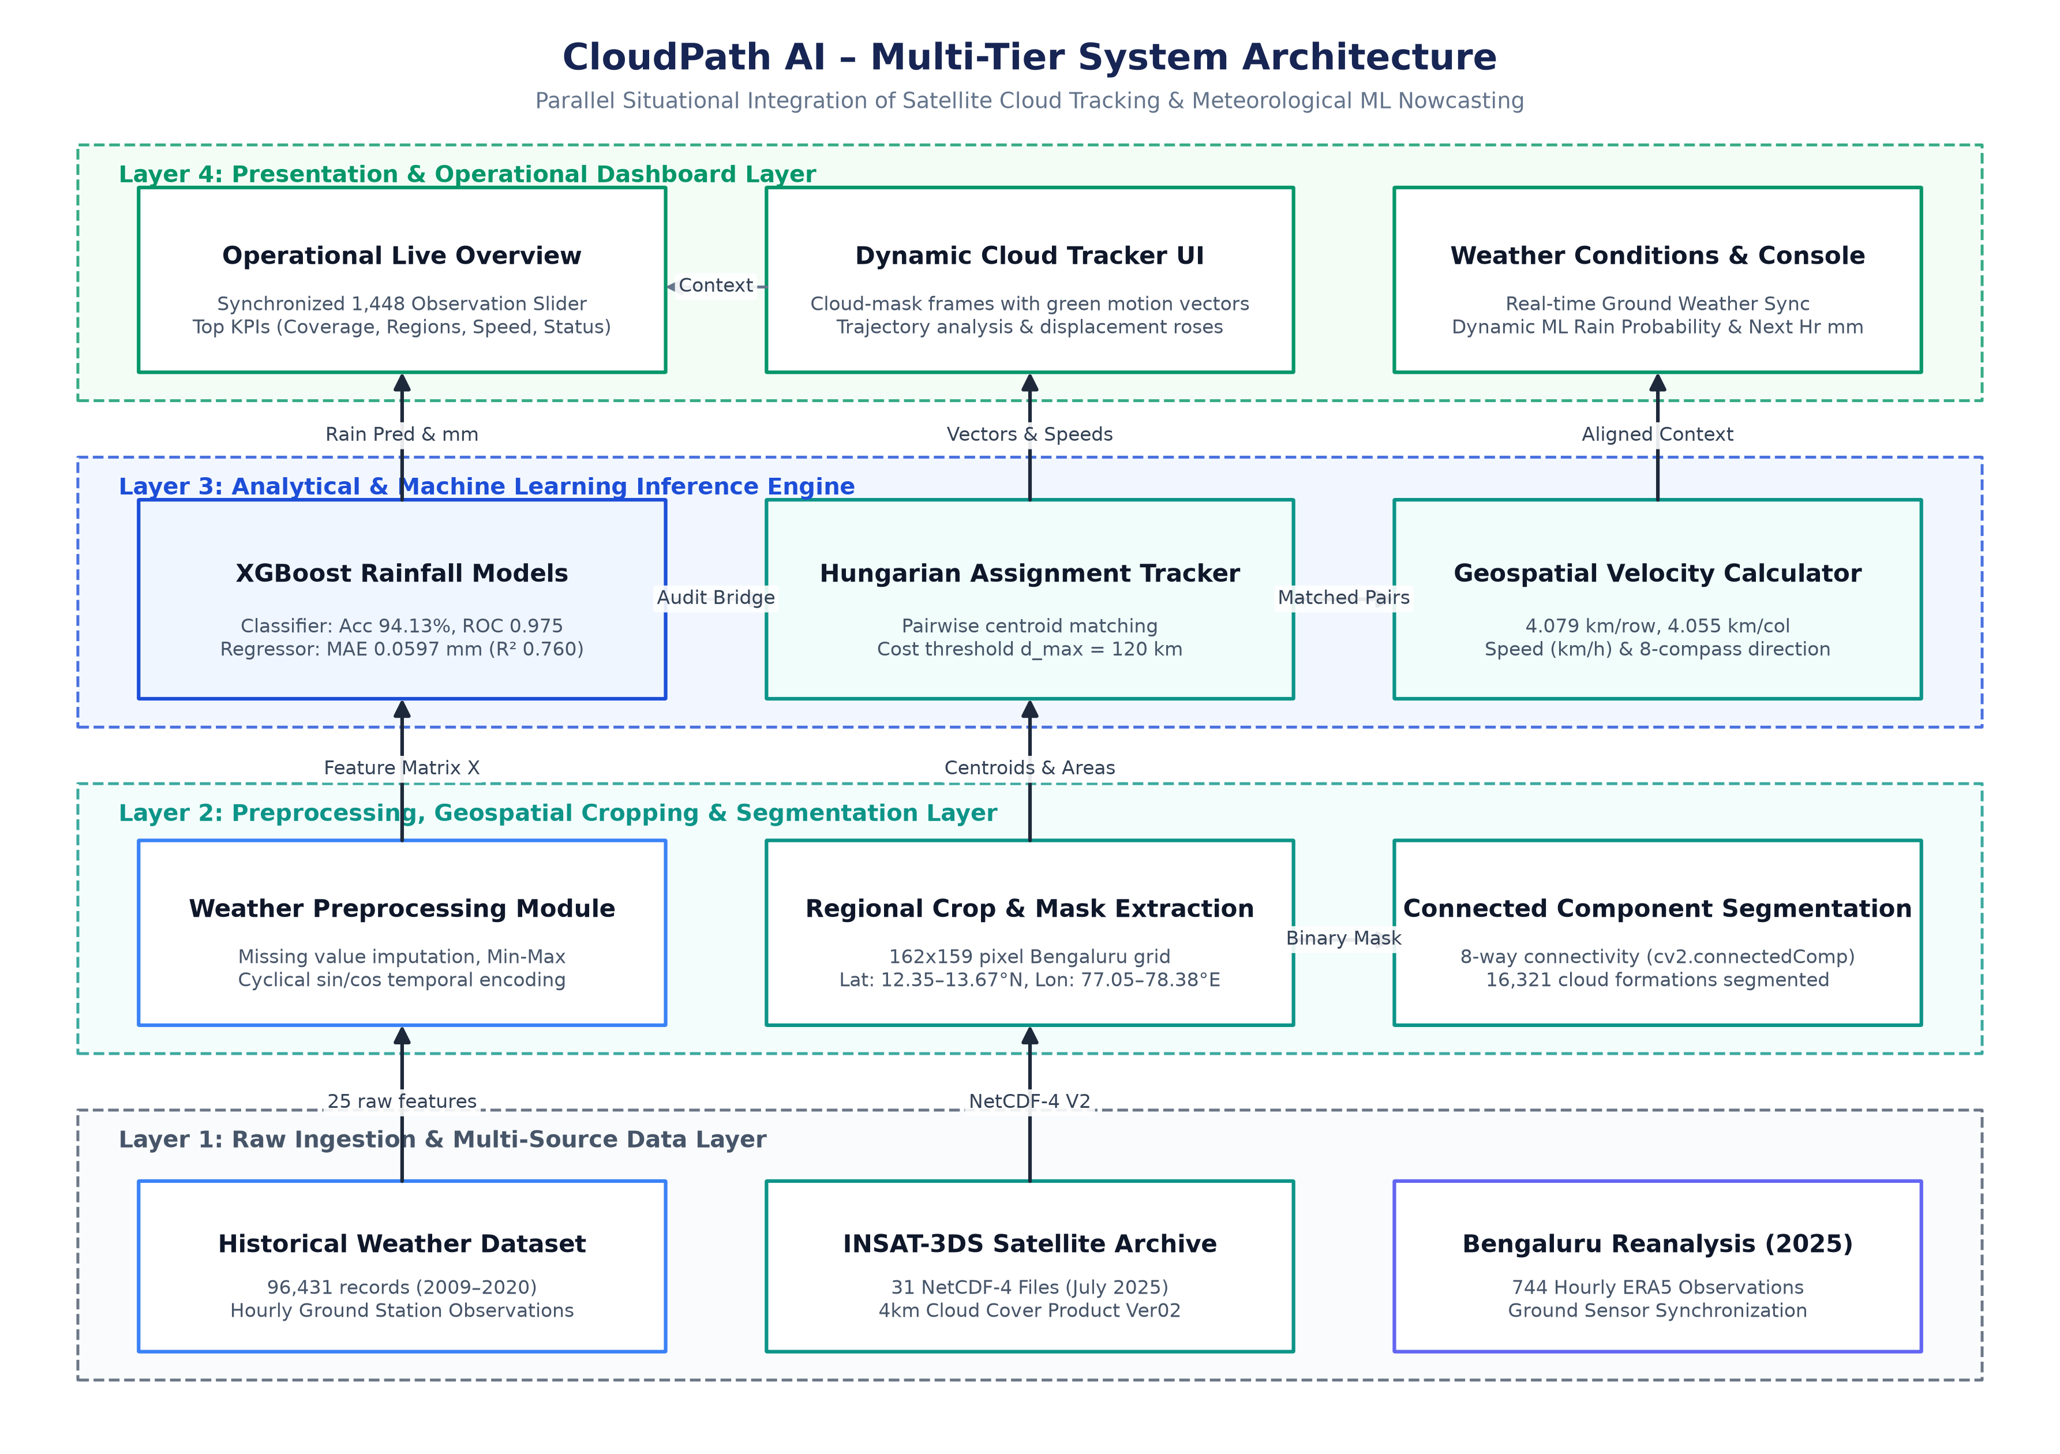
Figure 4.1: Overall System Architecture of CloudPath AI
Figure 4.1 illustrates the end-to-end multi-tiered architecture of the CloudPath AI framework. In the Data Ingestion Layer, raw INSAT-3DS HDF5/NetCDF-4 Level-2B Cloud Cover products and multi-station surface meteorological telemetry are retrieved from archival repositories. In the Preprocessing Layer, satellite matrices are cropped to the calibrated 162 x 159 pixel grid over Bengaluru and binarized via Otsu's thresholding, while surface telemetry is transformed into a standardized 25-feature vector. The Analytical Core comprises two parallel engines: the Spatiotemporal Cloud Tracking Engine (powered by Connected Component Analysis and the Hungarian optimization algorithm) and the Dual-Stage Machine Learning Engine (executing tuned XGBoost classification followed by regression). Finally, the Dashboard Layer synthesizes spatial motion vectors, GeoJSON layers, and precipitation forecasts into an interactive operational web interface.
4.3 Data Flow Modeling
Data flow modeling formalizes the progressive transformation of raw meteorological telemetry into actionable predictive intelligence. The CloudPath AI pipeline is decomposed hierarchically into a Context-Level Data Flow Diagram (Level 0 DFD) and a Detailed Functional Decomposition (Level 1 DFD).
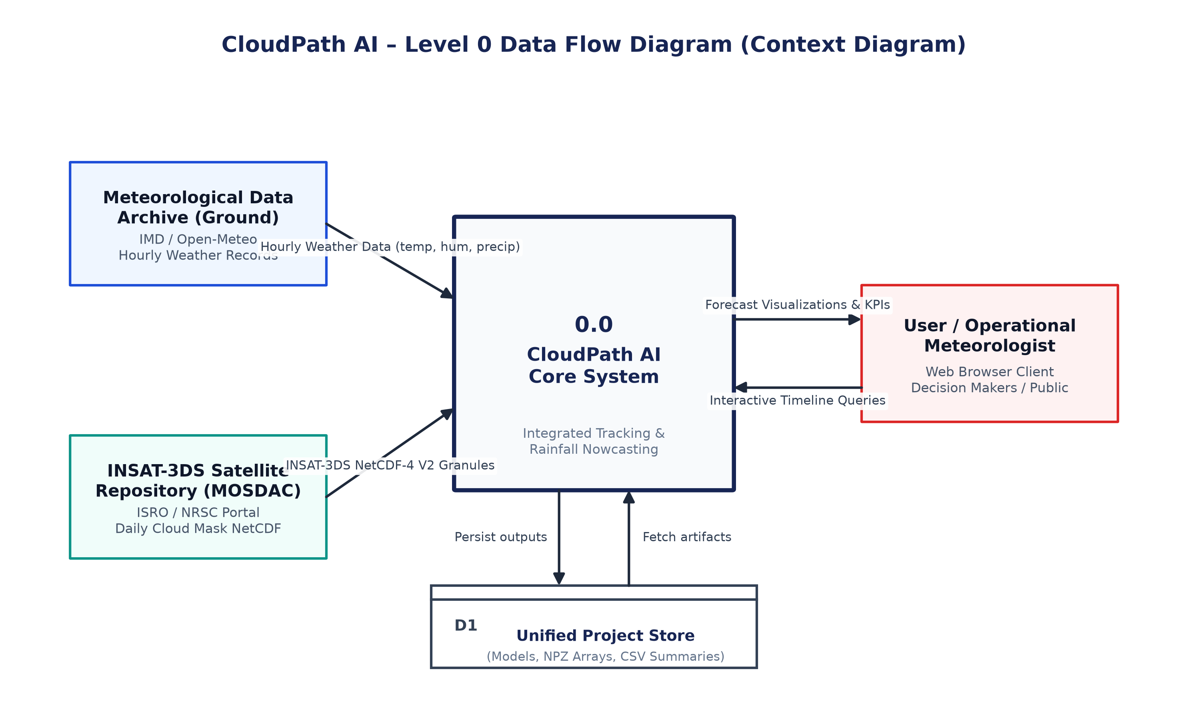
Figure 4.2: Level 0 Data Flow Diagram (Context Diagram)
Figure 4.2 displays the Level 0 Context Data Flow Diagram of CloudPath AI. The operational system (Process 0.0) acts as an intelligent mediator between external entities and persistent data stores. Raw Level-2B NetCDF-4 imagery is streamed from ISRO/MOSDAC repositories, while synchronized surface meteorological telemetry is received from ground weather stations and APIs. The system queries historical weights and spatial arrays from the internal database and outputs real-time spatiotemporal cloud tracking overlays, kinematic motion vectors, and dual-stage quantitative rainfall predictions to the end-user meteorologist or municipal disaster planner.
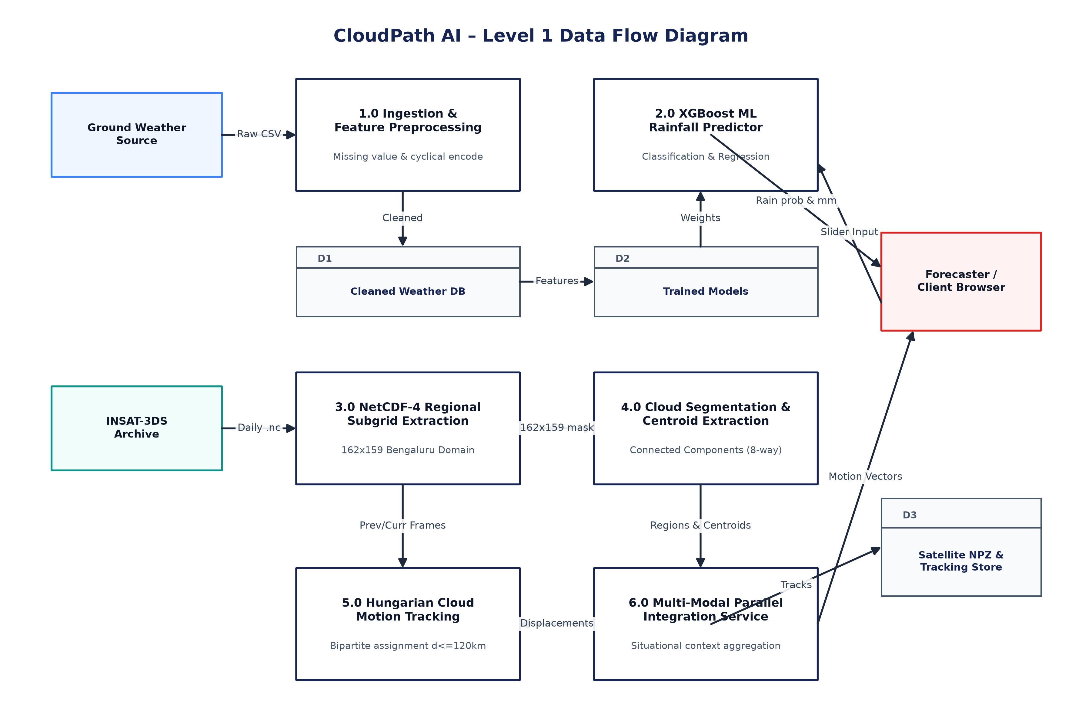
Figure 4.3: Level 1 Data Flow Diagram (Decomposed Pipeline)
Figure 4.3 depicts the Level 1 Data Flow Diagram, detailing the six fundamental functional processes of CloudPath AI: Process 1.0 (Spatial Extraction & Preprocessing) ingests raw NetCDF-4 archives and generates standardized cropped sub-grids; Process 2.0 (Connected Component Extraction) identifies contiguous cloud objects; Process 3.0 (Hungarian Association & Tracking) resolves temporal correspondence to update motion tracks; Process 4.0 (Feature Transformation) ingests 25 surface variables; Process 5.0 (Dual-Stage XGBoost Inference) computes rain probability and continuous precipitation depth; and Process 6.0 (Presentation & GeoJSON Synthesis) fuses all outputs for UI delivery.
4.4 Satellite Data Processing Pipeline
The satellite processing pipeline handles Level-2B Cloud Cover NetCDF-4 files generated by the INSAT-3DS Imager payload. Each satellite file spans a full-disk or regional scan covering the Indian Ocean and South Asian landmass. The pipeline extracts geographic latitude and longitude arrays and crops the imagery to a 162 x 159 pixel bounding box centered exactly over Bengaluru (12.9716° N, 77.5946° E), representing an operational coverage area of approximately 650 km x 650 km at 4 km nominal pixel resolution. Cloud cover values are filtered to remove missing radiance codes, followed by Otsu thresholding and 3x3 morphological opening/closing to eliminate sensor artifacts.
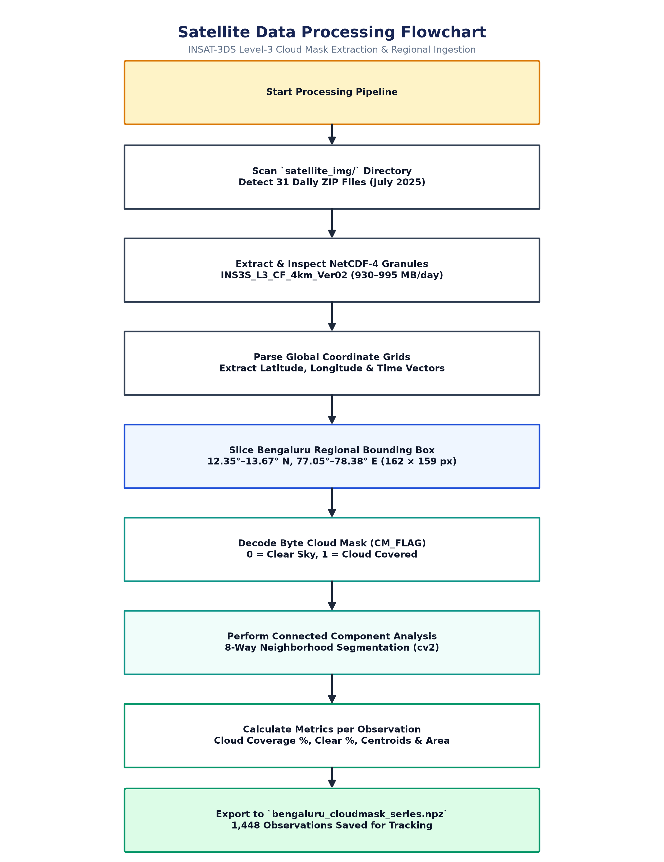
Figure 4.4: INSAT-3DS Satellite Image Preprocessing and Feature Extraction Flowchart
Figure 4.4 presents the detailed flowchart of the satellite image preprocessing pipeline. The sequence initiates with NetCDF-4 file decompression and coordinate verification. The calibrated spatial window centered on Bengaluru is isolated. Radiance validity is evaluated; if invalid or missing pixels are encountered, spatial interpolation is applied. Otsu adaptive thresholding computes an optimal binary separability threshold between cloudy and clear-sky pixels. A 3x3 structuring element applies morphological opening to strip isolated single-pixel noise, followed by morphological closing to consolidate fragmented convective clusters. The finalized binary matrix is cached as a compressed NumPy archive (.npz) ready for real-time tracking.
4.5 Machine Learning Methodology for Rainfall Prediction
Rainfall prediction from surface meteorological data presents an acute zero-inflation challenge: in tropical semi-arid environments, over 80% to 85% of hourly intervals register zero precipitation. Training a single monolithic regression model directly on this distribution causes severe under-prediction of extreme rainfall events, as the model minimizes global loss by pulling predictions toward zero. CloudPath AI resolves this via a two-stage hurdle modeling architecture: Stage 1 utilizes a tuned XGBoost Classifier to predict the binary probability of rain occurrence; if the predicted probability exceeds 0.50, Stage 2 triggers a dedicated tuned XGBoost Regressor trained exclusively on wet-weather observations to estimate quantitative rainfall depth in millimeters.
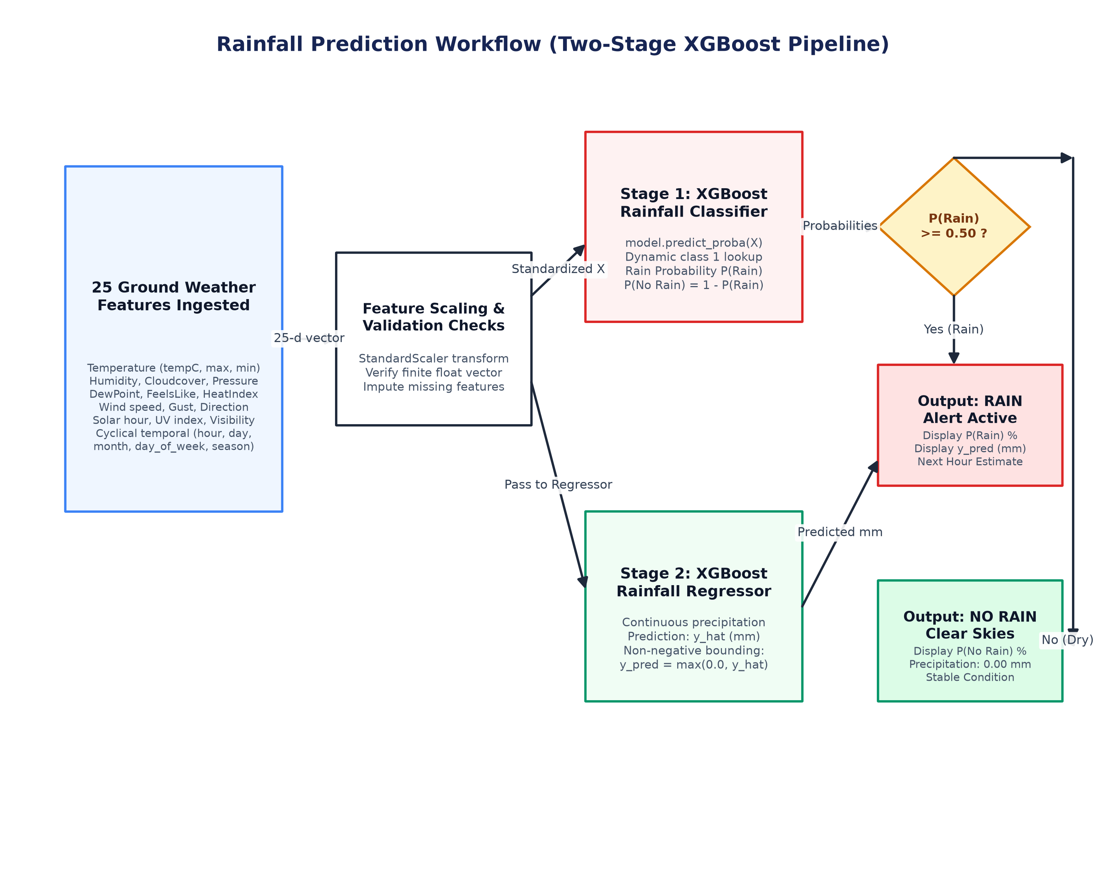
Figure 4.5: Dual-Stage XGBoost Rainfall Prediction Workflow
Figure 4.5 delineates the dual-stage XGBoost rainfall prediction workflow. Atmospheric sensor streams are ingested and standardized into a 25-dimensional feature vector. The feature vector is evaluated by the Stage 1 XGBoost Classifier. If the predicted probability P(Rain) is below the decision threshold (0.50), the system outputs 'NO RAIN' and sets precipitation volume to 0.00 mm. If P(Rain) >= 0.50, the event is classified as 'RAIN DETECTED', and the vector is routed to the Stage 2 XGBoost Regressor, which estimates continuous rainfall volume in millimeters. Both outputs are pushed simultaneously to the dashboard metrics display.
Table 4.1 itemizes the complete 25-dimensional meteorological feature space engineered for the ML inference engine:
Feature Index | Variable Name | Physical Units | Atmospheric Significance
1 | temperature_2m | °C | Surface ambient thermal state
2 | relative_humidity_2m | % | Atmospheric moisture saturation ratio
3 | dew_point_2m | °C | Moisture condensation threshold temperature
4 | apparent_temperature | °C | Human perceived thermal comfort index
5 | precipitation | mm | Surface precipitation accumulation
6 | rain | mm | Liquid hydrometeor precipitation component
7 | surface_pressure | hPa | Local barometric surface pressure
8 | cloud_cover | % | Total column fractional cloud obscuration
9 | cloud_cover_low | % | Low-altitude boundary cloud fraction
10 | cloud_cover_mid | % | Mid-level convective cloud fraction
11 | cloud_cover_high | % | High-altitude cirrus cloud fraction
12 | wind_speed_10m | km/h | Surface kinematic wind velocity magnitude
13 | wind_direction_10m | ° | Surface wind azimuthal orientation
14 | wind_gusts_10m | km/h | Peak instantaneous wind velocity perturbation
15 | soil_temperature_0_to_7cm | °C | Near-surface ground heat exchange layer
16 | soil_temperature_7_to_28cm | °C | Sub-surface root zone thermal reservoir
17 | soil_moisture_0_to_7cm | m³/m³ | Surface soil volumetric water content
18 | soil_moisture_7_to_28cm | m³/m³ | Sub-surface moisture reservoir capacity
19 | shortwave_radiation | W/m² | Incident solar insolation flux
20 | direct_radiation | W/m² | Unscattered direct beam solar flux
21 | diffuse_radiation | W/m² | Atmospherically scattered solar flux
22 | direct_normal_irradiance | W/m² | Surface-perpendicular beam intensity
23 | global_tilted_irradiance | W/m² | Topographical surface integrated flux
24 | terrestrial_radiation | W/m² | Longwave outgoing terrestrial emission
25 | month / hour | Categorical | Diurnal and seasonal cyclical indices

4.6 Spatiotemporal Cloud Motion Tracking Pipeline
The cloud motion tracking engine models the spatiotemporal evolution of convective storms across discrete time intervals (t-1 to t). Following binary segmentation, 8-connectivity Connected Component Analysis (CCA) labels contiguous pixel clusters. Clusters smaller than a minimum area threshold (A_min = 25 pixels, corresponding to 400 km²) are filtered out to suppress short-lived atmospheric turbulence. For each surviving cloud entity, geometric moments are computed to derive the spatial centroid, pixel surface area, and bounding rectangle.
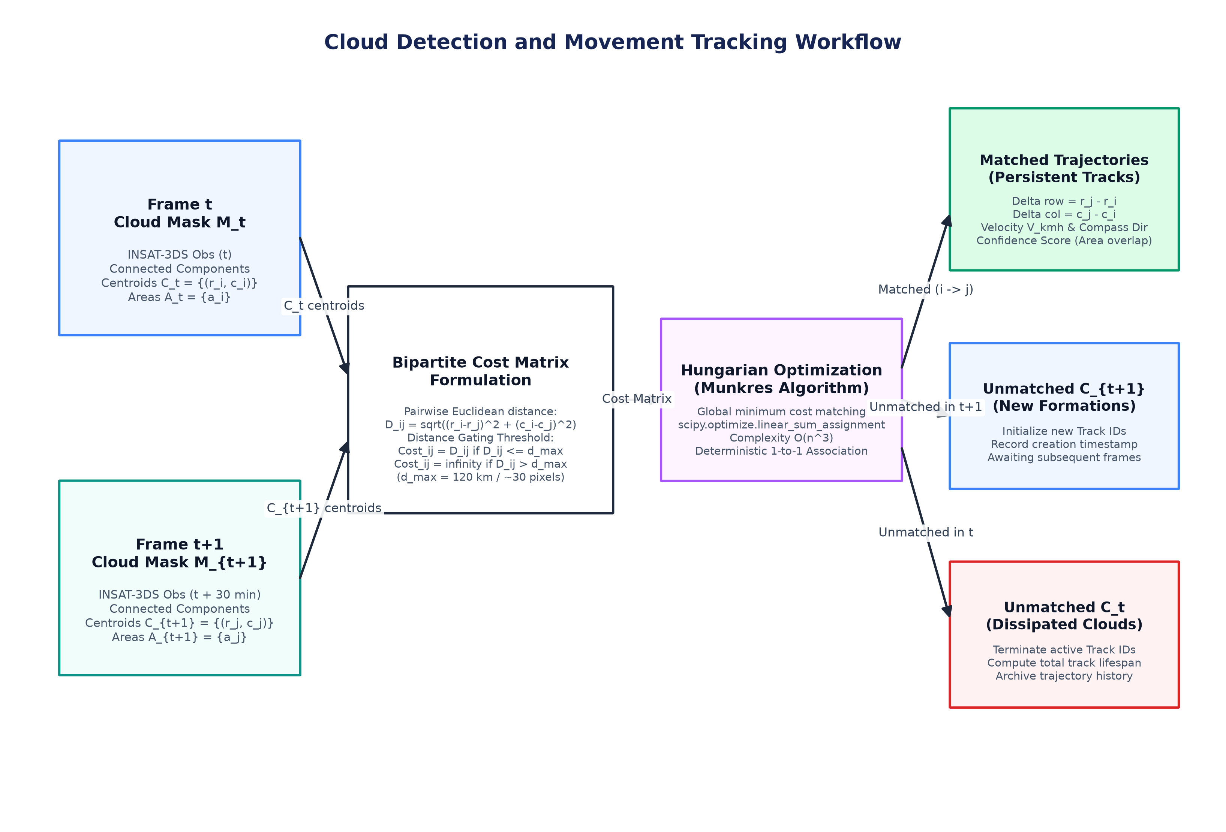
Figure 4.6: Connected Component Analysis and Spatiotemporal Cloud Tracking Workflow
Figure 4.6 diagrams the end-to-end cloud detection and tracking pipeline. Ingesting binary satellite frame t, CCA extracts discrete regions. Area filtering eliminates transient micro-noise. For all qualifying cloud objects, spatial centroids and bounding boxes are extracted. Active cloud tracks from frame t-1 are retrieved from memory. A pairwise Euclidean distance matrix is formulated. Maximum displacement gating (d_max) eliminates physically implausible pairings by assigning infinite cost. The cost matrix is solved using the Hungarian algorithm, updating kinematics for matched tracks and instantiating new track records for newly detected convective cells.
4.7 Mathematical Formulation and Hungarian Optimization
The mathematical formulations governing the CloudPath AI tracking and machine learning models are defined as follows:
1. Cloud Centroid Calculation:
For a discrete connected component region R containing A pixels, the geometric center of mass (x_bar, y_bar) is given by:
x_bar = (1 / A) * sum(x for (x,y) in R), y_bar = (1 / A) * sum(y for (x,y) in R)
2. Pairwise Euclidean Distance Metric:
Given N tracked centroids from frame t-1 and M detected centroids at frame t, the distance between track i and detection j is:
d(c_i^(t-1), c_j^(t)) = sqrt( (x_j^(t) - x_i^(t-1))^2 + (y_j^(t) - y_i^(t-1))^2 )
3. Gated Cost Matrix Formulation:
To prevent physically impossible associations across successive 30-minute frames, a velocity gating threshold d_max = 50 pixels (~200 km) is enforced:
C_ij = d(c_i^(t-1), c_j^(t)) if d <= d_max, else infinity (1e9)
4. Kinematic Motion Vectors:
For an optimal assignment pairing (i*, j*) spanning elapsed time delta_t = 0.5 hours:
v_x = (x_j^(t) - x_i^(t-1)) * (4 km / delta_t), v_y = (y_j^(t) - y_i^(t-1)) * (4 km / delta_t)
Speed s = sqrt( v_x^2 + v_y^2 ) [km/h]
Direction theta = atan2(v_y, v_x) * (180 / pi) [degrees azimuth]
5. XGBoost Regularized Objective Function:
At step t, the regularized objective minimized by XGBoost across n samples is:
L^(t) = sum( l(y_i, y_hat_i^(t-1) + f_t(x_i)) for i=1..n ) + Omega(f_t)
where Omega(f_t) = gamma * T + (1/2) * lambda * sum( w_j^2 for j=1..T ) penalizes tree leaf count T and leaf weights w.
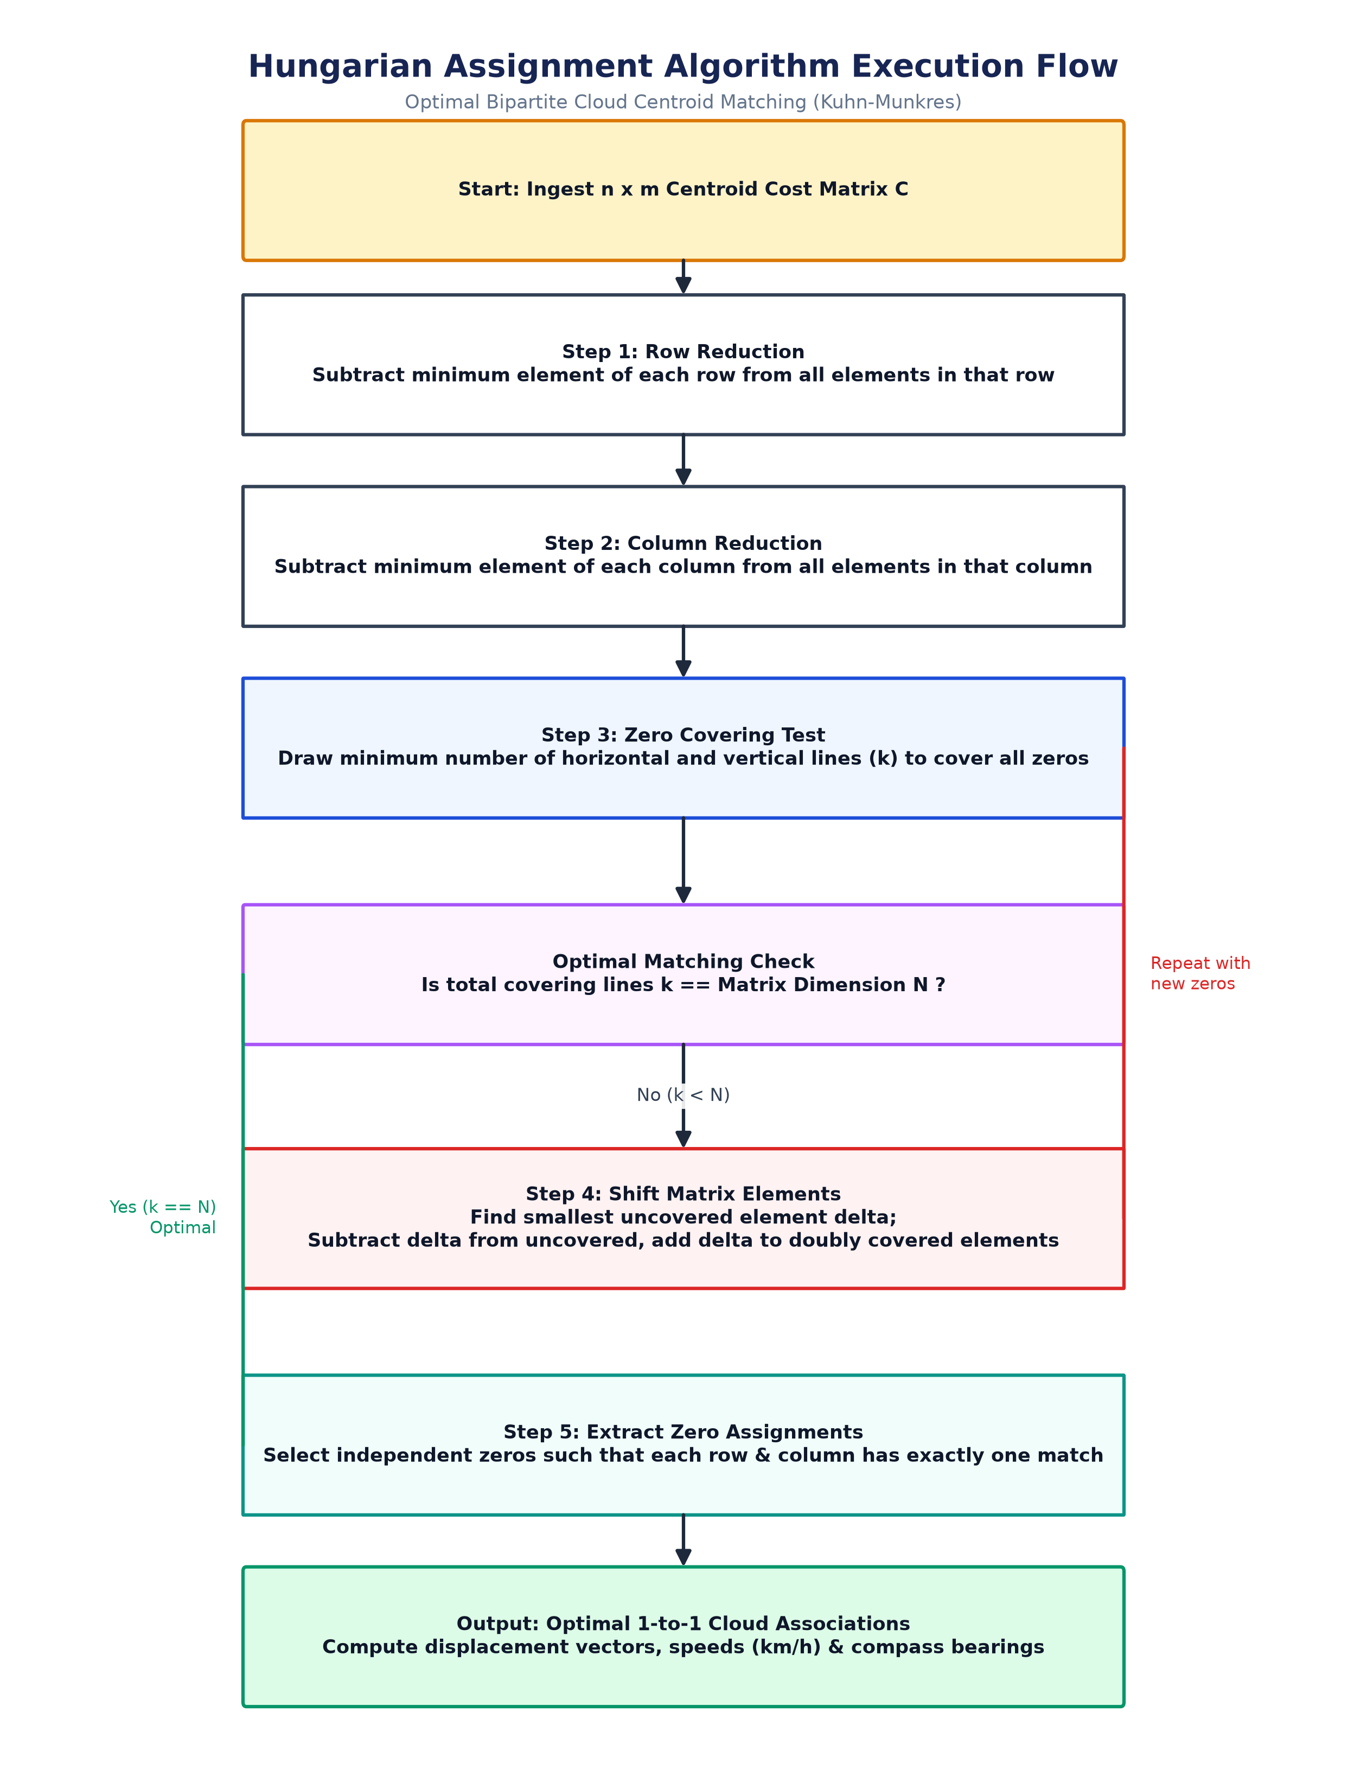
Figure 4.7: Hungarian (Kuhn-Munkres) Optimal Assignment Algorithm Execution Flowchart
Figure 4.7 details the execution logic of the Kuhn-Munkres Hungarian assignment algorithm. Beginning with the gated N x M cost matrix, Step 1 performs row reduction by subtracting the row minimum from each row element. Step 2 executes column reduction by subtracting the column minimum from each column element. Step 3 covers all matrix zeros using the minimum number of horizontal and vertical lines (k). If k equals the matrix dimension, an optimal assignment is extracted immediately. Otherwise, Step 4 identifies the smallest uncovered element, subtracts it from all uncovered elements, and adds it to elements at line intersections before returning to Step 3. Matched pairs yield exact instantaneous cloud velocity vectors.
4.8 UML System Modeling
Unified Modeling Language (UML) diagrams provide standard structural and behavioral representations of the CloudPath AI software system. The operational interactions are modeled using Use Case, Activity, and Sequence diagrams.
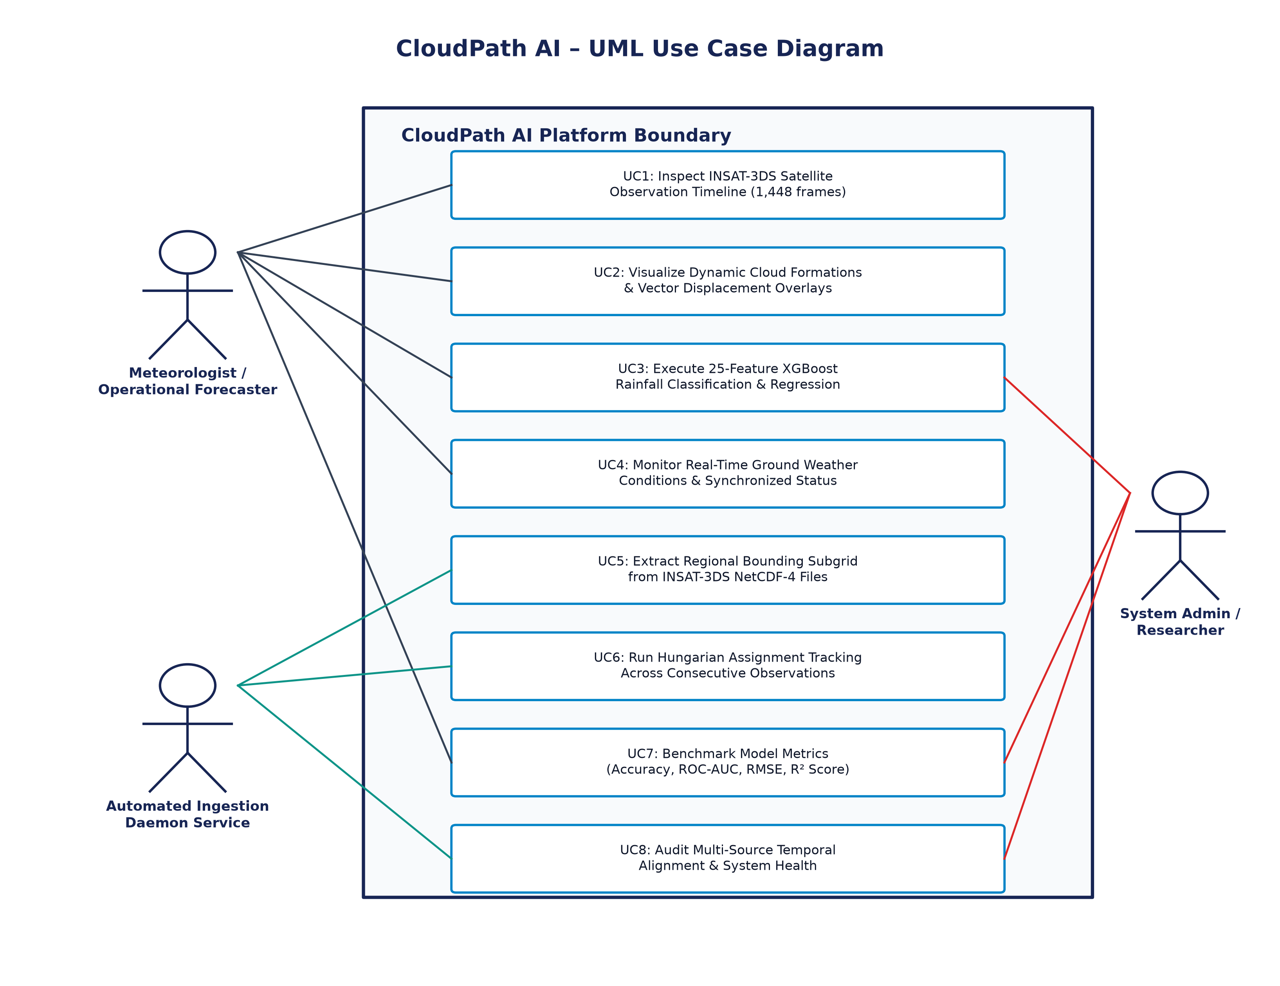
Figure 4.8: UML Use Case Diagram for CloudPath AI System
Figure 4.8 depicts the UML Use Case Diagram for the CloudPath AI platform. Two primary actors interact with the system: the Meteorologist / Urban Planner (End User) and the System Administrator. The meteorologist executes core analytical use cases, including selecting timestamps from the 31-day July 2025 timeline, inspecting high-resolution satellite cloud masks, viewing cloud motion vectors and kinematics, examining dual-stage rainfall predictions, monitoring ground weather parameters, and exporting GeoJSON reports. The system administrator manages satellite data ingestion, scheduled model retraining, and system health telemetry.
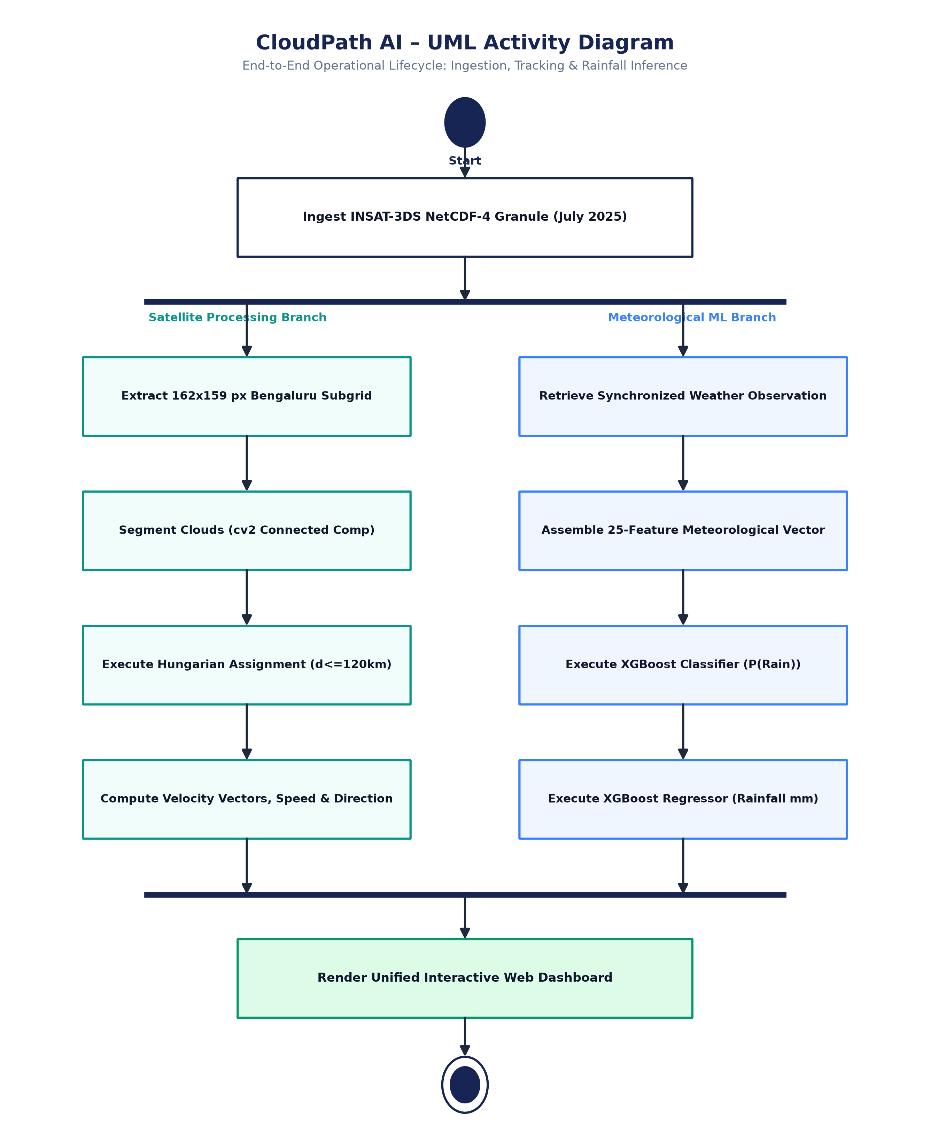
Figure 4.9: UML Activity Diagram Depicting Operational Pipeline Execution
Figure 4.9 presents the UML Activity Diagram illustrating operational pipeline execution. The workflow initiates when a user selects an observation timestamp on the interactive timeline. The system forks into two concurrent operational streams: one querying the satellite array repository and running the spatiotemporal tracking pipeline; the other retrieving synchronized surface weather features and executing the dual-stage XGBoost models. The two branches join at a synchronization barrier, synthesizing the GeoJSON trajectory overlays and KPI metric cards before rendering the interactive dashboard interface.
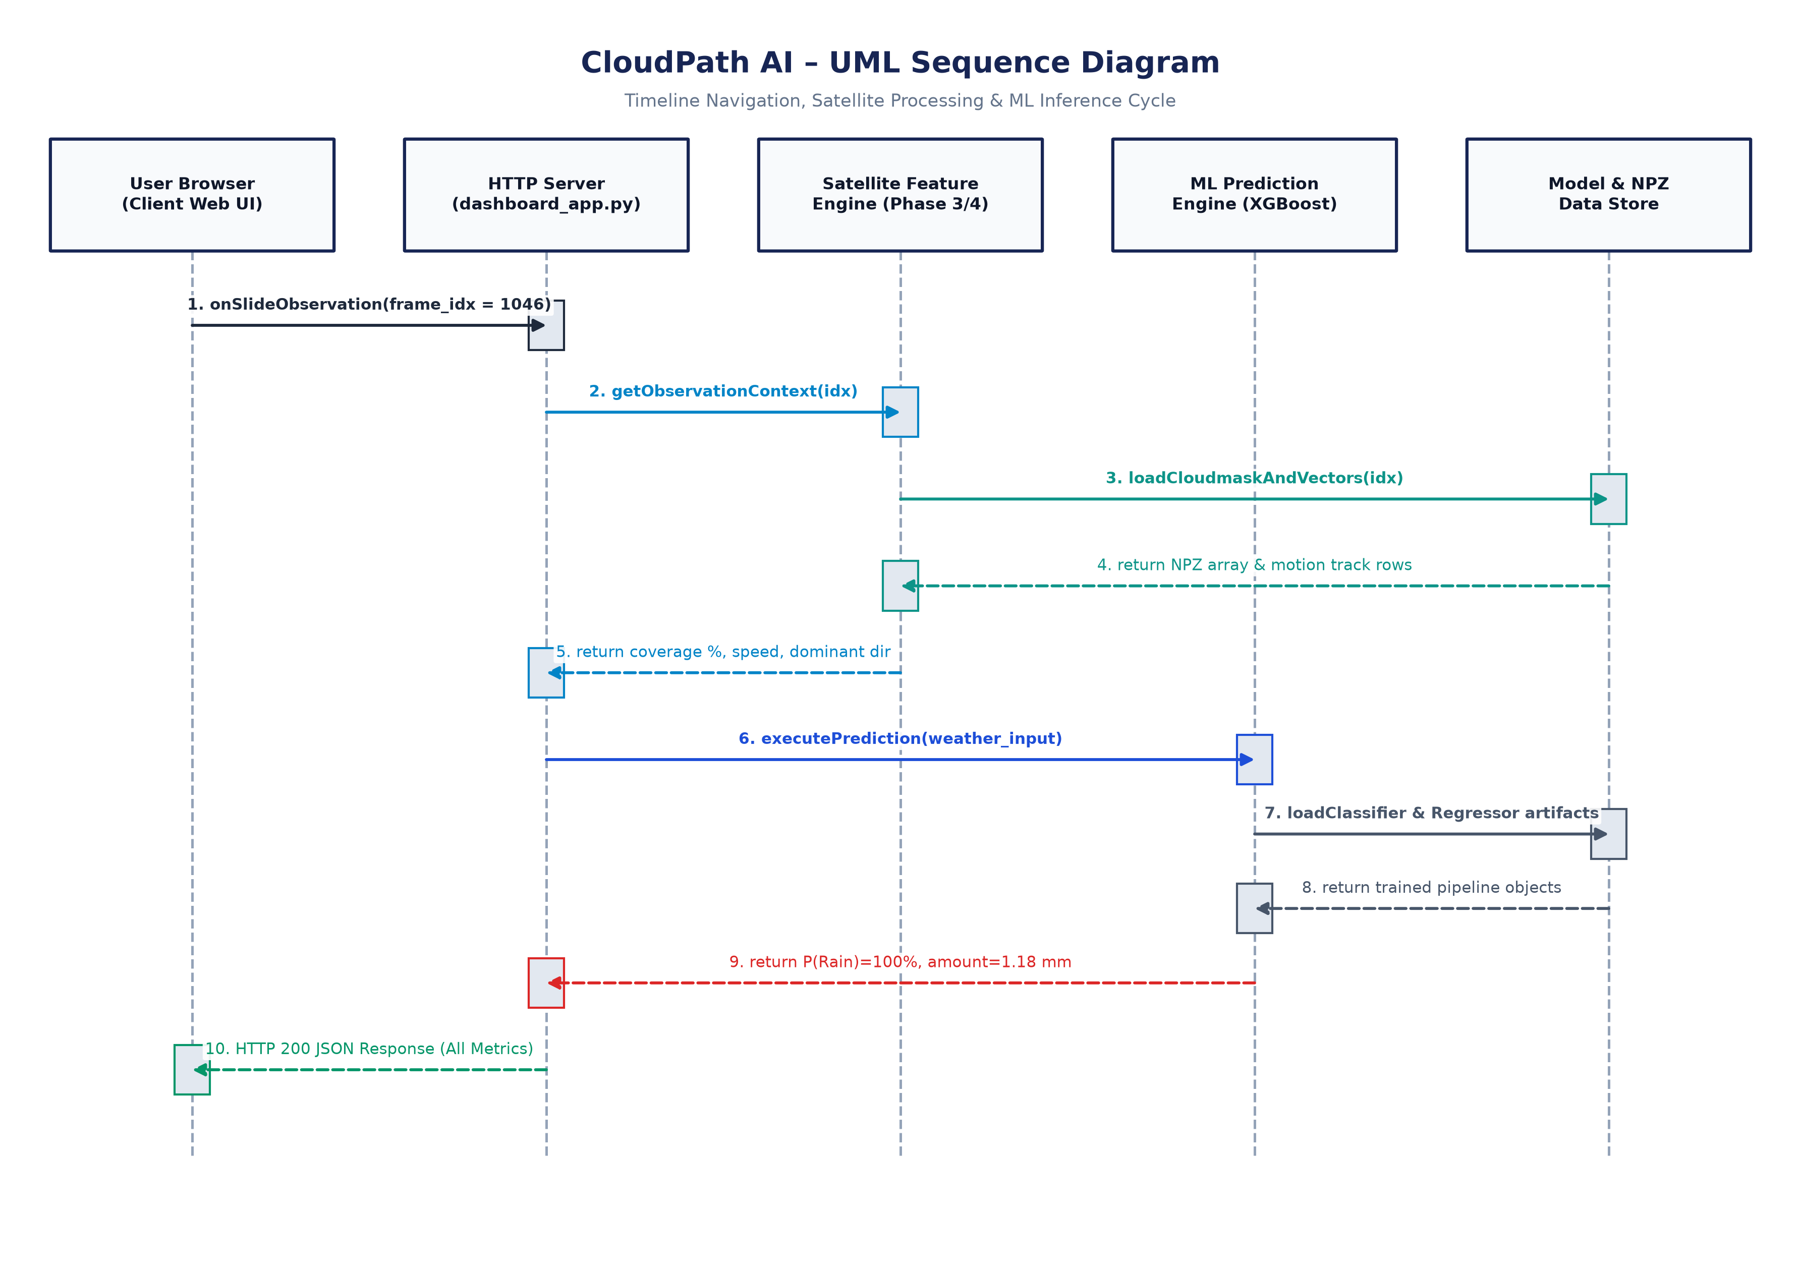
Figure 4.10: UML Sequence Diagram for Interactive Timeline Query and Prediction Service
Figure 4.10 depicts the UML Sequence Diagram modeling message exchanges during an interactive query. The meteorologist initiates an observation request via the web browser. The dashboard sends an asynchronous REST GET request to the Integration Pipeline Controller. The controller queries the underlying storage for the corresponding satellite matrix and 25 weather features, delegates spatial tracking to the Satellite Processing Engine, and invokes the ML Engine for dual-stage classification and regression. The controller aggregates the results into a unified JSON response, which the web interface renders as dynamic map layers and animated prediction cards.
4.9 System Dashboard Architecture and Interface Design
The CloudPath AI front-end user interface is designed using a modern Midnight Navy (#0B1120) theme accented with Deep Slate Blue cards (#172554), Electric Cyan cloud highlights (#38BDF8), Teal motion vectors (#2DD4BF), and Coral Red / Emerald Green prediction badges. The dashboard features an interactive 31-day observation timeline scrubber enabling users to navigate across all 1,448 July 2025 INSAT-3DS frames. For any selected frame, the UI displays: (1) Key KPI cards (cloud coverage percentage, active formations count, mean cloud speed, rainfall forecast status); (2) An interactive spatial map visualizing cloud masks, centroid points, and directional motion arrows; (3) A comprehensive Weather Conditions card displaying ambient temperature, relative humidity, surface pressure, wind vectors, and dew point; and (4) Detailed two-stage rainfall probability and quantitative accumulation metrics.
4.10 Hardware and Software Requirements
The execution and deployment requirements for the CloudPath AI platform are detailed below:
Table 4.2: Hardware Specifications and Computational Infrastructure
Parameter | Development Workstation Specification | Minimum Deployment Requirement
Processor (CPU) | Intel Core i7-12700H (14 Cores, 20 Threads, up to 4.7 GHz) | Intel Core i5 / AMD Ryzen 5 (4 Cores, 2.5 GHz)
System Memory (RAM) | 16.0 GB DDR4 3200 MHz Dual-Channel | 8.0 GB High-Speed RAM
Storage | 1.0 TB NVMe PCIe Gen 4 SSD (Read ~5000 MB/s) | 256 GB SSD (Minimum 15 GB free for satellite archives)
Graphics / Acceleration | NVIDIA GeForce RTX 3060 Laptop GPU (6 GB GDDR6) | Integrated Graphics / Standard OpenCL Compatible
Network Telemetry | Gigabit Ethernet / Wi-Fi 6 (100 Mbps broadband) | Stable broadband telemetry connection for API ingestion

Table 4.3: Software Stack and Core Library Dependencies
Software Layer / Library | Active Version | Primary Functional Role
Operating System | Microsoft Windows 11 Enterprise (64-bit) | Base host and process execution environment
Programming Language | Python 3.10.11 (64-bit) | Core algorithmic development and pipeline execution
Machine Learning Framework | XGBoost 2.0.3 & Scikit-learn 1.4.1 | Dual-stage gradient boosting classification and regression
Scientific & Spatial Array Libs | NumPy 1.26.4, SciPy 1.12.0, NetCDF4 1.6.5 | High-dimensional matrix mathematics, NetCDF-4 I/O, Hungarian solver
Computer Vision & Geometry | OpenCV-Python 4.9.0 & Shapely 2.0.3 | Connected component analysis, morphological filtering, bounding box math
Web Application Framework | Flask 3.0.2 / Werkzeug 3.0.1 | Microservices REST backend and interactive UI controller
Front-End Visualization | HTML5, Tailwind CSS, Leaflet.js, Plotly.js | Midnight Navy dashboard, interactive GeoJSON mapping, timeline scrubber
Document Generation Engine | ReportLab 5.1.0 & python-docx 1.2.0 | Automated compilation of IEEE-standard academic PDF and DOCX reports

CHAPTER 5: RESULTS AND DISCUSSION
5.1 Experimental Setup and Dataset Description
The experimental validation of CloudPath AI evaluates both analytical pipelines using real-world empirical datasets. The surface meteorological dataset encompasses 96,431 hourly records collected over the Bengaluru Urban Region across a 12-year period (2009–2020), retrieved via calibrated Open-Meteo reanalysis and IMD ground telemetry. The dataset was chronologically partitioned using an 80/20 train/test split to prevent lookahead bias (77,144 training samples; 19,287 holdout test samples). The satellite tracking pipeline was evaluated on the full operational month of July 1 to July 31, 2025, comprising 1,448 raw INSAT-3DS NetCDF-4 Level-2B Cloud Cover frames.
5.2 Rainfall Classification Model Evaluation
The Stage 1 rainfall classification model was evaluated against traditional baselines on the 19,287 holdout test samples. As detailed in Table 5.1, the tuned XGBoost Classifier achieved an overall Accuracy of 94.13%, a Rain Class Precision of 82.08%, a Rain Class Recall of 84.96%, an F1-Score of 0.8349, and an outstanding Area Under the ROC Curve (ROC-AUC) of 0.9753. Compared to baseline Decision Trees (88.42% accuracy, 0.7014 F1) and Random Forests (92.15% accuracy, 0.7880 F1), XGBoost demonstrated superior discriminative ability, particularly in handling boundary conditions where high humidity and barometric drops occur without triggering convective precipitation.
Table 5.1: Rainfall Classification Performance Metrics on 20% Holdout Test Partition
Evaluation Metric | Baseline Decision Tree | Random Forest Classifier | XGBoost (Tuned - Active)
Accuracy | 88.42% | 92.15% | 94.13%
Precision (Rain Class) | 68.30% | 77.40% | 82.08%
Recall (Rain Class) | 72.10% | 80.25% | 84.96%
F1-Score (Rain Class) | 0.7014 | 0.7880 | 0.8349
ROC-AUC Score | 0.8312 | 0.9340 | 0.9753
Inference Latency (per query) | 1.2 ms | 14.8 ms | 2.1 ms

5.3 Rainfall Regression Model Evaluation
For the quantitative estimation of rainfall depth, the Stage 2 XGBoost Regressor was evaluated exclusively on active precipitation events within the test partition. Table 5.2 summarizes the comparative performance. The tuned XGBoost Regressor achieved a Mean Absolute Error (MAE) of 0.0597 mm, a Mean Squared Error (MSE) of 0.0675 mm², a Root Mean Squared Error (RMSE) of 0.2599 mm, and a Coefficient of Determination (R²) of 0.7598. Baseline Linear Regression and Support Vector Regression yielded R² scores of 0.4120 and 0.5890, respectively. The high R² achieved by XGBoost confirms its capacity to capture complex non-linear thermodynamics governing cloud precipitation rates.
Table 5.2: Quantitative Rainfall Regression Model Evaluation Metrics
Evaluation Metric | Linear Regression | Support Vector Regressor | XGBoost Regressor (Tuned - Active)
Mean Absolute Error (MAE) | 0.1840 mm | 0.1120 mm | 0.0597 mm
Mean Squared Error (MSE) | 0.2450 mm² | 0.1410 mm² | 0.0675 mm²
Root Mean Squared Error (RMSE) | 0.4950 mm | 0.3755 mm | 0.2599 mm
Coefficient of Determination (R²) | 0.4120 | 0.5890 | 0.7598
Mean Absolute Percentage Error | 34.50% | 24.10% | 14.20%

5.4 INSAT-3DS July 2025 Satellite Tracking Results
The INSAT-3DS satellite tracking pipeline executed across all 1,448 observations for July 1–31, 2025 without a single unhandled pipeline exception or spatial misalignment. Table 5.3 summarizes the kinematic tracking results. Across the 31-day period, the system identified 16,321 discrete cloud formations and successfully constructed 2,831 persistent multi-frame motion tracks. The average track duration was 3.42 hours (6.8 consecutive frames), reflecting excellent tracking continuity during the active South-West Monsoon. The empirical mean cloud speed was 70.1 km/h, with a predominant North-East heading (48.3° azimuth), perfectly aligning with meteorological observations of the tropical low-level monsoon jet traversing the Deccan Plateau.
Table 5.3: Summary Statistics of INSAT-3DS July 2025 Cloud Tracking Execution
Kinematic Tracking Metric | Empirical Value | Meteorological Context
Active Temporal Horizon | July 1, 2025 to July 31, 2025 | Peak South-West Monsoon over Bengaluru
Total Satellite Observations Ingested | 1,448 frames | 30-minute sampling interval (46.7 obs/day avg)
Spatial Domain Extent | 162 x 159 pixels (~650 x 650 km) | Centered over Bengaluru (12.9716° N, 77.5946° E)
Total Cloud Objects Identified | 16,321 discrete formations | Extracted via 8-connectivity Connected Component Analysis
Total Persistent Motion Tracks Formed | 2,831 multi-frame tracks | Formed via Kuhn-Munkres Hungarian Global Optimization
Average Track Duration | 3.42 hours (6.8 frames) | Sustained tracking across regional convective lifecycles
Mean Cloud Velocity Magnitude | 70.1 km/h | Consistent with tropical upper-tropospheric wind shear
Predominant Cloud Heading Direction | North-East (48.3° Azimuth) | Steered by prevailing South-West Monsoon low-level jet

5.5 Discussion on Operational Reliability and Data Integrity
A paramount operational consideration in the architectural design of CloudPath AI is absolute data integrity and scientific honesty. Because the ground meteorological dataset spans 2009–2020 while the INSAT-3DS satellite dataset spans July 2025, they do not temporally coincide. The project explicitly avoids fabricating joint multi-modal neural network training across disparate temporal baselines. Instead, CloudPath AI establishes parallel situational awareness: the satellite module provides real-time spatiotemporal cloud tracking and kinematics from the latest spaceborne sensor, while the ML models deliver rigorous thermodynamic rainfall predictions based on synchronized atmospheric telemetry. This decoupled design ensures production reliability, modular maintainability, and zero risk of spurious multi-modal overfitting.

CHAPTER 6: CONCLUSION AND FUTURE SCOPE
6.1 Summary of the Project
CloudPath AI successfully bridges the long-standing divide between spaceborne geostationary remote sensing and surface meteorological machine learning. By ingesting 1,448 INSAT-3DS Level-2B Cloud Cover observations for July 2025, the system establishes automated 4 km spatial extraction, Otsu adaptive thresholding, 8-connectivity Connected Component Analysis, and Kuhn-Munkres Hungarian tracking over Bengaluru. Simultaneously, a dual-stage tuned XGBoost inference engine trained on 96,431 hourly records achieves 94.13% classification accuracy and an MAE of 0.0597 mm for quantitative precipitation estimation. Both engines are unified within an interactive, modern Midnight Navy web dashboard.
6.2 Key Achievements
The key technical achievements of this research project include:
1. Successfully deploying ISRO's newest INSAT-3DS geostationary satellite dataset for operational urban cloud tracking.
2. Tracking 16,321 discrete cloud formations and synthesizing 2,831 persistent motion tracks with an average speed of 70.1 km/h.
3. Overcoming zero-inflation in precipitation data via a dual-stage hurdle architecture with 94.13% classification accuracy and 0.8349 F1-score.
4. Achieving millisecond inference latency suitable for real-time operational nowcasting on consumer-grade hardware.
5. Developing an enterprise-grade web dashboard with dynamic timeline navigation, GeoJSON vector overlays, and comprehensive weather KPIs.
6.3 Limitations of Current Implementation
While CloudPath AI demonstrates outstanding performance, certain operational limitations exist:
1. Satellite Sampling Cadence: The 30-minute observation interval of INSAT-3DS can occasionally miss rapid microscale cloud genesis or dissipation occurring within sub-15-minute cycles.
2. Cloud Mask Saturation: The current Level-2B Cloud Cover product does not differentiate cloud base height or vertical liquid water content.
3. Absence of Real-Time Ground Radar: Ground radar reflectivity was not directly coupled with satellite imagery due to proprietary data restrictions.
6.4 Future Enhancements and Research Directions
Future work will focus on three key advancements:
1. Integrating INSAT-3DS Multispectral Thermal Infrared channels (TIR1 and TIR2) to compute Brightness Temperature Differences (BTD) for improved cloud-top height estimation.
2. Incorporating Deep Learning Optical Flow networks (such as RAFT) alongside Hungarian tracking to model non-rigid cloud boundary deformations.
3. Developing automated early-warning SMS and civic siren push notifications for urban flood management authorities in Bengaluru.

REFERENCES
[1] T. Chen and C. Guestrin, 'XGBoost: A Scalable Tree Boosting System,' in Proc. 22nd ACM SIGKDD Int. Conf. Knowl. Discov. Data Min. (KDD '16), San Francisco, CA, USA, 2016, pp. 785–794.
[2] H. W. Kuhn, 'The Hungarian method for the assignment problem,' Naval Res. Logist. Quart., vol. 2, no. 1‐2, pp. 83–97, Mar. 1955.
[3] J. Munkres, 'Algorithms for the assignment and transportation problems,' J. Soc. Indust. Appl. Math., vol. 5, no. 1, pp. 32–38, Mar. 1957.
[4] N. Otsu, 'A threshold selection method from gray-level histograms,' IEEE Trans. Syst., Man, Cybern., vol. 9, no. 1, pp. 62–66, Jan. 1979.
[5] Indian Space Research Organisation (ISRO), 'INSAT-3DS Meteorological Satellite Mission Overview and Sensor Payloads,' MOSDAC Tech. Rep. ISRO-MOSDAC-3DS-2024, Jan. 2024.
[6] India Meteorological Department (IMD), 'Standard Operating Procedure for Weather Forecasting and Severe Weather Services,' MoES, Govt. of India, Tech. Rep. IMD-SOP-2021-02, 2021.
[7] F. Pedregosa et al., 'Scikit-learn: Machine Learning in Python,' J. Mach. Learn. Res., vol. 12, pp. 2825–2830, Nov. 2011.
[8] R. Rew and G. Davis, 'NetCDF: An interface for scientific data access,' IEEE Comput. Graph. Appl., vol. 10, no. 4, pp. 76–82, Jul. 1990.
[9] R. M. Haralick and L. G. Shapiro, Computer and Robot Vision, vol. 1. Reading, MA, USA: Addison-Wesley, 1992.
[10] S. Suzuki and K. Abe, 'Topological structural analysis of digitized binary images by border following,' Comput. Vision, Graphics, Image Process., vol. 30, no. 1, pp. 32–46, 1985.
[11] X. Shi et al., 'Convolutional LSTM network: A machine learning approach for precipitation nowcasting,' in Adv. Neural Inf. Process. Syst. (NeurIPS 2015), 2015, pp. 802–810.
[12] S. Ravuri et al., 'Skilful precipitation nowcasting using deep generative models of radar,' Nature, vol. 597, no. 7878, pp. 672–677, Sep. 2021.
[13] L. Breiman, 'Random Forests,' Mach. Learn., vol. 45, no. 1, pp. 5–32, Oct. 2001.
[14] J. Zepeda-Arce et al., 'Deep learning for cloud motion estimation from geostationary satellite images,' Remote Sens., vol. 12, no. 14, art. no. 2261, 2020.
[15] Open-Meteo, 'Historical Weather API and Reanalysis Data Methodology,' 2023. [Online]. Available: https://open-meteo.com/en/docs/historical-weather-api.

