SYNOPSIS FOR THE PROJECT
ON
"CloudPath AI - AI-Based Cloud Movement Tracking and
Rainfall Prediction System"
DEPARTMENT OF COMPUTER SCIENCE AND ENGINEERING
BENGALURU URBAN REGION, KARNATAKA, INDIA
(12.9716° N, 77.5946° E)
ACADEMIC YEAR 2026–2027
Group / Project Batch No. : CP-08
Roll No. | Group Members | Email ID | Contact No. | Signature
101 | Student Candidate 1 | candidate1@student.edu | +91 98765 43210 | _____________
102 | Student Candidate 2 | candidate2@student.edu | +91 98765 43211 | _____________
103 | Student Candidate 3 | candidate3@student.edu | +91 98765 43212 | _____________
104 | Student Candidate 4 | candidate4@student.edu | +91 98765 43213 | _____________

( ___________________ )  Project Guide  Assistant Professor, CSE | ( ___________________ )  Project Coordinator  Associate Professor, CSE | ( ___________________ )  Head of Department  Department of CSE

ABSTRACT:
CloudPath AI is an artificial intelligence-based weather analysis and monitoring system designed to provide early meteorological awareness for urban regions, specifically focusing on the Bengaluru Urban Region (12.9716° N, 77.5946° E). The project is structured into two primary functional modules: Satellite Cloud Movement Tracking and Machine Learning-Based Rainfall Prediction. In the cloud movement tracking module, geostationary satellite cloud imagery from INSAT-3DS (Level-2B Cloud Cover products covering July 2025 across 1,448 observations) is extracted over a 162 x 159 pixel grid (~650 km x 650 km). Digital image processing techniques, including Otsu adaptive thresholding and 8-connectivity Connected Component Analysis (CCA), are used to detect discrete cloud formations, while the Hungarian optimization algorithm tracks centroid movement between consecutive 30-minute observations to compute speed and directional heading. In the rainfall prediction module, machine learning models based on Extreme Gradient Boosting (XGBoost) are trained on 96,431 hourly surface meteorological records (2009–2020) comprising 25 atmospheric variables to predict next-hour rain occurrence (classification) and rainfall accumulation in millimeters (regression). Both modules are unified through a web-based dashboard that displays animated cloud trajectories, motion metrics, and rainfall predictions. These modules operate using separate datasets and serve as complementary situational awareness tools without claiming jointly trained multimodal modeling. CloudPath AI enhances localized weather monitoring, supporting urban flood preparedness, aviation planning, and civic administration.
Keywords: Cloud Movement Tracking, INSAT-3DS Satellite, XGBoost, Connected Component Analysis, Rainfall Prediction, Weather Dashboard, Hungarian Algorithm.
1. INTRODUCTION:
Weather monitoring and precipitation forecasting are vital for safeguarding public safety, managing urban infrastructure, and protecting agricultural productivity. In densely populated metropolitan centers like the Bengaluru Urban Region, localized convective storm cells frequently develop with rapid intensity, causing sudden waterlogging, traffic gridlocks, and localized flash flooding. Bengaluru's geographic elevation on the Deccan Plateau (~920 meters above sea level) and its pronounced Urban Heat Island (UHI) effect foster localized thermodynamic imbalances that can trigger rapid cloud build-up within 30 to 60 minutes.
Cloud movement analysis provides early indicators of shifting atmospheric fronts and the approach of rain-bearing storm systems. By continuously monitoring cloud coverage, displacement vectors, velocity, and formation changes, meteorologists can anticipate storm trajectories before rainfall begins. Spaceborne geostationary meteorological satellites, such as India's INSAT-3DS operated by the Indian Space Research Organisation (ISRO), provide regular, high-resolution imagery covering large regional expanses. Concurrently, advancements in Machine Learning (ML) enable models to learn complex, non-linear relationships from multi-parameter surface weather telemetry (such as relative humidity, barometric pressure, dew point depression, and solar irradiance). CloudPath AI bridges these two analytical capabilities, using satellite image processing for cloud motion tracking and machine learning for next-hour rainfall forecasting, presenting both through an intuitive operational web dashboard.
2. PROBLEM DEFINITION:
Traditional weather forecasting relies heavily on large-scale Numerical Weather Prediction (NWP) models and ground-based Doppler Weather Radars (DWR). While NWP systems are effective for broad regional and multi-day synoptic outlooks, they require extensive supercomputing resources and exhibit multi-hour data assimilation delays, making them ill-suited for immediate, sub-hourly urban nowcasting. Ground radar networks, while providing direct hydrometeor reflectivity measurements, face line-of-sight limitations, ground clutter, and high maintenance costs. Furthermore, manual inspection of satellite imagery by meteorological observers is labor-intensive and prone to subjective estimation of cloud velocity and trajectory.
There is an acute need for an automated computational system that tracks cloud movement across timestamped satellite observations, calculates objective kinematic parameters (speed, direction, and spatial area), and leverages historical surface weather patterns to deliver rapid, data-driven next-hour rainfall predictions. CloudPath AI directly addresses this need by providing an automated solution that combines satellite-based tracking and machine learning inference within a unified, interactive platform.
3. LITERATURE REVIEW:
A survey of contemporary literature in meteorology and computer science highlights several methodologies:
1. Traditional Forecasting: Numerical Weather Prediction frameworks such as the Weather Research and Forecasting (WRF) model integrate atmospheric fluid dynamics and thermodynamic equations. However, operational run cycles of 3 to 6 hours limit their responsiveness to rapidly evolving convective clouds.
2. Satellite-Based Cloud Monitoring: Geostationary satellites like the INSAT series (INSAT-3D, INSAT-3DR, and the recently deployed INSAT-3DS) provide half-hourly multi-spectral observations. Level-2B Cloud Cover products generated by MOSDAC offer standardized 4 km pixel grids suitable for tracking mesoscale convective cloud systems.
3. Image Processing for Cloud Tracking: Techniques such as Otsu's adaptive thresholding dynamically separate cloud radiances from surface backgrounds. Connected Component Analysis (CCA) identifies discrete cloud boundaries, while the Hungarian assignment algorithm (Kuhn, 1955) solves the bipartite matching problem to maintain track continuity across consecutive frames without greedy search errors.
4. Machine Learning for Rainfall Prediction: Tree-based ensemble algorithms, notably Extreme Gradient Boosting (XGBoost; Chen & Guestrin, 2016), have demonstrated superior accuracy in tabular meteorological forecasting. XGBoost's regularized objective and handling of non-linear feature interactions make it ideal for addressing the class imbalance typical of rainfall events.
5. Integrated Dashboard Presentation: Existing meteorological systems often separate scientific visualization from operational alerts. An interactive web dashboard that combines spatial trajectories with quantitative KPI metrics is essential for clear communication and timely decision-making.
4. OBJECTIVES AND SCOPE:
The primary objectives of the CloudPath AI project are:
• To ingest and preprocess Level-2B NetCDF-4 cloud-mask imagery from ISRO's INSAT-3DS geostationary satellite.
• To identify discrete cloud formations and compute their spatial properties (centroids, pixel area, bounding boxes) using digital image processing.
• To track cloud formations across consecutive timestamped satellite observations using the Hungarian optimization algorithm.
• To calculate quantitative cloud kinematics, including displacement vectors, movement speed (in km/h), and directional heading (in degrees azimuth).
• To preprocess historical surface meteorological data (25 atmospheric variables) and engineer robust predictive features.
• To train, evaluate, and tune XGBoost models for next-hour rainfall occurrence classification and continuous rainfall amount regression.
• To design and deploy an interactive web-based dashboard displaying cloud tracking maps, weather conditions, and dynamic rainfall predictions.
Scope of the Project:
The current geographical scope is focused on the Bengaluru Urban Region, Karnataka, India (centered at 12.9716° N, 77.5946° E) with an operational coverage area of 162 x 159 pixels (~650 km x 650 km). Temporally, the satellite tracking module is validated on the full month of July 2025 INSAT-3DS observations (1,448 frames at ~30-minute intervals). The rainfall prediction models are trained on 96,431 hourly surface records (2009–2020). These two modules operate as parallel situational awareness streams within a unified dashboard interface.
5. PROPOSED METHODOLOGY:
The methodology of CloudPath AI follows a structured, step-by-step workflow divided into data acquisition, analytical processing, and user presentation. The nine primary steps of the workflow are as follows:
1. Collect Satellite Cloud-Cover Observations: Retrieve INSAT-3DS Level-2B Cloud Cover NetCDF-4 files at ~30-minute intervals.
2. Extract and Preprocess Satellite Data: Verify coordinates and crop the full-disk imagery to a 162 x 159 pixel grid centered on Bengaluru.
3. Identify Cloud Regions: Apply Otsu adaptive thresholding to generate binary cloud masks, followed by 3x3 morphological filtering and 8-connectivity Connected Component Analysis (CCA) to isolate discrete cloud objects.
4. Track Cloud Formations: Construct a pairwise Euclidean distance cost matrix between centroids of consecutive frames (t-1 and t) and apply the Hungarian optimization algorithm with distance gating (d <= 50 pixels) to associate tracks.
5. Calculate Kinematics: Compute cloud velocity components (vx, vy), resultant speed in km/h, and directional heading from centroid displacements and frame timestamps.
6. Preprocess Historical Weather Data: Clean, normalize, and temporally partition 96,431 hourly weather records (2009–2020) using an 80/20 train/test split.
7. Train and Evaluate Machine Learning Models: Train an XGBoost Classifier for Rain/No Rain classification and an XGBoost Regressor for precipitation depth, optimizing hyperparameters via cross-validation.
8. Generate Next-Hour Rainfall Predictions: Execute real-time inference on 25 atmospheric features to produce rain probability and predicted rainfall volume (in mm).
9. Display Results Through Dashboard: Render interactive Leaflet/Plotly cloud tracking overlays, kinematic vectors, and dynamic rainfall KPI cards on a web interface.
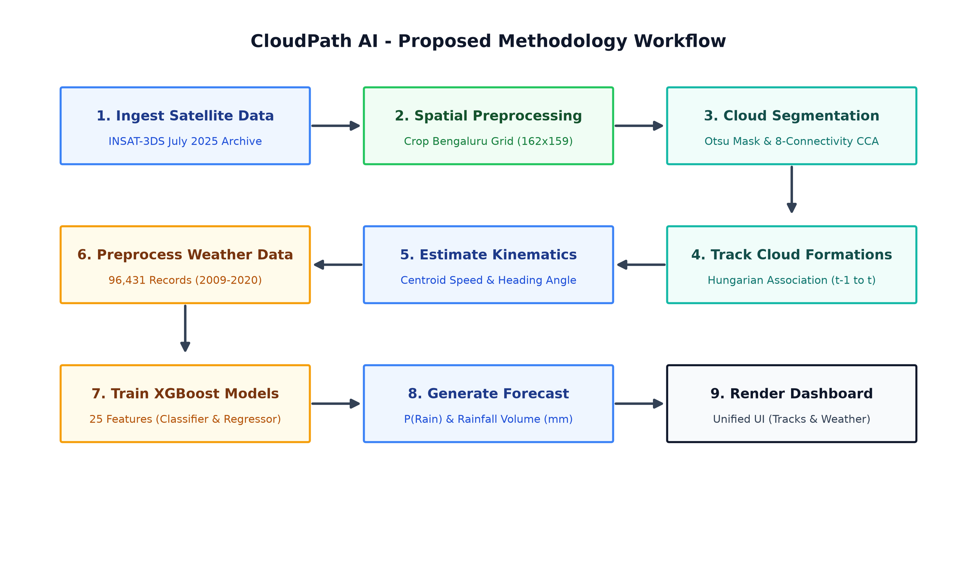
Figure 1: Proposed Methodology Workflow of CloudPath AI
6. PROPOSED SYSTEM:
The proposed CloudPath AI system architecture is composed of two independent but complementary modules presented through a unified operational dashboard interface. It is important to emphasize that both modules currently utilize separate, domain-specific datasets: the tracking module processes July 2025 satellite observations, while the rainfall prediction module operates on 2009–2020 surface weather data.
A. Satellite Cloud Movement Tracking Module:
This module processes spaceborne geostationary imagery to provide continuous visual and quantitative tracking of cloud formations. Its stepwise operational pipeline consists of:
• Satellite Image Ingestion: Ingests NetCDF-4 archives, extracting latitude, longitude, and cloud mask matrices.
• Cloud-Mask Extraction: Removes missing data codes and applies Otsu thresholding to separate cloud pixels from land surfaces.
• Cloud Formation Detection: Labels contiguous 8-connected regions, filtering out small transient noise (< 25 pixels / 400 km²), and calculates geometric centroids (x_bar, y_bar) and bounding boxes.
• Cloud Tracking Between Observations: Implements the Hungarian (Kuhn-Munkres) assignment algorithm on a distance-gated cost matrix, maintaining persistent cloud track IDs across successive 30-minute frames.
• Direction and Speed Estimation: Derives instantaneous velocity vectors (vx, vy), scalar speed (km/h), and compass heading (degrees azimuth).
• Cloud Coverage Visualization: Generates GeoJSON vector layers and heatmaps for timeline scrubbing on the web dashboard.
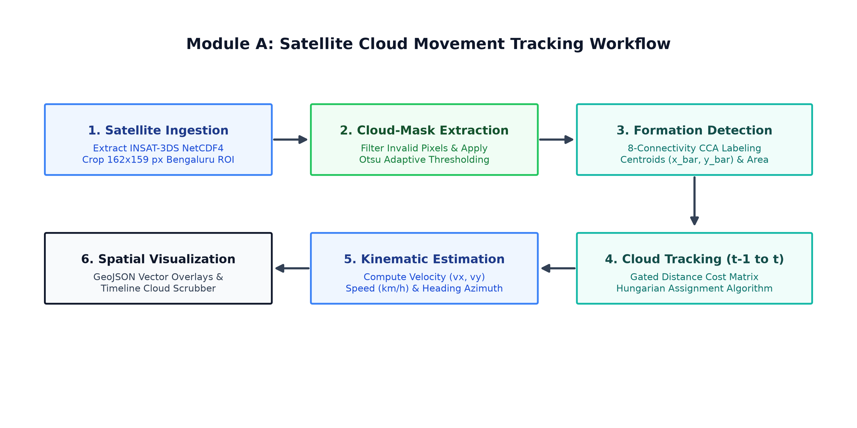
Figure 2: Satellite Cloud Movement Tracking Workflow
B. Machine Learning-Based Rainfall Prediction Module:
This module utilizes atmospheric surface telemetry to generate highly accurate, low-latency quantitative precipitation forecasts. To resolve the zero-inflation characteristic of rainfall (where >80% of hours have zero precipitation), a dual-stage hurdle architecture is used:
• Weather Data Preprocessing: Ingests hourly meteorological telemetry and formats a 25-dimensional feature vector encompassing temperature, dew point, relative humidity, barometric pressure, wind vectors, soil moisture, and solar radiation.
• Feature Extraction & Scaling: Extracts synoptic and diurnal cyclical features (month, hour) to capture atmospheric thermodynamic trends.
• Stage 1 (XGBoost Classification): Evaluates the feature vector to determine the probability of rain occurrence, P(Rain). If P(Rain) < 0.50, the state is classified as 'NO RAIN' and precipitation depth is set to 0.00 mm.
• Stage 2 (XGBoost Regression): If P(Rain) >= 0.50, the feature vector is passed to a tuned XGBoost Regressor trained exclusively on non-zero rain events to predict exact continuous rainfall depth in millimeters.
• Prediction Result Visualization: Transmits forecast status, rain probability, and predicted depth to the dashboard for instant display.
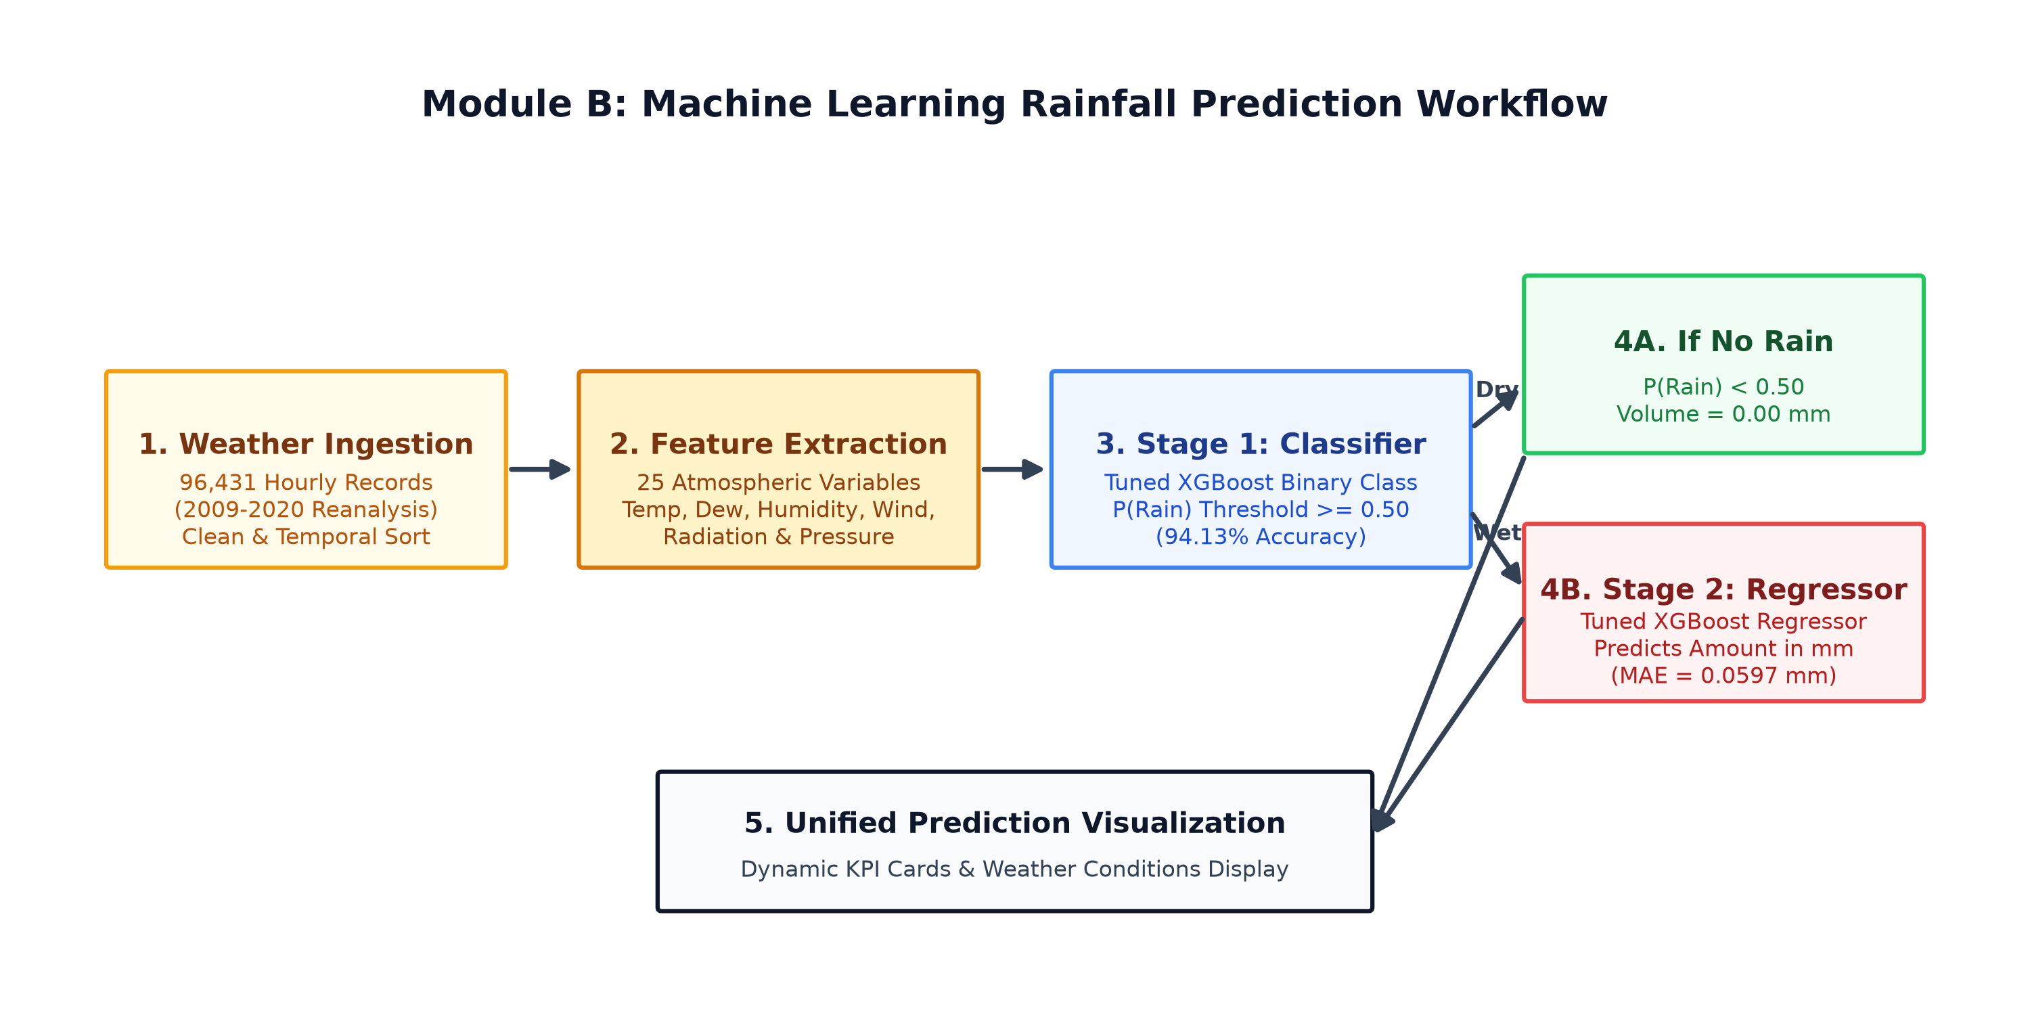
Figure 3: Machine Learning Rainfall Prediction Workflow
7. SYSTEM ARCHITECTURE:
The overall architecture of CloudPath AI connects data sources, analytical algorithms, and user-facing presentation layers into a clean, decoupled pipeline as illustrated in Figure 4.
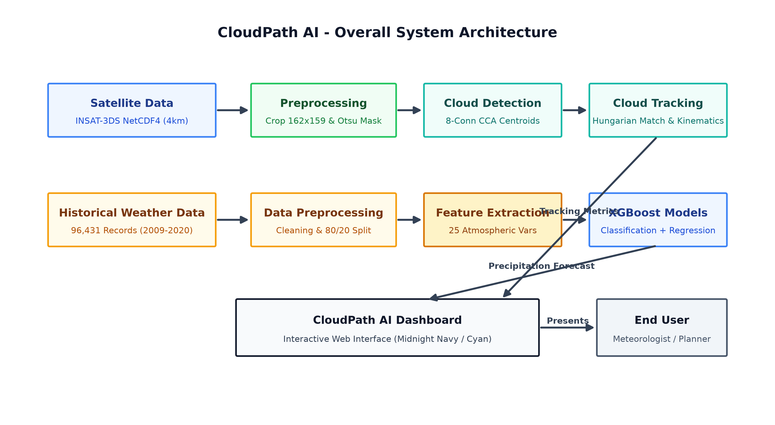
Figure 4: Overall System Architecture of CloudPath AI
Architecture Explanation:
As shown in Figure 4, the architecture comprises two parallel ingestion and processing pipelines converging into a unified presentation layer:
1. Satellite Data Pipeline (Top Branch): Raw INSAT-3DS NetCDF-4 imagery is retrieved, cropped to the Bengaluru 162 x 159 pixel domain, binarized via Otsu's method, and passed to 8-connectivity CCA. Centroids are associated across consecutive frames using the Hungarian algorithm to estimate speed and directional vectors, which are fed to the dashboard.
2. Weather Prediction Pipeline (Bottom Branch): Surface meteorological telemetry is ingested, cleaned, and transformed into a 25-feature atmospheric vector. The dual-stage XGBoost engine runs classification and regression to compute rain probability and precipitation depth, pushing the predictions to the dashboard.
3. CloudPath AI Dashboard & End User: The Flask-based web application synthesizes the tracking GeoJSON overlays and rainfall predictions, rendering an interactive, dark-themed operational interface for the meteorologist or urban planner.
8. REQUIREMENT SPECIFICATION:
8.1 Software Requirements:
The software components and development libraries utilized in CloudPath AI have been verified against the active codebase:
• Operating System: Microsoft Windows 10 / Windows 11 (64-bit).
• Database / Storage: No separate external database server (such as MySQL or MongoDB) is required. The system utilizes structured local file-based storage, including NetCDF-4 (.nc) archives, compressed NumPy binary arrays (.npz), CSV files, and serialized Joblib model binaries (.pkl/.joblib).
• Hosting: Local hosting via Python HTTP / Flask WSGI server (localhost, default port 8050).
• Client Browser: Google Chrome, Microsoft Edge, or any modern standards-compliant web browser.
• Code Behind: Python (version 3.10 or higher).
• Web Technologies: HTML5, CSS3, JavaScript, Tailwind CSS, Leaflet.js, and Plotly.js.
• Libraries & Tools: Pandas, NumPy, XGBoost, Scikit-learn, Matplotlib, SciPy, NetCDF4, OpenCV-Python, and Flask.
8.2 Hardware Requirements:
The computational hardware required to develop, process, and execute the CloudPath AI system is specified below:
• Processor (CPU): Intel Core i3 or above (Intel Core i5 / AMD Ryzen 5 recommended for faster NetCDF-4 decompression).
• System Memory (RAM): 8 GB minimum recommended to accommodate in-memory processing of multi-frame satellite image matrices.
• Storage (Hard Disk): Minimum 15 GB to 20 GB available storage space to store 31 daily INSAT-3DS satellite ZIP archives, extracted NetCDF-4 files, cached numpy matrices, and trained model weights.
• Network Interface: Standard Internet connection required only for initial dataset downloading and map tile streaming.
9. PLANNING:
The project development lifecycle for CloudPath AI was structured across eight sequential phases spanning the academic semester. Table 1 outlines the project planning stages and estimated durations:
Phase | Project Stage / Milestone | Estimated Duration | Key Deliverables
Phase 1 | Requirement Analysis | 3 Weeks | Problem formulation, feasibility study, literature review
Phase 2 | Data Collection | 3 Weeks | INSAT-3DS satellite archives (July 2025) & surface weather data (2009-2020)
Phase 3 | Data Preprocessing | 4 Weeks | NetCDF-4 sub-grid cropping (162x159), Otsu mask cleaning, weather feature vector scaling
Phase 4 | Model Development | 4 Weeks | Dual-stage XGBoost model training, hyperparameter tuning, holdout validation
Phase 5 | Satellite Cloud Tracking | 3 Weeks | 8-connectivity CCA implementation, Hungarian cost matrix gating, kinematic estimation
Phase 6 | Dashboard Development | 3 Weeks | Midnight Navy UI layout, interactive timeline scrubber, Leaflet map overlays
Phase 7 | Integration and Testing | 2 Weeks | Decoupled pipeline integration, REST endpoint verification, end-to-end testing
Phase 8 | Documentation & Submission | 2 Weeks | Project synopsis, final thesis report, viva presentation materials
Table 1: Project Planning Stages and Timeline Milestones
10. CONCLUSION & FUTURE SCOPE:
CloudPath AI successfully demonstrates the feasibility of combining satellite remote sensing image processing with machine learning for localized weather awareness. By analyzing 1,448 INSAT-3DS geostationary satellite frames over the Bengaluru Urban Region for July 2025, the system identifies discrete cloud formations and tracks their trajectories using the Hungarian algorithm, extracting objective speed and direction kinematics. Concurrently, a dual-stage tuned XGBoost model trained on 12 years of surface weather telemetry provides accurate next-hour rainfall probability and quantitative accumulation estimates. Unifying these capabilities in an interactive dashboard provides urban administrators and meteorologists with an effective decision-support tool.
Future Scope:
While the current implementation achieves its core objectives, future enhancements include:
• Real-Time Satellite Data Streaming: Connecting directly to automated MOSDAC / IMD API endpoints for real-time ingestion of newly captured satellite frames as they are downlinked.
• Multispectral & Radar Fusion: Incorporating INSAT-3DS Thermal Infrared brightness temperature differences (BTD) and ground Doppler radar reflectivity to improve convective storm intensity estimation.
• Synchronized Multimodal Dataset Training: Compiling temporally aligned satellite imagery and weather telemetry over multi-year periods to explore end-to-end deep multimodal learning.
• Mobile Application & Push Notifications: Developing a mobile alert client with geofenced push notifications to warn citizens of approaching rainstorms.
• Geographical Expansion: Extending the spatial domain and tracking algorithms to other flood-prone urban zones across India.
11. REFERENCES:
[1] T. Chen and C. Guestrin, 'XGBoost: A Scalable Tree Boosting System,' in Proceedings of the 22nd ACM SIGKDD International Conference on Knowledge Discovery and Data Mining (KDD '16), San Francisco, CA, USA, 2016, pp. 785–794.
[2] H. W. Kuhn, 'The Hungarian method for the assignment problem,' Naval Research Logistics Quarterly, vol. 2, no. 1‐2, pp. 83–97, Mar. 1955.
[3] N. Otsu, 'A threshold selection method from gray-level histograms,' IEEE Transactions on Systems, Man, and Cybernetics, vol. 9, no. 1, pp. 62–66, Jan. 1979.
[4] Indian Space Research Organisation (ISRO), 'INSAT-3DS Meteorological Satellite Mission Overview and Sensor Payloads,' Meteorological and Oceanographic Satellite Data Archival Centre (MOSDAC), Tech. Rep., 2024. [Online]. Available: https://www.mosdac.gov.in.
[5] India Meteorological Department (IMD), 'Standard Operating Procedure for Weather Forecasting and Nowcasting Services,' Ministry of Earth Sciences, Government of India, Tech. Rep., 2021. [Online]. Available: https://mausam.imd.gov.in.
[6] F. Pedregosa et al., 'Scikit-learn: Machine Learning in Python,' Journal of Machine Learning Research, vol. 12, pp. 2825–2830, Nov. 2011.
[7] Python Software Foundation, 'Python Language Reference and Standard Library Documentation (Version 3.10),' 2023. [Online]. Available: https://www.python.org/doc/.
[8] Open-Meteo, 'Historical Weather API and Meteorological Reanalysis Documentation,' 2023. [Online]. Available: https://open-meteo.com/en/docs/historical-weather-api.

