**Objective-wise Results** :

1. To implement image pre-processing for the input images.

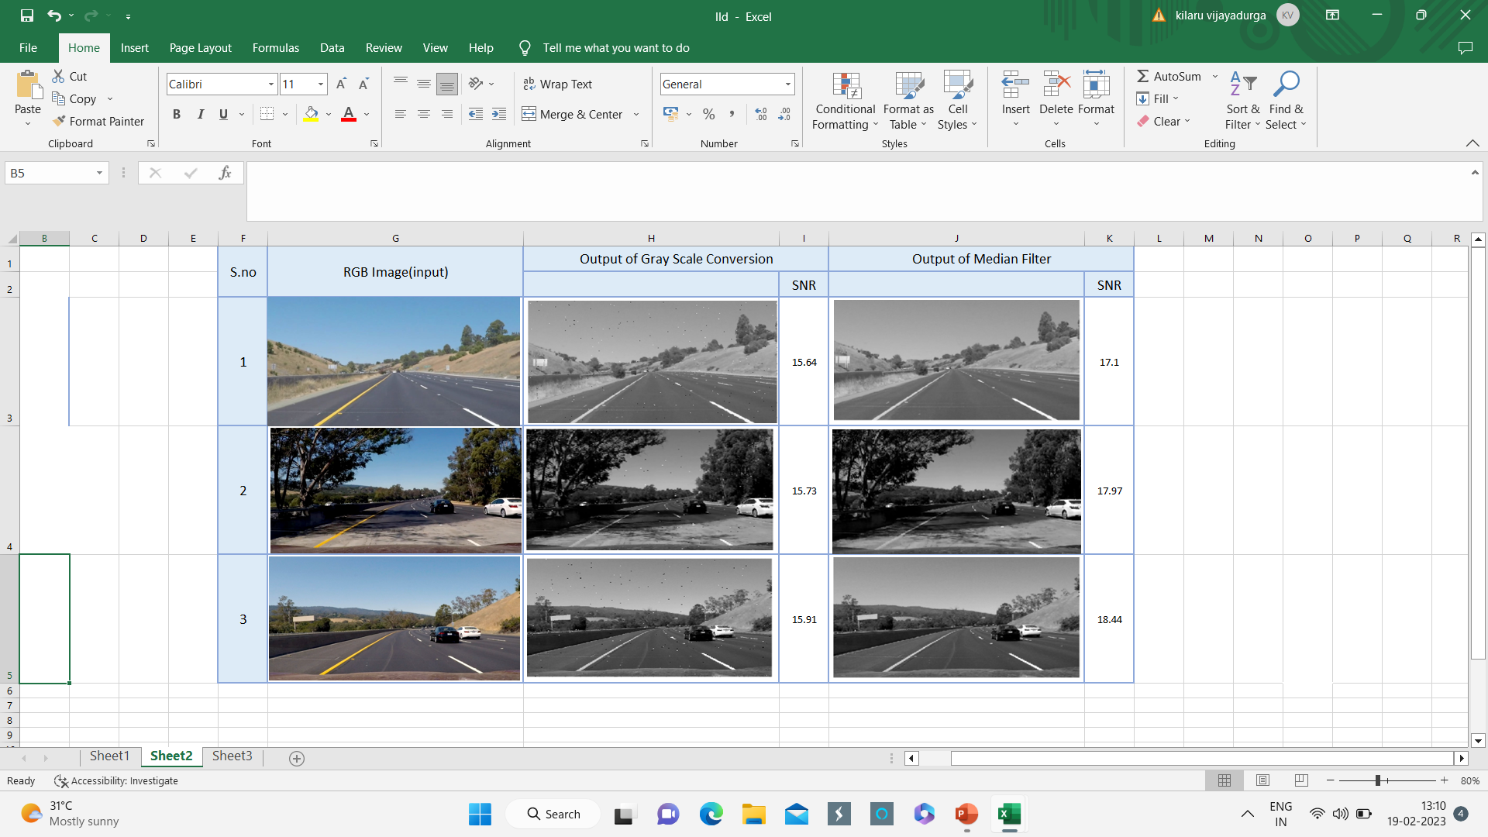

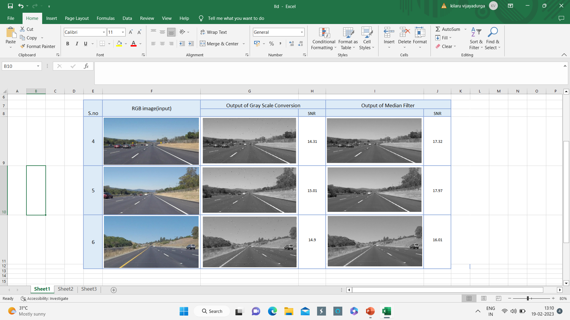

1. To implement image segmentation for the pre-processed images.
2. To detect lane lines on the input image using CNN.

