BVRIT HYDERABAD College of Engineering for Women
Comprehensive Knowledge Base — Source: bvrithyderabad.edu.in
Compiled for RAG chatbot grounding and general reference. Organized by section headings for chunking. Image locations are referenced with hyperlinks to the original site rather than embedded, since this document was generated in an automated environment without image-download access to this host.
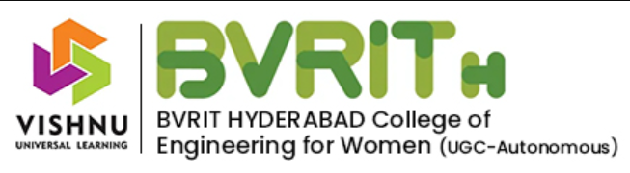

1. About BVRITH
BVRIT HYDERABAD College of Engineering for Women (BVRITH) is an autonomous engineering college established in 2012, the youngest institution under the Sri Vishnu Educational Society (SVES), founded by Chairman Sri K V Vishnu Raju.
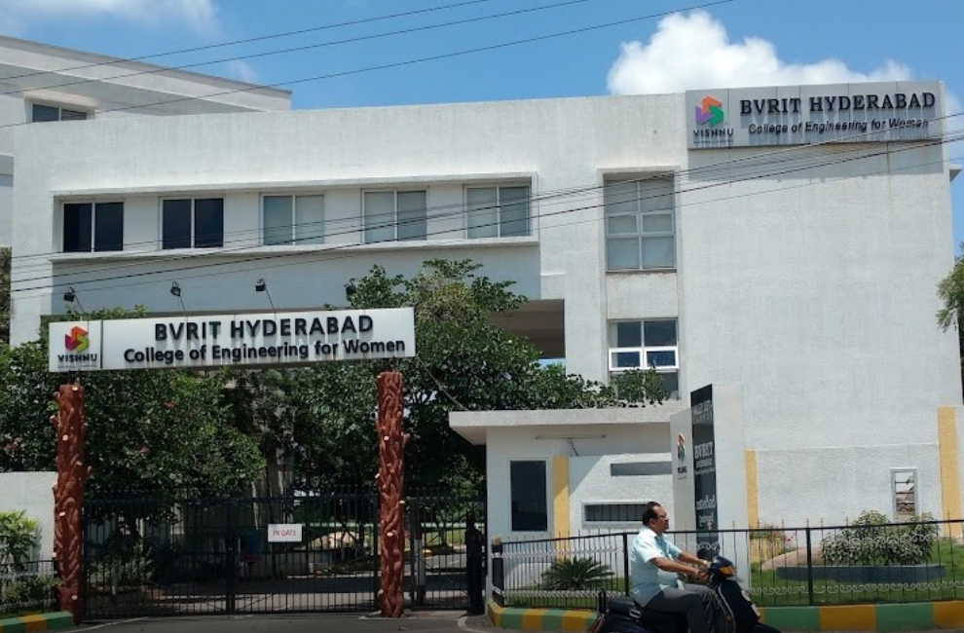
The college was accredited by NAAC with Grade 'A' (CGPA 3.23) in 2020, and granted UGC Autonomous status from Academic Year 2023-24 for a period of 10 years. It is approved by the All India Council for Technical Education (AICTE), recognized by the Government of Telangana, and affiliated to Jawaharlal Nehru Technological University Hyderabad (JNTUH).
BVRITH offers 4 UG programs (B.Tech in EEE, ECE, CSE, and CSE with Artificial Intelligence & Machine Learning) with a combined intake of 660 seats, and 3 PG programs: M.Tech in Data Sciences (intake 18), M.Tech in VLSI Design (intake 12), and M.Tech in CSE (intake 12). A Ph.D programme in VLSI-Communications (ECE) begins Academic Year 2026-27, alongside the existing CSE Ph.D research centre.

Accreditations & Rankings
- NAAC: Grade 'A' (CGPA 3.23), awarded 2020
- NBA: CSE, ECE, and EEE branches are NBA-accredited (first accredited 2018; ECE's accreditation renewed 2025-26 for a further 3 years)
- UGC Autonomous status conferred from AY 2023-24 for 10 years
- Ranked by NIRF for three consecutive years: 2019, 2020, and 2021 (147th rank in NIRF 2019)
- Ranked by ARIIA-2020 in Band B (26th to 50th)
- Recognized by AICTE for its Best Practices

National-Level Recognitions
- IMC Ramakrishna Bajaj National Quality Award — Education Category
- Deewang Mehtha Education Leadership Award (by IPE)
- Learning Innovation Award (by TalentSprint)
- Top 20 Performing Colleges Award (by IBM, for TGMC)
- Best Emerging College in Telangana 2018 (by Stumag)

Notable Achievements
- Entered the Asia Book of Records (7 March 2018) for the largest Mental Health Peer Counseling event for Women.
- First college to initiate mentorship programs with top MNCs including Microsoft, Amazon, and Qualcomm.
- Two JNTUH University Gold Medals across the first three graduating batches.
- Highest placement package on record: Microsoft, Rs. 54 LPA (2021-2025 batch).

Vision
To emerge as the best among the institutes of technology and research in the country dedicated to the cause of promoting quality technical education.

Mission
- Achieve academic excellence through innovative learning practices.
- Enhance intellectual ability and technical competency for a successful career.
- Encourage research and innovation.
- Nurture students towards holistic development with emphasis on leadership skills, life skills, and human values.

Core Values
- Holistic development — sports, social service, cultural clubs, internships and mentorships alongside academics.
- Excellence in Education — student-centric, outcome-based learning; faculty trained in scientific educational practices.
- Women empowerment — 'Educate a woman and you educate a family.'
- Integrity — ethical practice, fairness to staff, students and stakeholders.
- Social responsibility — contribution to the immediate neighborhood beyond the campus.
- Accountability and Transparency — across all levels of the organisation.
- Freedom of Expression — open exchange of opinions and suggestions.

Campus Group — Sri Vishnu Educational Society (SVES)
BVRITH is one of several institutions under SVES, organized across four campus clusters:

Green Meadows
- Shri Vishnu Engineering College for Women
- Vishnu Institute of Technology
- Smt. B Seetha Polytechnic College
- Vishnu Dental College & Hospital
- Shri Vishnu College of Pharmacy
- B.V. Raju Institute of Computer Education
- Vishnu School, Bhimavaram

Orchard Park
- B V Raju Institute of Technology (BVRIT)
- Vishnu Institute of Pharmaceutical Education and Research
- Vishnu High School, Narsapur

Valley Vista
- BVRIT Hyderabad College of Engineering for Women (this institution)

Lake View
- Vishnu Educational Development and Innovation Centre (VEDIC)

2. Management & Leadership

Founder Chairman
Late Padma Bhushan Dr. B.V. Raju founded the Dr. B.V. Raju Foundation and the institutions that grew into Sri Vishnu Educational Society. Starting as a low-grade cement industry employee, he rose to Managing Director and Chairman of Cement Corporation of India, later founding the Raasi Group of Industries (Sri Vishnu Cements, Raasi Refractories, Raasi Ceramics, Raasi Finance and Investments). He received the Padma Bhushan and an Honorary Doctorate from JNTU Hyderabad, and redirected his focus to education, establishing colleges across Narsapur and Bhimavaram.

Chairman
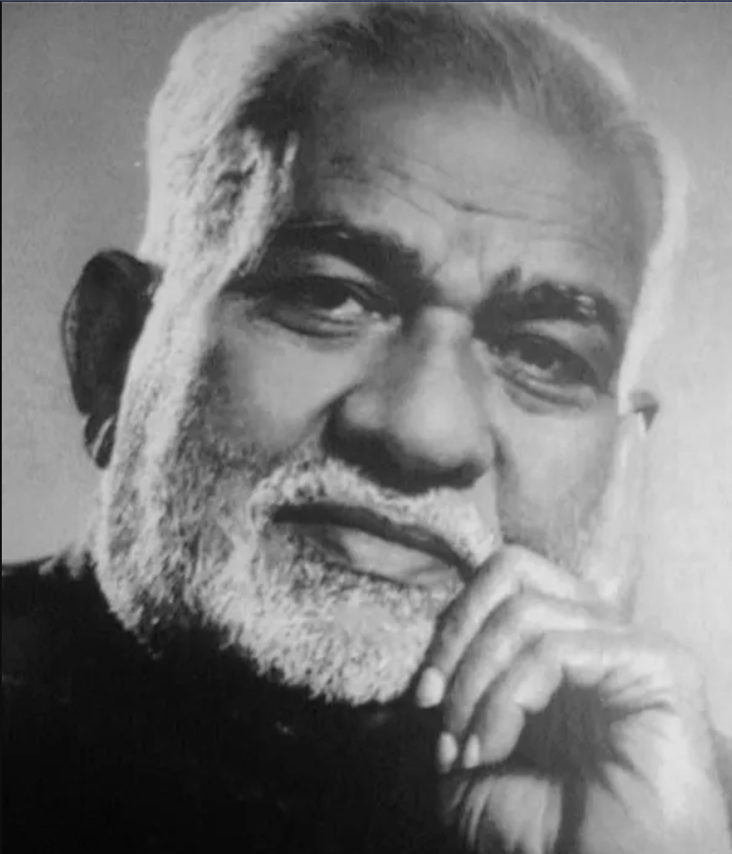
Sri K V Vishnu Raju took over as Chairman of SVES in 2002 after the founder's demise. An alumnus of REC Trichy and Michigan Technological University (USA), he worked as a Chemical Engineer at DuPont before returning to lead SVES's expansion into internationally-oriented engineering, medical, pharmacy, business management, and K-12 education.

Vice Chairman

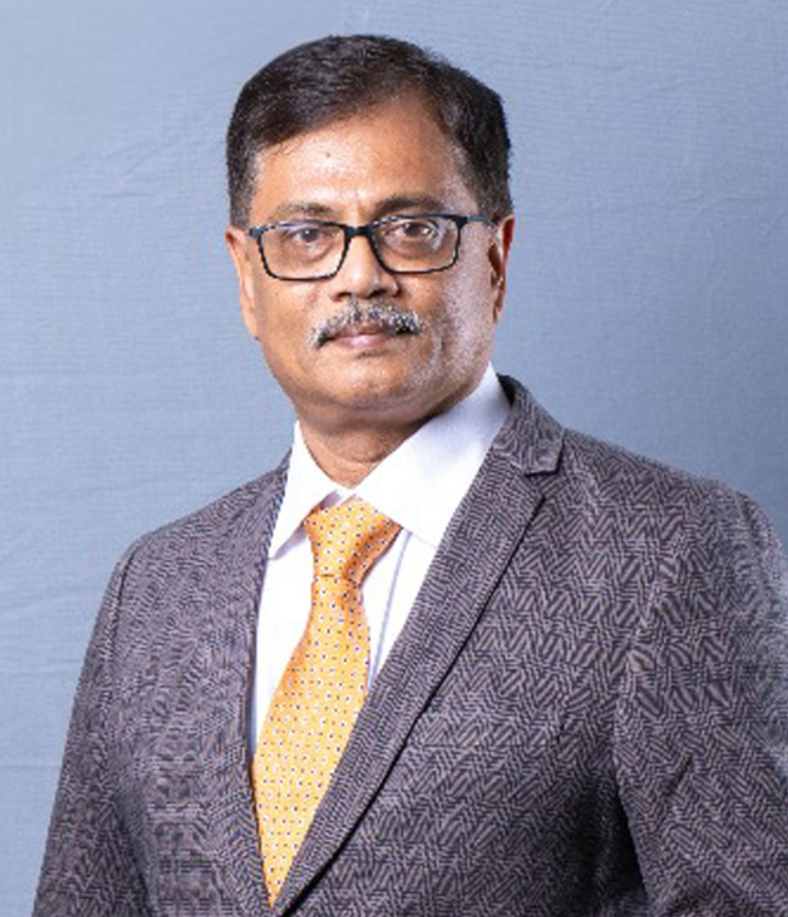

Sri Ravichandran Rajagopal holds a Mechanical Engineering degree from NIT Tiruchirapalli and a postgraduate management degree from IIM Calcutta. He began his career at Novartis India across Business Development, Product Development, and Vendor Development roles.

Secretary
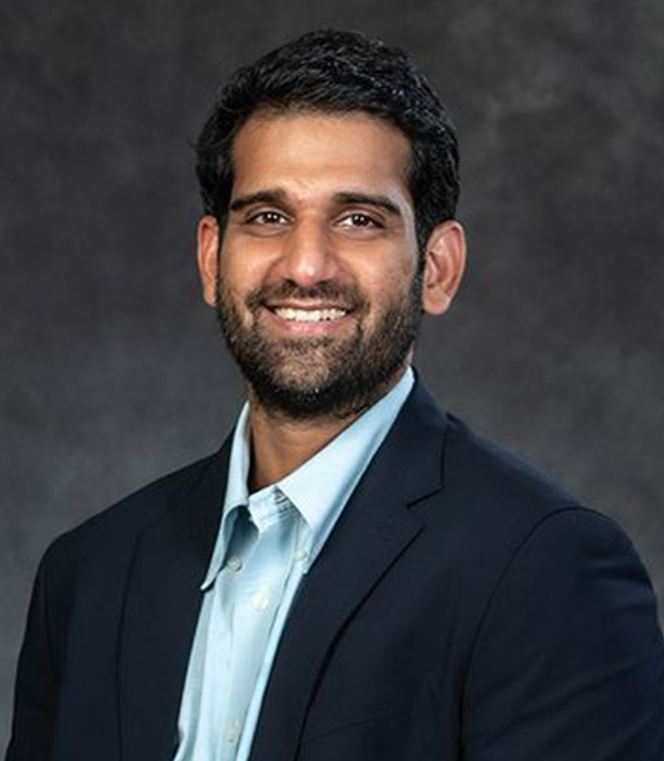
Sri Aditya Vissam is Secretary of SVES and its youngest management team member. An Industrial Engineering graduate from Penn State University (USA) with an MBA from Imperial College London, he previously worked at Office Depot (Minneapolis) and as Operations Manager at Amazon (London). He coordinates closely with VEDIC on teaching pedagogy and continuous assessment innovation.

Joint Secretary
Sri K. Sai Sumant (Kalidindi Sai Sumant) serves as Executive Director at Anjani Tiles Limited. He holds a Bachelor's in Materials Science and Engineering from Penn State University and an MBA from UC Irvine, and previously worked as an R&D Engineer at Glidewell Dental, USA, where he is listed as an inventor on a US patent.

Principal
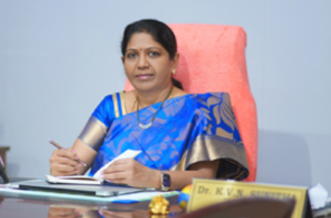
Dr. K.V.N. Sunitha has served as Founder Principal of BVRITH since August 2012. She completed her B.Tech in ECE (ANU), M.Tech in CS (REC Warangal, 1993) and Ph.D in CSE (JNTU Hyderabad, 2006), with 30+ years of teaching and 15+ years of research experience. She has guided 20 Ph.D scholars, authored 5 textbooks, and published 150+ papers, holding 7 patents. Her research areas include Natural Language Processing, Speech Processing, and Network & Web Security.
Awards include: Academic Excellence Award (2005), Best CSE Teacher Award by ISTE (2008), Distinguished Principal Award by CSI Mumbai at IIT Bombay (2017), Deewang Mehtha Women in Education Award (2017), Engineer of the Year Award by IEI Telangana (2019), Acharya Ratna National Award (2019), and Best Engineering College Principal in Telangana Award by ISTE (2019).

3. Departments

Computer Science and Engineering (CSE)
Established 2012. Intake grew from 60 (2012-13) to 120 (2014-15) to 180 (2019-20) to 360 (2024-25). NBA-accredited (2018-19, extended to 2021-22). Faculty strength: 49 (7 Professors, 6 Associate Professors, 36 Assistant Professors), plus Adjunct Faculty from industry. Domains include Machine Learning, Computer Networks, Data Mining, Image Processing, Cloud Computing, Blockchain, Deep Learning, and AI.
- Vision: Develop women as technocrats, researchers and entrepreneurs in computer science and engineering.
- Sample courses: Machine Learning, AI, Data Mining, Cloud Computing, Software Engineering, Data Analytics, Cyber Security, Advanced Computer Architecture, NLP.
- Department clubs/chapters: ACM Student Chapter, CSI Student Branch, TechBlitz.
- Notable recruiters for CSE graduates: Microsoft, Amazon, Flipkart, MuSigma, Xerox, Adobe, SAP Labs. Alumni also pursue higher studies at UT Austin, Purdue, University of Utah.

CSE — Artificial Intelligence & Machine Learning (AI&ML / CSM)
Established 2020 with an intake of 60; increased to 120 from AY 2025-26. Current strength ~180 students across 3 active years. Faculty: 28 (5 Professors, 5 Associate Professors, 18 Assistant Professors).
- Vision: Produce competent technocrats, researchers and entrepreneurs in AI & ML.
- Focus areas: neural networks, NLP, robotics, deep learning, computer vision, generative AI.
- AIML students have interned at Amazon, Microsoft, Optum, PwC, and Hexagon, and completed courses via Simplilearn, TalentSprint, Coursera, and LinkedIn Learning.

Electronics and Communication Engineering (ECE)
Established 2012 with intake 60, increased to 120 from AY 2014-15. M.Tech in VLSI Design launched AY 2024-25; Ph.D programme (VLSI-Communications) begins AY 2026-27. First NBA accreditation 2018-19, most recently renewed 2025-26 for 3 years.
- Three University Gold Medals: T Ravali (2013-17) and Ch Sowmya (2018-22, two medals).
- Achievements: 3rd Best IETE Student Branch Award (2013); Mathworks Academic Credentialing Award (3 consecutive years 2021-24); ~Rs. 59.87 lakh in funded projects from DST-TIDE, DST-SERB, TEQIP III-JNTUH, and Microsoft; 1 patent grant (portable medicine identification/alerting system for visually challenged and geriatric users); 4 faculty/alumni/student start-ups; 3 MSME-funded projects (Rs. 15 lakh each).
- Special labs: Assistive Technology Lab, IoT Maker Space Lab, Drone Technology Lab.
- Industry collaborations: Qualcomm (5G certifications), Synopsys (SARA), MathWorks, Pi Square Technologies, HCL Career Shaper, Manjeera Digital Systems.
- Dr Vasu Babu, Professor, ranked in the World's Top 2% Scientists list (Elsevier/Stanford, 2024) for ICT/Networking.

Electrical and Electronics Engineering (EEE)
Established 2012 with intake 60. NBA-accredited 2018-19 for 3 years. Headed by Dr. B. Srinivasa Rao (senior member IEEE, FIE, LMISTE).
- Ms. D Sowmya (2014-18 batch) received a JNTUH Gold Medal (85.2% aggregate) at the VIII Convocation, 24 April 2019.
- Two DST-funded projects worth ~Rs. 86 lakh: 'D-SIDES' (solar energy integration with distributed storage) and a Remote Diagnosis IoT system for assisted living.
- 34 KWp Grid-Tied Rooftop Solar PV plant inaugurated 16 December 2018 by the Chairman and Vice-Chairman.
- Recruiters: Robert Bosch, Latent View, TCS, Wipro, Capgemini, Ashok Leyland, Mahindra & Mahindra.
- Industrial visit/internship partners: BHEL, DRDO, NTPC, TSGenco, TS Transco, Mitsubishi, HBL, Toshiba Electricals, Premier Energies, Coca-Cola.

Information Technology (IT)
Launched 2012 with B.Tech intake 60 (raised to 120 from 2019); the linked M.Tech (Data Sciences) intake is 18, offered from 2020. Note: per the current UG intake list, IT is not part of the active 2024/2025 admission batches, though the department and its historical programme remain listed on the site.
- Vision: Emerge as a center of excellence in IT, producing women technocrats and global leaders.
- Facilities: well-equipped classrooms and computer labs with LAN & Wi-Fi; Centre of Excellence status in Data Science.

Basic Sciences and Humanities (BS&H)
Supports foundational first-year coursework (mathematics, physics, chemistry, English, and engineering fundamentals) across all B.Tech branches; not a degree-granting department in its own right.

Honor Degree Program
An additional Honor Degree track is offered alongside the standard B.Tech curriculum for students seeking extra academic depth (listed under Departments on the site; detailed structure not published in a single consolidated page).

Postgraduate & Doctoral Programs (summary)
Program | Intake | Started
M.Tech — Data Sciences | 18 | 2020
M.Tech — Computer Science and Engineering | 12 | —
M.Tech — VLSI Design (ECE) | 12 | 2024-25
Ph.D — ECE (VLSI-Communications) | — | 2026-27
Ph.D — CSE | — | —

4. Admissions

Eligibility
- 10+2 with MPC (Mathematics, Physics, Chemistry) as major subjects.
- Minimum 60% marks.
- Selection per TS EAMCET (Telangana State Engineering, Agriculture and Medical Common Entrance Test) criteria.

Entrance Exams & Seat Categories
Category A seats are filled by the Convener, TS EAMCET Admissions. Category B seats are filled directly by the college per Telangana State Council of Higher Education (TSCHE) guidelines. College codes: EAMCET/ECET code BVRW; PGECET code BVRW1.

Admission Process
- Applications open after TSEAMCET's notification for Convener seats, and after TSCHE's notification for B-category seats.
- Category A applications: online through the TSEAMCET Convener portal.
- Category B applications: online through the college website.
- A full admissions schedule is published each cycle by TSCHE.
Admissions contact: Dr J. Manoj Kumar, Professor i/c Admissions — 92471 64714.

5. Fee Structure
Tuition fees are listed per admitted batch year, in Indian Rupees (INR) per year.

2025 Batch
Branch | Tuition Fee | NBA Fee | JNTUH / Misc. Fee
CSE | 120000 | 3000 | 5500
ECE | 120000 | 3000 | 5500
EEE | 120000 | 3000 | 5500
CSM (CSE-AI&ML) | 120000 | — | 5500

2024 Batch
Branch | Tuition Fee | NBA Fee | JNTUH / Misc. Fee
CSE | 120000 | 3000 | 5500
ECE | 120000 | 3000 | 5500
EEE | 120000 | 3000 | 5500
CSM (CSE-AI&ML) | 120000 | — | 5500

2023 Batch
Branch | Tuition Fee | NBA Fee | JNTUH / Misc. Fee
CSE | 120000 | 3000 | 5500
ECE | 120000 | 3000 | 5500
IT | 120000 | 3000 | 5500
EEE | 120000 | 3000 | 5500
CSM (CSE-AI&ML) | 120000 | — | 5500

2022 Batch
Branch | Tuition Fee | NBA Fee | JNTUH / Misc. Fee
CSE | 120000 | 3000 | 2500
ECE | 120000 | 3000 | 2500
IT | 120000 | 3000 | 2500
EEE | 120000 | 3000 | 2500
CSM (CSE-AI&ML) | 120000 | — | 2500

2021 and 2020 Batches
Both years share identical fee structures: Tuition Fee Rs. 90,000, NBA Fee Rs. 3,000, JNTUH/Misc. Fee Rs. 5,500 across CSE, ECE, IT, EEE, and CSM (CSE-AI&ML).

Other Fees & Scholarships
Detailed hostel, mess, and transportation fee schedules are handled directly through the Admissions and Hostel offices and are not published as a fixed public table. The college participates in the PM Vidyalaxmi Scheme, a central-government education loan/scholarship scheme.

6. Placements
BVRITH publishes detailed year-by-year, company-by-company placement records dating back to the 2012-2016 graduating batch as downloadable batch reports.

Highlights by Batch
Batch | Highest Package | Total Placed
2021-2025 | Microsoft — Rs. 54.00 LPA | 614
2020-2024 | Microsoft Rs. 52 LPA / Amazon SDE Rs. 48.6 LPA | 508
2019-2023 | Palo Alto Networks — Rs. 54.75 LPA | 694
2018-2022 | — | 988

Frequent / Top Recruiters
Microsoft, Amazon, Adobe, Qualcomm, Synopsys, Optum, Visa, IBM, Oracle, Dell, State Street, PwC, Bank of America, Capgemini, Cognizant, TCS, Tech Mahindra, Infosys, Wipro, Accenture, Genpact, KPIT, UST, OpenText, Athena Health, DE Shaw, Flipkart, Walmart, Target, Intel, AMD, Virtusa, VMware, Goldman Sachs, JP Morgan Chase, DBS.

Training & Placement Team
- Sri. S. Jagapathi Reddy — Manager, Placements
- Sri. K. Mahesh Babu — Assistant Manager, Placements
Full company-wise, branch-wise breakdowns for each graduating batch (2012-2016 through 2021-2025) are published as downloadable PDF reports on the college placements page. The site also separately notes a recent highlight: 4 students placed by 5 companies in one cycle, with the highest package a reported Rs. 44 LPA — figures should be read as batch/cycle-specific and cross-checked against the current placements page for the year in question, since different pages on the site report different 'highest package' figures depending on when they were last updated.

7. Campus & Facilities

Library
Housed in the four-storey Ruby Block. Holds textbooks, reference books, novels, encyclopaedias, magazines, and national/international journals.
- Hours: 9:00 AM – 6:00 PM (Issue & Return counter 10:00 AM – 5:00 PM).
- Member of DELNET and the National Digital Library of India (NDLI); catalogued via Dewey Decimal Classification.
- Digital library: 10 internet-connected computers, NPTEL video lectures, online mock tests.
- E-journal access via IEEE-ASPP and J-GATE (JET) through the KNIMBUS mLibrary platform (including mobile access).
- Plagiarism checking via iThenticate (Turnitin) for staff/student publications and final-year projects.
- Floors: Ground — digital library, periodicals, newspapers; 1st — CSE/IT/BS&H stacks; 2nd — ECE/EEE stacks; 3rd — reference, project reports, activity area.
- Literary club 'PORTIA: The Literary Coven' runs through the library; rare book collection dating from 1919.
Staff: Dr. S. Satya Jaya (Librarian, M.Com, M.L.I.Sc, PhD); Y. Renuka, G. Krishnaveni, G. Urmilasree (Library Assistants).

Hostel
On-campus hostel with 4 blocks, 150+ rooms, 500+ resident capacity.
- Lady wardens and dedicated security officers per block; 100% ragging-free with an active anti-ragging squad.
- Full-time lady physical director organizes volleyball, badminton, throw-ball, and fitness activities.
- Amenities: 24/7 water supply, geysers, common room, gym access, entertainment/TV, fresh-choice bakery, fast-food center.

Gym
An on-campus gym / fitness centre is available to students under the guidance of an experienced instructor, described on the site as supporting complete physical, mental and social well-being.

Other Campus Facilities
- Food and Cafeteria
- Temple (on-campus)
- Security
- PCS (Placement/Career Services) Facilities
These facility pages exist on the site but publish only brief descriptive taglines rather than detailed operational specifics (seating capacity, exact timings, etc.).

8. Research & Development
R&D activity is organized under a central Research & Development section covering: faculty thrust areas, Ph.D awards, publications, research and consultancy projects, funded FDPs/conferences, patents (filed and granted), an R&D Incentive Policy, an R&D Center, Centres of Excellence (CoEs), a Research Advisory Committee, Research Ethics Committee, IPR Committee, and Seed Funding scheme. Faculty research profiles are also indexed via IRINS (Indian Research Information Network System).
- Ph.D Research Centres: ECE (VLSI-Communications, from AY 2026-27) and CSE.
- Plagiarism screening tool available centrally for research and academic writing.

9. Student Life — Clubs, Chapters & Differentiators

Community & Outreach Clubs
- NSS Unit ('BVRITH For the People'), Rotaract Club, Nature Club, Samskrithi Foundation, Voice4Girls, Women Safety Club.

Language & Literary Clubs
- Toastmasters Club, Meraki (Language Club), Foreign Language (German & French), Literary Club, Wall Magazine 'Magnum Opus', Artistry Club.

Cultural & Media Clubs
- Saarang (cultural club), Vishnu Institute of Film Music (Guitar), JASHN (Film & Media Club).

Wellness Clubs
- Cope BVRITH, Yoga, Bhagvad Gita Club, Sports Club.

Technical Clubs & Professional Chapters
- Department clubs: DEEPTHA (EEE), Electro Elitz (ECE), TechBlitz (CSE), SWE.
- Professional bodies: CSI, ISTE, IETE, IEEE, IEI, ACM, FOSS Club.

Differentiator Programs
- Vishnu Japan Outreach Centre (VJOC); VEDIC (pedagogy innovation centre); VSSC (Vishnu Student Success Center).
- Counselling by a professional psychologist; WISE (Women in Software Engineering); ATL (Assistive Technology Lab).
- GSAC (Graduate Study Abroad Center); IoT Maker Space; Drone Technology Laboratory.
- IIC BVRITH (Institution's Innovation Council); EDC (Entrepreneurship Development Cell); SDG initiatives; NASSCOM partnership; Student Affairs Council (SAC).

10. Governance & Approvals

Governance Bodies
- Governing Body, College Academic Council, College Academic Committee, Finance Committee, Examination Committee, IQAC.
- Statutory/welfare committees: Disciplinary Committee, SC & ST Committee, Sexual Harassment Committee, Ombudsperson, Anti-Ragging Committee, Grievance Redressal Committee, Internal Complaints Committee, Institution-Industry Cell.

Regulatory Approvals
- UGC Autonomous status and JNTUH Autonomous Conferment.
- JNTUH affiliation orders (current through AY 2025-26); AICTE Extension of Approval (EOA, current through AY 2025-26).
- NBA accreditation (current cycle 2025-28).
- NAAC: AQAR reports published for 2019-20 through 2022-23; NAAC Certificate on file.
- Other listings: Unnath Bharat Abhiyan (UBA), ARIIA, AISHE, NIRF participation, and National Innovation and Startup Policy (NISP) documentation.

11. Contact

BVRIT HYDERABAD College of Engineering for Women
Address: Plot No. 8-5/4, Rajiv Gandhi Nagar Colony, Nizampet Rd, Bachupally, Hyderabad – 500090
Phone: +91 40 4241 7773
Email: info@bvrithyderabad.edu.in | principal@bvrithyderabad.edu.in
Admissions contact: Dr J. Manoj Kumar (Professor i/c Admissions), 92471 64714

Social Media
- LinkedIn: linkedin.com/school/bvrit-hyderabad
- Instagram: instagram.com/bvrit_hyderabad_
- YouTube: youtube.com/@BvritHyderabadWomen
- Facebook: facebook.com/BvritHyderabad
- X (Twitter): x.com/bvrithyderabad

Parent Society
Sri Vishnu Educational Society (SVES) — Anjani Vishnu Centre, Plot No. 7 & 8, Ist Floor, Nagarjuna Hills, Punjagutta, Hyderabad – 500 082. Phone/Fax: +91 40 4033 4848.

Website
https://bvrithyderabad.edu.in/

