**04/03/2025**

**GIT Commands**

1. **git --version:** It is used know the version of git

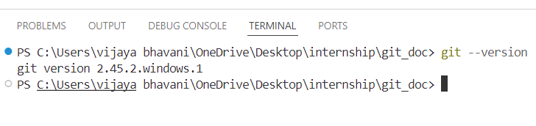

1. **git config --global –list :** list the author details

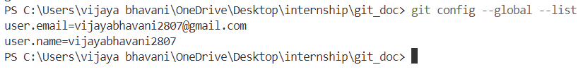

**git config --global user.name “username”**

**git config --global user.email “mail id”**

to set the author name and email

1. **git init:** used to create the empty repository or start the new repository 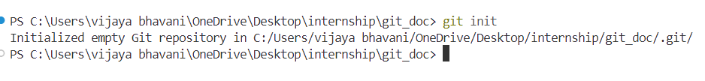
2. **git add <file_name>:** used to add the file to the staging area
3. **git add file1 file2 :** used to add the multiple files
4. **git add --all:** used to add all files in directory



1. **git status:** shows changes in working directory

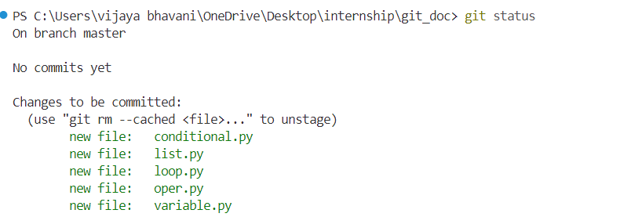

1. **git commit -m “message”:** used to record the changes permanently in the version history

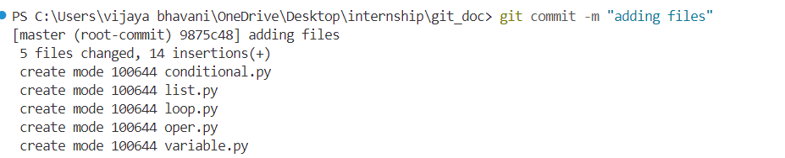

1. **git remote add origin url**: used to connect local repository to remote repository
2. **git push** -u origin master: used to upload changes in git hub

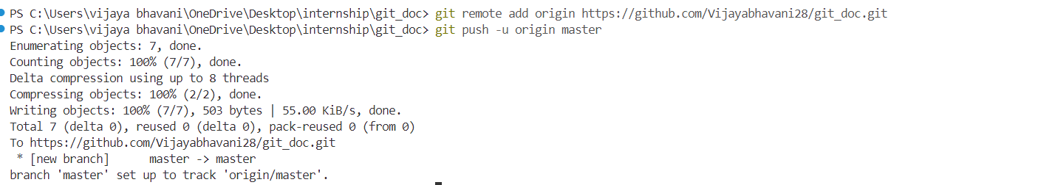

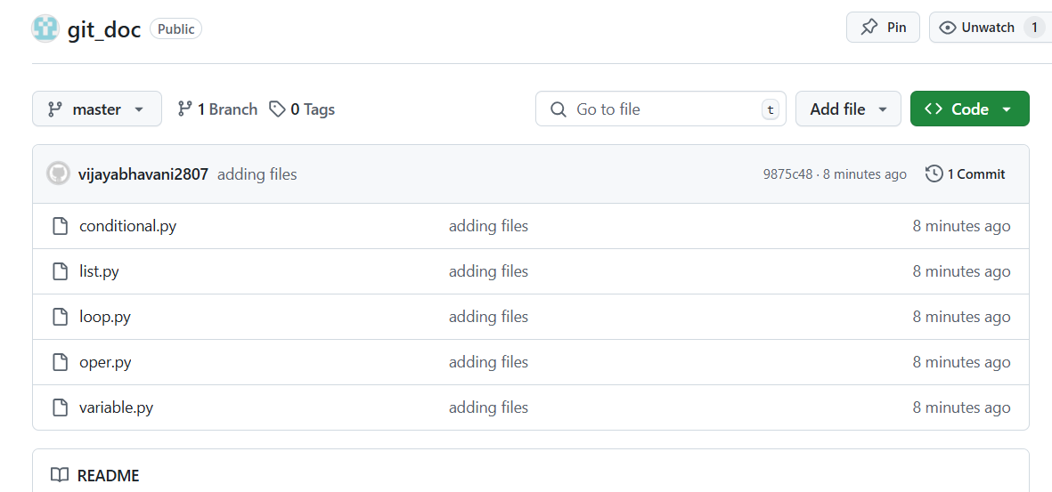

1. **git rm <file_name>:** remove the file from git repository and working directory
2. **git rm –cached <file_name> :** remove the file from git repository but is available in the working directory

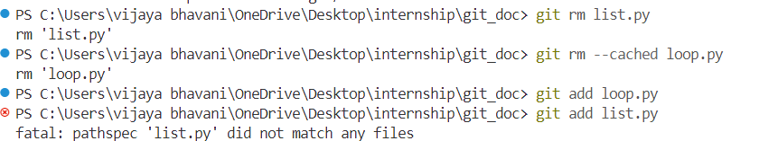

1. **git reset <file_name>:** used to unstages the file

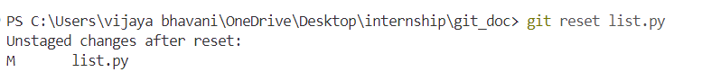

1. **git log:** list the versions history for the current branch

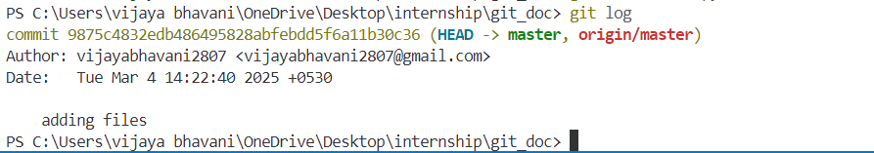

1. **git reset --hard[commit]:** this command discards all the history and goes back to the specified commit



1. **git reset commit:** Command undoes all the commits after the specified commit and preserve the changes locally

**Branch:**

1. **git branch:** lists all the local branches in the current repository



1. **git branch <branch name>:** creates a new branch

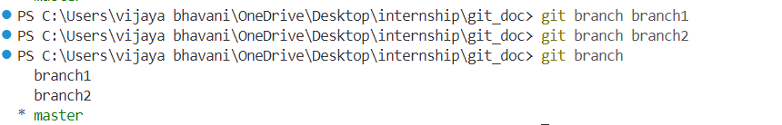

1. **git checkout <branch_name>:** switch the one branch to another branch



1. **git checkout -b <branch_name>:** create a new branch and switch to it



1. **git branch -d <branch_name>:** delete a branch



**Stash:**

1. **git stash save:** temporarily stores the all modified tracked files
2. **git stash list:** lists all the stashed changesets
3. **git stash pop:** restores the most recently stashed files

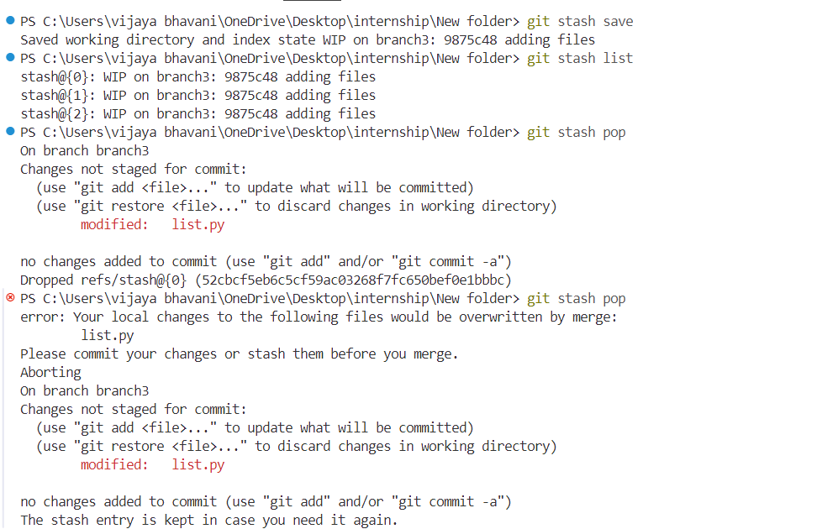

1. **git stash drop :** discards recently stashed changeset



**Diff:**

1. **git diff:** shows the file differences which are not yet staged

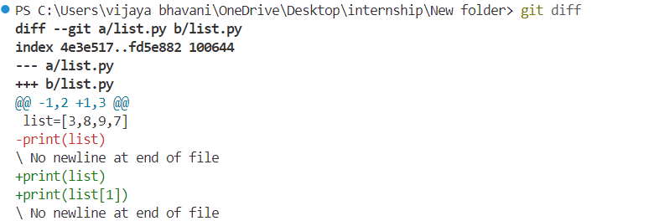

**git pull origin <branch_name>:** used to fetch and merge changes on the remote server to working directory

