**06/03/2025**

**Linux commands**

**sudo su :** to navigate user@ip to root@ip

**su user_name :**This command is used to switch one user to another user

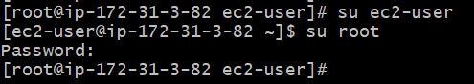

**sudo:** sudo is commonly used to run a command as root.

Sudo is used to start a shell as root

**man**: man is the systems manual pager

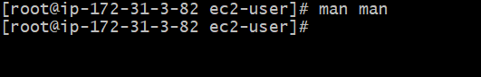

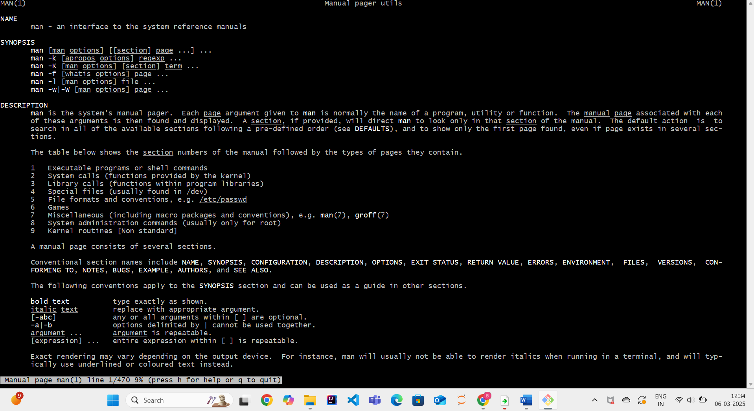

**mkdir dir_name:** This command is used to create new folder

**mkdir dir_name1 dir_name2:** this command is used to create multiple directories or folders same time



**mkdir -p dir_name/inside_dir:** it is used to create nested directories

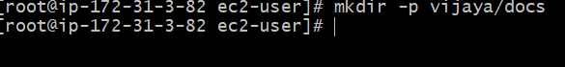

**ls:** this command is used to list all the directories

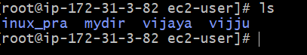

**ls /bin:**

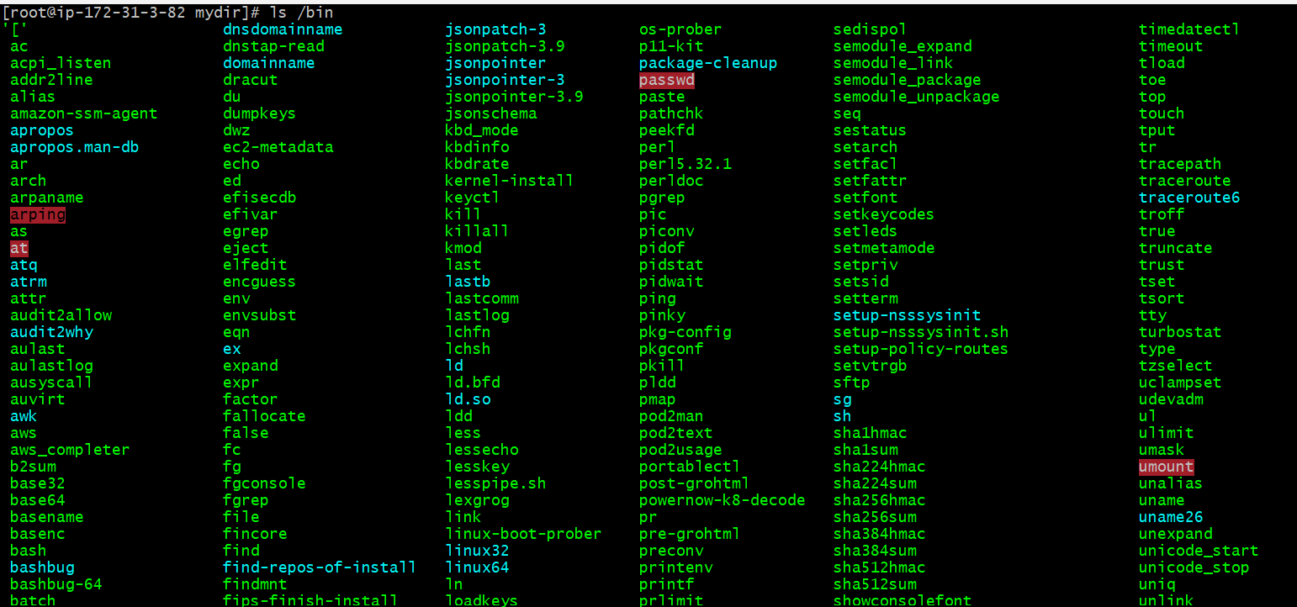

**ls -al /bin:**



**rmdir dir_name:** This command is used to delete the directory



**rmdir dir_name1 dir_name2**: to remove multiple folders at a time

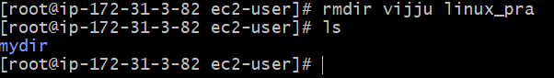

**rm -rf dir_name file_name:** to delete the floder with files in them

**cd dir_name:** This command is used to change one directory to another directory



**cd .. :** This command is used to back to the parent folder



**cd ../cars:** this command is used to navigate to a directory cars that is one level up from the current directory

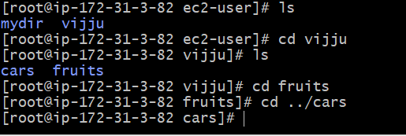

**cd /home:** This command is used to start from the root folder



Here home is the root folder

**pwd :** this command is used to show the current directory or current folder path

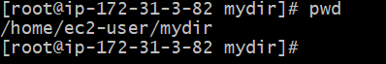

**touch <file_name>:** this command is used to create an empty file

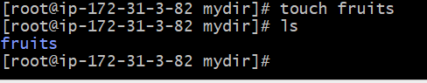

**mv old_file_name new_file_name:** this command is used to move a file or rename a file

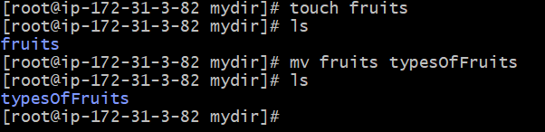

**mv file_name folder_name**: move a file from one folder to another folder

**mv file1 file2 folder_name**: move a multiple files from one folder to another folder

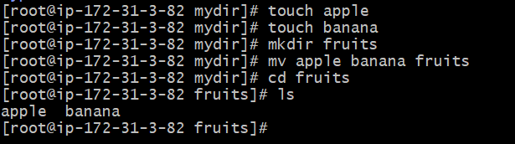

**cp exist_file_name copy_file_name:** copy a file

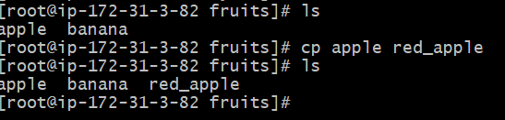

**Enter the data into files and show the data:**

**Convert the file into text file**

**echo file_name >> filename.txt:** This command is used to create a text file from existing empty file

**echo “content” >> file_name:** This command is used to enter the single content

**cat filename:** This is used display the information of the file

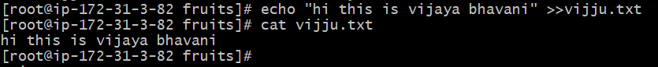

**cat >> file_name:** This command is used to enter the multiple lines of information into the file

after enter the command press enter

next enter the content and **press ctrl +d for saving and exit**



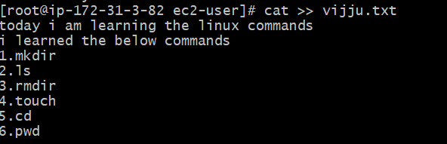

To see the complete file information

**cat filename:**

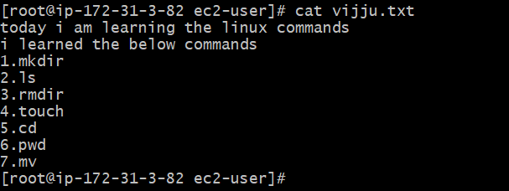

**cat file1 file2:** To print the multiple files at a time

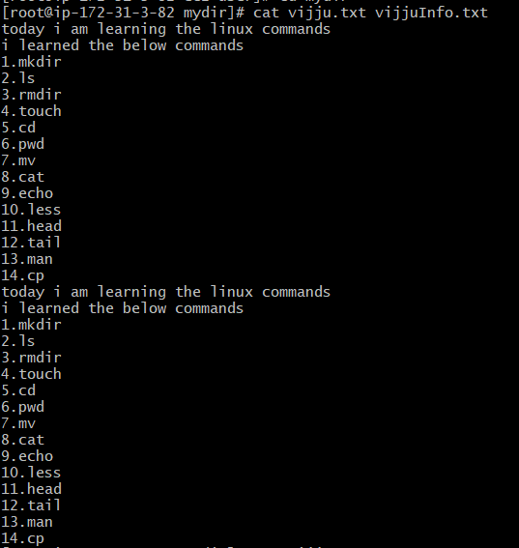

**cat file1 file2 >file3:** This used to combine multiple files into single file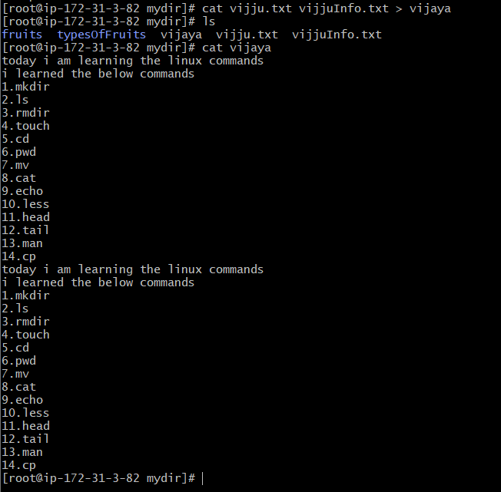

**cat -n filename:** This command is used to see the number of lines

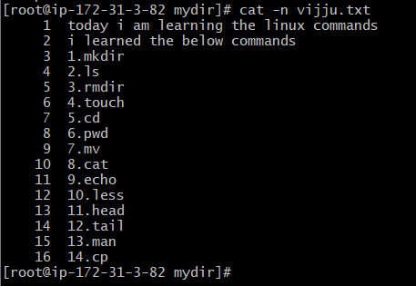

**tail -n +5 filename:**

**tail -n 5 filename:**

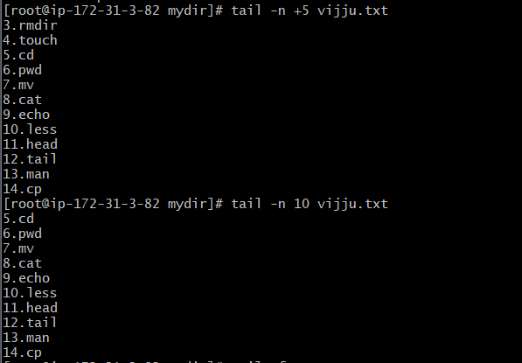

**tail -f filename:** It is used add the content to end of the file

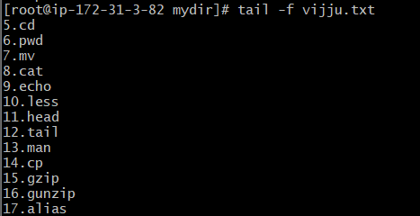

**less file_name :** shows the first page of the file



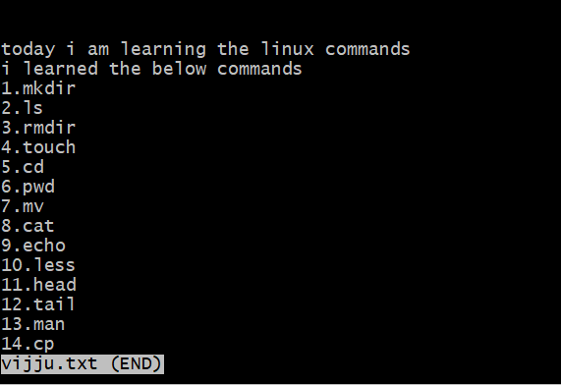

**head file_name:** shows the first 10 lines of the code

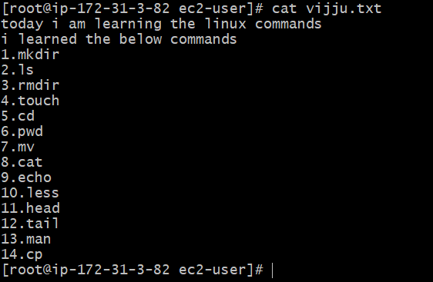

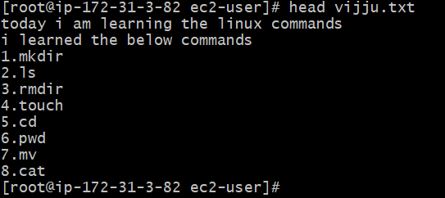

**tail file_name:** shows the last 10 lines in a file



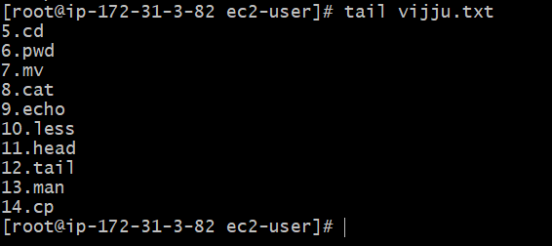

**Find:**

**find . -name “*.txt”:** to find the text files

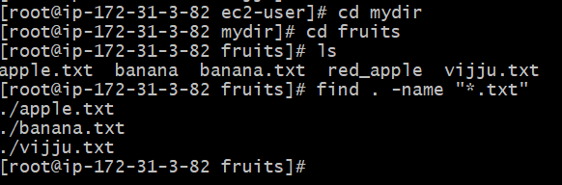

**find folder1 folder2 -name filename :** This command is used to find a file in different folders

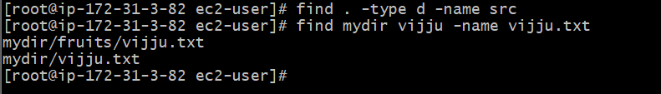

**Gzip:**

**gzip filename:** This command is used to compress a file using gzip compression protocol named L277

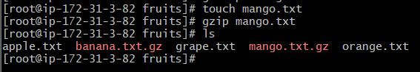

**gzip -k filename:** This command is used compress a file with extension of .gz

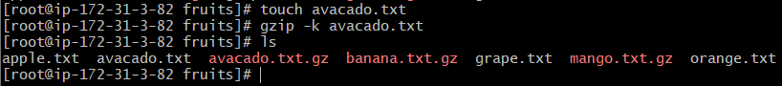

**gzip filename1 filename2:** This command is used compress multiple files at a time



**gzip -d filename.gz:** To decompress a file using the -d option

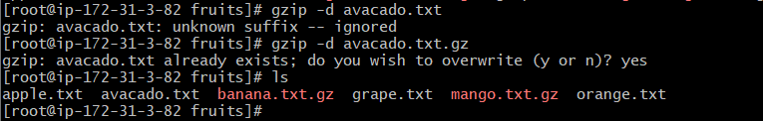

**Gunzip:**

**gunzip filename.gz:** This command is same as gzip, This command removes the .gz extension

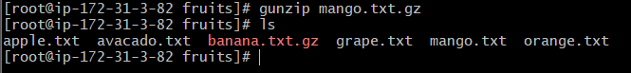

**tar:**

**tar -cf archive.tar file_name1 file_name2:** this command is used to create a archive file

**tar -xt archive.tar**: this command is used to extract the archive file

**tar -tf archive.tar:** This command is used to list the files

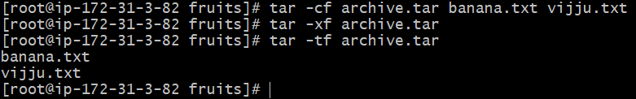

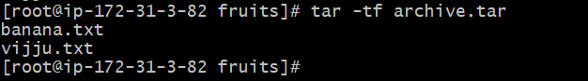

**tar -xf archive.tar -C directory:** This is used extract the files in another directory

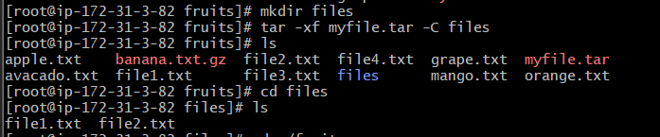

**tar -xf archive.tar.gz:** This command is used to unarchive the file

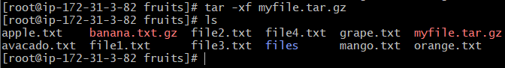

**Alias:**

**alias ll=’ls -al’:** This command is used to change command names

**unalias ll :** This command is used to change alias name to previous name

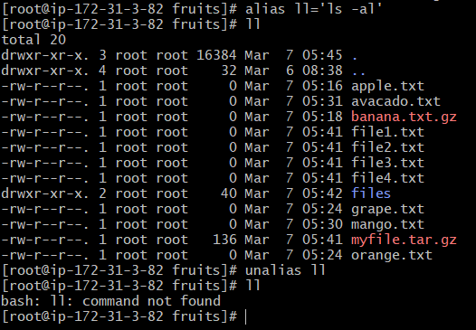

**wc:**

**wc filename:**



Here first column return the number of lines

Second column is number of words

Third column is number of bytes

**wc -l filename:** count the number of lines in a file

**wc -w filename:** count the number of words in a file

**wc -c filename:** it gives the number of bytes

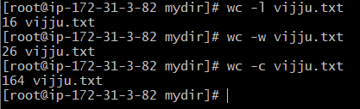

Grep:

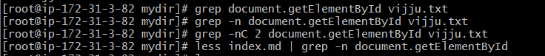

**Sort:**

**sort filename :** sorting

**sort -r filename:** reverse the order

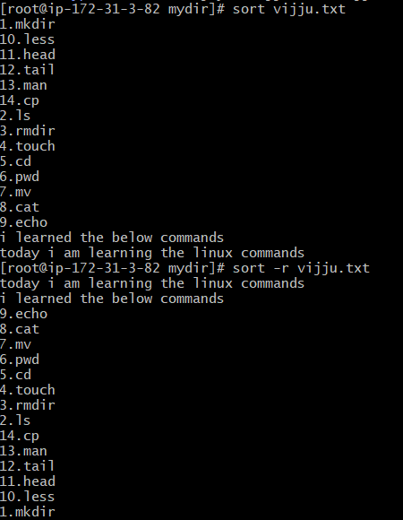

Uniq:

**uniq filename:** this command is used to print the uniq data doesn’t show the duplicate data

**sort filename | uniq :** It is used to remove the duplicate data after sorting

**sort filename | uniq -d:** It is used display the duplicate data

**sort filename | uniq -c:** It is used to count the occurences of the data

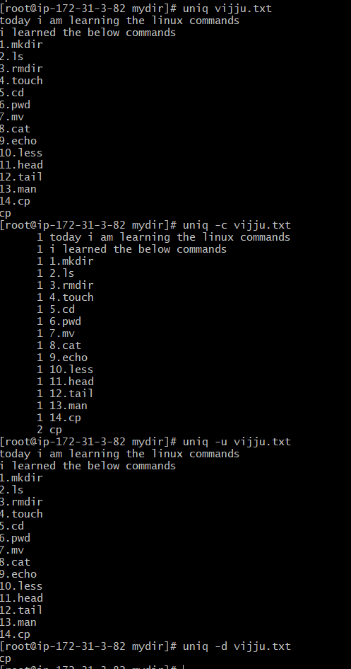

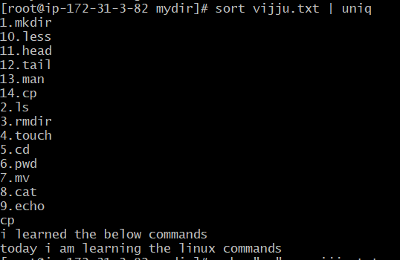

**Diff:**

**diff file1 file2 :** This command is used to find the difference between the two files

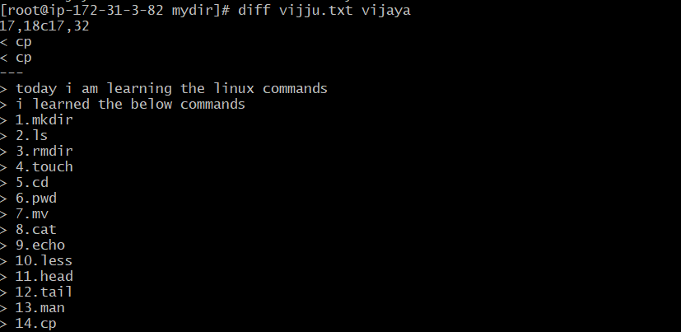

**diff -y file1 file2 :** This command is used to compare the two files line by line

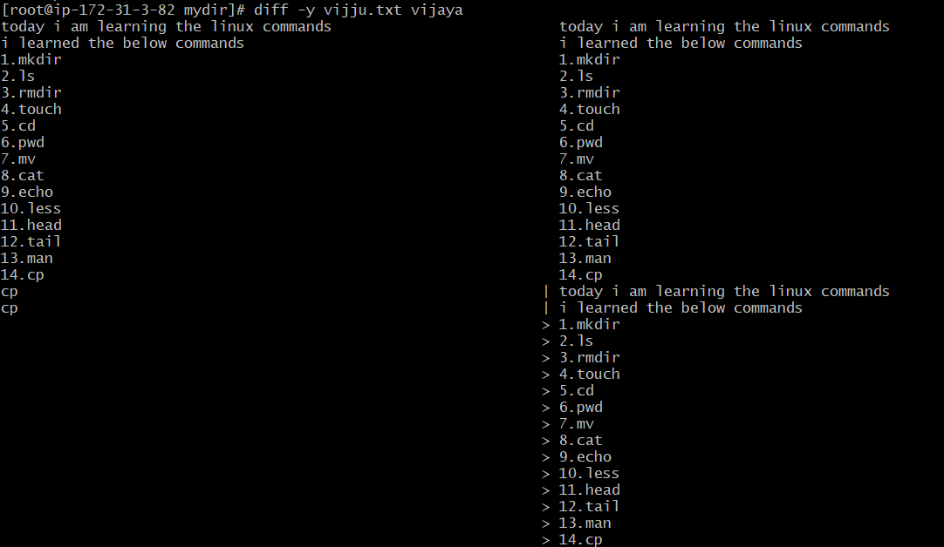

**diff -u file1 file2:**

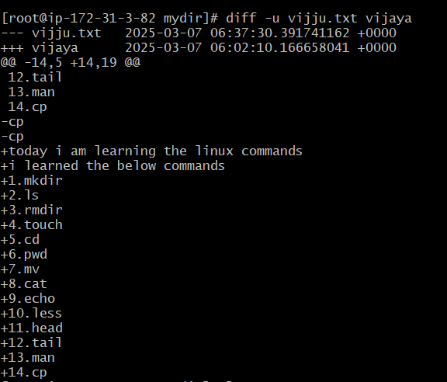

**Umask:**

**umask:** When you create a file, you don't have to decide permissions up front. Permissions have defaults. Those defaults can be controlled and modified using the umask command.

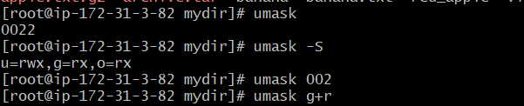

**DU**

**du:** This command is used to know the size of the directory

**du *:** This command is used to calculate the size of each file or directory

**du -m:** This command is used to calculate the size in mega bytes

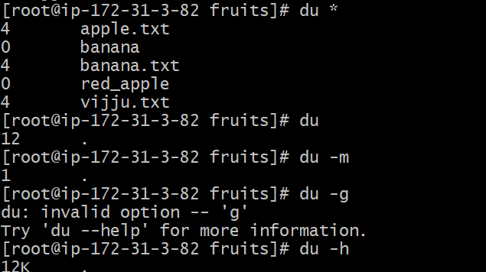

**DF:**

**df:** This command is used to get disk storage

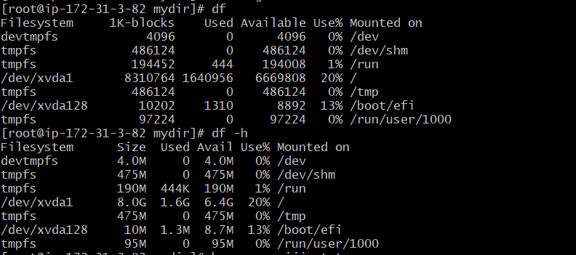

**Basename:** If you give a path to a file it will give the only file name



**Dirname:** If you give path, it will print the directories names



**Ps:** This command is used to inspect different processes

ps ax: it list all the users and our own process

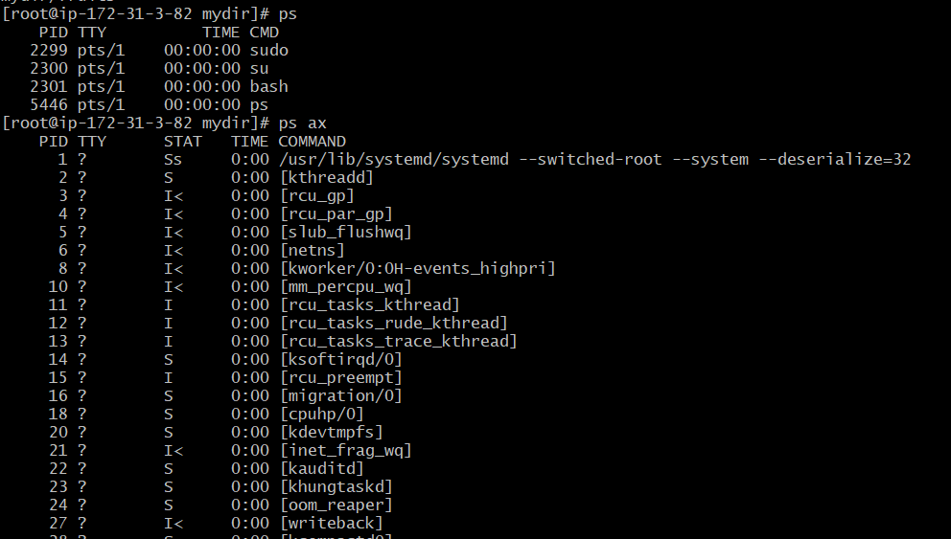

ps axww: This command is used to continue the command listing on a new line instad of cutting

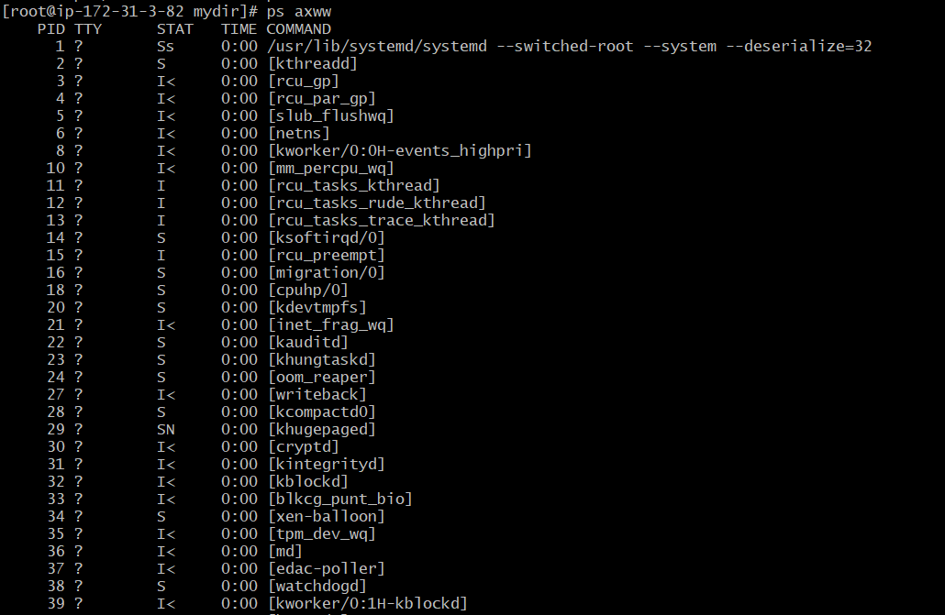

Top:

**top :** This command is used to display dynamic real time information about running processes in the system

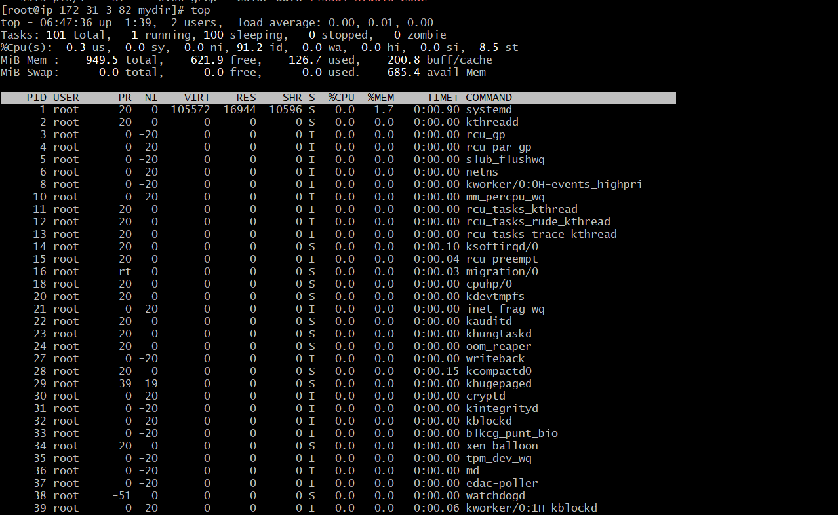

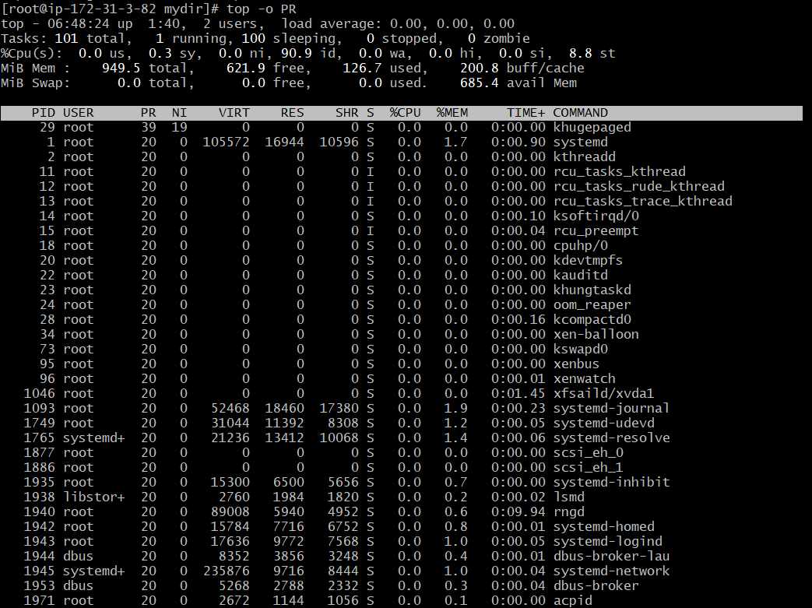

Chmod:

Chmod:

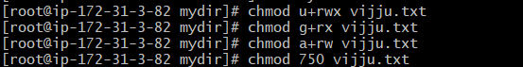

Chown:

KILL

kill <PID> : sending a signal to the processes

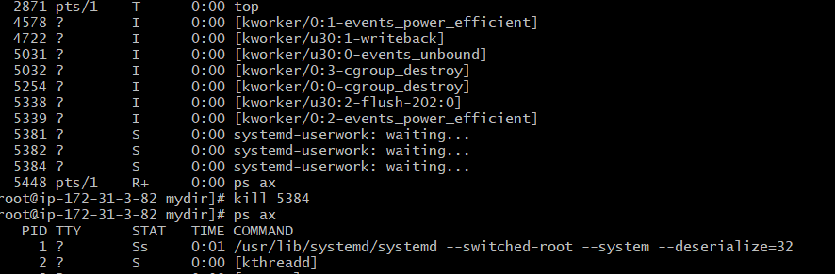

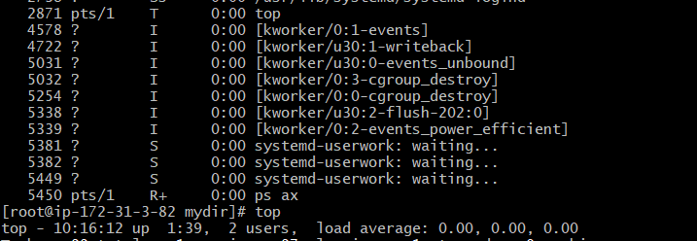

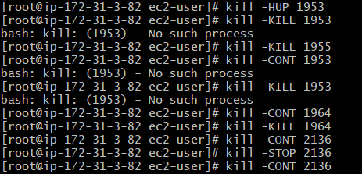

kill -HUP <PID>: hangup

kill -INT <PID>: interrupt

kill -KILL <PID>: stop and terminate the process

kill -TERM <PID>: terminate

kill -CONT <PID>: continue

kill -STOP <PID>: stopping

**uname:** this command is used to return name of the os

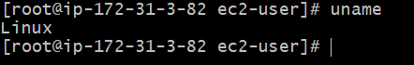

**uname -mp:** this command is used to show the hardware name print the processor architecture name

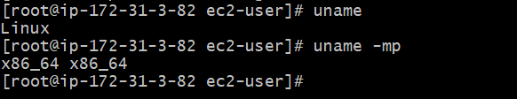

**uname -srv :** This command is used to print the operating system name and release and version



**uname -n :** This command is used to print the node network

**uname -a :** This command is used to print all information



**Nano:**

nano filename: This command redirects to the editor this used to enter the data into the files

after enter the ctrl+o for save the data

ctrl+x for the exit

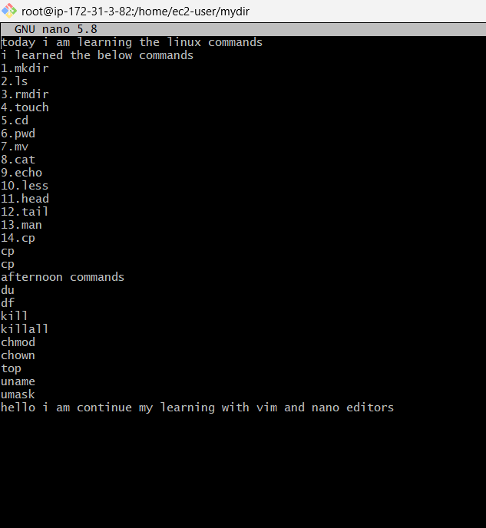

**vim:**

vim filename: This command is used to redirect to the text editor

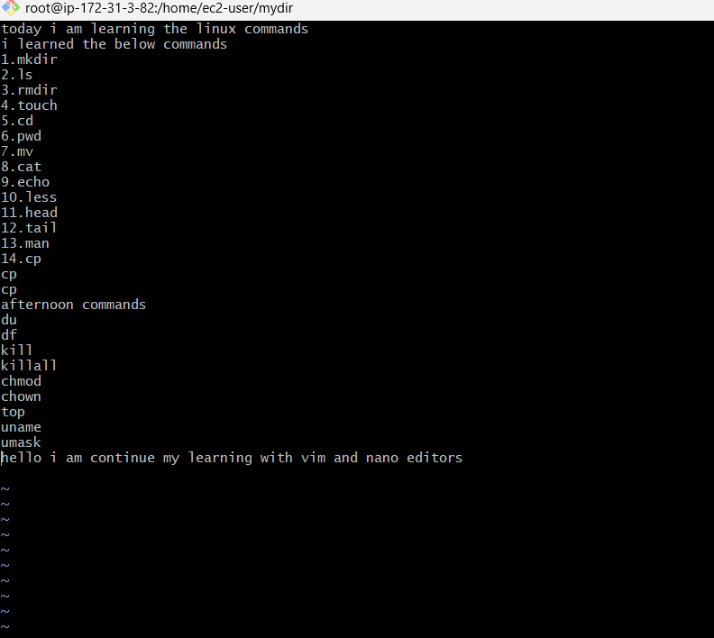

**:qa for exit**

**Type:**

**Type command_name :** this command is used to know the type of the commands

We have 4 types

1. Alias
2. Shell built in program
3. Executable
4. Shell functions

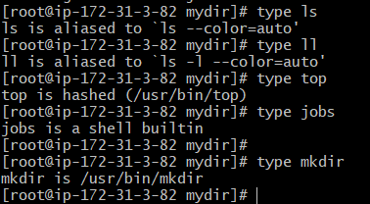

**Which:**

**Which command_name:** This command is used to know the path of the commands

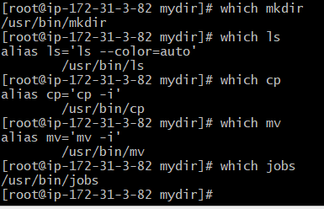

**WHO**

**who:** This command is used to displays the users logged in to the system

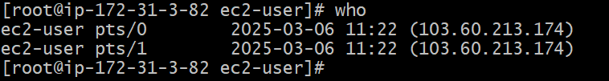

**who am i:** This command is used to list the current terminal details



**who -aH:** The -aH flags will tell who to display more information, including the idle time and the process ID of the terminal:

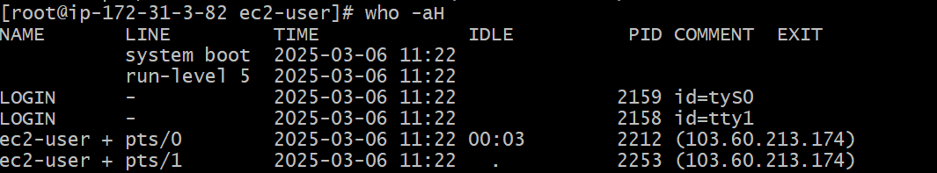

**who -aH am i:**



**whoami:** This command is used to print the username currently logout into the terminal session



**PASSWORD:**

**passwd:** to change the password

**passwd <username> <new password>:** This command is used to set the user name and change the password when you are the root user

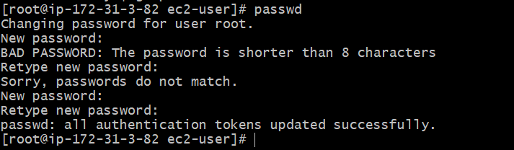**CLEAR:**

**clear:** clear command is used to clear the previous commandsand screen will be clear

**HISTORY:**

**history:** this command is used to show the history with numbers

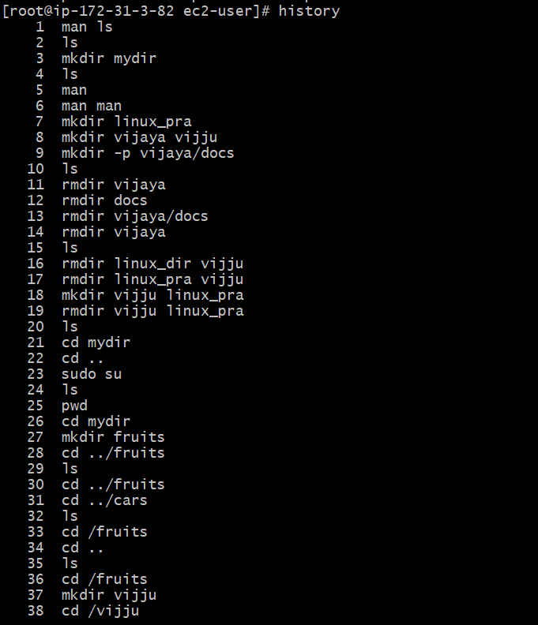

**history | grep docker:**

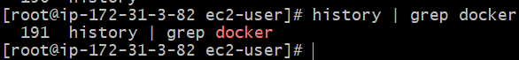

**history -c:** To clear the history