1. **What is git and github?**

**Ans.**

**Git:**

Git stands for Global Information Tracker

Git is a version control system

Git is open source

It is used to tracks the changes

Copy the projects from remote repository to local repository

Git is light weight and fast

It supports the branching model

**GitHub:**

GitHub is Cloud based server

Git hub is used to store the project files

Can not copy the code in GitHub

Using the GitHub, we can easily downloads and uploads the files from local repository to remote repository and remote repository to local repository

1. **What is CVCS and DVCS ?**

**Ans.**

**CVCS:**

CVCS stands for centralized version control system

Centralized version control systems only having the current version data only

Developers need to connect every time

Security is less

**DVCS:**

DVCS stands for Distributed version control system

It is also called as Decentralized Version control system

DVCS are having the previous versions data also

In DVCS, No need to connect servers everytime

It provides the more security

1. **Create a project of any and push the project**

**Ans.**

Step1 : create a folder in your local machine

Step2: create few files in empty folder

Step3: open terminal and execute the below commands

* **Git init:** This command creates the empty repository
* **Git add .:** this command is used to adding the files to the repository
* **Git commit -m “message”:** This command is used to committing the changes to the repository
* **Git remote add origin url:** This command is used to connect the local machine and remote repository
* **Git push origin master:** This command is used to upload the all changes into the remote repository

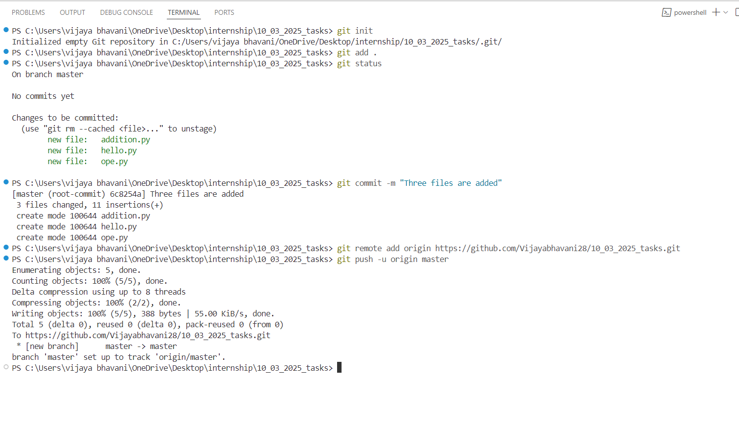

1. **Create 3 branches and 5 tags**

**Ans.**

Step1: git branch branchname: This command is used to create new branches

Step2: git tag [commit]: This command is used to create tags. Tags defines the multiple levels of the commits

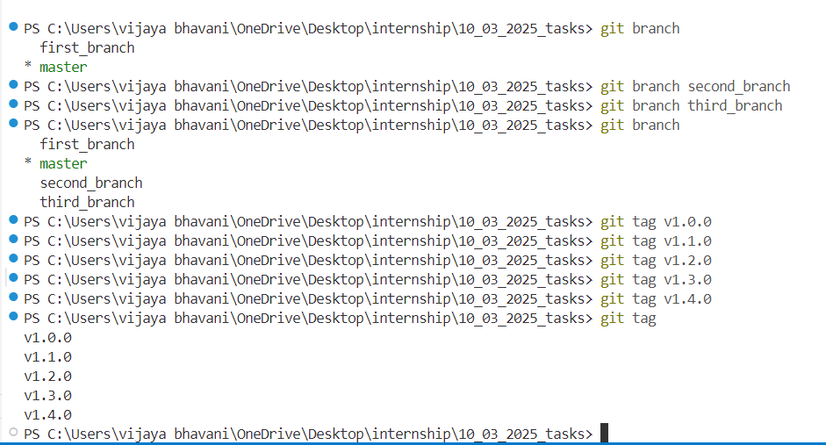

1. **Create a Keygen and push using ssh**

**Ans.**

We can create ssh key only through the git bash

Step1: Open git bash

Run the below commands for generating SSH key

Step2: ssh-keygen -c [vijayabhavani2807@gmail.com](mailto:vijayabhavani2807@gmail.com)

Step3: run the above command -🡪 press enter -🡪press enter -🡪 press y

Step4: Open the github

Step5: click on settings and open ssh keys

Step6: click on new ssh key

Step7: set the title and paste the ssh id in the description

Step8: create ssh key

1. **Create a sub branch in agit and switch from subbanch to mainbranch(hit:**

**use merge concept)**



1. **What is the importance of git checkout?**

**Ans.**

**Git checkout :**

Git checkout command is used to switch the one branch to another branch



1. **What is the importance of git merge?**

**Ans.**

Git merge:

Git merge command is used to merges the all changes and downloads the another branch



1. **What is Linux and how is it different from other operating systems?**

**Ans.**

**Linux:**

Linux is a operating system like windows, macOs

It is open source and free

It has the security features

It is developed by the Linus

1. **What are the basic Linux commands for file operations?**

**Ans.**

**Basic commands for File operations**

touch filename: touch command is used to create a new and empty file

echo : echo command is used to appends the single of data into the file

cat: Cat command is used to displays the data inside the file

1. **What is the difference between chmod and chown?**

**Ans.**

**Chmod:** Chmod command is used to modify the permissions of the authors, groups, and other

Chmod *** filename

* * first number represents the authors
* * second number represents the groups
* * third number represents the others

Chown: chown command is used to change the ownership

**Chown root**

1. **Explain the use of grep command.**
2. **How do you schedule a cron job in Linux?**

**Ans.**

Crontab: crontab * * * * file

Crontab jobs are the jobs to scheduling the multiple commands when and how many times it executed

* * it represents the minutes
* * second star represents the hours
* * third star represents the days
* * fourth star represents the weeks

1. **Explain the basic features of the Linux OS.**

**Ans.**

**Linux OS is open source :** Every one can use the linux Os

**Security:** It provides the Security Everytime asks the password so only root user can access

**Free of cost:** Linux OS is free to use

1. **What are the major differences between Linux and Windows?**

**Ans.**

Linux:

1. Linux is an operating system
2. No company was developed
3. It is free open source
4. Linux is case sensitive
5. Directories are separated by forward slash(/)

Windows:

1. Windows is an operating system.
2. It is developed by Microsoft Company
3. This is Paid operating system
4. Windows is case – insensitive
5. Folders are separated by backward slash(\)
6. **Define the basic components of Linux.**
7. **What is the chmod command in Linux, and how do you use it?**

**Ans.**

**Chmod:** Chmod command is used to modify the permissions of the authors, groups, and other

Chmod *** filename

* * first number represents the authors
* * second number represents the groups
* * third number represents the others

Chmod 755 filename:

Here 7 : author or owner can read, write and execute

5: can read and execute

5: can read and execute

1. **What are the most important Linux commands?**

**Ans.** mkdir, cd, rmdir, mv, cp, touch, cat, echo, vim, emacs, nano, crontab, find,sort, uniq, diff, du, df, ps, top, pwd, dirname, umask, basename etc.

1. **How do you create,remove and copy files in linux?**

**Ans.**

**Touch:** touch command is used to create a files

**Rm filename:** This command is used to remove files

**Cp:** This command is used to copy files one place to another

1. **What is ssh?**

**Ans.**

SSH: SSH stands for Secure shell

It is a protocol

It is used for security purpose