**Solution Abstract: AI-Powered Diabetes Prediction Chatbot**

Problem Statement

The problem is to develop an AI-powered chatbot that can predict the likelihood of an individual developing diabetes by analyzing medical data. The chatbot aims to provide early risk assessment and personalized preventive measures, enabling individuals to take proactive actions to manage their health effectively.

Solution Overview

The proposed solution involves creating an AI-powered chatbot that integrates machine learning algorithms for diabetes prediction. The chatbot will be designed to provide a user-friendly interface, analyze user input, offer accurate predictions, and recommend personalized preventive measures. Here is an abstract overview of the solution and a flowchart illustrating the process:

**Flow chart:**

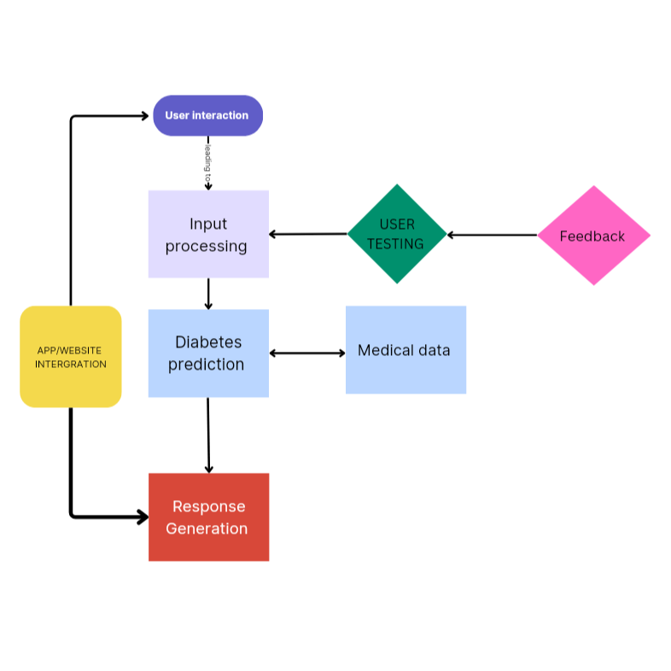

Flowchart Description

1. **User Interaction**: Users interact with the chatbot through a website or app interface.

2. **Input Processing (Chatbot)**: The chatbot processes user input, which may include medical data and queries related to diabetes risk assessment.

3. **Diabetes Prediction (Chatbot)**: Machine learning algorithms are used to analyze the medical data provided by the user. The chatbot predicts the likelihood of the user developing diabetes based on the data.

4. **Response Generation (Chatbot)**: The chatbot generates responses that include the diabetes risk assessment and personalized preventive measures.

5. **Medical Data (Data Source)**: The chatbot may refer to medical data from a trusted source to enhance the accuracy of predictions.

6. **Website/App Integration**: The chatbot is integrated into a website or app, ensuring a seamless user experience.

7. **User Testing**: Continuous testing is conducted to evaluate the chatbot's performance and user satisfaction.

8. **Feedback**: User feedback is collected to identify areas for improvement.

Key Features and Functionalities

User-friendly interface for easy interaction.

Natural Language Processing (NLP) techniques for understanding user queries.

Machine learning algorithms for diabetes prediction.

Personalized responses with risk assessment and preventive measures.

Continuous testing and improvement based on user feedback.