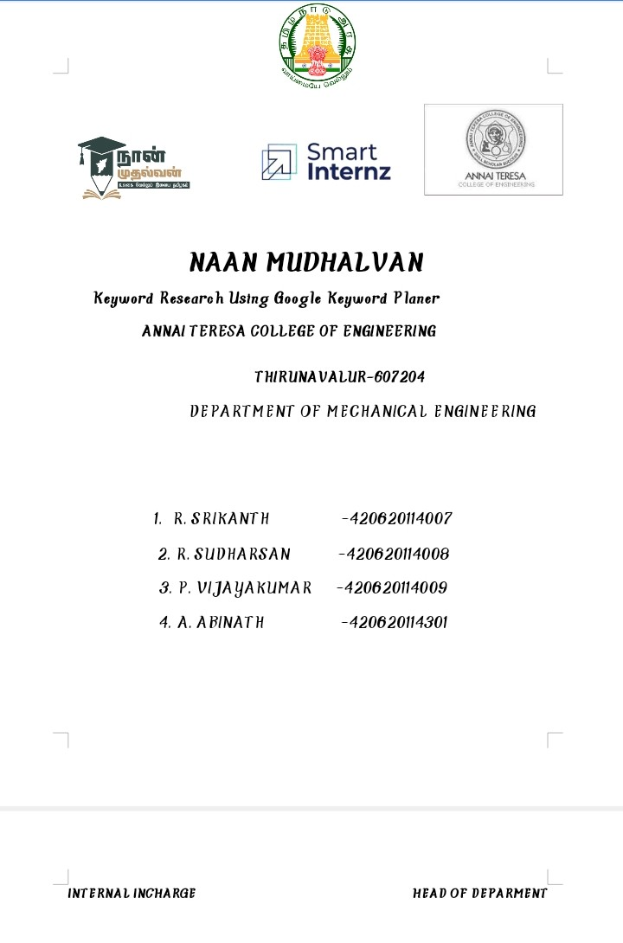

**How to Research Keyword using Google keyword Planner**

Easy 8 Step of Keyword Research using Google Keyword Planner

Subject: Digital Marketing

Example:

**Step 1.**

With you won or buyer Interest Choose a keyword First. Like “ Holidays Recipe” And Then Google It.

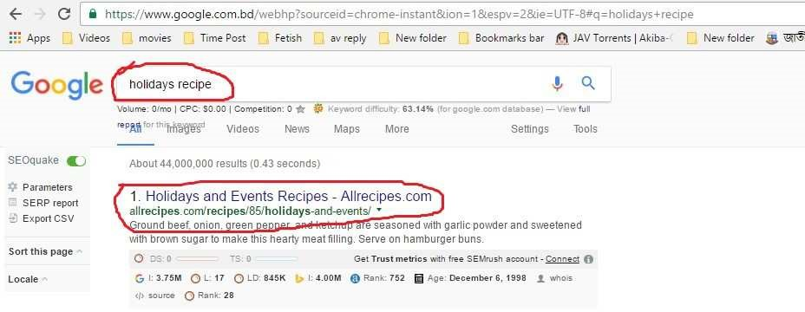

At your Google Search it is showing many results but you will select your Competitor Site.

For an Example I am using First Link at First Page “ [www.allrecipes.com”](http://www.allrecipes.com/)

**Step 2.**

If You done at 1st step Then move to “Google Keyword Planner” [Note: we learned about

Google keyword Planner Tools at previous Class]

Google it “Google Keyword Planner”

Then Go to “Keyword Research & Strategy with Keyword Planner - Google AdWords”



Click 1st link.

[Note: You Must have a gmail account and google adword account we learned about

Google keyword Planner Tools at previous Class]

If you are showing This image Then You have successfully done here ☺

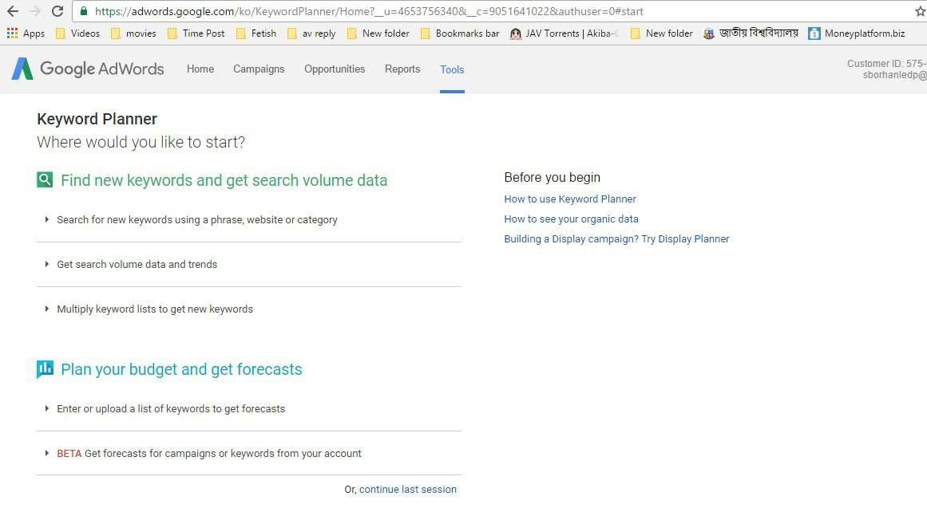

**Step-3.**

As a Successor at 2nd step then move to 3rd step.

At Keyword Planner

Where would you like to start?

Find new keywords and get search volume data

# Click



And then you should see

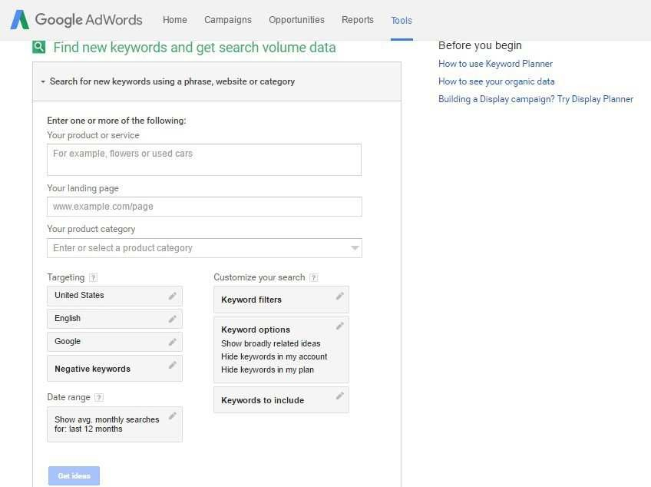

Step-4

We are now At Google keyword Planner Tools and We have got some New Box and some Categories Like:

1. 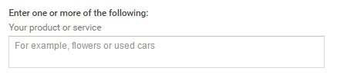Your products and service → You can research keyword using this box.

1. Your landing page. → You can research Competitor site keyword using this box. And I will show it today.



1. Your product category → Select product Category using this box.

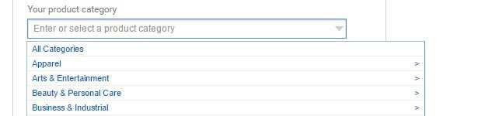

1. Targeting → You can choose audience country, Language, Search engine, and Local keyword using it.

5.Date range → You can choose searching date.

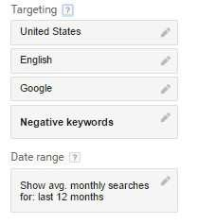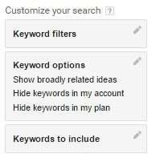

6. Customize your search→ This option is not so important for beginner.

Step-5

As we are Collecting Competitor site or Google 1st pages site So will using “ [www.allrecipes.com”](http://www.allrecipes.com/) and we used “ holiday recipe” keyword at google.

Now, Copy the link and past to Your Landing Page area at Google keyword Planner.

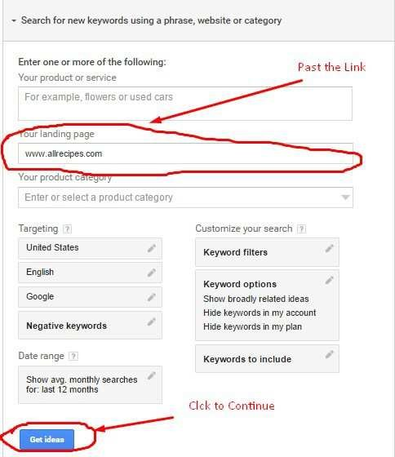

Step-6

If You done step-5 you will see result

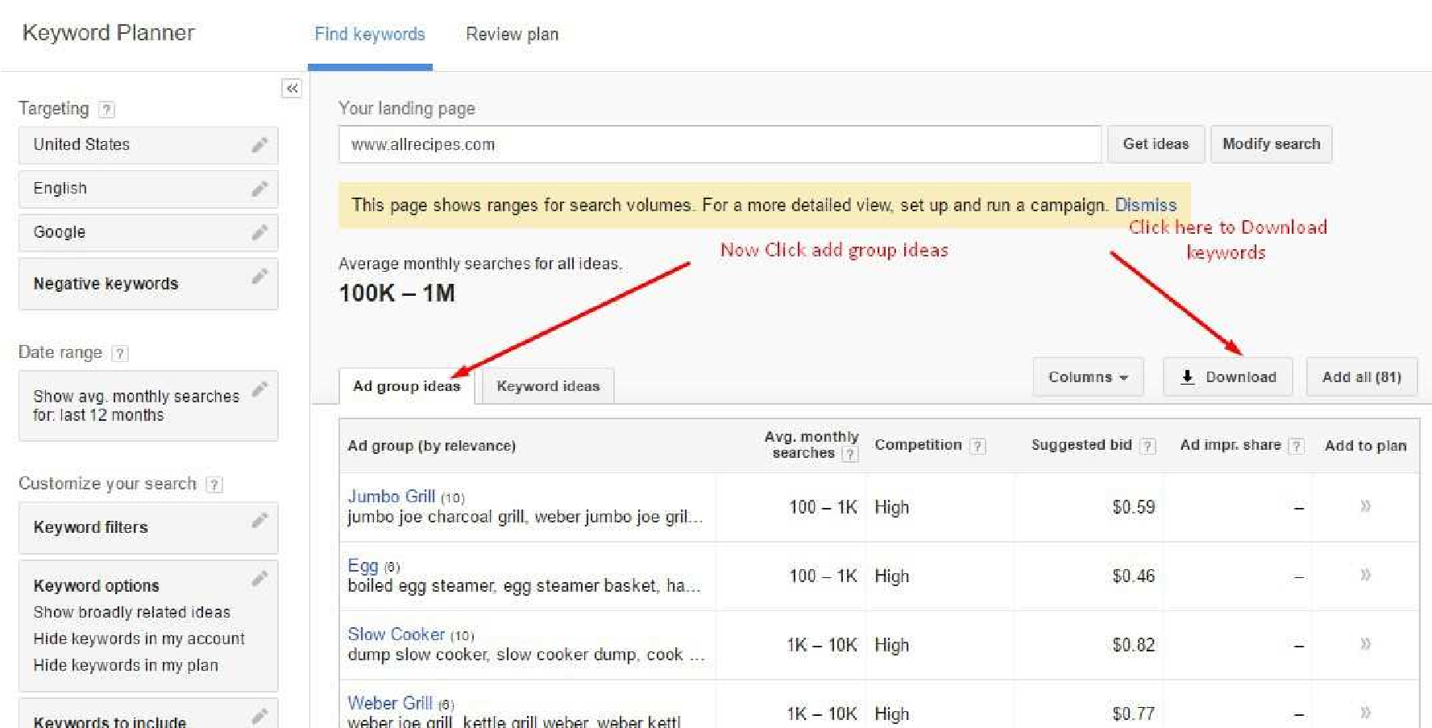

And Then Click add group and Click Download to download new keywords

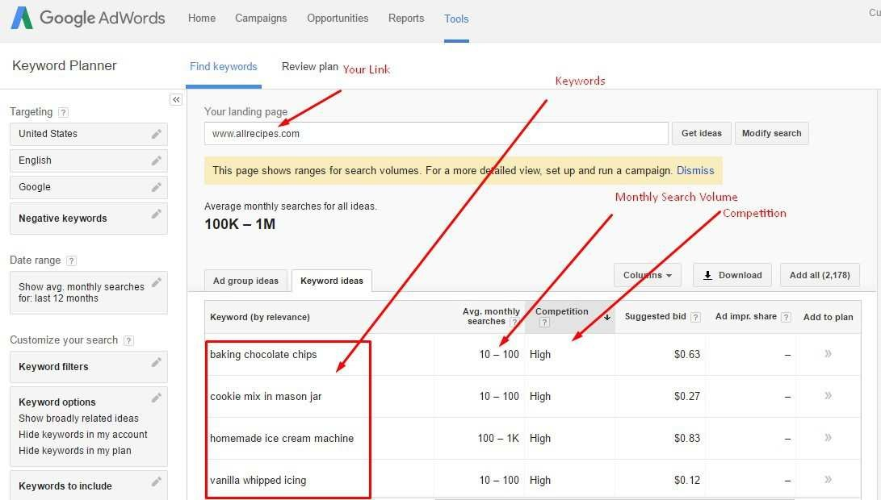

1. You have seen your link 2. Now Keywords

1. Monthly Search Volume
2. Competition

Then You will see a new Popup Box

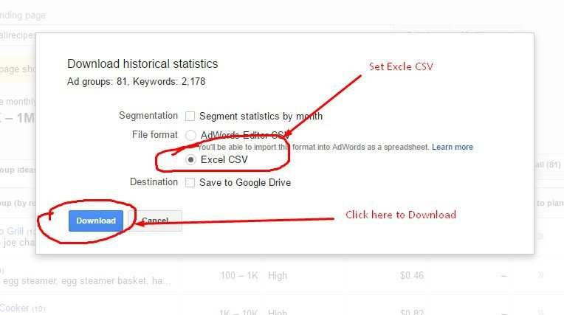

Select Excel CSV and Click Download Button.

And Click Save File



Congratulation You have Done Successfully 2/3 of your work ☺

Step-7

If you are using Google Chrome then You will Find downloaded Files Under your Browser. And Click Excel Sheet

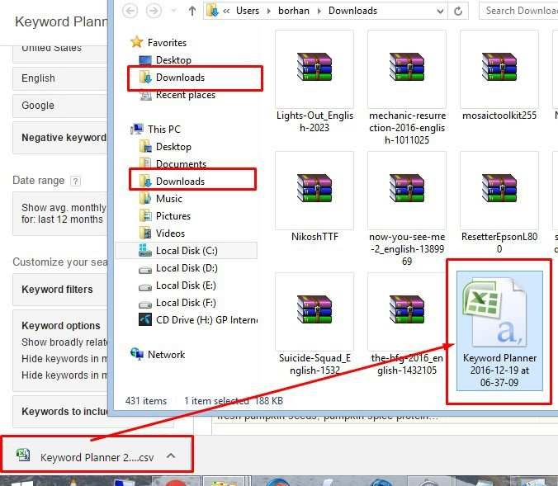

Impotent: Delete Each and Every Information Instead of

B (keyword),

D (Avg. Monthly Searches (exact match only)

And E (Competition)

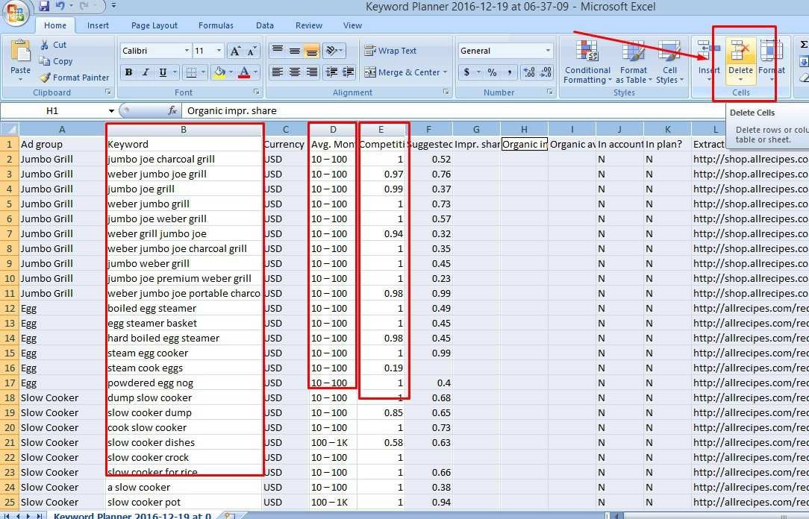

Step- 8

Write High, Medium and Low keyword at Right Corner

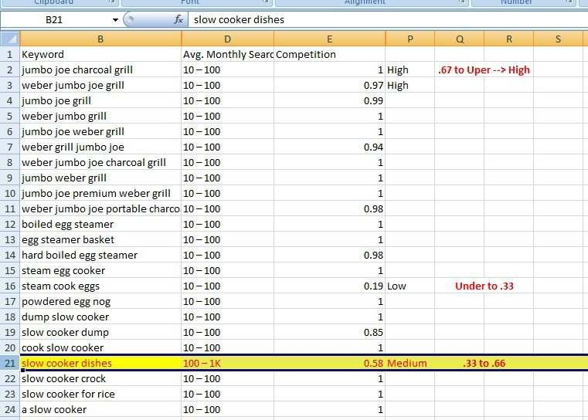

Using Module:

Google Keyword Planner:

▪**Low — Competitiveness in AdWords is under .33**

▪**Medium — Competitiveness in AdWords between .33 and .66**

▪**High — Competitiveness in AdWords is over .67**

# The End