**Product sales analysis**

**Project Objective:**

Objective:

Analyze sales data to derive actionable insights for improving inventory management and refining marketing strategies.

**Design Thinking Process and Development Phases:**

Design Thinking:

Utilize a human-centered approach to understand user needs, ideate on potential solutions, and prototype strategies for analysis.

**Development Phases:**

Include data collection, preprocessing, analysis, visualization, and insight implementation.

**Analysis Objectives:**

- Objective 1: Understand sales trends, patterns, and customer behavior.

- Objective 2: Identify top-performing products, sales channels, and geographical areas.

- Objective 3: Discover correlations between marketing efforts and sales performance.

**Data Collection Process:**

- Sources: Gather sales data from various channels (online platforms, stores, etc.).

- Methods: Use software or tools to collect, clean, and prepare the data for analysis.

**Data Visualization using IBM Cognos:**

- Tool: Utilize IBM Cognos for data visualization, creating informative dashboards and reports.

- Visual Representation: Generate charts, graphs, and reports to illustrate sales trends, product performance, and customer behavior.

**Derived Actionable Insights:**

- Inventory Management: Identify fast-moving products, slow-moving stock, and seasonal variations to optimize inventory levels.

- Marketing Strategies: Discover which marketing campaigns or channels are most effective and tailor strategies to enhance sales.

**Guiding Inventory Management and Marketing Strategies:**

- Inventory Management: Implement insights to streamline stock levels, reduce overstocking, and ensure availability of popular products.

- Marketing Strategies: Refine marketing efforts by focusing on high-performing channels, adjusting promotional campaigns, and targeting specific customer segments identified through the analysis.

This is the python code for visualizing the data set:

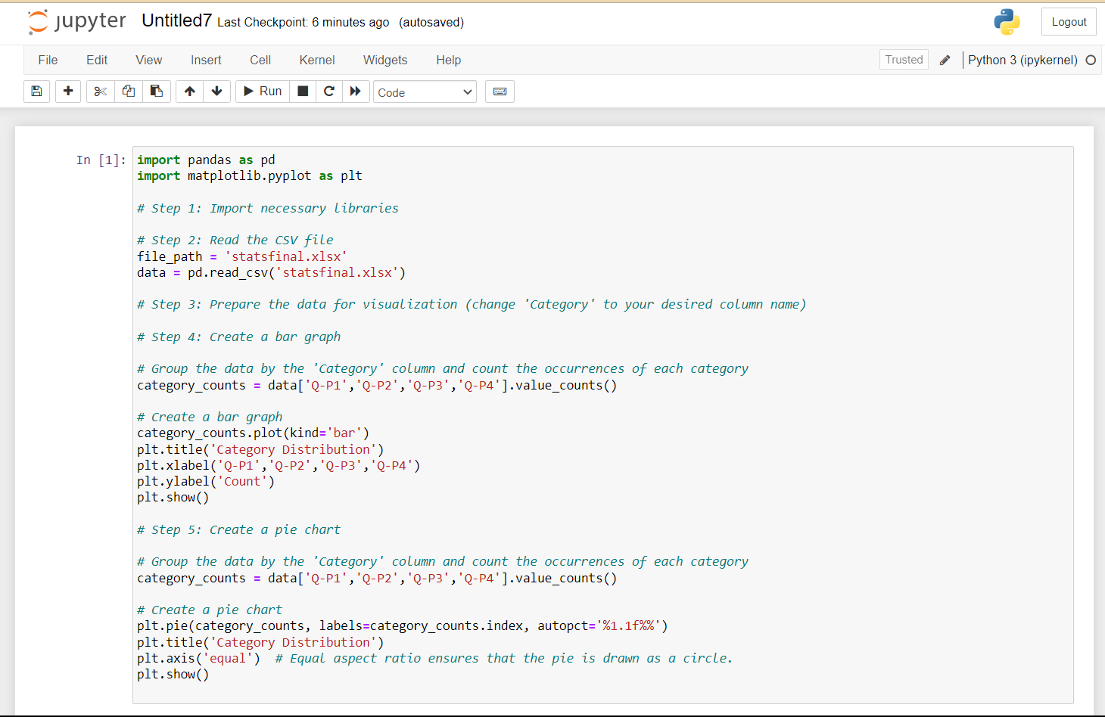

These are the visualization slides:

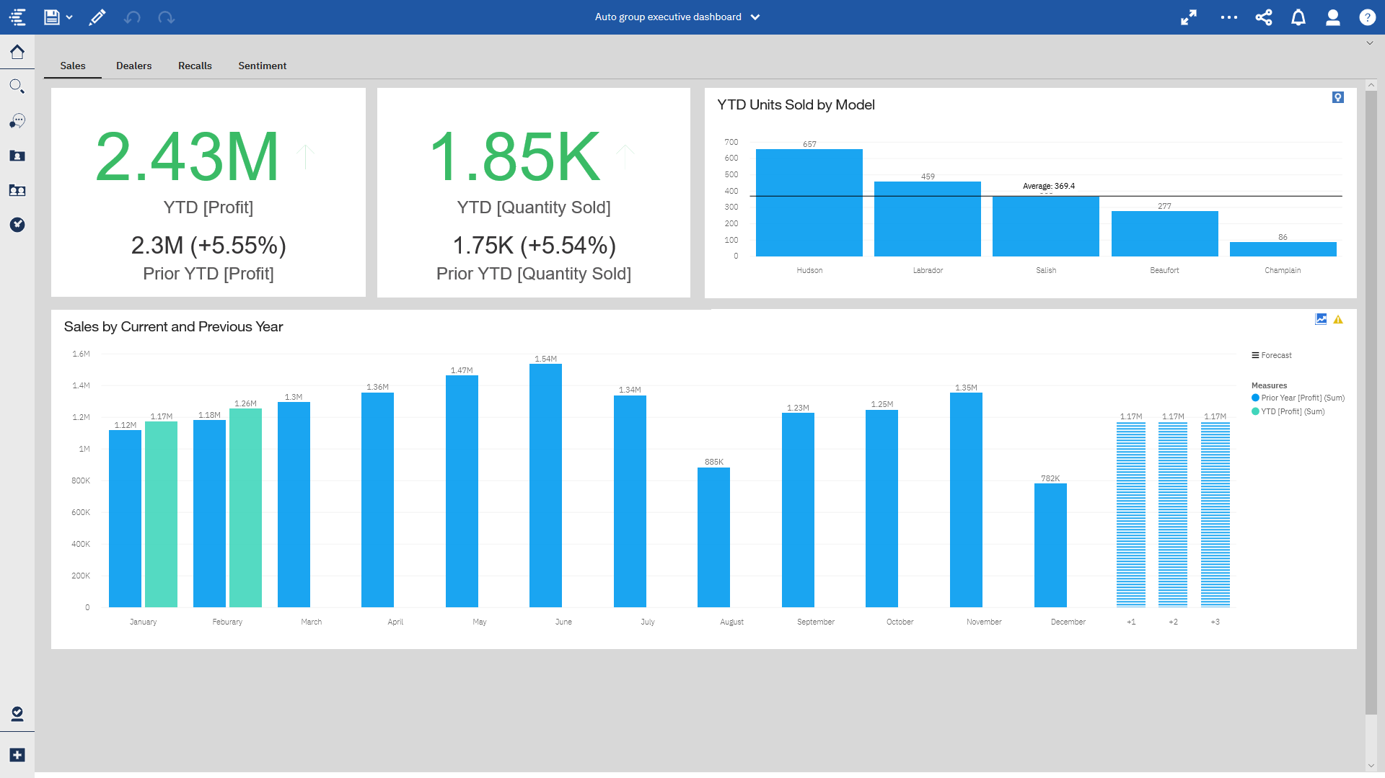

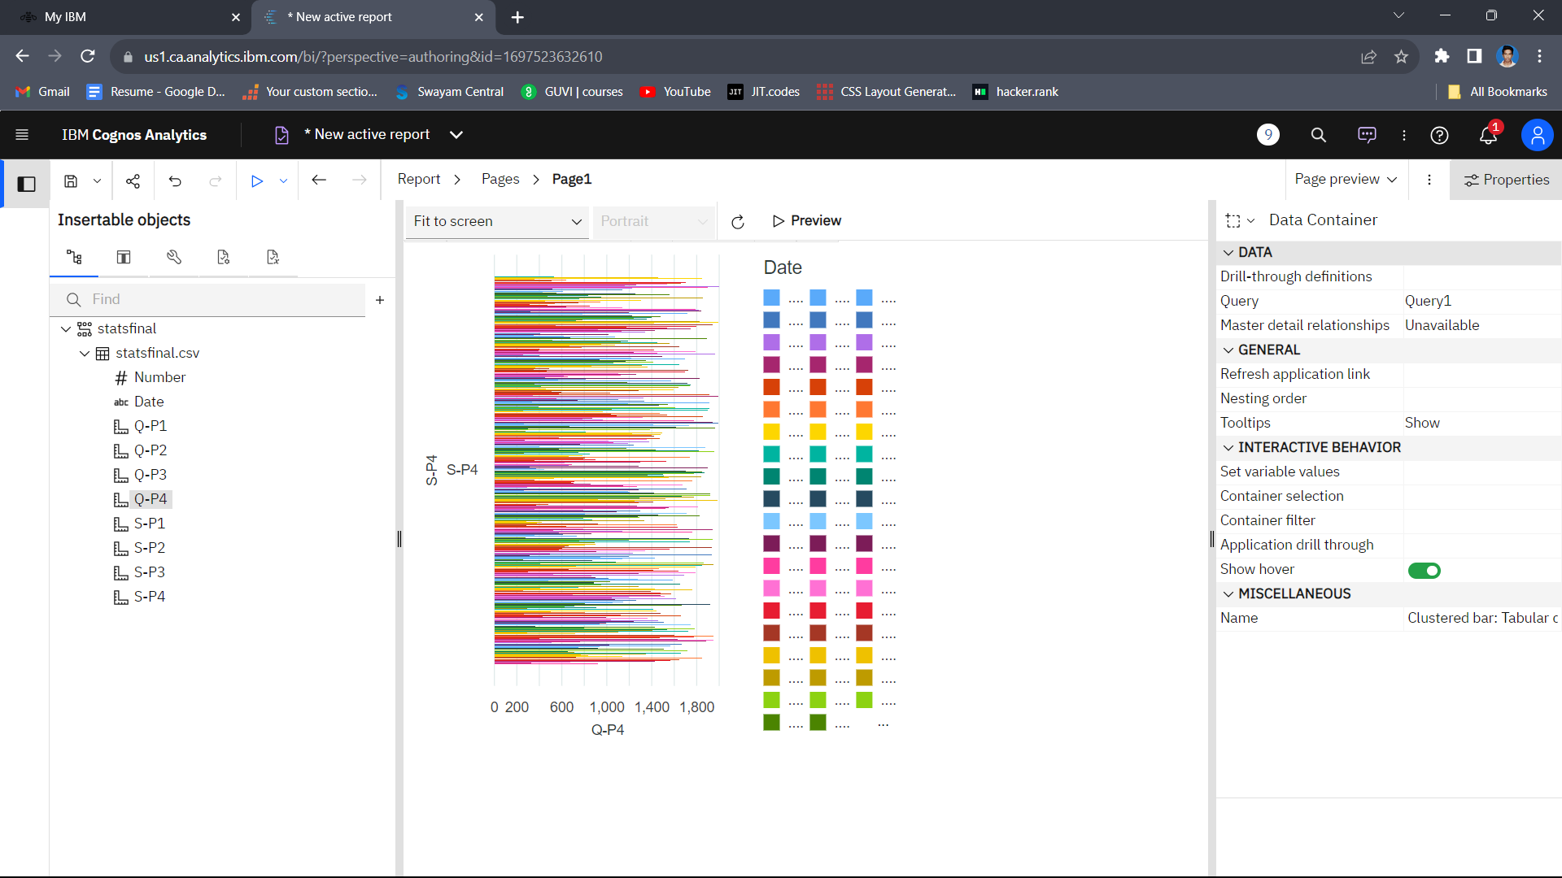

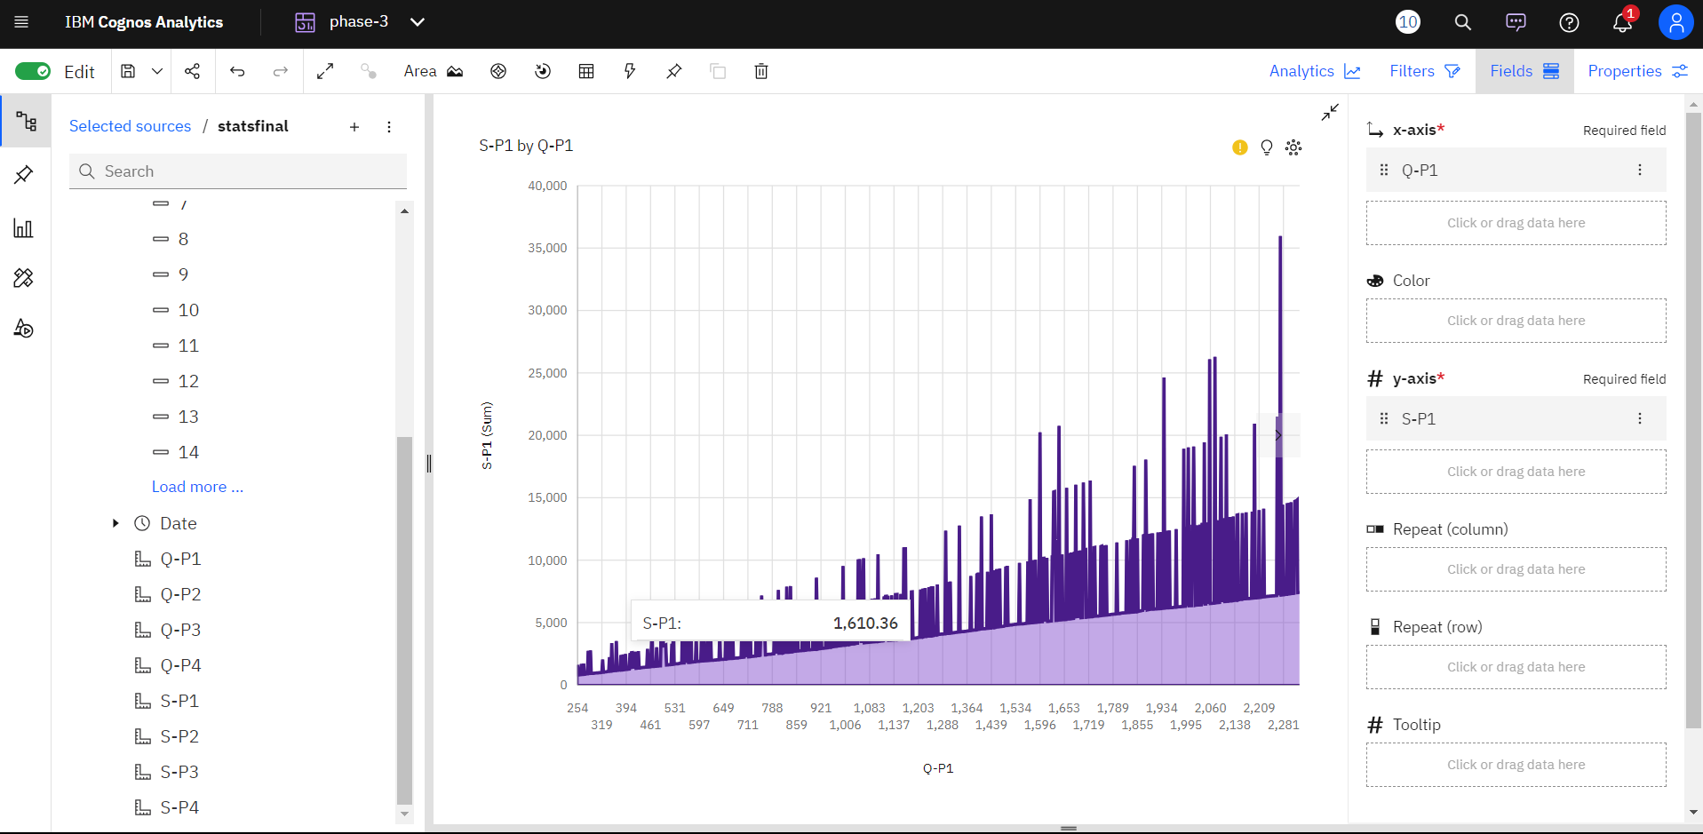

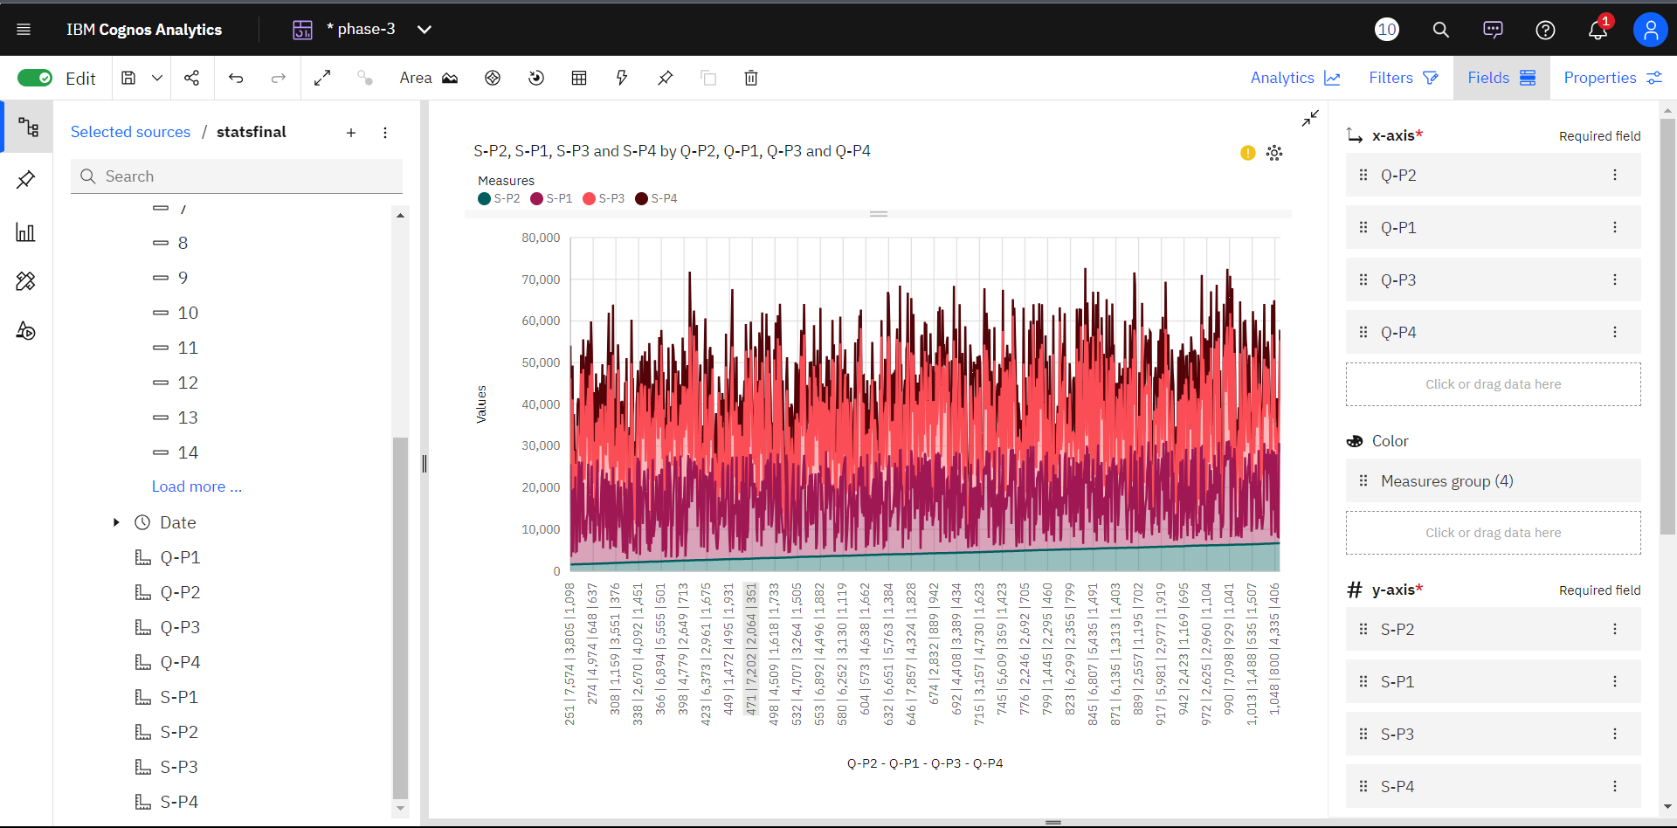

**Conclusion:**

This project's focus on sales analysis aims to offer actionable insights to fine-tune inventory and marketing strategies, optimizing operational efficiency and sales performance.