Wipro TalentNext – Database Solution Expert
Module 2: Reporting Aggregated Data Using the Group Function

Hands-on Assignment 1
Question
Find the highest, lowest, sum, and average salary of all employees. Label the columns
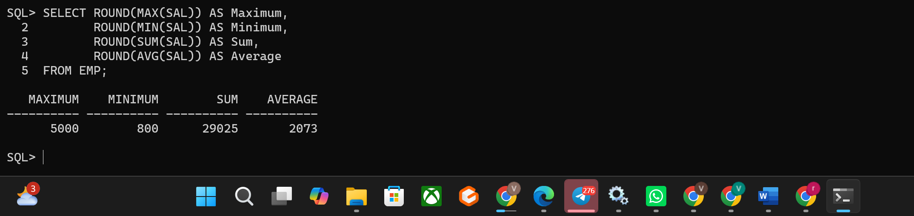
Hands-on Assignment 2
Question
Maximum, Minimum, Sum, and Average, respectively. Round your results to the nearest whole number.
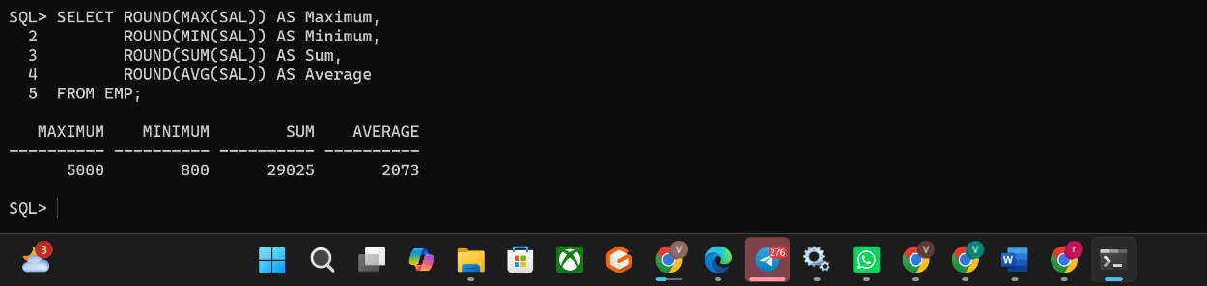
Hands-on Assignment 3
Question
Modify the above query to display the minimum, maximum, sum, and average salary for each job type.
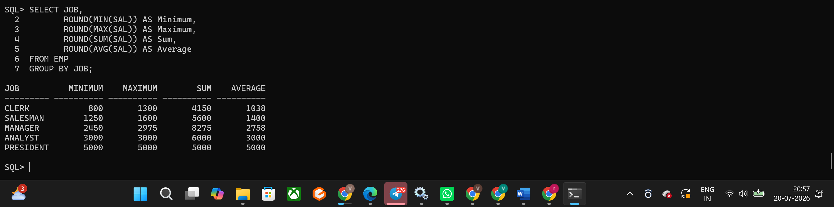
Hands-on Assignment 4
Question
Write a query to display the number of people with the same job.
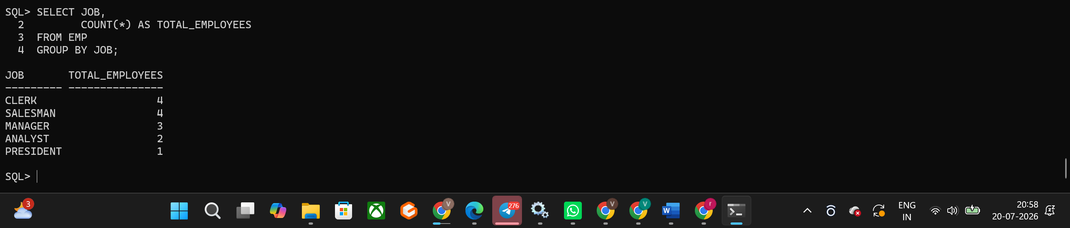
Hands-on Assignment 5
Question
Determine the number of managers without listing them. Label the column Number of Managers.
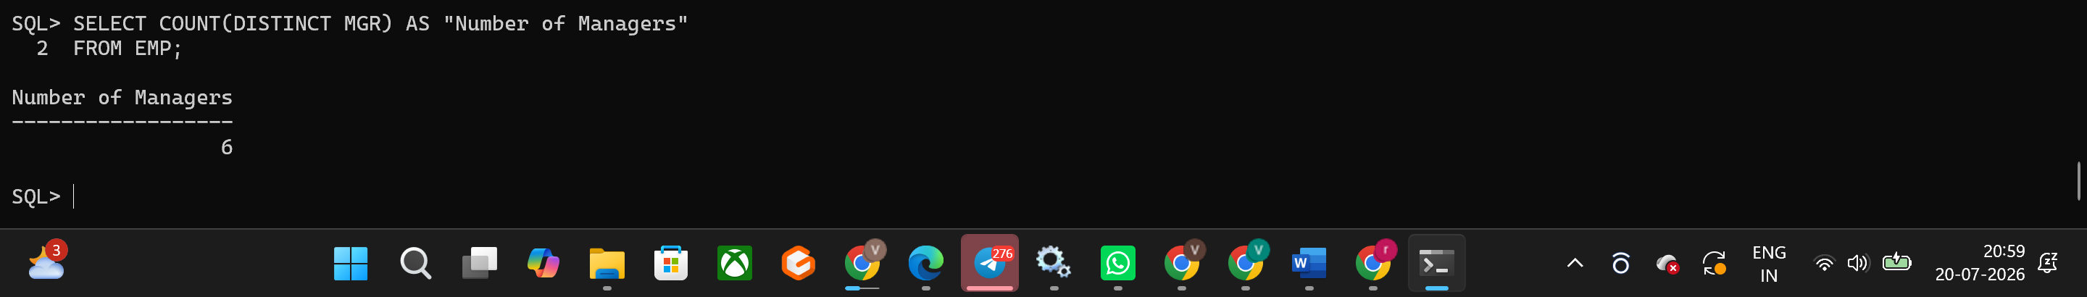
Hands-on Assignment 6
Question:
Find the difference between the highest and lowest salaries. Label the column DIFFERENCE.
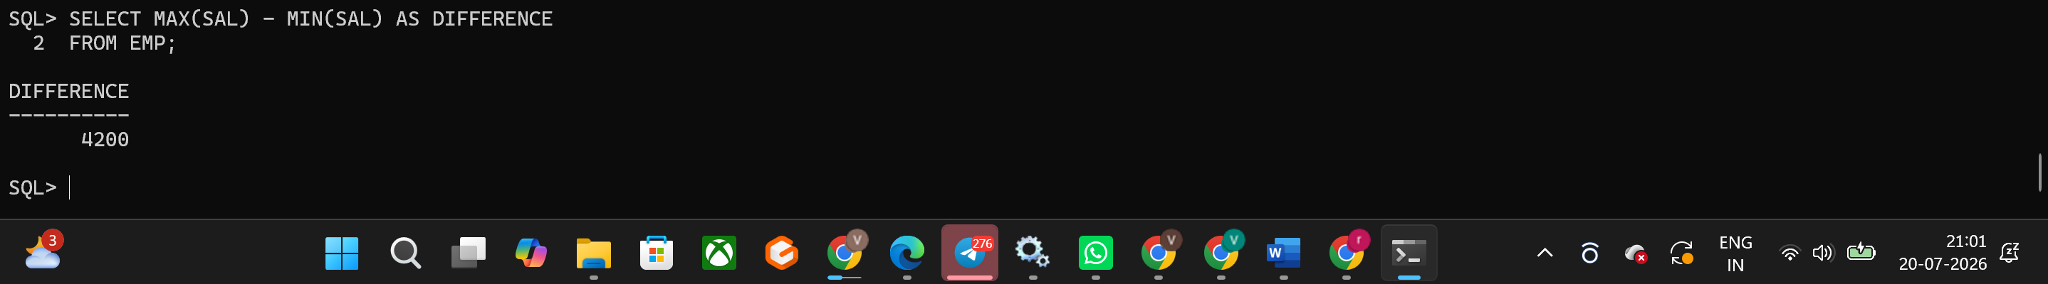
Hands-on Assignment 7
Question:
Create a report to display the manager number and the salary of the lowest-paid employee for that manager. Exclude anyone whose manager is not known. Exclude any groups where the minimum salary is $2000 or less. Sort the output in descending order of salary.
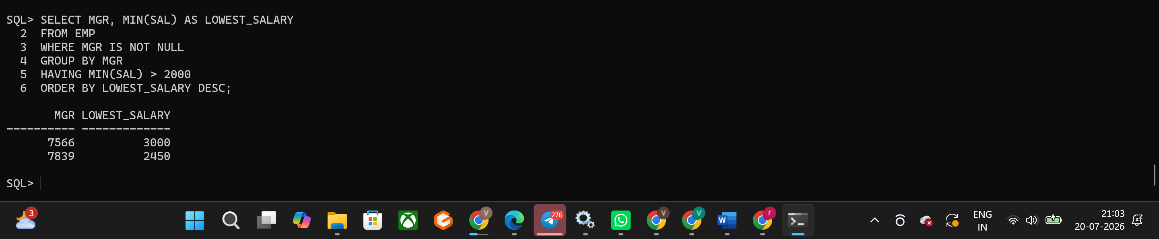
Hands-on Assignment 8
Question:
Create a query to display the total number of employees and, of that total, the number of employees hired in 1980, 1981, 1982, and 1983. Create appropriate column headings.
