Wipro TalentNext – Database Solution Expert
Module 2: Retrieving Data Using the SQL SELECT Statement

Hands-on 1
Question
Determine the structure of the DEPT table and its contents.
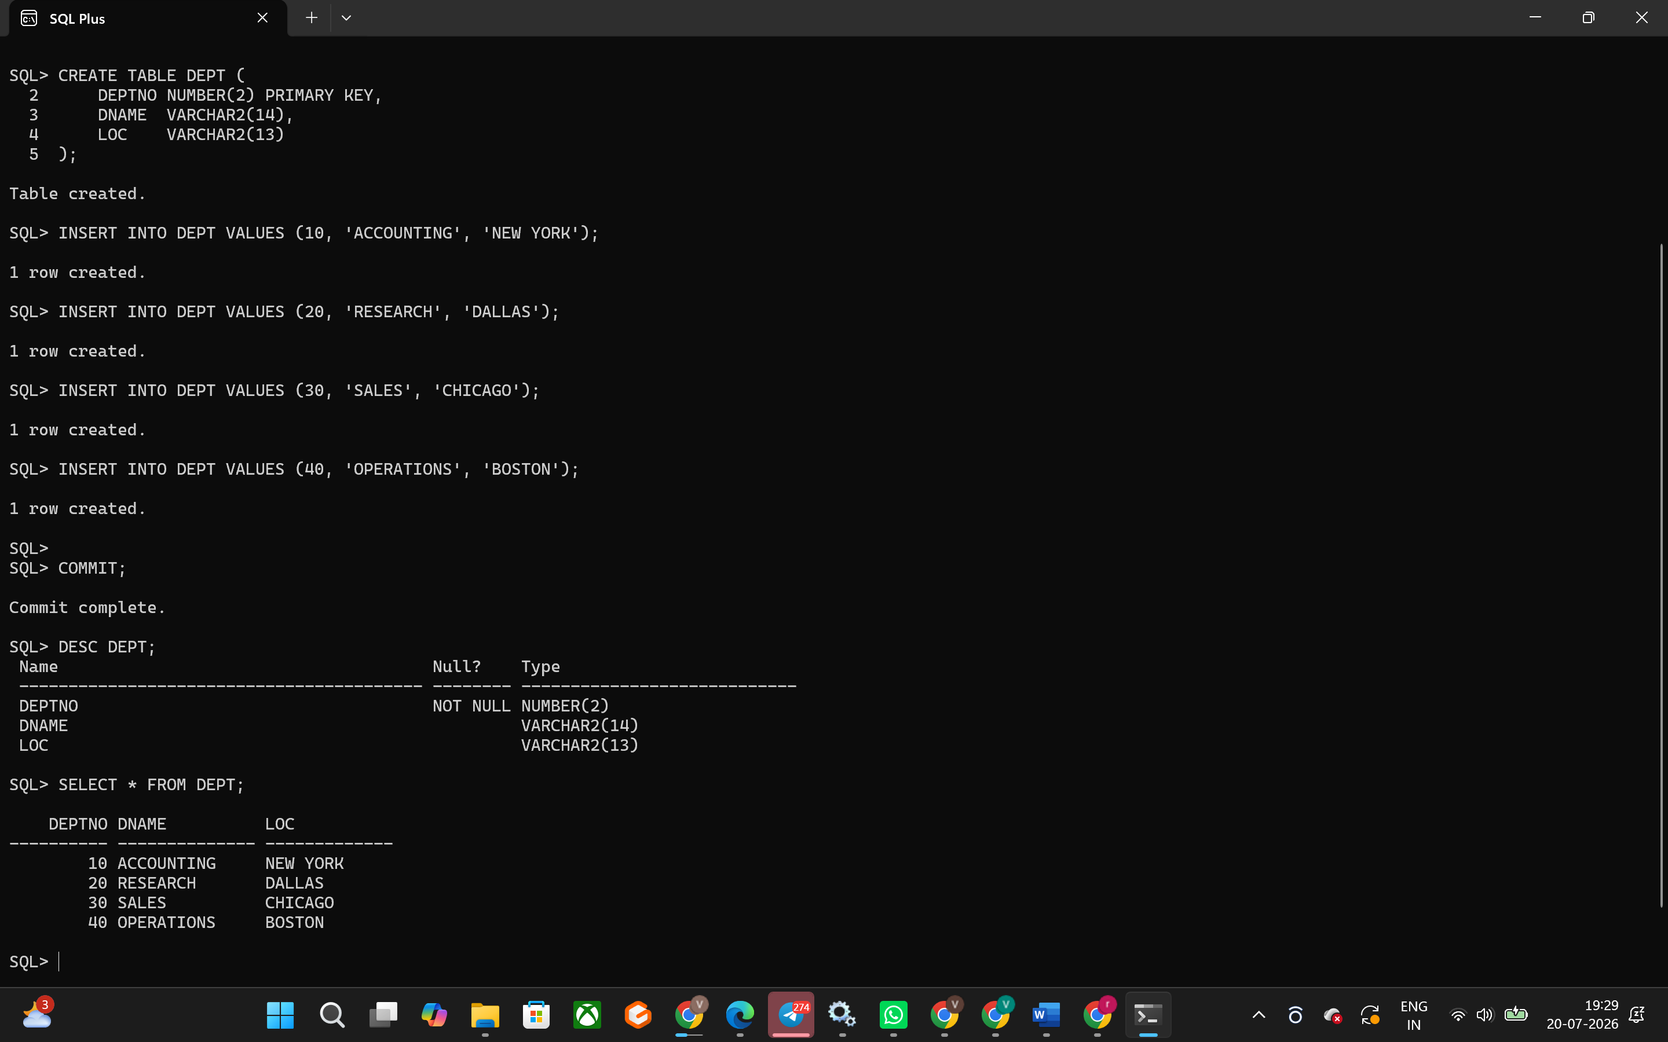
Hands-on Assignment 2
Question
Determine the Structure of EMP Table and its Contents.
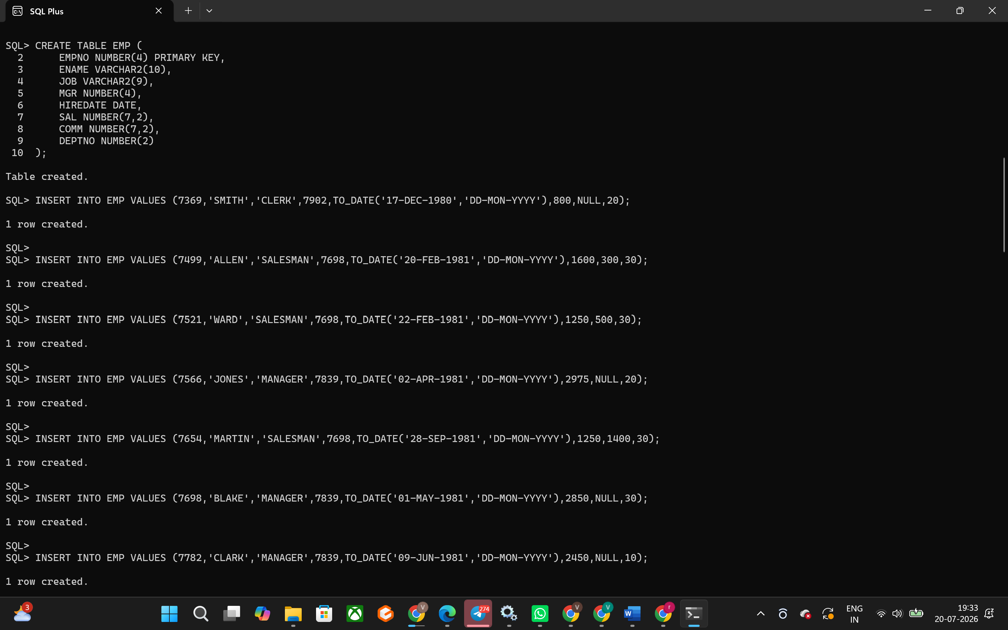
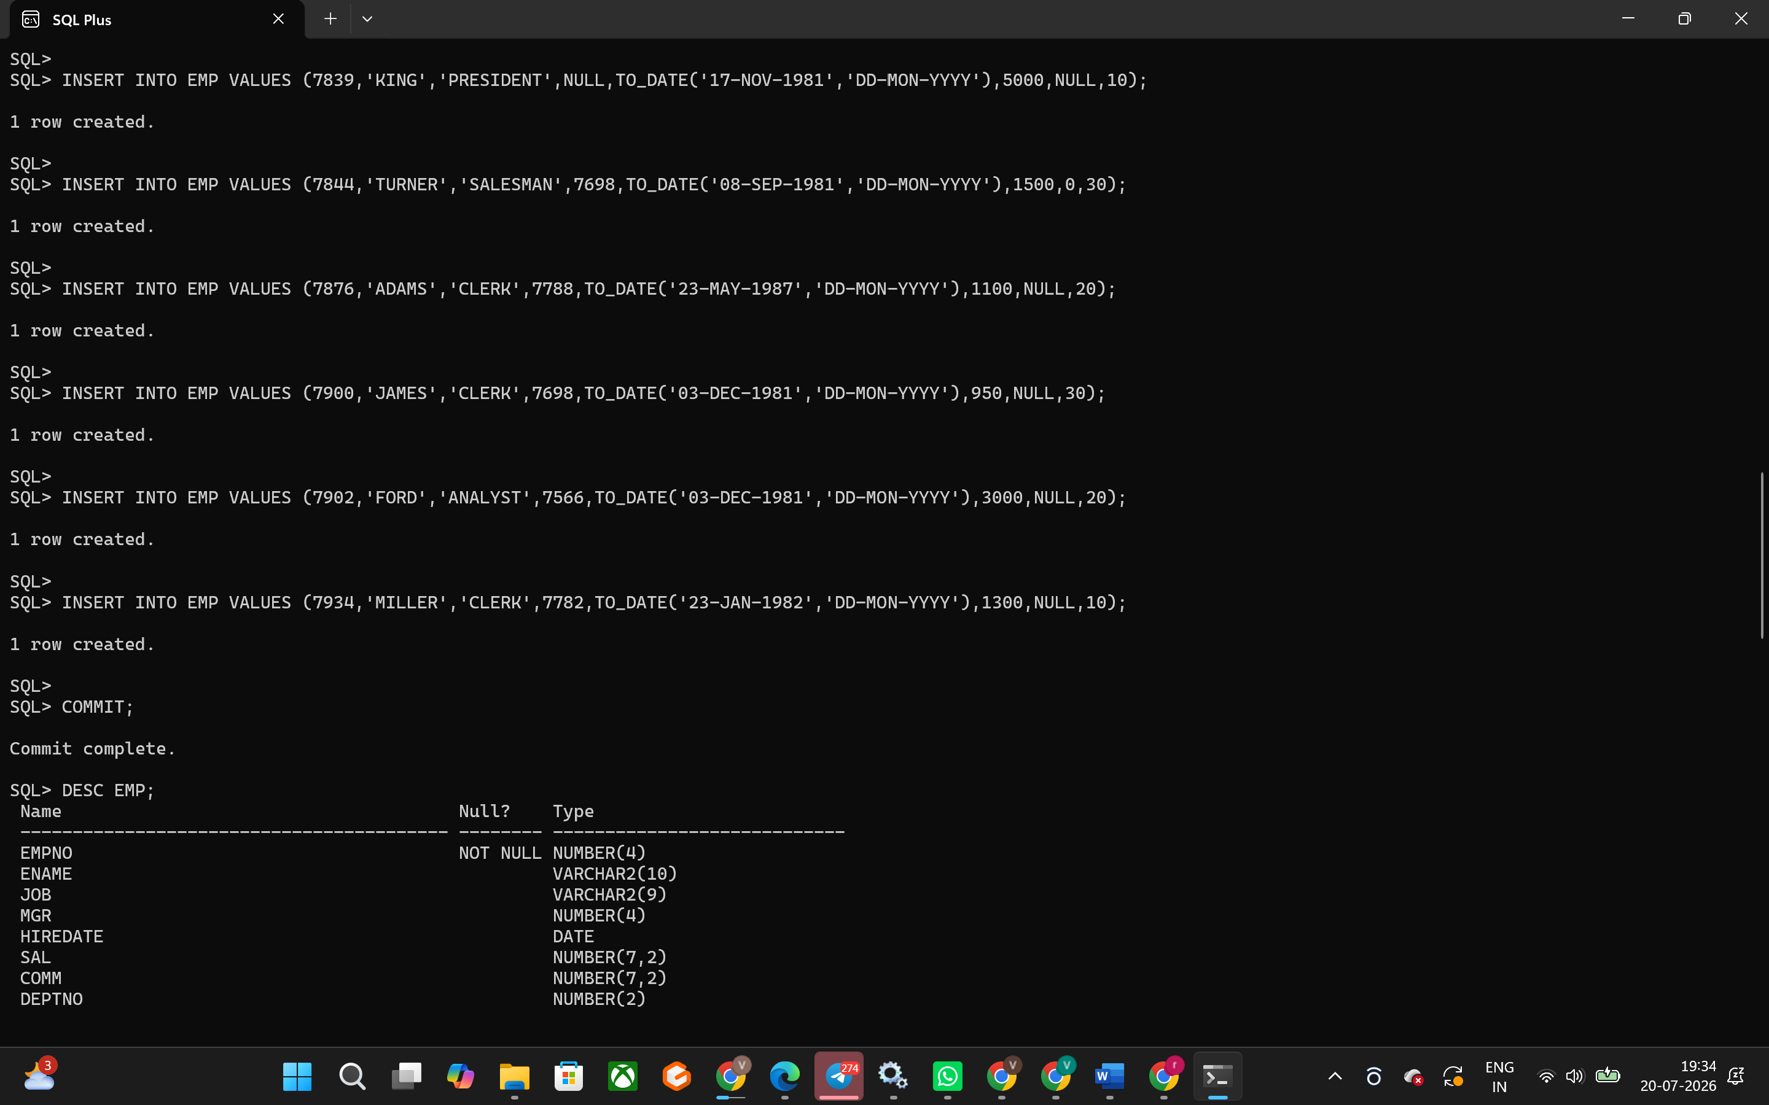
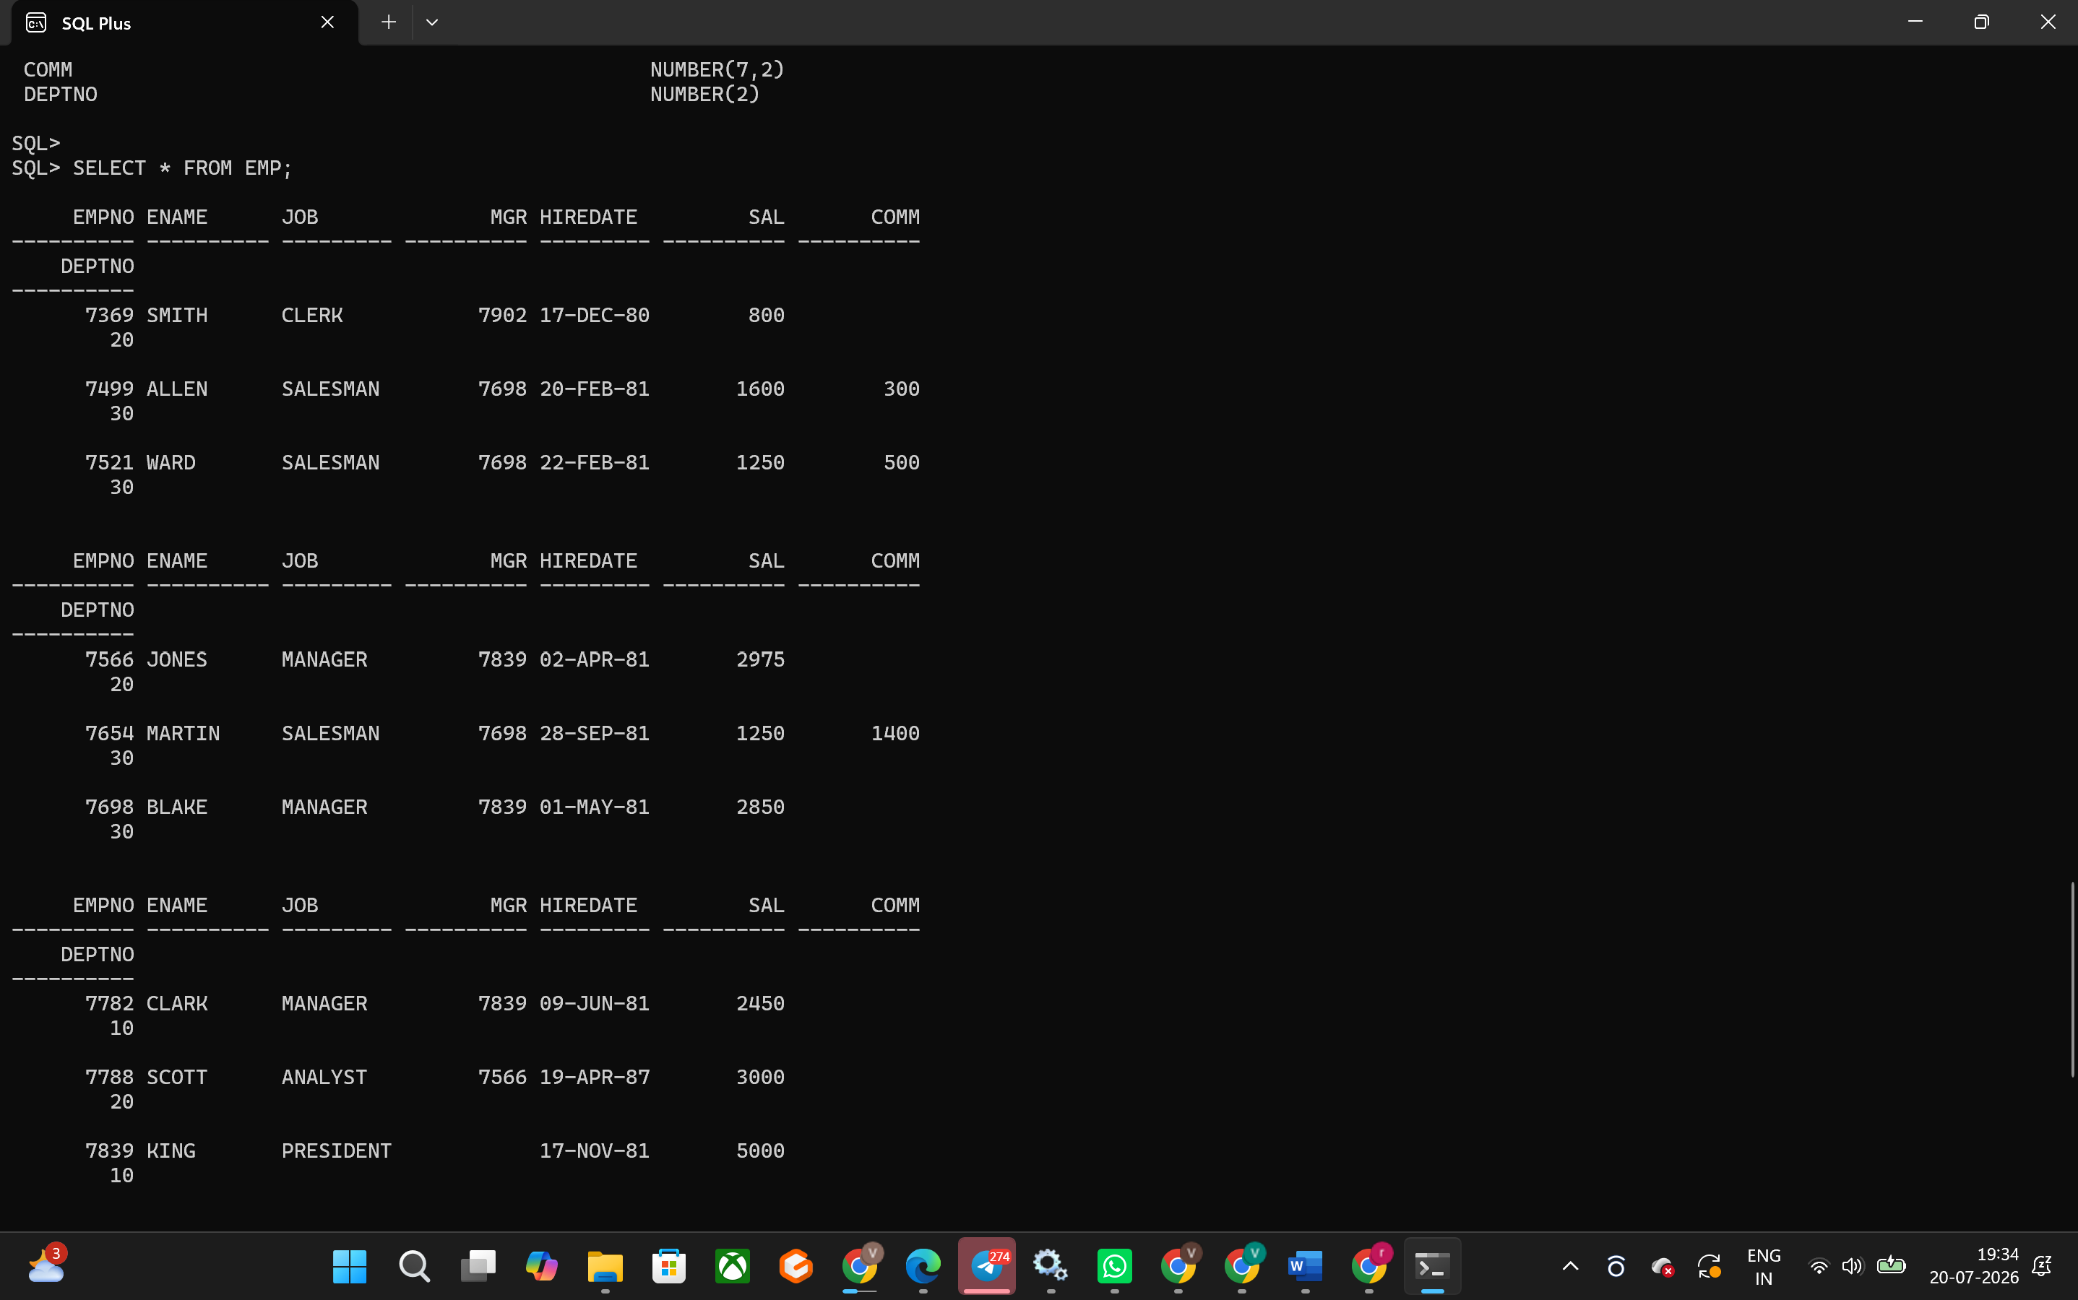
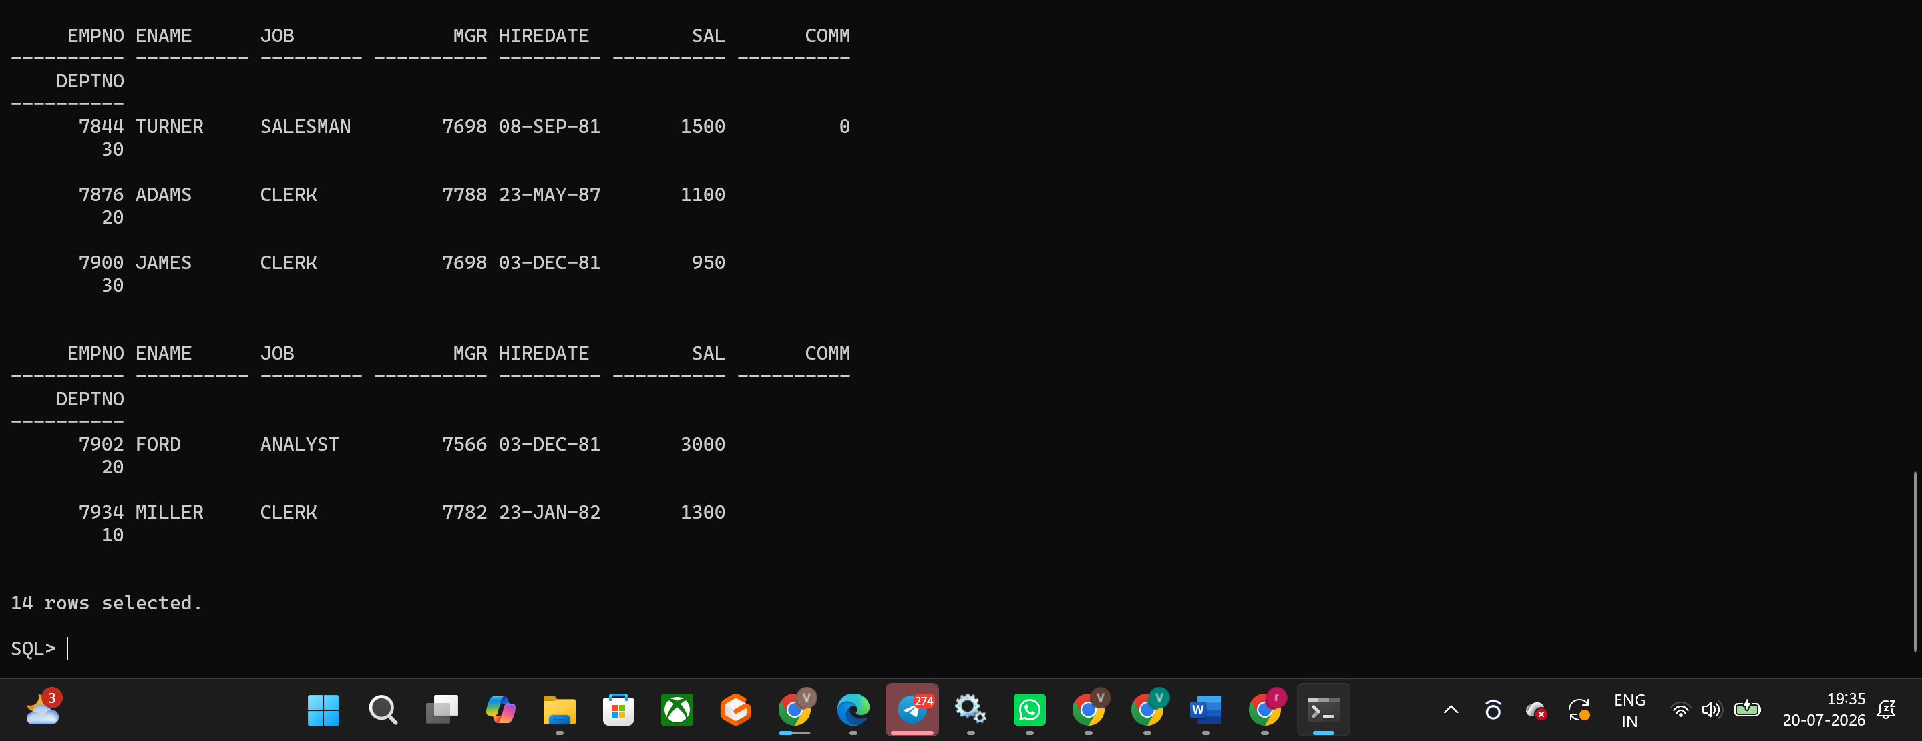

Hands-on Assignment 3
Question
Display the ENAME and DEPTNO from the EMP table whose EMPNO is 7788.
