Wipro TalentNext – Database Solution Expert
Module 2: Restricting and Sorting Data

Hands-on Assignment 1
Question
Display the ENAME, SAL, and COMM from the EMP table who earn commission and sort the records in descending order of Salary and Commission. Use the column's numeric position in the ORDER BY clause.
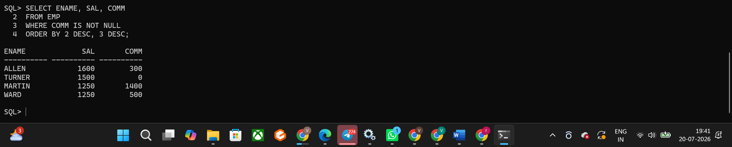
Hands-on Assignment 2
Question
The HR department needs a query to display all unique job codes from the EMP table.
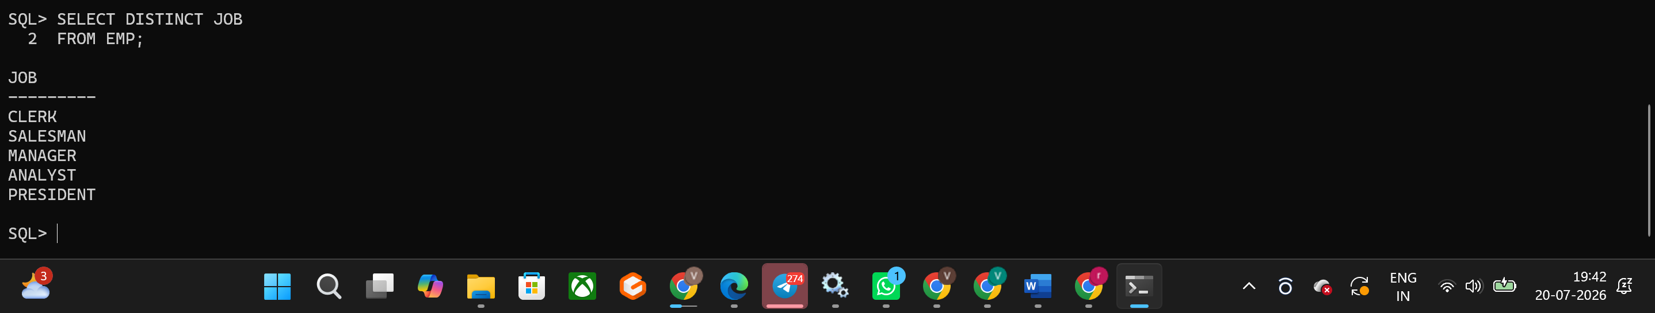
Hands-on Assignment 3
Question
The HR department wants more descriptive column headings for its report on employees. Name the column headings Emp #, Employee, Job, and Hire Date, respectively, by giving Column Alias.
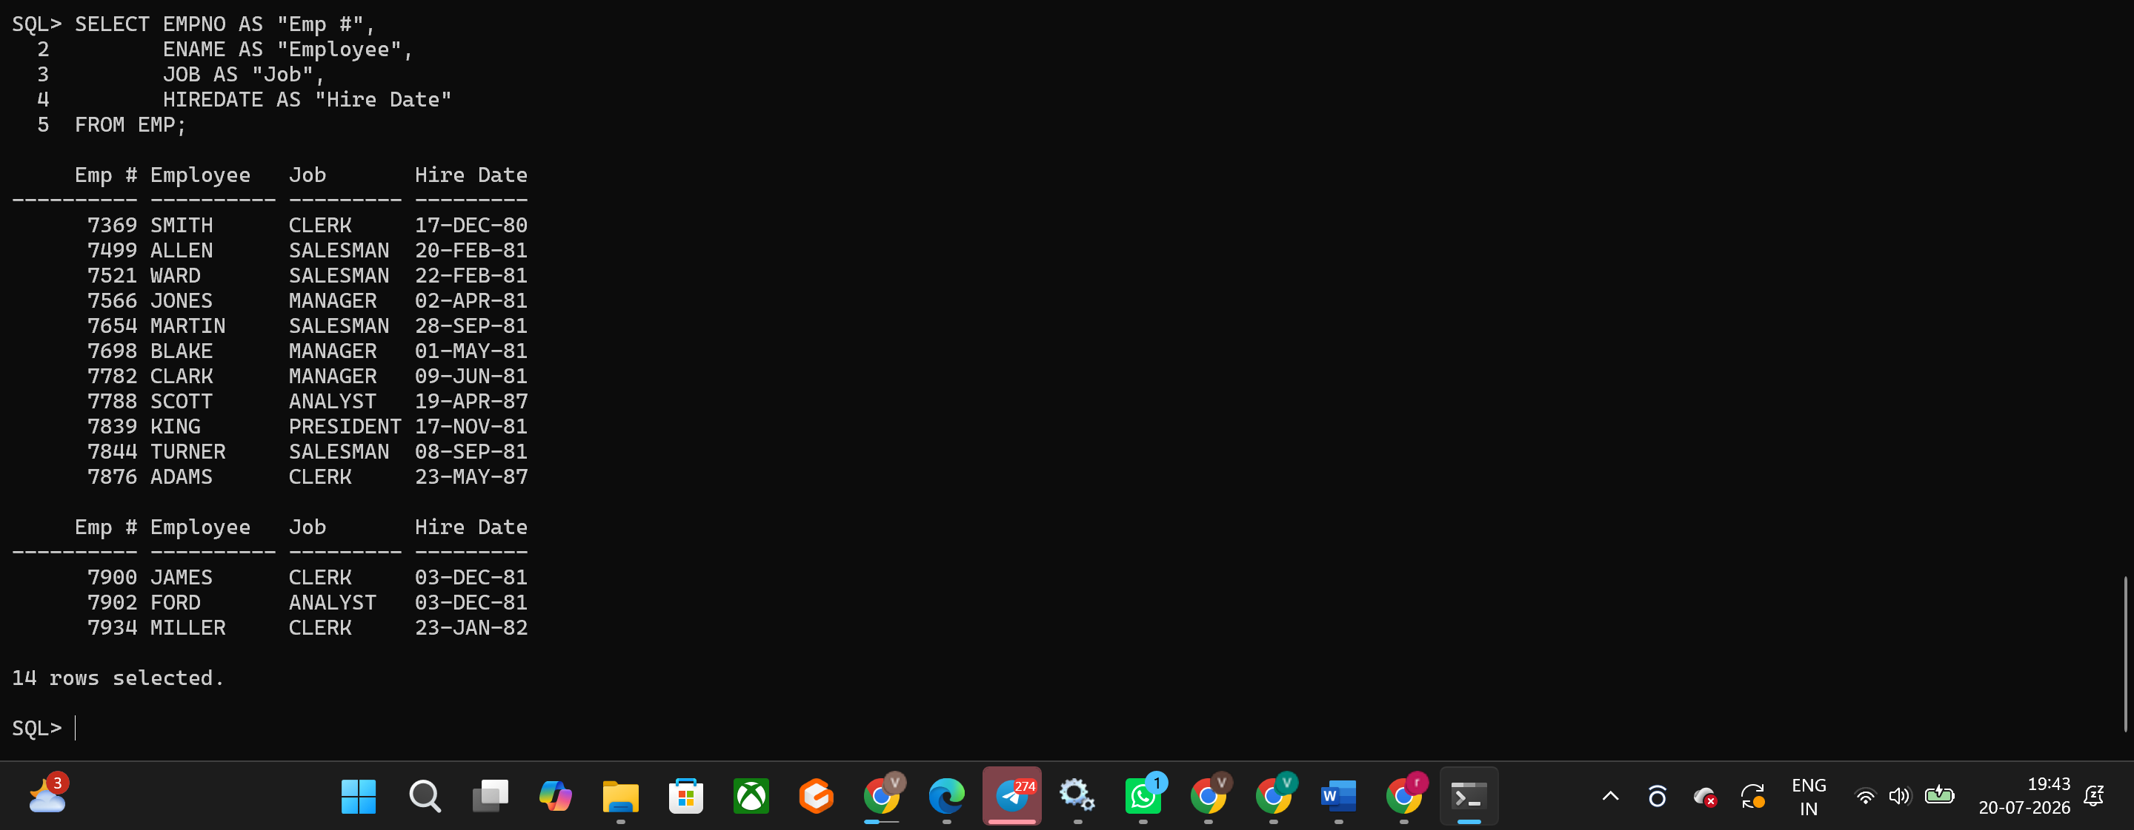
Hands-on Assignment 4
Question
The HR department has requested a report of all employees and their job IDs. Display the last name concatenated with the job ID (separated by a comma and space) and name the column Employee and Title.
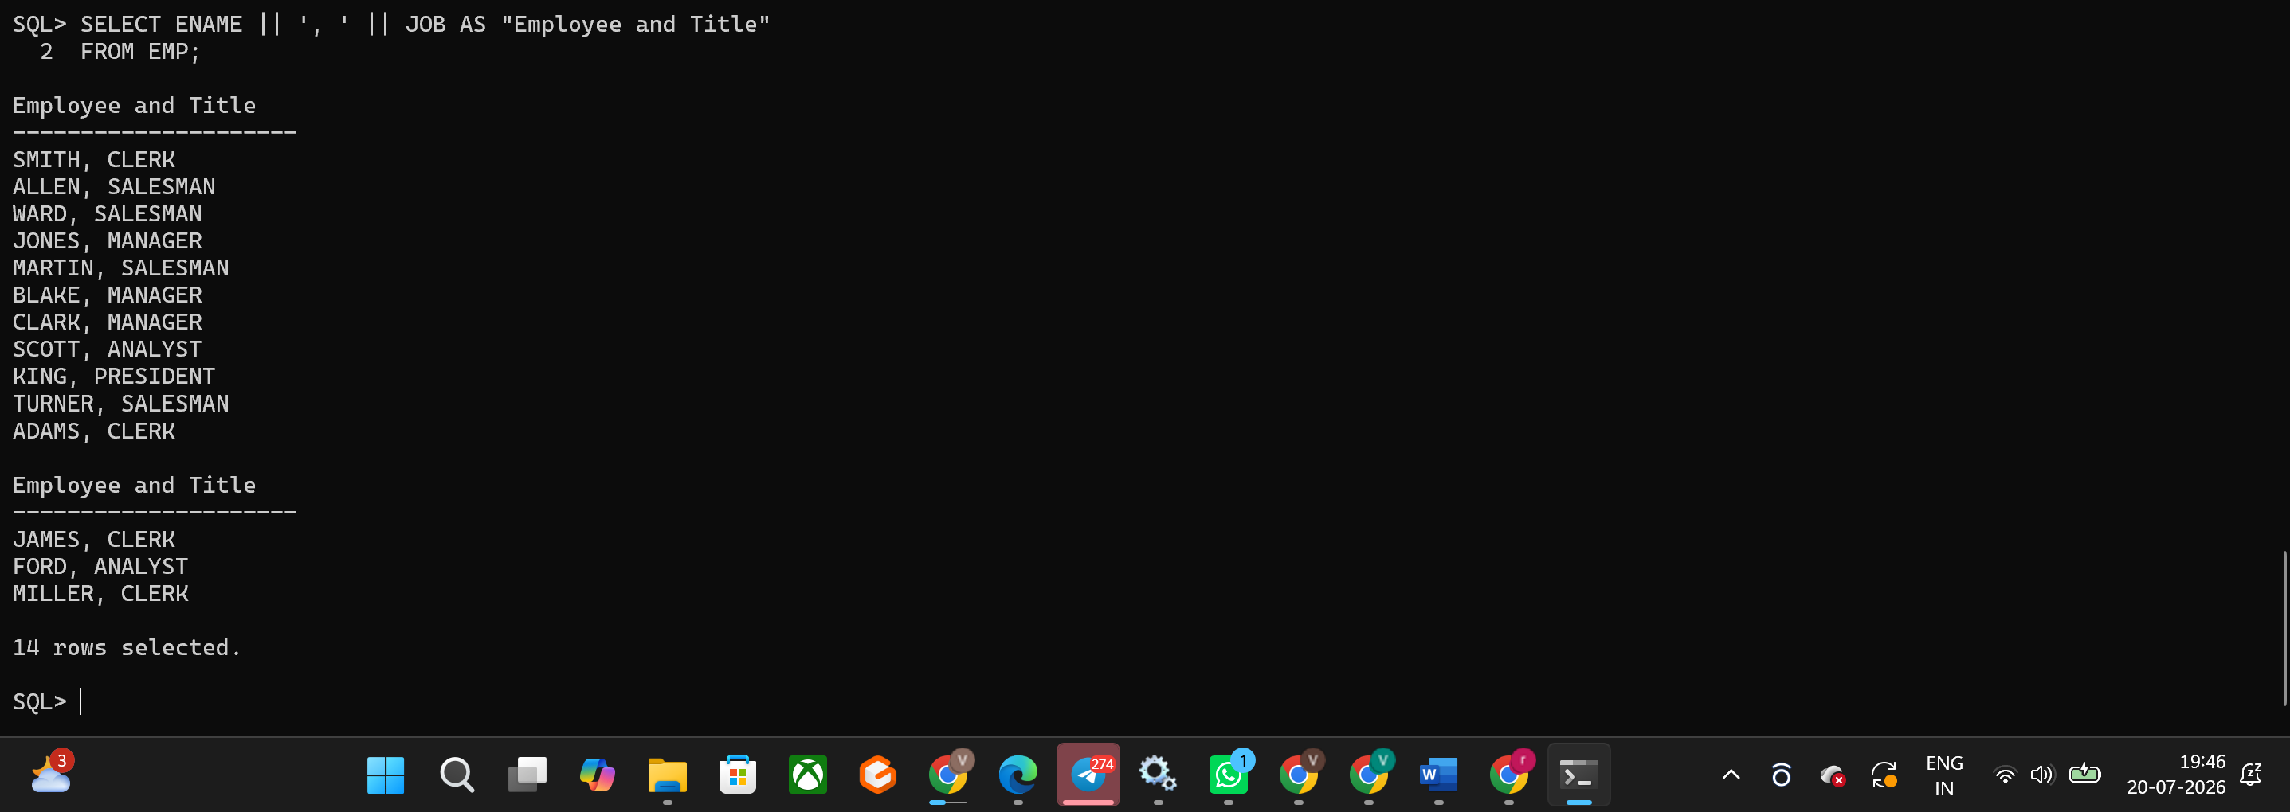
Hands-on Assignment 5
Question
Display ENAME, JOB, HIREDATE and MGR separated by commas. Name the column THE_OUTPUT.
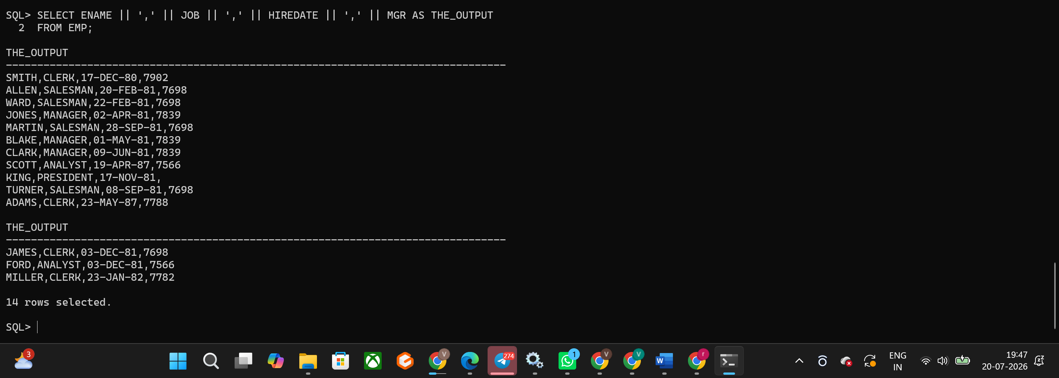
Hands-on Assignment 6
Question
Display the ENAME, JOB and HIREDATE for employees SCOTT or TURNER. Sort by Hire Date in ascending order.
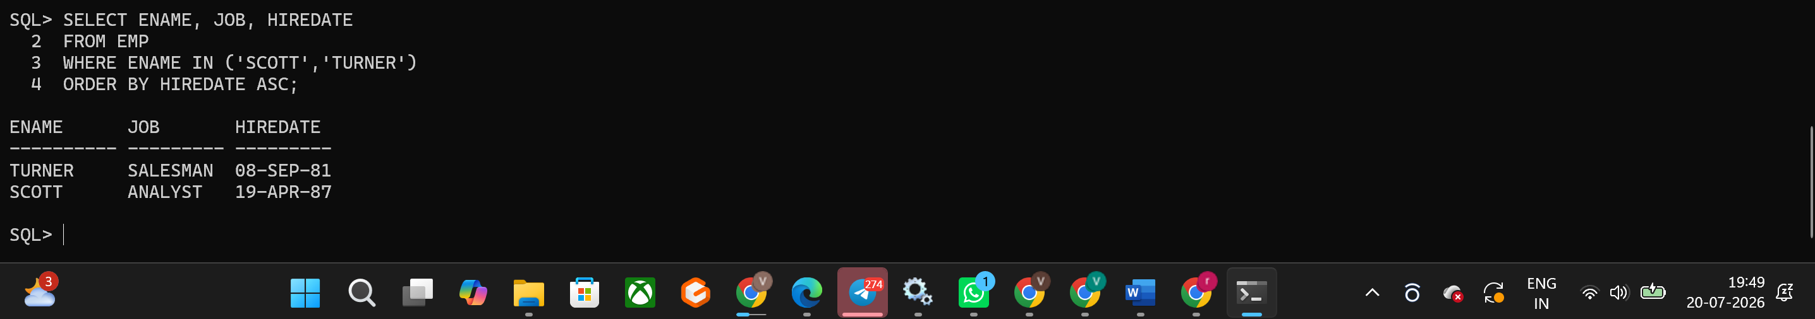
Hands-on Assignment 7
Question
Display the ENAME and DEPTNO of employees in departments 20 or 30, ordered alphabetically by ENAME.
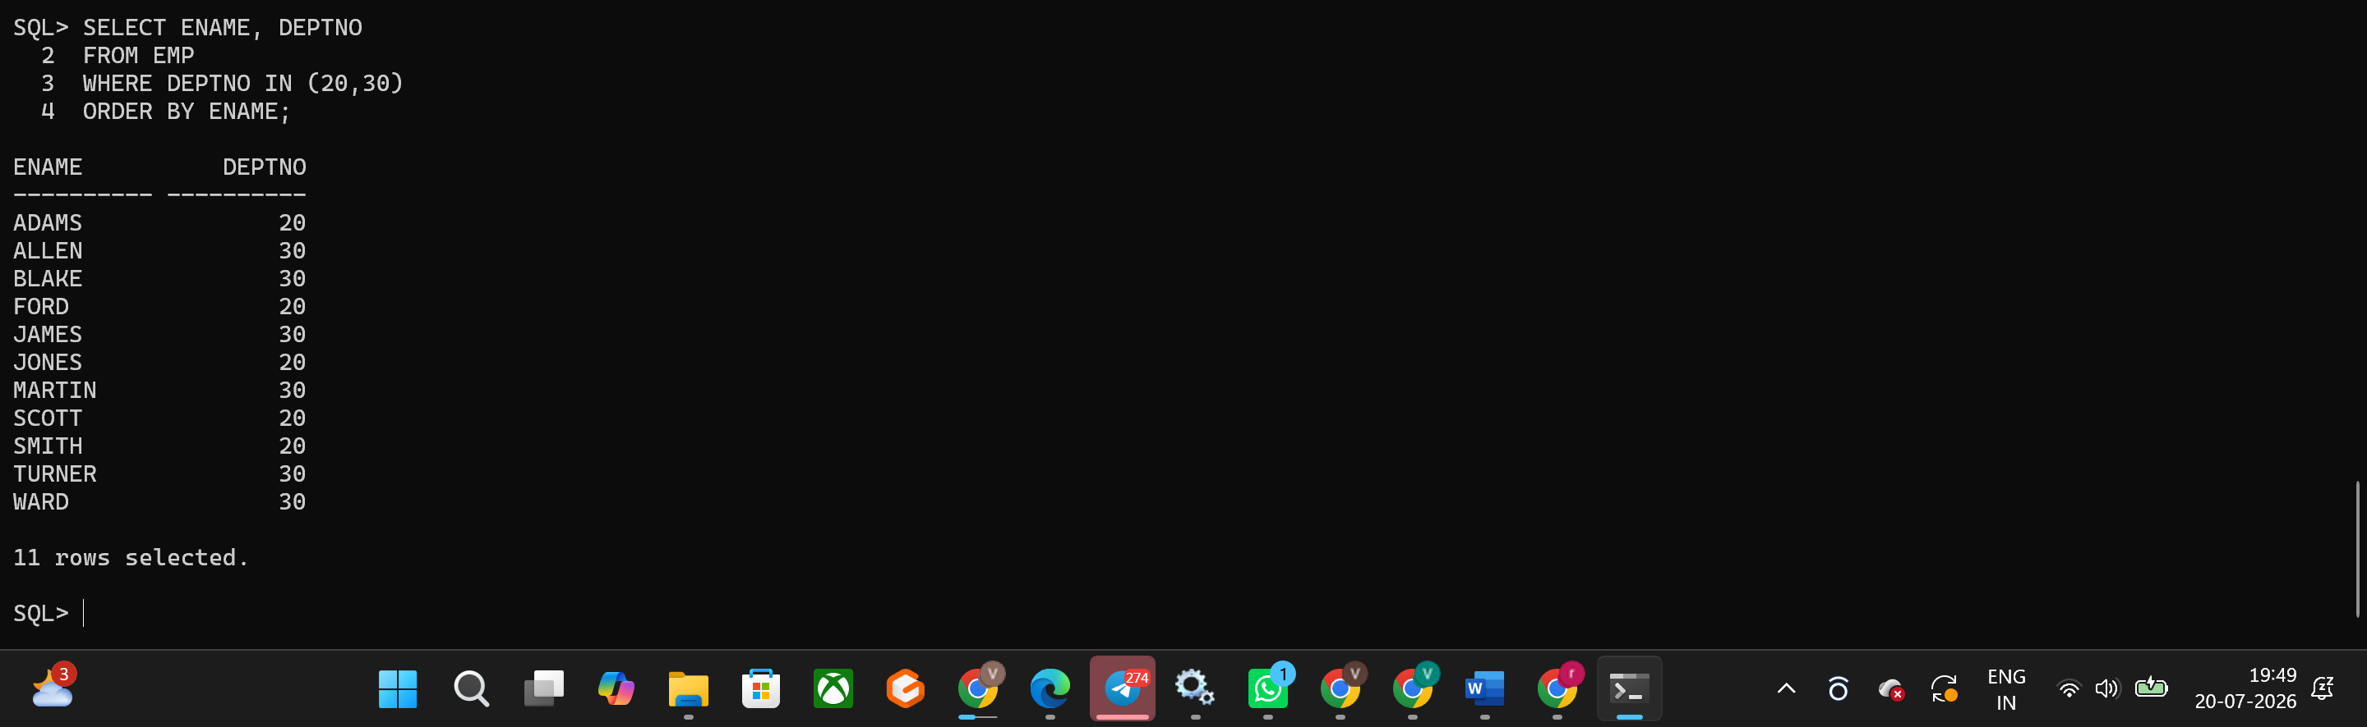
Hands-on Assignment 8
Question
Display the last name and salary of employees who earn between 2000 and 3000 and are in department 20 or 30. Label the columns Employee and Monthly Salary.
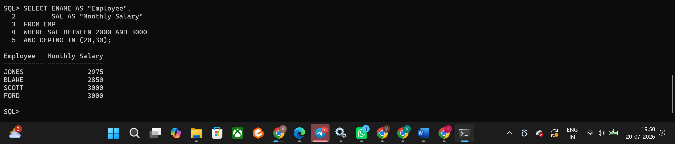
Hands-on Assignment 9
Question
Display the last name and hire date for all employees hired in 1981.
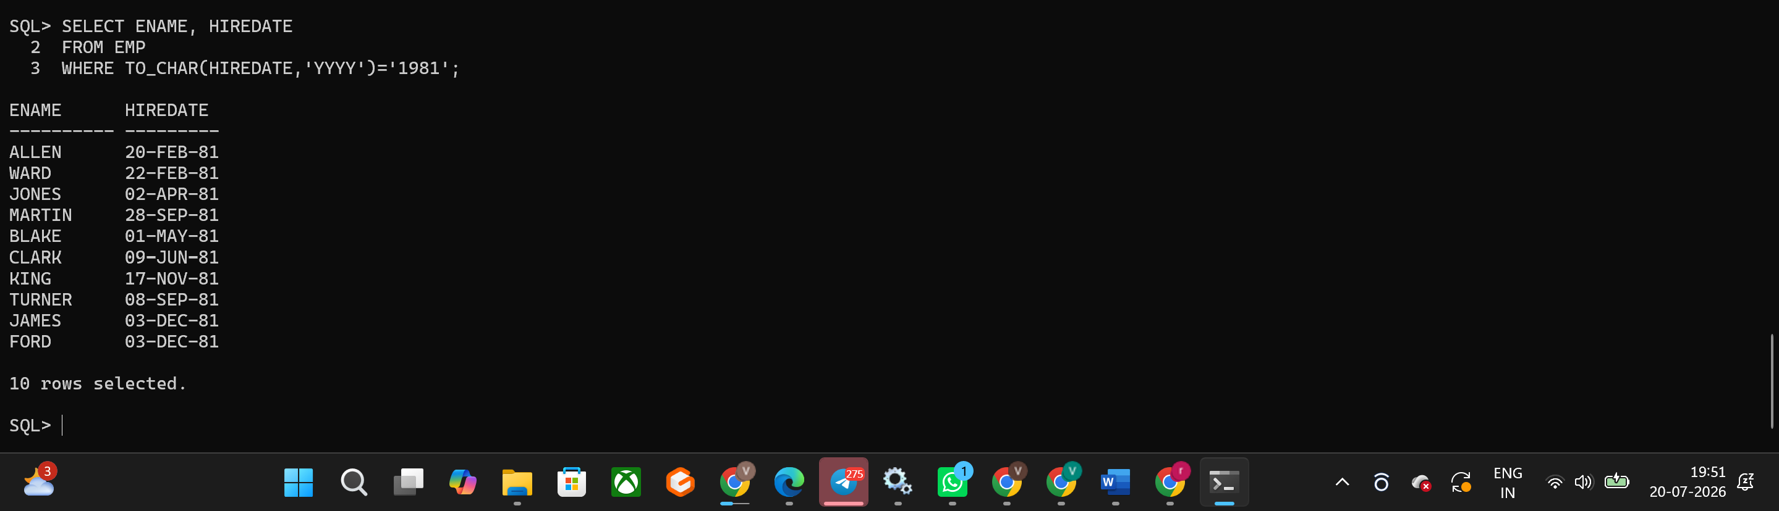
Hands-on Assignment 10
Question
Display the ENAME and SAL of employees who earn more than the amount entered by the user.
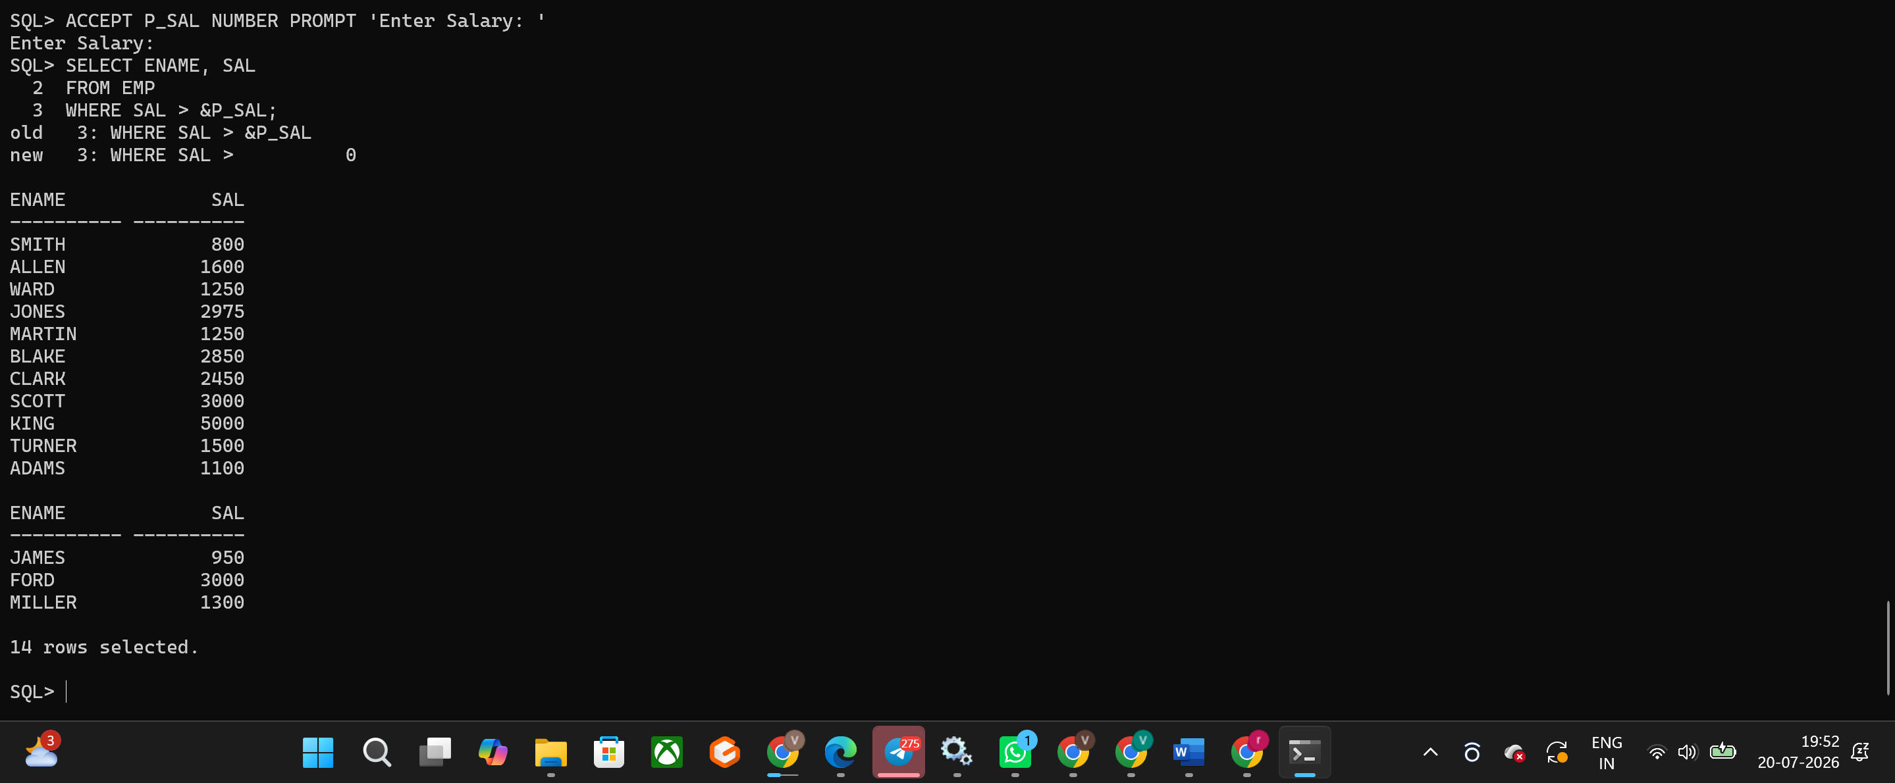
Hands-on Assignment 11
Question
Display the last name and job title of all employees who do not have a manager.
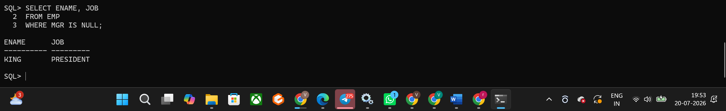

Hands-on Assignment 12
Question
Prompt the user for a Manager ID and display EMPNO, ENAME, SAL, DEPTNO. Sort the records by a column chosen by the user.
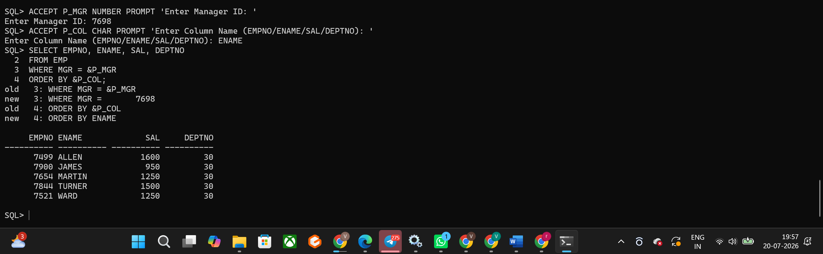
Hands-on Assignment 13
Question
The HR department wants to run reports based on a manager. Create a query that prompts the user for a MGR and generates the EMPNO, ENAME, SALARY, and DEPARTMENT for that manager's employees. The report should be sorted on a selected column.
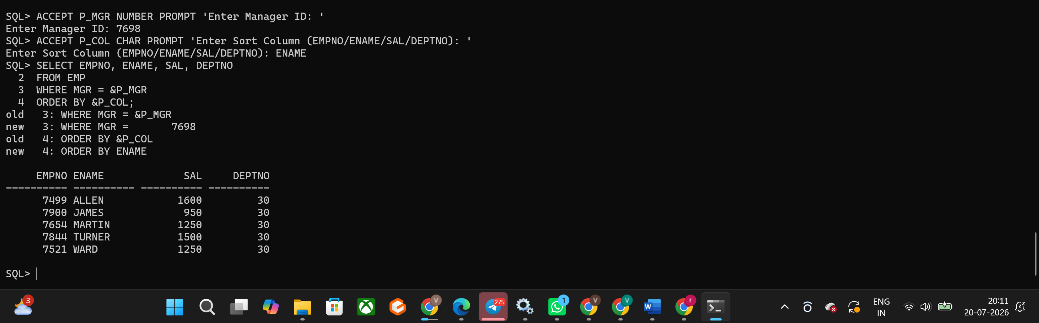
Hands-on Assignment 14
Question
Display all employee last names in which the third letter of the name is 'A'.
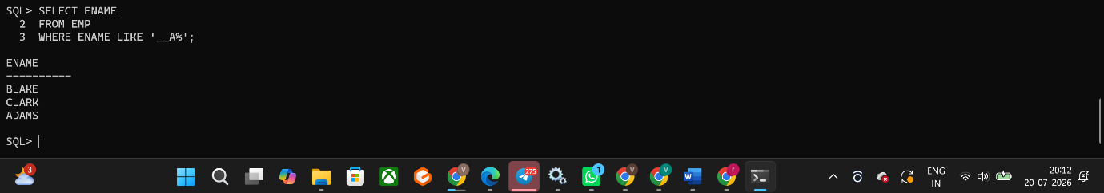
Hands-on Assignment 15
Question
Display the last name of all employees who have both an A and an S in their ENAME.
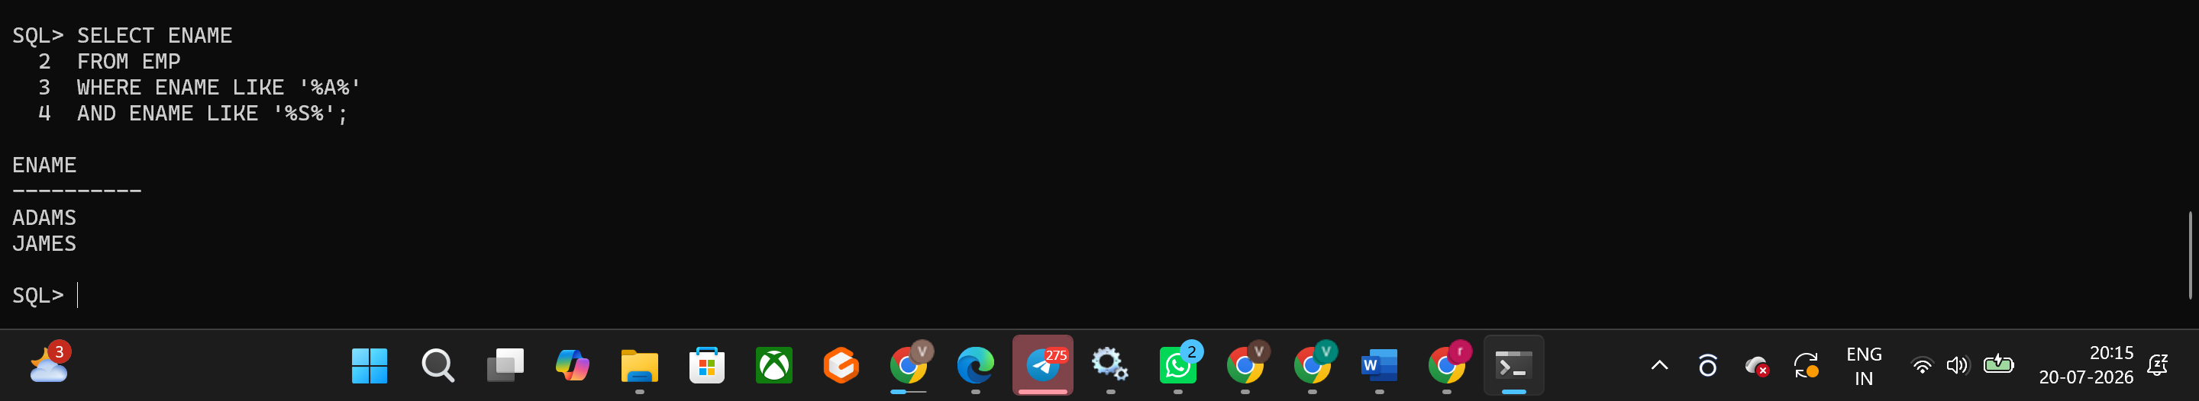
Hands-on Assignment 16
Question
Display the ENAME, JOB, and SAL for all employees whose JOB is CLERK and whose salary is 800, 950, or 1300.
