Wipro TalentNext – Database Solution Expert
Module 2: Using Single-Row Functions to Customize Output

Hands-on Assignment 1
Question
Write a query to display the current date. Label the column Date.
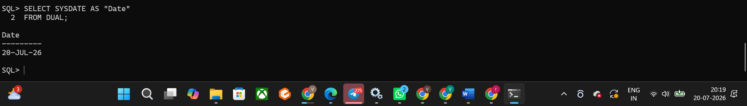
Hands-on Assignment 2
Question
The HR department needs a report to display the employee number, last name, salary, and salary increased by 15.5% (expressed as a whole number) for each employee. Label the column New Salary.
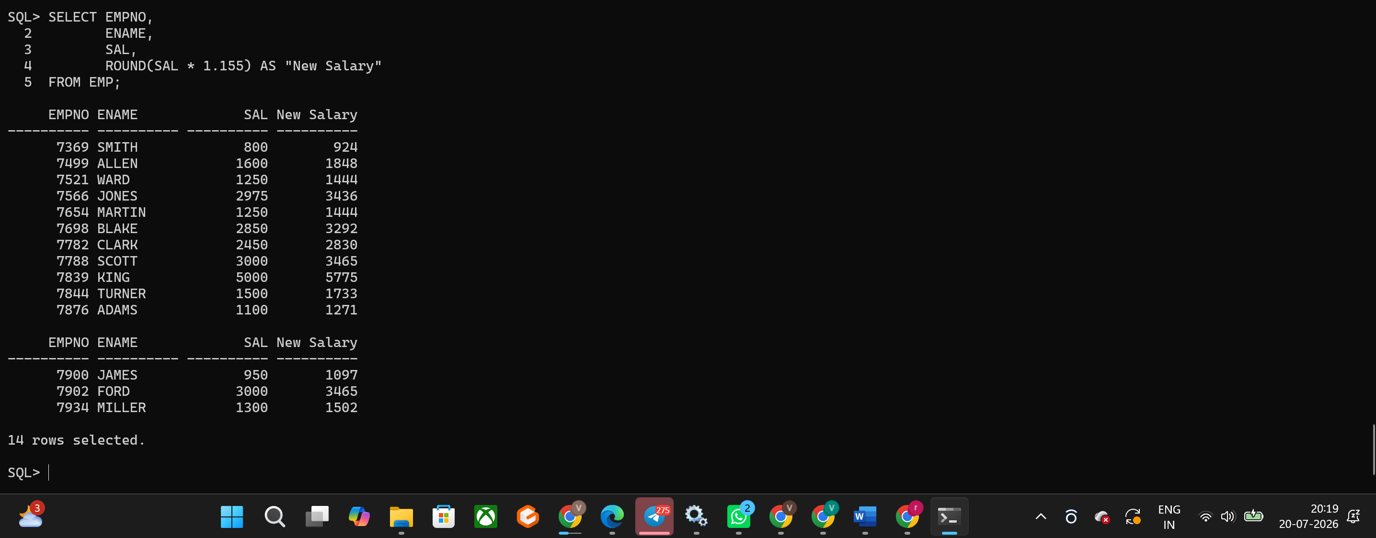
Hands-on Assignment 3
Question
Modify the previous query to add a column that subtracts the old salary from the new salary. Label the column Increase.
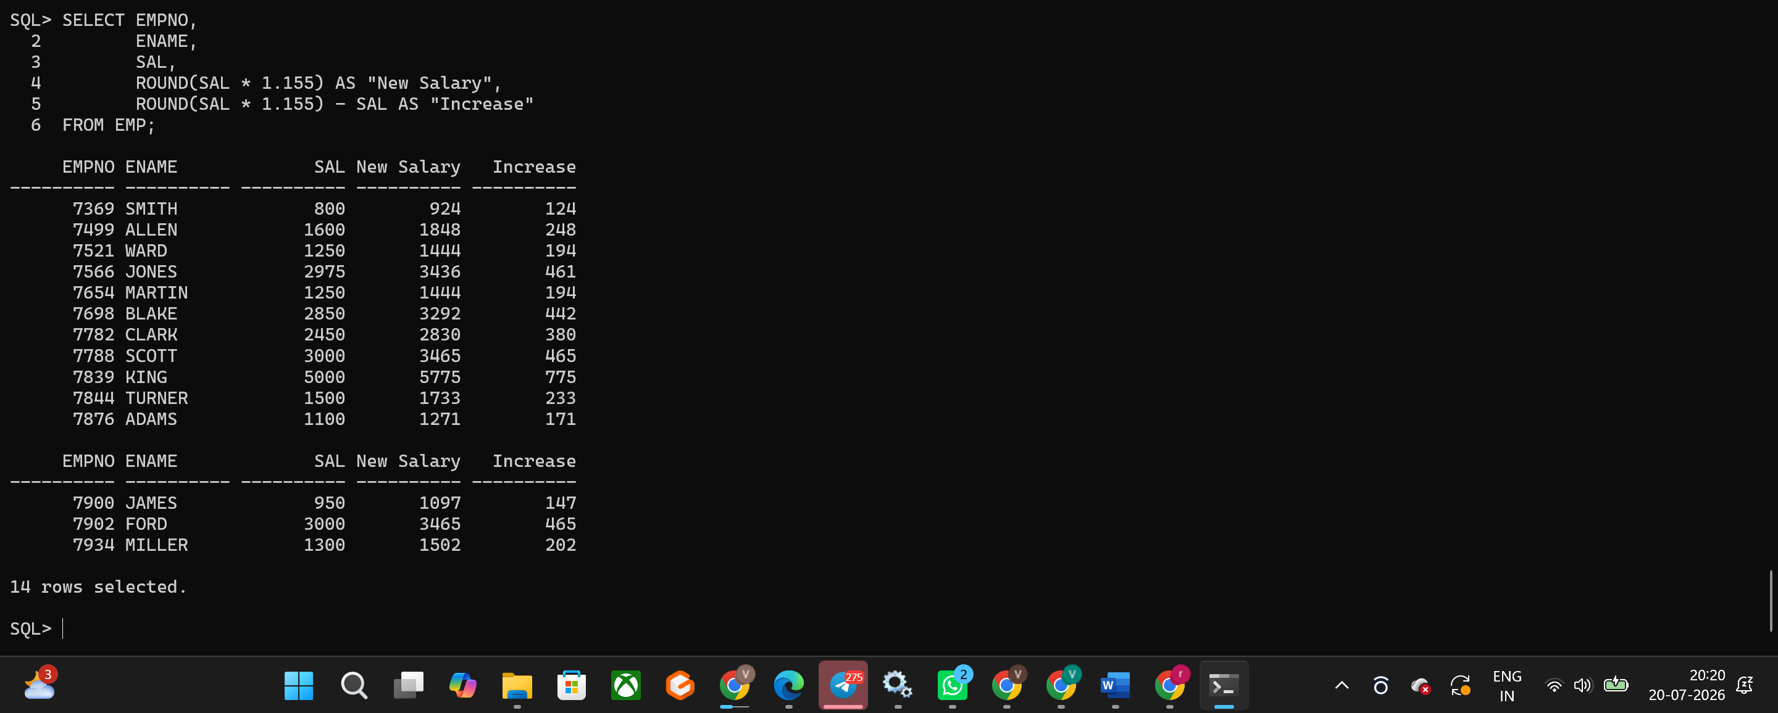
Hands-on Assignment 4
Question
Write a query that displays the employee name (first letter uppercase, remaining lowercase) and the length of the name for employees whose names start with J, A, or M. Sort the results by employee name.
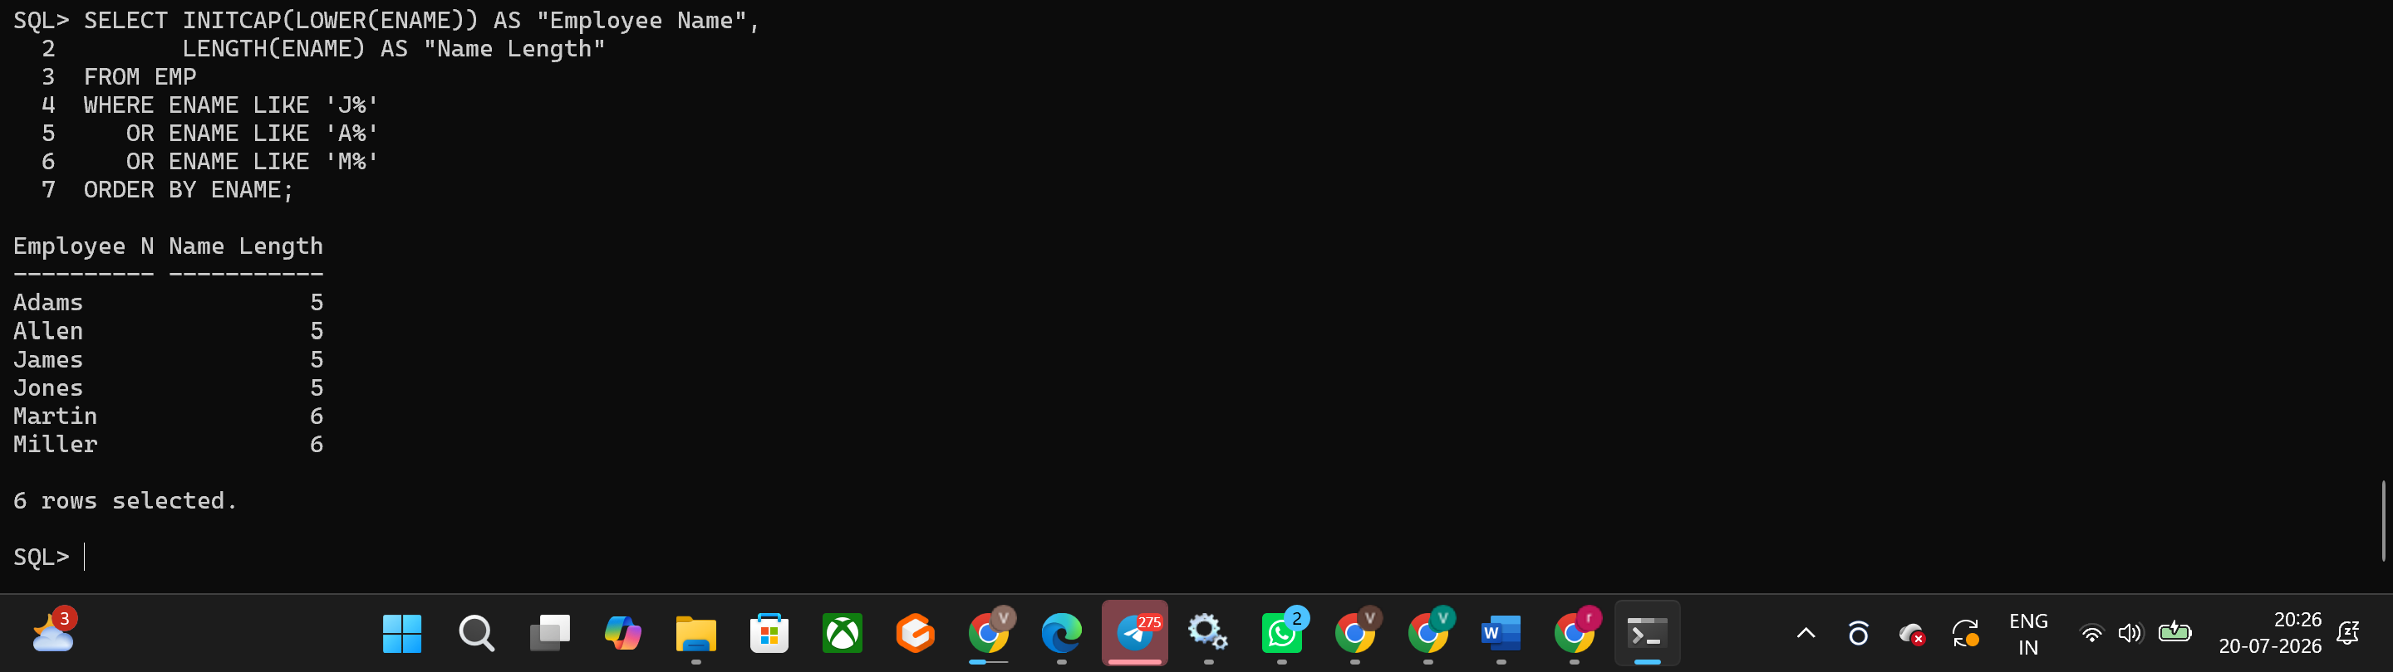
Hands-on Assignment 5
Question
Prompt the user to enter the first letter of the employee name and display employees whose names start with that letter.
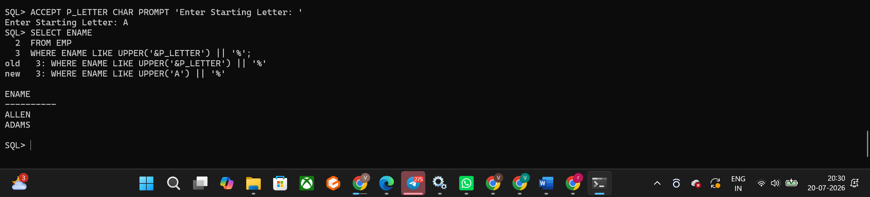
Hands-on Assignment 6
Question:
The HR department wants to find the length of employment for each employee. Display the employee name and calculate the number of months between today and the employee's hire date. Label the column MONTHS_WORKED. Round the number of months to the nearest whole number and order the results by MONTHS_WORKED.
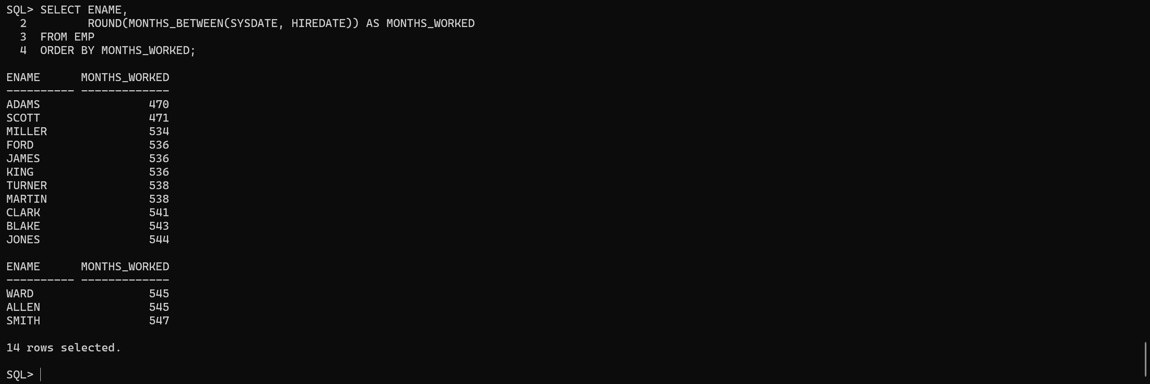

Hands-on Assignment 7
Question
Create a report that displays the following sentence for each employee:
Employee earns Salary monthly but wants three times the salary.
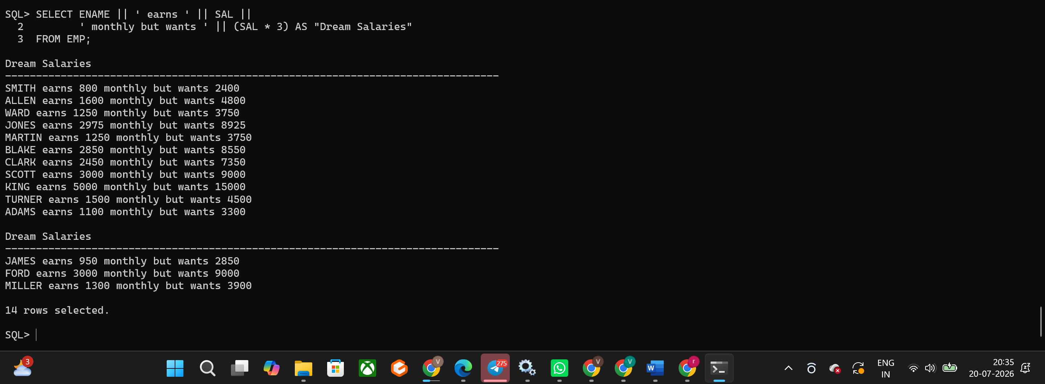
Hands-on Assignment 8
Question
Create a query to display the last name and salary for all employees. Format the salary to be 15 characters long, left-padded with the $ symbol. Label the column SALARY.
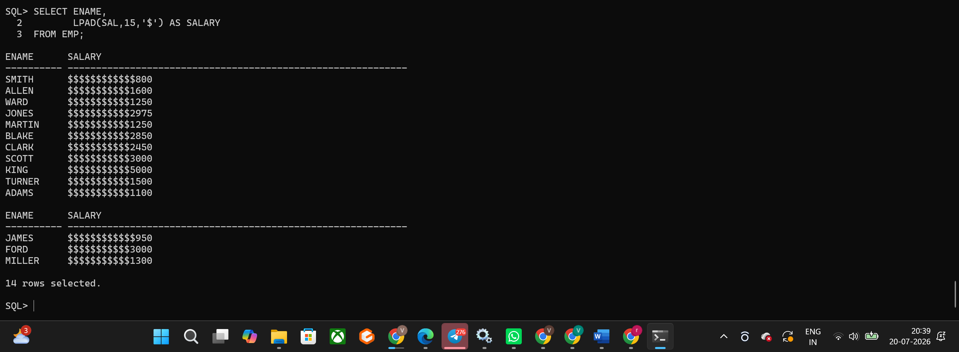
Hands-on Assignment 9
Question
Display each employee's last name, hire date, and salary review date, which is the first Monday after six months of service. Label the column REVIEW. Format the dates to appear in the format similar to "Monday, the Thirty-First of July, 2000."
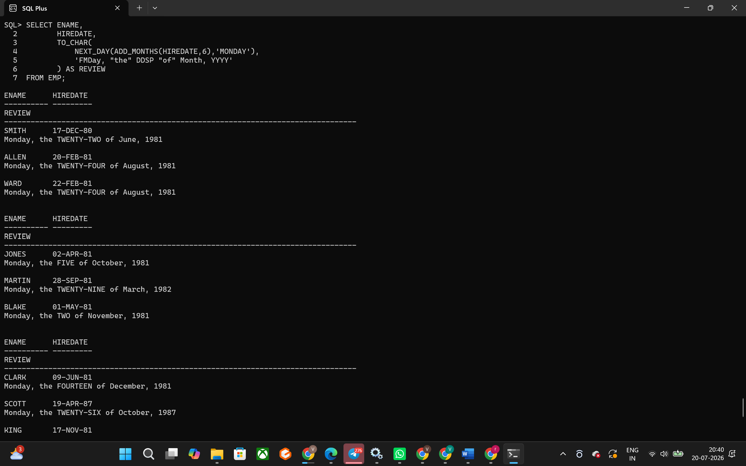
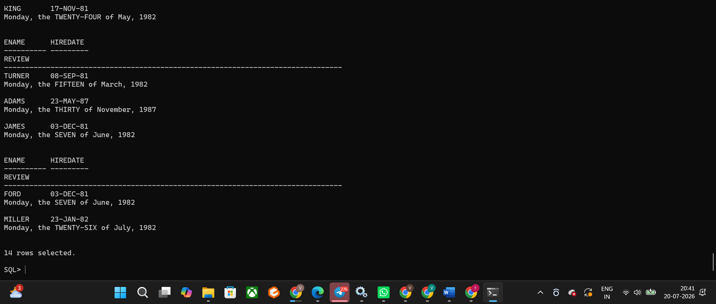
Hands-on Assignment 10
Question
Display the last name, hire date, and day of the week on which the employee started. Label the column DAY. Order the results by the day of the week, starting with Monday.
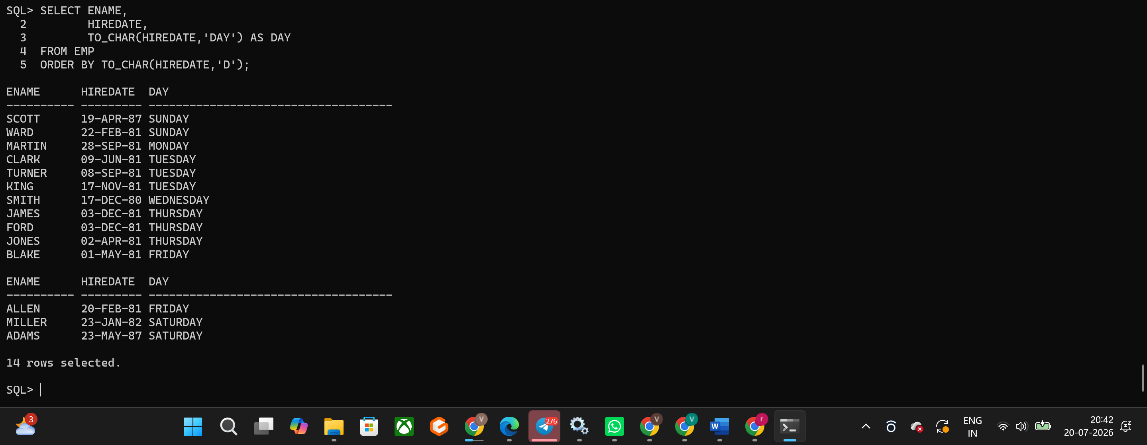
Hands-on Assignment 11
Question
Create a query that displays the employees' last names and commission amounts. If an employee does not earn commission, show "No Commission." Label the column COMM.
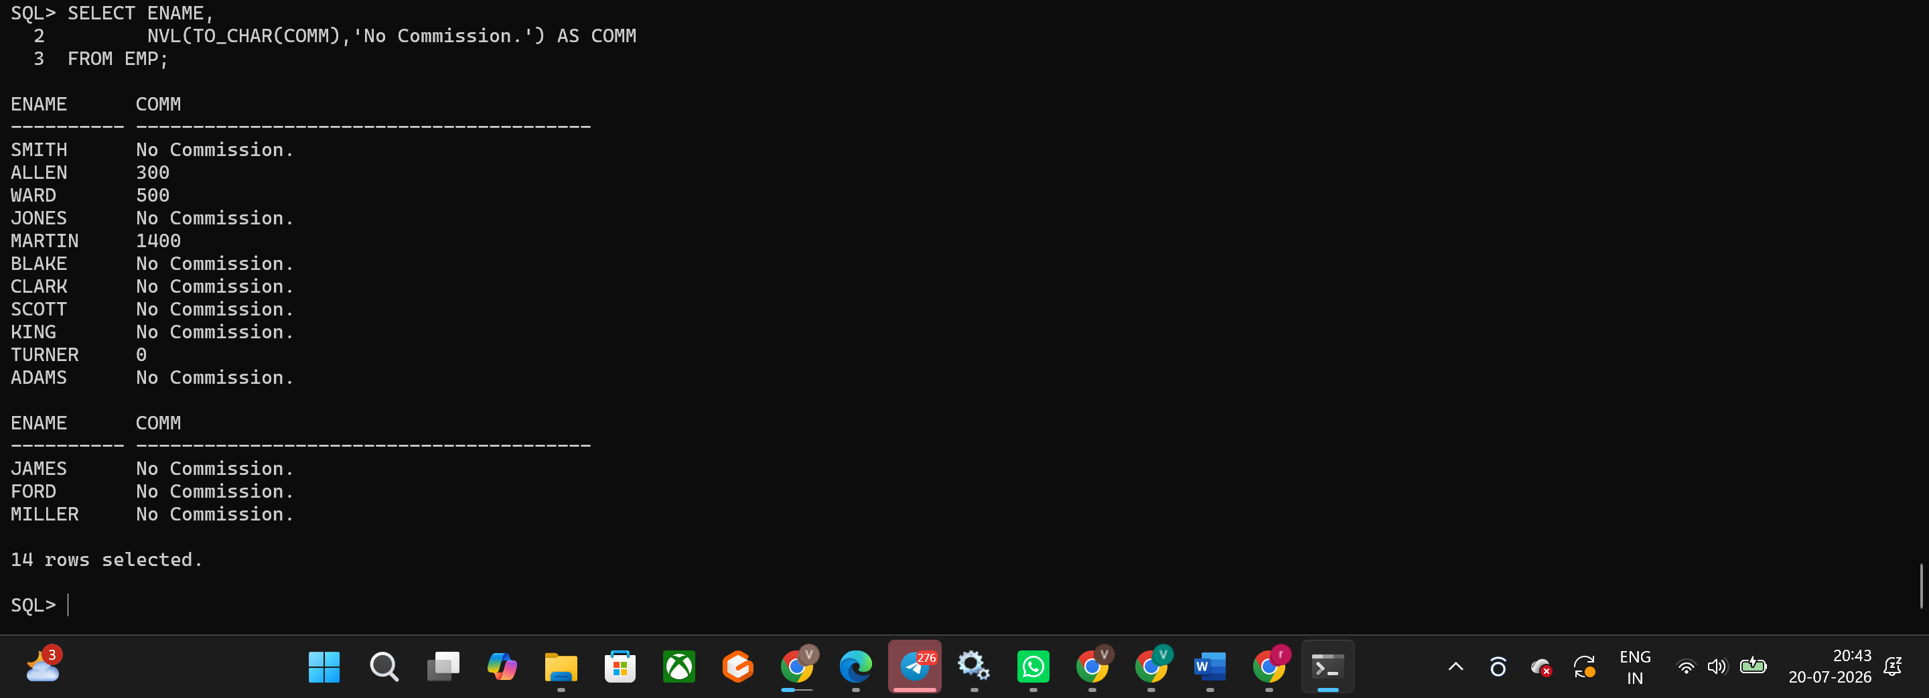
Hands-on Assignment 12
Question
Create a query that displays the first eight characters of the employees' last names and indicates the amounts of their salaries with asterisks. Each asterisk signifies a thousand dollars. Sort the data in descending order of salary. Label the column EMPLOYEES_AND_THEIR_SALARIES.
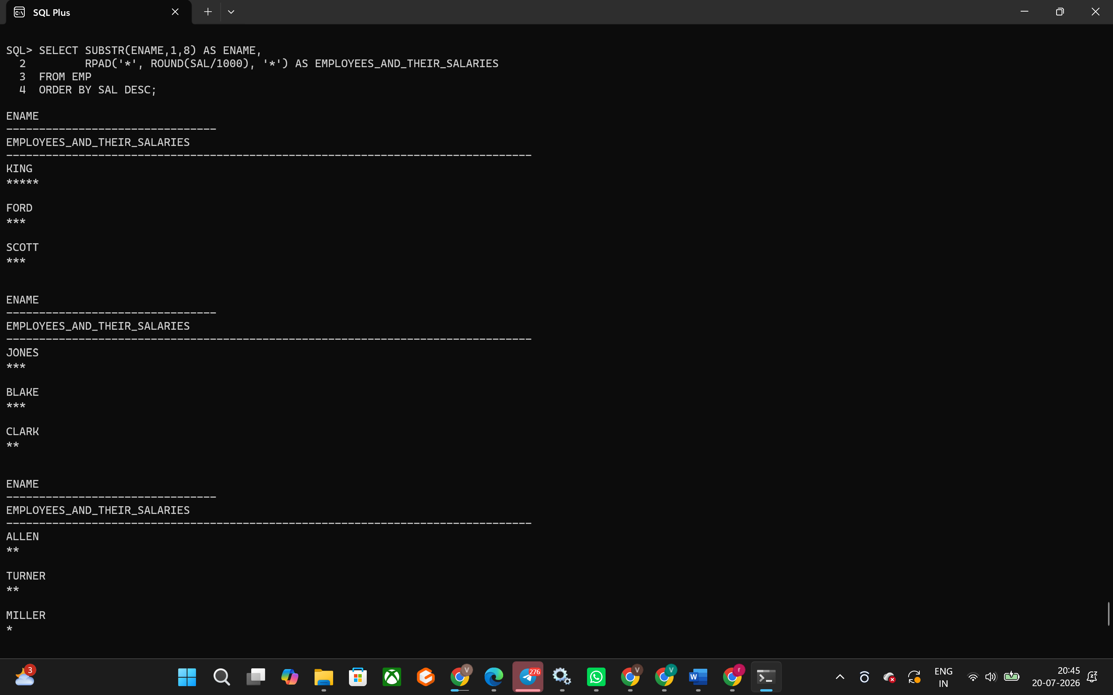
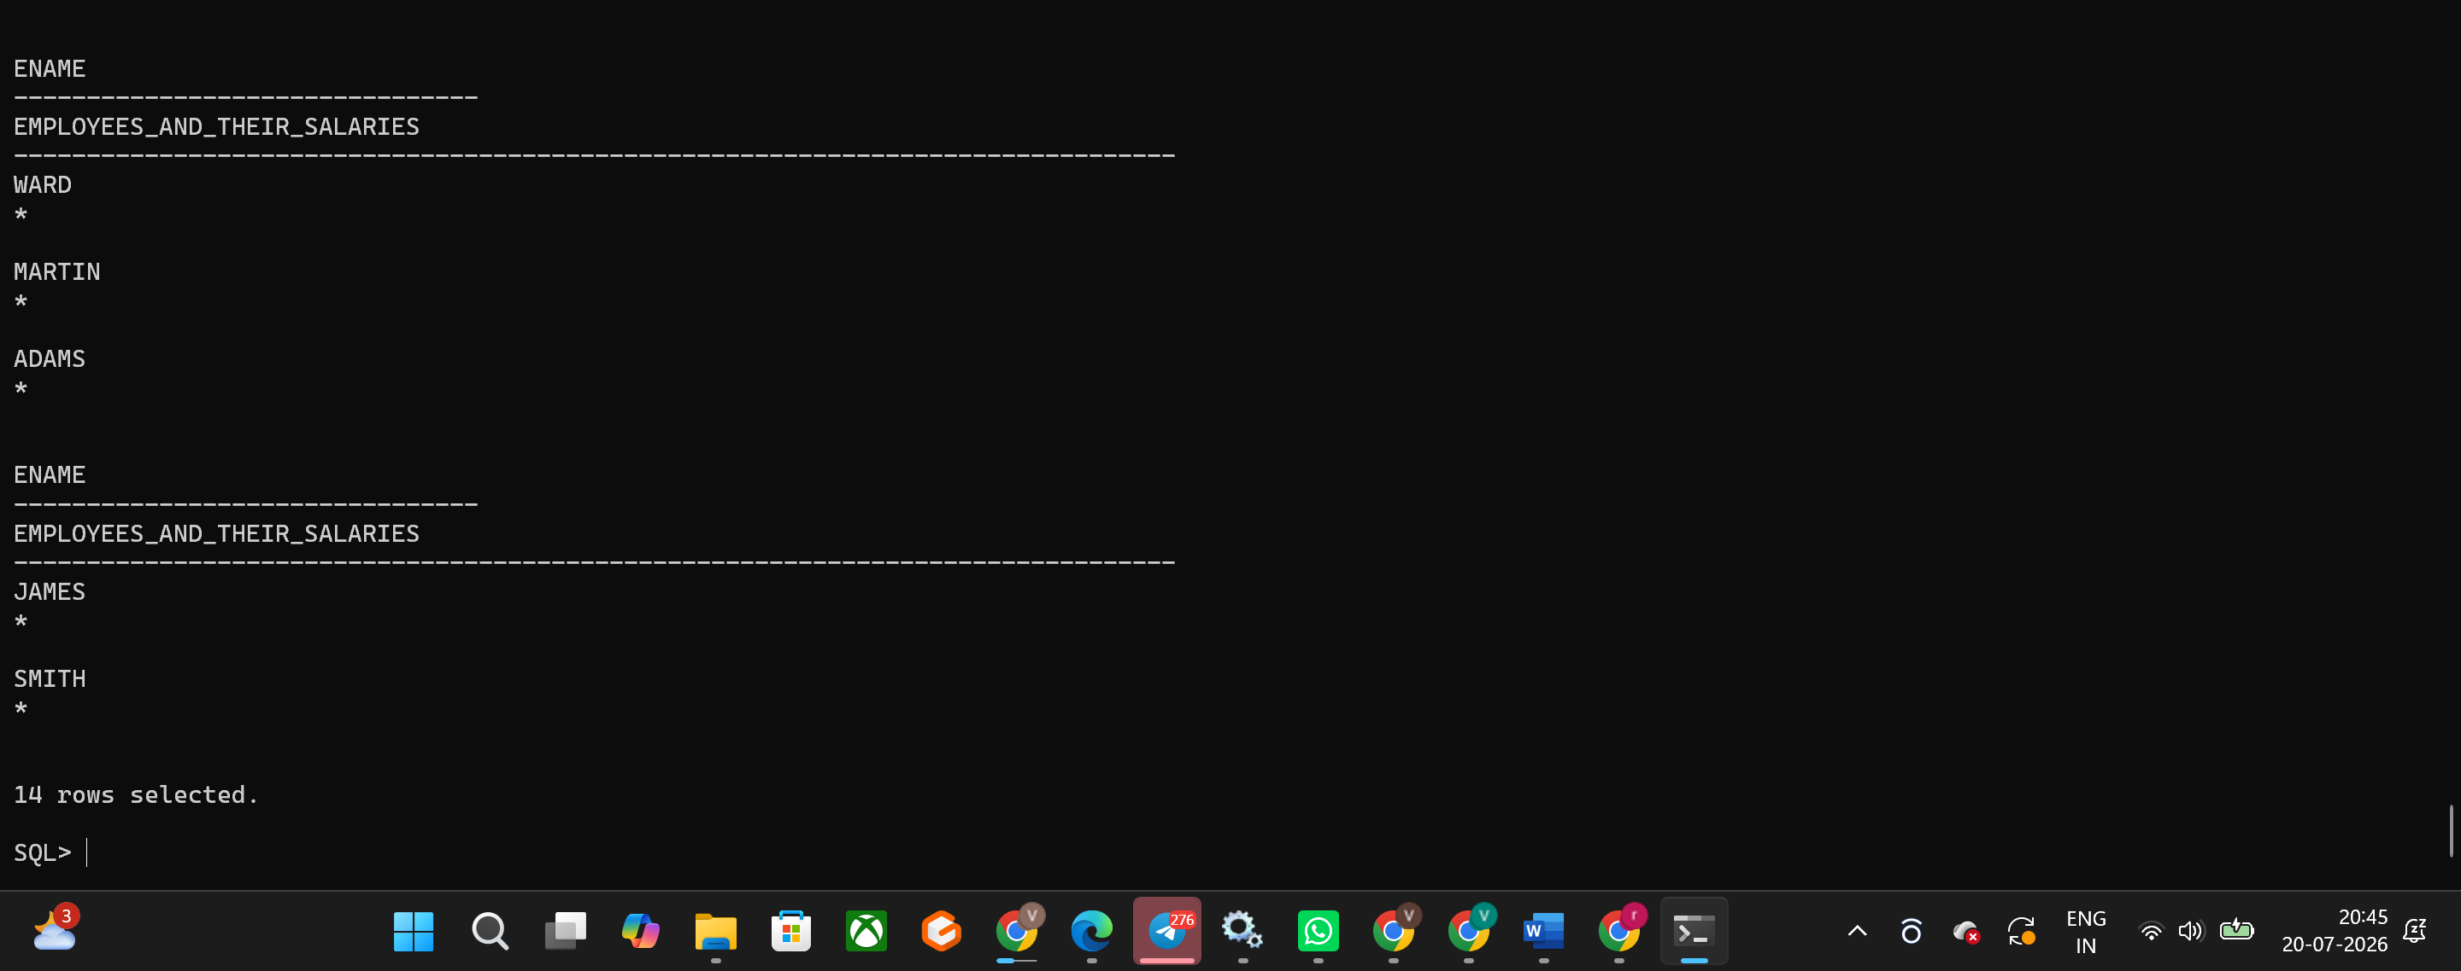
Hands-on Assignment 13
Question
Using the DECODE function, write a query that displays the grade of all employees based on the value of the column JOB_ID, using the following data: PRESIDENT-A, MANAGER-B, SALESMAN-C, CLERK-D.
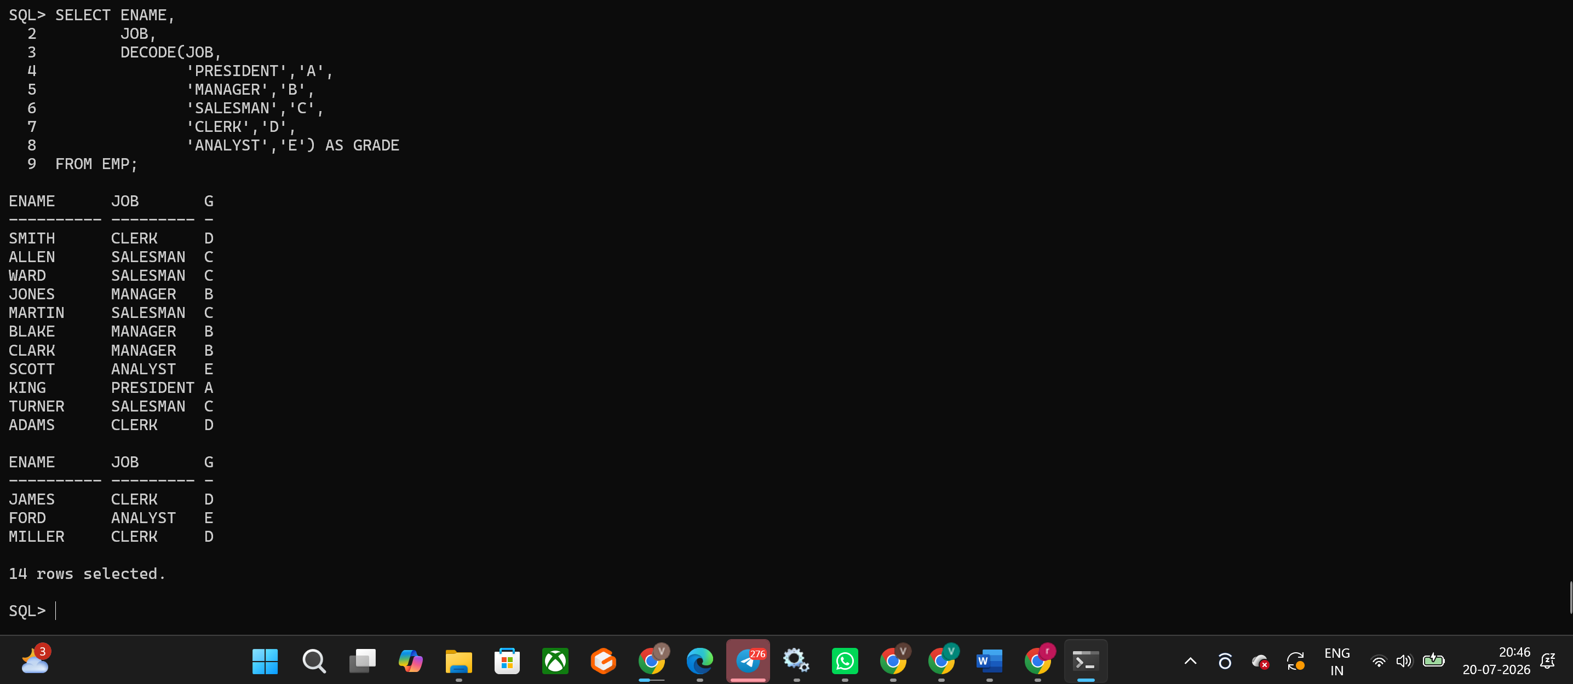
Hands-on Assignment 14
Question
Rewrite the statement in the preceding exercise using the CASE syntax.
