MINI PROJECT
Task 1: Convert to First Normal Form (1NF)
Step 1: Create the original table
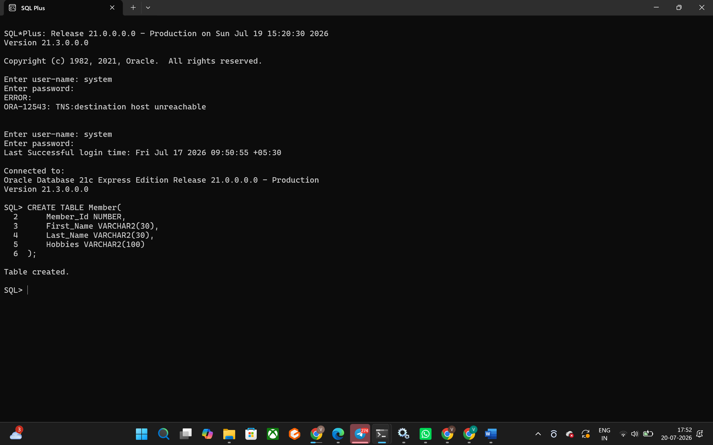
Step 2: Insert data
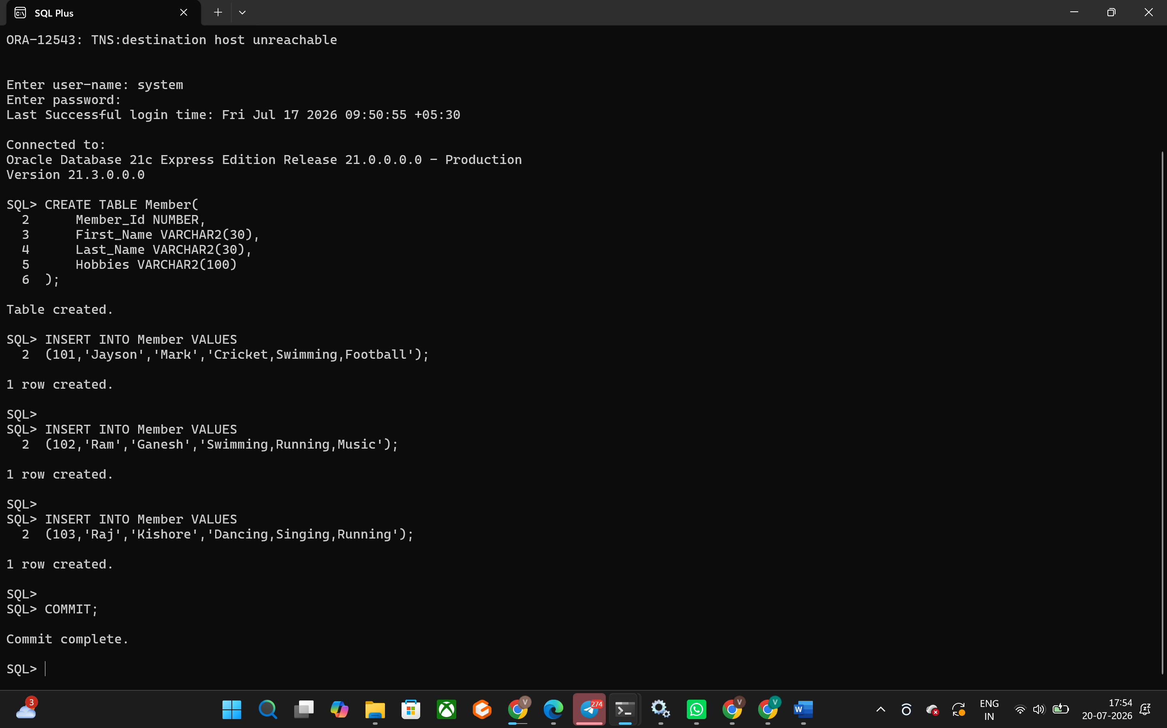

Step 3: Create the 1NF table
Each hobby becomes a separate row. 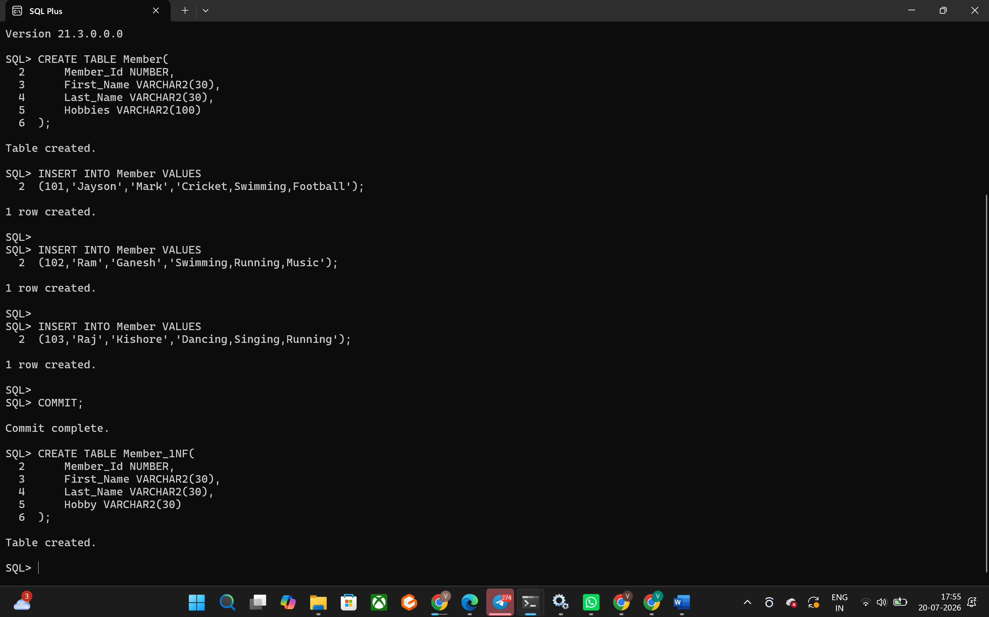

Insert data:
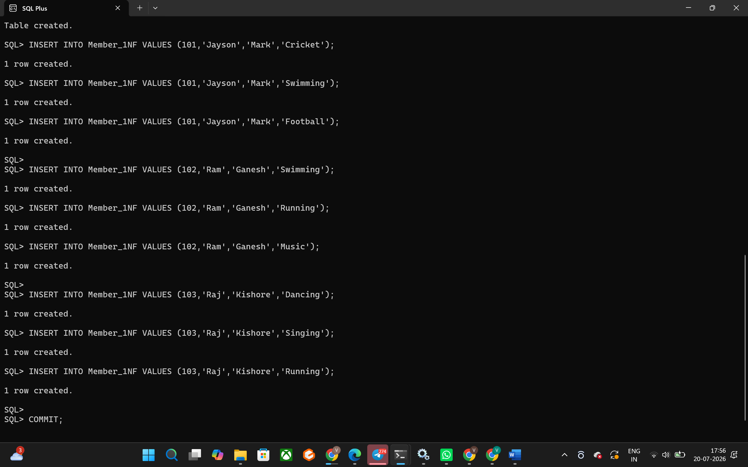

Display:
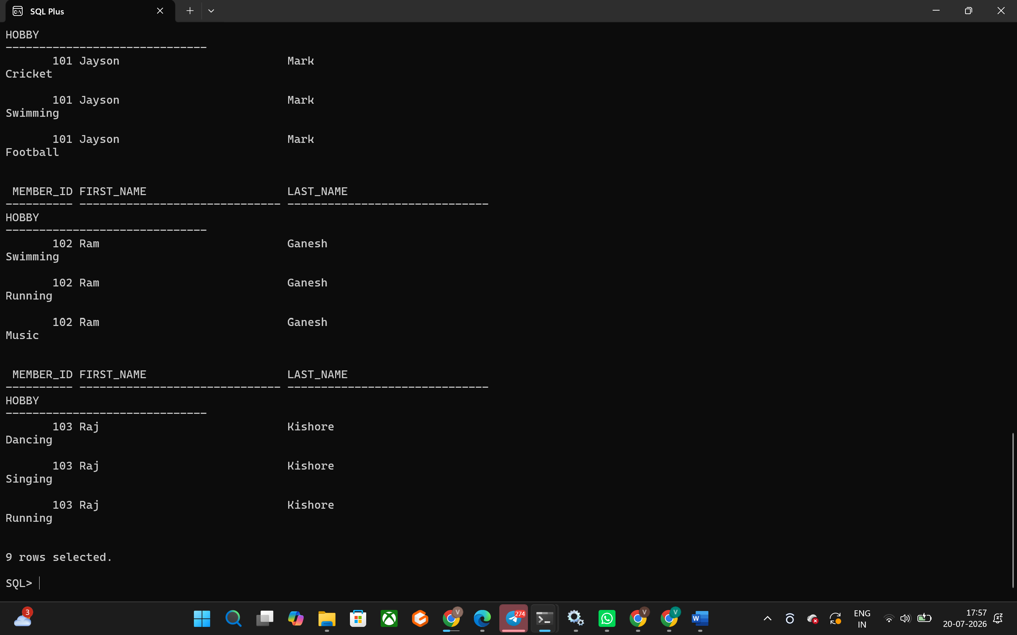

Task 2: Convert to Second Normal Form (2NF)
Employee Table
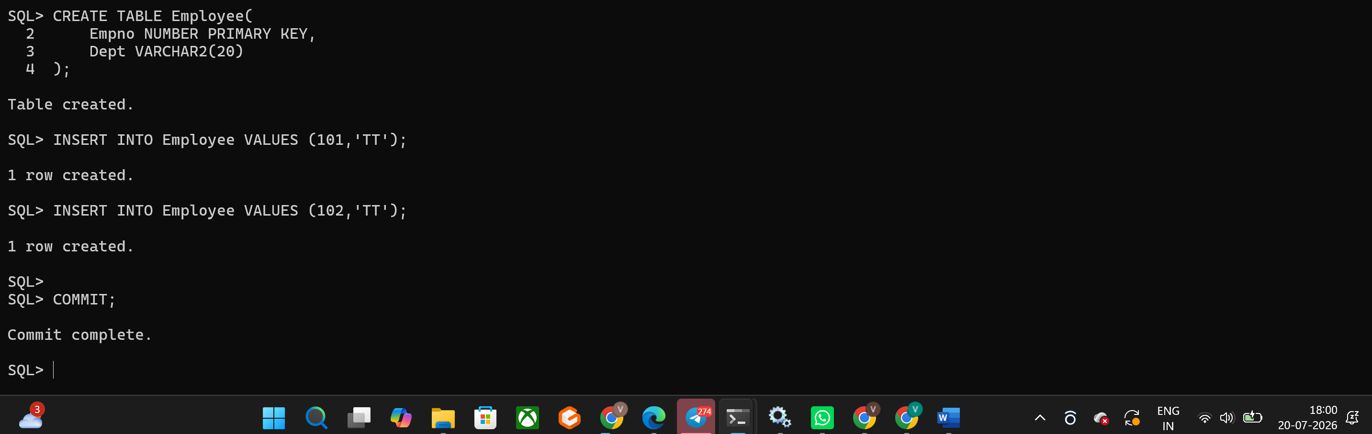
Training Table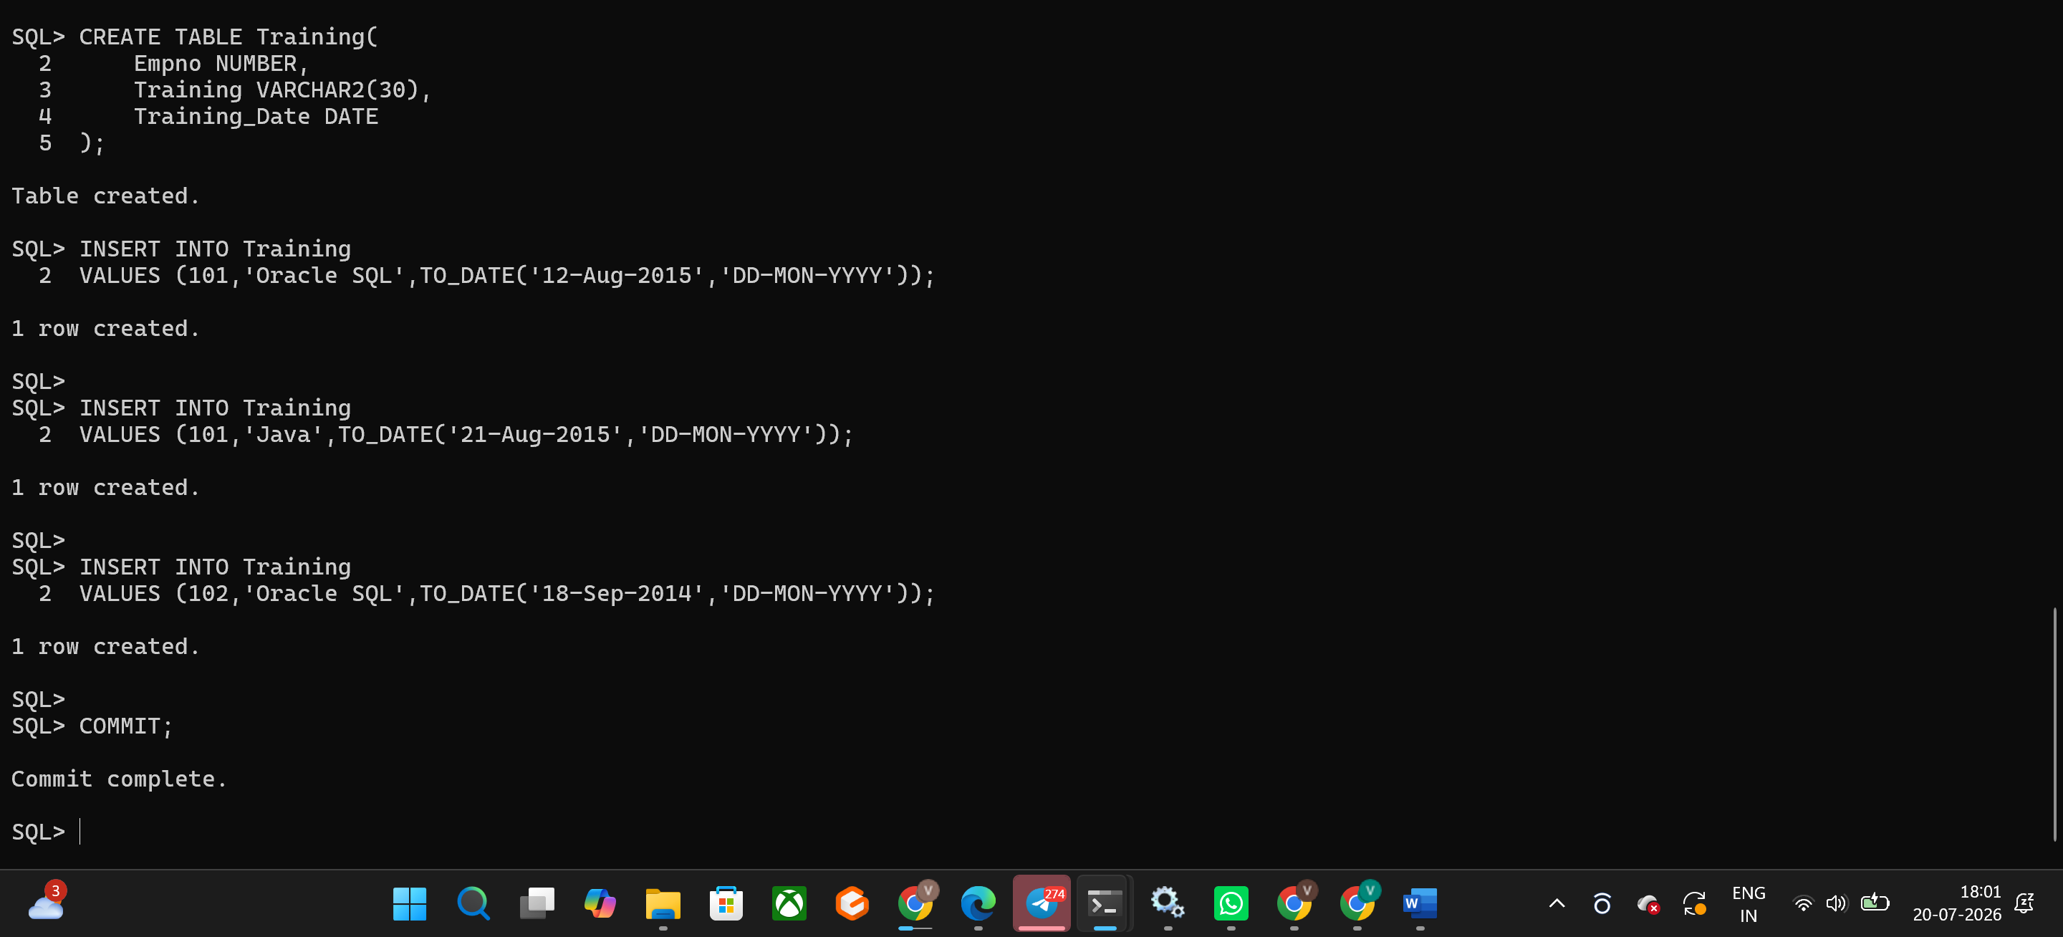
Display:
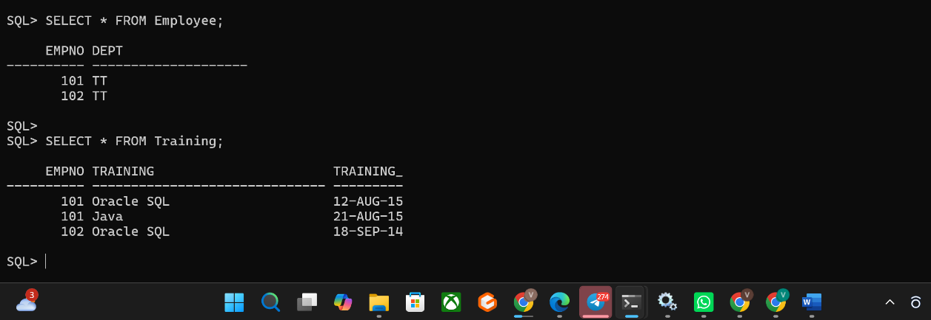
Task 3: Convert to Third Normal Form (3NF)
Step 1: Create the Member table
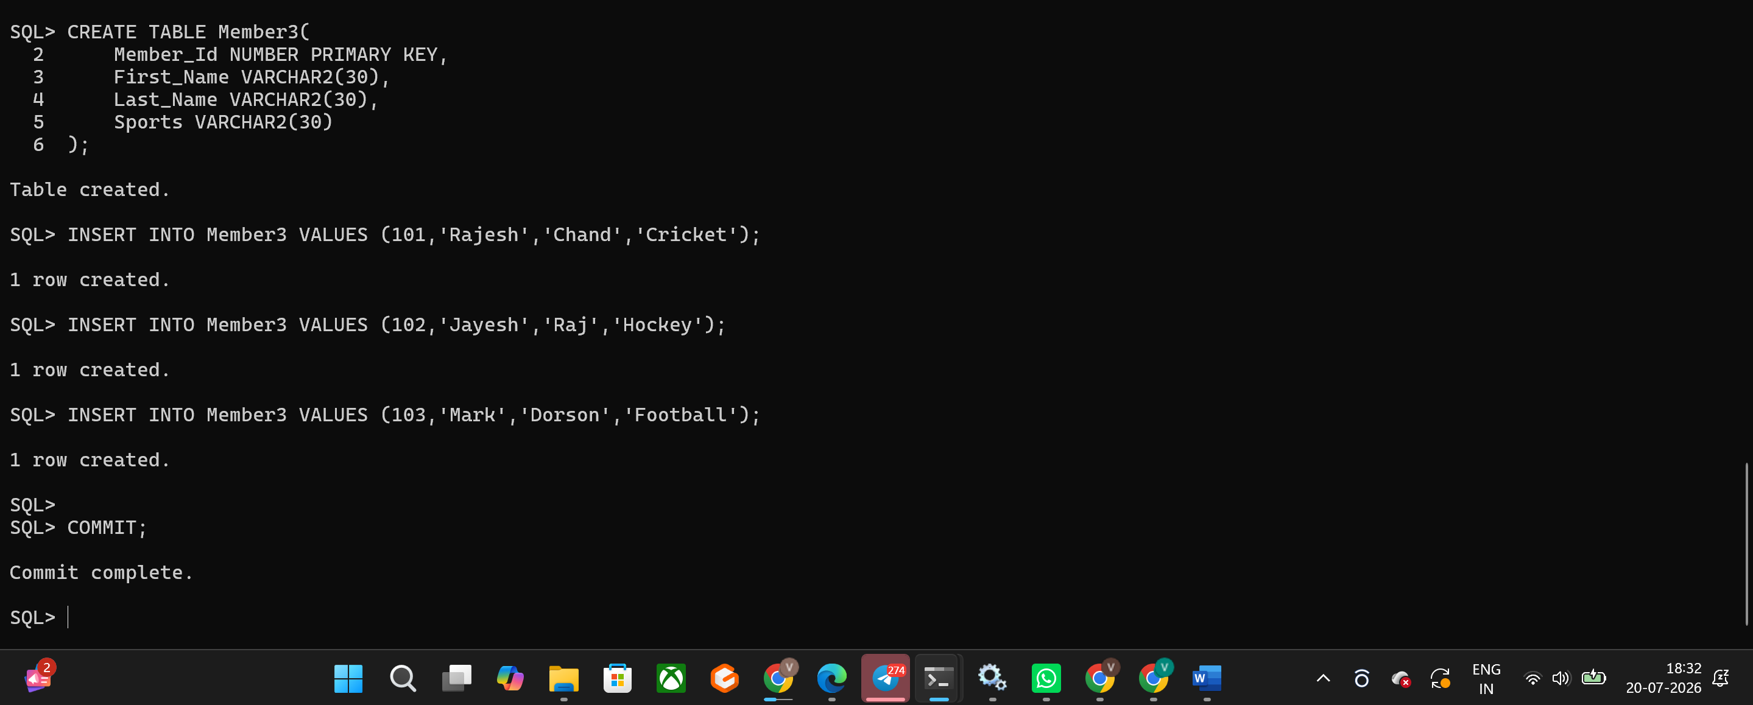
Step 2: Create the Sports table
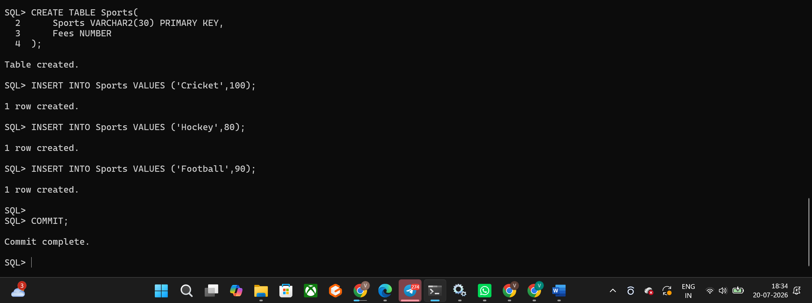

Step 3: Display the tables
