Wipro_TalentNext_DSE_Mini_Project_2

Step 1: Create the Tables
- Create LODGE_DETAILS
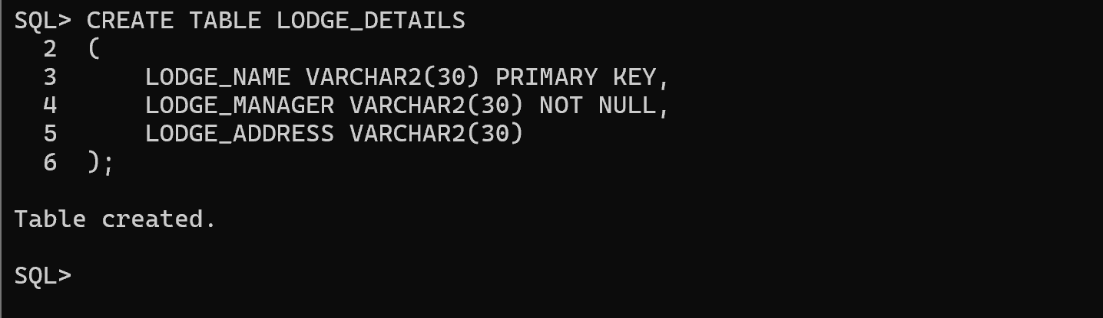
- Create SKILL_DETAILS
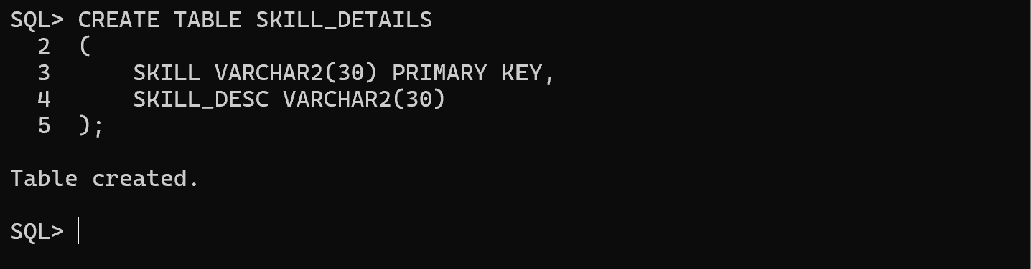
- Create EMP_DETAILS
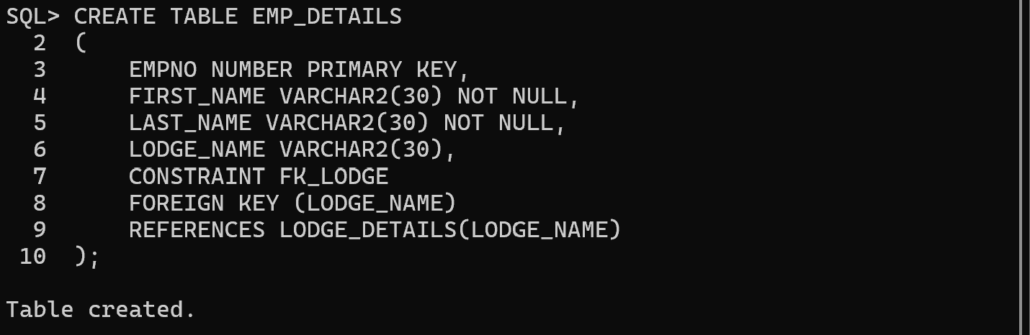
- Create EMP_SKILL
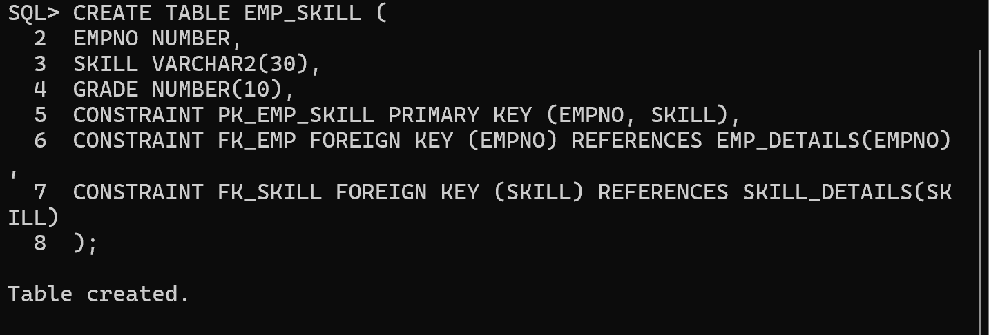
2.1 Insert into LODGE_DETAILS
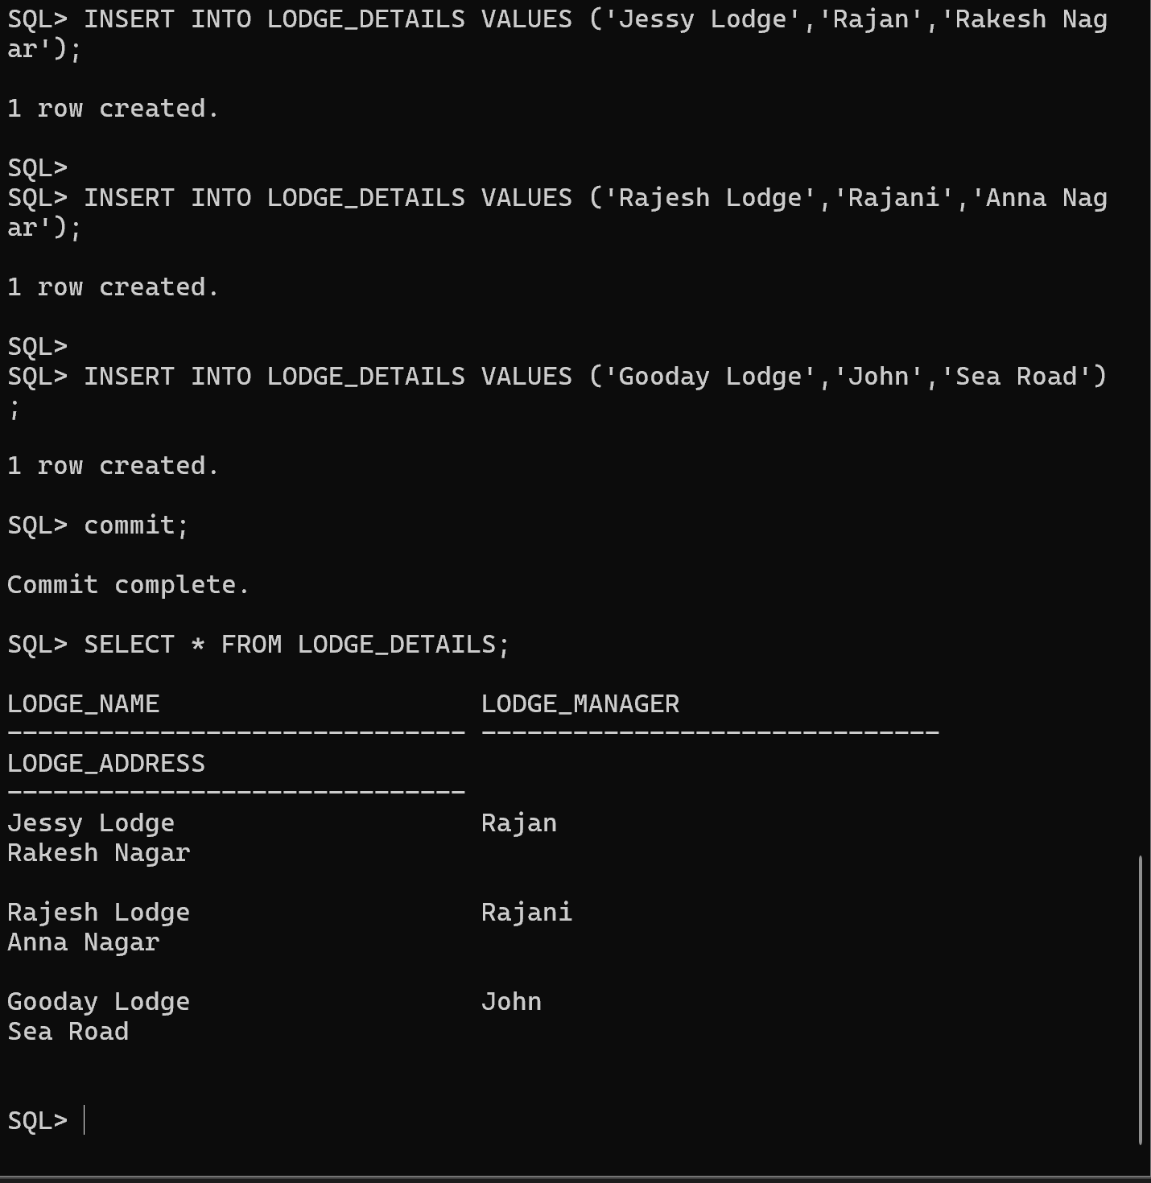
2.2 Insert into EMP_DETAILS
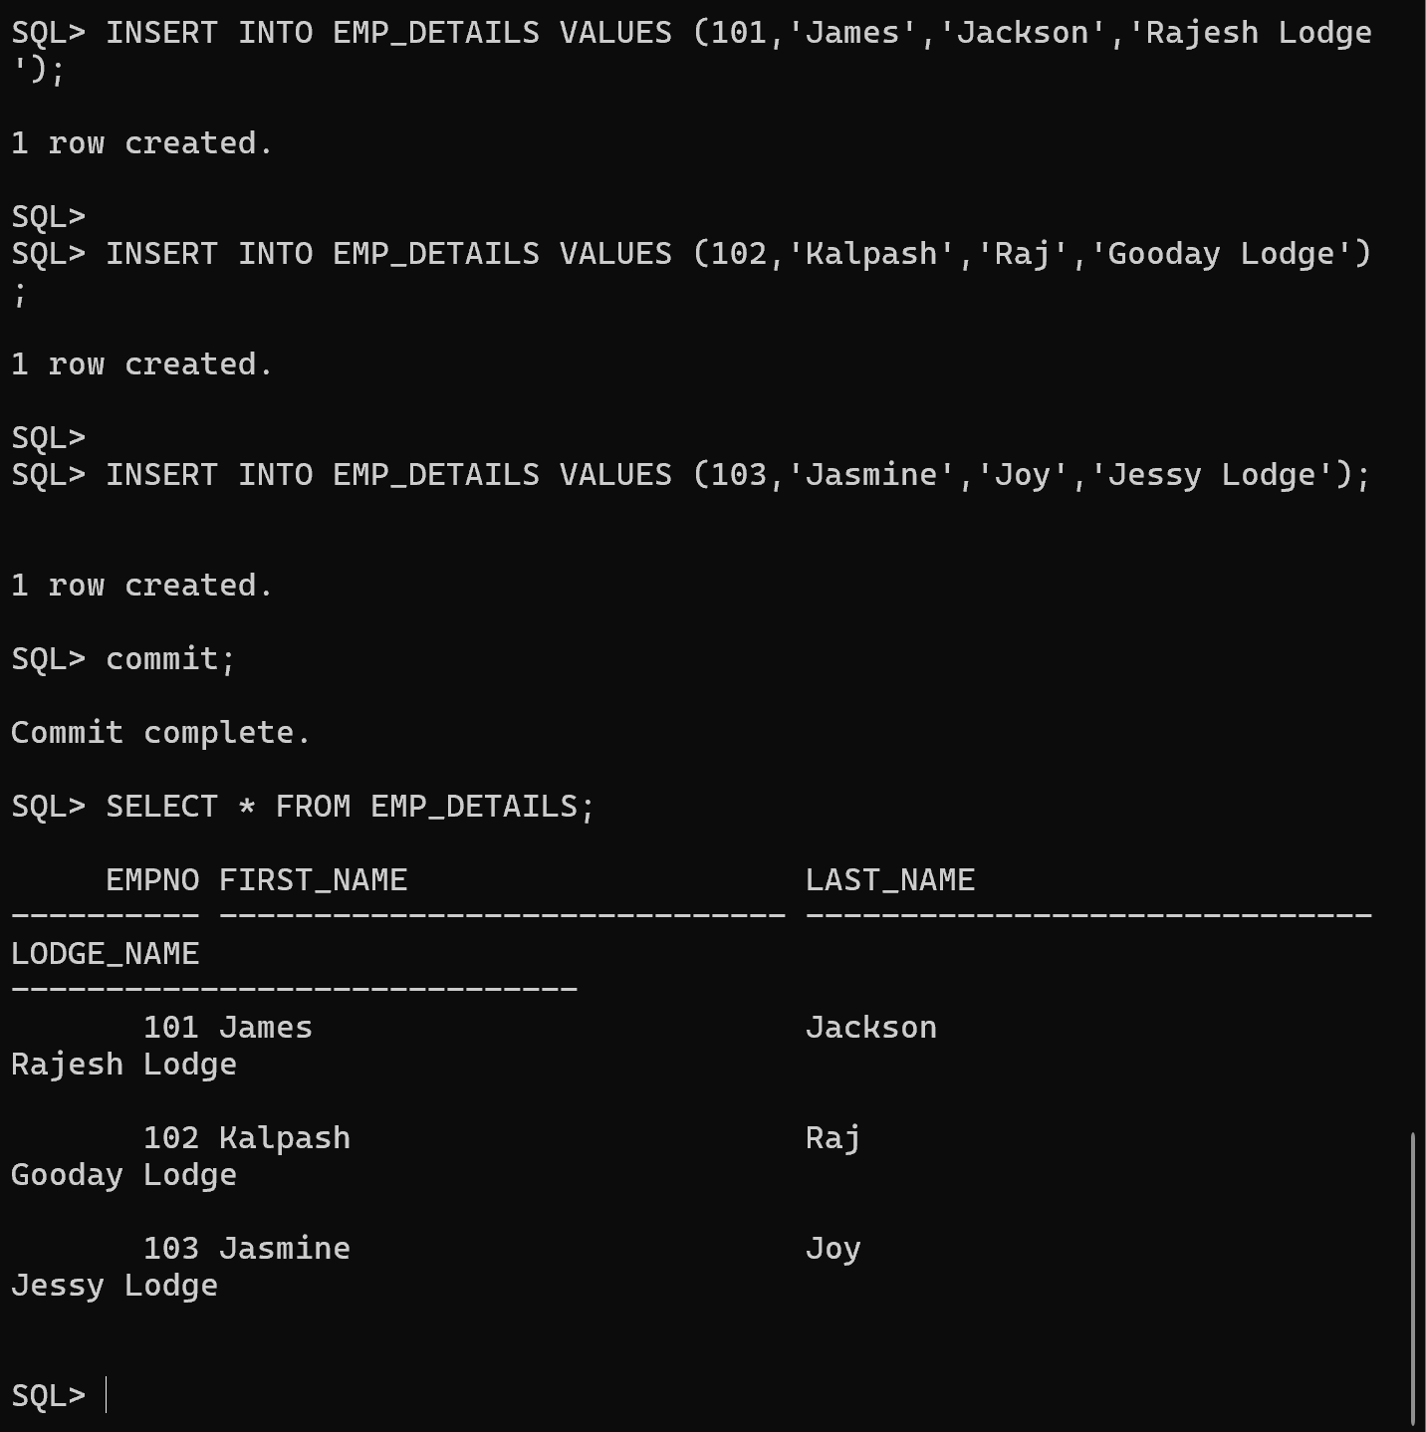

2.3 Insert into SKILL_DETAILS
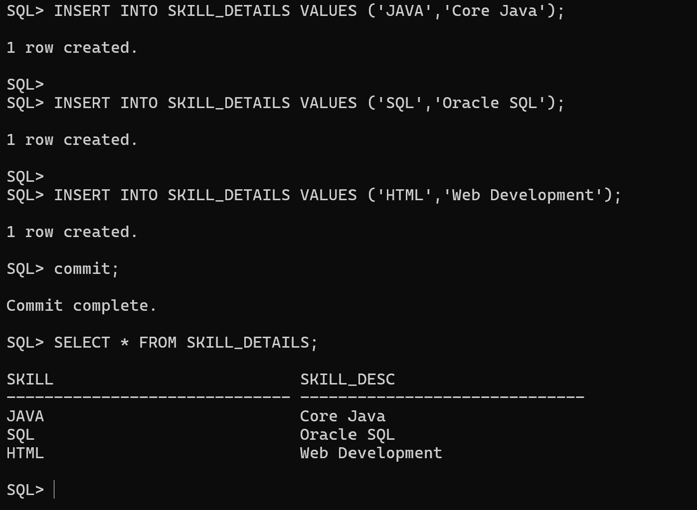
2.4 Insert into EMP_SKILL

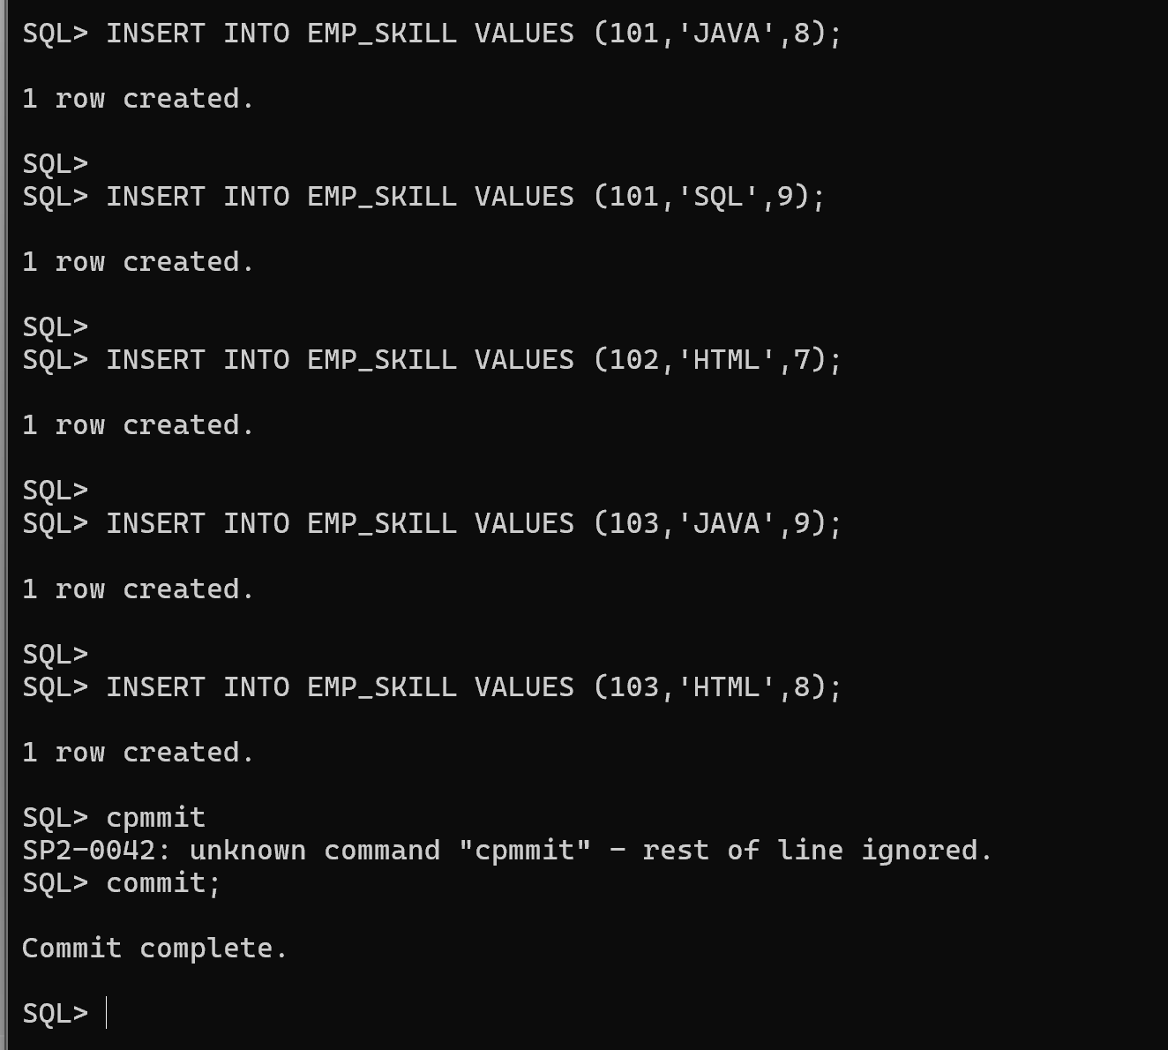
Question 3
Employee 101 has changed his lodge to Gooday Lodge.
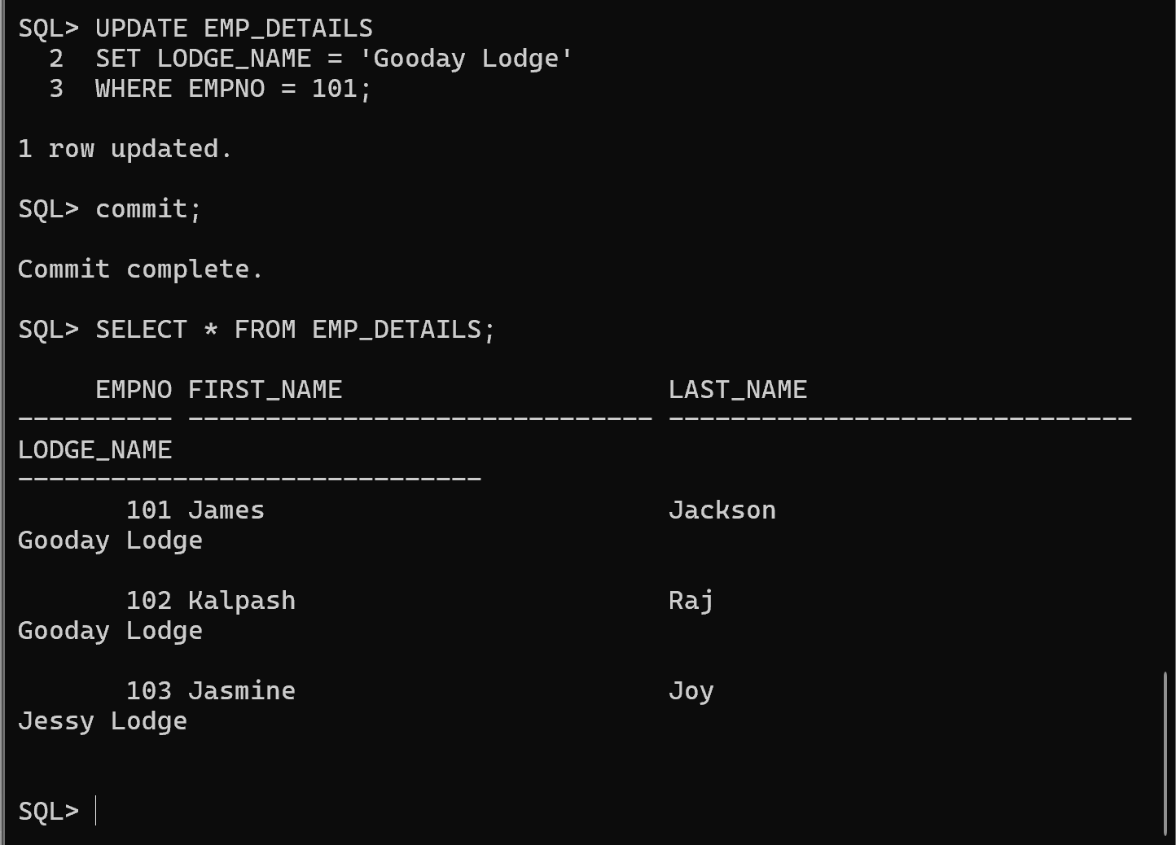
Question 4
Employee 103 has resigned from the company and vacated the lodge, so delete the details from the respective tables.
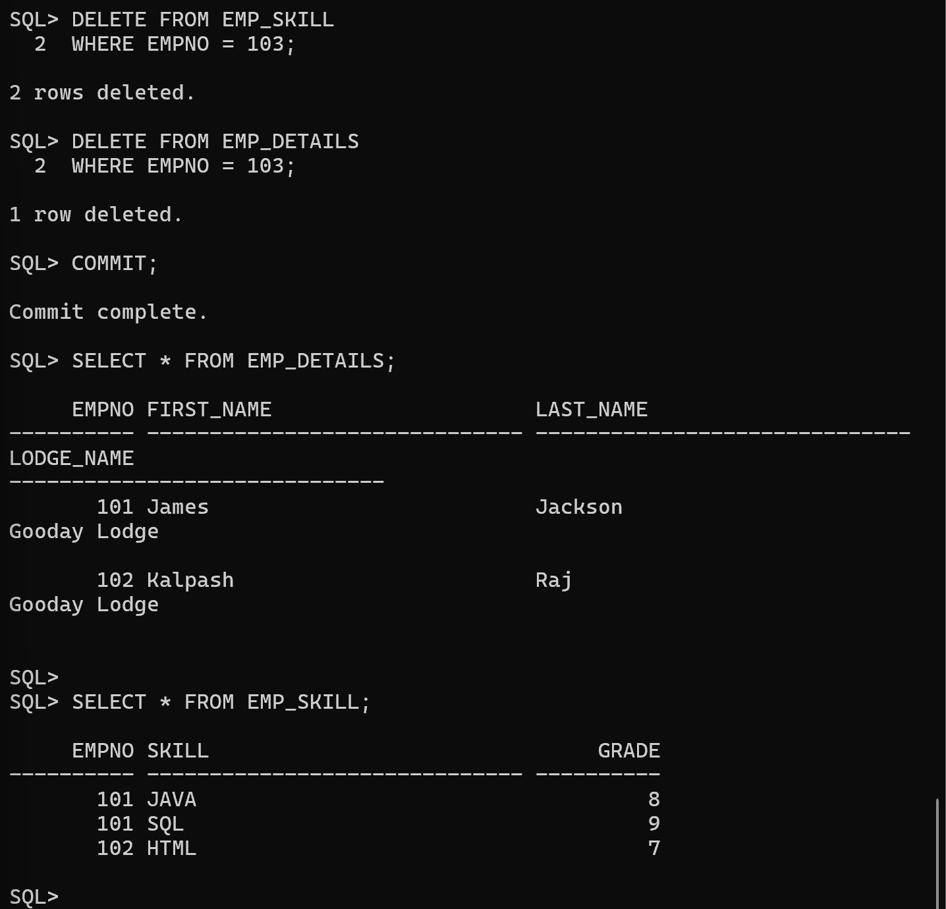
Question 5(a)
Write a query that will display the employee with skill Sybase. Pass Sybase in any case. Use Function.
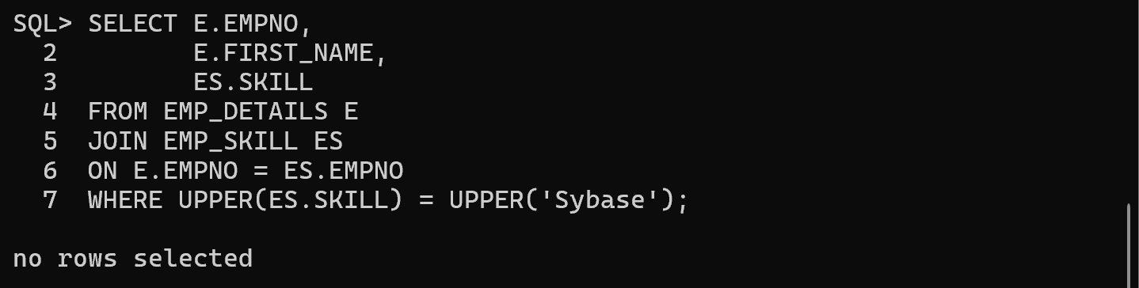
Question 5(b)
Display the employee details along with their skill details.
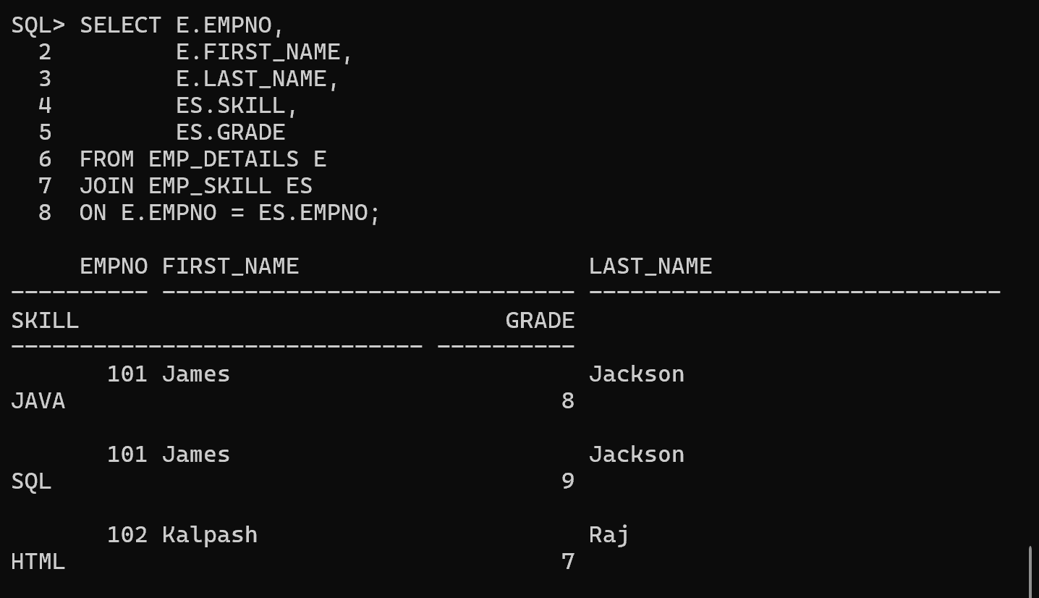
5(c) Display the number of skills employee 101 has
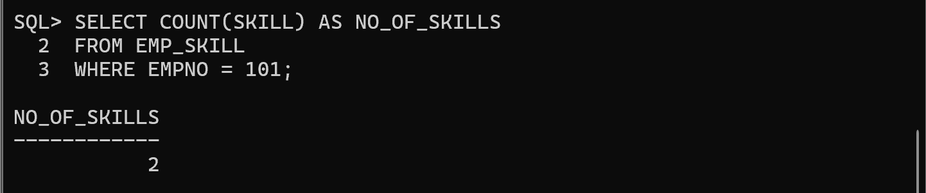
5(d) Display the employee FIRST_NAME who has the skill Oracle SQL
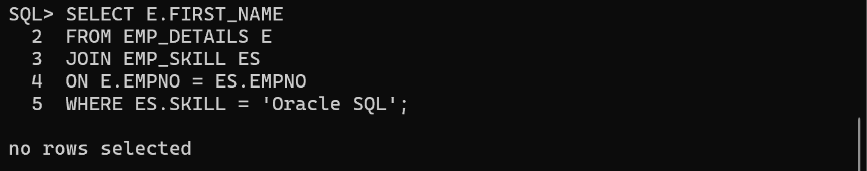
Question 6
Create a View EMP_VIEW so that the users can use it that contains columns:
EMPNO , FIRST_NAME , SKILL , LODGE_MANAGER
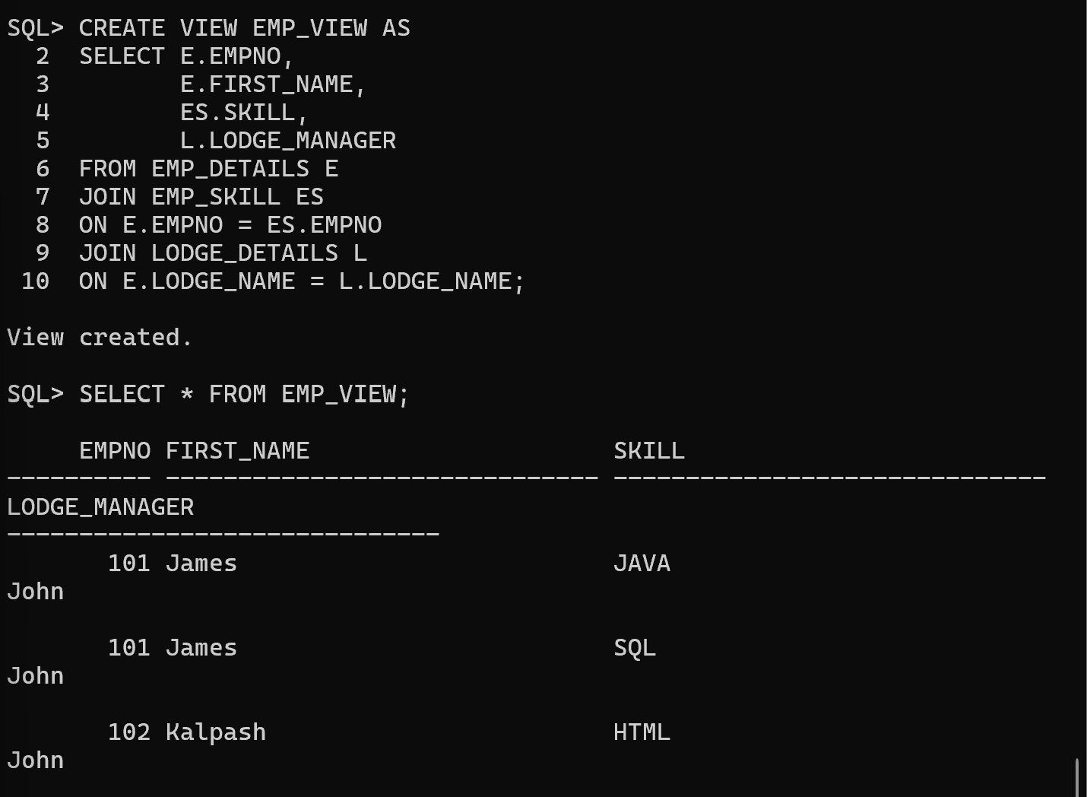
Question 7
Create a Synonym EMPV for the View EMP_VIEW.
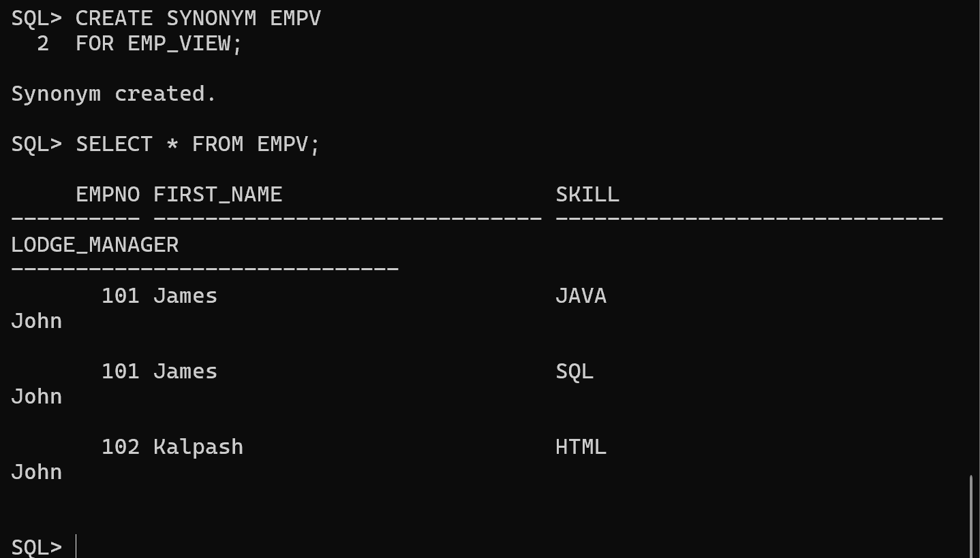
Question 8
Create an Index on the SKILL column in the EMP_SKILL table.
