***Noise Pollution Monitoring system***

***Project Objectives***:

The primary objective of the project is to monitor and mitigate noise pollution in a given area. This could involve assessing noise levels in residential or industrial zones to ensure compliance with noise regulations, identifying noise sources, and providing data for urban planning to improve noise conditions.

***IoT Sensor Deployment:***

Sensor Types: Deploy a variety of noise sensors (microphones or sound level meters) strategically throughout the area of interest.

Sensor Placement: Place sensors in locations that are representative of the noise environment, considering factors like proximity to roadways, industrial facilities, and residential areas.

Connectivity: Ensure sensors are connected to a network (e.g., Wi-Fi, LoRa, or cellular) for real-time data transmission.

***Platform Development:***

***Data Collection***: Develop a platform that collects noise data from deployed sensors.

Data Processing: Implement algorithms to process and analyze noise data, including identifying noise sources and calculating noise levels.

***User Access:*** Create a user interface for administrators and residents to access noise data, view reports, and set up notifications.

Data Storage: Store historical noise data for trend analysis and regulatory compliance.

***Mobile App Development:***

***User Interface***: Develop a mobile app that allows residents to access noise level information in their area, report noise disturbances, and receive noise alerts.

***Notifications:*** Implement real-time notifications to alert users when noise levels exceed set thresholds.

***Reporting***: Enable users to report noise complaints, including date, time, location, and details of the disturbance.

***Code implementation***

import RPi.GPIO as GPIO

import time

import sounddevice as sd

import numpy as np

# Setup GPIO pins for sensor

GPIO.setmode(GPIO.BCM)

SENSOR_PIN = 17

GPIO.setup(SENSOR_PIN, GPIO.IN)

# Function to measure sound levels

def measure_sound_level():

duration = 10 # Record sound for 10 seconds

sample_rate = 44100 # Sampling rate

recording = sd.rec(int(duration * sample_rate), samplerate=sample_rate, channels=1, dtype='float32')

sd.wait()

# Calculate the sound level (you can use different methods)

sound_level = 20 * np.log10(np.max(np.abs(recording)))

return sound_level

try:

while True:

if GPIO.input(SENSOR_PIN): # Check if the sensor is triggered

sound_level = measure_sound_level()

print(f"Sound level: {sound_level} dB")

time.sleep(1) # Poll every second

except KeyboardInterrupt:

GPIO.cleanup()

In this example:

We use the Raspberry Pi's GPIO pins to monitor a noise sensor (you can replace SENSOR_PIN with your specific GPIO pin).

We use the sounddevice library to record sound for a specific duration and calculate the sound level in decibels (dB) using a basic method.

The system continuously monitors the sensor and reports the sound level when it's triggered.

You can enhance this basic setup by:

Adding additional sensors for more accurate measurements.

Logging data to a file or sending it to a cloud service for storage and analysis.

Setting up thresholds to trigger alerts when noise levels exceed certain limits.

Creating a web interface or a mobile app for real-time monitoring and data visualization.

Make sure to adapt and modify the code to suit your specific requirements and hardware setup.

***Noise Pollution Monitoring system over IOT***

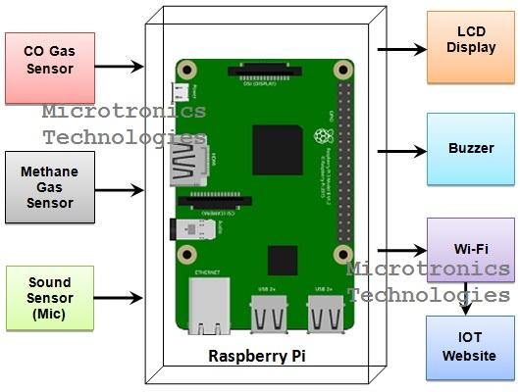

***Noise* *Pollution information platform using IOT***

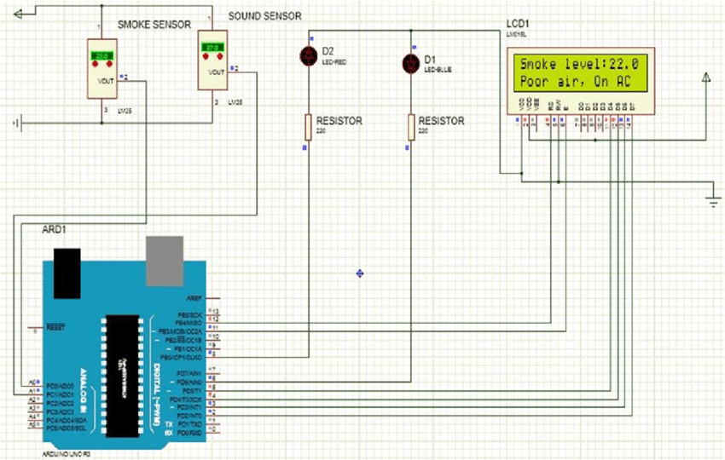

***Diagram of IOT sensor*** 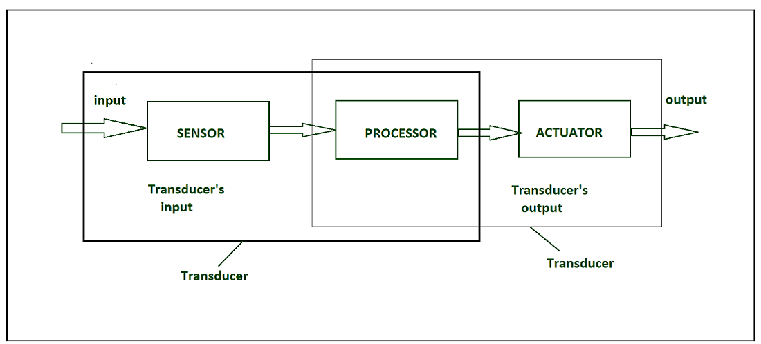

***Noise pollution information platform:***

***Noise Data Collection***:

• Collect noise data from various sources, including sensors, government databases, and user-contributed data.

***Data Analysis:***

•Process and analyze the noise data to provide meaningful insights.

***Real-time Noise Maps*:**

•Create real-time noise pollution maps that users can access to check noise levels in their area.

***Historical Data:***

•Store historical noise data for users to track changes over time.

***Noise Regulations:***

•Provide information on noise regulations and guidelines in different regions.

***Community Engagement*:**

•Allow users to report noise disturbances and share their experiences.

***Educational Content:***

•Include articles, videos, or infographics to educate users about noise pollution and its effects.

***Mobile App Interfaces:***

***Dashboard***: A user-friendly dashboard displaying real-time noise levels and historical data for the user's location.

***Noise Maps***: Access to interactive noise maps with color-coded noise levels.

***Noise Alerts***: Allow users to set noise level alerts for their preferred thresholds.

***Report Noise***: Enable users to report noise disturbances, including the ability to record and upload audio samples.

***Information Hub:*** Provide noise pollution information, tips, and local noise regulations.

***Profile and Settings:*** User profiles with settings to customize notifications and preferences.

***Community Features:*** Social features for users to connect, share experiences, and discuss noise issues.

***Feedback and Support***: A channel for users to provide feedback and seek assistance.

Additionally, you'll need to consider data security and privacy, as well as partnerships with local authorities, organizations, and sensor networks to ensure data accuracy and accessibility.

***Real-time noise level monitoring system public awareness***

***Education***: Such a system can educate the public about the sources and impact of noise pollution, raising awareness about its health and environmental effects.

***Behavioral Change:*** When people have access to real-time noise data, they may be more inclined to adjust their behavior to reduce noise, such as turning down the volume of loud music or avoiding noisy activities during quiet hours.

***Community Engagement***: The system can encourage community engagement and discussions about noise issues, fostering a sense of responsibility and collaboration among residents.

***Advocacy***: Armed with data, advocacy groups and individuals can better advocate for noise reduction measures and policies.

***Policy Influence:*** Increased public awareness can influence local governments and policymakers to implement noise regulations and zoning laws.

***Health Benefits***: The public can better understand the potential health benefits of reducing noise pollution, such as improved sleep and reduced stress.

***Data-Driven Decision-Making:*** Public awareness can promote data-driven decision-making regarding urban planning and development to create quieter and more livable communities.

***Contribution of noise pollution mitigation***

***Health Benefits:*** Reduction in noise pollution can lead to improved mental and physical health, as excessive noise is linked to stress, sleep disturbances, and various health issues.

***Quality of Life***: Lower noise levels enhance the overall quality of life for individuals and communities by creating more peaceful and enjoyable environments.

***Environmental Conservation***: Reducing noise pollution can help protect wildlife and their habitats, as many species are sensitive to noise disturbances.

***Economic Gains***: Quieter areas are often more attractive for residential and commercial development, which can boost property values and local economies.

***Safety Improvements***: Reduced noise levels can improve communication and awareness, enhancing safety on roadways and in other public spaces.

***Regulatory Compliance***: Compliance with noise regulations helps maintain a harmonious coexistence in urban areas and ensures that businesses and industries operate responsibly.

***Sustainability***: Noise reduction is part of sustainable urban planning, contributing to the creation of more livable and eco-friendly cities.

Overall, noise pollution mitigation has wide-ranging benefits for individuals, communities, and the environment