WATER QUALITY ANALYSIS

PHASE 3: DEVELOPMENT PART 1

LOADING AND PREPROCESSING THE DATASET:

OVERVIEW OF THE PROCESS:

DATA COLLECTION:Collect water quality data from various sources. This data can include parameters like pH, turbidity, temperature, dissolved oxygen, chemical concentrations, and more. Data can be collected through sensors, manual measurements, or public datasets.

DATA CLEANING:Before loading the data into Cognos, you need to clean it. This involves handling missing values, correcting errors, and ensuring data consistency.

DATA LOADING:You can load the cleaned data into IBM Cognos by connecting to a database or importing data from a file. IBM Cognos typically supports various data sources and formats.

DATA PREPROCESSING:Data preprocessing is essential to prepare the data for analysis. Some common preprocessing steps for water quality data includes,

Normalization/Scaling:Scale numerical features to a common range, e.g., between 0 and 1, to ensure that they have equal weight in the analysis.

Feature Engineering: Create new features from existing data that may be more informative for your analysis, like calculating averages, sums, or ratios of certain parameters.

Outlier Detection: Identify and handle outliers in the data, as they can skew the analysis.

Categorization: Convert categorical data, like water source types or locations, into numerical values for analysis.

DATA TRANSFORMATION:Depending on your analysis goals, you may need to transform the data. For water quality analysis, this might involve time-series aggregation, spatial aggregation, or any other transformation that helps in deriving meaningful insights.

EXPLORATORY DATA ANALYSIS:EDA involves visualizing the data and running basic statistical analyses to gain a better understanding of the dataset. Use Cognos to create various charts, graphs, and dashboards to explore the data.

FEATURE SECTION:Identify which features are most relevant for your water quality analysis. This can help reduce dimensionality and improve the efficiency of your analytics.

MODEL BUILDING AND ANALYSIS:Use Cognos to build models for water quality prediction, classification, or clustering, depending on your specific objectives. You can choose from a variety of data analysis techniques, including regression, decision trees, clustering algorithms, and more.

MODEL EVALUATION:Evaluate the performance of your models using appropriate metrics such as Mean Absolute Error (MAE), Root Mean Squared Error (RMSE), accuracy, precision, recall, or F1-score, depending on the type of analysis.

REPORTING AND VISUALIZATION:Create reports and dashboards in Cognos to present your findings and insights in a comprehensible manner. Visualizations such as maps, time series plots, and trend analysis can be particularly useful for water quality analysis.

DEPLOYMENT AND AUTOMATION:If the analysis needs to be automated for real-time monitoring, you can deploy the models and dashboards within IBM Cognos to ensure ongoing data analysis.

MAINTENANCE:Regularly update and maintain your data analysis process, including refreshing data, retraining models, and adapting to changes in data quality or data sources.

library(ggplot2) # Data visualization
library(readr) # CSV file I/O, e.g. the read_csv function
system("ls ../input")
water_qual<-read.csv("../input/IndiaAffectedWaterQualityAreas.csv",header=T,stringsAsFactor=FALSE)
str(water_qual)

'data.frame': 550242 obs. of 8 variables:
$ State.Name : chr "ANDHRA PRADESH" "ANDHRA PRADESH" "ANDHRA PRADESH" "ANDHRA PRADESH" ...
$ District.Name : chr "EAST GODAVARI(04)" "EAST GODAVARI(04)" "EAST GODAVARI(04)" "EAST GODAVARI(04)" ...
$ Block.Name : chr "PRATHIPADU(10)" "PRATHIPADU(10)" "PRATHIPADU(10)" "PRATHIPADU(10)" ...
$ Panchayat.Name : chr "GOKAVARAM(04)" "GOKAVARAM(04)" "GAJJANAPUDI(06)" "GAJJANAPUDI(06)" ...
$ Village.Name : chr "VANTHADA(014 )" "PANDAVULAPALEM(022 )" "G. KOTHURU(023 )" "GAJJANAPUDI(029 )" ...
$ Habitation.Name : chr "VANTHADA(0404410014010400)" "PANDAVULAPALEM(0404410022010400)" "G. KOTHURU(0404410023010600)" "GAJJANAPUDI(0404410029010600)" ...
$ Quality.Parameter: chr "Salinity" "Fluoride" "Salinity" "Salinity" ...
$ Year : chr "1/4/2009" "1/4/2009" "1/4/2009" "1/4/2009" ...
In [2]:
# Lets see the data in the dataset
head(water_qual)tail(water_qual)
# changing the variables names to ease of use
cnames<-c("state","district","block","panchayat","village","habitation","quality","year")colnames(water_qual)<-cnames

State.Name | District.Name | Block.Name | Panchayat.Name | Village.Name | Quality.  parameter | Year
ANDHRA  PRADESH | EAST  GODHAVARI(04) | PRATHIPADU(10) | GOKAVARAM(04) | VANTHADA  (014) | Salinity | 1/4/2009
ANDHRA  PRADESH | EAST  GODHAVARI(04) | PRATHIPADU(10) | GOKAVARAM(04) | PANDAVULAPALEM  (022) | Fluoride | 1/4/2009
ANDHRA  PRADESH | EAST  GODHAVARI(04) | PRATHIPADU(10) | GAJJANAPUDI(06) | G.KOTHURU  (023) | Salinity | 1/4/2009
ANDHRA  PRADESH | EAST  GODHAVARI(04) | PRATHIPADU(10) | GAJJANAPUDI(06) | GAJJANAPUDI  (029) | Salinity | 1/4/2009
ANDHRA  PRADESH | EAST  GODHAVARI(04) | PRATHIPADU(10) | CHINTALURU(10) | CHINTALURU  (028) | Fluoride | 1/4/2009

 | State.name | District.Name | Block.Name | Panchayat.Name | Village.Name | Quality.  Parameter | year
550237 | ASSAM | JORHAT | KALIAPANI | CHINTAMONIGARH | GHARACHOWA  HABI GAON | Iron | 1/4/2012
550238 | ASSAM | JORHAT | KALIAPANI | CHINTAMONIGARH | GHARACHOWA  HABI GAON | Iron | 1/4/2012
550238 | ASSAM | JORHAT | KALIAPANI | CHINTAMONIGARH | GHARACHOWA  HABI GAON | Iron | 1/4/2012
550241 | ASSAM | JORHAT | KALIAPANI | TAMULICHIGA  GAON | SIMALUGURI  GAON | Iron | 1/4/2012

library(ggplot2)#library(lubridate)library(dplyr)
#convert date column to year
water_qual$year<-format(as.Date(water_qual$year, format="%d/%m/%Y"),"%Y")
#plotiing the quality of water in india
ggplot(water_qual,aes(x=quality))+geom_bar(fill="chartreuse")

Attaching package: ‘dplyr’

The following objects are masked from ‘package:stats’:

filter, lag

The following objects are masked from ‘package:base’:

intersect, setdiff, setequal, union
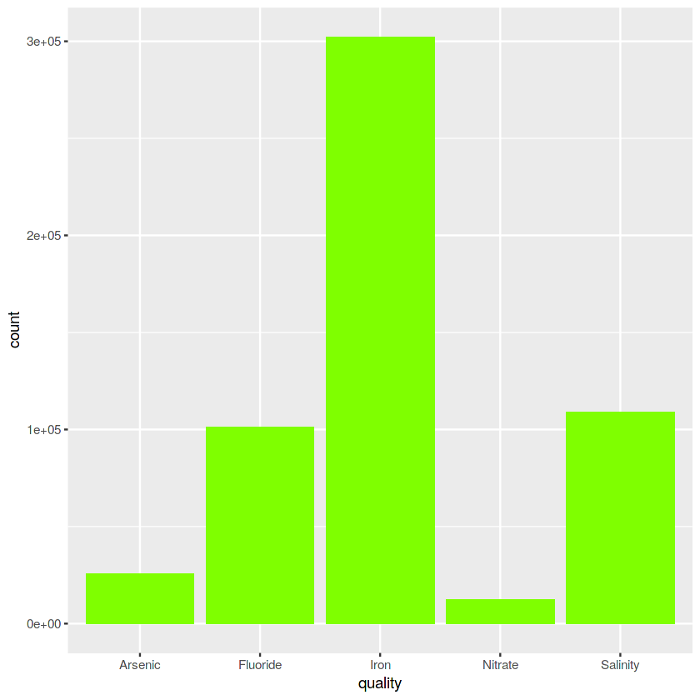

ggplot(water_qual,aes(x=year,y=quality,fill=factor(state)))+geom_bar(stat="identity")+theme(legend.position="bottom”)

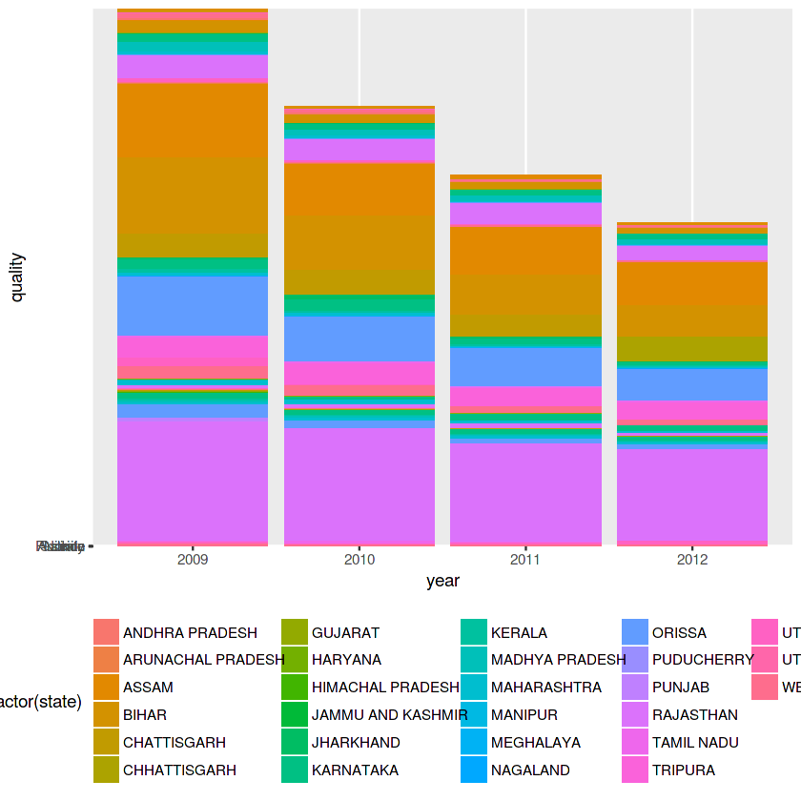

tn_wq_data<-water_qual %>% filter(state =="TAMIL NADU")
par(mfrow=c(1,2))
ggplot(tn_wq_data,aes(x=quality,fill=year))+geom_bar(position="dodge")+
theme(axis.text.x = element_text(angle = 90))+scale_fill_brewer(palette="Spectral")

ggplot(tn_wq_data,aes(x=quality,fill=year))+geom_bar(position="fill")+
ggtitle("Yearwise Water Quality in Tamilnadu")+scale_colour_brewer(palette="PRGn")
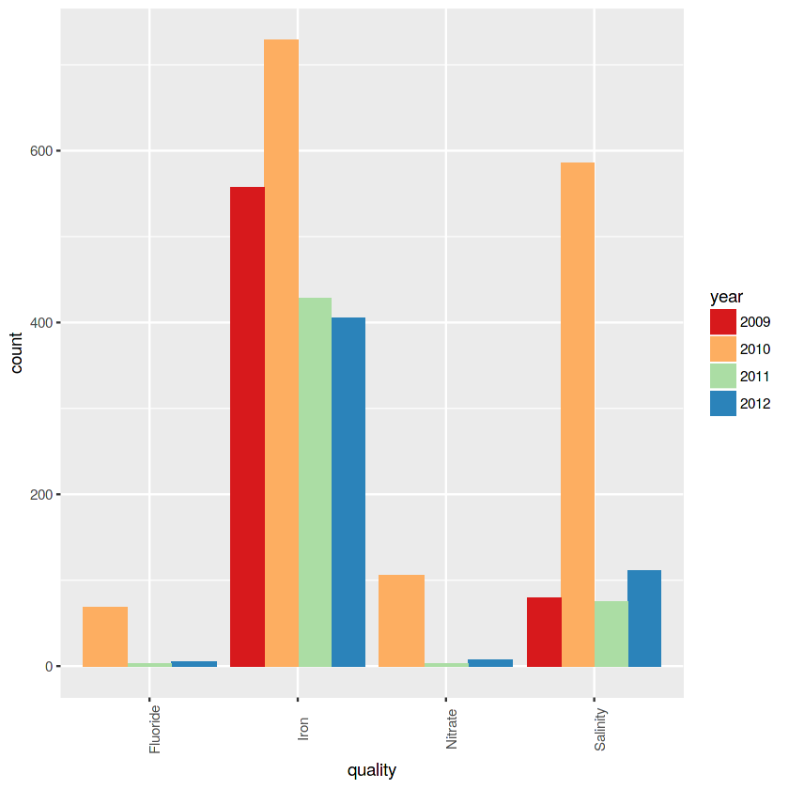

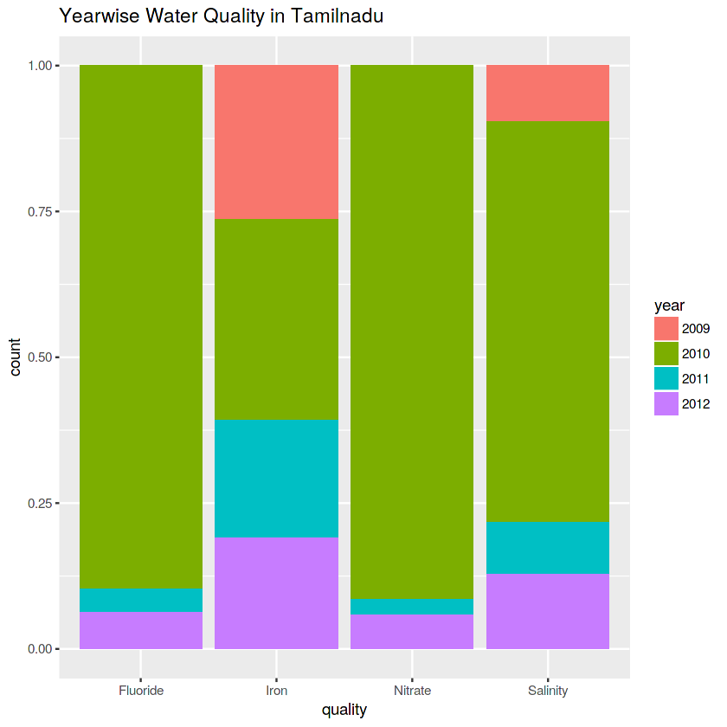
sta_qual<-data.frame(table(water_qual$state,water_qual$quality,water_qual$year))

sta_qual<-sta_qual %>% arrange(desc(Freq))

p <- ggplot(data = sta_qual, aes(x = Var1, y = Freq, group = Var2, fill = Var2))
p <- p + geom_bar(stat = "identity", width = 0.5, position = "dodge")
p <- p + theme_bw()
p <- p + theme(axis.text.x = element_text(angle = 90))
p<- p+ xlab("States")
p <-p+ylab("Count")
p <- p+ggtitle("State wise water Quality Proportion")+scale_fill_brewer(palette="Set1")
p

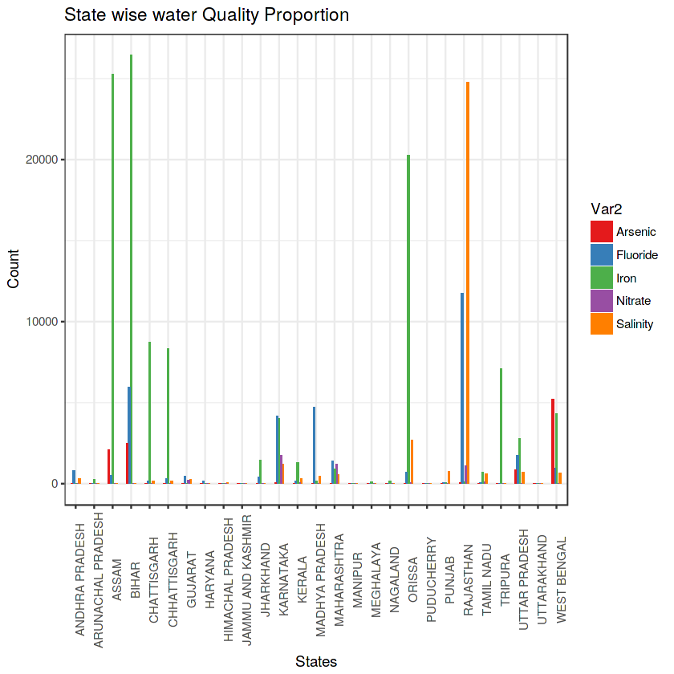

head(sta_qual)

VAR 1 | VAR 2 | VAR 3 | FREQUENCY
BIHAR | IRON | 2009 | 26442
ASSAM | IRON | 2009 | 25262
RAJASTHAN | SALINITY | 2009 | 24787
RAJASTHAN | SALINITY | 2010 | 23168
RAJASTHAN | SALINITY | 2011 | 20258
ORISSA | IRON | 2009 | 20255

sta_qual%>% ggplot(aes(x = Var3, y = Freq,fill=Var2))+geom_bar(stat="identity")+theme(axis.text.x=element_text(angle=90,hjust=0.5))+facet_wrap(~ Var1)+labs(title="Water Degradation in Indian States",x="Year",y="Freq")
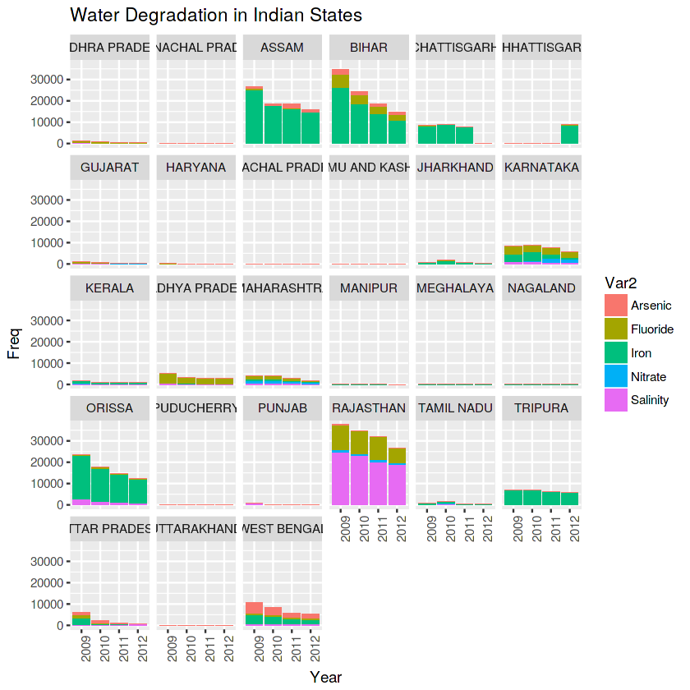

affected<-data.frame(table(water_qual$state,water_qual$quality,water_qual$year,water_qual$district))

affected_fil<-affected %>% filter(Var2=="Salinity" & Var1=="RAJASTHAN" & Freq>50)%>%arrange(desc(Freq))
head(affected_fil)

VAR 1 | VAR2 | VAR 3 | VAR 4 | FREQUENCY
RAJASTHAN | SALINITY | 2009 | BARMER | 11344
RAJASTHAN | SALINITY | 2010 | BARMER | 11025
RAJASTHAN | SALINITY | 2011 | BARMER | 10767
RAJASTHAN | SALINITY | 2012 | BARMER | 10570
RAJASTHAN | SALINITY | 2009 | JODHPUR | 7334
RAJASTHAN | SALINITY | 2010 | JODHPUR | 6843
ggplot(affected_fil,aes(x=Var4,y=Freq,fill=Var3))+geom_bar(stat="identity",position="dodge")+coord_flip()+scale_fill_brewer(palette="PuRd")+labs(title="Districts in Rajasthan which are Salinity Affected")

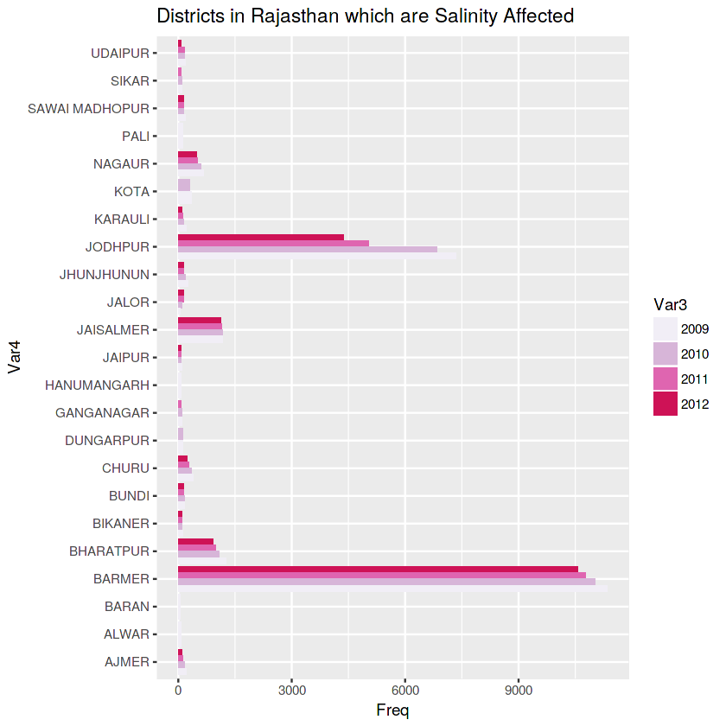

rankq<-sta_qual %>%
group_by(Var2) %>%
mutate(rank = rank(-Freq, ties.method = "first"))head(rankq)

VAR 3 | VAR 3 | VAR 3 | FREQUENCY | RANK
BIHAR | IRON | 2009 | 26442 | 1
ASSAM | IRON | 2009 | 25262 | 2
RAJASTHAN | SALINITY | 2009 | 24787 | 1
RAJASTHAN | SALINITY | 2010 | 23168 | 2
RAJASTHAN | SALINITY | 2011 | 20258 | 3
ORISA | IRON | 2009 | 20255 | 3

rankq %>% group_by(Var2)%>% filter(rank <15)%>% ggplot( aes(x = Var1,
y = rank,color=Var3)) + geom_point(size=3,alpha=0.7) +facet_wrap(~Var2)+theme(axis.text.x=element_text(angle=90,hjust=0.5))+scale_color_manual(values=c("red","purple","blue","green"))+labs(title="Top 15 water Degradation states",x="State",y="Rank")
