Yes. This is actually the best way to document your project. Instead of explaining code line by line, explain it function by function. This is how senior developers usually do KT (Knowledge Transfer).
Based on your two files (validation_service.py and data_comparison_service.py), here is a structured plan.

Imputation Validation Framework - Execution Plan
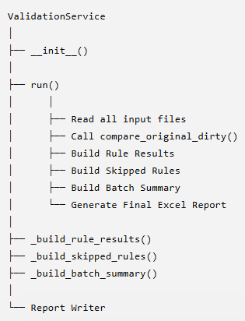

Inside
compare_original_dirty()
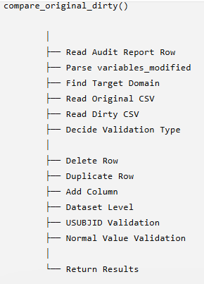

PART 1 ValidationService
This file controls the complete validation process.

1) init()
Purpose
Initialize required services.
Functions Used
__init__()
Why
Instead of writing everything in one file, we create reusable service objects.

2) run()
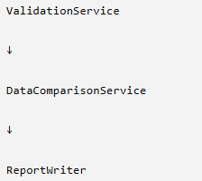
This is the main entry point.
Everything starts here.
Responsibilities
✔ Read Export Summary
✔ Read Export Audit Report
✔ Read P21 Issue Summary
✔ Read P21 Rules
✔ Read Working Rules
✔ Read Test Case File
✔ Call Data Comparison
✔ Generate Report
Flow
run()
↓
Read Files
↓
compare_original_dirty()
↓
_build_rule_results()
↓
_build_skipped_rules()
↓
_build_batch_summary()
↓
Excel Report

3) _build_rule_results()
Purpose
Create one validation result for every Rule ID.
Checks
✔ Rule injected
✔ Rule present in audit
✔ Imputation Passed
✔ Domain Match
✔ Count Match
✔ Present in P21
Returns
Rule Validation Sheet

4) _build_skipped_rules()
Purpose
Find rules available in Working Rules
BUT
Not available in Export Summary
Example
Working File

SD1017
↓
Export Summary
Not Present
↓
Skipped Rule

5) normalize_rule_id()
Purpose
Standardize Rule IDs.
Example
Before
SD1215
sd1215
SD1215
SD1215.0
After
SD1215
Reason
Avoid comparison mismatch.

6) _extract_rule_ids()
Purpose
Extract all Rule IDs from Export Summary.
Example
SD1215
SD1224
SD1356

7) _filter_export_detail_by_rule()
Purpose
Filter Audit Report by Rule ID.
Example
Need
SD1356
Returns only
SD1356 rows

8) _filter_p21_issue_by_rule()
Purpose
Find Rule inside Issue Summary.

9) _filter_p21_rules_by_rule()
Purpose
Verify Rule exists inside P21 Rules sheet.

10) _filter_working_rules_by_rule()
Purpose Check Rule belongs to selected Batch.

11) _is_rule_in_export_summary()
Purpose
Verify Rule actually injected.

12) _get_p21_actual_count()
Purpose
Calculate Found count from P21.
Example
Found
2
3
1
↓
6

13) _domain_match()
Purpose
Compare Audit Domain with P21 Source.
Example
Audit
AE
P21
AE
PASS

14) _exists_in_test_sheet()
Purpose
Verify Rule exists inside Study or Test Case sheet.

15) _exists_in_rule_cases_sheet()
Purpose
Verify Rule exists inside Rule Cases sheet.

16) _safe_first_value()
Purpose
Safely read first value. Instead of IndexError returns Empty String

17) _is_rule_skipped()
Purpose
Currently returns No Future enhancement.

18) _status()
Purpose
Calculate Final Status.
Example
PASS
FAIL
MANUAL REVIEW

19) _comments()
Purpose
Prepare Readable Comments.
Example
Rule validation successful.
Count mismatch.
Missing in P21.

20) _build_batch_summary()
Purpose
Prepare Batch Summary.
Calculates
✔ Total Rules
✔ Passed
✔ Failed
✔ Missing
✔ Pass %

PART 2 DataComparisonService
This is the heart of your project. Everything related to Original vs Dirty comparison happens here.

1) _extract_row_count()
Purpose
Extract Row Count from text.
Example
100 rows
↓
100
Used in
Row Count Validation.

2) compare_original_dirty()
Main comparison function.
Responsibilities
✔ Read Audit Row
✔ Read CSV
✔ Identify validation type
✔ Compare
✔ Return Results
Flow
Audit Report
↓
Read Rule
↓
Target Domain
↓
Open CSV
↓
Compare
↓
Return PASS/FAIL

3) _get_target_domain()
Purpose
Find actual Target Domain.
Example
Audit
CM
Variable
LB
Target
LB.csv

4) _validate_row_deleted_by_key_value()
Purpose
Validate Entire row removed using Key Value.

5) _validate_delete_row_by_index()
Purpose
Validate Delete Row using Row Index.

6) _validate_row_count_change()
Purpose Validate Expected Row Count vs Actual Row Count.

7) _validate_duplicate_row()
Purpose
Validate Duplicate Row. Checks Original 1 row Dirty 2 rows PASS

8) _validate_using_usubjid()
Purpose
Used when Row Index missing. Find rowusing USUBJID.

9) _failure_row()
Purpose
Generate Standard Failure Record. Used whenever comparison cannot continue.

10) _normalize_value()
Purpose Normalize values.
Example
Mild
↓
Mild
Dates
31-12-2024
↓
2024-12-31

11) _values_match()
Purpose
Compare Normalized Values. Instead of Actual==Expected
Uses Normalize
↓
Compare

12) _looks_like_date()
Purpose
Check whether value is Date. Used before date conversion.

13) _find_matching_row()
Purpose
Find Matching Row Priority
Row Index
↓
USUBJID
↓
Domain Key
Domain Keys
TS
TV
TA
TE
TI

Overall Execution Flow
ValidationService.run()
│
▼
Read Input Files
│
▼
compare_original_dirty()
│
▼
Read Audit Report
│
▼
Parse variables_modified
│
▼
Get Target Domain
│
▼
Read Original CSV
│
▼
Read Dirty CSV
│
▼
Determine Validation Type
│
├── Duplicate Row
├── Delete Row
├── Row Count
├── Add Column
├── Dataset Level
├── USUBJID
└── Normal Value
│
▼
Normalize Values
│
▼
Compare
│
▼
PASS / FAIL
│
▼
Return Imputation Results
│
▼
Build Rule Results
│
▼
Build Batch Summary
│
▼
Generate Excel Report

