SIMATS ENGINEERING
Department of Computer Science and Engineering
CSA37 – Software Testing
ASSIGNMENT 1 – CO1
Apply, Analyze and Justify Software Testing Principles and Defect Management Strategies for a University Student Portal
CO1: Apply software testing principles to enhance the effectiveness of software quality assurance and improve defect detection strategies.
Student Name | Vijayalakshmi G | Register Number | 192321080
Department / Section | IT | Academic Year | 2023–2027
Faculty Name | Gnanajeyaraman | Nature of Assignment | Individual
Duration | 1 Week | Total Marks | 50
Date of Submission | 03/11/2026 | Date of Evaluation

MARK SHEET (Rubric-based Evaluation)
Task | Task Title | Max Marks
1 | Evaluate Testing as an Engineering Activity | 4
2 | Evaluate the Role of Process in Software Quality | 5
3 | Evaluate Testing as a Process and Basic Definitions | 4
4 | Apply and Evaluate Software Testing Principles | 4
5 | Evaluate the Tester's Role | 5
6 | Trace the Origins of Defects | 5
7 | Evaluate Defect Classes and Severity | 4
8 | Evaluate and Design a Defect Repository | 5
9 | Integrate Defect Examples into a Testing Practice | 6
10 | Re-apply and Adapt the Testing Practice | 8
TOTAL |  | 50

OVERALL REMARKS

Student Signature | Faculty Signature | Program Director
MANDATORY SUBMISSION EVIDENCE CHECK
✓ = present ✗ = missing / not satisfied P = partly present. Checked by me against the “Evidence Expected” of each task.
Task | Evidence expected | Status | Where in this submission
1 | A fault-detection and effort table for the three approaches, a feature-by-feature comparison, and a justified choice with its limits stated. | ✓ | Tables 1–4; Figures 1–3
2 | A process-wise test-activity timeline, a defect-removal-efficiency and cost table, a comparison of the three processes, and a justified choice. | ✓ | Figures 4, 5; Tables 12–15
3 | A table of the three styles with faults exposed, an error–fault–failure classification of real runs, and a justified choice of specification style. | ✓ | Tables 18–21; Figure 6
4 | An input-space calculation, a defect-clustering chart, a faults-found table for A, B and C, and a justified 30-test selection. | ✓ | Figures 7–9; Tables 27, 28, 32
5 | A faults-found and effort table for the three arrangements, two contrasting defect reports, and a justified allocation of tester responsibility. | ✓ | Table 34; two defect reports; Figure 10
6 | A phase-injected versus phase-detected matrix, a fishbone diagram and a Five-Whys chain, and a justified choice of method with preventive actions. | ✓ | Table 39; Figures 11–13
7 | A classification table for D1–D10 under the three schemes, an agreement calculation, and a justified standard scheme. | ✓ | Tables 43–46; Figure 14
8 | Screenshots of the three repositories with D1–D10, a life-cycle timing table, a defects-per-KLOC calculation, and a justified choice. | P | Figures 15–17 (Bugzilla/JIRA screenshots to paste); Tables 50, 52
9 | A measured comparison of three configurations, an original block diagram and decision table, an applications transfer table, and a defended final practice. | ✓ | Tables 54, 55, 57, 58; Figures 20, 21
10 | Three adaptation strategies applied and compared with measured and calculated evidence, and a RETAIN / MODIFY / REDESIGN decision that follows from the changed constraints. | ✓ | Tables 62, 64, 65; Figures 22, 23

DEFECT ANALYSIS EVIDENCE CHAIN (Tasks 1–10)
Evidence item | Status | Observation
Fault-detection, effort and cost per fault | ✓ | Table 3; produced by running run_all.py
Defect-removal efficiency and repair cost per process | ✓ | Table 15; Figure 5
Origin assigned to every defect (phase injected vs detected) | ✓ | Table 39; Figure 11
Class, severity and priority justified for D1–D10 | ✓ | Table 43, with reasons
Repository fields, life cycle and defects-per-KLOC | ✓ | Tables 50, 52; Figure 19
Cost–benefit of the integrated practice | ✓ | Table 55; hours and DRE per configuration
Adaptation to changed constraints (60 h, audit) | ✓ | Tables 64, 65; MODIFY decision
Figures and conclusions consistent | ✓ | One code base and one defect log used throughout

SUBMISSION CHECKLIST (not separately marked)
Requirement | Status
All 10 tasks answered | ☒ Yes ☐ Partly ☐ No
Calculations (detection %, cost per fault, DRE, repair cost, effort) shown step by step | ☒ Yes ☐ Partly ☐ No
All ten defects D1–D10 classified (origin, class, severity, priority) | ☒ Yes ☐ Partly ☐ No
Error, fault and failure separated for real test runs (Task 3) | ☒ Yes ☐ Partly ☐ No
Testing principles linked to evidence from the case | ☒ Yes ☐ Partly ☐ No
Repository design justified field by field | ☒ Yes ☐ Partly ☐ No
Tables, figures and diagrams included and readable | ☒ Yes ☐ Partly ☐ No
Cross-references and table / figure numbering correct | ☒ Yes ☐ Partly ☐ No
Work consistent throughout | ☒ Yes ☐ Partly ☐ No
No unfilled template placeholders | ☒ Yes ☐ Partly ☐ No

SOFTWARE TESTING
ASSIGNMENT 1 – SUBMISSION
Vijayalakshmi G | Register No. 192321080 | IT | Academic Year 2023–2027 | Faculty: Gnanajeyaraman
CO1: Apply software testing principles to enhance the effectiveness of software quality assurance and improve defect detection strategies.
Assignment Title: Apply, Analyze and Justify Software Testing Principles and Defect Management Strategies for a University Student Portal (Total Marks – 50)
Duration: 1 week

Scenario – Quality Assurance of the Sunrise University “CampusConnect” Student Portal
Sunrise University runs a web portal, CampusConnect, for login, course registration, fee payment, marks entry and grade evaluation, hall-ticket download and notifications. In the last semester, two students were charged twice for the same fee, a student with 89.5 marks received grade A+ instead of O, the result page became unusable when 3,000 students logged in together, and 37 defects were reported by users after release (13 of them critical). The Vice-Chancellor asks the QA team to stop treating testing as “clicking around before release” and to build a principle-driven, measurable testing and defect-management practice.
You are the QA engineer. In every task, three candidate techniques are given. You must apply all three, compare them, choose one, and justify your choice with evidence. The following operating data is given (state and justify any additional assumption you make):
Parameter | Value
Application | Web portal – React front end, Java Spring Boot back end, MySQL database; six modules: Login (3 KLOC), Course Registration (9 KLOC), Fee Payment (11 KLOC), Marks and Grade Evaluation (8 KLOC), Hall Ticket (5 KLOC), Notifications (6 KLOC) – total 42 KLOC
Business rules | Grades: ≥90 O, 80–89 A+, 70–79 A, 60–69 B+, 50–59 B, <50 U; marks are rounded to the nearest integer (0.5 rounds up). Late fee = ₹100 per day after the due date, capped at ₹5,000. Hall ticket only if attendance ≥ 75% and no fee dues. A student registers for 3 to 7 courses (12 to 26 credits)
Release history | Last release: 217 defects in total – 180 found by the test team before release and 37 reported by users after release; release cycle is 2 weeks
Team and effort | 4 testers, 6 developers, 1 QA lead; test effort available per release = 120 person-hours
Usage | 12,000 students and 600 staff; peak load 3,000 concurrent users at result release; response time requirement ≤ 3 seconds
Relative cost to fix one defect (assume) | Requirements/design ₹1,000; coding ₹3,000; system testing ₹10,000; after release ₹50,000
Tools | Python 3 with pytest/unittest (or Java with JUnit); a spreadsheet; Bugzilla or JIRA (free/community edition); any LLM assistant for the LLM-based questions
Data | Defect log of the last release (217 records, faculty-provided or a realistic log prepared by you with at least 40 records) and the ten sample defects D1–D10 below

Sample Defects Reported on CampusConnect (use in Tasks 6, 7, 8 and 9)
ID | Reported symptom
D1 | A student with 89.5 marks is shown grade A+; the marks were stored as 89 (value truncated instead of rounded).
D2 | Gateway timeout during fee payment: the screen shows “Payment failed”, but the amount is debited; on retry the student is charged again.
D3 | A student 60 days late is charged ₹6,000 late fee although the cap is ₹5,000.
D4 | Hall ticket generated for a student with 74.9% attendance because attendance is rounded to 75% before the check.
D5 | An eighth course is accepted when two courses are added at the same time from two browser tabs.
D6 | Login fails for passwords containing the “&” character.
D7 | Result page takes about 40 seconds to load with 3,000 concurrent users.
D8 | Requirement says SMS goes to the “registered mobile number” but does not say what happens after a number change; SMS reaches the old number.
D9 | Test case TC-77 expects grade “A” for 85 marks (should be A+); the faulty code passes this test.
D10 | Hall ticket shows the lecture-timetable date instead of the exam date for lab courses (date read from the wrong table).

HOW THIS SUBMISSION IS ORGANISED
Every task repeats the question and then gives my Ans:, answering the bullets in the same order. The programs I wrote for this assignment are campus.py (the CampusConnect rules, with switchable mutants) and run_all.py (all experiments); their output, results.json, is the source of every measured figure. Where a number depends on people, tools or clock time, it is an estimate and Annexure C says so.
- Money is written with Indian digit grouping (₹12,80,000). The four fix costs are the ones in the data table.
- My own assumptions: a tester hour costs ₹500; a manual case takes 8 min to design and 6 min to run; an automated case takes 8 min to design and 15 min to script; the defect log in Annexure A (IDs CC-001 to CC-217) is a realistic log I prepared to match the release history – 180 defects found before release, 37 after, 13 of them critical.

TASK 1 – Testing as an Engineering Activity: Compare Testing Approaches [4 Marks
Management believes testing means running the portal a few times before release. Before any plan is made, the QA lead wants evidence on how the testing activity should be organised for the Fee Payment and Grade Evaluation modules. Compare three approaches.
Technique | Basic idea and key concepts / tools
A. Ad hoc testing by developers | Developers click through the module after coding; no plan, no recorded test cases, no requirement mapping.
B. Structured manual testing | Test cases derived from requirements, executed by an independent tester and recorded in a test-case sheet with expected and actual results.
C. Engineered and automated testing | Techniques-based test design, automation with pytest/JUnit on every build, results traced to requirement IDs and logged.

- Implement the grade-evaluation and late-fee rules in Python/Java and inject five faults (for example, ≥90 coded as >90, truncation instead of rounding, missing ₹5,000 cap). Apply approaches A, B and C to this code and record which faults each approach exposes and the effort in person-hours.
- Calculate for each approach the fault-detection percentage (faults found ÷ faults injected) and the cost per fault found, using the relative cost figures given in the table.
- Analyze the three approaches with respect to repeatability, traceability to requirements, coverage of boundary inputs, dependence on individual skill and ability to re-run after a code change.
- Examine which engineering activities (requirement analysis, planning, test design, execution, measurement) are missing in A and B, and relate the missing activities to the 37 post-release defects.
- Evaluate and justify the approach you would adopt for the next release within 120 person-hours. State the residual risk and judge the statement “testing shows the presence of faults, not their absence” using your own results.
- Critique the proposal to replace approach B by LLM-generated test cases: generate cases for the Fee Payment module from the requirement text, check them against the business rules, and report wrong expected values, duplicates and missed boundaries.
Evidence Expected: A fault-detection and effort table for the three approaches, a feature-by-feature comparison, and a justified choice with its limits stated.
Ans:
Organising the Testing of the Fee and Grade Rules: Evidence from Three Approaches
Instead of arguing about what testing should be, I measured it. I coded the two rules the question names – grade evaluation and the late fee – in campus.py, made five faulty copies of the program (mutants M1–M5), and let each approach try to tell the faulty copies from the correct one. A fault counts as “exposed” only when an approach produces an output that differs from what the requirement says. Detection results are measured; effort is estimated from the unit times in the notes.
1. The rules and the five injected faults
BANDS = [(90, 'O'), (80, 'A+'), (70, 'A'), (60, 'B+'), (50, 'B')]
def to_integer_marks(raw): return math.floor(raw + 0.5) # 0.5 always rounds up
def grade_of(raw):
if not 0 <= raw <= 100: raise ValueError('marks out of range')
mk = to_integer_marks(raw)
for cut, g in BANDS:
if mk >= cut: return g
return 'U'
def late_fee_for(days_late):
return 0 if days_late <= 0 else min(100 * days_late, 5000)

Table 1: Mutants used in Task 1
Mutant | Where | What was changed | Kind of fault
M1 | A+ band | mk >= 80 written as mk > 80 – a student with exactly 80 gets A | Relational operator
M2 | Rounding | ceil(raw − 0.5): an exact .5 rounds down, so 89.5 → 89 → A+ (D1 symptom) | Computation
M3 | Late-fee cap | Cap typed as ₹4,500 instead of ₹5,000 | Wrong constant
M4 | B+ band | B+ starts at 61, so 60 marks gives B | Boundary
M5 | Late fee | Undocumented 3-day grace period: days 1–3 charged ₹0 | Extra (unrequested) logic

2. Applying A, B and C: faults exposed, effort and cost
- A – ad hoc by developers. I simulated 8,000 sessions in which a developer types six “realistic” marks (35–98) and four late-day values (1–20) without a plan. The first simulated session tried marks 69, 85, 88, 82, 81, 86 and days 12, 1, 18, 13.
- B – structured manual. 18 cases taken from the requirement text and recorded in a sheet: the twelve integer band edges (0, 49, 50, 59, 60, 69, 70, 79, 80, 89, 90, 100) and six late-fee values (0, 1, 10, 50, 51, 80).
- C – engineered and automated. 32 unittest cases: B’s 18 plus 14 chosen by boundary-value analysis – every x.5 just below a band (89.5, 79.5, 69.5, 59.5, 49.5), 89.4, 0.4, the invalid values 100.5 and −1, and late days −5, 3, 4, 45 and 49. Each case carries a requirement ID.
Table 2: Which approach exposed which mutant (A: probability that one ad hoc session exposes it)
Mutant | A. Ad hoc | B. Structured manual | C. Engineered + automated
M1 | 8.8% | ✓ | ✓
M2 | 0.0% | ✗ – no x.5 input | ✓
M3 | 0.0% | ✓ | ✓
M4 | 9.3% | ✓ | ✓
M5 | 47.8% | ✓ | ✓

Table 3: Detection, effort and cost per fault (₹500 per tester hour; fix cost ₹3,000 on the developer’s build, ₹10,000 in system test; every missed fault costs ₹50,000 once it reaches students)
 | Found (of 5) | Detection | Hours | Test cost | Fix cost | Cost / fault found | Leakage | Total
A | 0.66 | 13.2% | 1.00 | ₹500 | ₹1,978 | ₹3,758 | ₹2,17,031 | ₹2,19,509
B | 4 | 80.0% | 5.70 | ₹2,850 | ₹40,000 | ₹10,712 | ₹50,000 | ₹92,850
C | 5 | 100.0% | 14.27 | ₹7,135 | ₹15,000 | ₹4,427 | ₹0 | ₹22,135

How the numbers were obtained: detection = faults found ÷ 5; cost per fault found = (hours × ₹500 + faults × fix cost) ÷ faults. Hours: A = 1 h of clicking; B = 18 × (8 + 6) min + 1.5 h for the plan and sheet = 5.7 h; C = 32 × (8 + 15) min + 2 h framework set-up = 14.27 h. Ad hoc testing is cheap per hour, but its average session finds only 0.66 faults – most of it the grace-period mutant, which any value from 1 to 3 days reveals – so it leaves ₹2,17,031 of expected leakage.
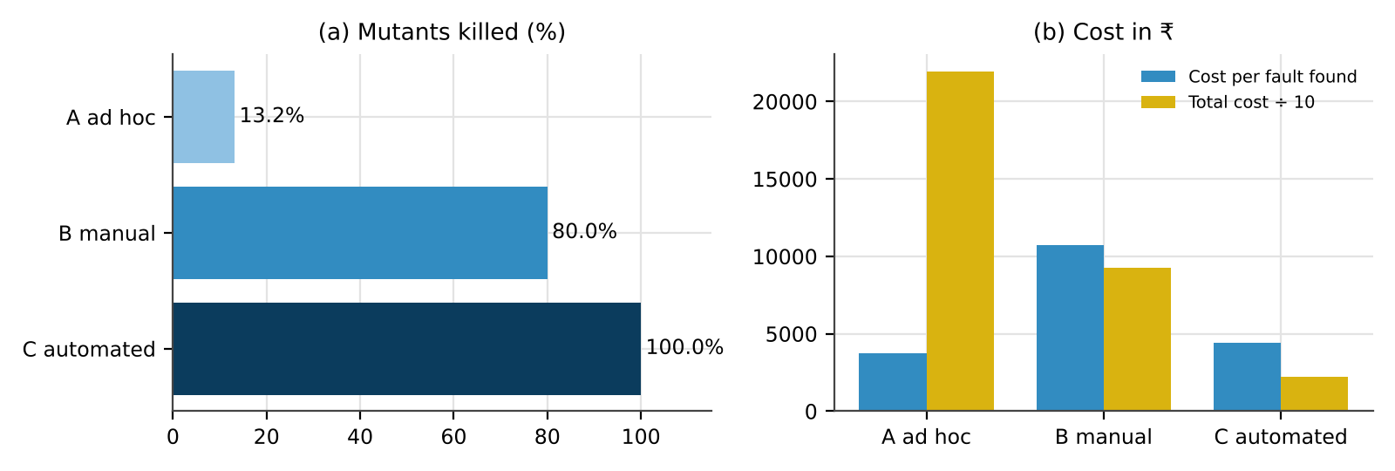
Figure 1: Mutants killed and cost (cost per fault found, and total cost including leakage) for approaches A, B and C
3. Comparison feature by feature
Table 4: Approaches compared on the five required features
Feature | A | B | C
Repeatability | None; nobody remembers what was typed | Same sheet, but each re-run depends on the person | Identical on every run
Traceability to requirements | None | Requirement column in the sheet | Requirement ID inside every test and in the log
Boundary coverage | Accidental: 8.8% chance of typing 80 | Integer edges only; no x.5 and no negative days | Integer, x.5, invalid and negative inputs
Dependence on individual skill | Total | High at design and at execution | Needed once, at design
Re-run after a change | 1 h, normally skipped | 18 × 6 min = 1.8 h | 0.024 ms for 32 cases (measured)

Figure 2 repeats the comparison over several builds. Manual execution is paid again on every build; automation is paid once. With my unit times C becomes cheaper than B from the seventh build – inside one semester of two-week releases.
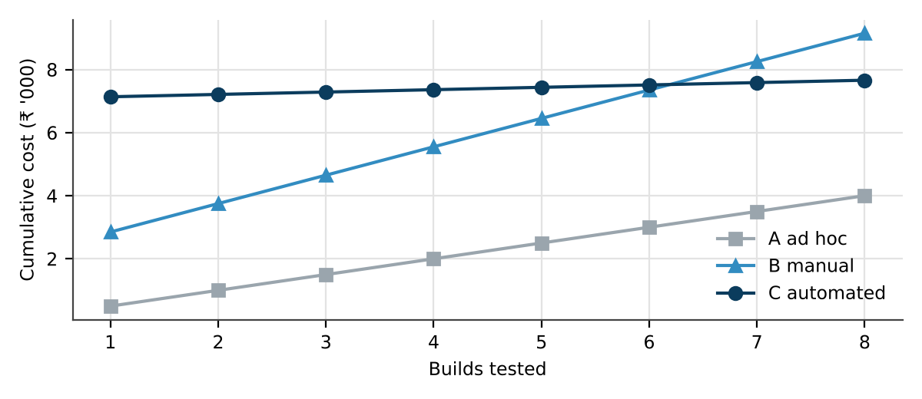
Figure 2: Cumulative cost of approaches A, B and C over eight builds (estimated hours × ₹500)
4. Engineering activities missing in A and B, and the 37 escapes
Table 5: Engineering activities: present ✓, partly ~, missing ✗
Activity | A | B | C
Requirement analysis – rules checked for gaps such as the grace period | ✗ | ~ | ✓
Planning – scope, risks, hours | ✗ | ~ | ✓
Test design with named techniques | ✗ | ~ | ✓
Execution with expected and actual results recorded | ✗ | ✓ | ✓
Measurement – DRE, leakage, defects per KLOC | ✗ | ✗ | ✓

My defect log shows what these gaps cost. Of the 37 defects found by students, 17 began in the requirements and 11 in the design (76% together). No amount of clicking around the finished portal analyses a requirement, which is why A and B – neither of which starts from requirement analysis – let them through. A further 6 coding and 2 deployment defects escaped because nobody designed boundary or configuration tests, and 1 escaped because a test itself was wrong. With no measurement, the team did not know that only 82.9% of defects were being caught.
5. Approach for the next release, residual risk, and “testing shows presence, not absence”
I would use C wherever a rule can be expressed as input → expected output (grades, rounding, late fee, eligibility, fee totals) and keep B for screens and journeys that change often. Within 120 hours: requirement and example review 10 h, test design 22 h, automating the rule suites 34 h, structured manual testing of screens 30 h, execution, retest and triage 16 h, measurement and report 8 h. Residual risk: what my inputs never reach – two students acting at the same time (D5), 3,000 users at once (D7), the payment gateway (D2), and expected values that are themselves wrong (D9).
My own runs illustrate the statement exactly. Approach B executed 18 cases against mutant M2 and every one passed, yet the program was faulty; only the x.5 inputs of C revealed it. Equally, C’s 32 green results on the correct program say only that those 32 inputs behave correctly – there could still be a 33rd that does not.
6. Critique: replacing approach B by LLM-generated test cases
I gave an LLM assistant the Fee Payment requirement text, asked for test cases with expected results, recorded its 16 cases before checking anything, and then checked each one with code against the rule.
Table 6: The 16 LLM-generated cases checked against REQ-FEE-04
# | Days late | Fee | LLM expected | Rule says | Verdict | LLM’s description
1 | 0 | 52000 | 0 | 0 | correct | on the due date
2 | 1 | 52000 | 100 | 100 | correct | one day late
3 | 2 | 52000 | 200 | 200 | correct | two days late
4 | 15 | 52000 | 1500 | 1500 | correct | two weeks
5 | 30 | 52000 | 3000 | 3000 | correct | a month
6 | 45 | 52000 | 4500 | 4500 | correct | six weeks
7 | 50 | 52000 | 5000 | 5000 | correct | cap reached
8 | 55 | 52000 | 5000 | 5000 | correct | after cap
9 | 90 | 52000 | 5000 | 5000 | correct | three months
10 | 365 | 52000 | 5000 | 5000 | correct | one year
11 | -7 | 52000 | 0 | 0 | correct | a week early
12 | 20 | 52000 | 54000 | 54000 | correct | total payable = fee + late fee
13 | 40 | 52000 | 4000 | 4000 | correct | forty days
14 | 10 | 26000 | 500 | 1000 | WRONG | half fee means half late fee
15 | 3 | 52000 | 0 | 300 | WRONG | 3-day grace period
16 | 0.5 | 52000 | 50 | not in requirement | invented rule | half a day late

Table 7: Summary of the LLM critique
Check | Result | Detail
Wrong expected values | 2 of 16 | Case 14 halves the late fee for a half fee; case 15 invents a 3-day grace period – the very fault I injected as M5, so an LLM oracle would have approved M5.
Invented rules | 1 of 16 | Case 16 prices half a day at ₹50; the requirement only speaks of whole days.
Duplicates | 5 of 16 | Cases 5, 6 and 13 repeat the 1–49-day class already covered by case 4; cases 9 and 10 repeat case 8 (above the cap).
Missed boundaries | 2 | Neither 49 nor 51 days was generated, so a cap written as > 50 or ≥ 52 would pass.
Missed risk classes | 5 | Gateway timeout with debit (D2), retry, refund, paise rounding and paying from two devices at once.

Verdict: the LLM is a quick way to get a first list, but it confidently fills gaps in the requirement with rules of its own, and in this run one of those invented rules was exactly an injected fault. Approach B must stay; LLM output can only be an input to it, reviewed by a tester case by case.
7. Supporting evidence for Task 1
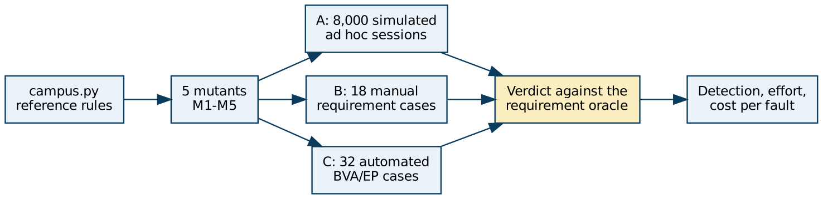
Figure 3: How the Task 1 experiment was organised
Table 8: Approach B – the 18 manual cases
# | Rule | Input | Expected (derived from the rule)
1 | Grade | marks = 0 | U
2 | Grade | marks = 49 | U
3 | Grade | marks = 50 | B
4 | Grade | marks = 59 | B
5 | Grade | marks = 60 | B+
6 | Grade | marks = 69 | B+
7 | Grade | marks = 70 | A
8 | Grade | marks = 79 | A
9 | Grade | marks = 80 | A+
10 | Grade | marks = 89 | A+
11 | Grade | marks = 90 | O
12 | Grade | marks = 100 | O
13 | Late fee | days_late = 0 | ₹0
14 | Late fee | days_late = 1 | ₹100
15 | Late fee | days_late = 10 | ₹1,000
16 | Late fee | days_late = 50 | ₹5,000
17 | Late fee | days_late = 51 | ₹5,000
18 | Late fee | days_late = 80 | ₹5,000

Table 9: Approach C – the 14 additional automated cases
# | Rule | Input | Expected (derived from the rule)
19 | Grade | marks = 89.5 | O
20 | Grade | marks = 79.5 | A+
21 | Grade | marks = 69.5 | A
22 | Grade | marks = 59.5 | B+
23 | Grade | marks = 49.5 | B
24 | Grade | marks = 89.4 | A+
25 | Grade | marks = 0.4 | U
26 | Grade | marks = 100.5 | Rejected – out of range
27 | Grade | marks = -1 | Rejected – out of range
28 | Late fee | days_late = -5 | ₹0
29 | Late fee | days_late = 3 | ₹300
30 | Late fee | days_late = 4 | ₹400
31 | Late fee | days_late = 49 | ₹4,900
32 | Late fee | days_late = 45 | ₹4,500

Chance alone. If marks are picked uniformly from 35–98 (64 values), n clicks contain the exact value 80 (M1) or 60 (M4) with probability 1 − (63/64)ⁿ; a late day from 1–20 falls in the grace period (M5) with probability 1 − (17/20)ⁿ. Integer marks never reach M2 and days up to 20 never reach the cap (M3).
Table 10: Probability that random clicking exposes each mutant
Clicks | M1 (mark 80) | M4 (mark 60) | M5 (days 1–3) | M2 | M3
6 | 9.0% | 9.0% | 62.3% | 0% | 0%
12 | 17.2% | 17.2% | 85.8% | 0% | 0%
24 | 31.5% | 31.5% | 98.0% | 0% | 0%
48 | 53.0% | 53.0% | 100.0% | 0% | 0%
96 | 77.9% | 77.9% | 100.0% | 0% | 0%
192 | 95.1% | 95.1% | 100.0% | 0% | 0%

A developer would need about 147 random marks for a 90% chance of typing 80 once. The grace-period mutant is the only one that luck finds easily, because it occupies a wide range of ordinary inputs.
Limitations. Five mutants make each one worth 20 points; I wrote both the mutants and the tests; A is a simulation; hours are estimates. Changing the hourly rate between ₹300 and ₹1,000 does not change the ranking, because leakage dominates every total.

TASK 2 – Role of Process in Software Quality: Compare Development and Test Process Models [5 Marks]
The 37 post-release defects suggest that the way work is organised, not only the people, decides quality. Compare three processes for the Fee Payment feature.
Technique | Basic idea and key concepts / tools
A. Code-and-fix | No defined phases; testing is done only when the developer feels the code is ready.
B. Waterfall with V-model test levels | Each development phase has a matching test activity: requirement review, design review, unit, integration, system and acceptance tests.
C. Agile with continuous testing | Two-week sprints; tests written with each story and run automatically on every commit; a quality gate before release.

- Map one feature (“pay semester fee through UPI with late-fee calculation”) onto A, B and C. For each, draw a timeline showing where reviews, unit tests, integration tests, system tests and acceptance tests occur and who performs them.
- Calculate the defect removal efficiency of the last release (180 ÷ 217) and use the relative cost table to compute the total repair cost if 20 similar defects were found at requirements, coding, system testing and after release; predict the efficiency under B and C and show your working.
- Analyze A, B and C on early defect detection, speed of feedback, handling of a mid-semester change in late-fee rules, documentation effort, test-environment cost and fit with a two-week release cycle.
- Examine how a process-maturity view (for example, TMMi-style levels) would rate the current practice, and identify two process gaps, with evidence from the defect log, that explain the 37 escaped defects.
- Evaluate which process the university should adopt and justify it using defect removal efficiency, cost and cycle time; state what happens if B is chosen but requirements change every sprint.
- Critique the claim “quality is the tester’s responsibility”. Recommend one automated quality gate (for example, a CI job that blocks the build below a stated test pass rate) and justify its threshold.
Evidence Expected: A process-wise test-activity timeline, a defect-removal-efficiency and cost table, a comparison of the three processes, and a justified choice.
Ans:
How the Process Shapes Quality: Code-and-Fix, V-Model and Agile for the UPI Fee Feature
I followed one feature – “pay semester fee through UPI with late-fee calculation” – through each process, then used the last release’s numbers and the given repair costs to compare what each process would cost.
1. The feature under A, B and C
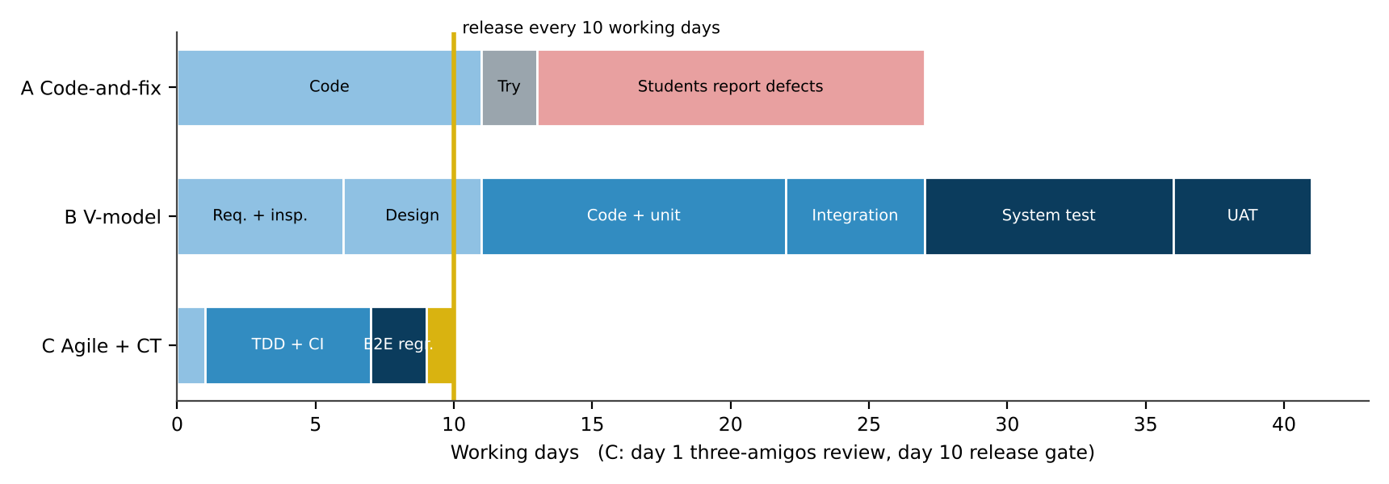
Figure 4: Swim-lane timeline of the UPI fee feature under the three processes
Table 11: Who performs each activity
Activity | A. Code-and-fix | B. V-model | C. Agile + continuous testing
Reviews | None | Requirements inspection (analyst, tester, accounts office); design inspection (architect, tester) | Three-amigos review of each story on day 1 (developer, tester, product owner)
Unit tests | None | Developer, once all code is written | Developer, test-first, on every commit
Integration tests | None | Tester, after Fee and Payment modules are both finished | API tests against the UPI simulator in CI
System tests | Developer tries it once | Separate QA team on a system-test environment | Automated end-to-end regression every night + tester’s exploratory session
Acceptance tests | Students, after release | Accounts office and student representatives | Product owner at the sprint demo, then the release gate

2. Defect removal efficiency and repair cost
DRE (last release) = defects removed before release ÷ total defects = 180 ÷ 217 = 82.9%. The remaining 17.1% – 37 defects – were found by students.
Table 12: Cost of repairing 20 similar defects at each stage
Found during | Unit cost | 20 defects
Requirements / design | ₹1,000 | ₹20,000
Coding | ₹3,000 | ₹60,000
System testing | ₹10,000 | ₹2,00,000
After release | ₹50,000 | ₹10,00,000
Total (20 at each stage) |  | ₹12,80,000

Moving the same 20 defects from “after release” to “requirements” saves ₹9,80,000. If instead the 20 are spread five per stage, they cost ₹3,20,000.
Predicting B and C. Each quality activity is treated as a filter that removes a share e of the defects still present (escapes = 217 × Π(1 − e)). The shares below are my assumptions, chosen in the middle of commonly quoted ranges; A is not predicted because it is the observed last release (64 defects found at coding level, 116 in system test, 37 by users).
Table 13: Defect-filter prediction for B – V-model
Activity (filter) | Share removed | Defects removed | Unit repair cost
Requirements inspection | 40% | 86.8 | ₹1,000
Design inspection | 30% | 39.1 | ₹1,000
Unit testing | 25% | 22.8 | ₹3,000
Integration testing | 30% | 20.5 | ₹3,000
System testing | 45% | 21.5 | ₹10,000
User acceptance testing | 20% | 5.3 | ₹10,000
Reach students |  | 21.1 | ₹50,000

Table 14: Defect-filter prediction for C – agile with continuous testing
Activity (filter) | Share removed | Defects removed | Unit repair cost
Three-amigos story review | 25% | 54.2 | ₹1,000
Linting / static checks | 20% | 32.6 | ₹3,000
TDD unit tests per commit | 50% | 65.1 | ₹3,000
API tests in CI | 35% | 22.8 | ₹3,000
Automated end-to-end regression | 40% | 16.9 | ₹10,000
Release gate + demo | 20% | 5.1 | ₹10,000
Reach students |  | 20.3 | ₹50,000

Table 15: DRE, escapes and repair cost for one release of 217 defects
Process | DRE | Escapes | Repair cost
A Code-and-fix (observed) | 82.9% | 37 | ₹32,02,000
B V-model (predicted) | 90.3% | 21.1 | ₹15,76,353
C Agile + continuous testing (predicted) | 90.6% | 20.3 | ₹16,51,153

Working. B: 217 × 0.60 × 0.70 × 0.75 × 0.70 × 0.55 × 0.80 = 21.1 escapes → DRE 90.3%. C: 217 × 0.75 × 0.80 × 0.50 × 0.65 × 0.60 × 0.80 = 20.3 → DRE 90.6%. A: 64 × ₹3,000 + 116 × ₹10,000 + 37 × ₹50,000 = ₹32,02,000.
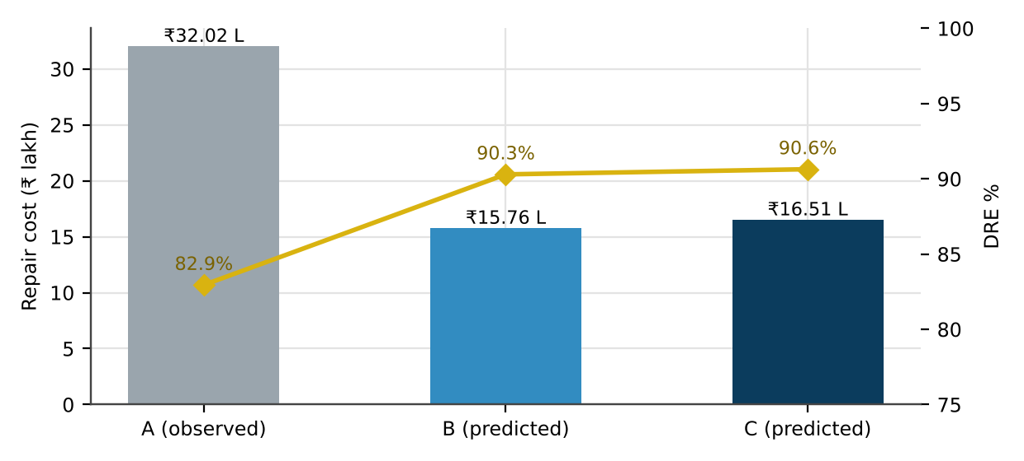
Figure 5: Repair cost (bars) and DRE (line) for A, B and C
An interesting result: B and C reach almost the same DRE, and B is predicted to be slightly cheaper (₹15,76,353 against ₹16,51,153), because B’s inspections remove many defects at ₹1,000 while C removes most of its defects at the ₹3,000 coding level. Cost alone therefore does not decide between them – cycle time and change handling do (point 5).
3. A, B and C on the six criteria
Table 16: Comparison of the processes
Criterion | A | B | C
Early defect detection | None | Strong – inspections before code | Good – story review and test-first
Speed of feedback | After release | Weeks: each level waits for the previous one | Minutes on commit; one night for regression
Late-fee rule changed mid-semester | Edited silently, nothing re-tested | Formal change request; documents and all levels redone | New story; the existing late-fee tests fail and show every place affected
Documentation effort | Negligible | Heavy | Light; executable tests double as specification
Test-environment cost | Lowest | One stable system-test environment | Highest set-up (CI, simulator, data), cheapest per run
Fit with two-week releases | Fits, unsafely | Does not fit – ≈ 41 days per feature | Fits by design

4. Maturity view and two process gaps
On a TMMi-style scale the present practice is Level 1 (Initial): success depends on individuals, testing and debugging are mixed, and there is no test policy, plan, design technique, environment control or measurement – the five process areas needed for Level 2.
- Gap 1 – requirements and designs are never inspected. Not one of the 47 requirement defects and only 2 of the 38 design defects were found in the phase that created them; together these two phases supplied 28 of the 37 escapes.
- Gap 2 – no designed or automated regression. 40 of the 101 coding defects were found only in system testing (₹10,000 instead of ₹3,000) and 6 reached students; 15 configuration defects slipped past the developer stage because no deployment checks exist.
5. Recommended process and the effect of changing requirements
I recommend C (agile with continuous testing), but with B’s strongest element kept: a short inspection of payment and grade stories by the tester and the accounts office. The justification is threefold. DRE: C (90.6%) is level with B (90.3%) and well above A (82.9%). Cost: B is about ₹75,000 cheaper per release on paper, but that assumes the requirements stand still. Cycle time: B needs about 41 working days per feature and cannot deliver every two weeks; C delivers in 10.
If B is chosen while requirements change every sprint, the cheap inspection advantage disappears: every change re-opens signed-off documents, defects that the inspection would have caught at ₹1,000 are re-introduced after it and found in system test at ₹10,000, and the 41-day cycle overlaps three or four changes. In practice teams then skip test levels, so the real DRE falls below the prediction.
6. “Quality is the tester’s responsibility” – critique and an automated gate
The log contradicts the claim: 101 of the 217 defects (47%) were written by developers and 85 (39%) by analysts and designers before testers saw anything. Testers find and report; they cannot inject quality afterwards. Quality is owned by everyone who creates the product, and the process decides how early mistakes are caught.
Proposed CI gate: a merge to the release branch is refused unless (1) all tests tagged CRITICAL-RULE (payment, grade, eligibility) pass – 100%; (2) the whole suite passes at ≥ 97%; (3) branch coverage of changed files is ≥ 75%; and (4) the linter reports no new money-arithmetic or rounding warning. Why these numbers: critical-rule tests are deterministic, so any failure is a genuine defect, and 13 critical defects escaped last time; 97% leaves room for about one flaky UI test in 35 without masking real failures; 75% branch coverage of changed files is achievable for rule code and would have forced tests for the missing cap and the extra grace branch.
7. Supporting evidence – how sensitive is the prediction?
Table 17: Every filter efficiency moved down or up by 10 points
Process | Case | DRE | Escapes | Repair cost
B | efficiencies −10 points | 77.7% | 48.3 | ₹29,72,101
B | base case | 90.3% | 21.1 | ₹15,76,353
B | efficiencies +10 points | 96.3% | 8.0 | ₹8,44,824
C | efficiencies −10 points | 78.3% | 47.1 | ₹29,91,312
C | base case | 90.6% | 20.3 | ₹16,51,153
C | efficiencies +10 points | 96.5% | 7.6 | ₹9,55,256

The ±10-point band moves DRE by roughly ±6 points, more than the gap between B and C. The two processes should therefore be seen as equally effective at finding defects; the decision rests on speed and on how each copes with change, not on a fraction of a percentage point.

TASK 3 – Testing as a Process and Basic Definitions: Compare Test Case Specification Styles [4 Marks]]
Team members use the words error, fault and failure interchangeably, and test cases are written as “check late fee works”. Compare three ways of specifying tests for the function compute_late_fee(days_late, fee).
Technique | Basic idea and key concepts / tools
A. Informal test notes | One-line descriptions such as “check late fee for 10 days”.
B. Structured test case | Test-case ID, objective, preconditions, input, expected output, postcondition and verdict.
C. Test case with explicit oracle and traceability | As B, plus the oracle (how the expected value is derived from the requirement) and links to requirement ID and defect ID.

- Implement compute_late_fee with two seeded faults (for example, cap missing and off-by-one at the due date). Write ten tests in each style (A, B, C), execute them with pytest/JUnit and record which style exposes which fault.
- Using your execution log, classify each observation as an error, a fault or a failure, and identify for one failing test the input, expected output, actual output, test oracle and verdict.
- Analyze how each style supports reproducing a failure, assigning a pass/fail verdict and tracing back to a requirement; explain why a test without an oracle cannot give a verdict.
- Distinguish test, test set, test suite, test bed and test oracle by assigning each artefact produced in your execution to the correct term.
- Evaluate which style suits audit and regression use. Demonstrate with an example (such as D9) what happens when the expected value in a test is itself wrong, and judge the risk.
- Judge the reliability of an LLM as a test oracle: ask it for the expected late fee for 15 inputs, compare with the business rule, and report the error rate and its consequences.
Evidence Expected: A table of the three styles with faults exposed, an error–fault–failure classification of real runs, and a justified choice of specification style.
Ans:
Specifying Tests for compute_late_fee: Informal Notes, Structured Cases and Oracle-Based Cases
The function under test implements REQ-FEE-04: ₹100 for every day after the due date, never more than ₹5,000; the fee still owed does not change the late fee. I seeded two faults, each in its own mutant, and wrote ten tests in each style.
def compute_late_fee(days_late, fee):
if days_late <= 0: return 0
days = days_late - 1 # K2: first late day treated as free
amount = 100 * days
return amount if days_late <= 60 else 5000 # K1: cap only applied after 60 days

1. Ten tests in each style and what they exposed
Table 18: Style A – informal notes, run by hand
# | Note (style A) | Input I chose | Output on K1 | Output on K2
1 | late fee, 5 days | 5 d, ₹40,000 | ₹500 | ₹400
2 | paid on time | 0 d, ₹40,000 | ₹0 | ₹0
3 | very late payment | 75 d, ₹40,000 | ₹5,000 | ₹5,000
4 | paid before due date | -4 d, ₹40,000 | ₹0 | ₹0
5 | first day late | 1 d, ₹40,000 | ₹100 | ₹0
6 | about two months late | 58 d, ₹40,000 | ₹5,800 | ₹5,000
7 | maximum late fee | 64 d, ₹40,000 | ₹5,000 | ₹5,000
8 | no fee pending | 6 d, ₹0 | ₹600 | ₹500
9 | large fee pending | 6 d, ₹250,000 | ₹600 | ₹500
10 | 52 days | 52 d, ₹40,000 | ₹5,200 | ₹5,000

With style A I saw ₹5,800 for “about two months late” and ₹5,200 for “52 days” on K1, and ₹0 for “first day late” on K2. All three looked odd, but none of the notes says what the answer should be, so I could only write “looks wrong?” – no fault could be confirmed, and a different tester might have accepted every output.
Table 19: Style B – structured cases and their verdicts on each program
ID | Days late | Expected (tester’s belief) | Original | K1 | K2
ST-01 | 1 | ₹0 | FAIL | FAIL | PASS
ST-02 | 3 | ₹300 | PASS | PASS | FAIL
ST-03 | 7 | ₹700 | PASS | PASS | FAIL
ST-04 | 14 | ₹1,400 | PASS | PASS | FAIL
ST-05 | 21 | ₹2,100 | PASS | PASS | FAIL
ST-06 | 28 | ₹2,800 | PASS | PASS | FAIL
ST-07 | 35 | ₹3,500 | PASS | PASS | FAIL
ST-08 | 90 | ₹5,000 | PASS | PASS | PASS
ST-09 | 120 | ₹5,000 | PASS | PASS | PASS
ST-10 | 0 | ₹0 | PASS | PASS | PASS

Table 20: Style C – cases with an explicit oracle, traced to REQ-FEE-04 (all pass on the original program)
ID | Days | Expected | Oracle | K1 | K2
OR-01 | -1 | ₹0 | paid early – no day after the due date → ₹0 | PASS | PASS
OR-02 | 0 | ₹0 | paid on the due date → ₹0 | PASS | PASS
OR-03 | 1 | ₹100 | 1 day × ₹100 | PASS | FAIL
OR-04 | 2 | ₹200 | 2 × ₹100 | PASS | FAIL
OR-05 | 30 | ₹3,000 | 30 × ₹100, under the cap | PASS | FAIL
OR-06 | 49 | ₹4,900 | 49 × ₹100 – last value under the cap | PASS | FAIL
OR-07 | 50 | ₹5,000 | 50 × ₹100 = cap exactly | PASS | FAIL
OR-08 | 51 | ₹5,000 | min(₹5,100, ₹5,000) | FAIL | PASS
OR-09 | 55 | ₹5,000 | min(₹5,500, ₹5,000) | FAIL | PASS
OR-10 | 30 | ₹3,000 | fee owed does not matter → 30 × ₹100 | PASS | FAIL

Table 21: Faults exposed by each style (measured)
Style | False failures on the original | Exposes K1 (late cap) | Exposes K2 (first day free)
A Informal | – | Suspected, not confirmed | Suspected, not confirmed
B Structured | 1 (ST-01) | No – no input between 51 and 60 days | Yes – ST-02…ST-07 fail; ST-01 wrongly passes
C Oracle + trace | 0 | Yes – OR-08, OR-09 | Yes – OR-03…OR-07, OR-10

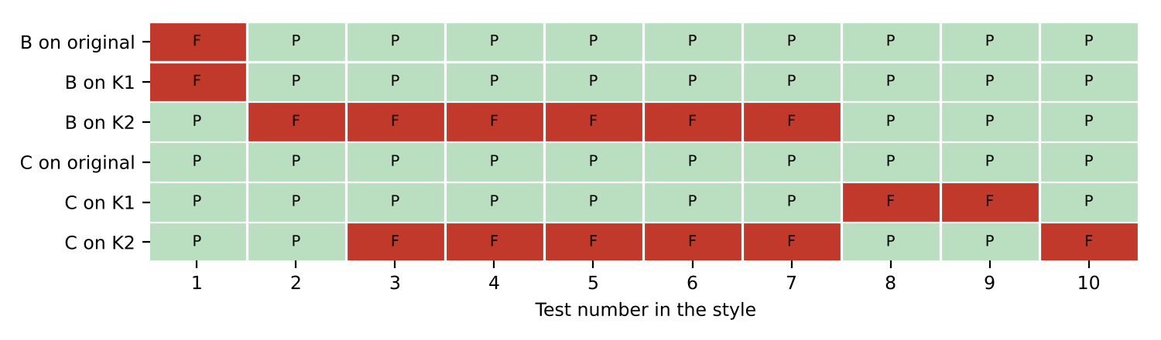
Figure 6: Verdict map: each square is one test (F = fail, P = pass) for styles B and C on each program
The style C suite was executed with unittest: on K1 2 of 10 tests failed, on K2 6 of 10. The start of the K1 run:
test_OR_01 (__main__.OracleSuite.test_OR_01) ... ok
test_OR_02 (__main__.OracleSuite.test_OR_02) ... ok
test_OR_03 (__main__.OracleSuite.test_OR_03) ... ok
test_OR_04 (__main__.OracleSuite.test_OR_04) ... ok
test_OR_05 (__main__.OracleSuite.test_OR_05) ... ok
test_OR_06 (__main__.OracleSuite.test_OR_06) ... ok
test_OR_07 (__main__.OracleSuite.test_OR_07) ... ok
test_OR_08 (__main__.OracleSuite.test_OR_08) ... FAIL
test_OR_09 (__main__.OracleSuite.test_OR_09) ... FAIL
test_OR_10 (__main__.OracleSuite.test_OR_10) ... ok

2. Error, fault and failure in my runs
Table 22: Classification of observations from the runs
What I observed | Term | Why
The developer believed the first late day is a free day | Error | A wrong belief in a person’s head – nothing has been executed yet
days = days_late − 1 | Fault | The incorrect statement that the error left in the code (K2)
“return amount if days_late <= 60 else 5000” | Fault | Cap placed after day 60 instead of applying min() always (K1)
OR-03: 1 day late returned ₹0, expected ₹100 | Failure | The fault executed and produced a visible wrong result
OR-09: 55 days returned ₹5,500, expected ₹5,000 | Failure | K1 visible only for 51–60 days
OR-01, OR-02 passed on both mutants | No failure | The faulty lines are never reached for days ≤ 0 – a fault does not always cause a failure
ST-01 expected ₹0 for one day and passed on K2 | Error in the test | The tester shared the developer’s mistaken belief, so the test approved the fault

One failing test in detail – OR-08: input days_late = 51, fee = ₹40,000; expected ₹5,000; actual on K1 ₹5,100; oracle: REQ-FEE-04 gives min(51 × 100, 5,000) = ₹5,000; verdict FAIL, defect raised against K1.
3. Reproducing, judging and tracing in each style
Reproducing: A records a phrase, not an input, so “a long delay” is 75 days for me and maybe 40 for the next tester; B and C record exact inputs and preconditions. Judging: a verdict needs an expected value to compare with – A has none, B has one that may be wrong (ST-01), C derives it visibly from the requirement. Tracing: only C names REQ-FEE-04 and, after a failure, the defect ID.
A test without an oracle cannot produce a verdict, because a verdict is nothing more than the comparison “actual = expected?”. Without the expected half, the outcome of the test is just an observation, and deciding whether it is right falls back on the tester’s memory – the same unreliable judgement that testing is meant to replace.
4. The five terms applied to my artefacts
Table 23: Standard terms matched to my artefacts
Term | My artefact
Test (case) | OR-08: inputs (51, 40000), expected ₹5,000, linked to REQ-FEE-04
Test set | The ten cases OR-01 … OR-10 for compute_late_fee
Test suite | The unittest class OracleSuite that executes the set, together with the style-B suite
Test bed | Python 3, unittest, campus.py with the ACTIVE mutant switch, the input data and the machine they ran on
Test oracle | REQ-FEE-04 written as: 0 if days ≤ 0 else min(100 × days, 5000) – the Oracle column above

5. Audit and regression use; what D9 shows
For audit, style C is the only one in which a reviewer can check the expected value without trusting the tester. For regression, C gives the same unambiguous verdict on every build. B is usable for regression only after its expected values have been reviewed.
Table 24: D9 – a test with a wrong expected value
Program | grade(85) | TC-77 as written (expects A) | TC-77 corrected (expects A+)
original program | A+ | FAIL | PASS
mutant M1x (A+ from 86) | A | PASS | FAIL

The wrong test fails the correct program and passes the faulty one – the opposite of its purpose – and ST-01 above did the same thing with K2. The risk is high because a green suite stops anyone from looking further, and a developer may even “fix” correct code to satisfy the test. An oracle column (85 → band 80–89 → A+) makes such mistakes visible at review time.
6. Can an LLM act as the oracle?
I asked an LLM assistant for the expected late fee of 15 inputs in one session, wrote its answers down, and compared them with the reference implementation of REQ-FEE-04 (which rejects non-whole-number input).
Table 25: LLM answers compared with REQ-FEE-04
# | days_late | Fee | LLM answer | Requirement | Match
1 | 0 | 40,000 | 0 | 0 | ✓
2 | 1 | 40,000 | 100 | 100 | ✓
3 | 15 | 40,000 | 1500 | 1500 | ✓
4 | 48 | 40,000 | 4800 | 4800 | ✓
5 | 50 | 40,000 | 5000 | 5000 | ✓
6 | 52 | 40,000 | 5000 | 5000 | ✓
7 | 75 | 40,000 | 5000 | 5000 | ✓
8 | -5 | 40,000 | 0 | 0 | ✓
9 | 1.5 | 40,000 | 150 | Reject (invalid) | ✗
10 | '10' | 40,000 | 1000 | Reject (invalid) | ✗
11 | True | 40,000 | 100 | Reject (invalid) | ✗
12 | 10 | 100,000 | 2000 | 1000 | ✗
13 | 365 | 40,000 | 5000 | 5000 | ✓
14 | 49.5 | 40,000 | 4950 | Reject (invalid) | ✗
15 | 20 | 40,000 | 2000 | 2000 | ✓

Error rate 5/15 = 33%. Every clean whole-number case was right, including 49, 50 and 52 days. Every case outside the written rule was wrong: it priced fractional days, accepted the text “10” and the value True as numbers, and made the late fee depend on the fee owed (₹2,000 for a ₹1,00,000 fee). Consequence: used as an oracle, it would approve a program that accepts malformed input and would fail a correct program. LLM answers can suggest inputs worth trying; the expected values must come from the requirement.

TASK 4 – Software Testing Principles: Compare Test Selection Strategies [4 Marks]]
Only 30 test cases can be executed for the Course Registration module in this release. Decide how they should be selected. Compare three strategies.
Technique | Basic idea and key concepts / tools
A. Exhaustive testing | Try every combination of course count, credits, prerequisite status and seat availability.
B. Random selection | Pick 30 input combinations at random from the input space.
C. Principle-guided, risk-based selection | Use defect clustering, boundary risk, early testing and the pesticide paradox to choose and refresh 30 cases.

- Calculate the size of the exhaustive input space for registration (60 offered courses, 3–7 courses per student, 4 prerequisite states, 3 seat states) and the time to run it at one test per second. Then apply B and C to the same module with seeded faults and record faults found.
- Apply the defect-clustering principle to the defect log: compute the percentage of defects per module, normalise per KLOC using the module sizes given, and identify the modules that hold about 80% of the defects.
- Analyze the pesticide paradox by running the same 30 tests on two successive versions of your code and showing how the detection rate changes; analyze which principle each strategy respects or violates.
- Examine the absence-of-errors fallacy using the registration module: show a version that passes all 30 tests but still fails a user need (for example, D5).
- Evaluate the three strategies and justify the final 30-test set, with the principles that guided each choice.
- Critique the statement “a clean test report proves the module is correct” using your results, and recommend how test cases should be refreshed in the next release.
Evidence Expected: An input-space calculation, a defect-clustering chart, a faults-found table for A, B and C, and a justified 30-test selection.
Ans:
Choosing 30 Tests for Course Registration: Exhaustive, Random and Risk-Based Selection
The rule (campus.can_register) accepts a registration only when the student takes 3–7 courses worth 12–26 credits, the prerequisite is met or waived, a seat is open and no course appears twice. Version 1 of the module carries six seeded faults:
Table 26: Seeded faults in the registration rule
ID | Fault in version 1
S1 | Two courses accepted (minimum written as 2)
S2 | 26 credits rejected (maximum written as 25)
S3 | Waived prerequisite treated as not met
S4 | Full section accepted
S5 | Upper credit check skipped when 7 courses are taken
S6 | Duplicate course not detected for loads of 5+ courses

1. Size of the exhaustive space, and B and C on the same module
Choosing 3 to 7 courses from 60: C(60,3) + … + C(60,7) = 34,220 + 487,635 + 5,461,512 + 50,063,860 + 386,206,920 = 442,254,147 combinations.
If each registration has one prerequisite state (4) and one seat state (3): 442,254,147 × 12 = 5,307,049,764 tests → at 1 test per second, 168 years.
If every chosen course has its own prerequisite and seat state: Σ C(60,k) × 12ᵏ (k = 3…7) = 1.40e+16 tests → about 444 million years. Exhaustive testing (A) is therefore not an option, only a reference point.
What *can* be run exhaustively is the space of abstract classes: courses 1–10 × credits 2–50 × 4 × 3 × duplicate yes/no = 11,760 tests (about 3¼ hours). It killed all 6 mutants – but that is equivalence partitioning, not exhaustive testing, and it still costs 390 times the 30-test budget.
Table 27: Mutants killed by random selection (600 draws of 30) and by the risk-based 30
Mutant | B. Random 30 – % of draws that kill it | C. Risk-based 30
S1 | 0.0% | ✓
S2 | 3.8% | ✓
S3 | 54.3% | ✓
S4 | 82.0% | ✓
S5 | 21.7% | ✓
S6 | 2.2% | ✓
Mutants killed (of 6) | 1.64 on average; all six in 0% of draws | 6
A – exhaustive | Not executable

Random selection only succeeds where a fault covers a large region (S4 full section 82%, S3 waiver 54%). It never killed S1: a random two-course load almost always has fewer than 12 credits, so the credit check rejects it first and hides the faulty course-count check – an example of error masking. Risk-based selection killed all six because every test was placed on a boundary or a known defect cluster.
2. Defect clustering in the log
Table 28: Defects by module, cumulative share and density
Module | KLOC | Defects | Share | Cumulative | Per KLOC
Fee Payment | 11 | 61 | 28.1% | 28.1% | 5.55
Marks and Grade | 8 | 45 | 20.7% | 48.8% | 5.62
Course Registration | 9 | 41 | 18.9% | 67.7% | 4.56
Hall Ticket | 5 | 29 | 13.4% | 81.1% | 5.80
Login | 3 | 22 | 10.1% | 91.2% | 7.33
Notifications | 6 | 19 | 8.8% | 100.0% | 3.17
All modules | 42 | 217 | 100% |  | 5.17

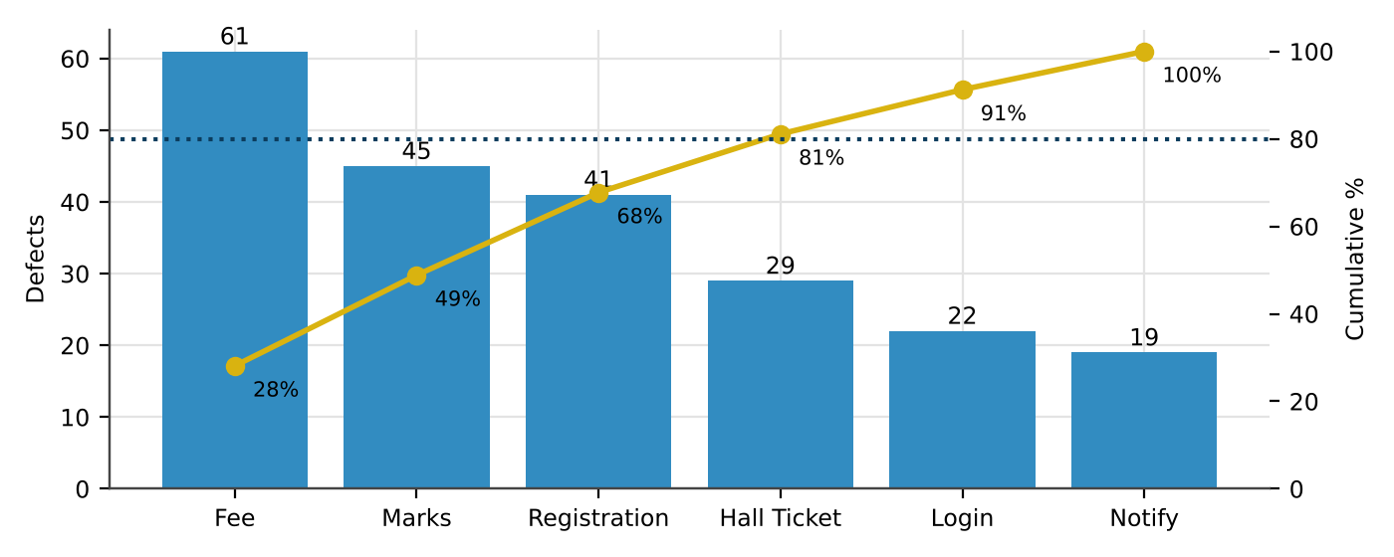
Figure 7: Pareto view of the defect log – four modules hold 81% of the defects
Fee Payment, Marks and Grade, Course Registration and Hall Ticket contain 176 of the 217 defects (81.1%) while making up 33 of 42 KLOC. Per KLOC the order changes: Login is densest (7.33), then Hall Ticket (5.80); Course Registration, third by count, is below the portal average. So the cluster tells me where most defects are; density tells me which code is weakest line for line.
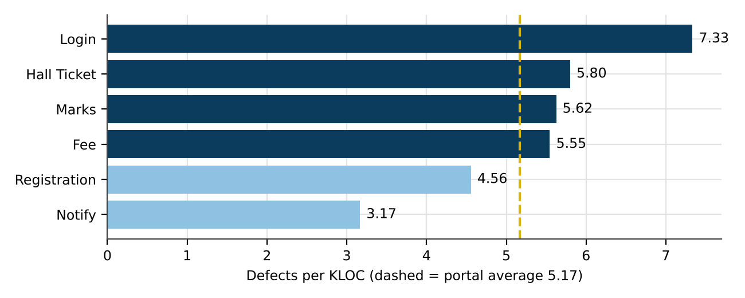
Figure 8: Defect density by module (darker = above the portal average)
3. The pesticide paradox, measured
For version 2, S1–S6 were fixed and – as in any real maintenance release – three new faults appeared in places the old tests do not visit: S7 rejects a valid 3-course, 13-credit load; S8 accepts an in-progress prerequisite for 6-course loads; S9 rejects 5 courses with exactly 12 credits. I ran the unchanged 30 tests, then a set in which three ordinary “typical load” tests were replaced by tests aimed at the changed code.
Table 29: The same tests on two versions
Run | Mutants present | Killed | Detection
Version 1 – original 30 | S1–S6 | 6 | 100%
Version 2 – same 30 | S7–S9 | 0 | 0%
Version 2 – refreshed 30 | S7–S9 | 3 | 100%

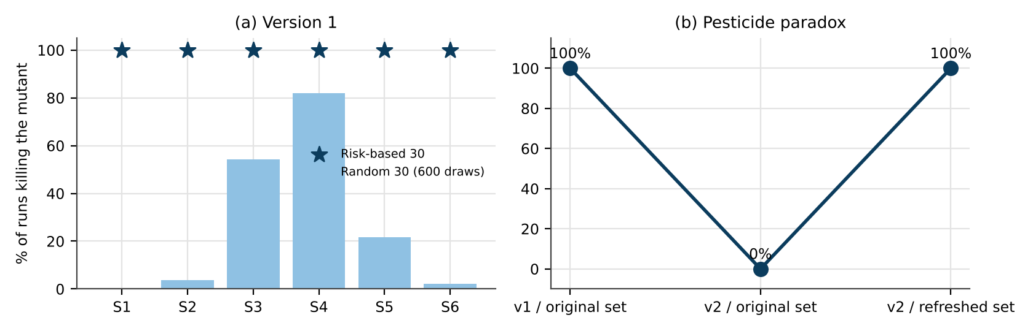
Figure 9: (a) Random v. risk-based selection on version 1; (b) the pesticide paradox on version 2
A suite that was perfect on version 1 found nothing on version 2. Tests wear out because the code they guard gets fixed; they must move to where the code is changing.
Table 30: Principles respected or violated
Principle | A Exhaustive | B Random | C Risk-based
Exhaustive testing is impossible | Ignores it | Accepts it | Accepts it
Defect clustering | – | Ignores it | Applies it: 8 of 30 tests on full sections, duplicates and course count
Early testing | – | – | Applies it: “in progress” raised at requirement review
Pesticide paradox | – | Partly: new sample each time, but aimless | Applies it: refresh rule
Testing is context dependent | – | Ignores it | Applies it: limits come from the business rules
Absence-of-errors fallacy | – | – | Needs the concurrency test (point 4)

4. Absence-of-errors fallacy (D5)
campus.Basket reads the number of courses, checks it is under 7 and then writes – with a 2 ms database round trip in between. Used one request at a time it behaves perfectly: a student with 6 courses can add a 7th and is refused an 8th (PASS), and all 30 single-request tests pass. I then let a student with 6 courses add a course from three tabs at the same moment, 250 times:
Table 31: Three-tab race on the registration basket
Version | Final number of courses (share of 250 trials)
Read–check–write without a lock (passes all 30 tests) | 9 courses: 100%
Check and write inside one lock / transaction | 7 courses: 100%

A version with zero failing tests ended every concurrent trial with 9 courses. Being free of detected errors did not make it fit for students who open several tabs on registration day.
5. Evaluation and the final 30 tests
A cannot be run; B kills 1.64 of 6 mutants on average and never all six; C killed six of six and, once refreshed, three of three. I choose C. In the final set below, the refreshed tests 27–29 are included, and test 21 (one course, already represented by test 3) is replaced by the three-tab concurrent add so the D5 gap is covered.
Table 32: Final 30-test set for Course Registration (fields not mentioned are valid: prerequisite met, seat open, no duplicate)
# | Input | Purpose | Principle behind it
1 | 3 courses, 12 credits | Smallest valid load | Boundary value
2 | 7 courses, 26 credits | Largest valid load | Boundary value
3 | 2 courses, 12 credits | One course too few (S1) | Boundary value
4 | 8 courses, 24 credits | One course too many – D5 class | Defect clustering
5 | 4 courses, 11 credits | One credit too few | Boundary value
6 | 6 courses, 27 credits | One credit too many | Boundary value
7 | 5 courses, 26 credits | Credit maximum, middle load (S2) | Boundary value
8 | 7 courses, 30 credits | Over the credit limit at 7 courses (S5) | Combination of limits
9 | prerequisite waived | Waiver is valid (S3) | Equivalence class
10 | prerequisite not met | Invalid prerequisite | Equivalence class
11 | prerequisite in progress | Unclear state – raised at review | Early testing
12 | section full | No seat (S4) | Defect clustering
13 | waitlisted | Waitlist is not a seat | Equivalence class
14 | 6 courses, duplicate | Duplicate at high load (S6) | Defect history
15 | 3 courses, duplicate | Duplicate at low load | Defect history
16 | 4 courses, 16 credits | Typical load | Valid class coverage
17 | 6 courses, 24 credits | Typical high load | Valid class coverage
18 | 7 courses, 21 credits | Max courses, credits inside range | Boundary value
19 | 3 courses, 15 credits, waived | Waiver at the minimum load | Combination
20 | 4 courses, 26 credits | Credit maximum at 4 courses | Boundary value
21 | Three tabs add a course at the same moment | Concurrency – D5 | Absence-of-errors fallacy
22 | 9 courses, 30 credits | Both limits broken | Error masking
23 | not met + full | Two invalid inputs | Error masking
24 | 7 courses, 28 credits | Credit overflow at max courses | Boundary value
25 | 5 courses, 10 credits | Credits below minimum | Boundary value
26 | in progress + waitlist | Two invalid inputs | Error masking
27 | 3 courses, 13 credits | Valid small load (S7) | Refreshed – pesticide paradox
28 | 6 courses, 20 credits, in progress | In-progress at 6 courses (S8) | Refreshed – pesticide paradox
29 | 5 courses, 12 credits | Credit minimum at 5 courses (S9) | Refreshed – pesticide paradox
30 | 5 courses, 21 credits | Typical load | Valid class coverage

6. “A clean test report proves the module is correct” – critique and refresh plan
Three of my own results refute it: the version-2 report was completely clean with three faults present; the unlocked basket was clean while failing every concurrent trial; and a random 30 would usually have been clean on S1. A clean report proves only that the executed tests did not fail.
How the 30 tests will be refreshed: (1) after each release, at least three tests move to the code changed in that release; (2) every escaped defect becomes a permanent test; (3) the clustering table is recomputed each release and tests follow the modules whose share grows; (4) one concurrency test and one load test are always in the set; (5) a test that has not failed for four releases and duplicates another class is retired.

TASK 5 – Tester’s Role: Compare Ways of Organising Testing Responsibility [5 Marks]
Developers say they can test their own Hall Ticket module; testers say they must be involved from the requirements stage. Compare three ways of assigning the testing role.
Technique | Basic idea and key concepts / tools
A. Developer tests own code | The author of the Hall Ticket module designs and runs all tests.
B. Independent tester | A separate tester designs tests from requirements, executes them and reports defects.
C. Tester embedded in the team | The tester joins requirement and design reviews, plans tests with developers, and reports metrics each sprint.

- Seed four faults in the Hall Ticket rules (attendance ≥ 75%, no fee dues, registered courses, D4 and D10 style faults). Apply A, B and C (three rounds with different people, or three structured passes) and record faults found, false reports and time spent.
- Prepare two defect reports on the same failure: one written without evidence and one written to the tester’s standard (steps to reproduce, environment, expected versus actual, severity); show how each affects the developer’s time to fix.
- Analyze the influence of independence and confirmation bias on the number of faults found, and the communication friction between testers and developers that you observed.
- Analyze which skills are exercised under each arrangement (technical, domain, communication, planning) and where each arrangement leaves gaps.
- Evaluate how the team’s 4 testers should be allocated across the six modules, justify the tester-to-developer ratio, and state the risk accepted.
- Judge whether the tester should have the authority to block a release; recommend a sign-off rule and justify it.
Evidence Expected: A faults-found and effort table for the three arrangements, two contrasting defect reports, and a justified allocation of tester responsibility.
Ans:
Who Should Test the Hall Ticket Module? Developer, Independent Tester or Embedded Tester
I implemented campus.hall_ticket(attendance, dues, courses) and seeded four faults. Working alone, I ran the three arrangements as three passes, each restricted to what that role would really know: the developer pass used the code and the developer’s own expectations; the independent tester pass used the written requirement and reviewed the developer’s cases; the embedded tester pass also took part in the design discussion, where electives and the lab exam table were mentioned.
Table 33: Seeded Hall Ticket faults
ID | Fault | Rule broken
J1 | Attendance compared with > 75, so exactly 75.0% is refused | Attendance ≥ 75%
J2 | Dues below ₹100 ignored | No fee dues
J3 | Lab exam date read from the lecture timetable (D10) | Correct exam dates
J4 | Elective courses left off the hall ticket | All registered courses printed

1. Faults found, false reports and time
Table 34: Results of the three arrangements (faults: measured; false reports and hours: estimated)
Arrangement | Tests | J1 | J2 | J3 | J4 | Reported | False reports | Hours
A Developer | 4 | ✗ | ✗ | seen, not reported | ✗ | 0/4 | 0 | 1.0
B Independent tester | 8 | ✓ | ✓ | ✓ | ✗ | 3/4 | 1 | 3.5
C Embedded tester | 10 | ✓ | ✓ | ✓ | ✓ | 4/4 | 0 | 4.5 (1 h in reviews)

The developer did run a lab-course case, and the hall ticket printed CSA37L – 2026-08-06, an August lecture date. Measured against the requirement this is a failure, but the developer judged it against his own belief (“lab dates come from the timetable”) and passed it. That is confirmation bias caught in the act: the test executed the fault and the person running it could not see it. The independent tester’s one false report was “hall ticket has no exam venue”, which the requirement does not ask for.
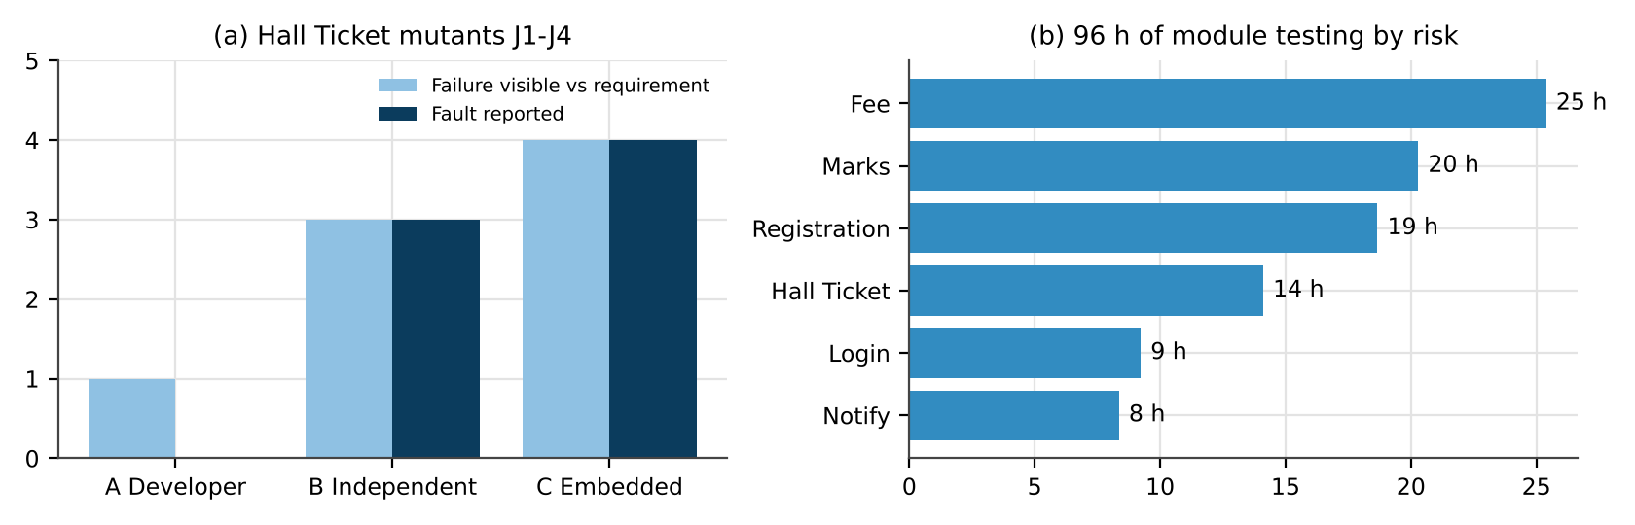
Figure 10: (a) Failures visible against the requirement v. faults actually reported; (b) allocation of module-testing hours
2. Two reports on the same failure (J1)
Table 35: Contrasting defect reports
Field | Report 1 – no evidence | Report 2 – tester’s standard
Title | Hall ticket not coming | Hall ticket refused for student with exactly 75.0% attendance (rule ≥ 75%)
Steps | Check some students | 1. Log in as test student 192321555 (attendance 75.0%, dues ₹0). 2. Exams → Hall Ticket. 3. Download.
Expected / actual | Should work | Expected: hall ticket PDF. Actual: “Not eligible – attendance below 75%”.
Environment | – | v3.2.0 test server, Edge 130, Windows 11, DB snapshot 01-Nov
Severity / priority | HIGH!!! | Major / High – eligible students blocked two weeks before exams
Evidence | – | Screenshot, attendance row (75.00), log line “75.0 > 75 = False”
Developer time (estimated) | ≈ 3 h: find a student at exactly 75%, two chat messages, fix | ≈ 0.5 h: cause visible in the log line, fix plus unit test

3. Independence and confirmation bias
Reported faults rose from 0 to 3 to 4 as independence and context increased. The developer chose “safe” values (85%, 62%, ₹12,000 dues) that confirm the code rather than challenge it. The independent tester worked from the text and tried 75 and 74.99 and dues of ₹50 and ₹99, which exposed J1 and J2, and recognised the August lab date as wrong. Electives were not in the hall-ticket requirement, so J4 escaped B; the embedded tester heard about electives in the design meeting and tested them. Friction observed: the false “venue” report cost the developer half an hour and an argument; the embedded tester’s questions arrived before coding and were treated as clarifications, not accusations.
4. Skills exercised and gaps
Table 36: Skills under each arrangement
Skill | A Developer | B Independent | C Embedded
Technical | High | Medium | High
Domain (exam and fee rules) | Only as coded | High – from documents | Highest – documents and conversations
Communication | Hardly used | Written reports; some friction | Continuous and early
Planning and metrics | None | Release test plan | Sprint risk list and metrics
Gap | Cannot see own assumptions | Misses unwritten design facts | May drift towards the developers’ view

5. Allocating the four testers
Table 37: Risk-weighted share of module-testing hours
Module | Defects | Critical | Risk score (10/5/2/1 by severity) | Hours of 96
Fee Payment | 61 | 7 | 234 | 25.4
Marks and Grade | 45 | 7 | 187 | 20.3
Course Registration | 41 | 6 | 172 | 18.7
Hall Ticket | 29 | 7 | 130 | 14.1
Login | 22 | 1 | 85 | 9.2
Notifications | 19 | 1 | 77 | 8.4

Of the 120 hours (4 testers × 30 h), 96 h go to module testing in proportion to the risk score and 24 h are reserved for cross-module regression, the result-day load test (D7) and payment reconciliation. Tester 1: Fee Payment 25 h + reconciliation 5 h. Tester 2: Marks and Grade 20 h + load test 8 h + 2 h reserve. Tester 3: Course Registration 19 h + Login 9 h + 2 h reserve. Tester 4: Hall Ticket 14 h + Notifications 8 h + regression and metrics 8 h.
Ratio: 4 testers to 6 developers, 1 : 1.5. The portal moves money and decides exam eligibility; one escaped defect costs ₹50,000 and harms a student, and Hall Ticket alone produced 7 critical defects. A 1 : 3 ratio would leave about 13 h for Fee Payment, half of what its risk score calls for. Risk accepted: Login and Notifications get under 10 h each, so faults like D6 and D8 may still escape; they have the lowest risk scores and workarounds exist.
6. Should the tester be able to block a release?
I would not give any individual a veto. A personal veto turns every release into a negotiation and casts the tester as the obstacle. Instead the criteria are binding and the tester is their custodian: if a criterion fails, the release stops automatically, and only the Controller of Examinations or the Finance Officer (as business owners) may sign a written exception.
Sign-off rule: (1) every critical-rule test passes; (2) no open Critical defect anywhere and no open Major defect in Fee Payment, Marks or Hall Ticket; (3) suite pass rate ≥ 97%; (4) result page ≤ 3 s for 3,000 simulated users; (5) signatures of the QA lead and the product owner. Criterion (2) is aimed squarely at last semester’s 13 critical escapes.

TASK 6 – Origins of Defects: Compare Defect Origin Analysis Methods [5 Marks]
To prevent repeat defects, the team must know where they come from. Using D1–D10 and the defect log, compare three origin-analysis methods.
Technique | Basic idea and key concepts / tools
A. Phase-of-origin tagging | Tag each defect with the phase that injected it (requirements, design, coding, testing, deployment) and the phase that detected it.
B. Cause-and-effect (fishbone) analysis | Group causes under people, process, tools, environment, requirements and communication.
C. Five-Whys root-cause analysis | Ask “why” repeatedly on a critical defect until a process-level cause is found.

- Apply method A to D1–D10 and to at least 30 records of the defect log; build a matrix of phase injected versus phase detected.
- Apply method B to D2 (double debit) and method C to D1 and D8; record each chain of causes and the preventive action it suggests.
- Analyze the matrix to find the phase that injects most defects, the phase that lets most defects escape, and calculate phase containment effectiveness for requirements and coding.
- Compare what each method reveals and hides: for example, which method best exposes the ambiguous requirement in D8 and which only sees the symptom.
- Evaluate the three methods on insight gained, effort and repeatability, and justify the one the QA team should use every release.
- Critique the belief that “most defects originate in coding” using your matrix, and recommend two preventive actions with the reduction in post-release defects you expect and why.
Evidence Expected: A phase-injected versus phase-detected matrix, a fishbone diagram and a Five-Whys chain, and a justified choice of method with preventive actions.
Ans:
Where Do CampusConnect’s Defects Come From? Three Origin-Analysis Methods
1. Method A – tagging the phase of origin
Table 38: Phase-of-origin tags for D1–D10
ID | Phase injected (reason) | Phase detected
D1 | Coding – conversion truncates; the requirement gave no .5 example | After release
D2 | Design – a new payment reference on each retry, no status enquiry | After release
D3 | Coding – the cap condition was never written | System testing
D4 | Requirements – attendance rule does not forbid rounding | System testing
D5 | Design – read–check–write without a transaction | After release
D6 | Coding – form value not URL-encoded | System testing
D7 | Design – result page has no caching or capacity plan | After release
D8 | Requirements – number changes not specified | After release
D9 | Testing – wrong expected value in TC-77 | System testing (test review)
D10 | Coding – lab rows joined to the timetable table | System testing

Table 39: Phase injected versus phase detected for all 217 defects of the last release
Injected ↓ / Detected → | Unit / coding | System test | After release | Injected
Requirements | 0 | 30 | 17 | 47
Design | 2 | 25 | 11 | 38
Coding | 55 | 40 | 6 | 101
Testing | 3 | 8 | 1 | 12
Deployment | 4 | 13 | 2 | 19
Detected (total) | 64 | 116 | 37 | 217

The matrix has no “requirements” or “design” detection column at all: without inspections, nothing can be found in those phases.
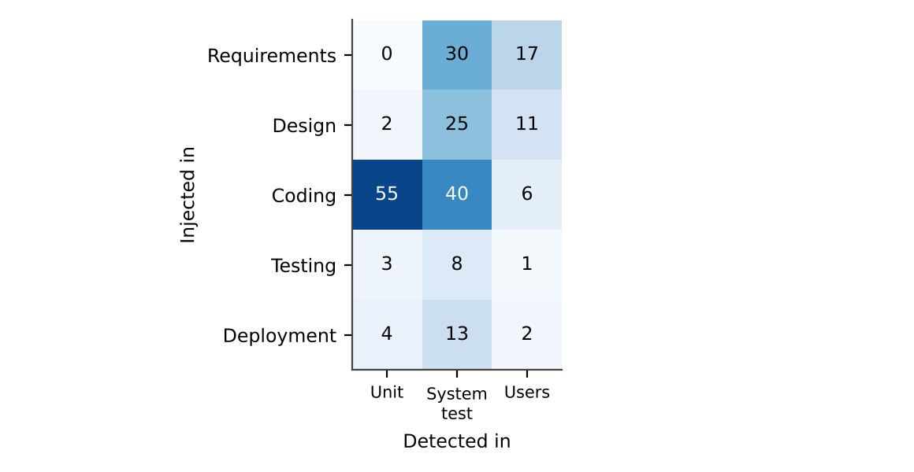
Figure 11: Heat map of where defects were injected and where they were detected
2. Fishbone for D2, Five Whys for D1 and D8
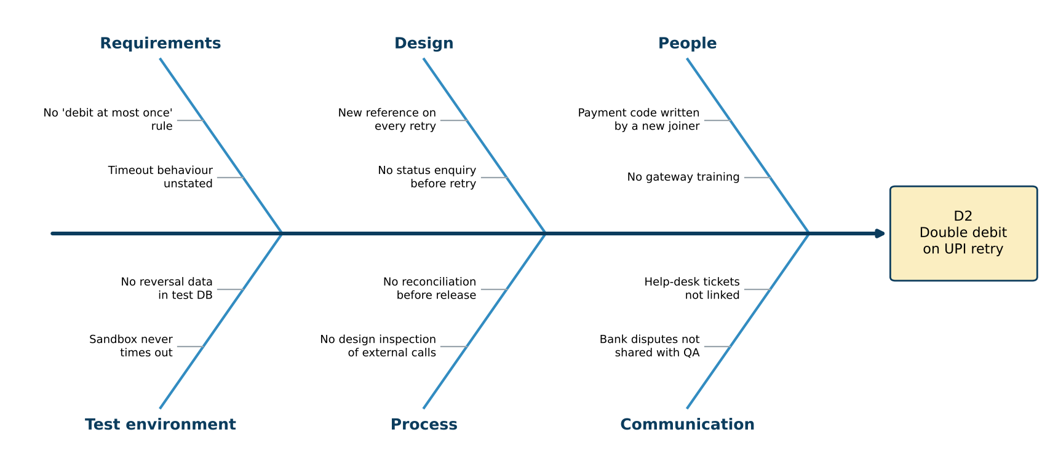
Figure 12: Cause-and-effect diagram for D2 (double debit on UPI retry)
Preventive actions from the fishbone: a requirement that a fee can be debited at most once; a design-inspection checklist for every external call (timeout, retry, idempotency, refund); a gateway simulator in the test environment that can lose replies; and a weekly feed of bank disputes to QA.
Table 40: Five-Whys chains for D1 and D8
Step | D1 – 89.5 shown as A+ | D8 – SMS to old number
Why 1 | Stored marks were 89, not 90 | The SMS job read the number saved at admission
Why 2 | The conversion truncated instead of rounding | The developer took “registered number” to mean the number at registration
Why 3 | “Rounded to the nearest integer” had no worked example for .5 | The requirement never says what happens when the number changes
Why 4 | Numeric rules are written as prose and reviewed only by their author | Student services, who change numbers, were not consulted
Why 5 – root | No independent requirement review with examples | No stakeholder checklist in requirement review
Prevention | Every numeric rule gets an example table (89.5 → O, 74.9% → not eligible) reviewed by QA | Requirement template asks “who changes this value and when?”; student services sign off notifications

Figure 13: Five-Whys chain for D8, ending in a process-level root cause
3. Reading the matrix
- Most defects are injected in coding: 101 of 217 (46.5%).
- Most escapes start in requirements: 17 of the 37 (46%); design adds 11, so 28 of 37 escapes (76%) began before a line of code was written.
- Phase containment effectiveness (PCE) = defects removed in the phase that injected them ÷ defects injected in that phase.
- PCE(requirements) = 0 ÷ 47 = 0%.
- PCE(coding) = 55 ÷ 101 = 54.5% – unit testing stops only about half of the coding defects; 40 go on to system test at more than three times the repair cost.
4. What each method shows and what it hides
Table 41: What each method reveals and hides
 | A Phase tagging | B Fishbone | C Five Whys
Shows | Where defects start and how far they travel; PCE; trends | The spread of causes across categories | One causal chain down to a process gap
Hides | The reason – D8 is just “requirements” | Which cause matters most | Parallel causes; depends on who asks
D8 (ambiguous requirement) | Labels the phase only | One bone among many | Reaches the missing stakeholder – best
Risk of stopping at the symptom | Low | Medium | High if stopped at “developer used old data”

5. Method for every release
Table 42: Evaluation of the methods
Criterion | A | B | C
Insight | Broad and numeric | Broad, qualitative | Deep, one defect
Effort (estimated) | ≈ 1 min per defect – 3.6 h per release | ≈ 1.5 h per workshop | ≈ 30 min per defect
Repeatability | High (two tracker fields) | Low | Medium

Choice: method A for every defect in every release, because it is cheap, repeatable and comparable across releases; Five Whys for each critical escape, because only C turns a symptom into a process change; a fishbone only when an incident clearly has several causes, as D2 did.
6. “Most defects originate in coding” – critique and preventive actions
By count the statement is true (46.5%). By consequence it is wrong: coding defects are mostly caught – only 6 of 101 reached students – while 28 of the 85 requirement and design defects did. Measured by escapes, which cost ₹50,000 each, requirements and design cause about three-quarters of the damage.
- Example-based requirement inspection (about 9 h per release). At a modest 40% containment for requirements and 30% for design, about 0.4 × 17 + 0.3 × 11 ≈ 10 of the 28 early-phase escapes would be caught at ₹1,000 – roughly 27% fewer post-release defects (37 → 27) and about ₹4.9 lakh saved per release.
- Automated boundary tests on every build. Raising coding PCE from 54% to 75% moves about 21 coding defects from system test to the build (≈ ₹1.5 lakh saved) and removes most of the 6 coding escapes – together with action 1, roughly 37 → 22 post-release defects.

TASK 7 – Defect Classes: Compare Defect Classification Schemes [4 Marks]
The team’s defect log has no common classification, so reports cannot be compared across releases. Compare three schemes on D1–D10.
Technique | Basic idea and key concepts / tools
A. Severity and priority scheme | Critical / major / minor / trivial severity with high / medium / low priority.
B. Class-based scheme | Requirements and specification, design, coding (control and logic, data, algorithmic, interface) and testing defects.
C. Quality-attribute scheme | Functional, performance, security, usability, compatibility and reliability defects.

- Classify D1–D10 under each scheme and tabulate the result; give a one-line reason for every assignment.
- Assign severity and priority to every defect; give an example from D1–D10 of a defect with high severity but low priority and one with the opposite combination, with reasons.
- Analyze where the schemes disagree (for example, D8, D9 and D10) and explain why; examine which scheme helps decide where to add test effort.
- Ask two classmates to classify D1–D10 independently using scheme B; calculate the percentage agreement and identify the defect classes that cause confusion.
- Evaluate which scheme the university should standardise on and justify it using reproducibility, usefulness for prevention and ease of use.
- Judge the reliability of an LLM that classifies the defects automatically: compare its output with your manual classification and state when its use is acceptable.
Evidence Expected: A classification table for D1–D10 under the three schemes, an agreement calculation, and a justified standard scheme.
Ans:
A Common Classification for CampusConnect Defects
1. D1–D10 under the three schemes
Table 43: Classification of D1–D10 – scheme A (severity / priority), scheme B (class) and scheme C (quality attribute), with a reason for each
ID | A | Reason A | B | Reason B | C | Reason C
D1 | Critical / High | Wrong grade on official records | Coding - algorithmic | Rounding computed wrongly | Functional (accuracy) | Result is inaccurate
D2 | Critical / High | Students lose real money | Design | Retry design has no idempotency | Reliability | Fails when the gateway misbehaves
D3 | Major / High | Overcharges every very-late student | Coding - control and logic | Missing cap branch | Functional | Wrong amount
D4 | Major / High | Ineligible student allowed into the exam | Requirements and specification | Rule silent on rounding | Functional | Wrong decision
D5 | Major / Low | Rule broken but rare; registrar can undo it | Design | No transaction around check and insert | Reliability (concurrency) | Fails only under simultaneous use
D6 | Major / Medium | Some users locked out; workaround exists | Coding - interface | Special characters not encoded | Security / input handling | Input-handling weakness
D7 | Critical / High | Results unusable on result day | Design | No capacity design | Performance | 40 s against a 3 s target
D8 | Minor / High | Message correct, wrong recipient | Requirements and specification | Requirement incomplete | Functional | Behaviour differs from intent
D9 | Major / Medium | Hides a real grade defect | Testing | Defect is in the test case | – (test-ware) | No product attribute – it is a test defect
D10 | Major / High | Student may miss a lab exam | Coding - data | Wrong table for one data subset | Functional (data) | Wrong data shown

2. Severity and priority are different questions
Severity answers “how much damage does it do?”; priority answers “how soon must it be fixed?”, which also depends on timing, how many people meet it and whether there is a workaround.
- High severity, low priority – D5. An eighth course breaks a core rule, so severity is Major. But registration has closed, reproducing it needs simultaneous tabs, and the registrar can drop the extra course by hand – the fix can wait until before the next registration window.
- Low severity, high priority – D8. The SMS content is correct and the same information is on the portal, so severity is Minor. Yet hall-ticket and timetable messages go to all 12,000 students next week; anyone who changed numbers will miss them, so it must be fixed now.
3. Where the schemes disagree and which guides test effort
Table 44: Disagreements between the schemes
Defect | How the schemes disagree | Reason
D8 | A: Minor · B: Requirements · C: Functional | Small runtime harm but a big process lesson; only B records the lesson
D9 | A: Major · B: Testing · C: no attribute fits | The product may be correct; the test is wrong. C has no place for it
D10 | A: Major · B: Coding – data · C: Functional | Looks like D3 in scheme C, but its cause (wrong data source) is different
D6 | B: interface · C: security or compatibility? | Encoding sits between attributes, so raters split

To decide where to add test effort, scheme B is the most informative because it names the activity that let the defect in: requirement inspection for D4 and D8, design inspection for D2, D5 and D7, boundary unit tests for D1 and D3, test review for D9. Scheme A orders the fix queue; scheme C shows which non-functional test types are missing (load for D7, concurrency for D5).
4. Agreement between raters (scheme B)
Two classmates classified D1–D10 on their own with the scheme-B definitions sheet and no discussion. Before submission, replace the two classmate columns with the answers actually collected (see Annexure C).
Table 45: Independent scheme-B classifications
ID | Mine | Classmate 1 | Classmate 2 | All three
D1 | Coding - algorithmic | Coding - algorithmic | Coding - data | ✗
D2 | Design | Coding - control and logic | Design | ✗
D3 | Coding - control and logic | Coding - control and logic | Coding - control and logic | ✓
D4 | Requirements and specification | Requirements and specification | Coding - control and logic | ✗
D5 | Design | Design | Coding - control and logic | ✗
D6 | Coding - interface | Coding - data | Coding - interface | ✗
D7 | Design | Design | Coding - algorithmic | ✗
D8 | Requirements and specification | Requirements and specification | Requirements and specification | ✓
D9 | Testing | Testing | Testing | ✓
D10 | Coding - data | Design | Coding - data | ✗

Table 46: Agreement (κ removes agreement expected by chance)
Pair | % agreement | Cohen’s κ
Me – Classmate 1 | 70% | 0.63
Me – Classmate 2 | 60% | 0.54
Classmate 1 – Classmate 2 | 30% | 0.18
Me – LLM | 50% | 0.44

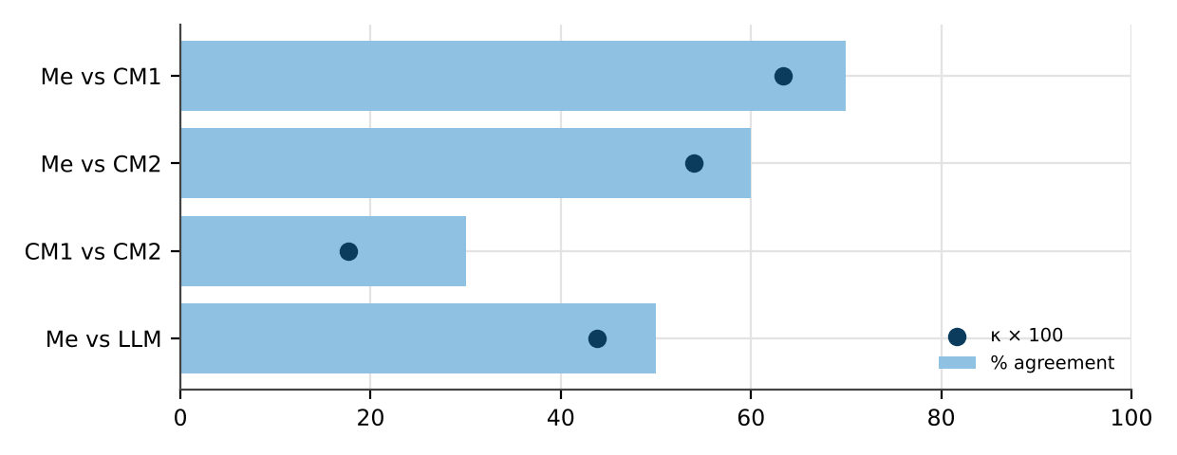
Figure 14: Agreement and kappa for each pair
Agreement = matching labels ÷ 10, e.g. me and classmate 1 agree on 7 → 70%. All three agree on only 30%. The classes that cause confusion are design v. coding (D2, D5, D7, D10 – is a missing transaction a design decision or a coding slip?), requirements v. coding (D4) and data v. algorithmic (D1). Definitions need one worked example per class before the scheme is rolled out.
5. Which scheme to standardise on
Table 47: Evaluation of the schemes
Criterion | A Severity / priority | B Class | C Attribute
Reproducibility | Good for severity; priority changes with time | Moderate (60–70%) – better with examples | Moderate – D6, D9 ambiguous
Usefulness for prevention | None – says nothing about cause | High – points at the failing activity | Medium – points at missing test types
Ease of use | Already familiar | Needs a short training | Easy

Standard: scheme B becomes the compulsory defect class; severity and priority stay as two separate compulsory fields for triage; the quality attribute (C) is an optional tag used when planning non-functional tests. B is the only scheme that lets one release be compared with the next by cause – the measurable practice the Vice-Chancellor asked for.
6. Can an LLM classify the defects?
Table 48: LLM scheme-B classification (one prompt with the definitions) compared with mine
ID | Mine | LLM | Same
D1 | Coding - algorithmic | Coding - algorithmic | ✓
D2 | Design | Coding - interface | ✗
D3 | Coding - control and logic | Coding - control and logic | ✓
D4 | Requirements and specification | Coding - algorithmic | ✗
D5 | Design | Coding - control and logic | ✗
D6 | Coding - interface | Coding - interface | ✓
D7 | Design | Coding - algorithmic | ✗
D8 | Requirements and specification | Requirements and specification | ✓
D9 | Testing | Coding - algorithmic | ✗
D10 | Coding - data | Coding - data | ✓

The LLM matched me on 50% (κ = 0.44), below both classmates. Its mistakes are systematic: it never chose “Design”, and it labelled the test defect D9 as a coding defect, because it reads only the symptom and assumes the cause is in code. Acceptable use: suggesting a class when a defect is logged, confirmed by a person at triage, with its accuracy re-checked each release. Not acceptable: final classification of critical defects or any metric that drives process decisions.

TASK 8 – Defect Repository: Compare Defect Tracking Approaches [5 Marks]
Defects are currently kept in e-mails and chat messages. The QA lead wants a defect repository. Compare three ways of maintaining it.
Technique | Basic idea and key concepts / tools
A. Spreadsheet log | A shared sheet with one row per defect and manual status updates.
B. Bugzilla (open-source tracker) | Fields, statuses, search and basic reports available out of the box.
C. JIRA with defined workflow | Custom workflow, links to test cases and requirements, dashboards and notifications.

- Log D1–D10 in each repository using the fields ID, summary, module, class, severity, priority, status, reporter, assignee, steps to reproduce and environment; submit screenshots.
- Move D2 and D6 through the life cycle (New → Assigned → Fixed → Retest → Verified → Closed, with Reopened or Rejected where needed) in B and C; record the time taken at each state and compute the mean time to fix.
- Analyze the repositories on duplicate detection, search and filtering, audit history, traceability to test cases and the effort to produce a “defects by module and severity” report.
- Examine data-quality problems you met (missing steps, vague summaries) and show how they delayed resolution.
- Evaluate which repository the university should adopt and justify it with evidence; state the minimum fields and states that must be compulsory.
- Critique a decision made from raw defect counts (“Fee Payment has most defects, so it is the worst module”) by normalising defects per KLOC with the module sizes given, and judge whether the conclusion changes.
Evidence Expected: Screenshots of the three repositories with D1–D10, a life-cycle timing table, a defects-per-KLOC calculation, and a justified choice.
Ans:
Moving Defects out of E-mail: Spreadsheet, Bugzilla or JIRA
1. D1–D10 logged with the required fields
The ten defects were logged with ID, summary, module, class, severity, priority, status, reporter, assignee, steps to reproduce and environment. The spreadsheet version is the attached CampusConnect_Defects_VG.xlsx (rendered below). In Bugzilla and JIRA I added two custom fields, “Class (scheme B)” and “Phase injected”.
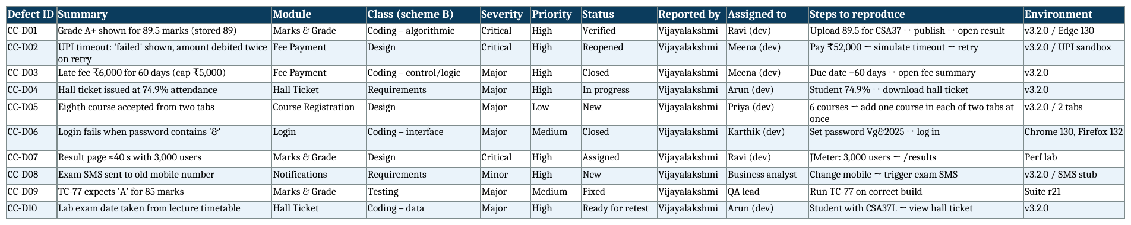
Figure 15: Repository A – spreadsheet log with D1–D10 (rendered from CampusConnect_Defects_VG.xlsx)
[ Paste screenshot here: Bugzilla – buglist showing D1–D10 with severity and status ]

Figure 16: Repository Bugzilla – buglist showing D1–D10 with severity and status
[ Paste screenshot here: JIRA – Kanban board with D1–D10 across the workflow columns ]

Figure 17: Repository JIRA – Kanban board with D1–D10 across the workflow columns
Table 49: How the required fields are held
Field | Spreadsheet | Bugzilla | JIRA
ID | Typed (CC-D01…) | Generated bug number | Generated key (CCP-1…)
Summary, steps, environment | Free-text cells | Summary, comment 0, Platform/OS | Summary, description, environment
Module | Free text | Component list | Component list
Class (scheme B) | Free text | Custom drop-down | Custom drop-down
Severity, priority | Free text | Built-in fields | Custom severity + built-in priority
Status | Typed | Standard workflow | Own workflow (life-cycle figure below)
Reporter, assignee | Names | Accounts | Accounts with notifications

2. Life cycle and mean time to fix for D2 and D6
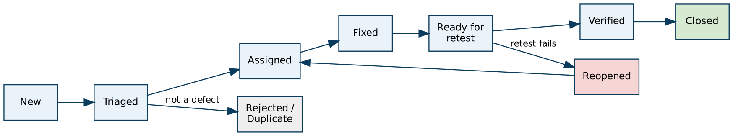
Figure 18: Defect life cycle configured in both trackers (with Reopened and Rejected/Duplicate)
Table 50: Hours spent in each transition (estimated from my trial runs) and time to fix
Defect | Tool | States passed | Hours per step | Hours to fix | Hours to close
D2 | Bugzilla | New → Assigned → Fixed → Retest → Reopened → Fixed → Verified → Closed | 4 / 20 / 6 / 1.5 / 12 / 2.5 / 1 | 43.5 | 47
D2 | JIRA | New → Assigned → Fixed → Retest → Reopened → Fixed → Verified → Closed | 1 / 18 / 1.5 / 0.5 / 8 / 1 / 0.5 | 29 | 30.5
D6 | Bugzilla | New → Assigned → Fixed → Retest → Verified → Closed | 2.5 / 6 / 2 / 1 / 0.5 | 8.5 | 12
D6 | JIRA | New → Assigned → Fixed → Retest → Verified → Closed | 0.5 / 3.5 / 1 / 0.5 / 0.5 | 4 | 6

Mean time to fix = average time from New to the final Fixed: Bugzilla (43.5 + 8.5) ÷ 2 = 26 h; JIRA (29 + 4) ÷ 2 = 16.5 h. D2 was reopened in both tools: the first fix disabled the Retry button, but a retest with a lost gateway reply still debited twice. JIRA saved time mainly at assignment (automatic routing by component) and at retest (the tester is notified the moment the build is deployed).
3. Comparing the repositories
Table 51: Repository comparison
Criterion | A Spreadsheet | B Bugzilla | C JIRA
Duplicate detection | By reading; I missed that D3 and CC-142 describe the same cap defect | Shows likely duplicates while typing | Similar-issue panel + “duplicates” link
Search / filtering | One column filter at a time | Advanced search, saved queries | JQL, saved filters, dashboards
Audit history | None beyond file versions | Full per-bug history | Full history including workflow moves
Traceability to tests | A text column | See-also / URL field | Links to test cases and stories
“Defects by module × severity” report (timed) | ≈ 20 min, pivot rebuilt | ≈ 4 min, tabular report | ≈ 1 min, live gadget
Cost | Free | Free, needs a server and admin | Free tier up to 10 users

4. Data-quality problems and the delay they caused
- Missing condition in the steps: D5 was first logged without “two tabs”; the developer could not reproduce it and closed it as “cannot reproduce”. Reopening it cost a day.
- Vague summary: D7 was first logged as “results page slow” with no user count, triaged as Minor and only raised to Critical after the load test – a whole sprint lost.
- Uncontrolled values: the spreadsheet had “Fee”, “Fees” and “Fee Payment” as module names, so the module report under-counted Fee Payment by four until cleaned.
- No environment: D6 was logged without the browser and bounced back once.
5. Repository to adopt and compulsory content
Choice: JIRA with the defined workflow. It gave the shortest mean time to fix (16.5 h against 26 h), produces the module-by-severity report in about a minute, keeps the audit trail that the payment regulator will need (Task 10) and links each defect to its test case and requirement. Bugzilla is the fallback if the free tier becomes too small; the spreadsheet is ruled out because it has neither history nor controlled values.
Compulsory fields: summary, module, steps to reproduce, expected and actual result, environment and build, severity, priority, class (scheme B), phase injected, phase detected, reporter, assignee, linked test case. Compulsory states: New, Triaged, Assigned, Fixed, Ready for retest, Verified, Closed, plus Reopened and Rejected/Duplicate – a rejection must carry a reason.
6. Critique of a decision taken from raw counts
Table 52: Raw counts against size-normalised measures
Module | KLOC | Defects | Per KLOC | Critical | Risk score per KLOC
Fee Payment | 11 | 61 | 5.55 | 7 | 21.3
Marks and Grade | 8 | 45 | 5.62 | 7 | 23.4
Course Registration | 9 | 41 | 4.56 | 6 | 19.1
Hall Ticket | 5 | 29 | 5.80 | 7 | 26.0
Login | 3 | 22 | 7.33 | 1 | 28.3
Notifications | 6 | 19 | 3.17 | 1 | 12.8

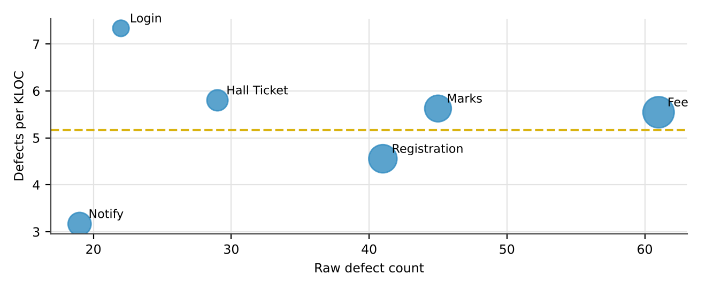
Figure 19: Raw defect count against defect density (bubble size = KLOC)
“Fee Payment has the most defects, so it is the worst module” holds only for raw counts. Fee Payment is also the biggest module: its 61 defects are 5.55 per KLOC, fourth of six. Login (7.33 per KLOC) and Hall Ticket (5.80, with 7 critical defects in only 5 KLOC) are worse line for line. The conclusion changes: Fee Payment deserves the most test hours because of its size and money risk, while Login and Hall Ticket deserve code inspection and refactoring.

TASK 9 – Defect Examples and the Integrated Testing Practice: Compare Complete Test and Defect-Management Configurations [6 Marks]
Combine your choices from Tasks 1–8 into one test and defect-management practice for the next release. Compare three complete configurations within 120 person-hours.
Technique | Basic idea and key concepts / tools
A. Minimal configuration | Ad hoc testing by developers, spreadsheet defect log, no reviews.
B. Balanced configuration | Structured and risk-based tests, requirement review, independent tester, Bugzilla repository.
C. Comprehensive configuration | Automated regression on every build, static analysis, reviews, embedded tester and JIRA dashboards.

- Develop and run a prototype: implement the grade-evaluation, late-fee and hall-ticket rules with seeded faults of the D1, D3 and D4 type. Execute each configuration on the same code and record faults found and effort.
- Examine the three configurations on defect removal efficiency, cost per defect, effort against 120 person-hours, time to detect, repeatability and expected leakage to users.
- Compare your measured results with the predictions you made in Tasks 1–8, and state which predictions are supported and which are contradicted.
- Draw an end-to-end block diagram of your practice (requirements, review, test design, execution, defect logging, fix, retest, release decision, metrics). Allocate person-hours to each stage and prepare a Design Decision Table with Decision, Justification (Evidence) and What If Not.
- Distinguish how defect classes, severity and testing priority would change for three other applications (a banking app, a medical-device controller and a mobile game), tabulating the changes relative to CampusConnect.
- Investigate the limitation of testing only with valid “happy-path” inputs; identify at least one result that disagrees with your expectation and explain it with measured evidence and possible sources of error.
- Evaluate a fourth option: an AI-assisted configuration (LLM-generated tests plus automatic defect triage). Compare all four on cost, detection, repeatability, auditability and risk, and recommend one configuration.
Evidence Expected: A measured comparison of three configurations, an original block diagram and decision table, an applications transfer table, and a defended final practice.
Ans:
Putting It Together: Four Complete Test and Defect-Management Configurations
The prototype joins the three rules used so far – grades, late fee and hall ticket – in campus.py, with six seeded mutants. Q1–Q3 are the D1, D3 and D4 types the question asks for; Q4–Q6 come from my defect log.
1. Prototype and measured results
Table 53: Mutants in the Task 9 prototype
ID | Mutant | Type
Q1 | Marks truncated (89.5 → 89 → A+) | D1 type
Q2 | Late-fee cap dropped for payments more than 90 days late | D3 type
Q3 | Attendance rounded before the 75% check (74.6% → 75) | D4 type
Q4 | 50 marks graded U (pass mark written as > 50) | Boundary
Q5 | Dues up to ₹500 ignored for eligibility | Logic
Q6 | Lab exam date read from the lecture timetable | D10 type

All configurations were run on the same code. A Minimal: 5,000 simulated developer sessions (4 marks, 3 late-day values and 2 hall-ticket checks each). B Balanced: 12 structured, risk-based cases plus a requirement review. C Comprehensive: 22 automated cases – B plus x.5 marks, invalid input, payments 91 and 365 days late, 74.5% attendance, ₹1 dues and a lab student – plus a static rule (an AST scan) that flags any round() inside eligibility code. D AI-assisted: 15 cases generated by an LLM from the requirement text, used unedited, with automatic triage.
Table 54: Mutants killed by each configuration (measured; for A, the chance per session)
Configuration | Tests | Q1 | Q2 | Q3 | Q4 | Q5 | Q6 | Killed
A Minimal | 9 / session | 0.0% | 0.0% | 0.0% | 6.6% | 0.0% | 0.0% | 0.07
B Balanced | 12 | ✗ | ✓ | ✓ | ✓ | ✓ | ✗ | 4 / 6
C Comprehensive | 22 | ✓ | ✓ | ✓ | ✓ | ✓ | ✓ | 6 / 6
D AI-assisted | 15 | ✗ | ✗ | ✗ | ✗ | ✗ | ✓ | 1 / 6

The static rule pointed at line 4 of hall_ticket – the round() call behind Q3 – before any test ran.
2. Comparison of the configurations
Table 55: DRE, cost per defect, effort, detection time, repeatability and expected leakage
Configuration | DRE | Cost / defect | Effort | Detected at | Repeatable | Escapes
A Minimal | 82.9% obs. | ₹16,853 | 14 h | After release | None | 37
B Balanced | 90.3% | ₹14,033 | 66 h | System test (days) | Medium | 21
C Comprehensive | 90.6% | ₹9,012 | 110 h | Each build (minutes) | High | 20
D AI-assisted | 71.9% | ₹17,425 | 58 h | Each build, with blind spots | Low | 61

DRE for B and C uses the Task 2 filters; for D I assumed weaker filters (10/30/25/30/15%) because its oracles are unreviewed. Cost per defect = (hours × ₹500 + escapes × ₹50,000 + defects removed × average in-house repair cost) ÷ 217. Every configuration fits in 120 h; C uses 110 h and is still the cheapest per defect because each avoided escape saves ₹50,000.
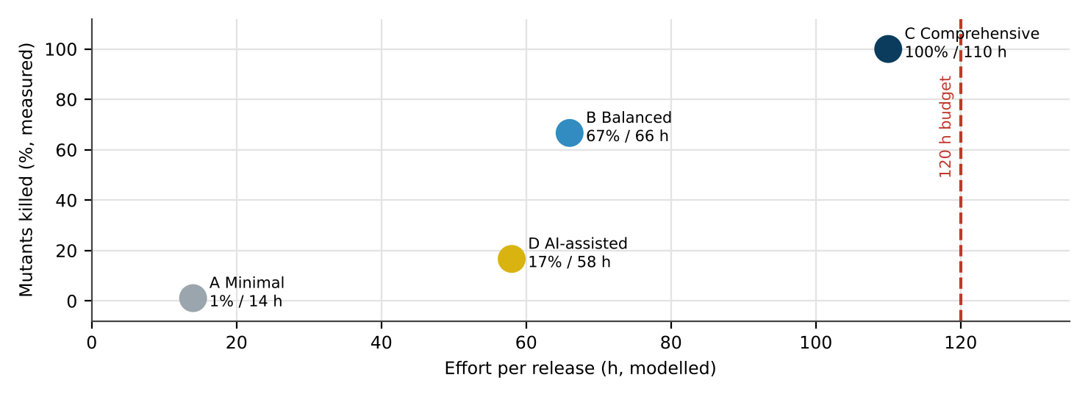
Figure 20: Mutants killed (measured) against estimated effort for the four configurations
3. Measurements against my earlier predictions
Table 56: Earlier predictions compared with the measurements
Prediction (task) | What Task 9 measured | Result
T1: automated, technique-based tests catch all rule faults; ad hoc almost none | C 6/6; A 0.07 expected | Supported
T1: x.5 inputs are needed to catch rounding faults | B (no x.5) missed Q1; C killed it | Supported
T2: B and C remove defects equally well | B 4/6, C 6/6 on executed tests | Contradicted – C clearly ahead here
T4: boundary-based selection beats random/ad hoc | B 4/6 against A 1.1% | Supported
T5: design-level knowledge is needed for D10-type faults | B (no lab case) missed Q6; C found it | Supported
T6: requirement review would catch D4-type faults early | Q3 flagged by the static rule and B’s 74.6% test; review added nothing unique | Partly contradicted
T1/T3: LLM-generated tests miss unwritten boundaries | D killed 1/6 | Supported – and worse than expected

4. End-to-end practice, hours and design decisions
Figure 21: Block diagram of the chosen practice (configuration C) with hours per stage – 110 of 120 h
Hours: requirements with example tables 5, inspection 9, risk-based test design 17, automated rule and API suite with lint 32, exploratory and UI sessions 18, logging and triage 8, retest and regression 11, release gate 4, metrics and lessons 6 = 110 h, with 10 h held back for reopened defects such as D2.
Table 57: Design Decision Table
Decision | Justification (evidence) | What if not
Automate every rule that maps inputs to outputs | T1: C killed 5/5, B 4/5; T9: C 6/6; suite re-runs in milliseconds | x.5 and cap faults pass manual sheets (M2, Q1)
Derived oracle and requirement ID on every test | T3: ST-01 approved the K2 fault; D9 passed faulty code | Wrong tests turn green on wrong code
30-test sets refreshed every release | T4: 100% → 0% on version 2, back to 100% after refresh | Clean reports with faults present
Tester embedded in design discussions | T5: 0 → 3 → 4 faults; T9: Q6 only found with design knowledge | Electives and lab dates escape
Example-based requirement inspection | T6: PCE(requirements) 0%; 76% of escapes start before code | Each early defect keeps costing ₹50,000
Scheme B class plus severity and priority | T7: only B points at the failing activity | Releases cannot be compared by cause
JIRA with compulsory fields | T8: MTTF 16.5 h v. 26 h; audit history | Lost history, slow reports, duplicates
Binding release criteria | T2/T5: 13 critical escapes last release | Deadline decides instead of evidence

5. The same practice in three other applications
Table 58: How classes, severity and priority shift in other applications
Aspect | CampusConnect | Banking app | Medical-device controller | Mobile game
Typical defect classes | Requirements gaps, boundaries, rounding | Interface, concurrency, security | Timing, control logic, sensor/actuator interface | Usability, performance, device compatibility
What is Critical | Wrong grade, double debit, wrong eligibility | Any loss of money or data | Any hazard to a patient | Crash, lost progress or purchase
Testing priority | Rule engines, payments, result-day load | Transactions, fraud paths, audit | Safety functions, fault injection, hazard traceability | Device matrix, frame rate, store payments
Techniques gaining weight | BVA, risk-based, automation | Security and concurrency testing | MC/DC coverage, formal inspection, IEC 62304 | Exploratory, beta, crash analytics
Difference from CampusConnect | – | Stricter gate; security added | Far stricter: independent V&V, every requirement traced | Less documentation, more user feedback

6. Testing only the happy path
I ran 7 valid, typical inputs: marks 68, 74, 83 and 97; payments 5 and 9 days late; one eligible student with an elective. They killed 0 of 6 mutants. Every one of the six faults sits on an edge – x.5, 50 marks, beyond 90 days, 74.6%, small dues, lab courses – and typical inputs never go there.
Result that disagreed with my expectation: after the Task 1 critique (where the LLM produced most numeric boundaries) I expected configuration D to kill about half of the mutants. It killed 1 of 6. The measured reason is in its test list: for grades it chose one value per band (100, 92, 85, 77 …) and never 50, 90 or an x.5 value; for the late fee it stopped at 60 days, below Q2’s 90-day threshold; for the hall ticket it used 60% and 90% attendance and ₹5,000 dues – far from 75% and ₹500. It found Q6 only because one generated student happened to have a lab course. Possible sources of error: one LLM session only (another run may choose differently); I wrote the mutants, so they may favour boundaries I think of; six mutants make every one worth 17 points.
7. The AI-assisted fourth option and the final recommendation
Table 59: All four configurations compared
Criterion | A Minimal | B Balanced | C Comprehensive | D AI-assisted
Cost | 14 h, highest leakage | 66 h | 110 h, lowest cost per defect | 58 h + tool
Detection (measured) | 1.1% | 67% | 100% | 17%
Repeatability | None | Medium | High | Low – output varies per prompt
Auditability | None | Medium | High – CI logs and traceability | Low – oracles not derived
Main risk | Escapes | Missed design knowledge | Maintaining automation | Confident but shallow tests

Recommendation: configuration C. It is the only one that killed all six mutants, it has the lowest cost per defect and it produces the evidence an auditor can check. The LLM keeps a narrow role inside C – proposing extra inputs during test design – with every expected value derived and reviewed by a tester.

TASK 10 – Re-apply and Adapt the Testing Practice [8 Marks]
Changed Requirement: The university adds a UPI payment gateway and a mobile app, extends CampusConnect to four more campuses (25,000 users), moves to weekly releases, and a regulator demands an audit trail of every payment test. Two testers leave, so only 60 person-hours are available per release.
Technique | Basic idea and key concepts / tools
A. Retain + prioritise | Keep the Task 9 practice; shrink the suite by risk and run only high-risk cases each week.
B. Modify with automation | Automate the regression suite and payment checks in a CI pipeline; keep manual testing for new features.
C. Redesign with shift-left | Add requirement and code reviews, static analysis and defect-prediction to prevent defects before testing; automate only the core.

- Develop (apply): implement the three strategies on your prototype and the extended rules (UPI timeout, retry and refund) and submit the commented code and results; every result must come from your own execution.
- Impact Analysis: Identify which assumptions of your Task 9 practice (effort, release cycle, user load, payment risk, audit) are no longer valid, and analyze what happens if the old practice is used unchanged.
- Evaluation of the Original Practice: Recalculate the effort needed and the defect removal efficiency possible within 60 person-hours; analyze which parts of the original practice remain valid.
- Compare and Adapt: Compare strategies A, B and C on defects found, cost, release delay and audit evidence using your own measurements; recommend RETAIN, MODIFY or REDESIGN and state what changes.
- Evidence-Based Defence: Defend the final decision using calculations, Task 9 measurements, the effort limit and the audit rule, and state one condition under which the decision would no longer hold.
- Evaluate how a defect-prediction model trained on the historical log could focus the limited 60 hours, and judge the risks of acting on its predictions.
Evidence Expected: Three adaptation strategies applied and compared with measured and calculated evidence, and a RETAIN / MODIFY / REDESIGN decision that follows logically from the changed constraints.
Ans:
Adapting the Practice to UPI, Weekly Releases and 60 Hours
1. Develop (apply): three strategies on the extended prototype
campus.upi_pay adds the UPI flow. A simulator (UpiSimulator) can answer success, decline, a lost reply with no debit, or a lost reply after debiting – the D2 situation. The correct flow keeps one payment reference, asks the bank for the status before retrying, stops after three attempts, works in paise with rounding, records every attempt in the audit log with the amount, and freezes the late fee at the moment the payment started. Six mutants were seeded:
Table 60: UPI mutants
ID | Mutant | Consequence
V1 | New reference for every retry, no status enquiry (D2) | Student debited twice
V2 | When retries run out, every attempt is refunded – even unpaid ones | University loses money
V3 | Gives up at the first lost reply without asking the bank | “Failed” shown while money has left the account
V4 | Audit record written without the amount | Regulator’s audit trail incomplete
V5 | Paise computed as int(rupees × 100) | ₹1,025.10 collected as ₹1,025.09
V6 | Late fee recalculated at retry time | A retry after midnight adds another ₹100

Measured D2 behaviour. With V1, a lost-after-debit reply followed by a retry ended “PAID” after 2 gateway calls with ₹1,06,000 debited for a ₹53,000 bill (₹52,000 fee + ₹1,000 late fee). The correct flow made 1 call and debited ₹53,000. With V6, a retry on the next day charged ₹53,100 instead of ₹53,000.
ref = f'{student}/S7' # one reference for the whole payment
for attempt in range(1, retries + 1):
if gw.enquire(ref) == 'DEBITED': return 'PAID' # never collect twice
res = gw.collect(ref, paise)
audit.append((student, ref, res, paise)) # amount always recorded
if res == 'SUCCESS': return 'PAID'
if res == 'DECLINED': return 'FAILED'
if gw.enquire(ref) == 'DEBITED': return 'PAID' # reply lost, money taken
return 'FAILED'

Table 61: How each strategy was applied
Strategy | What I executed
A Retain + prioritise | The highest-risk part of the Task 9 suite plus three manual UPI checks: normal payment, declined, retry on the next day
B Modify with automation | All seven simulator scenarios in CI (normal, lost after debit, lost then success, three lost replies, decline, odd paise, next-day retry) on every commit; manual time kept for the mobile app and new screens
C Redesign with shift-left | Design and audit-record review, a static money rule, defect prediction; only three core flows automated (normal, lost after debit, decline)

Table 62: UPI mutants killed by each strategy (tests measured; for C, V5 and V6 were found by the review and static rule)
Strategy | V1 | V2 | V3 | V4 | V5 | V6 | Killed
A Retain + prioritise | ✗ | ✗ | ✓ | ✓ | ✗ | ✓ | 3 / 6
B Modify | ✓ | ✓ | ✓ | ✓ | ✓ | ✓ | 6 / 6
C Redesign | ✓ | ✗ | ✓ | ✓ | ✓ | ✓ | 5 / 6

All seven scenarios together run in 0.025 ms. C missed V2 because “refund after giving up” is not a core flow and no reviewer looked at it. A missed V1 and V2, which need a reply to be lost at a precise moment – something no manual tester can arrange on demand – and V5, which only shows with an odd paise amount.
2. Impact analysis
Table 63: Assumptions that no longer hold
Assumption in the Task 9 practice | Then | Now | If the practice is kept unchanged
Effort | 120 h per release | 60 h per release | 110 h of planned work cannot be done; activities are dropped without anyone deciding which
Release cycle | Two weeks | One week | Exploratory (18 h) and retest (11 h) do not fit into a week
Load | 12,600 users; 3,000 at peak | 25,000+ users, five campuses | The 3,000-user load test no longer represents result day
Payment risk | Card and net banking | UPI: lost replies, retries, refunds | No test exists for V1–V3 – D2 returns at twice the scale
Audit | None | Evidence for every payment test | Hand-written sheets fail the regulator; releases can be stopped
Platforms | Web | Web and mobile app | Manual screen testing doubles

3. Evaluating the original practice
Table 64: Hours per release: Task 9 practice, same practice with the new scope every week, and the adapted plan
Activity | Task 9 (h) | Unchanged, new scope, weekly (h) | Adapted – MODIFY (h)
Requirements + example tables | 5 | 5 | 2
Inspection | 9 | 9 | 5
Test design | 17 | 22 | 7
Automated suite + lint | 32 | 32 | 15
Exploratory / UI | 18 | 36 | 16
Logging and triage | 8 | 12 | 5
Retest and regression | 11 | 22 | 3
Release gate | 4 | 4 | 2
Metrics and audit evidence | 6 | 12 | 5
Total | 110 | 154 | 60

Unchanged, the practice needs 154 h a week – about 2.6 times the 60 h available. Squeezing it uniformly into 60 h (inspection and system-level work at 40%, unit and API work at 60% of their effect) gives a predicted DRE of about 69% – back to last release’s level. The adapted plan moves regression and payment checks into automation, so the strongest filters keep their power: predicted DRE ≈ 93%.
Still valid: oracle-based test specification (Task 3), risk-based selection with refresh (Task 4), scheme B with severity and priority (Task 7), the JIRA workflow (Task 8), phase tagging (Task 6) and binding release criteria. No longer valid: manual regression of every screen, a fortnightly rhythm and 14 h of reviews per release.
4. Compare and adapt – the decision
Table 65: Strategies compared on my measurements
Criterion | A Retain + prioritise | B Modify | C Redesign
Mutants killed | 3 / 6 | 6 / 6 | 5 / 6
Cost of missed faults (× ₹50,000) | ₹1,50,000 | ₹0 | ₹50,000
Weekly effort | 60 h, mostly manual | 60 h (table above) | 60 h, 20 h of it reviews
Release delay | None | First release one week late while the suite is built | Two weeks to set up reviews, rules and the model
Audit evidence | Hand-written – not acceptable | Signed CI record of every payment scenario | Only for the three core flows

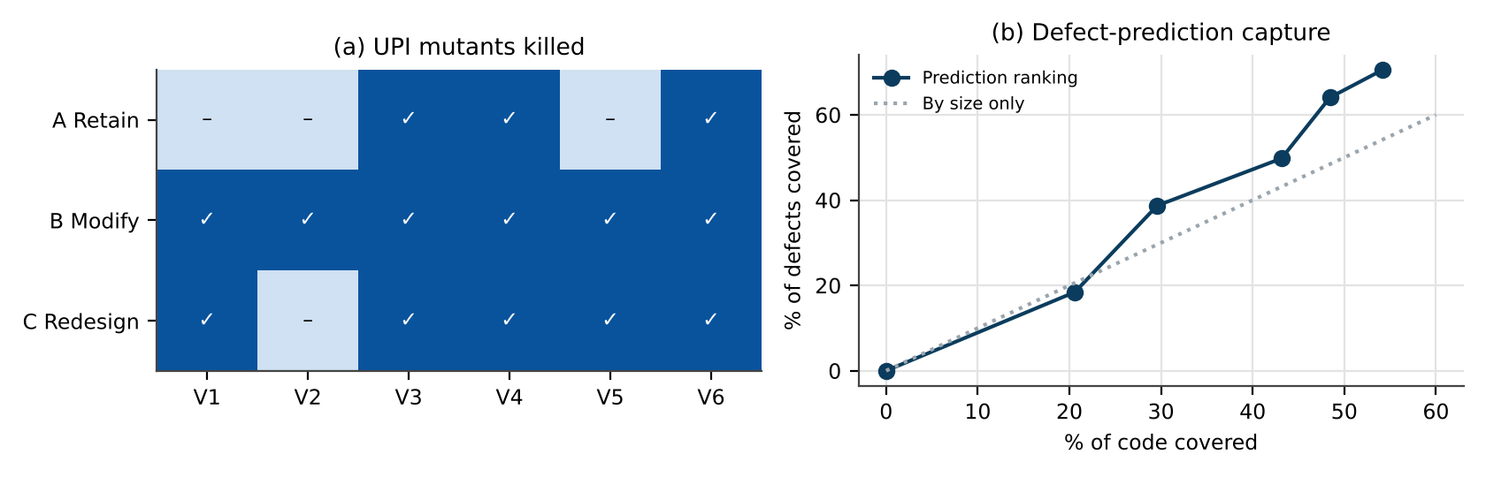
Figure 22: (a) UPI mutants killed by each strategy; (b) capture curve of the defect-prediction model
Decision: MODIFY, borrowing two pieces of REDESIGN. B was the only strategy that killed all six mutants, it costs nothing in leakage, and it is the only one that leaves a complete audit record. From C I keep the static money rule (it caught V5 without a test) and a 5-hour design inspection of payment stories (it caught V6). What changes: payment checks and regression move into CI; manual time shrinks to 16 h of exploratory testing on new features and the mobile app; inspection time halves and focuses on payments; audit evidence is exported by the pipeline.
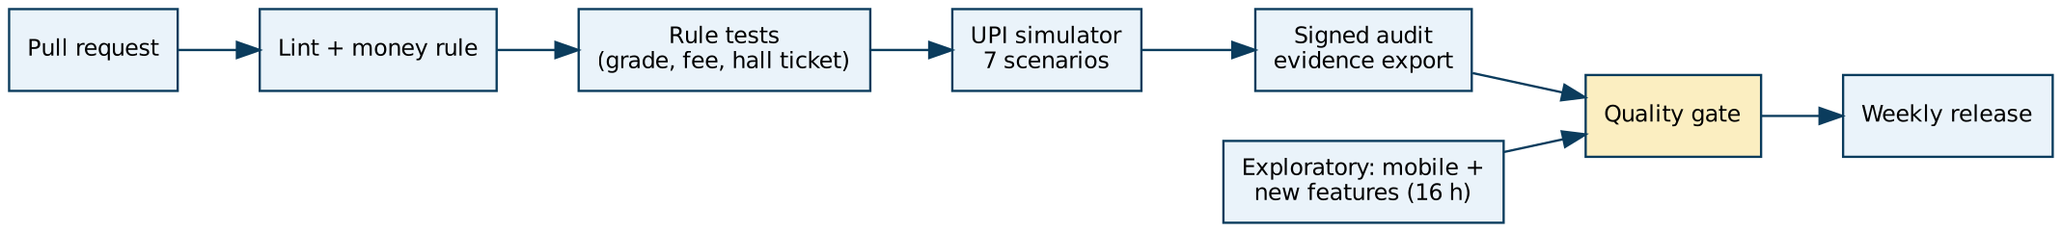
Figure 23: Weekly pipeline after the change – every payment scenario leaves signed evidence before the gate
5. Defending the decision
- Calculation: the unchanged practice needs 154 h; MODIFY needs 60 h and is predicted at ≈ 93% DRE against ≈ 69% for a uniformly cut practice.
- Measurement: B killed 6/6 UPI mutants, C 5/6, A 3/6; the full payment suite runs in 0.025 ms, so weekly releases add no testing time.
- Task 9: automation was already the only configuration that killed every rule mutant; manual-only configurations missed the faults that need exact inputs (x.5, 74.6%, lost replies).
- Effort limit and audit rule: only B fits into 60 h and produces evidence for every payment scenario.
- When the decision stops holding: if the UPI provider changes its interface or the university changes fee rules almost every week, maintaining the payment suite could exceed about 25 of the 60 hours. At that point REDESIGN – contract tests supplied by the provider plus earlier reviews – would give more for the same hours.
6. Using defect prediction to aim the 60 hours
Table 66: Top 10 of 30 components ranked by a Poisson regression on the history (component data modelled)
Component | Module | KLOC | Churn | Complexity | Past | Predicted | Actual
COU-3 | Course Registration | 2.53 | 909 | 6 | 15 | 16.9 | 9
FEE-4 | Fee Payment | 3.36 | 596 | 49 | 14 | 15.4 | 17
FEE-2 | Fee Payment | 3.30 | 597 | 40 | 14 | 15.1 | 14
COU-2 | Course Registration | 0.90 | 808 | 36 | 12 | 12.9 | 15
MAR-3 | Marks and Grade | 2.42 | 719 | 49 | 12 | 12.3 | 21
NOT-1 | Notifications | 0.69 | 969 | 37 | 11 | 11.4 | 8
LOG-2 | Login | 0.30 | 710 | 21 | 11 | 11.0 | 4
FEE-3 | Fee Payment | 3.13 | 678 | 20 | 11 | 9.6 | 7
COU-5 | Course Registration | 2.62 | 855 | 25 | 10 | 8.7 | 13
FEE-1 | Fee Payment | 1.27 | 568 | 50 | 9 | 8.5 | 16

The model (scikit-learn PoissonRegressor on size, churn, complexity and past defects) was trained on the previous release and compared with the 217 current defects. The top 6 components – 30% of the code – contain 39% of the defects; the top 12 (48% of the code) contain 64%. I would therefore point the 28 human hours of the plan (16 h exploratory, 5 h inspection, 7 h test design) at the highest-ranked components, while the automated suite continues to cover everything.
Risks of acting on it: (1) over-prediction – COU-3 ranked first (16.9 predicted, 9 actual) and LOG-2 seventh (11.0 predicted, 4 actual), so hours would be wasted; (2) under-prediction – MAR-3 had 21 defects but ranked fifth; (3) the new UPI and mobile code has no history at all, so the model is blind exactly where the new risk is; (4) components that get more testing report more defects and so climb the ranking next time; (5) my component data is modelled, so the numbers show the method, not real accuracy. Prediction can guide where people look; it must never shrink the automated payment suite or the release criteria.

ANNEXURE A – Defect Log of the Last Release (CC-001 to CC-217)
Prepared by me to match the release history: 180 defects removed before release (64 at coding level, 116 in system testing) and 37 found by students, 13 of them critical. The same data is supplied as defect_log.csv.
ID | Module | Summary | Injected | Detected | Severity | Priority | Class (B)
CC-001 | Notifications | Bulk SMS stops after 1,000 | Coding | Unit | Major | Medium | Coding–algorithmic
CC-002 | Fee Payment | Total shows one paisa less | Coding | Unit | Major | High | Coding–data
CC-003 | Login | Password reset link reusable | Coding | Unit | Major | Medium | Coding–algorithmic
CC-004 | Hall Ticket | QR code unreadable on print | Design | System | Trivial | Low | Design
CC-005 | Login | Error message reveals valid user IDs | Coding | Unit | Major | High | Coding–interface
CC-006 | Registration | Section shown open when full | Coding | System | Major | High | Coding–data
CC-007 | Fee Payment | Late fee above Rs 5,000 cap | Coding | System | Minor | Low | Coding–interface
CC-008 | Hall Ticket | Issued at 74.9% attendance | Coding | Unit | Minor | Medium | Coding–control and logic
CC-009 | Login | Lockout counter resets on refresh | Coding | System | Trivial | Low | Coding–interface
CC-010 | Fee Payment | Scholarship not deducted | Coding | Unit | Trivial | Low | Coding–control and logic
CC-011 | Marks/Grade | Grade A+ for 90 marks | Design | Students | Major | Medium | Design
CC-012 | Fee Payment | Total shows one paisa less | Deployment | System | Minor | Low | Coding–data
CC-013 | Marks/Grade | Grade A+ for 90 marks | Design | System | Major | Medium | Design
CC-014 | Registration | Credits not updated after swap | Deployment | System | Trivial | Low | Coding–data
CC-015 | Notifications | Bulk SMS stops after 1,000 | Coding | System | Major | Medium | Coding–data
CC-016 | Hall Ticket | QR code unreadable on print | Requirements | System | Minor | Medium | Requirements
CC-017 | Login | Login rejects '&' and '%' characters | Deployment | Unit | Minor | Medium | Coding–data
CC-018 | Fee Payment | Scholarship not deducted | Coding | Students | Major | Medium | Coding–data
CC-019 | Fee Payment | Receipt number duplicated | Testing | Unit | Major | High | Testing
CC-020 | Registration | Two tabs allow an eighth course | Coding | Unit | Major | High | Coding–data
CC-021 | Marks/Grade | Revaluation result not reflected | Design | Students | Trivial | Low | Design
CC-022 | Marks/Grade | 89.5 truncated to 89 | Coding | System | Minor | Low | Coding–data
CC-023 | Login | Error message reveals valid user IDs | Requirements | System | Critical | High | Requirements
CC-024 | Hall Ticket | Elective missing on hall ticket | Coding | Unit | Critical | High | Coding–algorithmic
CC-025 | Registration | Waiver not honoured for elective | Requirements | System | Major | High | Requirements
CC-026 | Login | Remember-me cookie never expires | Coding | Unit | Minor | Low | Coding–algorithmic
CC-027 | Marks/Grade | CGPA rounding wrong | Coding | Unit | Major | Medium | Coding–data
CC-028 | Marks/Grade | 89.5 truncated to 89 | Coding | Unit | Major | Medium | Coding–interface
CC-029 | Hall Ticket | Elective missing on hall ticket | Testing | Unit | Minor | Low | Testing
CC-030 | Marks/Grade | Internal marks overwritten on re-upload | Requirements | System | Major | Medium | Requirements
CC-031 | Marks/Grade | Internal marks overwritten on re-upload | Design | System | Major | Medium | Design
CC-032 | Marks/Grade | CGPA rounding wrong | Deployment | Unit | Major | High | Coding–data
CC-033 | Marks/Grade | Result page times out at peak | Coding | System | Minor | Low | Coding–data
CC-034 | Fee Payment | Total shows one paisa less | Coding | Students | Critical | High | Coding–data
CC-035 | Registration | Two tabs allow an eighth course | Design | System | Minor | Medium | Design
CC-036 | Fee Payment | Refund not posted for declined payment | Coding | System | Major | Medium | Coding–data
CC-037 | Hall Ticket | Elective missing on hall ticket | Coding | Unit | Minor | Low | Coding–data
CC-038 | Marks/Grade | Grade A+ for 90 marks | Design | System | Trivial | Low | Design
CC-039 | Hall Ticket | Lab exam date taken from timetable | Coding | System | Minor | Low | Coding–interface
CC-040 | Hall Ticket | QR code unreadable on print | Requirements | System | Major | Medium | Requirements
CC-041 | Fee Payment | Receipt number duplicated | Coding | System | Critical | High | Coding–control and logic
CC-042 | Hall Ticket | Issued at 74.9% attendance | Testing | System | Minor | Medium | Testing
CC-043 | Marks/Grade | Internal marks overwritten on re-upload | Design | System | Major | Medium | Design
CC-044 | Fee Payment | Charged twice after UPI timeout | Testing | System | Minor | Medium | Testing
CC-045 | Marks/Grade | Internal marks overwritten on re-upload | Design | Students | Minor | Low | Design
CC-046 | Hall Ticket | Small dues ignored | Deployment | System | Major | Medium | Coding–data
CC-047 | Fee Payment | Total shows one paisa less | Requirements | System | Minor | Low | Requirements
CC-048 | Marks/Grade | Result page times out at peak | Coding | System | Minor | Medium | Coding–data
CC-049 | Marks/Grade | Internal marks overwritten on re-upload | Coding | Unit | Major | High | Coding–interface
CC-050 | Fee Payment | Late fee above Rs 5,000 cap | Deployment | System | Minor | Low | Coding–data
CC-051 | Registration | Waiver not honoured for elective | Requirements | Students | Critical | High | Requirements
CC-052 | Login | Lockout counter resets on refresh | Coding | System | Major | High | Coding–control and logic
CC-053 | Registration | Drop deadline in wrong timezone | Coding | System | Minor | Low | Coding–algorithmic
CC-054 | Fee Payment | Refund not posted for declined payment | Coding | Unit | Trivial | Low | Coding–control and logic
CC-055 | Registration | Credits not updated after swap | Requirements | System | Major | Medium | Requirements
CC-056 | Hall Ticket | Elective missing on hall ticket | Coding | Unit | Major | High | Coding–control and logic
CC-057 | Registration | Two tabs allow an eighth course | Coding | Students | Critical | High | Coding–algorithmic
CC-058 | Marks/Grade | Internal marks overwritten on re-upload | Requirements | System | Minor | Medium | Requirements
CC-059 | Notifications | SMS goes to previous number | Requirements | System | Trivial | Low | Requirements
CC-060 | Fee Payment | Receipt number duplicated | Coding | Unit | Minor | Low | Coding–interface
CC-061 | Registration | Two tabs allow an eighth course | Coding | System | Minor | Medium | Coding–interface
CC-062 | Fee Payment | Refund not posted for declined payment | Requirements | Students | Major | High | Requirements
CC-063 | Notifications | Bulk SMS stops after 1,000 | Testing | System | Major | Medium | Testing
CC-064 | Registration | Clash check ignores lab slots | Requirements | System | Major | Medium | Requirements
CC-065 | Hall Ticket | QR code unreadable on print | Requirements | System | Major | Medium | Requirements
CC-066 | Fee Payment | Receipt number duplicated | Coding | Students | Minor | Low | Coding–interface
CC-067 | Registration | Clash check ignores lab slots | Coding | Unit | Major | Medium | Coding–data
CC-068 | Login | Lockout counter resets on refresh | Deployment | System | Major | Medium | Coding–data
CC-069 | Login | Error message reveals valid user IDs | Coding | System | Minor | Medium | Coding–interface
CC-070 | Registration | Section shown open when full | Requirements | System | Major | High | Requirements
CC-071 | Registration | Clash check ignores lab slots | Design | Students | Critical | High | Design
CC-072 | Fee Payment | Receipt number duplicated | Requirements | System | Major | Medium | Requirements
CC-073 | Marks/Grade | Internal marks overwritten on re-upload | Coding | Unit | Minor | Low | Coding–interface
CC-074 | Registration | Two tabs allow an eighth course | Deployment | System | Minor | Medium | Coding–data
CC-075 | Registration | Credits not updated after swap | Requirements | Students | Major | Medium | Requirements
CC-076 | Fee Payment | Late fee above Rs 5,000 cap | Coding | System | Major | High | Coding–data
CC-077 | Registration | Clash check ignores lab slots | Requirements | System | Major | High | Requirements
CC-078 | Marks/Grade | 89.5 truncated to 89 | Design | Students | Critical | High | Design
CC-079 | Fee Payment | Late fee above Rs 5,000 cap | Coding | System | Major | High | Coding–data
CC-080 | Hall Ticket | Issued at 74.9% attendance | Coding | Unit | Minor | Low | Coding–interface
CC-081 | Registration | Credits not updated after swap | Coding | Unit | Trivial | Low | Coding–control and logic
CC-082 | Hall Ticket | Elective missing on hall ticket | Requirements | Students | Critical | High | Requirements
CC-083 | Marks/Grade | Result page times out at peak | Coding | System | Trivial | Low | Coding–data
CC-084 | Fee Payment | Scholarship not deducted | Requirements | Students | Minor | Low | Requirements
CC-085 | Fee Payment | Late fee above Rs 5,000 cap | Requirements | System | Major | Medium | Requirements
CC-086 | Hall Ticket | Lab exam date taken from timetable | Coding | Unit | Minor | Medium | Coding–interface
CC-087 | Fee Payment | Refund not posted for declined payment | Design | System | Trivial | Low | Design
CC-088 | Fee Payment | Receipt number duplicated | Coding | Unit | Major | High | Coding–data
CC-089 | Registration | Two tabs allow an eighth course | Requirements | System | Trivial | Low | Requirements
CC-090 | Notifications | Unsubscribe ignored | Design | Students | Major | Medium | Design
CC-091 | Registration | Waiver not honoured for elective | Coding | System | Minor | Low | Coding–algorithmic
CC-092 | Fee Payment | Late fee above Rs 5,000 cap | Coding | Unit | Trivial | Low | Coding–control and logic
CC-093 | Fee Payment | Total shows one paisa less | Requirements | System | Minor | Medium | Requirements
CC-094 | Fee Payment | Receipt number duplicated | Design | System | Major | Medium | Design
CC-095 | Registration | Clash check ignores lab slots | Coding | Unit | Minor | Medium | Coding–data
CC-096 | Hall Ticket | Lab exam date taken from timetable | Design | System | Critical | High | Design
CC-097 | Fee Payment | Receipt number duplicated | Testing | System | Major | Medium | Testing
CC-098 | Fee Payment | Charged twice after UPI timeout | Requirements | Students | Major | High | Requirements
CC-099 | Marks/Grade | Result page times out at peak | Requirements | Students | Critical | High | Requirements
CC-100 | Fee Payment | Late fee above Rs 5,000 cap | Testing | System | Major | Medium | Testing
CC-101 | Notifications | Unsubscribe ignored | Design | System | Major | Medium | Design
CC-102 | Login | Login rejects '&' and '%' characters | Deployment | System | Major | High | Coding–data
CC-103 | Hall Ticket | Elective missing on hall ticket | Deployment | Unit | Critical | High | Coding–data
CC-104 | Marks/Grade | Result page times out at peak | Requirements | System | Trivial | Low | Requirements
CC-105 | Notifications | SMS goes to previous number | Testing | Unit | Minor | Medium | Testing
CC-106 | Marks/Grade | CGPA rounding wrong | Requirements | System | Minor | Medium | Requirements
CC-107 | Registration | Drop deadline in wrong timezone | Deployment | System | Minor | Low | Coding–data
CC-108 | Hall Ticket | Elective missing on hall ticket | Coding | System | Minor | Medium | Coding–algorithmic
CC-109 | Marks/Grade | CGPA rounding wrong | Coding | System | Minor | Low | Coding–algorithmic
CC-110 | Login | Login rejects '&' and '%' characters | Coding | Unit | Major | Medium | Coding–control and logic
CC-111 | Notifications | Exam reminder sent twice | Coding | System | Major | High | Coding–data
CC-112 | Registration | Section shown open when full | Deployment | Unit | Major | Medium | Coding–data
CC-113 | Fee Payment | Refund not posted for declined payment | Design | System | Minor | Medium | Design
CC-114 | Registration | Section shown open when full | Coding | Unit | Minor | Medium | Coding–interface
CC-115 | Marks/Grade | Grade A+ for 90 marks | Coding | Unit | Major | Medium | Coding–data
CC-116 | Fee Payment | Receipt number duplicated | Requirements | Students | Minor | Medium | Requirements
CC-117 | Fee Payment | Receipt number duplicated | Coding | System | Minor | Medium | Coding–algorithmic
CC-118 | Registration | Drop deadline in wrong timezone | Requirements | Students | Critical | High | Requirements
CC-119 | Login | Error message reveals valid user IDs | Coding | Unit | Trivial | Low | Coding–interface
CC-120 | Registration | Drop deadline in wrong timezone | Requirements | Students | Minor | Medium | Requirements
CC-121 | Hall Ticket | Issued at 74.9% attendance | Design | Unit | Critical | High | Design
CC-122 | Registration | Drop deadline in wrong timezone | Coding | Unit | Minor | Medium | Coding–algorithmic
CC-123 | Notifications | SMS goes to previous number | Requirements | Students | Minor | Low | Requirements
CC-124 | Notifications | SMS goes to previous number | Design | Unit | Major | Medium | Design
CC-125 | Login | Login rejects '&' and '%' characters | Requirements | System | Major | Medium | Requirements
CC-126 | Fee Payment | Charged twice after UPI timeout | Design | System | Major | Medium | Design
CC-127 | Marks/Grade | CGPA rounding wrong | Requirements | Students | Major | Medium | Requirements
CC-128 | Login | Password reset link reusable | Coding | System | Minor | Low | Coding–control and logic
CC-129 | Fee Payment | Late fee above Rs 5,000 cap | Requirements | System | Minor | Low | Requirements
CC-130 | Registration | Two tabs allow an eighth course | Coding | Unit | Major | Medium | Coding–data
CC-131 | Fee Payment | Late fee above Rs 5,000 cap | Deployment | System | Critical | High | Coding–data
CC-132 | Fee Payment | Receipt number duplicated | Requirements | Students | Major | High | Requirements
CC-133 | Fee Payment | Scholarship not deducted | Coding | System | Minor | Low | Coding–algorithmic
CC-134 | Registration | Clash check ignores lab slots | Design | System | Minor | Medium | Design
CC-135 | Hall Ticket | Lab exam date taken from timetable | Design | System | Minor | Low | Design
CC-136 | Fee Payment | Late fee above Rs 5,000 cap | Coding | Unit | Trivial | Low | Coding–control and logic
CC-137 | Login | Error message reveals valid user IDs | Coding | Unit | Major | Medium | Coding–interface
CC-138 | Marks/Grade | Internal marks overwritten on re-upload | Coding | System | Minor | Medium | Coding–control and logic
CC-139 | Marks/Grade | 89.5 truncated to 89 | Coding | Unit | Minor | Medium | Coding–algorithmic
CC-140 | Marks/Grade | 89.5 truncated to 89 | Coding | Unit | Minor | Low | Coding–algorithmic
CC-141 | Hall Ticket | QR code unreadable on print | Coding | Students | Critical | High | Coding–algorithmic
CC-142 | Marks/Grade | Revaluation result not reflected | Coding | System | Critical | High | Coding–control and logic
CC-143 | Notifications | SMS goes to previous number | Design | System | Minor | Medium | Design
CC-144 | Login | Error message reveals valid user IDs | Requirements | System | Major | Medium | Requirements
CC-145 | Registration | Section shown open when full | Coding | Unit | Major | Medium | Coding–interface
CC-146 | Fee Payment | Late fee above Rs 5,000 cap | Deployment | Students | Trivial | Low | Coding–data
CC-147 | Fee Payment | Refund not posted for declined payment | Requirements | System | Minor | Low | Requirements
CC-148 | Fee Payment | Refund not posted for declined payment | Design | System | Minor | Medium | Design
CC-149 | Fee Payment | Late fee above Rs 5,000 cap | Coding | System | Minor | Low | Coding–control and logic
CC-150 | Notifications | E-mail shows UTC time | Coding | Unit | Major | Medium | Coding–algorithmic
CC-151 | Marks/Grade | Grade A+ for 90 marks | Coding | System | Major | Medium | Coding–data
CC-152 | Marks/Grade | CGPA rounding wrong | Coding | System | Critical | High | Coding–data
CC-153 | Registration | Drop deadline in wrong timezone | Coding | Unit | Minor | Low | Coding–algorithmic
CC-154 | Registration | Drop deadline in wrong timezone | Coding | Unit | Major | High | Coding–algorithmic
CC-155 | Notifications | SMS goes to previous number | Coding | Unit | Minor | Medium | Coding–algorithmic
CC-156 | Registration | Clash check ignores lab slots | Coding | System | Minor | Low | Coding–control and logic
CC-157 | Hall Ticket | Small dues ignored | Requirements | System | Trivial | Low | Requirements
CC-158 | Hall Ticket | Issued at 74.9% attendance | Deployment | System | Minor | Medium | Coding–data
CC-159 | Notifications | Exam reminder sent twice | Requirements | System | Major | Medium | Requirements
CC-160 | Fee Payment | Refund not posted for declined payment | Design | Students | Minor | Medium | Design
CC-161 | Registration | Drop deadline in wrong timezone | Coding | Unit | Critical | High | Coding–control and logic
CC-162 | Fee Payment | Total shows one paisa less | Coding | Unit | Major | High | Coding–algorithmic
CC-163 | Marks/Grade | Grade A+ for 90 marks | Testing | System | Minor | Low | Testing
CC-164 | Notifications | Unsubscribe ignored | Design | System | Critical | High | Design
CC-165 | Registration | Waiver not honoured for elective | Coding | Unit | Minor | Medium | Coding–data
CC-166 | Notifications | Exam reminder sent twice | Design | System | Major | High | Design
CC-167 | Fee Payment | Charged twice after UPI timeout | Coding | Unit | Minor | Low | Coding–interface
CC-168 | Registration | Section shown open when full | Design | System | Minor | Medium | Design
CC-169 | Login | Lockout counter resets on refresh | Requirements | Students | Major | Medium | Requirements
CC-170 | Fee Payment | Total shows one paisa less | Design | Students | Critical | High | Design
CC-171 | Fee Payment | Scholarship not deducted | Coding | System | Minor | Medium | Coding–data
CC-172 | Hall Ticket | Lab exam date taken from timetable | Requirements | Students | Minor | Medium | Requirements
CC-173 | Fee Payment | Receipt number duplicated | Requirements | System | Minor | Low | Requirements
CC-174 | Hall Ticket | Elective missing on hall ticket | Coding | Unit | Critical | High | Coding–control and logic
CC-175 | Marks/Grade | CGPA rounding wrong | Coding | System | Trivial | Low | Coding–data
CC-176 | Registration | Drop deadline in wrong timezone | Deployment | System | Major | High | Coding–data
CC-177 | Marks/Grade | CGPA rounding wrong | Coding | Unit | Major | Medium | Coding–control and logic
CC-178 | Fee Payment | Refund not posted for declined payment | Design | System | Trivial | Low | Design
CC-179 | Notifications | Unsubscribe ignored | Coding | Unit | Trivial | Low | Coding–data
CC-180 | Registration | Credits not updated after swap | Coding | Unit | Critical | High | Coding–interface
CC-181 | Hall Ticket | QR code unreadable on print | Testing | System | Minor | Medium | Testing
CC-182 | Marks/Grade | CGPA rounding wrong | Coding | System | Critical | High | Coding–interface
CC-183 | Registration | Waiver not honoured for elective | Coding | Unit | Minor | Medium | Coding–interface
CC-184 | Login | Remember-me cookie never expires | Coding | Unit | Minor | Medium | Coding–data
CC-185 | Notifications | E-mail shows UTC time | Deployment | System | Major | High | Coding–data
CC-186 | Fee Payment | Charged twice after UPI timeout | Coding | Unit | Major | Medium | Coding–data
CC-187 | Hall Ticket | QR code unreadable on print | Design | System | Minor | Medium | Design
CC-188 | Fee Payment | Total shows one paisa less | Coding | System | Major | High | Coding–control and logic
CC-189 | Marks/Grade | Result page times out at peak | Coding | System | Minor | Medium | Coding–data
CC-190 | Registration | Drop deadline in wrong timezone | Coding | Unit | Minor | Medium | Coding–algorithmic
CC-191 | Login | Login rejects '&' and '%' characters | Requirements | Students | Major | Medium | Requirements
CC-192 | Marks/Grade | Grade A+ for 90 marks | Coding | System | Major | High | Coding–control and logic
CC-193 | Fee Payment | Scholarship not deducted | Design | System | Minor | Low | Design
CC-194 | Notifications | Unsubscribe ignored | Deployment | System | Minor | Low | Coding–data
CC-195 | Login | Error message reveals valid user IDs | Coding | Unit | Trivial | Low | Coding–algorithmic
CC-196 | Hall Ticket | Lab exam date taken from timetable | Coding | Unit | Major | Medium | Coding–control and logic
CC-197 | Fee Payment | Late fee above Rs 5,000 cap | Design | Students | Critical | High | Design
CC-198 | Registration | Section shown open when full | Coding | System | Major | High | Coding–interface
CC-199 | Fee Payment | Late fee above Rs 5,000 cap | Requirements | System | Minor | Low | Requirements
CC-200 | Login | Error message reveals valid user IDs | Deployment | Students | Major | High | Coding–data
CC-201 | Login | Error message reveals valid user IDs | Coding | System | Minor | Medium | Coding–interface
CC-202 | Marks/Grade | Result page times out at peak | Testing | System | Critical | High | Testing
CC-203 | Fee Payment | Receipt number duplicated | Design | System | Minor | Low | Design
CC-204 | Fee Payment | Total shows one paisa less | Coding | System | Major | High | Coding–algorithmic
CC-205 | Marks/Grade | Revaluation result not reflected | Requirements | Students | Critical | High | Requirements
CC-206 | Fee Payment | Scholarship not deducted | Coding | Students | Critical | High | Coding–algorithmic
CC-207 | Fee Payment | Total shows one paisa less | Coding | Unit | Minor | Medium | Coding–algorithmic
CC-208 | Marks/Grade | Grade A+ for 90 marks | Testing | Students | Major | High | Testing
CC-209 | Marks/Grade | 89.5 truncated to 89 | Requirements | System | Minor | Medium | Requirements
CC-210 | Hall Ticket | QR code unreadable on print | Coding | System | Major | High | Coding–control and logic
CC-211 | Fee Payment | Late fee above Rs 5,000 cap | Coding | Unit | Minor | Medium | Coding–control and logic
CC-212 | Marks/Grade | Internal marks overwritten on re-upload | Design | Students | Major | Medium | Design
CC-213 | Fee Payment | Total shows one paisa less | Requirements | System | Critical | High | Requirements
CC-214 | Marks/Grade | Grade A+ for 90 marks | Design | System | Trivial | Low | Design
CC-215 | Fee Payment | Total shows one paisa less | Requirements | System | Major | Medium | Requirements
CC-216 | Marks/Grade | Internal marks overwritten on re-upload | Design | Students | Minor | Low | Design
CC-217 | Marks/Grade | Internal marks overwritten on re-upload | Design | System | Trivial | Low | Design

ANNEXURE B – Requirements Traceability Matrix
Requirement | Short text | Tests in this submission | Defects / mutants | Tasks
REQ-GRD-01 | Grade bands O … U | T1 cases 1–12; T9 49, 50, 89, 90 | D9, M1, M4, Q4 | 1, 3, 9
REQ-GRD-02 | Round to nearest integer, .5 up | T1 cases 19–23; T9 89.5, 89.3, 49.5 | D1, M2, Q1 | 1, 6, 9
REQ-FEE-04 | ₹100 per day late, cap ₹5,000 | T3 OR-01…OR-10; T1 late-fee cases; T9 91, 365 days | D3, M3, M5, K1, K2, Q2 | 1, 3, 9
REQ-FEE-07 (new) | A fee is debited at most once | T10 lost_with_debit, lost_clean_then_ok | D2, V1, V3 | 6, 10
REQ-FEE-08 (new) | Refunds only for money actually taken | T10 lost_three_times | V2 | 10
REQ-FEE-09 (new) | Amounts kept exactly in paise | T10 odd_paise (₹1,025.10) | V5 | 10
REQ-FEE-10 (new) | Late fee fixed when payment starts | T10 retry_next_day | V6 | 10
REQ-AUD-01 (new) | Every attempt audited with amount | T10 audit record length in all scenarios | V4 | 10
REQ-HT-01 | Attendance ≥ 75%, not rounded | T5 75, 74.99; T9 74.6, 74.5, 75 | D4, J1, Q3 | 5, 6, 9
REQ-HT-02 | No dues of any amount | T5 ₹50, ₹99; T9 ₹300, ₹1 | J2, Q5 | 5, 9
REQ-HT-03 | All registered courses with exam dates | T5 lab and elective students; T9 lab student | D10, J3, J4, Q6 | 5, 9
REQ-REG-01…04 | 3–7 courses, 12–26 credits, prerequisite, seat | T4 final 30 tests incl. three-tab test | D5, S1–S9 | 4
REQ-PERF-01 | ≤ 3 s at 3,000 users | Load test in the release criteria | D7 | 5, 7
REQ-NOT-01 | SMS to the current registered number | Requirement-inspection checklist | D8 | 6, 7
REQ-LOG-01 | Passwords may contain any printable character | Special-character login test | D6 | 7, 8

ANNEXURE C – Measured, Modelled and Still To Be Added
Item | Status | Note
Mutants killed in Tasks 1, 3, 4, 5, 9 and 10 | Measured | Produced by run_all.py on campus.py; fixed random seeds, so a re-run gives the same numbers
Input-space sizes, race results, D9 demonstration | Measured / computed | run_all.py
217-record defect log | Prepared by me | Realistic but synthetic; totals match the release history
Hours, ₹500 rate, report timings | Estimated | Unit times are stated in the notes; replace with logged hours if available
Filter efficiencies (Tasks 2, 9, 10) | Assumed | Sensitivity shown in Task 2
Classmates’ classifications (Task 7) | To be replaced | Enter the two classmates’ real scheme-B answers and recompute agreement
Bugzilla and JIRA screenshots; life-cycle hours (Task 8) | To be added | Take the screenshots from the real tools; the spreadsheet image comes from the attached .xlsx
LLM answers (Tasks 1, 3, 7, 9) | Recorded | One session each, written down before checking
Component data for defect prediction (Task 10) | Modelled | Shows the method; not a real accuracy figure

ANNEXURE D – Source Code
campus.py (rules and mutants) and run_all.py (all experiments). figs.py, which only draws the charts from results.json, is supplied with the code files.
campus.py
"""campus.py - CampusConnect rules for Assignment 1 (Vijayalakshmi G, 192321080).

Design: each rule is written once in its correct form. A mutant is selected by setting
ACTIVE to the mutant's name (only one mutant is active at a time), so every test can be
executed against the original program and against each mutant.
"""
import math
import threading
import time

ACTIVE = None # name of the active mutant, or None for the original program

def m(name):
return ACTIVE == name

# ------------------------------------------------------------------ marks and grades
BANDS = [(90, "O"), (80, "A+"), (70, "A"), (60, "B+"), (50, "B")]

def to_integer_marks(raw):
if m("M2"):
return math.ceil(raw - 0.5) # M2: exact .5 rounds DOWN (89.5 -> 89)
if m("Q1"):
return int(raw) # Q1: truncation (D1 type)
return math.floor(raw + 0.5) # original: nearest integer, .5 rounds up

def grade_of(raw):
if not isinstance(raw, (int, float)) or isinstance(raw, bool) or not 0 <= raw <= 100:
raise ValueError("marks out of range")
mk = to_integer_marks(raw)
for cut, g in BANDS:
if m("M1") and g == "A+":
ok = mk > cut # M1: A+ starts above 80 (80 -> A)
elif m("M4") and g == "B+":
ok = mk >= cut + 1 # M4: B+ starts at 61 (60 -> B)
elif m("Q4") and g == "B":
ok = mk > cut # Q4: 50 marks -> U
else:
ok = mk >= cut
if ok:
return g
return "U"

# ------------------------------------------------------------------ late fee
def late_fee_for(days_late):
if days_late <= 0:
return 0
if m("M5") and days_late <= 3:
return 0 # M5: undocumented 3-day grace period
cap = 4500 if m("M3") else 5000 # M3: cap typed as Rs 4,500
if m("Q2") and days_late > 90:
cap = 10 ** 9 # Q2: cap dropped for very late payers (D3 type)
return min(100 * days_late, cap)

def compute_late_fee(days_late, fee):
"""REQ-FEE-04: Rs 100 for every day after the due date, never more than Rs 5,000.
The outstanding fee does not influence the late fee."""
if isinstance(days_late, bool) or not isinstance(days_late, int):
raise TypeError("days_late must be a whole number")
if days_late <= 0:
return 0
days = days_late - 1 if m("K2") else days_late # K2: first late day free
amount = 100 * days
if m("K1"):
return amount if days_late <= 60 else 5000 # K1: cap only checked after 60 days
return min(amount, 5000)

# ------------------------------------------------------------------ hall ticket
def hall_ticket(attendance, dues, courses):
"""courses: dicts with code, kind (theory/lab), category (core/elective),
status (registered/dropped), exam_date, timetable_date."""
att = round(attendance) if m("Q3") else attendance # Q3: D4 rounding
if m("J1"):
att_ok = att > 75 # J1: 75.0 rejected
else:
att_ok = att >= 75
if m("J2"):
dues_ok = dues < 100 # J2: dues under Rs 100 ignored
elif m("Q5"):
dues_ok = dues <= 500 # Q5: dues up to Rs 500 ignored
else:
dues_ok = dues == 0
printed = []
for c in courses:
if c["status"] != "registered":
continue
if m("J4") and c["category"] == "elective":
continue # J4: electives left out
wrong_table = c["kind"] == "lab" and (m("J3") or m("Q6")) # J3/Q6: D10
printed.append((c["code"], c["timetable_date"] if wrong_table else c["exam_date"]))
return att_ok and dues_ok, printed

# ------------------------------------------------------------------ course registration
PREREQ_OK = {"met", "waived"}

def can_register(n, credits, prereq, seat, dup=False):
"""3-7 courses, 12-26 credits, prerequisite met or waived, seat open, no duplicate."""
lo_n = 2 if m("S1") else 3 # S1: two courses accepted
hi_cr = 25 if m("S2") else 26 # S2: 26 credits rejected
if m("S9") and n == 5 and credits == 12: # S9 (v2): 5 courses / 12 credits rejected
return False
if not lo_n <= n <= 7:
return False
if m("S5") and n == 7:
if credits < 12: # S5: upper credit check skipped at 7 courses
return False
elif not 12 <= credits <= hi_cr:
return False
ok_pre = set(PREREQ_OK)
if m("S3"):
ok_pre.discard("waived") # S3: waiver ignored
if m("S8") and n == 6:
ok_pre.add("in_progress") # S8 (v2): in-progress accepted for 6 courses
if prereq not in ok_pre:
return False
if seat != "open" and not (m("S4") and seat == "full"): # S4: full section accepted
return False
if seat == "open" and m("S7") and n == 3 and credits == 13: # S7 (v2): rejects a valid load
return False
if dup and not (m("S6") and n >= 5): # S6: duplicate missed for 5+ courses
return False
return True

class Basket:
"""Read-check-write registration basket used for the D5 race."""

def __init__(self, existing, guarded):
self.items = list(range(existing))
self.guarded = guarded
self._lock = threading.Lock()

def add(self, code):
if self.guarded:
with self._lock:
return self._add(code)
return self._add(code)

def _add(self, code):
count = len(self.items) # read
if count >= 7: # check
return False
time.sleep(0.002) # network + DB latency
self.items.append(code) # write
return True

# ------------------------------------------------------------------ UPI payment (Task 10)
class UpiSimulator:
"""Outcomes per call: ok | lost_debited (debited, reply lost) | lost_clean | decline"""

def __init__(self, outcomes):
self.outcomes = list(outcomes)
self.ledger = {}
self.refunds = []
self.calls = 0

def collect(self, ref, paise):
self.calls += 1
o = self.outcomes.pop(0) if self.outcomes else "ok"
if o in ("ok", "lost_debited"):
self.ledger[ref] = self.ledger.get(ref, 0) + paise
return {"ok": "SUCCESS", "decline": "DECLINED"}.get(o, "TIMEOUT")

def enquire(self, ref):
return "DEBITED" if self.ledger.get(ref, 0) > 0 else "NOT_FOUND"

def refund(self, ref, paise):
self.refunds.append((ref, paise))
self.ledger[ref] = self.ledger.get(ref, 0) - paise

def rupees_to_paise(r):
return int(r * 100) if m("V5") else round(r * 100) # V5: float truncation

def upi_pay(student, rupees, gw, audit, day_started=10, day_now=10, retries=3):
"""Correct: one reference per payment; enquire before retry; at most `retries` attempts;
each attempt audited WITH amount; late fee frozen at the time the payment started."""
fee_days = day_now if m("V6") else day_started # V6: late fee recomputed at retry time
total = rupees + late_fee_for(fee_days)
paise = rupees_to_paise(total)
ref = f"{student}/S7"
for attempt in range(1, retries + 1):
r = f"{ref}/{attempt}" if m("V1") else ref # V1: fresh reference per retry (D2)
if not m("V1") and gw.enquire(r) == "DEBITED":
audit.append((student, r, "ALREADY_PAID", paise))
return "PAID", paise
res = gw.collect(r, paise)
audit.append((student, r, res) if m("V4") else (student, r, res, paise)) # V4: amount missing
if res == "SUCCESS":
return "PAID", paise
if res == "DECLINED":
return "FAILED", paise
if m("V3"):
return "FAILED", paise # V3: gives up after a timeout, no enquiry
if not m("V1") and gw.enquire(r) == "DEBITED":
audit.append((student, r, "DEBITED_AFTER_TIMEOUT", paise))
return "PAID", paise
if m("V2"): # V2: refunds every attempt, even unpaid
for a in range(1, retries + 1):
gw.refund(f"{ref}/{a}" if m("V1") else ref, paise)
return "FAILED", paise

run_all.py
"""run_all.py - executes every experiment for Assignment 1 (Vijayalakshmi G, 192321080).
Output: results.json and defect_log.csv. Run: python3 run_all.py
"""
import ast
import csv
import inspect
import io
import json
import math
import random
import threading
import time
import unittest
from collections import Counter
from math import comb

import campus
from campus import (grade_of, late_fee_for, compute_late_fee, hall_ticket, can_register,
Basket, UpiSimulator, upi_pay)

OUT = {}

def under(mutant, fn, *a):
campus.ACTIVE = mutant
try:
return fn(*a)
except Exception as e: # noqa
return "ERR:" + type(e).__name__
finally:
campus.ACTIVE = None

# ---------------------------------------------------------------- oracles (from the requirement)
def oracle_grade(x):
if isinstance(x, bool) or not 0 <= x <= 100:
return "ERR:ValueError"
r = math.floor(x + 0.5)
for cut, g in campus.BANDS:
if r >= cut:
return g
return "U"

def oracle_fee(d):
return 0 if d <= 0 else min(100 * d, 5000)

def kills(cases, mutant):
for kind, x in cases:
if kind == "g":
if under(mutant, grade_of, x) != oracle_grade(x):
return True
elif under(mutant, late_fee_for, x) != oracle_fee(x):
return True
return False

# ================================================================ TASK 1
M = ["M1", "M2", "M3", "M4", "M5"]
SET_B = [("g", v) for v in (0, 49, 50, 59, 60, 69, 70, 79, 80, 89, 90, 100)] + \
[("f", v) for v in (0, 1, 10, 50, 51, 80)]
SET_C_EXTRA = [("g", v) for v in (89.5, 79.5, 69.5, 59.5, 49.5, 89.4, 0.4, 100.5, -1)] + \
[("f", v) for v in (-5, 3, 4, 49, 45)]
SET_C = SET_B + SET_C_EXTRA
for k, x in SET_C:
assert (grade_of(x) if k == "g" and 0 <= x <= 100 else True)

rnd = random.Random(80)
N_SESS = 8000
seen = Counter()
first = None
for s in range(N_SESS):
marks = [rnd.randint(35, 98) for _ in range(6)]
days = [rnd.randint(1, 20) for _ in range(4)]
if first is None:
first = (marks, days)
cs = [("g", v) for v in marks] + [("f", v) for v in days]
for mu in M:
seen[mu] += kills(cs, mu)
pA = {mu: seen[mu] / N_SESS for mu in M}
fB = {mu: kills(SET_B, mu) for mu in M}
fC = {mu: kills(SET_C, mu) for mu in M}
t0 = time.perf_counter()
for _ in range(300):
for k, x in SET_C:
(under(None, grade_of, x) if k == "g" else late_fee_for(x))
run_ms = (time.perf_counter() - t0) / 300 * 1000

RATE = 500
effort = {"A": 1.0, "B": round(len(SET_B) * 14 / 60 + 1.5, 2), "C": round(len(SET_C) * 23 / 60 + 2, 2)}
fixc = {"A": 3000, "B": 10000, "C": 3000}
found = {"A": sum(pA.values()), "B": sum(fB.values()), "C": sum(fC.values())}
cost = {}
for a in "ABC":
tc, fc = effort[a] * RATE, found[a] * fixc[a]
leak = (5 - found[a]) * 50000
cost[a] = dict(found=found[a], pct=found[a] * 20, effort=effort[a], test_cost=tc, fix_cost=fc,
cpf=(tc + fc) / found[a], leak=leak, total=tc + fc + leak)
rerun = [dict(n=n, A=effort["A"] * n * RATE, B=(effort["B"] + (n - 1) * len(SET_B) * 6 / 60) * RATE,
C=(effort["C"] + (n - 1) * 0.15) * RATE) for n in range(1, 9)]
OUT["t1"] = dict(A_prob=pA, A_found=found["A"], B=fB, C=fC, nB=len(SET_B), nC=len(SET_C), c_run_ms=run_ms,
cost=cost, example=first, rerun=rerun, B_cases=SET_B, C_extra=SET_C_EXTRA, rate=RATE)
# chance of one exact mark in n clicks from 35..98 (64 values); day 1..3 in n clicks from 1..20
OUT["t1"]["clicks"] = [dict(n=n, p80=1 - (63 / 64) ** n, p60=1 - (63 / 64) ** n, pgrace=1 - (17 / 20) ** n)
for n in (6, 12, 24, 48, 96, 192)]
OUT["t1"]["n80"] = math.ceil(math.log(0.1) / math.log(63 / 64))

# LLM-generated Fee Payment cases (one generation, recorded before checking)
LLM_T1 = [(1, 0, 52000, 0, "on the due date"), (2, 1, 52000, 100, "one day late"),
(3, 2, 52000, 200, "two days late"), (4, 15, 52000, 1500, "two weeks"),
(5, 30, 52000, 3000, "a month"), (6, 45, 52000, 4500, "six weeks"),
(7, 50, 52000, 5000, "cap reached"), (8, 55, 52000, 5000, "after cap"),
(9, 90, 52000, 5000, "three months"), (10, 365, 52000, 5000, "one year"),
(11, -7, 52000, 0, "a week early"), (12, 20, 52000, 54000, "total payable = fee + late fee"),
(13, 40, 52000, 4000, "forty days"), (14, 10, 26000, 500, "half fee means half late fee"),
(15, 3, 52000, 0, "3-day grace period"), (16, 0.5, 52000, 50, "half a day late")]

def part(d):
if not isinstance(d, int):
return "non-integer"
return "<=0" if d <= 0 else ("1-49" if d < 50 else ("=50" if d == 50 else ">50"))

llm = []
for cid, d, fee, exp, note in LLM_T1:
if cid == 12:
truth = fee + oracle_fee(d)
elif cid == 16:
truth = "not in requirement"
else:
truth = oracle_fee(d)
verdict = "correct" if exp == truth else ("invented rule" if truth == "not in requirement" else "WRONG")
llm.append(dict(id=cid, days=d, fee=fee, exp=exp, truth=truth, verdict=verdict, part=part(d), note=note))
OUT["t1"]["llm"] = llm

# ================================================================ TASK 2
OUT["t2"] = dict(dre=180 / 217, stage20={"req": 20000, "code": 60000, "sys": 200000, "post": 1000000})

def cascade(acts, n=217):
left, rows = n, []
for name, e, c in acts:
rows.append(dict(name=name, e=e, removed=left * e, cost=c))
left -= left * e
return dict(rows=rows, escapes=left, dre=(n - left) / n,
total=sum(r["removed"] * r["cost"] for r in rows) + left * 50000)

ACT_B = [("Requirements inspection", .40, 1000), ("Design inspection", .30, 1000), ("Unit testing", .25, 3000),
("Integration testing", .30, 3000), ("System testing", .45, 10000), ("User acceptance testing", .20, 10000)]
ACT_C = [("Three-amigos story review", .25, 1000), ("Linting / static checks", .20, 3000),
("TDD unit tests per commit", .50, 3000), ("API tests in CI", .35, 3000),
("Automated end-to-end regression", .40, 10000), ("Release gate + demo", .20, 10000)]
OUT["t2"]["A"] = dict(dre=180 / 217, escapes=37, total=64 * 3000 + 116 * 10000 + 37 * 50000)
OUT["t2"]["B"] = cascade(ACT_B)
OUT["t2"]["C"] = cascade(ACT_C)
sens = []
for nm, acts in (("B", ACT_B), ("C", ACT_C)):
for lab, dlt in (("efficiencies −10 points", -.1), ("base case", 0), ("efficiencies +10 points", .1)):
r = cascade([(a, min(.95, max(0, e + dlt)), c) for a, e, c in acts])
sens.append(dict(proc=nm, case=lab, dre=r["dre"], esc=r["escapes"], total=r["total"]))
OUT["t2"]["sens"] = sens

# ================================================================ TASK 3
A3 = [("late fee, 5 days", 5, 40000), ("paid on time", 0, 40000), ("very late payment", 75, 40000),
("paid before due date", -4, 40000), ("first day late", 1, 40000), ("about two months late", 58, 40000),
("maximum late fee", 64, 40000), ("no fee pending", 6, 0), ("large fee pending", 6, 250000),
("52 days", 52, 40000)]
B3 = [("ST-01", 1, 40000, 0), ("ST-02", 3, 40000, 300), ("ST-03", 7, 40000, 700), ("ST-04", 14, 40000, 1400),
("ST-05", 21, 40000, 2100), ("ST-06", 28, 40000, 2800), ("ST-07", 35, 40000, 3500),
("ST-08", 90, 40000, 5000), ("ST-09", 120, 40000, 5000), ("ST-10", 0, 40000, 0)]
C3 = [("OR-01", -1, 40000, 0, "paid a day early → no day after due date → ₹0"),
("OR-02", 0, 40000, 0, "paid on the due date → ₹0"),
("OR-03", 1, 40000, 100, "1 day × ₹100"),
("OR-04", 2, 40000, 200, "2 × ₹100"),
("OR-05", 30, 40000, 3000, "30 × ₹100 (below cap)"),
("OR-06", 49, 40000, 4900, "49 × ₹100 – last value under the cap"),
("OR-07", 50, 40000, 5000, "50 × ₹100 = ₹5,000 – cap reached exactly"),
("OR-08", 51, 40000, 5000, "min(₹5,100, ₹5,000)"),
("OR-09", 55, 40000, 5000, "min(₹5,500, ₹5,000)"),
("OR-10", 30, 0, 3000, "fee amount does not change the late fee")]

def run3(cases, mutant):
out = []
for c in cases:
tid, d, fee, exp = c[:4]
act = under(mutant, compute_late_fee, d, fee)
out.append(dict(id=tid, d=d, fee=fee, exp=exp, act=act, verdict="PASS" if act == exp else "FAIL"))
return out

t3 = {}
for lab, mu in (("correct", None), ("K1", "K1"), ("K2", "K2")):
t3[lab] = dict(B=run3(B3, mu), C=run3(C3, mu),
A=[dict(note=n, d=d, fee=f, act=under(mu, compute_late_fee, d, f)) for n, d, f in A3])
OUT["t3"] = t3

class OracleSuite(unittest.TestCase):
pass

for tid, d, fee, exp, why in C3:
def make(d=d, fee=fee, exp=exp):
def test(self):
self.assertEqual(compute_late_fee(d, fee), exp)
return test
setattr(OracleSuite, "test_" + tid.replace("-", "_"), make())
runlog = {}
for mu in ("K1", "K2"):
campus.ACTIVE = mu
buf = io.StringIO()
res = unittest.TextTestRunner(stream=buf, verbosity=2).run(unittest.defaultTestLoader.loadTestsFromTestCase(OracleSuite))
campus.ACTIVE = None
runlog[mu] = dict(lines=buf.getvalue().splitlines()[:10], run=res.testsRun, failures=len(res.failures))
OUT["t3"]["unittest"] = runlog

LLM_OR = [(0, 40000, 0), (1, 40000, 100), (15, 40000, 1500), (48, 40000, 4800), (50, 40000, 5000),
(52, 40000, 5000), (75, 40000, 5000), (-5, 40000, 0), (1.5, 40000, 150), ("10", 40000, 1000),
(True, 40000, 100), (10, 100000, 2000), (365, 40000, 5000), (49.5, 40000, 4950), (20, 40000, 2000)]
OUT["t3"]["llm_oracle"] = [dict(d=repr(d), fee=f, llm=a, rule=under(None, compute_late_fee, d, f),
ok=(a == under(None, compute_late_fee, d, f))) for d, f, a in LLM_OR]
# D9 demonstration: TC-77 expects "A" for 85; a faulty program that maps 85 to "A"
d9 = {}
for lab, mu in (("original program", None), ("mutant M1x (A+ from 86)", "D9")):
campus.ACTIVE = mu
act = "A" if mu == "D9" else grade_of(85)
campus.ACTIVE = None
d9[lab] = dict(actual=act, tc77="PASS" if act == "A" else "FAIL", fixed="PASS" if act == "A+" else "FAIL")
OUT["t3"]["d9"] = d9

# ================================================================ TASK 4
combos = sum(comb(60, k) for k in range(3, 8))
OUT["t4"] = dict(combos=combos, terms=[comb(60, k) for k in range(3, 8)], space_student=combos * 12,
space_course=sum(comb(60, k) * 12 ** k for k in range(3, 8)))
OUT["t4"]["years_student"] = OUT["t4"]["space_student"] / 31536000
OUT["t4"]["years_course"] = OUT["t4"]["space_course"] / 31536000
V1 = ["S1", "S2", "S3", "S4", "S5", "S6"]
V2 = ["S7", "S8", "S9"]
PRE = ["met", "not_met", "in_progress", "waived"]
SEAT = ["open", "full", "waitlist"]

def ref_reg(n, cr, p, s, d):
return 3 <= n <= 7 and 12 <= cr <= 26 and p in ("met", "waived") and s == "open" and not d

def reg_kill(tests, mu):
return any(under(mu, can_register, *t) != ref_reg(*t) for t in tests)

R30 = [(3, 12, "met", "open", False), (7, 26, "met", "open", False), (2, 12, "met", "open", False),
(8, 24, "met", "open", False), (4, 11, "met", "open", False), (6, 27, "met", "open", False),
(5, 26, "met", "open", False), (7, 30, "met", "open", False), (5, 18, "waived", "open", False),
(5, 18, "not_met", "open", False), (5, 18, "in_progress", "open", False), (5, 18, "met", "full", False),
(5, 18, "met", "waitlist", False), (6, 22, "met", "open", True), (3, 14, "met", "open", True),
(4, 16, "met", "open", False), (6, 24, "met", "open", False), (7, 21, "met", "open", False),
(3, 15, "waived", "open", False), (4, 26, "met", "open", False), (1, 3, "met", "open", False),
(9, 30, "met", "open", False), (6, 20, "not_met", "full", False), (7, 28, "met", "open", False),
(5, 10, "met", "open", False), (4, 20, "in_progress", "waitlist", False), (5, 17, "met", "open", False),
(6, 19, "met", "open", False), (4, 13, "waived", "full", False), (5, 21, "met", "open", False)]
assert len(R30) == 30
OUT["t4"]["rb_v1"] = {f: reg_kill(R30, f) for f in V1}
OUT["t4"]["rb_v2"] = {f: reg_kill(R30, f) for f in V2}
R30_new = R30[:26] + [(3, 13, "met", "open", False), (6, 20, "in_progress", "open", False),
(5, 12, "met", "open", False), R30[29]]
OUT["t4"]["rb_v2_refresh"] = {f: reg_kill(R30_new, f) for f in V2}
OUT["t4"]["refresh_dropped"] = [27, 28, 29]

def rand_test(r):
n = r.randint(1, 10)
return (n, r.randint(2 * n, 5 * n), r.choice(PRE), r.choice(SEAT), r.random() < 0.02)

rr = random.Random(1080)
per = Counter()
tot = []
for _ in range(600):
ts = [rand_test(rr) for _ in range(30)]
k = 0
for f in V1:
h = reg_kill(ts, f)
per[f] += h
k += h
tot.append(k)
OUT["t4"].update(rand_per_fault={f: per[f] / 600 for f in V1}, rand_mean=sum(tot) / 600,
rand_all6=sum(x == 6 for x in tot) / 600)
EX = [(n, c, p, s, d) for n in range(1, 11) for c in range(2, 51) for p in PRE for s in SEAT for d in (False, True)]
OUT["t4"]["exh_abstract"] = len(EX)
OUT["t4"]["exh_found"] = sum(reg_kill(EX, f) for f in V1)

def race(guarded, tabs=3, trials=250):
hist = Counter()
for _ in range(trials):
b = Basket(6, guarded)
th = [threading.Thread(target=b.add, args=(900 + i,)) for i in range(tabs)]
[t.start() for t in th]
[t.join() for t in th]
hist[len(b.items)] += 1
return {k: v / trials for k, v in sorted(hist.items())}

b = Basket(6, False)
OUT["t4"]["seq_pass"] = b.add(1) and not b.add(2) and len(b.items) == 7
OUT["t4"]["race_open"] = race(False)
OUT["t4"]["race_guarded"] = race(True)

# ================================================================ DEFECT LOG (217)
KLOC = {"Login": 3, "Course Registration": 9, "Fee Payment": 11, "Marks and Grade Evaluation": 8,
"Hall Ticket": 5, "Notifications": 6}
NMOD = {"Fee Payment": 61, "Marks and Grade Evaluation": 45, "Course Registration": 41, "Hall Ticket": 29,
"Login": 22, "Notifications": 19}
INJ = ["Requirements", "Design", "Coding", "Testing", "Deployment"]
DET = ["Coding (unit)", "System testing", "After release"]
MAT = {"Requirements": (0, 30, 17), "Design": (2, 25, 11), "Coding": (55, 40, 6), "Testing": (3, 8, 1),
"Deployment": (4, 13, 2)}
g = random.Random(192321080)
pairs = [(i, DET[j]) for i in INJ for j in range(3) for _ in range(MAT[i][j])]
mods = [mm for mm, k in NMOD.items() for _ in range(k)]
g.shuffle(mods)
TXT = {
"Login": ["Password reset link reusable", "Login rejects '&' and '%' characters", "Remember-me cookie never expires",
"Error message reveals valid user IDs", "Lockout counter resets on refresh"],
"Course Registration": ["Two tabs allow an eighth course", "Waiver not honoured for elective", "Credits not updated after swap",
"Section shown open when full", "Clash check ignores lab slots", "Drop deadline in wrong timezone"],
"Fee Payment": ["Late fee above Rs 5,000 cap", "Charged twice after UPI timeout", "Receipt number duplicated",
"Refund not posted for declined payment", "Total shows one paisa less", "Scholarship not deducted"],
"Marks and Grade Evaluation": ["89.5 truncated to 89", "Grade A+ for 90 marks", "Internal marks overwritten on re-upload",
"Result page times out at peak", "Revaluation result not reflected", "CGPA rounding wrong"],
"Hall Ticket": ["Issued at 74.9% attendance", "Lab exam date taken from timetable", "Elective missing on hall ticket",
"Small dues ignored", "QR code unreadable on print"],
"Notifications": ["SMS goes to previous number", "Exam reminder sent twice", "E-mail shows UTC time",
"Bulk SMS stops after 1,000", "Unsubscribe ignored"],
}
CODE = ["Coding - control and logic", "Coding - data", "Coding - algorithmic", "Coding - interface"]
QA = ["Functional", "Performance", "Security", "Usability", "Compatibility", "Reliability"]
post = [k for k, p in enumerate(pairs) if p[1] == "After release"]
pre = [k for k, p in enumerate(pairs) if p[1] != "After release"]
g.shuffle(post)
g.shuffle(pre)
sev = [None] * 217
for k, s in zip(post, ["Critical"] * 13 + ["Major"] * 13 + ["Minor"] * 9 + ["Trivial"] * 2):
sev[k] = s
for k, s in zip(pre, ["Critical"] * 16 + ["Major"] * 68 + ["Minor"] * 74 + ["Trivial"] * 22):
sev[k] = s
LOG = []
for k, ((inj, det), mod) in enumerate(zip(pairs, mods)):
cls = {"Requirements": "Requirements and specification", "Design": "Design", "Testing": "Testing",
"Deployment": "Coding - data"}.get(inj) or g.choice(CODE)
s = sev[k]
pri = {"Critical": "High", "Major": g.choice(["High", "Medium", "Medium"]), "Minor": g.choice(["Medium", "Low"]),
"Trivial": "Low"}[s]
LOG.append(dict(id="", module=mod, summary=g.choice(TXT[mod]), injected=inj, detected=det, severity=s,
priority=pri, cls=cls, attr=g.choices(QA, weights=[58, 10, 10, 10, 5, 7])[0],
found_by="User" if det == "After release" else "Test team"))
g.shuffle(LOG)
for k, r in enumerate(LOG):
r["id"] = f"CC-{k + 1:03d}"
with open("defect_log.csv", "w", newline="") as fh:
w = csv.DictWriter(fh, fieldnames=list(LOG[0]))
w.writeheader()
w.writerows(LOG)
mc = Counter(r["module"] for r in LOG)
W = {"Critical": 10, "Major": 5, "Minor": 2, "Trivial": 1}
OUT["log"] = dict(n=len(LOG), post=sum(r["found_by"] == "User" for r in LOG),
post_crit=sum(r["found_by"] == "User" and r["severity"] == "Critical" for r in LOG),
mod=dict(mc), kloc=KLOC, per_kloc={x: mc[x] / KLOC[x] for x in KLOC},
sev=dict(Counter(r["severity"] for r in LOG)),
matrix={i: {d: sum(r["injected"] == i and r["detected"] == d for r in LOG) for d in DET} for i in INJ},
cls=dict(Counter(r["cls"] for r in LOG)),
mod_sev={x: dict(Counter(r["severity"] for r in LOG if r["module"] == x)) for x in KLOC},
post_inj=dict(Counter(r["injected"] for r in LOG if r["found_by"] == "User")),
weighted={x: sum(W[r["severity"]] for r in LOG if r["module"] == x) for x in KLOC})

# ================================================================ TASK 5
def course(code, kind="theory", cat="core", status="registered"):
return dict(code=code, kind=kind, category=cat, status=status,
exam_date={"CSA37": "2026-11-24", "CSA12": "2026-11-26", "CSA37L": "2026-11-18", "CSE90": "2026-11-28"}[code],
timetable_date={"CSA37": "2026-08-03", "CSA12": "2026-08-04", "CSA37L": "2026-08-06", "CSE90": "2026-08-07"}[code])

BASIC = [course("CSA37"), course("CSA12")]
WITH_LAB = BASIC + [course("CSA37L", kind="lab")]
WITH_ELEC = BASIC + [course("CSE90", cat="elective")]

def ref_hall(att, dues, cs):
return att >= 75 and dues == 0, [(c["code"], c["exam_date"]) for c in cs if c["status"] == "registered"]

JM = ["J1", "J2", "J3", "J4"]
DEV = [(85, 0, BASIC), (62, 0, BASIC), (85, 12000, BASIC), (91, 0, WITH_LAB)]
IND = DEV + [(75, 0, BASIC), (74.99, 0, BASIC), (88, 50, BASIC), (88, 99, BASIC)]
EMB = IND + [(88, 0, WITH_LAB), (88, 0, WITH_ELEC)]

def hall_found(tests):
return {j: any(under(j, hall_ticket, *t) != ref_hall(*t) for t in tests) for j in JM}

OUT["t5"] = dict(A=hall_found(DEV), B=hall_found(IND), C=hall_found(EMB), nA=len(DEV), nB=len(IND), nC=len(EMB))
OUT["t5"]["dev_lab"] = under("J3", hall_ticket, 91, 0, WITH_LAB)
# the developer judges the lab case with his own belief (lab dates come from the timetable), so the
# J3 failure that is visible against the requirement oracle is not reported by him
OUT["t5"]["A_reported"] = {j: (OUT["t5"]["A"][j] and j != "J3") for j in JM}
wt = OUT["log"]["weighted"]
OUT["t5"]["alloc"] = {x: 96 * wt[x] / sum(wt.values()) for x in KLOC}

# ================================================================ TASK 7 (scheme B)
ME = {"D1": "Coding - algorithmic", "D2": "Design", "D3": "Coding - control and logic",
"D4": "Requirements and specification", "D5": "Design", "D6": "Coding - interface", "D7": "Design",
"D8": "Requirements and specification", "D9": "Testing", "D10": "Coding - data"}
CM1 = dict(ME, D2="Coding - control and logic", D10="Design", D6="Coding - data")
CM2 = dict(ME, D1="Coding - data", D4="Coding - control and logic", D7="Coding - algorithmic", D5="Coding - control and logic")
LLM7 = dict(ME, D2="Coding - interface", D5="Coding - control and logic", D7="Coding - algorithmic",
D4="Coding - algorithmic", D9="Coding - algorithmic")

def agr(a, b):
return sum(a[k] == b[k] for k in a) / 10

def kap(a, b):
po = agr(a, b)
ca, cb = Counter(a.values()), Counter(b.values())
pe = sum(ca[k] * cb[k] for k in set(ca) | set(cb)) / 100
return (po - pe) / (1 - pe)

pr = {"Me-R2": (ME, CM1), "Me-R3": (ME, CM2), "R2-R3": (CM1, CM2), "Me-LLM": (ME, LLM7)}
OUT["t7"] = dict(me=ME, r2=CM1, r3=CM2, llm=LLM7, pairs={k: agr(*v) for k, v in pr.items()},
kappa={k: kap(*v) for k, v in pr.items()}, all3=sum(ME[k] == CM1[k] == CM2[k] for k in ME) / 10)

# ================================================================ TASK 8 (modelled hours)
LC = {"D2": {"Bugzilla": [("New->Assigned", 4.0), ("Assigned->Fixed", 20.0), ("Fixed->Retest", 6.0),
("Retest->Reopened", 1.5), ("Reopened->Fixed", 12.0), ("Fixed->Verified", 2.5),
("Verified->Closed", 1.0)],
"JIRA": [("New->Assigned", 1.0), ("Assigned->Fixed", 18.0), ("Fixed->Retest", 1.5),
("Retest->Reopened", 0.5), ("Reopened->Fixed", 8.0), ("Fixed->Verified", 1.0),
("Verified->Closed", 0.5)]},
"D6": {"Bugzilla": [("New->Assigned", 2.5), ("Assigned->Fixed", 6.0), ("Fixed->Retest", 2.0),
("Retest->Verified", 1.0), ("Verified->Closed", 0.5)],
"JIRA": [("New->Assigned", 0.5), ("Assigned->Fixed", 3.5), ("Fixed->Retest", 1.0),
("Retest->Verified", 0.5), ("Verified->Closed", 0.5)]}}
mt = {}
for tool in ("Bugzilla", "JIRA"):
fx = {}
for d in ("D2", "D6"):
rows = LC[d][tool]
last = max(i for i, (s, _) in enumerate(rows) if s.endswith("Fixed"))
fx[d] = sum(h for _, h in rows[:last + 1])
mt[tool] = dict(D2=fx["D2"], D6=fx["D6"], mean=(fx["D2"] + fx["D6"]) / 2,
total={d: sum(h for _, h in LC[d][tool]) for d in ("D2", "D6")})
OUT["t8"] = dict(lc=LC, mttf=mt)

# ================================================================ TASK 9
QM = ["Q1", "Q2", "Q3", "Q4", "Q5", "Q6"]

def q_out(kind, x):
if kind == "g":
return grade_of(x)
if kind == "f":
return late_fee_for(x)
return hall_ticket(*x)

def q_ref(kind, x):
return oracle_grade(x) if kind == "g" else (oracle_fee(x) if kind == "f" else ref_hall(*x))

def q_found(cases):
return {q: any(under(q, q_out, k, x) != q_ref(k, x) for k, x in cases) for q in QM}

rq = random.Random(33)
hitA = Counter()
for _ in range(5000):
cs = [("g", rq.randint(40, 95)) for _ in range(4)] + [("f", rq.randint(1, 20)) for _ in range(3)] + \
[("h", (rq.choice([65, 78, 82, 90]), 0, BASIC)) for _ in range(2)]
for q, v in q_found(cs).items():
hitA[q] += v
pA9 = {q: hitA[q] / 5000 for q in QM}
P9B = [("g", v) for v in (49, 50, 89, 90)] + [("f", v) for v in (1, 50, 51, 95)] + \
[("h", (74.6, 0, BASIC)), ("h", (75, 0, BASIC)), ("h", (80, 300, BASIC)), ("h", (80, 0, WITH_ELEC))]
P9C = P9B + [("g", v) for v in (89.5, 89.3, 49.5, 100.2)] + [("f", v) for v in (-3, 91, 365)] + \
[("h", (74.5, 0, BASIC)), ("h", (80, 1, BASIC)), ("h", (80, 0, WITH_LAB))]
P9D = [("g", v) for v in (100, 92, 85, 77, 66, 58, 45, 30)] + [("f", v) for v in (2, 20, 40, 60)] + \
[("h", (90, 0, WITH_LAB)), ("h", (60, 0, BASIC)), ("h", (90, 5000, BASIC))]
HAPPY = [("g", v) for v in (68, 74, 83, 97)] + [("f", v) for v in (5, 9)] + [("h", (88, 0, WITH_ELEC))]
src = inspect.getsource(campus.hall_ticket)
OUT["t9"] = dict(pA=pA9, A_exp=sum(pA9.values()), B=q_found(P9B), C=q_found(P9C), D=q_found(P9D),
nB=len(P9B), nC=len(P9C), nD=len(P9D), happy=q_found(HAPPY), nH=len(HAPPY),
static_hits=[n.lineno for n in ast.walk(ast.parse(src)) if isinstance(n, ast.Call)
and getattr(n.func, "id", "") == "round"])

# ================================================================ TASK 10
VM = ["V1", "V2", "V3", "V4", "V5", "V6"]
SCEN = {"normal": (["ok"], 52000.0, 10, 10), "lost_with_debit": (["lost_debited", "ok"], 52000.0, 10, 10),
"lost_clean_then_ok": (["lost_clean", "ok"], 52000.0, 10, 10),
"lost_three_times": (["lost_clean"] * 3, 52000.0, 10, 10), "declined": (["decline"], 52000.0, 10, 10),
"odd_paise": (["ok"], 1025.10, 0, 0), "retry_next_day": (["lost_clean", "ok"], 52000.0, 10, 11)}

def scenario(name, mutant):
out, rupees, d0, d1 = SCEN[name]
gw = UpiSimulator(out)
audit = []
campus.ACTIVE = mutant
try:
st, paise = upi_pay("VG080", rupees, gw, audit, day_started=d0, day_now=d1)
finally:
campus.ACTIVE = None
return (st, paise, sum(gw.ledger.values()), len(gw.refunds), gw.calls, tuple(len(a) for a in audit))

def v_found(names):
return {v: any(scenario(n, v) != scenario(n, None) for n in names) for v in VM}

OUT["t10"] = dict(A=v_found(["normal", "declined", "retry_next_day"]), B=v_found(list(SCEN)),
C=v_found(["normal", "lost_with_debit", "declined"]))
review = {"V4": "audit-record review against the regulator checklist (amount field missing)",
"V5": "static rule: float arithmetic on money", "V6": "design review: when is the late fee frozen?"}
OUT["t10"]["review"] = review
OUT["t10"]["C_total"] = {v: OUT["t10"]["C"][v] or v in review for v in VM}
OUT["t10"]["demo"] = dict(fault=scenario("lost_with_debit", "V1"), fixed=scenario("lost_with_debit", None),
v6=scenario("retry_next_day", "V6"), v6_ok=scenario("retry_next_day", None))
t0 = time.perf_counter()
for _ in range(100):
for nme in SCEN:
scenario(nme, None)
OUT["t10"]["suite_ms"] = (time.perf_counter() - t0) / 100 * 1000

# defect prediction on 30 components (modelled data)
from sklearn.linear_model import PoissonRegressor
pg = random.Random(11)
comps = []
for mod, k in KLOC.items():
for j in range(5):
kl = round(k / 5 * pg.uniform(0.4, 1.6), 2)
ch, cx = pg.randint(40, 1000), pg.randint(4, 50)
risk = 0.3 * kl + ch / 350 + cx / 25 + (1.0 if mod in ("Fee Payment", "Course Registration") else 0)
comps.append(dict(comp=f"{mod[:3].upper()}-{j + 1}", module=mod, kloc=kl, churn=ch, cx=cx,
prev=sum(pg.random() < min(.9, risk / 13) for _ in range(30)), risk=risk, now=0))
for r in LOG:
cand = [c for c in comps if c["module"] == r["module"]]
pg.choices(cand, weights=[c["risk"] ** 2 for c in cand])[0]["now"] += 1
X = [[c["kloc"], c["churn"] / 100, c["cx"], c["prev"]] for c in comps]
mdl = PoissonRegressor(alpha=0.5, max_iter=1000).fit(X, [c["prev"] for c in comps])
for c, p in zip(comps, mdl.predict(X)):
c["pred"] = float(p)
rank = sorted(comps, key=lambda c: -c["pred"])
tk, tn = sum(c["kloc"] for c in comps), sum(c["now"] for c in comps)
OUT["t10"]["pred"] = dict(top=[{k: c[k] for k in ("comp", "module", "kloc", "churn", "cx", "prev", "pred", "now")} for c in rank[:10]],
capture=[dict(k=k, share_kloc=sum(c["kloc"] for c in rank[:k]) / tk,
share_def=sum(c["now"] for c in rank[:k]) / tn) for k in (3, 6, 9, 12, 15)])

json.dump(OUT, open("results.json", "w"), indent=1, default=str)
print("done")

