Software Testing Lab Record - Experiments 1 to 50
Manual, JUnit, Selenium WebDriver and Apache JMeter

How to read this record
Group | Experiments | Status
JUnit | 5-10, 25-30, 45-50 | Executed. Code and real console output included for all 18 (JDK 21, JUnit 5).
Manual | 1-4, 21-24, 41-44 | Test documents prepared in full. Manual testing has no program output; the Actual Result / Status columns are left for you to fill when you execute the cases on your own application.
Selenium | 11-15, 31-35 | Code written and compile-checked against Selenium 4.27. Not executed here (no browser or internet in my environment): run on your machine and paste your screenshot where indicated.
Apache JMeter | 16-20, 36-40 | Test plans written as valid .jmx files. Not executed here (JMeter not available): open in JMeter, run, and paste your screenshot where indicated.
The JUnit 'screenshots' are images rendered from the real console output of the runs; they are not captures of a desktop.

Experiment 1 (Manual)
Aim: Identify and document the software defects of an ATM system from its specification
Status: Prepared - manual experiment; record the Actual Result / Status columns when you execute it

Specification under review (sample ATM SRS extract)
ID | Requirement
S1 | The user inserts the card and enters a 4-digit PIN. After 3 wrong attempts the card is retained.
S2 | The user may withdraw amounts in multiples of 100, minimum 100 and maximum 20,000 per transaction.
S3 | The daily withdrawal limit is 40,000 per card.
S4 | Balance enquiry displays the available balance.
S5 | A receipt is printed if the user wants one.
S6 | The ATM responds quickly to every request.
S7 | If the ATM does not have enough cash, the transaction is cancelled.

Defects found (specification review / inspection)
ID | Req. | Defect description | Type | Severity
D1 | S1 | Not stated whether the wrong-PIN counter resets on a successful login or persists across sessions/ATMs; behaviour after card retention is undefined. | Incomplete | Major
D2 | S2 | Withdrawal in 'multiples of 100' conflicts with available note denominations (e.g. 200/500) - amounts such as 300 may be impossible to dispense. | Ambiguous / conflicting | Major
D3 | S2, S3 | No rule for a request that is within the per-transaction limit but exceeds the remaining daily limit. | Missing | Major
D4 | S5 | 'If the user wants' - the prompt/choice step before printing is not specified. | Ambiguous | Minor
D5 | S6 | 'Responds quickly' is not measurable, so it cannot be tested (no response-time target). | Untestable | Minor
D6 | S7 | No rule for the account debit when dispensing fails midway or power is lost (risk of debit without cash). | Missing | Critical
D7 | - | No session timeout / automatic card ejection when the user walks away. | Missing | Major
D8 | S4 | 'Available balance' vs 'ledger balance' is not defined. | Ambiguous | Minor

Conclusion: 8 defects (1 critical, 4 major, 3 minor) were documented against the 7 requirements; they should be fixed in the SRS before design starts.

Experiment 2 (Manual)
Aim: Perform exploratory testing on a simple inventory management system
Status: Prepared - manual experiment; record the Actual Result / Status columns when you execute it

Session charter
Field | Value
Mission | Explore add / update / delete / search / low-stock features to find functional and usability defects
Area | Inventory Management System (web or desktop)
Time box | 60 minutes
Tester / Date | (your name) / (date)
Setup | Fresh database with 5 sample items; Chrome latest

Test ideas executed during the session (with tours)
# | Tour | What to try | What to look for | Observed (fill in)
1 | Feature | Add an item with all valid fields | Item appears in list with correct values
2 | Data | Quantity = 0, -1, 99999999, 1.5, 'abc' | Validation messages; no negative stock
3 | Data | Item name with 255+ chars, special chars <>&'" | Truncation, escaping, crashes
4 | Data | Add duplicate item code | Duplicate rejected or merged consistently
5 | Money | Unit price 0.001, 99999.999 | Rounding and currency format
6 | Interrupt | Update quantity then press Back / refresh | Lost update, double submit
7 | Delete | Delete an item that has stock / is referenced | Confirmation, dependent data
8 | Search | Search with partial, upper/lower case, blank, wildcard | Correct results, no error on blank
9 | Low stock | Reduce quantity to exactly the threshold and threshold-1 | Alert triggers at the right boundary
10 | Usability | Navigate with keyboard only; resize window | Tab order, layout

Bugs and questions log
ID | Summary | Steps / evidence | Severity
B1 | (record defect)
B2
Q1 | (question for product owner)

Debrief: record what percentage of time went to setup, test design and bug investigation, and list areas not covered.

Experiment 3 (Manual)
Aim: Create a defect report for a web-based form submission application
Status: Prepared - manual experiment; record the Actual Result / Status columns when you execute it
Illustrative defect reports for a registration form. Replace the sample defects with those you observe.
Field | DEF-001 | DEF-002 | DEF-003
Summary | Form accepts a 5-digit mobile number | Submit button remains enabled after click -> duplicate records | Email validation rejects valid address with '+' sign
Module | Registration form | Registration form | Registration form
Environment | Windows 11, Chrome 130, build 1.0.3 | Windows 11, Chrome 130, build 1.0.3 | Android 14, Chrome 130, build 1.0.3
Steps to reproduce | 1. Open /register 2. Enter 12345 in Mobile 3. Fill other fields correctly 4. Click Submit | 1. Fill valid data 2. Double-click Submit rapidly | 1. Enter name+tag@example.com in Email 2. Submit
Expected result | Error: 'Enter a 10-digit mobile number' | Button disabled after first click; one record created | Address accepted (valid per RFC 5322)
Actual result | Form submitted successfully | Two identical records created | Error 'Invalid email'
Severity | Major | Major | Minor
Priority | High | High | Medium
Status | New | New | New
Reported by / date | (name) / (date) | (name) / (date) | (name) / (date)
Attachment | Screenshot | Screen recording | Screenshot

Experiment 4 (Manual)
Aim: Classify the defects of a loan application by defect class and build a defect repository
Status: Prepared - manual experiment; record the Actual Result / Status columns when you execute it

Defect classes used
Requirements/Specification, Design, Coding (control/logic, algorithmic/processing, data, module interface) and Testing/Documentation defects.

Classified defects - loan application
ID | Defect | Class | Sub-class | Injected | Detected | Sev.
L1 | Minimum loan amount not stated in the requirements | Requirements | Missing | Req. | Review | Major
L2 | EMI screen designed without tenure > 30 years option required by customer | Design | Functional | Design | UAT | Major
L3 | EMI formula uses simple instead of compound interest | Coding | Algorithmic | Code | System test | Critical
L4 | Loop skips last applicant in joint application | Coding | Control/Logic | Code | Unit test | Major
L5 | Date of birth stored as text; age check fails for 29 Feb | Coding | Data | Code | System test | Major
L6 | Credit-score service called with wrong parameter order | Coding | Module interface | Code | Integration | Critical
L7 | Help text describes a field that no longer exists | Documentation | User manual | Doc. | Review | Minor
L8 | Test case missing for rejected-application flow | Testing | Test design | Test | Review | Minor

Defect repository - schema and sample records
Field | Description | Sample (L3)
Defect ID | Unique id | L3
Title / description | Short description | EMI uses simple interest
Class / sub-class | From the defect taxonomy | Coding / Algorithmic
Phase injected / detected | Life-cycle phases | Code / System test
Severity / priority | Impact and urgency | Critical / High
Status | New, Open, Fixed, Verified, Closed | Fixed
Fix effort (hours) | Time to fix | 3
Owner / date | Developer and date | (name) / (date)

Summary by class
Class | Count
Requirements | 1
Design | 1
Coding | 4
Documentation | 1
Testing | 1
Total | 8

Experiment 5 (JUnit)
Aim: Factorial of a number validated with JUnit assertions
Status: Executed here (JUnit 5, JDK 21) - output captured below

Program and test code
class Factorial { static long of(int n){ if(n<0) throw new IllegalArgumentException("negative"); long r=1; for(int i=2;i<=n;i++) r*=i; return r; } }
class FactorialTest {
@Test void zero(){ assertEquals(1, Factorial.of(0)); }
@Test void one(){ assertEquals(1, Factorial.of(1)); }
@Test void five(){ assertEquals(120, Factorial.of(5)); }
@Test void ten(){ assertEquals(3628800L, Factorial.of(10)); }
@Test void negative(){ assertThrows(IllegalArgumentException.class, () -> Factorial.of(-3)); }
}

Output (JUnit console launcher)
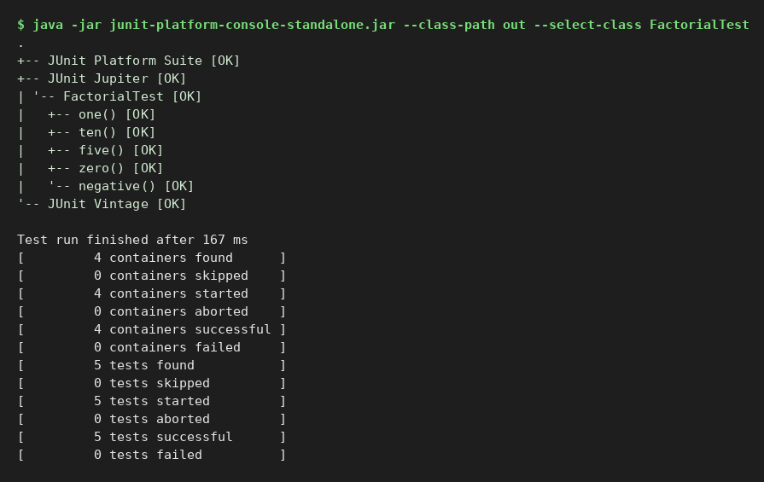
Result: all test cases passed.

Experiment 6 (JUnit)
Aim: Leap year check validated with JUnit assertions
Status: Executed here (JUnit 5, JDK 21) - output captured below

Program and test code
class LeapYear { static boolean is(int y){ return (y%4==0 && y%100!=0) || y%400==0; } }
class LeapYearTest {
@ParameterizedTest(name="{0} is leap") @ValueSource(ints={2000,2004,2024,1600}) void leap(int y){ assertTrue(LeapYear.is(y)); }
@ParameterizedTest(name="{0} is not leap") @ValueSource(ints={1900,2023,2100,1999}) void notLeap(int y){ assertFalse(LeapYear.is(y)); }
}

Output (JUnit console launcher)
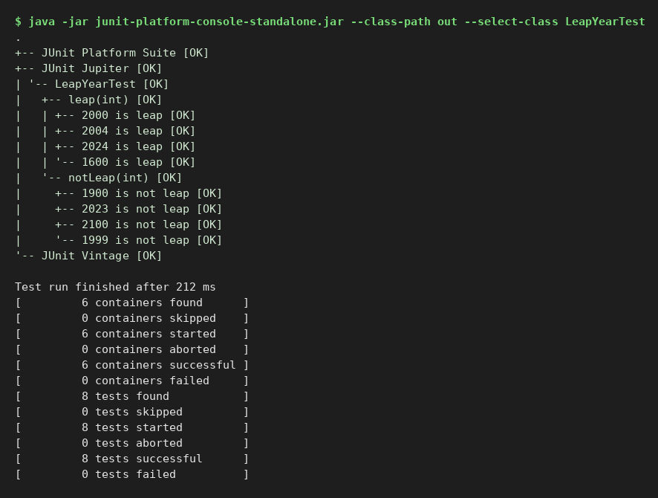
Result: all test cases passed.

Experiment 7 (JUnit)
Aim: Prime number check validated with JUnit assertions
Status: Executed here (JUnit 5, JDK 21) - output captured below

Program and test code
class Prime { static boolean is(int n){ if(n<2) return false; for(int i=2;(long)i*i<=n;i++) if(n%i==0) return false; return true; } }
class PrimeTest {
@ParameterizedTest @ValueSource(ints={2,3,5,7,11,97,7919}) void primes(int n){ assertTrue(Prime.is(n)); }
@ParameterizedTest @ValueSource(ints={-5,0,1,4,9,100,7917}) void nonPrimes(int n){ assertFalse(Prime.is(n)); }
}

Output (JUnit console launcher)
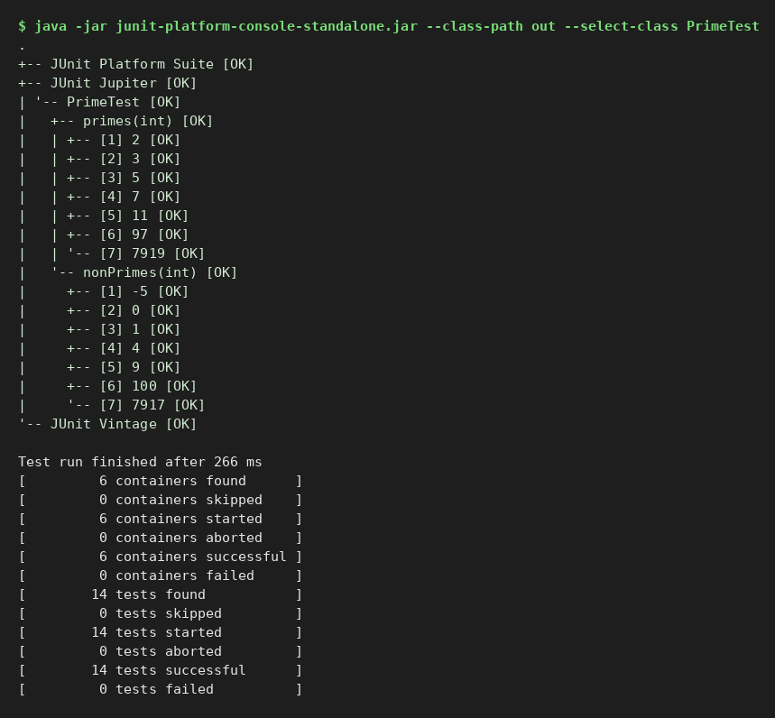
Result: all test cases passed.

Experiment 8 (JUnit)
Aim: String reversal validated with JUnit assertions
Status: Executed here (JUnit 5, JDK 21) - output captured below

Program and test code
class Rev { static String of(String s){ return s==null? null : new StringBuilder(s).reverse().toString(); } }
class RevTest {
@Test void hello(){ assertEquals("olleh", Rev.of("hello")); }
@Test void empty(){ assertEquals("", Rev.of("")); }
@Test void palindrome(){ assertEquals("madam", Rev.of("madam")); }
@Test void spaces(){ assertEquals("c b a", Rev.of("a b c")); }
@Test void nullInput(){ assertNull(Rev.of(null)); }
}

Output (JUnit console launcher)
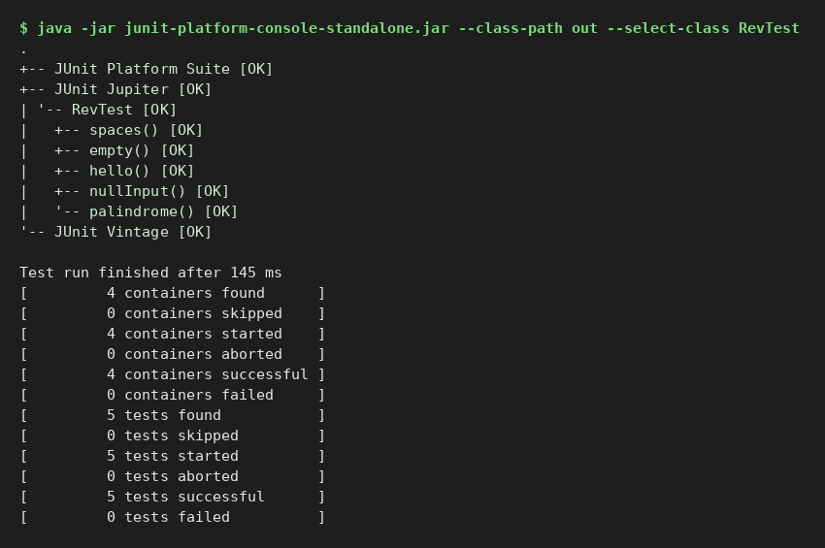
Result: all test cases passed.

Experiment 9 (JUnit)
Aim: Exception handling of a division program using assertThrows
Status: Executed here (JUnit 5, JDK 21) - output captured below

Program and test code
class Div { static int divide(int a,int b){ return a/b; } }
class DivTest {
@Test void normal(){ assertEquals(5, Div.divide(10,2)); }
@Test void divideByZero(){ ArithmeticException ex = assertThrows(ArithmeticException.class, () -> Div.divide(10,0)); assertEquals("/ by zero", ex.getMessage()); }
@Test void zeroNumerator(){ assertEquals(0, Div.divide(0,7)); }
@Test void negative(){ assertEquals(-3, Div.divide(-9,3)); }
}

Output (JUnit console launcher)
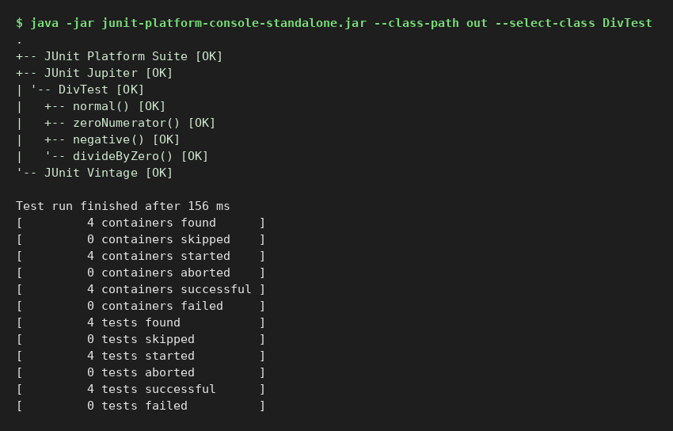
Result: all test cases passed.

Experiment 10 (JUnit)
Aim: Security testing: password hashing and authentication
Status: Executed here (JUnit 5, JDK 21) - output captured below

Program and test code
import java.security.*; import javax.crypto.*; import javax.crypto.spec.*; import java.util.*;
class Auth {
private final Map<String,String[]> users=new HashMap<>();
static String hash(String pw, byte[] salt){ try{ var f=SecretKeyFactory.getInstance("PBKDF2WithHmacSHA256");
return Base64.getEncoder().encodeToString(f.generateSecret(new PBEKeySpec(pw.toCharArray(),salt,65536,256)).getEncoded()); }catch(Exception e){ throw new RuntimeException(e);} }
static byte[] newSalt(){ byte[] s=new byte[16]; new SecureRandom().nextBytes(s); return s; }
void register(String u,String pw){ byte[] s=newSalt(); users.put(u,new String[]{Base64.getEncoder().encodeToString(s),hash(pw,s)}); }
boolean login(String u,String pw){ var r=users.get(u); if(r==null) return false; return MessageDigest.isEqual(hash(pw,Base64.getDecoder().decode(r[0])).getBytes(), r[1].getBytes()); }
String stored(String u){ return users.get(u)[1]; }
}
class SecurityTest {
Auth a=new Auth();
@Test void correctPasswordAuthenticates(){ a.register("alice","S3cret!"); assertTrue(a.login("alice","S3cret!")); }
@Test void wrongPasswordRejected(){ a.register("alice","S3cret!"); assertFalse(a.login("alice","wrong")); }
@Test void unknownUserRejected(){ assertFalse(a.login("ghost","x")); }
@Test void passwordNotStoredInPlaintext(){ a.register("bob","hunter2"); assertNotEquals("hunter2", a.stored("bob")); }
@Test void sameSaltSamePasswordSameHash(){ byte[] s=Auth.newSalt(); assertEquals(Auth.hash("p",s), Auth.hash("p",s)); }
@Test void differentSaltsGiveDifferentHashes(){ assertNotEquals(Auth.hash("p",Auth.newSalt()), Auth.hash("p",Auth.newSalt())); }
@Test void sqlInjectionStringRejected(){ a.register("carol","pw"); assertFalse(a.login("carol","' OR '1'='1")); }
@Test void caseSensitive(){ a.register("dave","Pass"); assertFalse(a.login("dave","pass")); }
}

Output (JUnit console launcher)
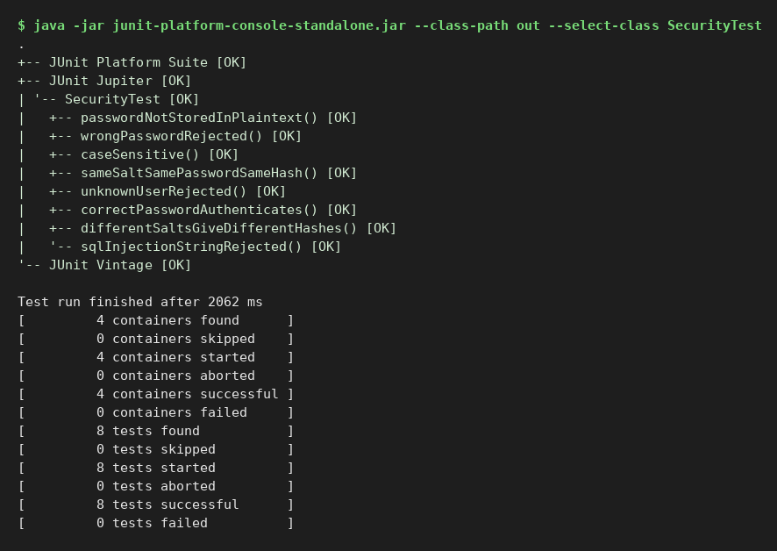
Result: all test cases passed.

Experiment 11 (Selenium)
Aim: Open Chrome using Selenium WebDriver and verify the title and URL of a web page
Status: Prepared - code compiles against Selenium 4.27; needs Chrome and internet, so run it on your machine and paste your screenshot
Needs Base.java (shared helper) listed in Experiment 11 and included in the zip; target sites: the-internet.herokuapp.com and selenium.dev practice pages.

Base.java (shared by all Selenium experiments)
import org.openqa.selenium.WebDriver;
import org.openqa.selenium.chrome.ChromeDriver;
import org.openqa.selenium.chrome.ChromeOptions;
import java.time.Duration;

/** Shared helper: creates a Chrome driver (Selenium Manager downloads chromedriver automatically). */
public class Base {
public static WebDriver newDriver() {
ChromeOptions o = new ChromeOptions();
// o.addArguments("--headless=new"); // uncomment to run without opening a window
o.addArguments("--start-maximized");
WebDriver d = new ChromeDriver(o);
d.manage().timeouts().implicitlyWait(Duration.ofSeconds(5));
return d;
}
}

Code
import org.openqa.selenium.WebDriver;

public class Exp11_OpenChrome {
public static void main(String[] args) {
WebDriver driver = Base.newDriver();
try {
driver.get("https://www.selenium.dev/");
String title = driver.getTitle();
String url = driver.getCurrentUrl();
System.out.println("Title : " + title);
System.out.println("URL : " + url);
System.out.println(title.contains("Selenium") ? "Title check : PASS" : "Title check : FAIL");
System.out.println(url.equals("https://www.selenium.dev/") ? "URL check : PASS" : "URL check : FAIL");
} finally { driver.quit(); }
}
}

Expected output (reference - your values may differ slightly)
Title : Selenium
URL : https://www.selenium.dev/
Title check : PASS
URL check : PASS

Screenshot of your run
[ Paste your screenshot of the run here ]

Experiment 12 (Selenium)
Aim: Locate web elements using id, name, class name, CSS selector and XPath in Selenium
Status: Prepared - code compiles against Selenium 4.27; needs Chrome and internet, so run it on your machine and paste your screenshot
Needs Base.java (shared helper) listed in Experiment 11 and included in the zip; target sites: the-internet.herokuapp.com and selenium.dev practice pages.

Code
import org.openqa.selenium.*;

public class Exp12_Locators {
public static void main(String[] args) {
WebDriver d = Base.newDriver();
try {
d.get("https://the-internet.herokuapp.com/login");
WebElement byId = d.findElement(By.id("username"));
WebElement byName = d.findElement(By.name("password"));
WebElement byClass = d.findElement(By.className("radius")); // the Login button
WebElement byCss = d.findElement(By.cssSelector("form#login button[type='submit']"));
WebElement byXpath = d.findElement(By.xpath("//input[@id='password']"));
System.out.println("By.id -> <" + byId.getTagName() + "> id=" + byId.getAttribute("id"));
System.out.println("By.name -> <" + byName.getTagName() + "> name=" + byName.getAttribute("name"));
System.out.println("By.className -> <" + byClass.getTagName() + "> text=" + byClass.getText());
System.out.println("By.cssSelector -> <" + byCss.getTagName() + "> text=" + byCss.getText());
System.out.println("By.xpath -> <" + byXpath.getTagName() + "> type=" + byXpath.getAttribute("type"));
} finally { d.quit(); }
}
}

Expected output (reference - your values may differ slightly)
By.id -> <input> id=username
By.name -> <input> name=password
By.className -> <button> text=Login
By.cssSelector -> <button> text=Login
By.xpath -> <input> type=password

Screenshot of your run
[ Paste your screenshot of the run here ]

Experiment 13 (Selenium)
Aim: Automate the filling and submission of a web form using Selenium WebDriver
Status: Prepared - code compiles against Selenium 4.27; needs Chrome and internet, so run it on your machine and paste your screenshot
Needs Base.java (shared helper) listed in Experiment 11 and included in the zip; target sites: the-internet.herokuapp.com and selenium.dev practice pages.

Code
import org.openqa.selenium.*;

public class Exp13_FormSubmit {
public static void main(String[] args) {
WebDriver d = Base.newDriver();
try {
d.get("https://www.selenium.dev/selenium/web/web-form.html");
d.findElement(By.id("my-text-id")).sendKeys("Test User");
d.findElement(By.name("my-password")).sendKeys("Secret123");
d.findElement(By.name("my-textarea")).sendKeys("Automated form submission with Selenium");
d.findElement(By.cssSelector("button[type='submit']")).click();
String msg = d.findElement(By.id("message")).getText();
System.out.println("Page title after submit : " + d.getTitle());
System.out.println("Message : " + msg);
System.out.println(msg.equals("Received!") ? "RESULT: PASS" : "RESULT: FAIL");
} finally { d.quit(); }
}
}

Expected output (reference - your values may differ slightly)
Page title after submit : Web form
Message : Received!
RESULT: PASS

Screenshot of your run
[ Paste your screenshot of the run here ]

Experiment 14 (Selenium)
Aim: Automate checkbox and radio button selection using Selenium WebDriver
Status: Prepared - code compiles against Selenium 4.27; needs Chrome and internet, so run it on your machine and paste your screenshot
Needs Base.java (shared helper) listed in Experiment 11 and included in the zip; target sites: the-internet.herokuapp.com and selenium.dev practice pages.

Code
import org.openqa.selenium.*;

public class Exp14_CheckboxRadio {
public static void main(String[] args) {
WebDriver d = Base.newDriver();
try {
d.get("https://www.selenium.dev/selenium/web/web-form.html");
WebElement check1 = d.findElement(By.id("my-check-1")); // checked by default
WebElement check2 = d.findElement(By.id("my-check-2")); // unchecked by default
System.out.println("Before: check1=" + check1.isSelected() + ", check2=" + check2.isSelected());
check1.click(); // uncheck
if (!check2.isSelected()) check2.click(); // check
System.out.println("After : check1=" + check1.isSelected() + ", check2=" + check2.isSelected());

WebElement radio1 = d.findElement(By.id("my-radio-1"));
WebElement radio2 = d.findElement(By.id("my-radio-2"));
radio2.click();
System.out.println("Radio : radio1=" + radio1.isSelected() + ", radio2=" + radio2.isSelected());
boolean ok = !check1.isSelected() && check2.isSelected() && !radio1.isSelected() && radio2.isSelected();
System.out.println(ok ? "RESULT: PASS" : "RESULT: FAIL");
} finally { d.quit(); }
}
}

Expected output (reference - your values may differ slightly)
Before: check1=true, check2=false
After : check1=false, check2=true
Radio : radio1=false, radio2=true
RESULT: PASS

Screenshot of your run
[ Paste your screenshot of the run here ]

Experiment 15 (Selenium)
Aim: Capture a screenshot of a web page and store it in the local system using Selenium WebDriver
Status: Prepared - code compiles against Selenium 4.27; needs Chrome and internet, so run it on your machine and paste your screenshot
Needs Base.java (shared helper) listed in Experiment 11 and included in the zip; target sites: the-internet.herokuapp.com and selenium.dev practice pages.

Code
import org.openqa.selenium.*;
import java.io.File;
import java.nio.file.*;

public class Exp15_Screenshot {
public static void main(String[] args) throws Exception {
WebDriver d = Base.newDriver();
try {
d.get("https://www.selenium.dev/");
File src = ((TakesScreenshot) d).getScreenshotAs(OutputType.FILE);
Path dest = Paths.get("screenshots", "selenium_home.png");
Files.createDirectories(dest.getParent());
Files.copy(src.toPath(), dest, StandardCopyOption.REPLACE_EXISTING);
System.out.println("Screenshot saved at: " + dest.toAbsolutePath());
System.out.println(Files.size(dest) > 0 ? "RESULT: PASS" : "RESULT: FAIL");
} finally { d.quit(); }
}
}

Expected output (reference - your values may differ slightly)
Screenshot saved at: <project folder>/screenshots/selenium_home.png
RESULT: PASS

Screenshot of your run
[ Paste your screenshot of the run here ]

Experiment 16 (Apache JMeter)
Aim: Create a basic test plan using Thread Group, HTTP Request sampler and listeners in JMeter
Status: Prepared - .jmx plan is valid XML in JMeter 5.6 format; open it in JMeter, run it, and paste your screenshot
Test plan file: Exp16_BasicTestPlan.jmx (in the zip). Open with File > Open in JMeter 5.6, then press Start (green arrow).

Test plan structure
Test Plan
Thread Group (5 users, ramp-up 2 s, loop 2)
HTTP Request: GET jsonplaceholder.typicode.com/posts/1
View Results Tree
Summary Report

Expected result
10 samples (5 users x 2 loops), all 200 OK, Error % = 0.00

Screenshot of your run (View Results Tree / report)
[ Paste your screenshot of the run here ]

Experiment 17 (Apache JMeter)
Aim: Detect defects in a web page response using the Response Assertion in JMeter
Status: Prepared - .jmx plan is valid XML in JMeter 5.6 format; open it in JMeter, run it, and paste your screenshot
Test plan file: Exp17_ResponseAssertion.jmx (in the zip). Open with File > Open in JMeter 5.6, then press Start (green arrow).

Test plan structure
Test Plan
Thread Group (1 user)
HTTP Request: GET example.com /
Response Assertion: response code equals 200
Response Assertion: body contains 'Example Domain'
Response Assertion: body must NOT contain 'Error' (defect check)
View Results Tree

Expected result
1 sample, all three assertions pass (green). To see a defect detected, change the expected text to something absent - the sampler turns red with the assertion failure message.

Screenshot of your run (View Results Tree / report)
[ Paste your screenshot of the run here ]

Experiment 18 (Apache JMeter)
Aim: Configure HTTP Request Defaults and HTTP Header Manager for REST API requests in JMeter
Status: Prepared - .jmx plan is valid XML in JMeter 5.6 format; open it in JMeter, run it, and paste your screenshot
Test plan file: Exp18_HttpDefaultsHeaders.jmx (in the zip). Open with File > Open in JMeter 5.6, then press Start (green arrow).

Test plan structure
Test Plan
HTTP Request Defaults (https://jsonplaceholder.typicode.com)
HTTP Header Manager (Content-Type, Accept: application/json)
Thread Group (3 users)
GET /posts/1
GET /users/1
GET /comments?postId=1
View Results Tree

Expected result
9 samples (3 users x 3 requests), 200 OK. Request paths only - domain and headers come from the defaults/manager.

Screenshot of your run (View Results Tree / report)
[ Paste your screenshot of the run here ]

Experiment 19 (Apache JMeter)
Aim: Simulate user think time using the Constant Timer in JMeter
Status: Prepared - .jmx plan is valid XML in JMeter 5.6 format; open it in JMeter, run it, and paste your screenshot
Test plan file: Exp19_ConstantTimer.jmx (in the zip). Open with File > Open in JMeter 5.6, then press Start (green arrow).

Test plan structure
Test Plan
HTTP Request Defaults
Thread Group (3 users, loop 2)
GET /posts + Constant Timer 2000 ms
GET /todos/1 + Constant Timer 2000 ms
View Results Tree, Summary Report

Expected result
12 samples; each sampler is followed by a 2000 ms pause, so total time per thread is about 8 s of think time plus response time.

Screenshot of your run (View Results Tree / report)
[ Paste your screenshot of the run here ]

Experiment 20 (Apache JMeter)
Aim: Compare the Summary Report and Aggregate Report listeners in JMeter
Status: Prepared - .jmx plan is valid XML in JMeter 5.6 format; open it in JMeter, run it, and paste your screenshot
Test plan file: Exp20_SummaryVsAggregate.jmx (in the zip). Open with File > Open in JMeter 5.6, then press Start (green arrow).

Test plan structure
Test Plan
HTTP Request Defaults
Thread Group (10 users, ramp 5 s, loop 3)
GET /posts
GET /users
Summary Report (summary.csv)
Aggregate Report (aggregate.csv)

Expected result
60 samples. Summary Report shows #Samples, Average, Min, Max, Std Dev, Error %, Throughput, KB/s. Aggregate Report adds Median and the 90%, 95% and 99% percentile columns.

Screenshot of your run (View Results Tree / report)
[ Paste your screenshot of the run here ]

Experiment 21 (Manual)
Aim: Create test cases for a simple calculator application using equivalence class partitioning
Status: Prepared - manual design; the same classes are automated and executed in Experiment 25 (16 tests passed)

Input equivalence classes
Class | Description | Valid?
E1 | Positive integer | Valid
E2 | Negative integer | Valid
E3 | Zero | Valid
E4 | Non-numeric input (e.g. 'abc') | Invalid
E5 | Divisor equal to zero (division only) | Invalid

Test cases
TC | Operation | A | B | Classes | Expected
1 | Add | 5 | 3 | E1,E1 | 8
2 | Add | -5 | -3 | E2,E2 | -8
3 | Add | 5 | -3 | E1,E2 | 2
4 | Add | 0 | 0 | E3,E3 | 0
5 | Subtract | 10 | 4 | E1,E1 | 6
6 | Multiply | -3 | 4 | E2,E1 | -12
7 | Multiply | 0 | 99 | E3,E1 | 0
8 | Divide | 12 | 4 | E1,E1 | 3
9 | Divide | 0 | 5 | E3,E1 | 0
10 | Divide | 5 | 0 | E1,E5 | Error: division by zero
11 | Add | abc | 3 | E4,E1 | Error: invalid input

Experiment 22 (Manual)
Aim: Create test cases for a student grade evaluation system using boundary value analysis
Status: Prepared - manual design; the same values are automated and executed in Experiment 26 (23 tests passed)
Rules: marks 0-100 valid. 90-100 = O, 80-89 = A, 70-79 = B, 60-69 = C, 50-59 = D, 0-49 = F.
TC | Marks | Boundary tested | Expected
1 | -1 | Just below minimum | Invalid marks
2 | 0 | Minimum | F
3 | 1 | Just above minimum | F
4 | 49 | Just below D | F
5 | 50 | Lower bound of D | D
6 | 59 | Upper bound of D | D
7 | 60 | Lower bound of C | C
8 | 69 | Upper bound of C | C
9 | 70 | Lower bound of B | B
10 | 79 | Upper bound of B | B
11 | 80 | Lower bound of A | A
12 | 89 | Upper bound of A | A
13 | 90 | Lower bound of O | O
14 | 99 | Just below maximum | O
15 | 100 | Maximum | O
16 | 101 | Just above maximum | Invalid marks

Experiment 23 (Manual)
Aim: Execute black-box testing on a login module
Status: Prepared - manual experiment; record the Actual Result / Status columns when you execute it
TC | Description | Test data | Expected result | Actual | Status
1 | Valid username and password | user01 / Pass@123 | Login succeeds, dashboard shown
2 | Valid username, wrong password | user01 / wrong | Error 'Invalid credentials'
3 | Wrong username, valid password | nouser / Pass@123 | Error 'Invalid credentials'
4 | Both fields empty | - / - | Mandatory field messages
5 | Username empty | - / Pass@123 | 'Username required'
6 | Password empty | user01 / - | 'Password required'
7 | Case sensitivity of password | user01 / pass@123 | Login rejected
8 | SQL injection attempt | ' OR '1'='1 / x | Login rejected, no error stack
9 | Leading/trailing spaces in username | user01 / Pass@123 | Trimmed or rejected consistently
10 | Account lock after 3 wrong attempts | 3 x wrong password | Account locked message
11 | Password masked | any | Characters shown as dots
12 | Back button after logout | - | Login page, no cached session

Experiment 24 (Manual)
Aim: Create test data for a ticket booking application
Status: Prepared - manual experiment; record the Actual Result / Status columns when you execute it

Field-wise test data
Field | Valid data | Invalid data | Boundary data
From / To station | Chennai, Bengaluru | Same station both; 'xyz123'; blank | 1-char name; 50-char name
Journey date | Tomorrow; date 120 days ahead | Yesterday; 31-02-2026; text | Today; last bookable day; last day + 1
No. of passengers | 1, 4 | 0, -1, 'two' | 1, 6, 7 (assuming max 6)
Passenger age | 25, 60 | -5, 'abc' | 0, 4, 5 (child rules); 59, 60 (senior); 120
Mobile number | 9876543210 | 98765, 12 digits, letters | 10 digits exactly; 9 and 11 digits
Email | user@example.com | user@, @example.com, user example.com | 254-character address
Class | Sleeper, 3A, 2A | (none selected) | -
Payment card | 4111 1111 1111 1111 (test card), 12/30, CVV 123 | Expired 01/20; wrong CVV 12; 15-digit number | Expiry this month
Coupon code | VALID10 (10% off) | EXPIRED10, blank spaces | Case: valid10

Sample booking data sets
Set | From | To | Date | Pax | Class | Purpose
1 | Chennai | Bengaluru | T+1 | 1 | Sleeper | Happy path
2 | Chennai | Chennai | T+1 | 1 | 3A | Same station - negative
3 | Chennai | Madurai | T-1 | 2 | 2A | Past date - negative
4 | Chennai | Delhi | T+120 | 6 | 3A | Max passengers / last day
5 | Chennai | Delhi | T+121 | 7 | 3A | Beyond limits - negative

Experiment 25 (JUnit)
Aim: Equivalence class partitioning tests for a calculator
Status: Executed here (JUnit 5, JDK 21) - output captured below

Program and test code
class Calc { int add(int a,int b){return a+b;} int sub(int a,int b){return a-b;} int mul(int a,int b){return a*b;}
int div(int a,int b){ if(b==0) throw new ArithmeticException("Division by zero"); return a/b; } }
class CalcECPTest {
Calc c=new Calc();
@ParameterizedTest(name="add({0},{1})={2} [class: {3}]")
@CsvSource({"5,3,8,positive+positive","-5,-3,-8,negative+negative","5,-3,2,positive+negative","0,0,0,zero+zero","0,7,7,zero+positive"})
void addClasses(int a,int b,int e,String cls){ assertEquals(e,c.add(a,b)); }
@ParameterizedTest(name="sub({0},{1})={2}") @CsvSource({"10,4,6","-2,-5,3","0,9,-9"}) void sub(int a,int b,int e){ assertEquals(e,c.sub(a,b)); }
@ParameterizedTest(name="mul({0},{1})={2}") @CsvSource({"3,4,12","-3,4,-12","-3,-4,12","0,99,0"}) void mul(int a,int b,int e){ assertEquals(e,c.mul(a,b)); }
@ParameterizedTest(name="div({0},{1})={2}") @CsvSource({"12,4,3","-12,4,-3","0,5,0"}) void div(int a,int b,int e){ assertEquals(e,c.div(a,b)); }
@Test void invalidClassDivideByZero(){ assertThrows(ArithmeticException.class,()->c.div(5,0)); }
}

Output (JUnit console launcher)
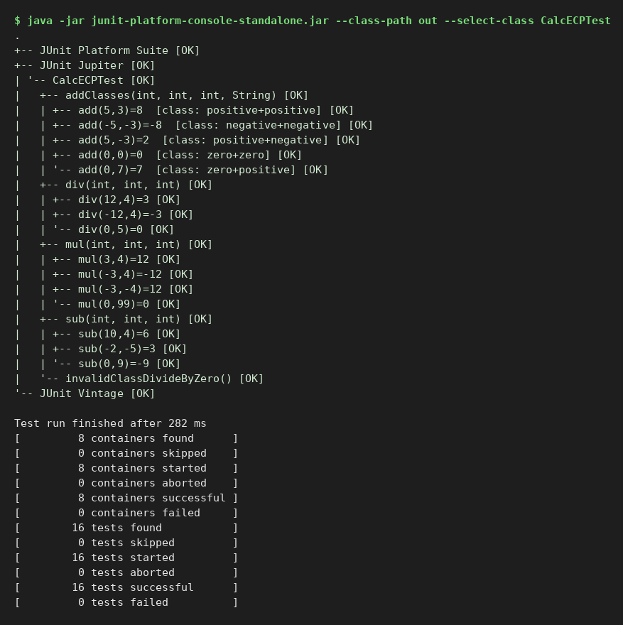
Result: all test cases passed.

Experiment 26 (JUnit)
Aim: Boundary value analysis for student grade evaluation
Status: Executed here (JUnit 5, JDK 21) - output captured below

Program and test code
class Grade { static char of(int m){ if(m<0||m>100) throw new IllegalArgumentException("Invalid marks: "+m);
if(m>=90) return 'O'; if(m>=80) return 'A'; if(m>=70) return 'B'; if(m>=60) return 'C'; if(m>=50) return 'D'; return 'F'; } }
class GradeBVATest {
@ParameterizedTest(name="marks {0} -> {1}")
@CsvSource({"0,F","1,F","49,F","50,D","51,D","59,D","60,C","61,C","69,C","70,B","71,B","79,B","80,A","81,A","89,A","90,O","91,O","99,O","100,O"})
void boundaries(int m,char g){ assertEquals(g,Grade.of(m)); }
@ParameterizedTest(name="invalid marks {0}") @ValueSource(ints={-1,101,-100,1000}) void invalid(int m){ assertThrows(IllegalArgumentException.class,()->Grade.of(m)); }
}

Output (JUnit console launcher)
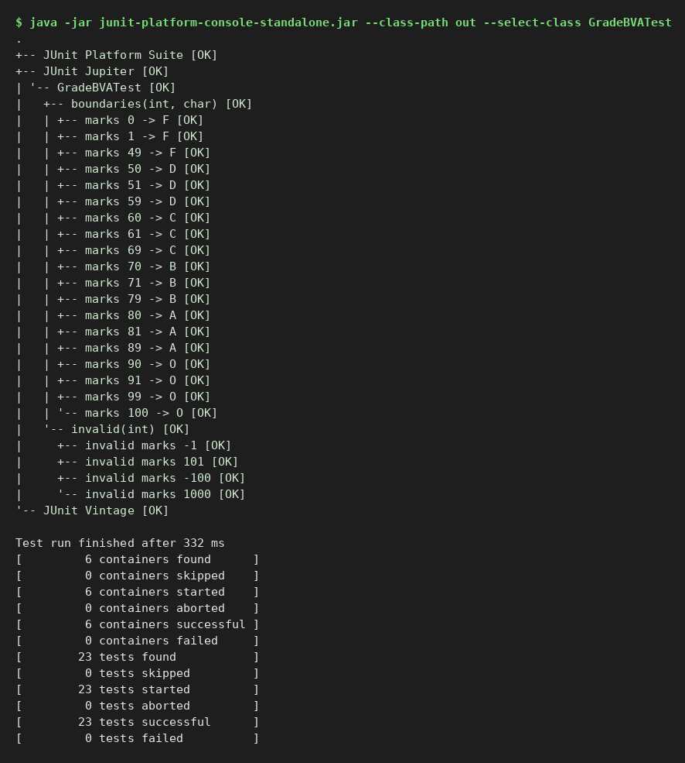
Result: all test cases passed.

Experiment 27 (JUnit)
Aim: Voting eligibility by age using boundary value analysis
Status: Executed here (JUnit 5, JDK 21) - output captured below

Program and test code
class Voting { static boolean eligible(int age){ if(age<0||age>120) throw new IllegalArgumentException("Invalid age"); return age>=18; } }
class VotingBVATest {
@ParameterizedTest(name="age {0} -> eligible={1}") @CsvSource({"0,false","1,false","17,false","18,true","19,true","119,true","120,true"}) void valid(int a,boolean e){ assertEquals(e,Voting.eligible(a)); }
@ParameterizedTest(name="invalid age {0}") @ValueSource(ints={-1,121}) void invalid(int a){ assertThrows(IllegalArgumentException.class,()->Voting.eligible(a)); }
}

Output (JUnit console launcher)
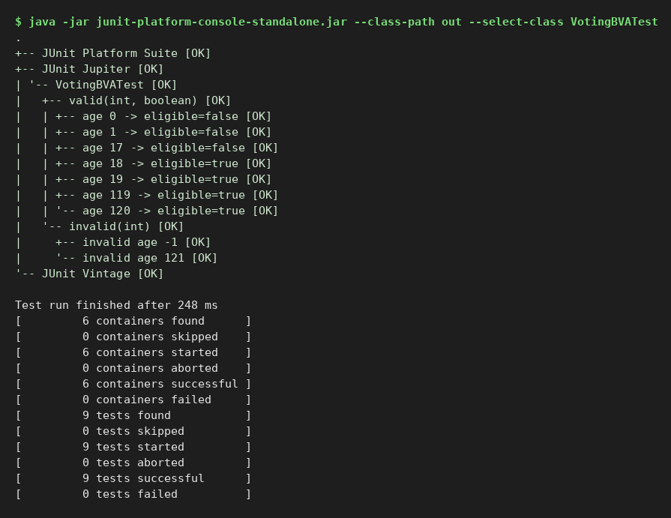
Result: all test cases passed.

Experiment 28 (JUnit)
Aim: White-box testing: statement coverage on a sorting program
Status: Executed here (JUnit 5, JDK 21) - output captured below

Program and test code
class Sorter { static int[] sort(int[] a){ if(a==null) return new int[0]; int[] r=a.clone();
for(int i=0;i<r.length-1;i++) for(int j=0;j<r.length-1-i;j++) if(r[j]>r[j+1]){ int t=r[j]; r[j]=r[j+1]; r[j+1]=t; } return r; } }
class SorterTest {
@Test void nullInput_coversNullStatement(){ assertArrayEquals(new int[0], Sorter.sort(null)); }
@Test void emptyArray(){ assertArrayEquals(new int[0], Sorter.sort(new int[]{})); }
@Test void unsorted_coversSwapStatements(){ assertArrayEquals(new int[]{1,2,3,5,9}, Sorter.sort(new int[]{5,2,9,1,3})); }
@Test void alreadySorted(){ assertArrayEquals(new int[]{1,2,3}, Sorter.sort(new int[]{1,2,3})); }
@Test void duplicatesAndNegatives(){ assertArrayEquals(new int[]{-4,0,2,2,7}, Sorter.sort(new int[]{2,7,-4,2,0})); }
}

Output (JUnit console launcher)
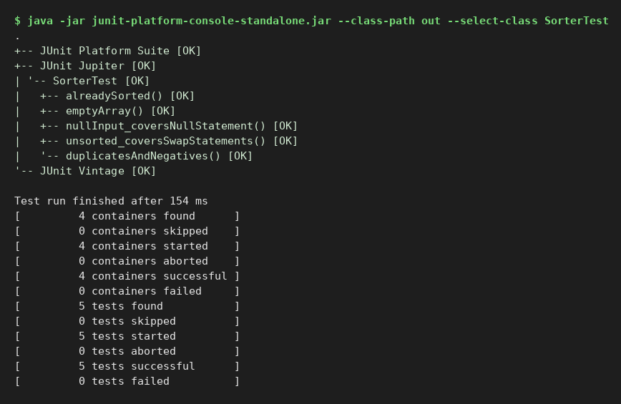
Result: all test cases passed.

Experiment 29 (JUnit)
Aim: Path coverage testing on a payroll calculation program
Status: Executed here (JUnit 5, JDK 21) - output captured below

Program and test code
class Payroll { static double net(double hours,double rate){ double gross; if(hours>40) gross=40*rate+(hours-40)*rate*1.5; else gross=hours*rate;
double tax; if(gross>5000) tax=gross*0.20; else tax=gross*0.10; return gross-tax; } }
class PayrollPathTest {
@Test @DisplayName("Path 1: no overtime, low tax") void p1(){ assertEquals(360.0, Payroll.net(40,10),0.001); }
@Test @DisplayName("Path 2: no overtime, high tax") void p2(){ assertEquals(4800.0, Payroll.net(40,150),0.001); }
@Test @DisplayName("Path 3: overtime, low tax") void p3(){ assertEquals(495.0, Payroll.net(50,10),0.001); }
@Test @DisplayName("Path 4: overtime, high tax") void p4(){ assertEquals(6600.0, Payroll.net(50,150),0.001); }
}

Output (JUnit console launcher)
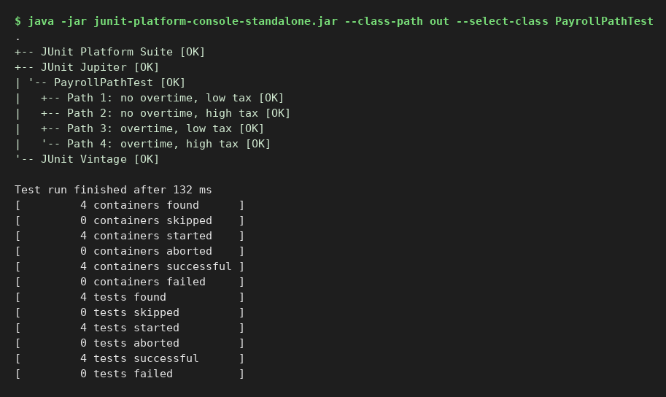
Result: all test cases passed.

Experiment 30 (JUnit)
Aim: Branch coverage on largest-of-three program
Status: Executed here (JUnit 5, JDK 21) - output captured below

Program and test code
class Largest { static int of(int a,int b,int c){ if(a>=b){ if(a>=c) return a; else return c; } else { if(b>=c) return b; else return c; } } }
class LargestTest {
@Test @DisplayName("a>=b true, a>=c true") void aLargest(){ assertEquals(9, Largest.of(9,4,2)); }
@Test @DisplayName("a>=b true, a>=c false") void cLargestFirst(){ assertEquals(9, Largest.of(5,3,9)); }
@Test @DisplayName("a>=b false, b>=c true") void bLargest(){ assertEquals(9, Largest.of(2,9,4)); }
@Test @DisplayName("a>=b false, b>=c false") void cLargestSecond(){ assertEquals(9, Largest.of(2,4,9)); }
@Test void allEqual(){ assertEquals(5, Largest.of(5,5,5)); }
}

Output (JUnit console launcher)
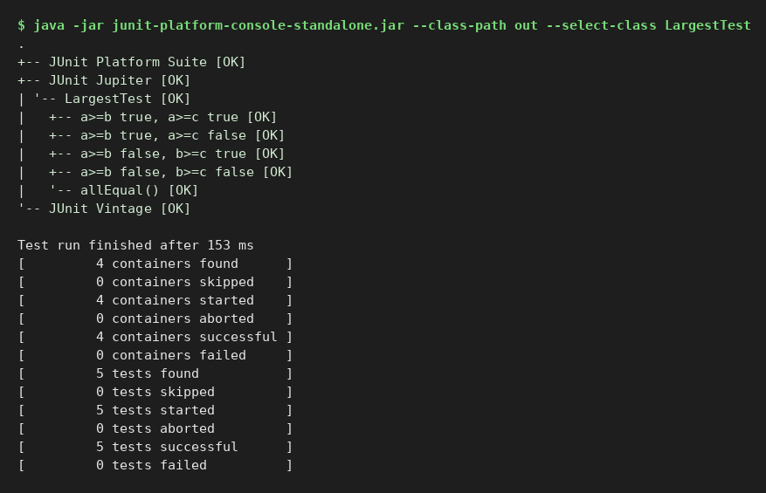
Result: all test cases passed.

Experiment 31 (Selenium)
Aim: Execute black-box testing on a login page using Selenium WebDriver
Status: Prepared - code compiles against Selenium 4.27; needs Chrome and internet, so run it on your machine and paste your screenshot
Needs Base.java (shared helper) listed in Experiment 11 and included in the zip; target sites: the-internet.herokuapp.com and selenium.dev practice pages.

Code
import org.junit.jupiter.api.*;
import org.openqa.selenium.*;
import static org.junit.jupiter.api.Assertions.*;

class Exp31_BlackBoxLogin {
WebDriver d;
@BeforeEach void open() { d = Base.newDriver(); d.get("https://the-internet.herokuapp.com/login"); }
@AfterEach void close() { d.quit(); }

void login(String u, String p) {
d.findElement(By.id("username")).sendKeys(u);
d.findElement(By.id("password")).sendKeys(p);
d.findElement(By.cssSelector("button[type='submit']")).click();
}
String flash() { return d.findElement(By.id("flash")).getText(); }

@Test void validCredentials() { login("tomsmith", "SuperSecretPassword!"); assertTrue(flash().contains("You logged into a secure area!")); assertTrue(d.getCurrentUrl().endsWith("/secure")); }
@Test void invalidUsername() { login("wronguser", "SuperSecretPassword!"); assertTrue(flash().contains("Your username is invalid!")); }
@Test void invalidPassword() { login("tomsmith", "wrongpass"); assertTrue(flash().contains("Your password is invalid!")); }
@Test void emptyCredentials() { login("", ""); assertTrue(flash().contains("Your username is invalid!")); }
}

Expected output (reference - your values may differ slightly)
JUnit tree: 4 tests successful (validCredentials, invalidUsername, invalidPassword, emptyCredentials)

Screenshot of your run
[ Paste your screenshot of the run here ]

Experiment 32 (Selenium)
Aim: Implement data-driven testing of a login page using JUnit parameterized tests and Selenium
Status: Prepared - code compiles against Selenium 4.27; needs Chrome and internet, so run it on your machine and paste your screenshot
Needs Base.java (shared helper) listed in Experiment 11 and included in the zip; target sites: the-internet.herokuapp.com and selenium.dev practice pages.

Code
import org.junit.jupiter.api.*;
import org.junit.jupiter.params.ParameterizedTest;
import org.junit.jupiter.params.provider.CsvSource;
import org.openqa.selenium.*;
import static org.junit.jupiter.api.Assertions.*;

class Exp32_DataDrivenLogin {
WebDriver d;
@BeforeEach void open() { d = Base.newDriver(); d.get("https://the-internet.herokuapp.com/login"); }
@AfterEach void close() { d.quit(); }

@ParameterizedTest(name = "user={0}, pass={1} -> expect \"{2}\"")
@CsvSource({
"tomsmith, SuperSecretPassword!, You logged into a secure area!",
"tomsmith, badpass, Your password is invalid!",
"nouser, SuperSecretPassword!, Your username is invalid!",
"admin, admin123, Your username is invalid!",
"TOMSMITH, SuperSecretPassword!, Your username is invalid!"
})
void login(String user, String pass, String expected) {
d.findElement(By.id("username")).sendKeys(user);
d.findElement(By.id("password")).sendKeys(pass);
d.findElement(By.cssSelector("button[type='submit']")).click();
assertTrue(d.findElement(By.id("flash")).getText().contains(expected));
}
}

Expected output (reference - your values may differ slightly)
JUnit tree: 5 parameterized invocations successful, one per CSV row

Screenshot of your run
[ Paste your screenshot of the run here ]

Experiment 33 (Selenium)
Aim: Automate dropdown selection using the Select class in Selenium WebDriver
Status: Prepared - code compiles against Selenium 4.27; needs Chrome and internet, so run it on your machine and paste your screenshot
Needs Base.java (shared helper) listed in Experiment 11 and included in the zip; target sites: the-internet.herokuapp.com and selenium.dev practice pages.

Code
import org.openqa.selenium.*;
import org.openqa.selenium.support.ui.Select;

public class Exp33_Dropdown {
public static void main(String[] args) {
WebDriver d = Base.newDriver();
try {
d.get("https://the-internet.herokuapp.com/dropdown");
Select s = new Select(d.findElement(By.id("dropdown")));
s.selectByVisibleText("Option 1");
System.out.println("selectByVisibleText -> " + s.getFirstSelectedOption().getText());
s.selectByValue("2");
System.out.println("selectByValue -> " + s.getFirstSelectedOption().getText());
s.selectByIndex(1);
System.out.println("selectByIndex -> " + s.getFirstSelectedOption().getText());
System.out.println("Total options -> " + s.getOptions().size());
System.out.println(s.getFirstSelectedOption().getText().equals("Option 1") ? "RESULT: PASS" : "RESULT: FAIL");
} finally { d.quit(); }
}
}

Expected output (reference - your values may differ slightly)
selectByVisibleText -> Option 1
selectByValue -> Option 2
selectByIndex -> Option 1
Total options -> 3
RESULT: PASS

Screenshot of your run
[ Paste your screenshot of the run here ]

Experiment 34 (Selenium)
Aim: Test the boundary values of a numeric input field using Selenium WebDriver
Status: Prepared - code compiles against Selenium 4.27; needs Chrome and internet, so run it on your machine and paste your screenshot
Needs Base.java (shared helper) listed in Experiment 11 and included in the zip; target sites: the-internet.herokuapp.com and selenium.dev practice pages.

Code
import org.junit.jupiter.api.*;
import org.junit.jupiter.params.ParameterizedTest;
import org.junit.jupiter.params.provider.CsvSource;
import org.openqa.selenium.*;
import static org.junit.jupiter.api.Assertions.*;

/** Boundary values of a numeric input field (the-internet.herokuapp.com/inputs accepts numbers only). */
class Exp34_NumericBoundary {
WebDriver d;
@BeforeEach void open() { d = Base.newDriver(); d.get("https://the-internet.herokuapp.com/inputs"); }
@AfterEach void close() { d.quit(); }

@ParameterizedTest(name = "typed \"{0}\" -> field holds \"{1}\"")
@CsvSource({ "-1,-1", "0,0", "1,1", "99,99", "100,100", "101,101", "2147483647,2147483647", "abc," })
void boundary(String typed, String expected) {
WebElement f = d.findElement(By.cssSelector("input[type='number']"));
f.clear();
f.sendKeys(typed);
assertEquals(expected == null ? "" : expected, f.getAttribute("value"));
}
}

Expected output (reference - your values may differ slightly)
JUnit tree: 8 parameterized invocations successful (-1, 0, 1, 99, 100, 101, 2147483647, abc)

Screenshot of your run
[ Paste your screenshot of the run here ]

Experiment 35 (Selenium)
Aim: Handle JavaScript alert, confirm and prompt pop-ups using Selenium WebDriver
Status: Prepared - code compiles against Selenium 4.27; needs Chrome and internet, so run it on your machine and paste your screenshot
Needs Base.java (shared helper) listed in Experiment 11 and included in the zip; target sites: the-internet.herokuapp.com and selenium.dev practice pages.

Code
import org.openqa.selenium.*;

public class Exp35_Alerts {
public static void main(String[] args) {
WebDriver d = Base.newDriver();
try {
d.get("https://the-internet.herokuapp.com/javascript_alerts");
// 1. Simple alert -> accept
d.findElement(By.xpath("//button[text()='Click for JS Alert']")).click();
Alert a = d.switchTo().alert();
System.out.println("Alert text : " + a.getText());
a.accept();
System.out.println("Result : " + d.findElement(By.id("result")).getText());
// 2. Confirm -> dismiss
d.findElement(By.xpath("//button[text()='Click for JS Confirm']")).click();
Alert c = d.switchTo().alert();
System.out.println("Confirm text : " + c.getText());
c.dismiss();
System.out.println("Result : " + d.findElement(By.id("result")).getText());
// 3. Prompt -> type text, accept
d.findElement(By.xpath("//button[text()='Click for JS Prompt']")).click();
Alert p = d.switchTo().alert();
System.out.println("Prompt text : " + p.getText());
p.sendKeys("Hello Selenium");
p.accept();
System.out.println("Result : " + d.findElement(By.id("result")).getText());
} finally { d.quit(); }
}
}

Expected output (reference - your values may differ slightly)
Alert text : I am a JS Alert
Result : You successfully clicked an alert
Confirm text : I am a JS Confirm
Result : You clicked: Cancel
Prompt text : I am a JS prompt
Result : You entered: Hello Selenium

Screenshot of your run
[ Paste your screenshot of the run here ]

Experiment 36 (Apache JMeter)
Aim: Execute black-box testing of a login request using the HTTP POST sampler in JMeter
Status: Prepared - .jmx plan is valid XML in JMeter 5.6 format; open it in JMeter, run it, and paste your screenshot
Test plan file: Exp36_LoginPostBlackBox.jmx (in the zip). Open with File > Open in JMeter 5.6, then press Start (green arrow).

Test plan structure
Test Plan
HTTP Request Defaults (httpbin.org)
Thread Group (1 user)
POST /post username=admin, password=admin123
Assertion: code 200; echoed username present
POST /post username='', password=''
Assertion: echoed username is empty
View Results Tree

Expected result
2 samples, 200 OK, assertions pass; the response body echoes the posted form fields.

Screenshot of your run (View Results Tree / report)
[ Paste your screenshot of the run here ]

Experiment 37 (Apache JMeter)
Aim: Implement data-driven testing using the CSV Data Set Config in JMeter
Status: Prepared - .jmx plan is valid XML in JMeter 5.6 format; open it in JMeter, run it, and paste your screenshot
Test plan file: Exp37_CsvDataDriven.jmx (in the zip). Open with File > Open in JMeter 5.6, then press Start (green arrow).

Test plan structure
Test Plan
HTTP Request Defaults (httpbin.org)
CSV Data Set Config (users.csv: username,password)
Thread Group (1 user, loop 5)
POST /post username=${username}, password=${password}
Assertion: response contains ${username}
Summary Report, View Results Tree

users.csv
username,password
alice,pass1
bob,pass2
carol,pass3
dave,pass4
eve,pass5

Expected result
5 samples; sample labels read 'POST login alice' ... 'POST login eve' (one CSV row per iteration).

Screenshot of your run (View Results Tree / report)
[ Paste your screenshot of the run here ]

Experiment 38 (Apache JMeter)
Aim: Correlate dynamic values using the JSON Extractor in JMeter
Status: Prepared - .jmx plan is valid XML in JMeter 5.6 format; open it in JMeter, run it, and paste your screenshot
Test plan file: Exp38_JsonExtractorCorrelation.jmx (in the zip). Open with File > Open in JMeter 5.6, then press Start (green arrow).

Test plan structure
Test Plan
HTTP Request Defaults (jsonplaceholder)
Thread Group (1 user)
1. GET /posts?_limit=1
JSON Extractor: postId = $[0].id
2. GET /posts/${postId}
Assertion: contains "id": ${postId}
View Results Tree

Expected result
2 samples; second request path in the tree shows /posts/1 - the value was correlated from the first response.

Screenshot of your run (View Results Tree / report)
[ Paste your screenshot of the run here ]

Experiment 39 (Apache JMeter)
Aim: Control the flow of a test plan using Loop, Once Only and If controllers in JMeter
Status: Prepared - .jmx plan is valid XML in JMeter 5.6 format; open it in JMeter, run it, and paste your screenshot
Test plan file: Exp39_Controllers.jmx (in the zip). Open with File > Open in JMeter 5.6, then press Start (green arrow).

Test plan structure
Test Plan
HTTP Request Defaults
Thread Group (2 users)
Once Only Controller -> GET /posts/1
Loop Controller (3) -> GET /todos/1
If Controller (${__jexl3(${__threadNum} == 1,)}) -> GET /users/1
View Results Tree

Expected result
9 samples: once-only 2 (one per thread), loop 6 (3 x 2 threads), if 1 (thread 1 only).

Screenshot of your run (View Results Tree / report)
[ Paste your screenshot of the run here ]

Experiment 40 (Apache JMeter)
Aim: Create test cases for API testing and verify status codes and response data in JMeter
Status: Prepared - .jmx plan is valid XML in JMeter 5.6 format; open it in JMeter, run it, and paste your screenshot
Test plan file: Exp40_ApiTesting.jmx (in the zip). Open with File > Open in JMeter 5.6, then press Start (green arrow).

Test plan structure
Test Plan
HTTP Request Defaults + Header Manager
Thread Group (1 user)
TC1 GET /posts/1 -> assert 200, body has userId
TC2 POST /posts -> assert 201, body echoes title
TC3 GET /posts/9999 -> assert 404
TC4 DELETE /posts/1 -> assert 200
View Results Tree, Summary Report

Expected result
4 samples, all assertions pass (note: jsonplaceholder is a fake API - POST/DELETE do not persist data).

Screenshot of your run (View Results Tree / report)
[ Paste your screenshot of the run here ]

Experiment 41 (Manual)
Aim: Execute smoke testing on a new version of a messaging application
Status: Prepared - manual experiment; record the Actual Result / Status columns when you execute it
Smoke test verifies that the critical functions of build v2.0 work well enough to accept the build for deeper testing. Any Fail = build rejected.
# | Smoke check | Expected | Actual | Pass/Fail
1 | App installs and launches | Home screen opens, no crash
2 | Sign in / OTP verification | User reaches chat list
3 | Open an existing chat | Previous messages load
4 | Send a text message | Delivered tick appears
5 | Receive a text message | Notification and message shown
6 | Send an image | Image uploaded and visible to receiver
7 | Create a group and send message | All members receive it
8 | Voice / video call connects | Call rings and audio works
9 | Logout and login again | Session restored, data intact
10 | Upgrade from v1.9 keeps data | Chats preserved

Decision: ACCEPT build if all rows pass; otherwise REJECT and return to development.

Experiment 42 (Manual)
Aim: Implement regression testing for a content management system after updates
Status: Prepared - manual experiment; record the Actual Result / Status columns when you execute it

Change summary
Update 5.2 -> 5.3: new rich-text editor, changed user-role permissions, new image upload size limit.

Impact analysis and regression test selection
Area | Impacted by change? | Regression tests | Priority
Create/edit/publish article | Yes (editor) | RT1-RT4 | High
Image upload | Yes (size limit) | RT5-RT6 | High
User roles & permissions | Yes | RT7-RT9 | High
Search | Indirect | RT10 | Medium
Menu / navigation | No | RT11 (sanity) | Low
Comments moderation | No | RT12 (sanity) | Low

Regression test cases
ID | Test case | Expected | Actual | Status
RT1 | Create article with bold, list, link | Formatting saved and rendered
RT2 | Edit and save existing article | Old content preserved
RT3 | Paste from Word into editor | Clean HTML, no junk styles
RT4 | Publish and view on site | Article visible
RT5 | Upload image within limit | Upload succeeds
RT6 | Upload image above limit | Clear error message
RT7 | Editor cannot delete others' posts | Access denied
RT8 | Admin can manage users | Allowed
RT9 | Author cannot change roles | Access denied
RT10 | Search for new article | Appears in results
RT11 | Menu links work | No broken links
RT12 | Approve/reject comment | Status changes

Exit criteria: 100% of High-priority tests pass; no open critical/major defects.

Experiment 43 (Manual)
Aim: Create test scenarios for an e-commerce checkout process for system testing
Status: Prepared - manual experiment; record the Actual Result / Status columns when you execute it
ID | Scenario | Test steps (summary) | Expected result | Status
CK1 | Checkout as logged-in user, COD | Cart -> checkout -> address -> COD -> place order | Order confirmed, email sent
CK2 | Guest checkout | Cart -> continue as guest -> details | Order placed, option to create account
CK3 | Card payment success | Enter valid test card | Payment success, order status Paid
CK4 | Card payment failure | Enter declined card | Error shown, cart preserved
CK5 | Apply valid coupon | Apply VALID10 | Total reduced by 10%
CK6 | Apply expired / invalid coupon | Apply EXPIRED10 | Error message, total unchanged
CK7 | Change quantity in cart | Increase item to 3 | Subtotal, tax and total recalculated
CK8 | Out-of-stock item at checkout | Item sold out meanwhile | User informed, order blocked for item
CK9 | Invalid / incomplete address | Leave PIN code blank | Field validation message
CK10 | Shipping method change | Standard -> Express | Shipping charge and date update
CK11 | Session timeout during payment | Wait beyond timeout | No double charge, cart restored
CK12 | Back button after payment | Press Back on confirmation | No duplicate order
CK13 | Order shows in history | My Orders | New order listed with correct total
CK14 | Cancel order before shipping | Cancel from My Orders | Refund initiated, stock restored

Experiment 44 (Manual)
Aim: Execute acceptance testing for a hotel reservation system
Status: Prepared - manual experiment; record the Actual Result / Status columns when you execute it

Acceptance criteria
ID | Criterion
AC1 | A guest can search rooms by date, number of guests and price, and see only available rooms.
AC2 | A guest can book a room and receive a confirmation number by email within 1 minute.
AC3 | Double booking of the same room for overlapping dates is impossible.
AC4 | A booking can be modified or cancelled according to the cancellation policy.
AC5 | The receptionist can check a guest in and out and print the bill.

UAT test cases
TC | Criterion | Scenario | Expected result | Actual | Accept?
U1 | AC1 | Search 2 guests, 2 nights | Only rooms free for both nights
U2 | AC2 | Book a Deluxe room | Confirmation number shown and emailed
U3 | AC3 | Two users book last room simultaneously | One succeeds, other gets 'not available'
U4 | AC4 | Cancel 48 h before check-in | Full refund as per policy
U5 | AC4 | Cancel 2 h before check-in | Penalty applied
U6 | AC5 | Check in guest with booking id | Room status Occupied
U7 | AC5 | Check out and print bill | Correct total with taxes

Sign-off
Role | Name | Decision (Accept / Reject) | Signature / Date
Hotel manager (client)
Front-desk lead
QA lead

Experiment 45 (JUnit)
Aim: Unit testing a bank account management application
Status: Executed here (JUnit 5, JDK 21) - output captured below

Program and test code
class BankAccount { private double bal; private final String id;
BankAccount(String id,double open){ if(open<0) throw new IllegalArgumentException("Opening balance cannot be negative"); this.id=id; bal=open; }
void deposit(double a){ if(a<=0) throw new IllegalArgumentException("Deposit must be positive"); bal+=a; }
void withdraw(double a){ if(a<=0) throw new IllegalArgumentException("Withdrawal must be positive"); if(a>bal) throw new IllegalStateException("Insufficient funds"); bal-=a; }
double balance(){ return bal; } }
class BankAccountTest {
BankAccount acc;
@BeforeEach void setUp(){ acc=new BankAccount("ACC-1",1000); }
@Test void openingBalance(){ assertEquals(1000,acc.balance()); }
@Test void deposit(){ acc.deposit(500); assertEquals(1500,acc.balance()); }
@Test void withdraw(){ acc.withdraw(300); assertEquals(700,acc.balance()); }
@Test void withdrawAll(){ acc.withdraw(1000); assertEquals(0,acc.balance()); }
@Test void overdrawRejected(){ assertThrows(IllegalStateException.class,()->acc.withdraw(1001)); assertEquals(1000,acc.balance()); }
@Test void negativeDepositRejected(){ assertThrows(IllegalArgumentException.class,()->acc.deposit(-5)); }
@Test void negativeOpeningRejected(){ assertThrows(IllegalArgumentException.class,()->new BankAccount("X",-1)); }
}

Output (JUnit console launcher)
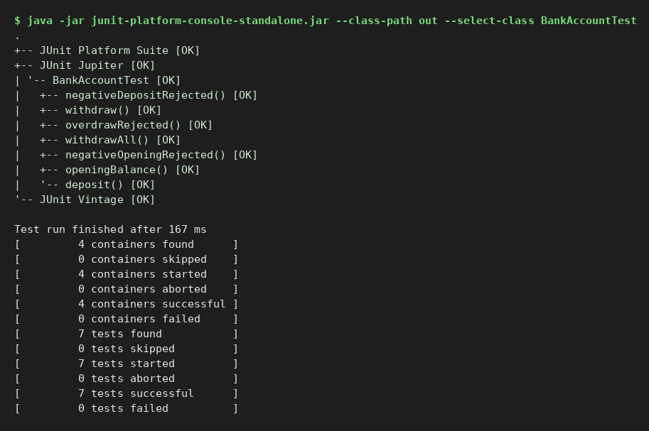
Result: all test cases passed.

Experiment 46 (JUnit)
Aim: Test harness with a stub and a driver: fare calculation
Status: Executed here (JUnit 5, JDK 21) - output captured below

Program and test code
interface DistanceService { double km(String from,String to); }
class FareCalculator { private final DistanceService ds; FareCalculator(DistanceService ds){this.ds=ds;}
double fare(String f,String t,boolean senior){ double d=ds.km(f,t); if(d<=0) throw new IllegalArgumentException("Invalid route");
double fare=30+Math.max(0,d-2)*12; return senior? fare*0.5 : fare; } }
/** Stub: replaces the real (unfinished) DistanceService with canned answers. */
class DistanceStub implements DistanceService { private final double v; DistanceStub(double v){this.v=v;} public double km(String a,String b){ return v; } }
/** Driver: the test class below calls the module under test, standing in for the missing caller. */
class FareDriverTest {
@Test void minimumFareWithinTwoKm(){ assertEquals(30.0,new FareCalculator(new DistanceStub(2)).fare("A","B",false),0.001); }
@Test void tenKmFare(){ assertEquals(126.0,new FareCalculator(new DistanceStub(10)).fare("A","B",false),0.001); }
@Test void seniorDiscount(){ assertEquals(63.0,new FareCalculator(new DistanceStub(10)).fare("A","B",true),0.001); }
@Test void invalidRoute(){ assertThrows(IllegalArgumentException.class,()->new FareCalculator(new DistanceStub(0)).fare("A","A",false)); }
}

Output (JUnit console launcher)
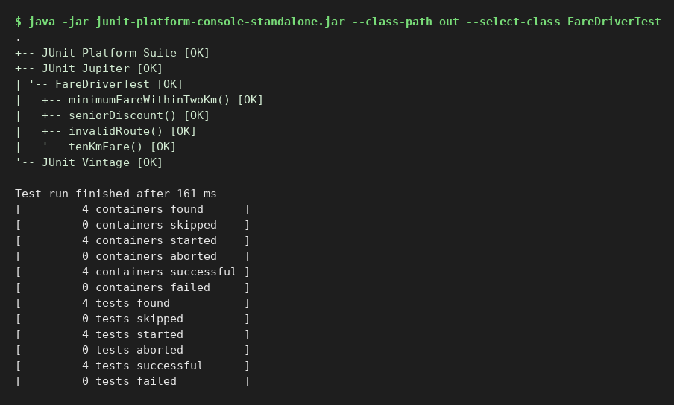
Result: all test cases passed.

Experiment 47 (JUnit)
Aim: Integration testing for a library management system
Status: Executed here (JUnit 5, JDK 21) - output captured below

Program and test code
import java.util.*;
class Book { final String isbn,title; boolean available=true; Book(String i,String t){isbn=i;title=t;} }
class Member { final String name; final List<Book> loans=new ArrayList<>(); Member(String n){name=n;} }
class Catalog { private final Map<String,Book> m=new HashMap<>(); void add(Book b){m.put(b.isbn,b);} Book find(String i){return m.get(i);} }
class Library { private final Catalog cat; static final int LIMIT=2; Library(Catalog c){cat=c;}
void borrow(Member mem,String isbn){ Book b=cat.find(isbn); if(b==null) throw new NoSuchElementException("No such book"); if(!b.available) throw new IllegalStateException("Already borrowed");
if(mem.loans.size()>=LIMIT) throw new IllegalStateException("Loan limit reached"); b.available=false; mem.loans.add(b); }
void giveBack(Member mem,String isbn){ Book b=cat.find(isbn); mem.loans.remove(b); b.available=true; } }
class LibraryIntegrationTest {
Catalog cat; Library lib; Member m;
@BeforeEach void init(){ cat=new Catalog(); cat.add(new Book("1","Java")); cat.add(new Book("2","Testing")); cat.add(new Book("3","Selenium")); lib=new Library(cat); m=new Member("Ravi"); }
@Test void borrowUpdatesCatalogAndMember(){ lib.borrow(m,"1"); assertFalse(cat.find("1").available); assertEquals(1,m.loans.size()); }
@Test void cannotBorrowSameBookTwice(){ lib.borrow(m,"1"); assertThrows(IllegalStateException.class,()->lib.borrow(new Member("Anu"),"1")); }
@Test void loanLimitEnforced(){ lib.borrow(m,"1"); lib.borrow(m,"2"); assertThrows(IllegalStateException.class,()->lib.borrow(m,"3")); }
@Test void returnMakesBookAvailable(){ lib.borrow(m,"1"); lib.giveBack(m,"1"); assertTrue(cat.find("1").available); assertTrue(m.loans.isEmpty()); }
@Test void unknownBook(){ assertThrows(NoSuchElementException.class,()->lib.borrow(m,"99")); }
@Test void borrowAfterReturnByAnotherMember(){ lib.borrow(m,"1"); lib.giveBack(m,"1"); Member n=new Member("Anu"); lib.borrow(n,"1"); assertEquals(1,n.loans.size()); }
}

Output (JUnit console launcher)
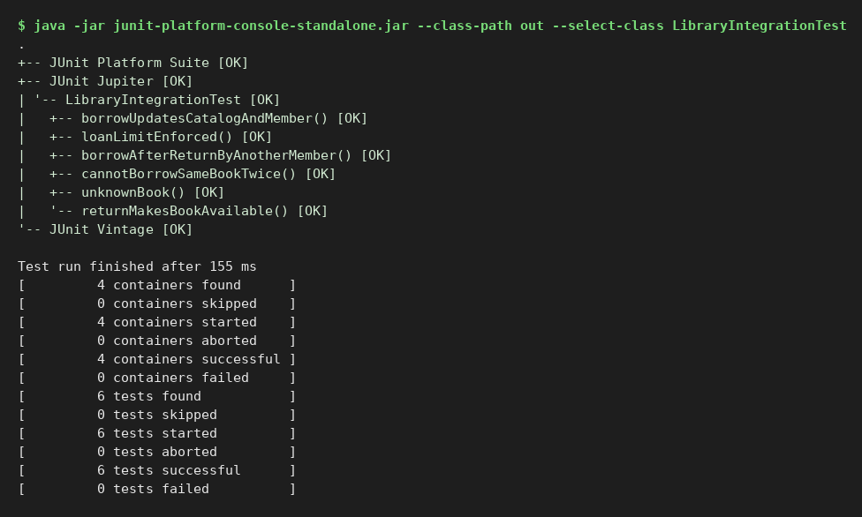
Result: all test cases passed.

Experiment 48 (JUnit)
Aim: Regression test suite using tags and test suites
Status: Executed here (JUnit 5, JDK 21) - output captured below

Program and test code
import org.junit.platform.suite.api.*;
class Cart { int items; void add(){items++;} void clear(){items=0;} }
class CartTests {
@Test @Tag("smoke") @Tag("regression") void addItem(){ Cart c=new Cart(); c.add(); assertEquals(1,c.items); }
@Test @Tag("regression") void clearCart(){ Cart c=new Cart(); c.add(); c.add(); c.clear(); assertEquals(0,c.items); }
@Test @Tag("regression") void addMany(){ Cart c=new Cart(); for(int i=0;i<5;i++) c.add(); assertEquals(5,c.items); }
}
class PriceTests {
@Test @Tag("smoke") void gst(){ assertEquals(118.0,100*1.18,0.001); }
@Test @Tag("regression") void discount(){ assertEquals(90.0,100*0.9,0.001); }
}
@Suite @SuiteDisplayName("Regression Suite") @SelectClasses({CartTests.class,PriceTests.class}) @IncludeTags("regression") class RegressionSuite {}
@Suite @SuiteDisplayName("Smoke Suite") @SelectClasses({CartTests.class,PriceTests.class}) @IncludeTags("smoke") class SmokeSuite {}

Output (JUnit console launcher)
RegressionSuite
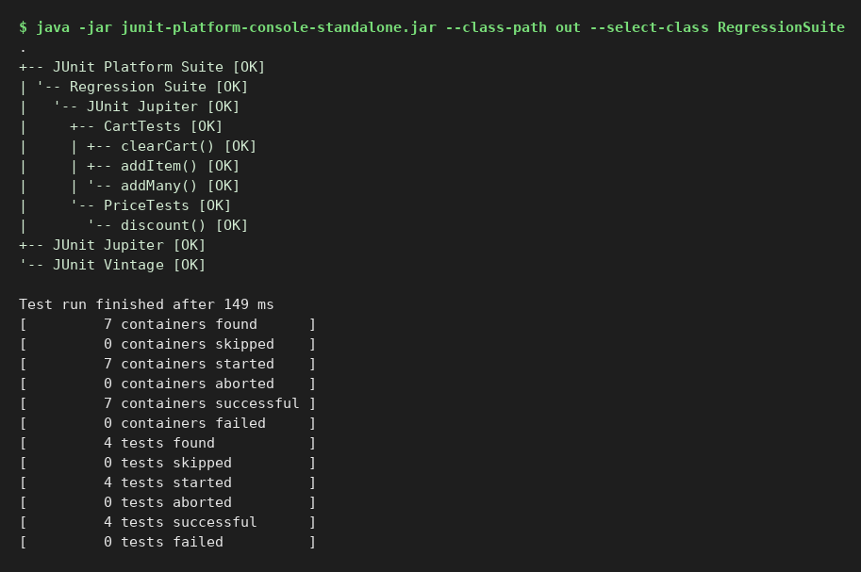
SmokeSuite
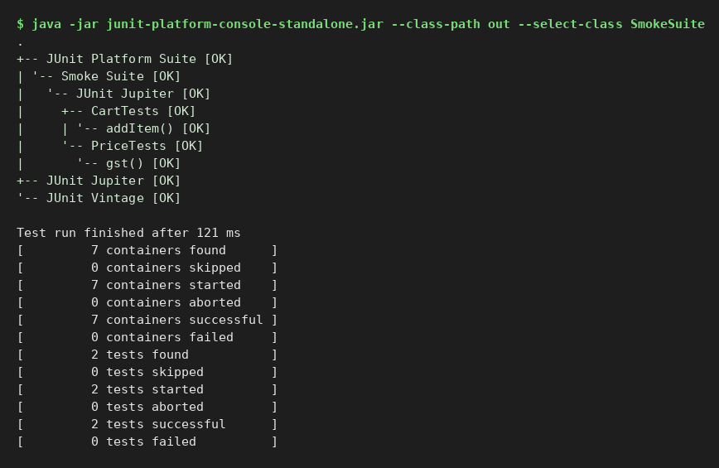
Result: all test cases passed.

Experiment 49 (JUnit)
Aim: JUnit test life cycle using a stack implementation
Status: Executed here (JUnit 5, JDK 21) - output captured below

Program and test code
import java.util.*;
class MyStack { private final Deque<Integer> d=new ArrayDeque<>(); void push(int x){d.push(x);} int pop(){ if(d.isEmpty()) throw new RuntimeException("Stack underflow"); return d.pop(); } int peek(){return d.peek();} boolean isEmpty(){return d.isEmpty();} int size(){return d.size();} }
class StackLifecycleTest {
static MyStack s;
@BeforeAll static void beforeAll(){ System.out.println("[@BeforeAll] once before all tests"); }
@BeforeEach void beforeEach(TestInfo i){ s=new MyStack(); s.push(10); s.push(20); System.out.println(" [@BeforeEach] new stack for "+i.getDisplayName()); }
@AfterEach void afterEach(TestInfo i){ System.out.println(" [@AfterEach] cleanup after "+i.getDisplayName()); s=null; }
@AfterAll static void afterAll(){ System.out.println("[@AfterAll] once after all tests"); }
@Test void pushIncreasesSize(){ s.push(30); assertEquals(3,s.size()); System.out.println(" -> test pushIncreasesSize ran"); }
@Test void popReturnsLast(){ assertEquals(20,s.pop()); System.out.println(" -> test popReturnsLast ran"); }
@Test void peekDoesNotRemove(){ assertEquals(20,s.peek()); assertEquals(2,s.size()); System.out.println(" -> test peekDoesNotRemove ran"); }
@Test void underflow(){ s.pop(); s.pop(); assertThrows(RuntimeException.class,()->s.pop()); System.out.println(" -> test underflow ran"); }
}

Output (JUnit console launcher)
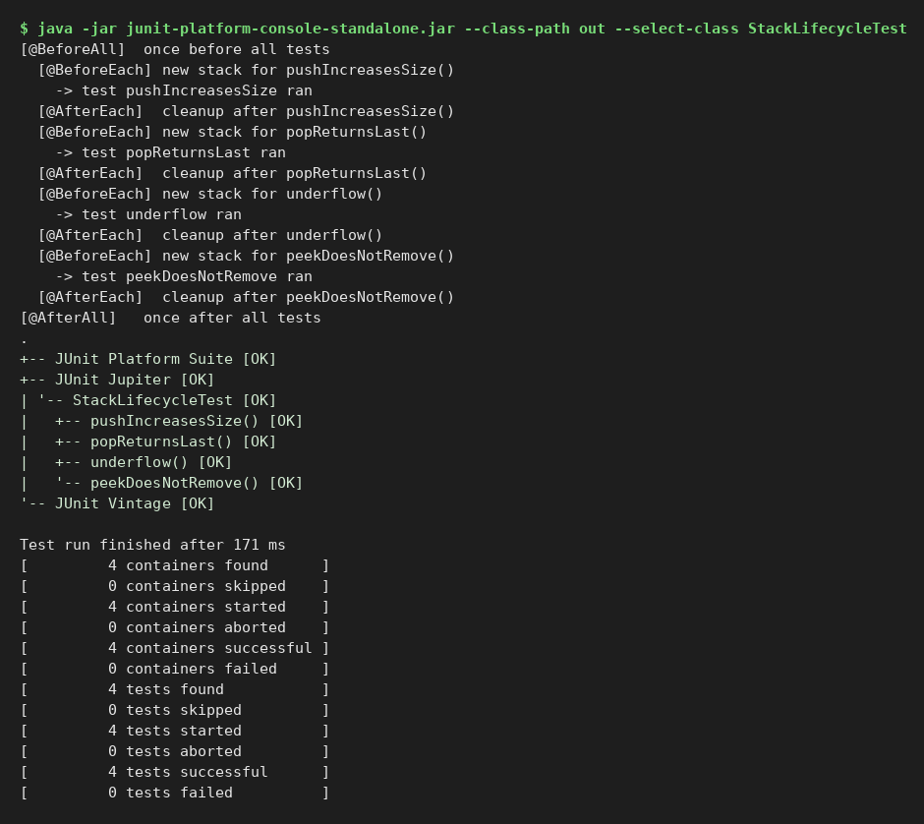
Result: all test cases passed.

Experiment 50 (JUnit)
Aim: Compound interest validated with parameterized tests
Status: Executed here (JUnit 5, JDK 21) - output captured below

Program and test code
class Interest { static double amount(double p,double r,int n,double t){ if(p<0||r<0||n<=0||t<0) throw new IllegalArgumentException("Invalid input"); return p*Math.pow(1+r/n,n*t); } }
class InterestTest {
@ParameterizedTest(name="P={0} r={1} n={2} t={3} -> A={4}")
@CsvSource({"1000,0.05,1,1,1050.00","1000,0.05,1,2,1102.50","1000,0.10,2,1,1102.50","5000,0.06,12,1,5308.39","10000,0.08,4,3,12682.42","0,0.05,1,1,0.00","1000,0,1,5,1000.00"})
void compound(double p,double r,int n,double t,double e){ assertEquals(e,Interest.amount(p,r,n,t),0.01); }
@ParameterizedTest @CsvSource({"-1,0.05,1,1","1000,-0.05,1,1","1000,0.05,0,1","1000,0.05,1,-1"}) void invalid(double p,double r,int n,double t){ assertThrows(IllegalArgumentException.class,()->Interest.amount(p,r,n,t)); }
}

Output (JUnit console launcher)
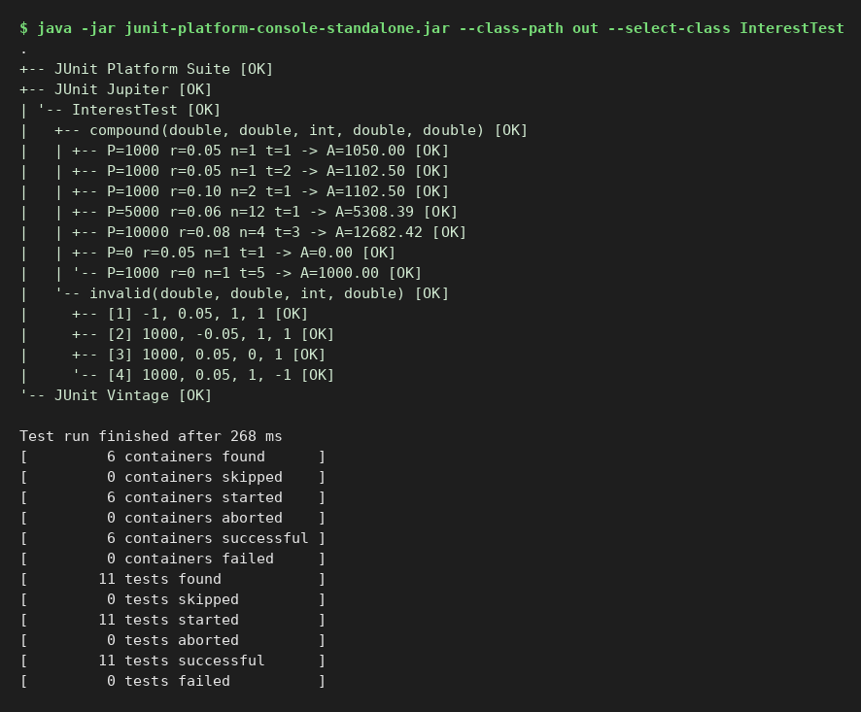
Result: all test cases passed.

