Install Eclipse, Python and Selenium

Eclipse is an Integrated Development Environment.

This page describes the steps required for its installation, it's linking with Python installation and setting up of the Selenium package.

1. General installation process
2. Python Installation
3. Eclipse Installation
4. Selenium Configuration in Eclipse

General installation process

1. Download and extract Python in a user folder.
2. Download and extract Eclipse in a separate user folder.
3. Create a folder to serve as Eclipse workspace.
4. Configure Eclipse to use the Python executable.
5. Run a script to confirm successful installation.

Python Installation

The Python version which is currently being used is composed of different packages/modules that have been identified as required.

1. Download both Python archives from here: Part1 and Part2 (2 archives required due to Confluence size limitations) - note, the PyGetWindow module is missing here - to be added manually
2. Create a folder called "Apps" on the root of C drive (C:\Apps)
3. Extract the contents of the "Latest_Python37.7z.001" file and move it into the Apps folder.
4. Check that the python executable can be found in the following location: "C:\Apps\Python37\python.exe"  
   Alternative: the previous Python installation file called “Python37.zip” is still available [*here*](https://jlrglobal.sharepoint.com/sites/DECTeam/Shared%20Documents/Software%20Engineering%20Guild/Python37.zip) .

Eclipse Installation

1. Download the “eclipse.zip” file from [here](https://jlrglobal.sharepoint.com/sites/DECTeam/Shared%20Documents/Software%20Engineering%20Guild/eclipse.zip).
2. Create the folder Eclipse inside the Apps folder: "C:\Apps\Eclipse"
3. Create the folder EclipseWorkspace in the Eclipse root folder: "C:\Apps\Eclipse\EclipseWorkspace"
4. Extract the contents of the downloaded zip file and move them into "C:\Apps\Eclipse"
5. Launch the “eclipse.exe” executable that should now be found in the following location: "C:\Apps\Eclipse\eclipse.exe".
6. The first window dialogue that will show up will have an error message; press "OK" button and then "Choose" button in the next window dialogue.
7. In Workspace, add the previously created folder "C:\Apps\Eclipse\EclipseWorkspace", check the "Use this as the default..." checkbox and click the Launch button.
8. The eclipse home page will open.
9. Create a new project using a wizard: File > New > Project
10. Select PyDev > PyDev Project, then press "Next". (If you cannot see PyDev you need to install the [Eclipse plugin](https://www.pydev.org/manual_101_install.html))
11. Add as project name "HelloWorld". This will be stored in "C:\Apps\Eclipse\EclipseWorkspace\HelloWorld"

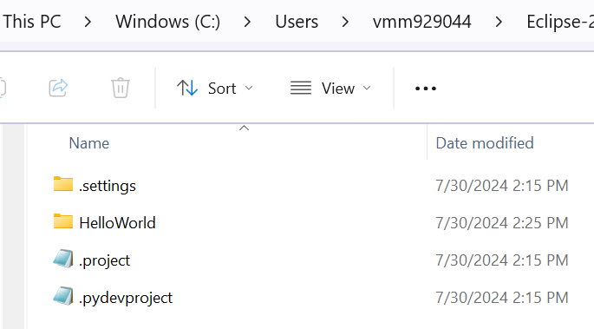

1. Click on the hyperlink “Please configure an interpreter…”
2. Select the option “Manual config.”
3. Select the option “browse for python/pypy.exe”
4. Navigate to the Python installation folder and select the “python.exe” file, then click “Open”.
5. Interpreter Name and Executable are loaded. Click “OK”
6. Ensure all folders in the list are selected, then click “OK”.
7. Click on “Apply and Close”.
8. After the python interpreter has been configured, select "Finish"
9. Select "Open Perspective" in the next dialogue box.

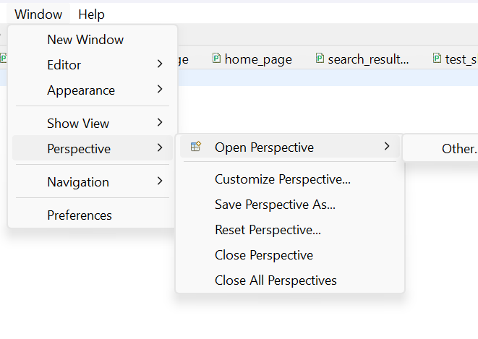

1. Deselect "Always show Welcome at start up" option in the bottom right corner (1), then close the Welcome Window (2)
2. Configure the following viewing preferences.

Window > Appearance > Show Toolbar

Window > Show View > Console

1. In the PyDev Package Explorer area, right click on the "HelloWorld" project and select "New > File", name it "MyFirstScript.py"

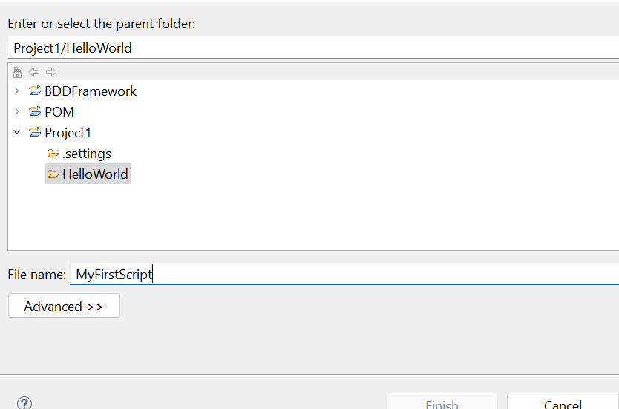

1. Select the "Finish" Button.
2. Accept the Default Eclipse preferences

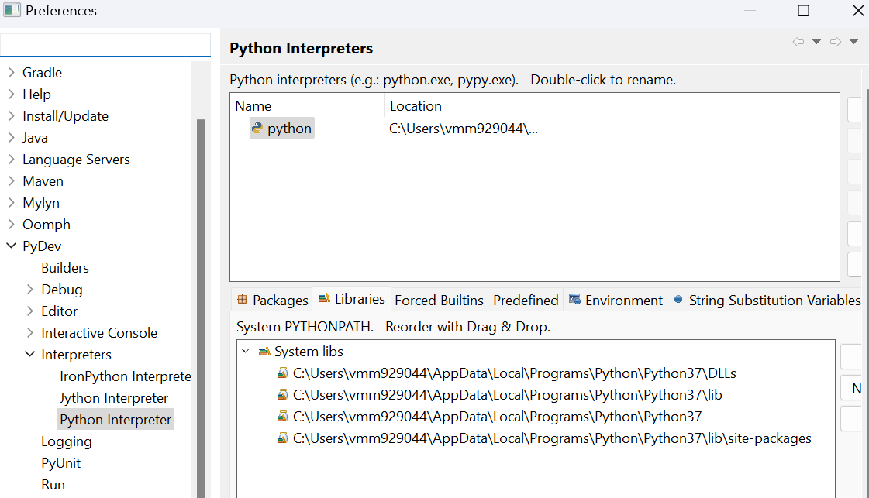

1. Type the following command in the area seen below: print("Hello World")

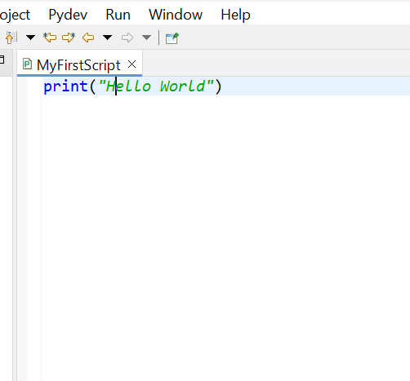

1. Select Run in the top Toolbar, then select "Run As " then select "Python Run.”

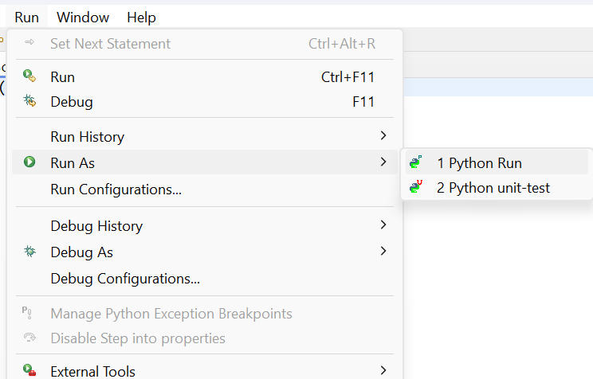

1. Check the bottom box "Always save...”, then press "OK"

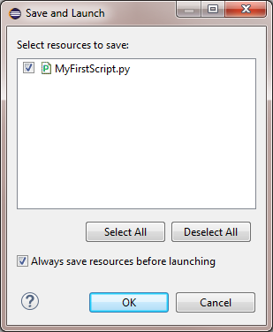

1. In the console area now "Hello World" is printed.

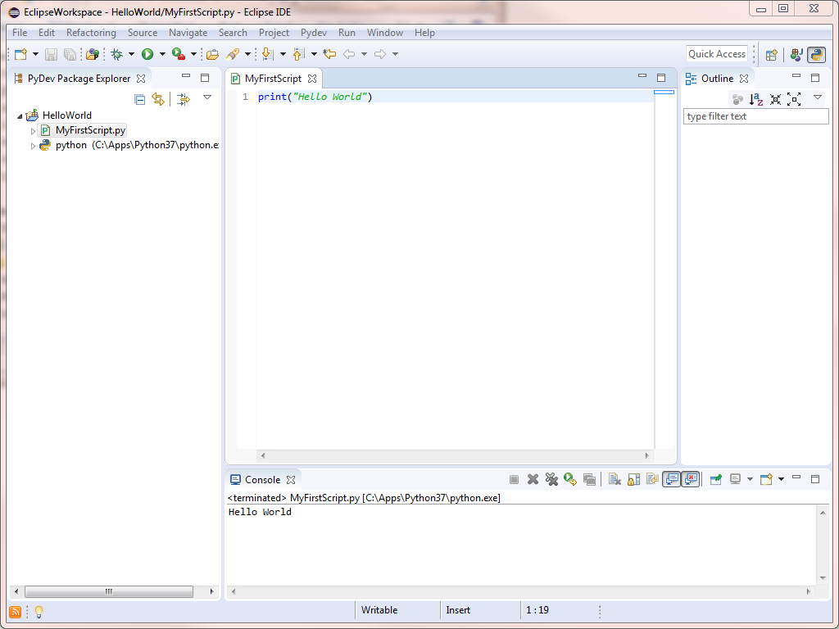

1. Congratulations for setting up Eclipse and Python!!!

Selenium Configuration in Eclipse

The Selenium package is already present in the Python installation file, but for it to work properly with Google Chrome browser, a specific executable is required. The steps of obtaining the correct executable and where to place it to make it work are detailed below.

1. Download the chromedriver zip archive for Google Chrome:
2. Go to the folder location  C:\Apps\Python37\Lib\site-packages\selenium\webdriver\chrome and extract here the contents of the archive above.  
     
   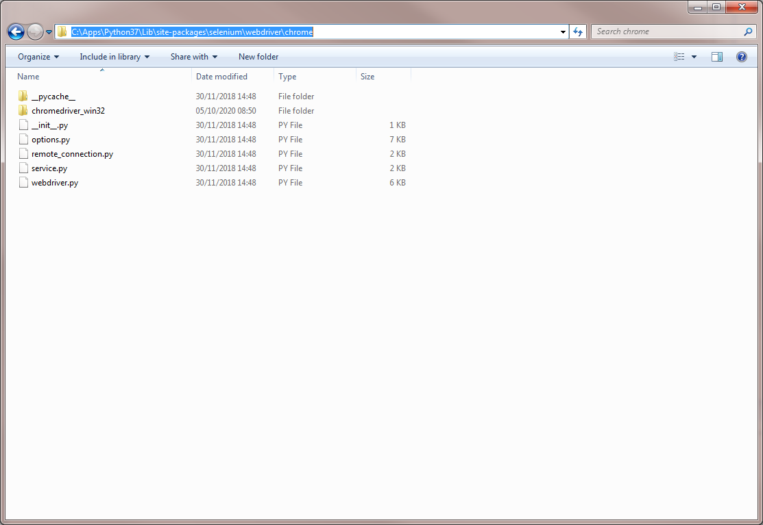
3. The folder chromedriver_win32 will contain a single executable - "chromedriver.exe"  
     
   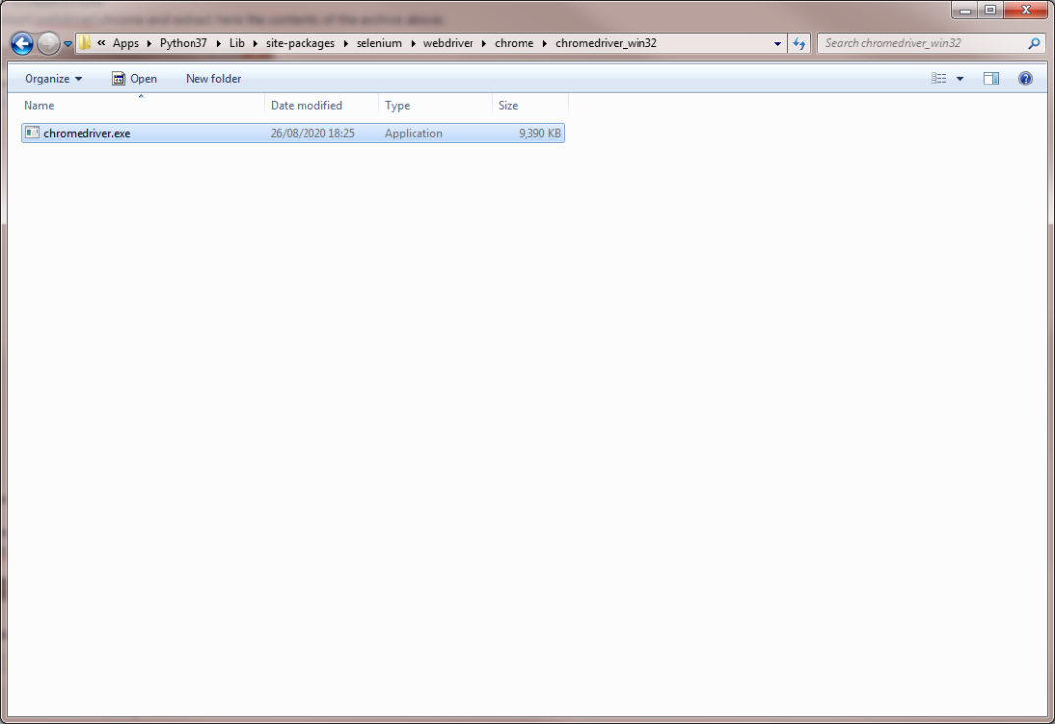
4. In the HelloWorld Project, create a new python script called "MySecondScript". Type the following lines of code:

from selenium.webdriver.chrome.webdriver import WebDriver

driver=WebDriver(r"C:\Apps\Python37\Lib\site-packages\selenium\webdriver\chrome\chromedriver_win32\chromedriver.exe")  
driver.get('[*http://www.google.com*](http://www.google.com/)')

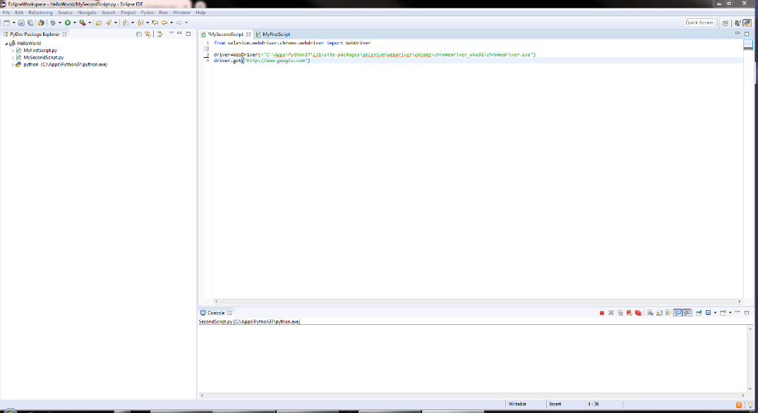

1. If Selenium and the chromedriver are installed correctly, the following Google Chrome page appears with the message "Chrome is being controlled by automated test software"