CHATAKE INNOWORKS PVT. LTD.
APOLLO AGRIVERSE
MODULE 1 | APOLLO AGRIGUARD
Intelligent Soil-Crop Digital Twin & Precision Farming Blueprint
From terrain preparation and soil development to forecasting, harvesting and post-season learning
Portfolio field | Official designation
Umbrella | Apollo AgriVerse
Official module | Apollo AgriGuard - Precision Crop Intelligence & Protection System
Core technology | Apollo Soil360 - hierarchical soil, plot, plant and farm digital twin
Research identity | APOLLO-SOIL360 - multiscale physics-informed soil-crop intelligence
Integration | Standalone platform with an open, versioned Apollo RoboLink / ROS2 docking end
Document | Internal Team Blueprint v1.0 | 05 August 2026

Prepared for the four-member Apollo AgriGuard team and Apollo AgriVerse program leadership
Program Sponsor / Product Owner: Akash Shivadas Chatake

Document control and reading guide
Purpose. This is the complete handoff blueprint for Apollo AgriVerse Module 1. It defines the scientific scope, soil-first digital twin, field experiments, IoT network, data and model packages, 100-hour command window, team ownership, delivery gates and the open ROS2 docking contract.

Item | Decision
Primary audience | Apollo AgriGuard soil/IoT, AI/ML, platform and field-operations team
Primary object | Soil-crop system across farm, field, plot/management zone and representative plant/row scales
Lifecycle | Survey and terrain preparation through harvest and post-harvest soil recovery
Standalone rule | AgriGuard owns its ingestion, twin, intelligence, dashboard, APIs, tests and manual task workflow
Robotics boundary | AgriGuard requests missions; Apollo RoboLink owns navigation, actuation, payloads and robot safety
Evidence posture | Every result is labelled verified field result, controlled trial, simulation, design target or projection

Contents
- 1. Executive decision, official identity and core technology
- 2. Project charter, outcomes and boundaries
- 3. Whole-farm life-cycle and digital-twin doctrine
- 4. Apollo Soil360 intelligent soil-development core
- 5. Mulch, hydrogel and soil-treatment experimental programme
- 6. IoT, field sensing, imagery and data-quality plan
- 7. Hierarchical digital-twin data model and operational ledger
- 8. AI/ML model work packages
- 9. Weather, yield forecasting and the rolling 100-hour command window
- 10. Decision engine, dashboard and farm workflows
- 11. Apollo Indian field dataset and annotation programme
- 12. Public datasets, Earth observation and authoritative resources
- 13. Software architecture, repository and MLOps blueprint
- 14. Hardware, field resources and pilot-site plan
- 15. ROS2 open-end docking contract
- 16. Four-member team structure and execution governance
- 17. Twenty-four-week roadmap, milestones and acceptance gates
- 18. Evaluation, safety, ethics and risk management
- 19. Deliverables, research outputs and handover
- Appendices: entity schema, interfaces, first 30 days, source register and approvals

1. Executive decision, official identity and core technology
Apollo AgriGuard is Module 1 of Apollo AgriVerse. Its complete responsibility is the intelligence of cultivated land: how terrain, soil, water, weather, crop, treatment and operations interact from field preparation through harvest. Crop protection remains part of the system, but it is no longer the complete definition.
Official naming decision. Keep Apollo AgriGuard as the public module name so existing research remains recognisable. Name its core technology Apollo Soil360. Use APOLLO-SOIL360 as the academic identity for papers, datasets and benchmark reports.

Layer | Name | Meaning
Product / module | Apollo AgriGuard | Precision Crop Intelligence & Protection System
Core engine | Apollo Soil360 | Soil-first whole-farm digital twin, prediction and decision engine
Academic identity | APOLLO-SOIL360 | A multiscale physics-informed soil-crop digital twin for intelligent soil development, 100-hour risk forecasting and precision farm operations
Robotics interface | AgriGuard MissionBridge | Optional adapter that translates approved farm tasks into versioned RoboLink mission requests

1.1 North-star outcome
At any time, the user should be able to open a farm, field, plot or representative plant record and answer: What is its current state? How did it reach this state? What is likely to happen in the next 100 hours and by harvest? What action is recommended? What evidence and uncertainty support that recommendation? What actually happened after the action?

1.2 Apollo AgriVerse portfolio position
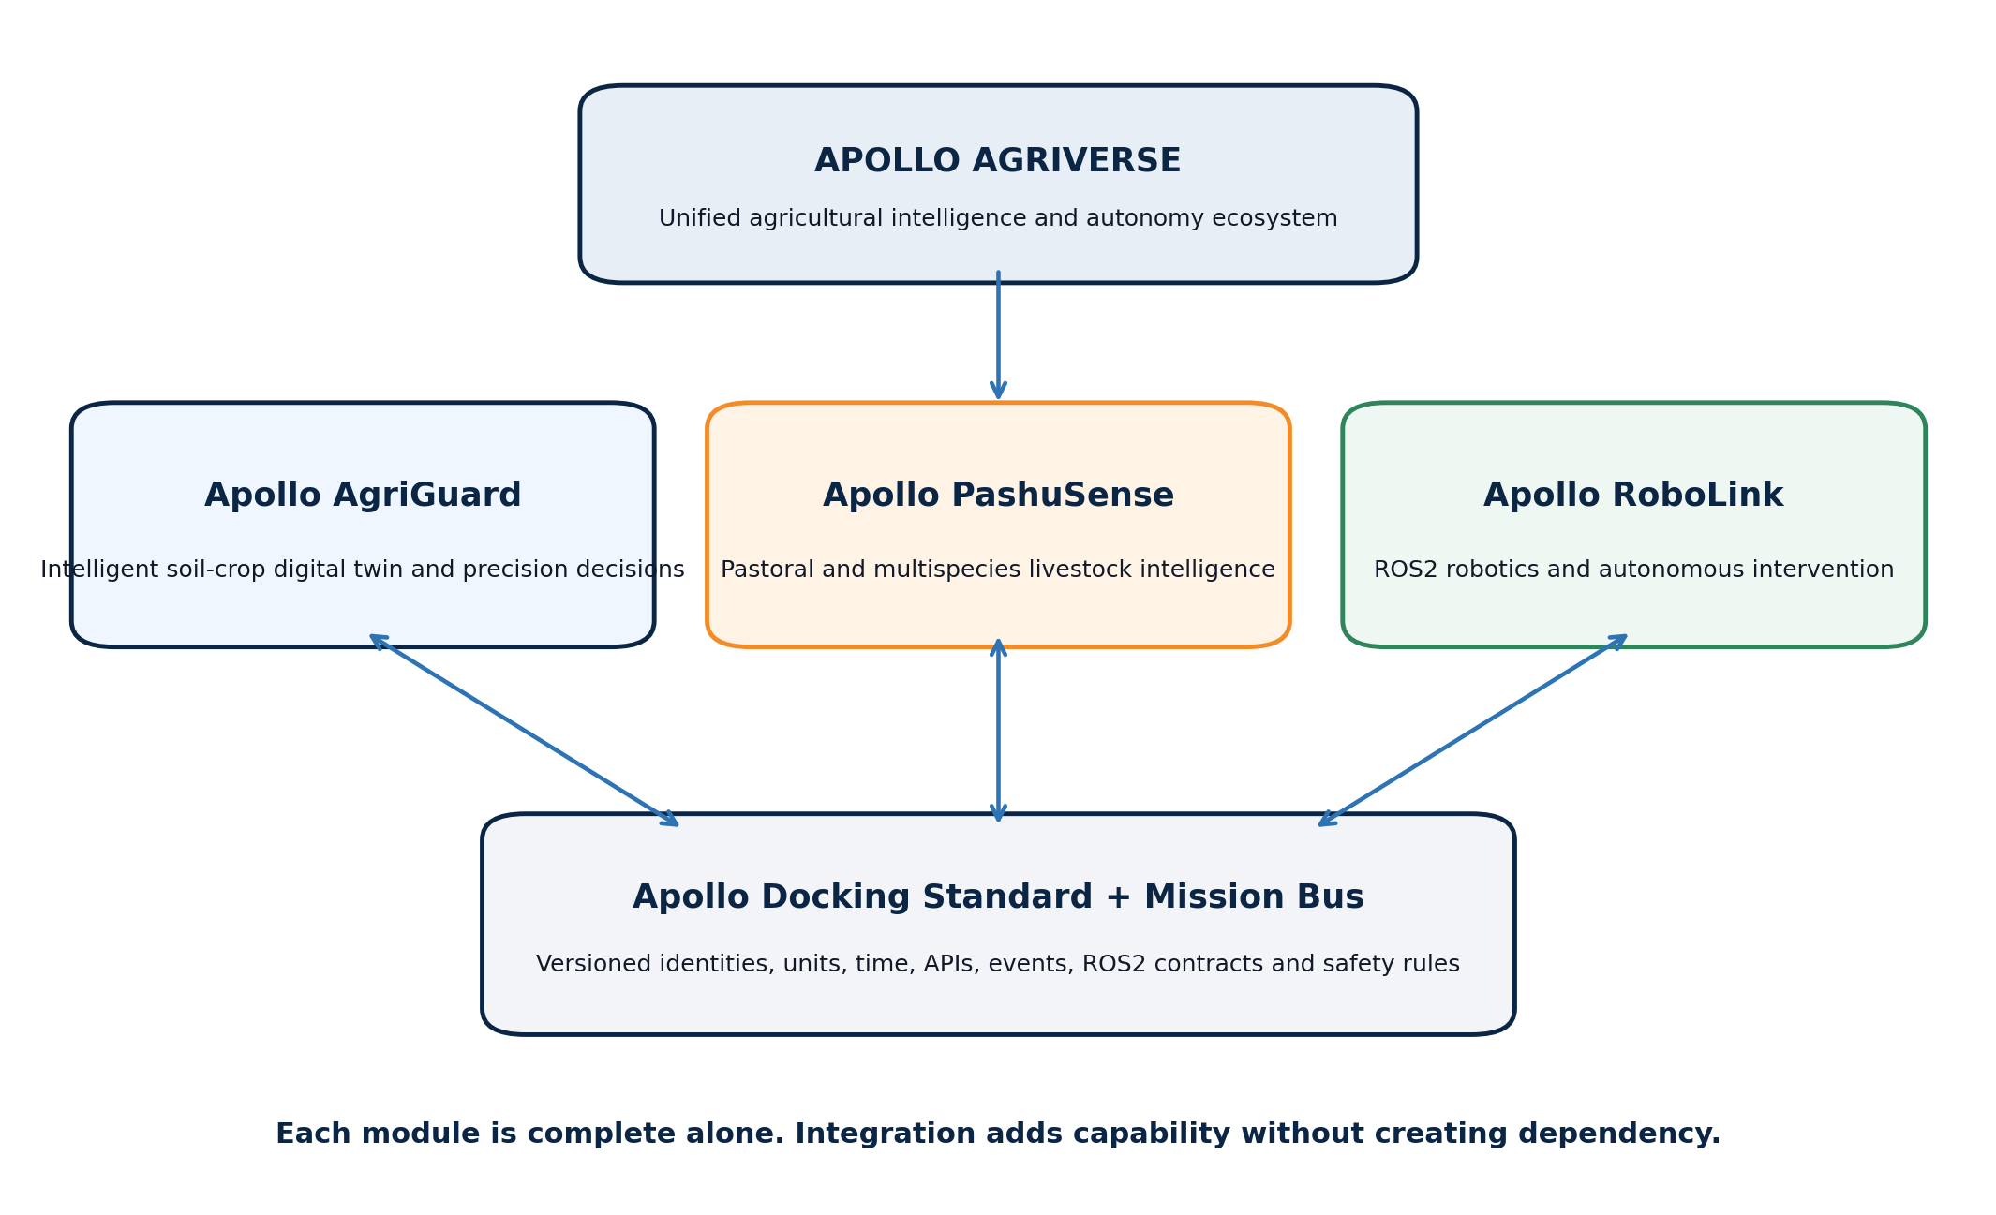
Figure 1. Apollo AgriVerse module architecture.
Module | Owns | Does not own
Apollo AgriGuard | Soil, crop, weather, irrigation, field operations, predictions, alerts and intervention plans | Livestock intelligence; robot navigation and motor/payload control
Apollo PashuSense | Animal/flock identity, behaviour, health-risk, feed and production intelligence | Crop/soil models; robot navigation
Apollo RoboLink | ROS2 navigation, perception, mission execution, safety, telemetry and payload drivers | Farm-domain forecasting or authoritative farm records

2. Project charter, outcomes and boundaries

2.1 Mission
Build a low-cost, explainable and India-adaptable precision-agriculture platform that develops a continuously updated digital representation of soil and crop systems, predicts plot- and plant-scale behaviour, and converts evidence into timely, safe and measurable farm actions.

2.2 Primary objectives
- Map terrain, drainage, soil variability and management zones before cultivation begins.
- Measure and model soil physical, chemical and management state, including approved mulch, hydrogel and amendment treatments.
- Create farm, field, plot/zone and representative plant/row twins with complete event and task history.
- Fuse IoT, laboratory, camera, satellite, weather and field-operation data into quality-controlled time series.
- Forecast soil moisture, crop stress, disease/pest risk, phenology, yield and harvest readiness with uncertainty.
- Operate a rolling 100-hour early-warning and resource-planning window.
- Recommend irrigation, inspection, crop protection, soil operations and harvest actions with explanations and approval rules.
- Expose approved missions through a stable ROS2 docking interface without depending on a physical robot.
- Create a publishable Indian farm dataset for soil-treatment, crop-behaviour and intervention-response research.

2.3 In scope
- Open-field annual crops as the first implementation target; architecture also supports orchards and protected cultivation through crop packs.
- Terrain survey, sampling design, soil baseline, amendments, sowing, establishment, growth, protection, harvest and post-harvest recovery.
- RGB-first computer vision; satellite, thermal, multispectral and drone inputs as optional tiers.
- Plot/management-zone intelligence for all fields; plant-level intelligence for sentinel plants, perennials, research plots or trackable plants.
- Manual task workflow, reports and dashboard as the complete standalone operating mode.
- Replayable simulation, synthetic sensors and mock mission interfaces when no field or robot is available.

2.4 Explicitly out of scope for version 1
- Replacing certified soil laboratories, agronomists or statutory pesticide/fertilizer guidance.
- Assuming inexpensive continuous NPK or pH probes are laboratory-equivalent without crop- and soil-specific calibration.
- A permanent unique identity for every plant in dense annual crops; rows, stands and sampled plants are the correct unit there.
- Unsupervised chemical spraying, fertilizer dosing, heavy machinery or harvester deployment based only on an ML score.
- Robot navigation, mapping, collision avoidance, actuator control or emergency-stop logic.
- Universal accuracy claims across crops, farms and seasons before external field validation.

3. Whole-farm life-cycle and digital-twin doctrine
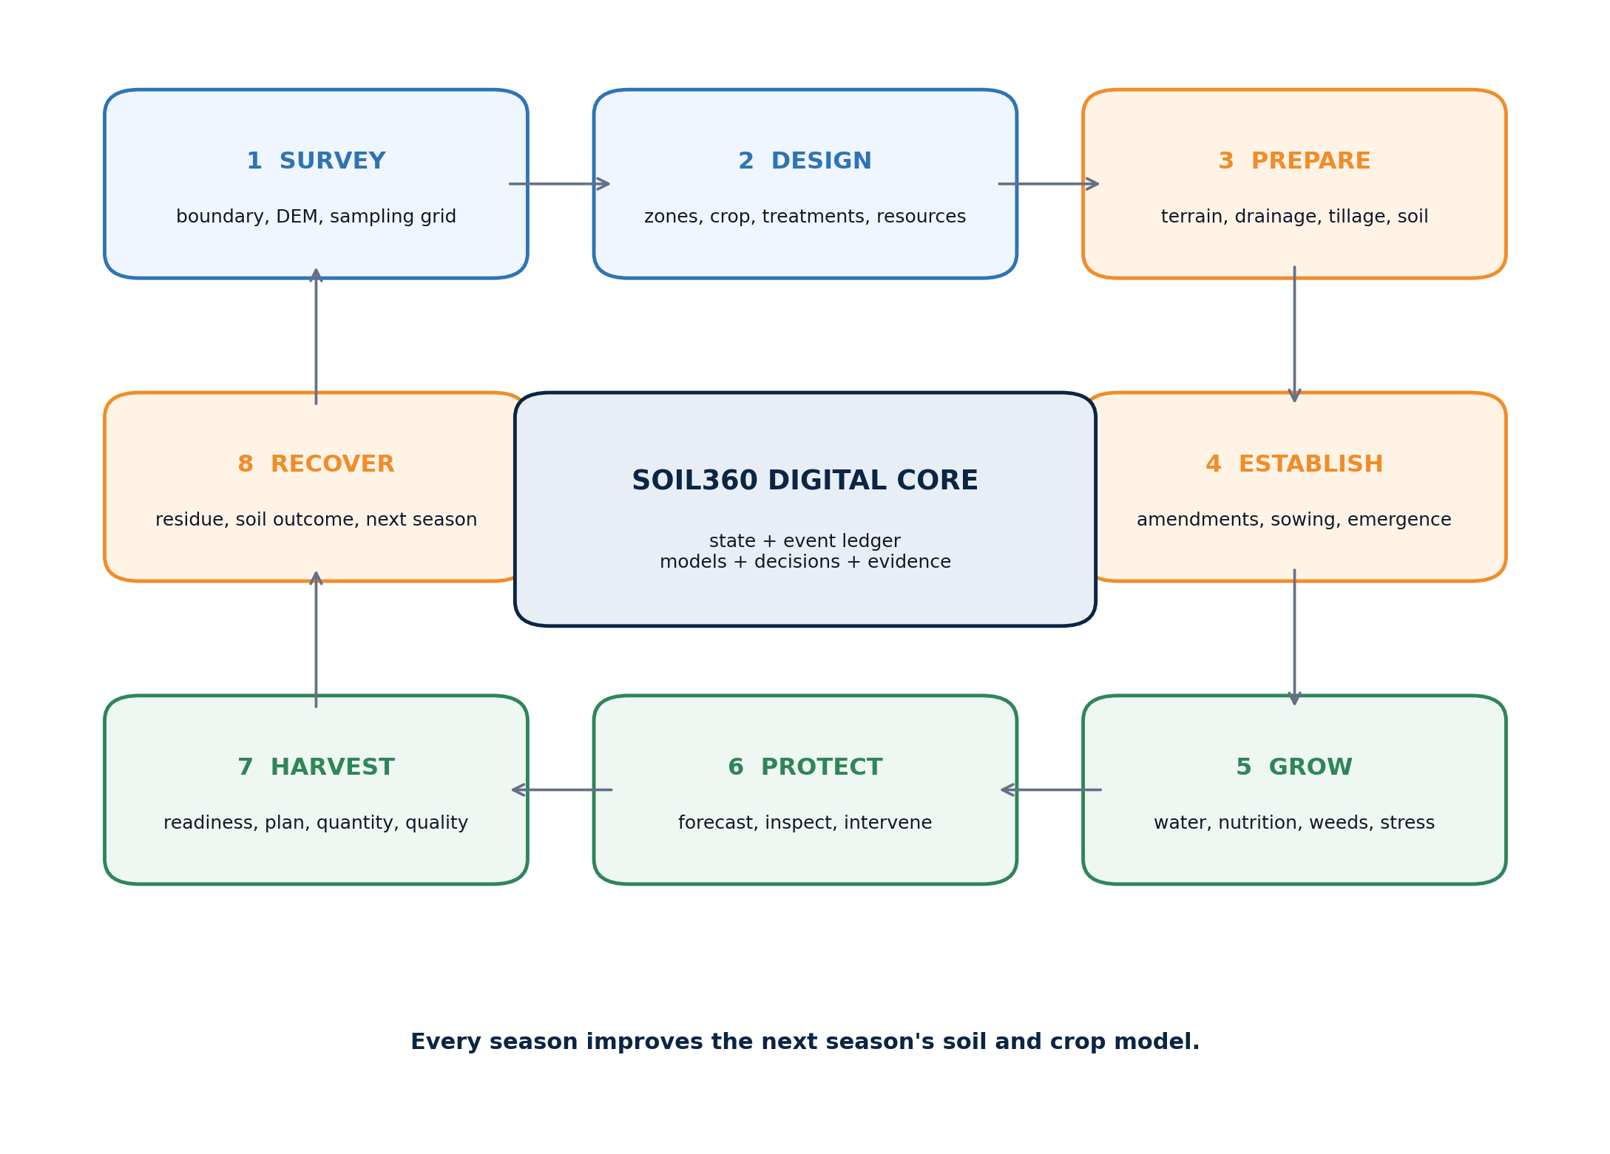
Figure 2. Full farm life-cycle owned by Apollo AgriGuard.

3.1 Life-cycle stages and outputs
Stage | Required digital-twin output | Decision examples
Survey | Farm boundary, DEM/slope, drainage, sampling grid, baseline imagery | Where to sample; where water may accumulate; how to divide zones
Design | Crop cycle, treatment plan, irrigation plan, zone assignments, targets | Crop/variety and experimental layout; resource budget
Prepare | Tillage, levelling, drainage, amendment and soil-operation events | Sequence and verify terrain/soil preparation
Establish | Sowing/transplant, mulch/hydrogel, emergence and gap records | Resow, inspect or correct installation/irrigation
Grow | Soil-water, canopy, phenology, nutrition and stress state | Irrigate, inspect, sample or adjust approved plan
Protect | Disease/pest/weed risk, alerts, evidence and completed action | Prioritize scouting; request permitted intervention
Harvest | Readiness, weather exposure, yield/quality forecast, task plan | Choose zone order, labour/equipment window and logistics
Recover | Actual yield, residue, post-season soil test and lessons | Measure treatment effect and design next season

3.2 What the digital twin is
Authoritative definition. The digital twin is a synchronized state model plus an immutable event, task and evidence ledger. A map or 3D farm view is useful, but it is only a presentation layer; the twin remains valid without it.

- State: best current estimate of soil, crop, environment, asset and operation condition.
- History: raw and corrected observations, samples, treatments, decisions, actions and outcomes.
- Models: current prediction, uncertainty, model version, feature snapshot and explanation.
- Future: scenarios for no action, recommended action and alternative actions.
- Tasks: planned, assigned, started, completed, verified, failed or cancelled farm work.
- Learning loop: measured response is linked back to the action that caused or preceded it.

3.3 Hierarchical representation
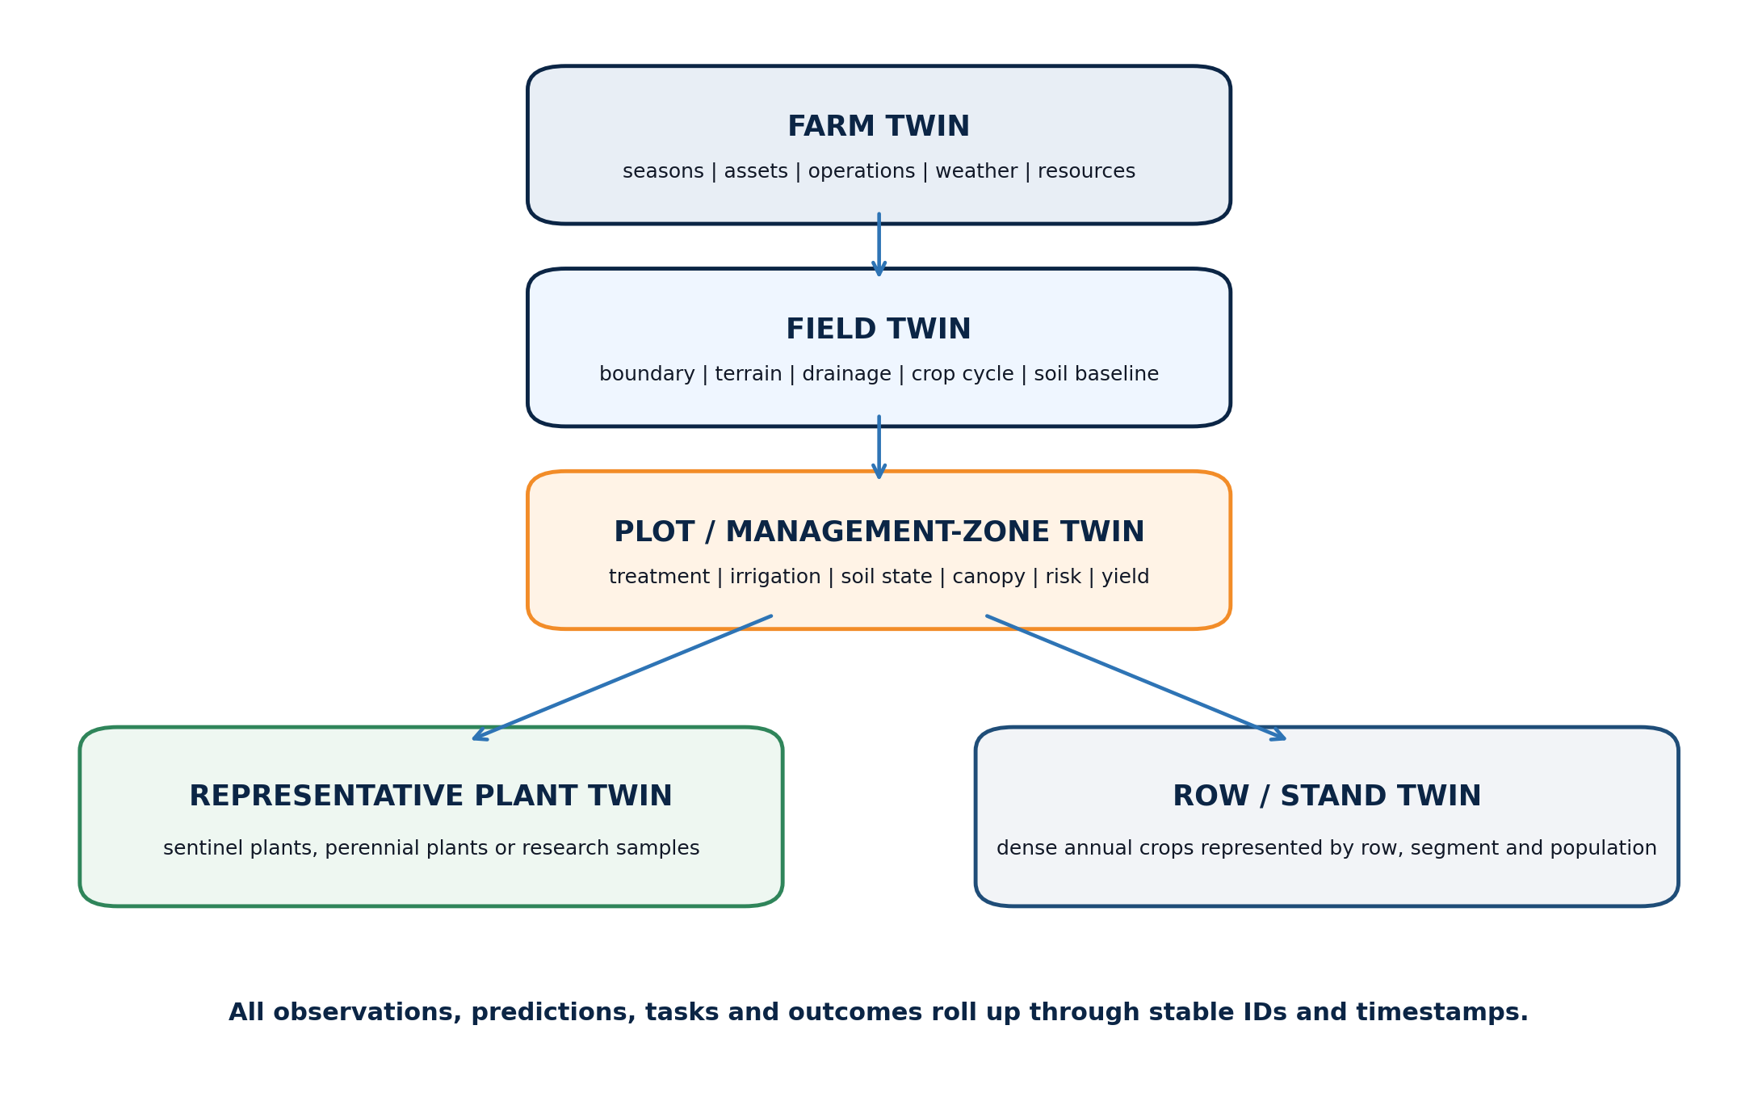
Figure 3. Hierarchical soil-crop digital twin.
Scale rule. Do not promise one sensor or permanent identity per plant across a large annual-crop field. Use management zones and row/stand states for coverage; use representative sentinel plants for detailed biological measurements. Use plant identity where it is physically stable and valuable, such as orchards or research plots.

4. Apollo Soil360 intelligent soil-development core

4.1 Soil-state dimensions
Dimension | Variables | Primary evidence | Update frequency
Geometry and terrain | Elevation, slope, aspect, microrelief, drainage path, erosion risk | Survey/RTK/DEM, field walk, imagery | Baseline and after major earthwork
Physical | Texture, bulk density, compaction, infiltration, aggregate condition, rootable depth | Lab/field tests, penetrometer, infiltration test | Baseline, targeted checks, post-season
Water | Volumetric moisture, tension, water balance, infiltration, evapotranspiration, waterlogging | Calibrated probes, flow/rain, weather, model | Minutes to hours
Thermal | Soil temperature by depth, surface temperature and diurnal range | Temperature probes, thermal/remote observations | Minutes to hours
Chemical | pH, EC/salinity, organic carbon, N-P-K and selected micronutrients | Certified/validated laboratory and field sampling | Baseline and agronomic schedule
Biological proxy | Residue, root activity, canopy response, optional respiration/microbial tests | Field/lab records and crop response | Stage or season
Management | Tillage, amendment, mulch, hydrogel, irrigation, fertilizer and traffic | Verified operation events and material batches | Every action

4.2 Soil-state estimation
Soil360 should never copy the last sensor reading into the twin as unquestioned truth. It should estimate state by combining calibrated sensor data, soil laboratory values, weather and water balance, spatial neighbours, crop stage and observation quality. Each field stores a value, unit, depth, location, timestamp, uncertainty and provenance.
- Start with deterministic water balance and interpolation baselines before deep learning.
- Use calibration curves per soil type and sensor batch; retain raw readings beside converted values.
- Treat laboratory samples as high-authority but sparse observations, not continuous signals.
- Flag impossible rate changes, stuck sensors, drift, time gaps and depth/location mismatches.
- Produce management-zone state with an uncertainty map; do not create false plant-scale precision from 10-250 m public rasters.

4.3 Intelligent soil-development loop
Loop step | System function | Required evidence
Diagnose | Identify limiting soil-water, physical or chemical condition | Baseline sample, sensor history, terrain and crop response
Design | Select expert-approved treatment and control plan | Agronomic rationale, target, constraints, randomisation and budget
Apply | Record exact operation, material, batch, location and time | Geo-referenced completion and operator verification
Observe | Measure immediate and delayed response | Moisture/temperature, emergence, biomass, yield and soil endpoints
Attribute | Estimate treatment effect against controls/replicates | Controlled-trial analysis with uncertainty
Adapt | Update next operation or next-season plan | Benefit, risk, cost and soil-health result

5. Mulch, hydrogel and soil-treatment experimental programme
Research opportunity. Public Earth-observation and crop datasets cannot answer how a particular mulch paper, hydrogel, soil and irrigation combination behaves in a Solapur plot. Apollo must create a controlled, locally measured treatment-response dataset; this is a major originality point.

5.1 Trial families
Trial family | Treatment factors | Outcome families
Mulch | Approved paper/biodegradable material, coverage, installation quality, control | Evaporation, soil temperature, weed pressure, emergence, degradation, yield and cost
Hydrogel | Agronomist-approved formulation/dose, placement, irrigation regime, control | Moisture retention, irrigation interval, root-zone response, biomass, yield and residue/safety checks
Organic/soil amendment | Approved compost/biochar/organic matter or conditioner plan | SOC proxy, EC/pH, infiltration, water holding, crop response and economics
Irrigation | Method, timing, amount, deficit strategy and treatment interaction | Water balance, stress hours, water-use efficiency and production
Terrain/soil operation | Levelling, drainage, tillage depth/intensity, traffic/control | Runoff, ponding, compaction, emergence uniformity and yield variability

5.2 Experimental design minimum
- Use a randomised block or agronomist-approved field design with untreated/standard-practice controls and sufficient replication.
- Log plot geometry before treatment; keep treatment, irrigation and sampling identities stable for the full season.
- Use matched sensor depths and acquisition schedules across treatment and control plots.
- Pre-register primary endpoints and analysis so the team does not select only favourable outcomes.
- Record material product, composition/grade, supplier, batch, application method, amount, installation date and safety documentation.
- Use an agronomist/soil scientist to approve treatment levels and a qualified lab for chemical/soil endpoints.

5.3 Treatment-effect model
The primary scientific output is not merely a yield comparison. The treatment twin should estimate a time-varying response: how each treatment changes soil moisture retention, thermal behaviour, crop establishment, stress exposure, water use, yield and post-season soil condition under different weather and irrigation regimes.
Analysis level | Recommended baseline | Advanced option
Immediate sensor response | Treatment/control curves and area under stress threshold | Hierarchical state-space model
Repeated plot outcomes | Mixed-effects model with block/plot effects | Bayesian multilevel model
Intervention timing | Before-after plus matched control | Causal impact / difference-in-differences where assumptions hold
Yield and efficiency | ANOVA/regression with uncertainty and agronomic checks | Causal forest/uplift model after adequate multi-season data

Safety rule. No material treatment is selected or applied only because a model predicts benefit. Agronomic suitability, manufacturer guidance, environmental compatibility and applicable Indian rules remain controlling constraints.

6. IoT, field sensing, imagery and data-quality plan

6.1 Sensor architecture
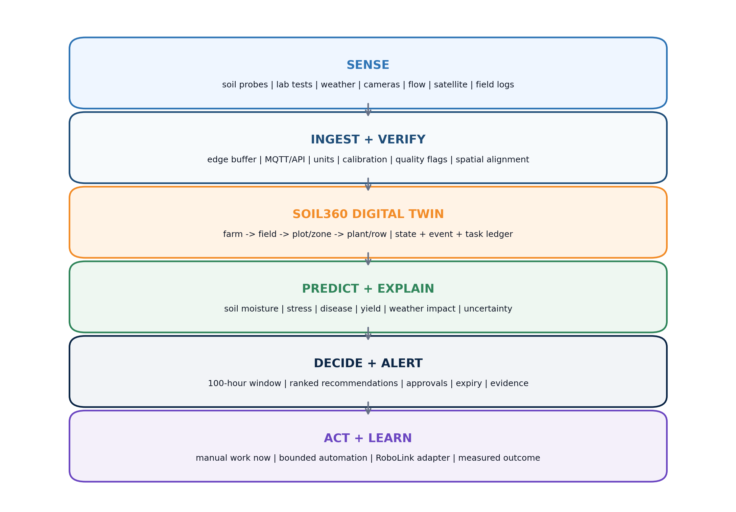
Figure 4. Apollo AgriGuard layered system.
Layer | Minimum pilot | Advanced / optional
Soil | Calibrated moisture and temperature at crop-relevant depths; periodic pH/EC/lab tests | Tensiometers, profile probes, compaction/infiltration, EC mapping
Weather | Air temperature/humidity, rainfall, wind, pressure; solar radiation if available | Leaf wetness, canopy temperature, reference station redundancy
Water system | Flow and runtime; tank/line state; irrigation event log | Pressure, valve state, pump energy and zone-level metering
Vision | Fixed RGB or repeatable phone capture and field scouting images | Thermal, multispectral, drone or rover imaging
Location | Surveyed field/plot polygons and sensor coordinates | RTK GNSS and detailed DEM
Gateway | ESP32-class nodes plus buffered MQTT gateway and local clock checks | LoRaWAN, solar edge gateway and on-device inference

6.2 Sensor-to-twin pipeline
- Capture raw value, device ID, location, depth, timestamp, battery and calibration version.
- Buffer locally during connectivity loss; preserve acquisition time separately from arrival time.
- Validate schema, units, range, rate of change and duplicate event ID.
- Assign quality flag: valid, suspect, corrected, missing, stale or rejected.
- Store immutable raw observation; create corrected/derived observation as a new record.
- Update state estimator; trigger only models whose required evidence has changed.
- Write prediction, explanation and any alert back into the same entity timeline.

6.3 Data-quality and calibration rules
- Use SI or explicitly registered agronomic units; never mix percentages, fractions, mm and volumetric content silently.
- Store sensor depth and installation method; a moisture number without depth is incomplete evidence.
- Calibrate moisture probes against local soil samples across the expected wet-dry range.
- Do not train with values generated by a failed sensor as though they were ground truth.
- Monitor sensor uptime, drift, stuck values, cross-sensor disagreement and clock skew.
- Design offline-first: dashboard and alerts degrade gracefully when cloud or internet is unavailable.

7. Hierarchical digital-twin data model and operational ledger

7.1 Core entity graph
Entity | Purpose | Key relationships
Farm | Ownership, location, timezone, resources and seasons | Contains fields, assets, users and weather context
Field | Stable cultivated boundary and terrain/soil baseline | Contains plots/zones and crop cycles
Plot / Zone | Experimental plot or management unit | Has treatment, sensors, state, predictions, alerts and tasks
PlantSample / RowStand | Detailed biological unit or dense-crop population | Belongs to plot/zone and crop cycle
CropCycle | Crop, variety, dates, growth stages and target | Links season, plots, operations, models and harvest
Treatment | Mulch, hydrogel, amendment, irrigation or operation design | Applied through verified operation events
Observation | Raw/corrected lab, sensor, vision, weather or field measurement | Carries unit, location, time, depth, quality and provenance
Prediction | State forecast with horizon, interval, version and explanation | May create alert/recommendation
Task | Planned-to-verified human or robot work | Links recommendation, operator, evidence and outcome
HarvestRecord | Measured quantity, quality, loss and location | Closes forecast and treatment evaluation loop

7.2 Task and event state machine
Every operation—sampling, tillage, mulch installation, sowing, irrigation, scouting, spraying, weeding or harvesting—must become a timestamped FarmOperation event. The ML engine may use verified operations as features; it must never infer that a recommended task was executed merely because it was created.
State | Required information | Twin effect
Planned | Target, time window, reason, owner and approval rule | No physical state change
Assigned | Person or mission executor | Resource reserved
Started | Actual start, executor and location | Operation in progress
Completed | Actual end, materials/amounts and execution evidence | Candidate state transition
Verified | Human/sensor confirmation and outcome | Authoritative management event for models
Failed/cancelled | Reason, partial action and residual risk | No assumed completion; may re-alert

7.3 Digital twin invariants
- IDs are stable; display names may change.
- Every value has units, time, source, quality and spatial scope.
- Raw observations are immutable; corrections are new versioned records.
- Predictions expire and never overwrite measured outcomes.
- A recommendation is not an executed operation.
- Every automated state transition is replayable from stored events.
- Private module databases are not read directly by other Apollo modules.

8. AI/ML model work packages
Model doctrine. Use the simplest defensible baseline first, then add spatial, temporal or deep models only when they improve a pre-declared metric on farm/season-separated data. Physics and agronomic rules constrain the models; ML estimates residual behaviour and uncertainty.

8.1 Model registry
Package | Problem | Baseline | Advanced path | Output
AAG-M01 Terrain | Slope, drainage and zone delineation | DEM derivatives + rules + clustering | Learned risk zoning with field labels | Management zones and sampling plan
AAG-M02 Soil state | Spatial/temporal soil-water state | Interpolation + water balance | State-space, Gaussian process or graph model | Moisture/stress map with uncertainty
AAG-M03 Treatment | Mulch/hydrogel/amendment response | Mixed-effects regression | Bayesian/causal heterogeneity model | Expected benefit/risk by context
AAG-M04 Crop vision | Plant/stand count, gaps, canopy, weed/disease | Classical indices + detector/segmenter | Multimodal temporal vision | Geo-referenced observation and severity
AAG-M05 Phenology | Growth stage and development rate | Thermal-time/rule model | Sequence model with imagery/weather | Stage probabilities and deviation
AAG-M06 Stress | Water, heat, nutrient or disease-risk anomaly | Threshold/rule + isolation model | Multimodal anomaly/forecast model | Risk, cause candidates and lead time
AAG-M07 Yield | Plant/plot/field harvest quantity/quality | Historical mean + linear/tree model | Temporal fusion / hybrid crop model | Forecast distribution by horizon
AAG-M08 Decision | Action ranking under constraints | Expert rules + scorecard | Constrained optimisation / contextual policy | Recommendation, priority and approval

8.2 Physics-informed hybrid models
- Water: maintain a root-zone water balance using rainfall, irrigation, runoff, drainage and crop evapotranspiration; train ML on residual error.
- Growth: use crop calendar, thermal time and water stress as structured features; avoid black-box forecasts that ignore crop stage.
- Yield: constrain predictions to non-negative plausible ranges and aggregate plant/plot forecasts consistently to field totals.
- Treatment: separate weather, irrigation, block and soil effects from treatment response using controlled-design metadata.
- Forecasting: calibrate probability and prediction intervals at each horizon; do not report only point estimates.

8.3 Crop packs
The platform is shared, but each crop pack owns crop-specific phenology, thresholds, disease classes, canopy interpretation, rooting depth, harvest unit and validation data. The first team release should select one flagship crop and one secondary crop; additional crops are adapters, not a single universal model.
Shared platform | Crop-pack configuration
IDs, geometry, observations, events, alerts, tasks, APIs and dashboard | Crop/variety, phenology scale, root depth, water parameters and planting geometry
Training/evaluation framework, MLOps and digital-twin engine | Vision classes, stress thresholds, disease ontology and yield unit
Weather/soil ingestion and 100-hour orchestration | Sensitive stages, action rules, harvest criteria and local agronomic constraints

9. Weather, yield forecasting and the rolling 100-hour command window
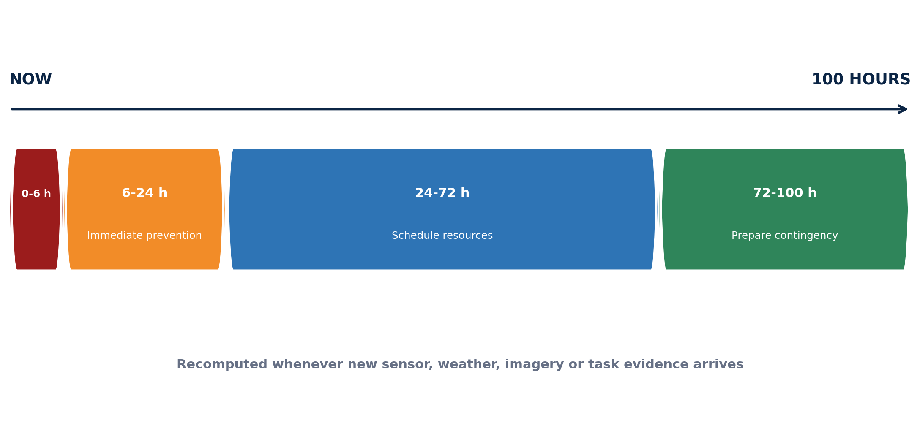
Figure 5. Rolling 100-hour farm command window.

9.1 The 100-hour design
Horizon | Operational purpose | Typical actions | Forecast treatment
0-6 h | Detect and contain an active condition | Verify sensor/irrigation failure; inspect severe stress; secure equipment | Nowcast + live sensor evidence; highest urgency
6-24 h | Prevent avoidable next-day loss | Adjust permitted irrigation plan; scout; protect exposed materials | Short-range forecast with local bias correction
24-72 h | Schedule people, water and equipment | Prepare drainage, scouting, treatment or harvest resources | Ensemble/probability and scenario comparison
72-100 h | Prepare contingency | Reserve labour/robot window; stage inputs; review harvest/weather risk | Lower confidence; communicate uncertainty clearly

9.2 Alert classes
Alert class | Evidence combination | Recommended response
Soil-water deficit | Root-zone estimate + forecast ET/rain + crop stage | Inspect/irrigate according to approved water constraints
Waterlogging / heavy rain | Terrain/drainage + soil saturation + rain probability | Inspect drainage, protect inputs and defer unsafe operations
Heat/cold stress | Forecast + canopy/air temperature + sensitive stage | Protect/irrigate only within agronomic plan; schedule inspection
Disease/pest window | Weather suitability + imagery/scouting + crop stage | Targeted scouting; agronomist-approved protection decision
Irrigation-system failure | Expected flow/state vs measured flow/pressure/moisture | Check pump, line, valve or blockage; avoid duplicate watering
Harvest weather/readiness | Maturity/yield/quality estimate + rain/wind/heat window | Plan harvest order and resources; human supervisor approves
Sensor/data failure | Stale, drifting or inconsistent device evidence | Repair/calibrate; suppress unsafe downstream automation

9.3 Alert score and payload
Rank alerts using hazard probability, exposed area/value, crop-stage sensitivity, time-to-impact, confidence, actionability and cost of a false alarm. Each alert payload must contain: target entity, observed/forecast evidence, severity, probability or calibrated confidence, lead time, recommended action, alternatives, approval level, expiry, model/rule version and acknowledgement state.
No false certainty. A 100-hour window is a rolling decision horizon, not a promise of perfect 100-hour prediction. Accuracy and uncertainty must be reported separately for 0-24, 24-48, 48-72 and 72-100 hour bands.

9.4 Yield forecast ladder
Forecast | When | Primary inputs | Use
Pre-season potential | Before sowing | Soil baseline, crop/variety, climate normals and management scenario | Scenario planning; not an operational promise
Establishment update | After emergence | Stand count/gaps, treatment, soil-water and weather | Replant/management assessment
In-season dynamic | Each stage | Canopy, phenology, stress exposure, operations and forecast weather | Resource and risk planning
Pre-harvest | Final weeks/days | Maturity, biomass/yield proxies, harvest loss and weather window | Labour, machine, storage and route planning
Final measured | At harvest | Weighed/verified quantity and quality by plot/zone | Model evaluation and next-season learning

10. Decision engine, dashboard and farm workflows

10.1 Dashboard surfaces
Surface | Must show | Primary user decision
Farm command | Active crop cycles, 100-hour alerts, resource conflicts and task status | What requires attention now and next
Field map | Plots/zones, soil-water/stress state, uncertainty and latest imagery | Where to inspect or operate
Soil360 | Depth profiles, samples, sensor quality, treatment and water balance | What is changing in the soil and why
Crop 360 | Phenology, canopy/stand, stress, disease evidence and yield trend | Whether crop development is on track
Treatment comparison | Control vs mulch/hydrogel/amendment response and cost | Whether benefit is real and repeatable
Task board | Planned/assigned/started/completed/verified work | Who acts, when and with what evidence
Model/evidence | Version, inputs, confidence, explanation and evaluation | Whether an alert/forecast is trustworthy

10.2 Required end-to-end workflows
- Register farm -> draw/import field -> create plot/zone -> begin crop cycle.
- Design soil sampling -> capture sample -> import lab result -> update soil baseline.
- Register sensor -> calibrate -> install with depth/location -> stream/replay observations.
- Create treatment/control plan -> approve -> apply -> verify -> compare response.
- Ingest weather/satellite/camera data -> update twin -> issue or suppress alert.
- Create recommendation -> human approve -> assign manual task or mission request -> verify outcome.
- Forecast yield -> harvest by plot/zone -> record actual -> evaluate model and treatment.
- Close season -> generate soil/crop report -> preserve lessons for next season.

10.3 Standalone completion definition
Module-complete criterion. Apollo AgriGuard is complete when a user can execute every workflow with human/manual farm tasks, view the synchronized twin, receive and acknowledge alerts, compare predictions with outcomes and export reports. A robot adds execution capacity but is not required for completion.

11. Apollo Indian field dataset and annotation programme

11.1 Dataset identity
Recommended name: Apollo Soil360 Field Benchmark (AS360-FB). It should be versioned by crop, farm, season and release; raw private farm data and de-identified/public benchmark releases must remain distinct.

11.2 Collection plan
Data family | Minimum fields | Collection rule
Farm/terrain | Boundary, DEM/slope, plot polygons, drainage, soil map and survey method | Freeze geometry version before trial; version later edits
Soil samples | Depth, location, time, method, lab, pH, EC, SOC/OC, NPK and selected physical data | Use verified units, lab method and chain of custody
IoT | Raw value, converted value, device, depth, location, time, calibration and quality | Retain raw + corrected; buffer during outages
Treatment | Type, material, batch, amount, method, control/block, application and verification | No unlabelled treatment mixing across plots
Crop | Crop/variety, sowing, emergence, plant/stand, stage, canopy, stress and scouting | Use shared ontology and repeated viewpoints
Imagery | RGB/thermal/multispectral, camera, pose/location, time, weather and labels | Split by farm/season, not random near-duplicate frames
Operations | Task, reason, recommendation, approval, executor, materials, start/end and outcome | Separate recommendation, completion and verification
Harvest | Plot/zone area, quantity, quality, moisture, loss, method and time | Measure; do not infer ground truth from model

11.3 Annotation ontology
- Geometry: farm, field, plot, management zone, row/segment and sensor point.
- Crop: crop/variety, growth stage, stand count, gap, canopy cover and maturity.
- Visual stress: healthy/unknown plus expert-confirmed disease, pest, weed, nutrient and abiotic classes.
- Soil/treatment: control, mulch, hydrogel, amendment, irrigation regime and installation quality.
- Event: planned, executed, verified and outcome timestamps.
- Quality: annotator, reviewer, confidence, evidence type and unresolved/unknown flag.

11.4 Split and leakage policy
Evaluation rule. All publishable model results must use time-, plot-, farm- or season-separated splits appropriate to the claim. Adjacent video frames, repeat images of the same plant and measurements from the same treatment plot must not be scattered randomly across train and test sets.

11.5 Data governance
- Obtain farm permission and define ownership, research use, commercial use, retention and deletion before collection.
- Protect precise farm coordinates in public releases; publish de-identified geometry or controlled access where necessary.
- Maintain dataset cards, licences, consent records, annotation guidelines and known limitations.
- Version data with immutable manifests and checksums; do not move large raw datasets through ordinary Git branches.

12. Public datasets, Earth observation and authoritative resources
Use policy. Public datasets are for pretraining, physics baselines and benchmarking. They cannot replace local plot measurements for mulch/hydrogel response, Indian soil calibration or deployable crop thresholds. Re-check licence and terms before every training or commercial use.

12.1 Recommended resource registry
Resource | Use | Critical limitation
SoilGrids / ISRIC | Global 250 m soil-property priors at standard depths | Baseline covariate only; too coarse to claim plot/plant truth
Copernicus Sentinel-2 | Multispectral crop/canopy time series | Cloud-sensitive; 10/20/60 m bands; field alignment required
Copernicus Sentinel-1 | Radar observations useful through cloud | Requires careful preprocessing and crop/context calibration
NASA SMAP | Regional/global surface soil-moisture context | Not plot-scale ground truth
NASA POWER | Global meteorological and solar history/API | Coarse gridded context; use local station for field operations
ERA5-Land | Historical land/weather reanalysis | Training/context, not a real-time field sensor
ECMWF Open Data | Real-time deterministic/ensemble forecast inputs including the 100-hour horizon | Bias-correct locally; retain model/run/lead time
IMD Agromet | Indian district/block forecasts and advisories | Official operational context; preserve bulletin time/source
NRSC Bhuvan | Indian thematic, terrain and EO viewing/services | Terms/licensing must be checked; do not use restricted content for autonomous vehicle control
FAO AquaCrop | Crop-water productivity physics baseline | Calibrate by crop/site; benchmark hybrid yield/water models
CropHarvest | Open remote-sensing crop classification benchmark | Geographic domain shift; verify included dataset licences
Agriculture-Vision | Aerial RGB/NIR field-anomaly segmentation | US fields; useful pretraining/benchmark, not local deployment truth
PlantVillage | Healthy/diseased leaf image pretraining | Controlled backgrounds; field validation mandatory
Global Wheat | Wheat-head detection/segmentation and yield proxies | Crop-specific benchmark; use site-separated validation

12.2 Data-resolution doctrine
- Satellite and global soil products provide context and priors; they do not manufacture centimetre-scale truth.
- Local soil samples and calibrated probes anchor the twin; remote sensing helps interpolate and detect change.
- All raster products must be stored with acquisition time, resolution, processing level, cloud/quality mask and licence.
- Weather reanalysis trains historical models; real-time forecasts drive the 100-hour window; the local station verifies microclimate.

12.3 Standards
Standard / pattern | Apollo use
OGC SensorThings API | Open geospatial model for heterogeneous Things, Sensors, ObservedProperties and Observations
GeoJSON / PostGIS | Farm/field/plot/zone geometries and spatial queries
MQTT | Low-bandwidth sensor/event transport with persistent IDs and local buffering
REST/OpenAPI | Module-facing digital-twin, prediction, task and report services
ROS2 + Apollo interfaces | Robot-time mission request, feedback and result exchange through the optional adapter

13. Software architecture, repository and MLOps blueprint

13.1 Recommended low-cost stack
Layer | Recommended starting stack | Reason
Field/IoT | ESP32-class nodes; MQTT; local gateway buffer | Low cost, replaceable sensors and offline tolerance
Backend | Python, FastAPI, Pydantic and background workers | Same language as ML; explicit versioned schemas
Data | PostgreSQL + PostGIS; object storage for imagery/models | Relational integrity, spatial queries and portable storage
Time series | PostgreSQL time-series pattern or compatible extension | Keep observations queryable without locking the model to a vendor
ML/CV | scikit-learn, PyTorch, OpenCV and crop/physics packages | Strong free ecosystem and Colab compatibility
MLOps | DVC/data manifests, MLflow-compatible tracking, model/data cards | Reproducibility and evidence traceability
Annotation | CVAT/Label Studio/QGIS | Vision, time-series review and geospatial labelling
Dashboard | React/Next.js or staged Streamlit prototype; Plotly/Grafana | Map, timeline, alert and operational views
Packaging | Docker, CI, typed tests and environment lock files | Same behaviour across four members and field gateway

13.2 Repository structure
Path | Responsibility
apps/dashboard | Farm command, Soil360, Crop 360, treatment and task views
services/api | Versioned REST/OpenAPI endpoints, auth and orchestration
packages/domain | IDs, units, events, entities and validation rules
packages/twin | State estimator, event replay and farm/field/plot/plant aggregation
packages/forecast | Weather, soil-water, stress, yield and alert packages
packages/vision | Plant/stand, canopy, weed, disease and imagery pipelines
adapters/iot | weather | eo | MQTT, sensors, IMD/ECMWF/NASA/Copernicus and file ingestion
adapters/ros2 | Optional MissionBridge only; no navigation or actuation
contracts | OpenAPI, JSON Schema, MQTT and ROS2 interface definitions
tests/fixtures/simulators | Unit, schema, replay, sensor and mission mocks
docs/data_registry | ADRs, SOPs, dataset/model cards, licences and field protocols

13.3 Branch and integration policy
- Protected main contains tested milestone releases only; protected develop is the daily integration branch.
- Each member works on short-lived task branches such as feature/AAG-101-soil-ingestion or feature/AAG-204-yield-forecast.
- Merge feature -> develop through a pull request, one peer review and passing checks; merge develop -> main only at a tested release gate.
- Clone once; fetch/pull for updates. Daily backup is commit and push on the member's task branch, not recloning main.
- Never commit raw datasets, secrets, virtual environments, generated videos, ROS build folders or large uncontrolled model files.

13.4 Reproducibility contract
Artifact | Required metadata
Dataset | Version, licence, source, split manifest, schema, checksums and exclusions
Experiment | Code commit, environment, data version, seed, features, hyperparameters and metrics
Model | Purpose, crop/domain, limitations, thresholds, calibration, evaluation and owner
Prediction | Model version, feature snapshot, horizon, uncertainty, explanation and expiry
Release | Migration notes, test report, known risks, rollback and evidence classification

14. Hardware, field resources and pilot-site plan

14.1 Three resource tiers
Tier | Resources | Purpose
Tier 0 - simulation | Mac/PC or Colab, synthetic/replayed sensors, public imagery/data, mocked farm operations | Develop complete platform before field deployment
Tier 1 - low-cost pilot | Weather station, calibrated soil moisture/temperature, rain/flow, RGB capture, gateway, periodic lab tests | One flagship crop and controlled plots
Tier 2 - research expansion | Tensiometers/profile probes, RTK/DEM, thermal/multispectral/drone, EC mapping and redundant stations | Advanced publications and spatial validation

14.2 Pilot bill-of-functions
Function | Required capability | Procurement note
Plot geometry | Survey/import polygons and stable markers | Prefer reusable markers and measured coordinates
Soil moisture/temperature | Multiple crop-relevant depths in control and treatment plots | Choose field-serviceable probes and calibrate locally
Weather | Air temperature/humidity, rain and wind; time-synchronised logging | Locate away from obvious local obstruction where feasible
Irrigation | Measure applied water and operation time by treatment/zone | Flow evidence is essential for water-use claims
Imagery | Repeatable phone/fixed-camera RGB protocol | Consistent view/time plus calibration target where possible
Connectivity | Gateway buffer, retry, device health and local storage | Pilot must survive intermittent internet
Ground truth | Soil lab, field measurements, biomass/harvest quantity and quality | Budget for measurement before advanced hardware
Treatment materials | Approved mulch/hydrogel/amendment plus control | Retain labels, technical/safety sheets, lot and application record

14.3 Field partners
- Host farmer/farm manager: operations, access, ground truth and practical constraints.
- Agronomist/crop expert: crop pack, thresholds, treatment design, scouting and action approval.
- Soil scientist/laboratory: sampling protocol, analysis method and interpretation.
- IoT/electrical mentor: installation, power, weatherproofing, calibration and maintenance.
- Safety reviewer: equipment, chemical, field and robotics interfaces.
Budget priority. When resources are limited, spend first on trustworthy ground truth, plot controls, calibration and water measurement. More sensors do not repair a weak experimental design.

15. ROS2 open-end docking contract
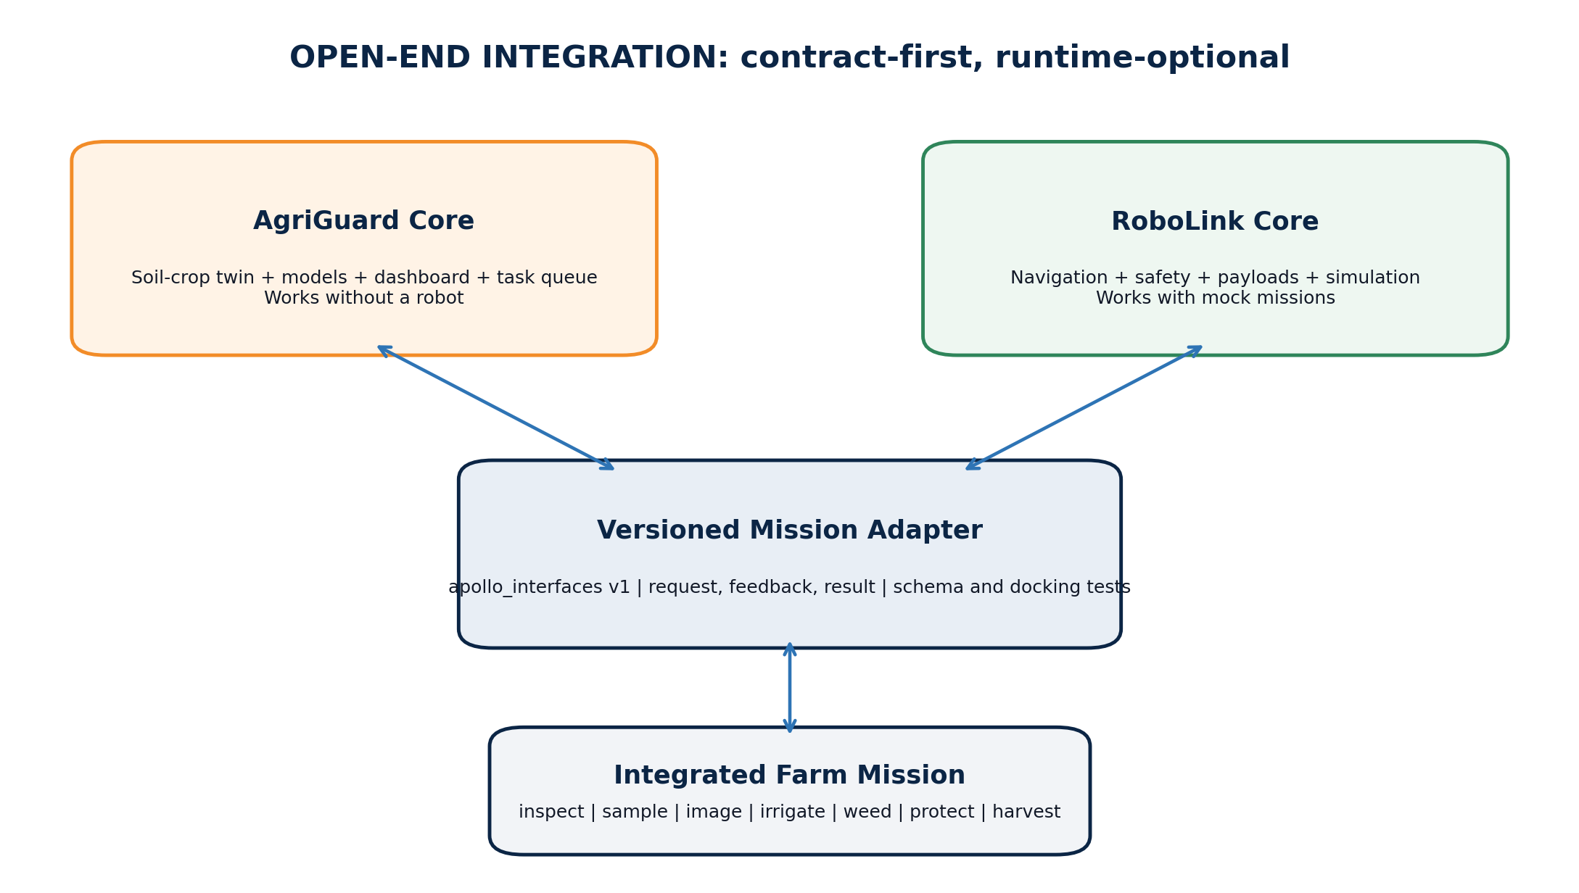
Figure 6. Apollo AgriGuard open-end ROS2 docking architecture.

15.1 Ownership boundary
Apollo AgriGuard owns | Apollo RoboLink owns
Farm/field/plot geometry for planning and mission target context | Robot map conversion, localisation and traversability
Risk/forecast, recommendation, approval and mission intent | Route planning, obstacle avoidance and mission feasibility
Target observations and expected evidence | Sensors/payload drivers, capture and transport
Task state and agronomic outcome | Robot feedback, execution status, faults and safety events
MissionBridge adapter, schemas, mocks and docking tests | ROS2 nodes, actions, lifecycle, QoS and emergency behaviour

15.2 Mission request minimum
Field | Requirement
mission_id / idempotency_key | Stable unique IDs; retries must not duplicate physical work
mission_type | inspect_zone, capture_imagery, sample_point, irrigate_zone, weed/protect_target or harvest_zone
target | Farm/field/plot/zone IDs plus permitted geometry and coordinate reference
priority and window | Not-before, deadline, expiry and cancellation rules
evidence | Alert/prediction/task IDs, reason, confidence and data timestamp
parameters | Operation-specific values, limits and units; never ambiguous free text
safety/approval | Approval level, geofence, human supervisor and prohibited conditions
result contract | Accepted/rejected, feedback, evidence artifacts, completion, quantity and fault

15.3 Automation classes
Class | Examples | Policy
A - observe | Patrol, image, measure, verify | May be pre-approved in geofence with RoboLink safety controls
B - reversible/low energy | Open approved irrigation zone within bounded limit | Requires rules, interlocks, audit and immediate stop
C - agronomic intervention | Spray, weed, fertilize, soil operation | Human/domain approval plus RoboLink safety and legal compliance
D - heavy machinery | Autonomous harvester or high-energy vehicle | Human supervisor and dedicated field safety case; never forecast-only deployment

15.4 Mock-first tests
- AgriGuard publishes a valid mission and receives accept/reject, feedback and result from a simulator.
- Duplicate request returns the same mission rather than repeating physical work.
- Expired/cancelled mission cannot start.
- Coordinate, unit, schema and interface-version mismatch fails safely.
- RoboLink fault becomes a failed task with residual risk and possible re-alert.
- Mission result evidence updates the twin only after domain verification where required.

16. Four-member team structure and execution governance

16.1 Workstream ownership
Member / workstream | Primary ownership | Integration outputs
Member 1 - Soil, IoT & Twin | Soil schema, sensors, calibration, ingestion, state estimator and treatment ledger | Quality-controlled observations and plot/soil twin APIs
Member 2 - Vision & EO | Plant/stand/canopy/disease/weed models, image protocol, satellite and map processing | Geo-referenced observations, masks, counts and crop-state features
Member 3 - Forecast & Decision | Weather, soil-water, stress, yield, 100-hour alerts, treatment analysis and uncertainty | Predictions, explanations, recommendations and evaluation
Member 4 - Platform, MLOps & Interface | Backend, database, dashboard, auth, deployment, CI, model registry and MissionBridge | End-to-end product, contracts, releases and ROS2 mocks

Team rule. Ownership is not isolation. Every interface has a producer and consumer reviewer; no member waits for another because all external inputs have fixtures, recorded replays or mocks.

16.2 Decision forums
Cadence | Forum | Output
Daily, 15 min | Blockers and interface change check | Updated task board; no design debate
Twice weekly | Integration demo on develop | Running vertical slice and defects
Weekly | Field/data/model review | Data quality, metrics, risks and next experiment
Fortnightly | Architecture and domain gate | Approved ADR/schema/model or agronomic change
Milestone | Release review | Evidence pack and develop -> main decision

16.3 Definition of done
- Code reviewed, typed/linted where applicable and covered by tests.
- Schema/API change is versioned and contract tests pass.
- Data/model card and licence/provenance are updated.
- Metric is compared with a declared baseline using leakage-safe split.
- Feature works in an end-to-end replay or field demo, not only in a notebook.
- Dashboard and logs expose uncertainty, failure and manual fallback.

17. Twenty-four-week roadmap, milestones and acceptance gates

17.1 Delivery roadmap
Weeks | Milestone | Team outputs | Gate
1-2 | Charter and contracts | Crop/pilot choice, scope, repo, entity schema, field/trial protocol, licence register | Signed charter; synthetic schema round-trip
3-5 | Twin skeleton | Farm/field/plot/crop/treatment/task APIs, map, event replay and synthetic data | Register -> observe -> twin -> task demo
6-8 | Ingestion and field readiness | IoT/weather/imagery adapters, quality rules, calibration and sensor simulator | 72-hour replay with faults and recovery
9-11 | Baseline intelligence | Soil-water, crop vision, phenology and yield baselines | Every model beats or explains failure vs naive baseline
12-14 | 100-hour command | Forecast fusion, alert payload, task queue, dashboard and uncertainty | Scenario replay generates traceable expiring alerts
15-17 | Treatment pilot | Control/treatment data, response analysis and Soil360 comparison | Trial metadata complete; no treatment leakage
18-20 | Integrated field release | End-to-end live/replay workflow, offline buffer, reports and monitoring | Two-week pilot or equivalent replay evidence
21-22 | Mission docking | ROS2 adapter, simulator, idempotency, cancellation and fault tests | Mock mission contract passes without robot dependency
23-24 | Release and research pack | v1.0, dataset/model cards, metrics, paper outline, demo and handover | Develop -> main; tagged release and evidence pack

17.2 Acceptance gates
Gate | Pass condition
G1 Scope | One flagship crop and pilot farm/trial defined; owners and out-of-scope signed
G2 Data | Stable IDs/units/timestamps; calibration and quality flags; split manifest and licence register
G3 Twin | Event replay reproduces current state; every prediction/task traces to inputs and version
G4 Models | Leakage-safe metrics against naive/physics baseline; uncertainty and limitations reported
G5 Alerts | Lead time, precision/recall, false alerts per plot-week and horizon calibration reported
G6 Operations | Recommendation, approval, completion, verification and outcome remain distinct
G7 Standalone | Full manual workflow works during robot and internet unavailability
G8 Docking | Versioned mission and result schemas pass simulation, retry, cancel and fault tests
G9 Release | Security, privacy, accessibility, rollback, documents and evidence classifications complete

18. Evaluation, safety, ethics and risk management

18.1 Evaluation matrix
Capability | Metrics | Required split / comparison
Sensor/state quality | Uptime, missingness, drift, calibration error and uncertainty coverage | Device/plot/time breakdown; field/lab reference
Crop vision | Precision, recall, F1, mAP/IoU, count MAE and calibration | Farm/season/field-separated; field imagery, not only curated leaves
Soil moisture forecast | MAE/RMSE, bias, threshold-event recall and interval coverage | Per depth/plot/horizon vs persistence and water balance
Yield forecast | MAE/RMSE/MAPE where valid, R2, rank correlation and interval coverage | Forecast date, crop, field and season vs historical/mean baseline
Treatment effect | Effect estimate, CI/credible interval, water-use efficiency and cost | Randomised/matched controls with block/season effects
100-hour alerts | Precision/recall, false alarms per plot-week, lead time and acknowledgement | 0-24, 24-48, 48-72 and 72-100 h bands
Twin/platform | Replay consistency, latency, schema success, offline recovery and audit completeness | Fault injection and end-to-end scenario tests

18.2 Safety controls
- Agronomic thresholds and intervention rules are reviewed and versioned by a domain expert.
- Chemical, fertilizer and treatment actions require product/legal compliance and explicit approval.
- Sensor failure or stale data reduces automation authority; it must not silently preserve a previous safe state.
- Robotic observation may be pre-approved; intervention and heavy equipment use higher approval classes.
- Geofences, no-go areas, weather limits, human stop and emergency-stop remain RoboLink responsibilities.
- All alerts and actions are auditable; failed or partial tasks retain residual risk.

18.3 Risk register
Risk | Effect | Control
Weak local ground truth | High benchmark score but poor farm deployment | Field protocol, expert labels, measured harvest and external-season test
Cheap sensor drift | Wrong irrigation/stress state | Local calibration, redundancy, drift alarms and lab/field checks
Weather/model overconfidence | Unnecessary or unsafe task | Ensembles, horizon calibration, expiry and human approval
Treatment confounding | False mulch/hydrogel benefit claim | Controls, randomisation/blocks, operation logging and multi-season validation
Connectivity/power loss | Missing data and delayed alert | Edge buffer, local decision subset, health telemetry and graceful recovery
Domain shift | Model fails on new crop/farm/season | Crop packs, holdout tests, monitoring and abstain/unknown state
Interface drift | AgriGuard/RoboLink integration breaks | Versioned contracts, consumer tests and deprecation window
Licence/terms violation | Cannot publish or commercialise | Per-source register; Bhuvan and dataset restrictions reviewed before use
Unsafe automation | Crop, equipment or human harm | Authority classes, interlocks, supervisor and separate RoboLink safety case

18.4 Claims discipline
Label | Meaning
Verified field result | Measured on a defined farm/season with documented protocol and evaluation
Controlled trial result | Treatment/control evidence with registered design and uncertainty
Simulation result | Synthetic or replayed data; useful for engineering but not field efficacy
Design target | A planned acceptance threshold, not an achieved result
Projection | Scenario estimate that depends on explicit assumptions

19. Deliverables, research outputs and handover

19.1 Product deliverables
- Apollo AgriGuard v1.0 web application and versioned API.
- Apollo Soil360 farm/field/plot/plant-row digital twin and event replay engine.
- IoT/weather/EO ingestion adapters, sensor simulator and offline buffering.
- Crop vision, soil-water, treatment, stress, yield and 100-hour alert model packages.
- Treatment/control comparison and season-closing report.
- Manual task workflow plus optional ROS2 MissionBridge adapter and mocks.
- Apollo Soil360 Field Benchmark dataset card, schema, split manifests and controlled release.
- Deployment, field calibration, annotation, safety, monitoring and rollback SOPs.

19.2 Demonstration sequence
- Open a farm map and select a field, plot and representative plant/row twin.
- Replay/live-ingest soil, weather, imagery and irrigation data with visible quality flags.
- Show control vs mulch/hydrogel treatment state and response through time.
- Generate a soil-water/stress/yield update and a 100-hour alert with evidence and uncertainty.
- Approve a manual inspection/irrigation/harvest task and verify its measured outcome.
- Publish the same approved intent as a mock RoboLink mission; receive feedback/result.
- Close the season with actual yield, treatment effect, model error and next-season recommendation.

19.3 Research publication tracks
Track | Research question | Primary contribution
Soil digital twin | Can a physics-informed multiscale twin improve plot soil-moisture/state estimates? | State estimator, uncertainty and local calibration dataset
Treatment response | How do mulch/hydrogel/soil practices alter water, temperature, stress and yield? | Controlled Apollo field benchmark and causal/multilevel analysis
Forecasting | Does multimodal twin state improve dynamic yield and 100-hour risk forecasts? | Horizon-calibrated hybrid forecasting
Operations | Can event-sourced tasks close the loop between recommendation and measured outcome? | Auditable Sense -> Predict -> Decide -> Act -> Learn architecture
Robotics docking | Can domain intelligence and ROS2 execution evolve independently through stable contracts? | Mock-first agricultural mission standard and safety classes

19.4 Handover checklist
- Scope, crop packs, owners and domain reviewers approved.
- Repository protections, environments, secrets handling and CI documented.
- Entity/API/mission contracts versioned and published.
- Pilot geometry, treatment protocol, calibration and sampling SOP approved.
- Public and Apollo data licences/consents recorded.
- Baselines, evaluation splits, metrics and evidence labels frozen before final training.
- Manual workflow, fault replay and ROS2 mock docking demonstrated.
- Release, model/data cards, limitations, safety and next-season backlog accepted.

Appendix A. Minimum data schemas

A.1 Soil observation
Field | Type / example | Rule
observation_id | UUID | Globally unique and immutable
entity_id | plot/zone/plant-row ID | Stable Apollo identity
observed_property | soil_moisture_vwc | Controlled vocabulary
value / unit | 0.214 / m3 m-3 | Unit required; raw value retained
depth_cm | 20 | Required for depth-dependent soil data
location | point/polygon reference | Coordinate reference recorded
phenomenon_time | ISO-8601 with timezone | Actual acquisition time
result_time | ISO-8601 | Arrival/processing time
sensor/sample | device/sample/lab method ID | Calibration/method traceability
quality | valid/suspect/corrected/rejected | No silent correction
provenance | source/version/operator | Required for audit and publication

A.2 Prediction / alert
Field | Purpose
prediction_id / target_id | Stable prediction and farm entity references
variable and horizon | What is predicted and for which valid time/window
point / interval / probability | Value plus calibrated uncertainty
model/rule/data version | Reproducibility and rollback
feature snapshot | Evidence used at prediction time
explanation | Dominant drivers, thresholds and limitations
severity / actionability | Alert ranking separate from raw probability
recommendation / alternatives | Proposed response and acceptable alternatives
approval / expiry | Authority requirement and last useful time
acknowledgement / task link | Operational response and outcome trace

Appendix B. Interface catalogue
Interface | Example | Owner
REST | GET /v1/farms/{farm_id}/twin | AgriGuard platform
REST | GET /v1/fields/{field_id}/command-window?hours=100 | Forecast/decision workstream
REST | POST /v1/plots/{plot_id}/observations | Soil/IoT workstream
REST | POST /v1/tasks/{task_id}/verify | Platform/operations
MQTT | apollo/agriguard/v1/farms/{farm}/plots/{plot}/soil | IoT adapter
MQTT | apollo/agriguard/v1/devices/{device}/health | IoT adapter
ROS2 | /apollo/agriguard/mission_requests | MissionBridge publishes
ROS2 | /apollo/robolink/mission_feedback | RoboLink publishes
ROS2 | /apollo/robolink/mission_results | RoboLink publishes; MissionBridge consumes

Appendix C. First 30 days - launch plan
Week | Team actions | End-of-week evidence
1 | Select flagship crop/pilot; freeze v0.1 entities; assign four workstreams; define treatment and ground-truth plan | Signed charter, repo protections, schema and field/trial draft
2 | Build farm/field/plot/treatment/task APIs; sensor and weather simulators; public-source licence register | Synthetic register -> observe -> twin -> task demo
3 | Implement soil-water baseline, one crop-vision baseline and one yield baseline; design camera/calibration SOP | Reproducible metrics, split manifests and model cards
4 | Create 100-hour alert payload/dashboard; publish MissionBridge schema and mock; finalize 60-day pilot backlog | End-to-end replay plus risks, owners and acceptance gates

C.1 First demonstration
Demo 1. Create one farm and two plots (control and treatment), replay seven days of soil/weather/irrigation data, update Soil360, show a treatment comparison, generate one traceable 100-hour alert, complete a manual task and send the same intent to a mocked ROS2 mission executor. No physical robot or live farm is required.

C.2 First four task branches
- feature/AAG-101-soil-twin-ingestion
- feature/AAG-102-crop-vision-baseline
- feature/AAG-103-100h-yield-alert-baseline
- feature/AAG-104-platform-dashboard-missionbridge

Appendix D. Authoritative source register
1. ISRIC SoilGrids
2. Copernicus Data Space - Sentinel-2
3. Copernicus Data Space - Sentinel-1
4. NASA / NSIDC SMAP data
5. NASA POWER Data Access Viewer
6. Copernicus ERA5-Land
7. ECMWF IFS and AIFS open forecast data
8. India Meteorological Department Agromet Advisory Services
9. NRSC / ISRO Bhuvan
10. FAO AquaCrop
11. OGC SensorThings API standard
12. CropHarvest official repository
13. Agriculture-Vision official repository
14. TensorFlow Datasets - PlantVillage
15. Global Wheat datasets
16. ROS2 documentation
17. ROS2 releases and target platforms - REP 2000
Resource access and current descriptions checked for this planning document on 05 August 2026. Licences, API conditions, data availability and terms must be re-checked before download, publication, commercial use or autonomous-operation integration.

Approval record
Role | Name | Decision / date
Program Sponsor / Product Owner | Akash Shivadas Chatake | ____________________________
Apollo AgriGuard Team Lead | To be assigned | ____________________________
Agronomy / Soil Domain Reviewer | To be assigned | ____________________________
Apollo RoboLink Interface Lead | To be assigned | ____________________________

Final directive. Build Apollo AgriGuard as a complete soil-crop intelligence and farm-decision platform. Keep MissionBridge optional, versioned and tested. When AgriGuard, PashuSense and RoboLink dock through the same Apollo standard, the full AgriVerse system is assembled without weakening any individual module.

