Vi Editor - Assignments
- Invoke the vi editor with a filename (which is to be created)
Ans-vi <filename_NEW> ‘
- Type a few lines(at least 10) in the editor. Let one or more lines contain the words given below.
delhi mumbai chennai Mumbai
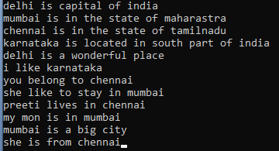

- Save the file without exiting the editor ANS- Press “W”
- Navigate quickly to the beginning & end of the file
Ans- Type "gg" in command mode, press the Esc key and then press Shift + G
- Delete first two lines & copy it after the last lines
Ans-2dd-delete first two,G-go to last line,$ to go to the end of last line,p- paste after cursor

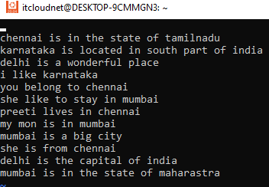
- Now Copy the last two lines & paste them before the first line.
Ans- press yy to copy last 2 lines from the cursor, go to first line press P to paste it before cursor
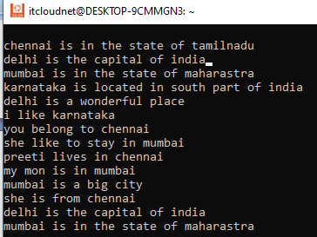
- Combine last two lines of the file in a single line.
Go to the line which should have the next line appended to it and then press shift-j (upper case j or J).
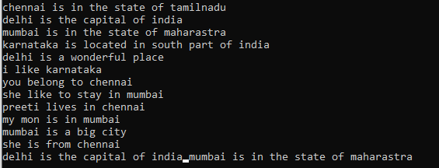
- How will you insert a line before the first line? (Hint : Find such an option in the tutorial document)
add \n at the end of the string or press i
- How will you paste a yanked buffer before the current line?
type P to insert the copied line
- Search the document for a string “delhi”
Press Esc key./delhi
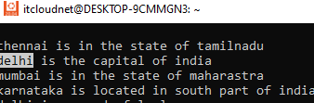
- Replace a single occurrence of “delhi” with “Mumbai
Press y to replace the match or l to replace the match and quit.(:s/delhi/Mumbai)
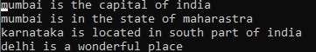
- Replace all occurrences of “delhi” on a particular line with “Mumbai” using one command
Ans-:s/delhi/Mumbai/9:9th line,
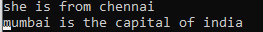
- Replace “delhi” with “mumbai” for the entire document using one command.
Ans-:s%/delhi/Mumbai/g
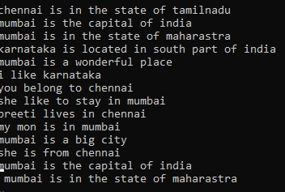
- Replace all occurrences of “delhi” with “mumbai” for part of a document (e.g. line number 13 to 37). Ans- consider lines from 4-12 :4,12s/delhi/Mumbai/g
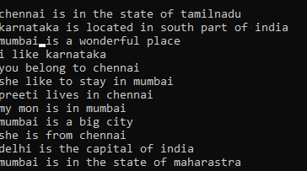

- Undo the above command Ans-U
- Replace only the first occurrence of “delhi” with “mumbai” in each line, for part of a document (e.g. line number 13 to 37).
Ans-consider lines from 4-13:4,13s/delhi/mumbai
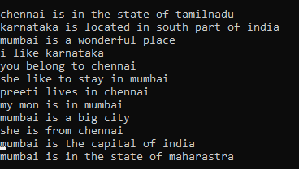
- Undo the above comment. Redo it. Undo it again. Ans-U ctrl+R u
- Replace all occurrences of “delhi” with “mumbai” for complete file interactively.
Ans-:s%/delhi/Mumbai/gc and a
- Search for a word backwards. Loop through all matches. Ans-./delhi
- Search for a word forwards. Loop through all matches Ans- ?delhi
- Join two lines together. Ans-J
- Enable line numbering and then disable it
Ans-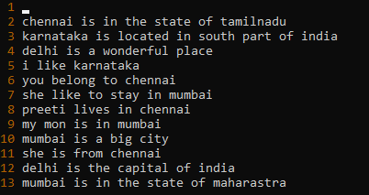
- Make the search case insensitive
go into command mode (press Escape), and type :set noic
- Delete 4 lines (and then paste them somewhere else)
Ans -4dd and p.
- What is the command to delete part of the line starting from the current cursor position? Ans- Type dd (D) and hit Enter
- What is the command to delete the current word? Ans-dW0

