ASSIGNMENT 2 - CO2
Functions and Object-Oriented Concepts in C++
Function prototyping, call by reference, return by reference, inline functions, default arguments, overloading, classes, static members, arrays of objects and friend functions
Name | Vijayan P
Register Number | 192525312
Department | Computer Science and Engineering
Nature of assignment | Individual, 50 marks, K5 (Evaluate)
Submission date | 31/10/2026
Compiler used | g++ 13.3.0 (Ubuntu 24.04), -std=c++17 -Wall -Wextra
GitHub repository | https://github.com/Vijayan111/DSA0102_CPP.git

Q1 - Call by Value, by Reference and by Pointer
Problem in one line. The concession function prints the right fee inside, but the fee stored for the student never changes. That is the typical symptom of passing the fee by value, so I wrote the function three ways and checked each one.

1. Three implementations and the prediction
Starting fee 45000, concession 10%. All three functions use integer arithmetic, fee -= fee * percent / 100, so 10% of 45000 is 4500.
Version | Predicted stored fee | Observed stored fee | Matches?
By value (long long fee) | 45000 | 45000 | Yes
By reference (long long& fee) | 40500 | 40500 | Yes
By pointer (long long* fee) | 40500 | 40500 | Yes

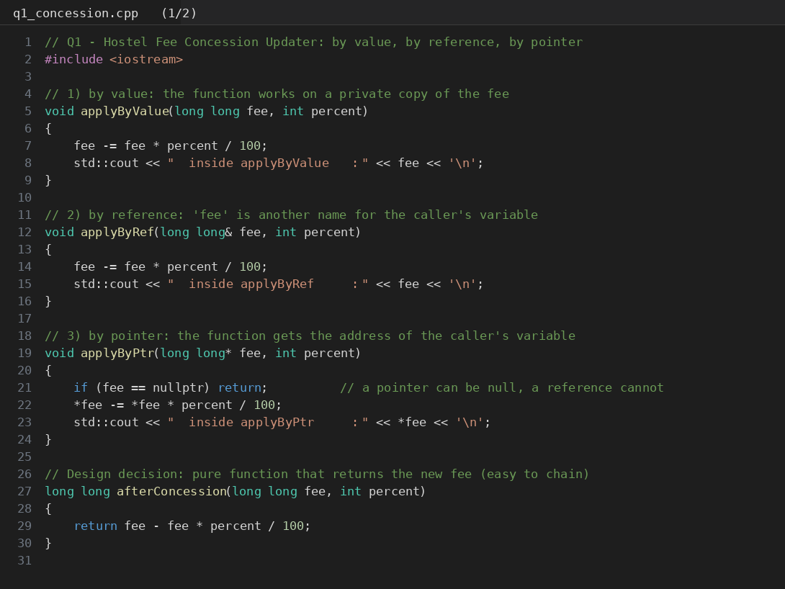
Code screenshot: q1_concession.cpp (part 1 of 2)
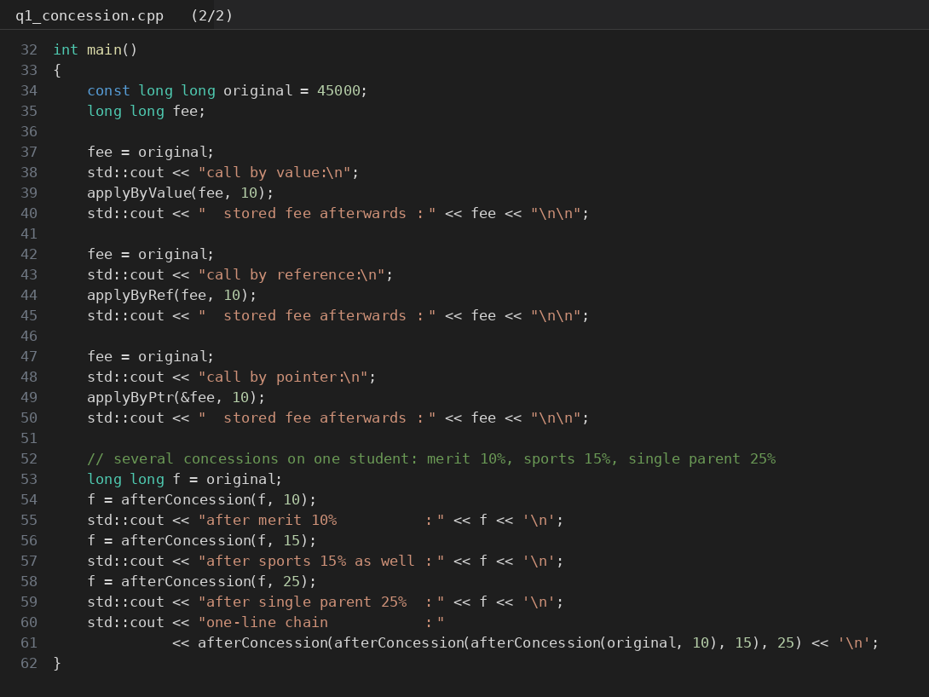
Code screenshot: q1_concession.cpp (part 2 of 2)
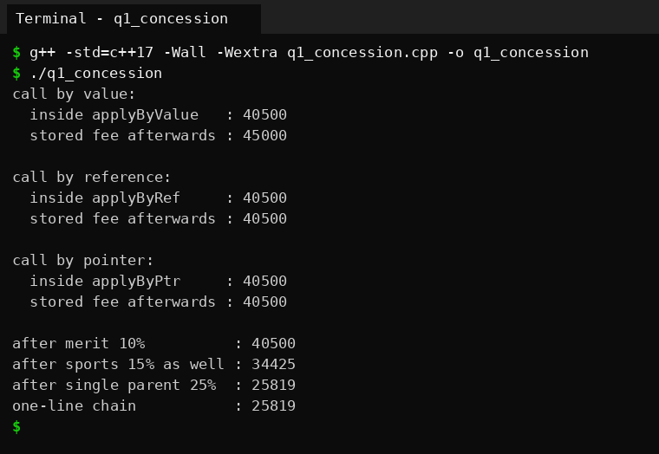
Output screenshot: q1_concession, fee inside and after each call

2. Inquiry - where each version keeps its parameter
- By value: the function gets a brand new long long in its own stack frame, filled with a copy of the caller's number. Subtracting from it changes only that copy, and the copy is thrown away when the function returns. The inside print shows 40500 because the copy really did change.
- By reference: there is no new fee variable. fee is just another name for hostelFee in main, so fee -= ... changes the caller's variable directly. (Internally the compiler usually passes an address, but in the language there is no copy to talk about.)
- By pointer: the function has a new local variable, but it holds an address, not the fee. *fee follows that address back to hostelFee in the caller. Unlike a reference, a pointer can be null, so I check for nullptr first.
So only two of the three change the caller's fee, because only those two reach the caller's object. The by-value version works on a private copy.
When to use a const reference. When the function only needs to read the argument and the argument is big or costly to copy, for example void printReceipt(const Student& s). It avoids the copy, the compiler stops me from changing the object by mistake, and it also accepts temporaries. For a small type like long long or int, plain by-value is just as cheap and simpler.

3. Predict the output
Program given in the question (q1_predict.cpp):
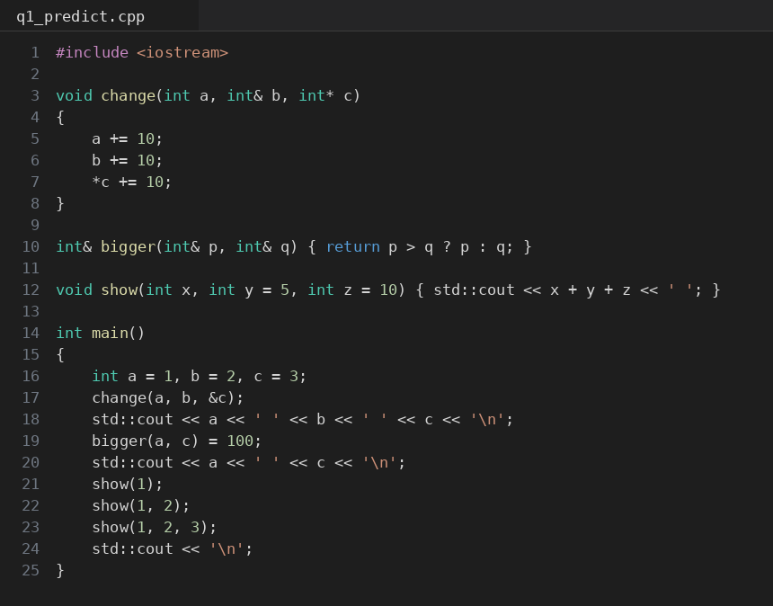
Code screenshot: q1_predict.cpp
 | Predicted (before running) | Observed
Line 1 | 1 12 13 | 1 12 13
Line 2 | 1 100 | 1 100
Line 3 | 16 13 6 (with a space after the 6) | 16 13 6 (with a space after the 6)

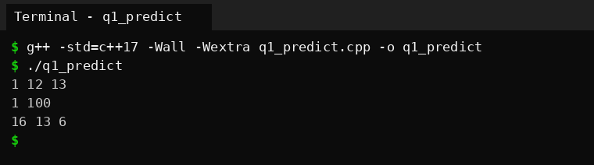
Output screenshot: q1_predict
There was no difference between my prediction and the real output. The reasoning:
- change(a, b, &c): a is by value, so only the copy gets +10 and a stays 1. b is a reference, so it becomes 12. c is changed through its address, so it becomes 13. First line is 1 12 13.
- bigger(a, c) = 100: at this point a is 1 and c is 13. The function returns a reference to the larger one, which is c, so the assignment writes 100 into c. a is untouched, so the second line is 1 100.
- show(1) uses both defaults, y = 5 and z = 10, so 1 + 5 + 10 = 16. show(1, 2) uses only the default for z, so 1 + 2 + 10 = 13. show(1, 2, 3) uses no default, so 6. Each call prints a number followed by a space, which is why the third line ends with a space.

4. Complete the code
TODO 1 is replaced with fee -= fee * percent / 100; inside applyConcession, and nothing else in the program was touched.
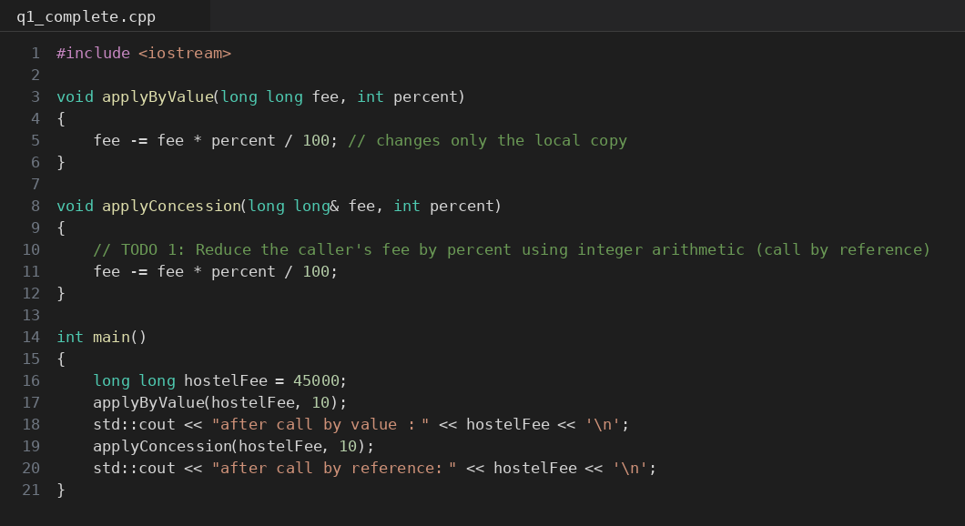
Code screenshot: q1_complete.cpp
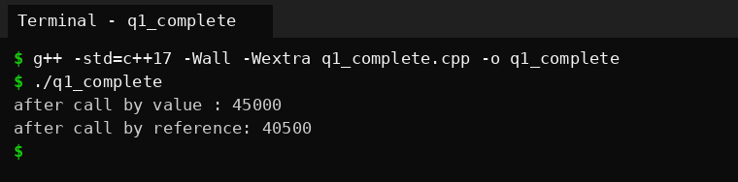
Output screenshot: q1_complete, matches the expected output (45000 and 40500)
Why the call by value leaves the fee at 45000: applyByValue(hostelFee, 10) copies 45000 into its own parameter fee. The subtraction happens on that copy, which disappears when the function ends. hostelFee in main is a different variable at a different address, so it still holds 45000. The next call goes through a reference, so it works on hostelFee itself and gives 40500.

5. Design decision - change in place or return the new fee?
A student can get several concessions at once, so I tested three of them one after the other (merit 10%, then sports 15%, then single parent 25%). Output is in the first screenshot above: 45000 becomes 40500, then 34425, then 25819.
My choice: return the new fee (long long afterConcession(long long fee, int percent)) and let the caller store it, for example fee = afterConcession(fee, 10);. Reasons:
- Calls chain naturally: afterConcession(afterConcession(fee, 10), 15). With the in-place version I would need three separate statements.
- The original fee is still available after the call, which is useful for printing "fee before / fee after" on the receipt, for undo, and for testing.
- No hidden side effect. The exact bug in the problem (calculating the right number but forgetting to store it) becomes visible in the code, because the returned value has to be assigned somewhere.
- The cost is copying 8 bytes, which is nothing.
The in-place reference version is still the better choice if the object being updated is a large record, for example void applyConcession(Student& s, int percent), because returning a whole Student by value would copy it. Another point is business policy: whether concessions are added up, applied one after another or only the highest one counts is a decision for the hostel office. The function should not hide that decision, and returning a value keeps that logic in the caller.

6. Alternative concept and complexity analysis
If applyConcession returns the new fee, the program becomes:
long long applyConcession(long long fee, int percent) { return fee - fee * percent / 100; } and in main hostelFee = applyConcession(hostelFee, 10);
Time is O(1) in every version (one multiplication, one division and one subtraction). The difference is in how much is copied per call. I measured the size of a long long and of a large Student (a 64 character name, 100 marks and a fee), and then timed 20 million calls of each style. The functions were marked noipa so the compiler could not optimise the calls away.
Parameter style | Bytes copied per call | Time, 20M calls, -O0 | Time, 20M calls, -O2
long long by value | 8 | 56.0 ms | 21.6 ms
Student by value | 472 | 551.2 ms | 477.1 ms
Student& by reference | 8 (an address) | 54.2 ms | 22.4 ms
const Student& | 8 (an address) | 56.2 ms | 27.0 ms

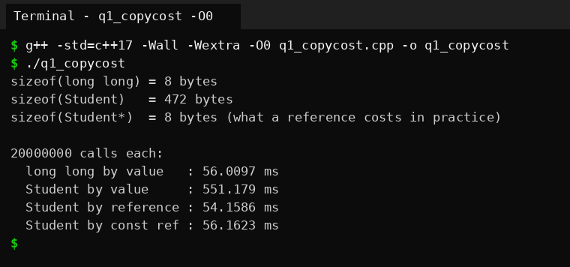
Output screenshot: q1_copycost compiled with -O0
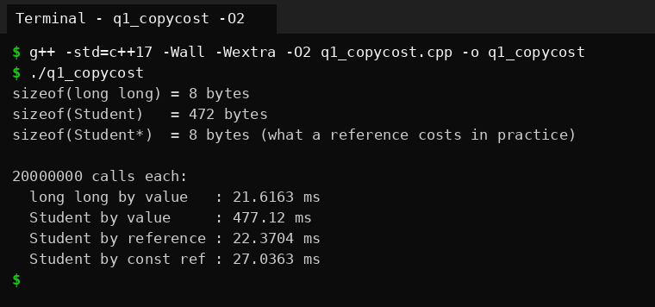
Output screenshot: q1_copycost compiled with -O2
Space copied is O(1) for every style, but the constant is very different: 472 bytes against 8 bytes for the large object. Passing the Student by value was about 10 times slower than by reference at -O0 and about 21 times slower at -O2. A reference and a const reference cost the same (the small differences between those two rows are measurement noise). For a plain long long, by value is already as cheap as passing an address, so there is no reason to use a reference there.
Evidence summary: three working implementations, predictions made before running (all matched), observed results, and a defended interface design (return the new fee; use a reference for big records; use a const reference for read-only access).

Q2 - Return by Reference and Its Dangers
Problem in one line. The marks of a class sit in an array. One function should hand back the highest mark itself so that moderation (+2) can be applied directly, and a second function that returns a reference to a local variable shows what goes wrong.

1. Returning a reference to the highest mark
I wrote three versions that search the array the same way and differ only in the return type: int& highest(...), const int& highestConst(...) and int highestCopy(...).
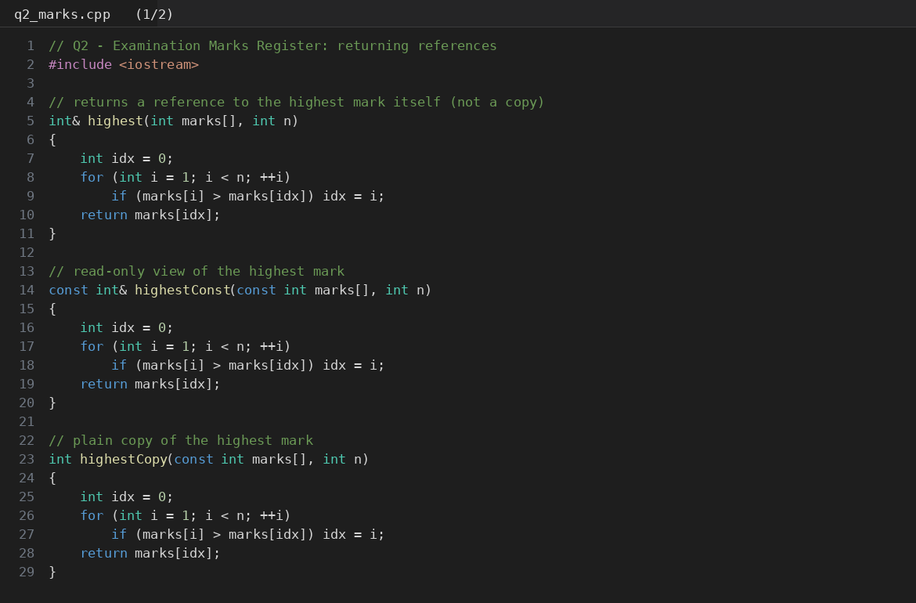
Code screenshot: q2_marks.cpp (part 1 of 2)
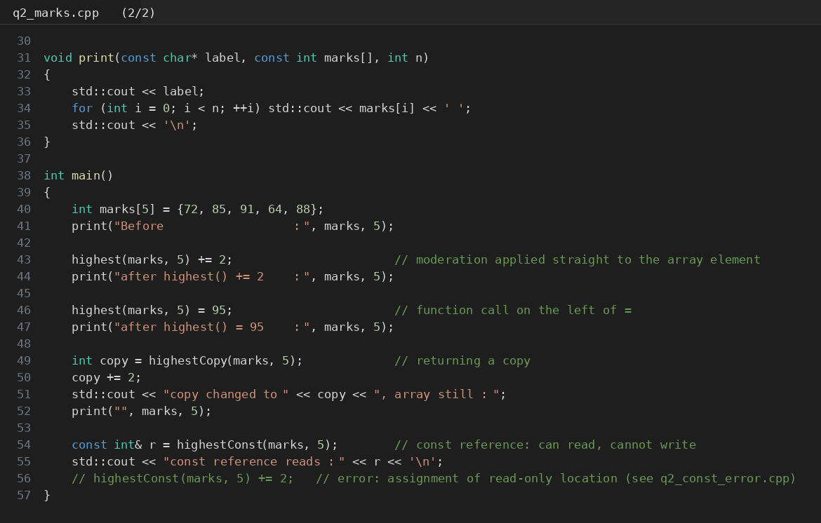
Code screenshot: q2_marks.cpp (part 2 of 2)
Step | Predicted array (before running) | Observed
Start | 72 85 91 64 88 | 72 85 91 64 88
highest(marks, 5) += 2 | 72 85 93 64 88 | 72 85 93 64 88
highest(marks, 5) = 95 | 72 85 95 64 88 | 72 85 95 64 88
copy version, copy += 2 | array unchanged (copy = 97) | array unchanged (copy = 97)

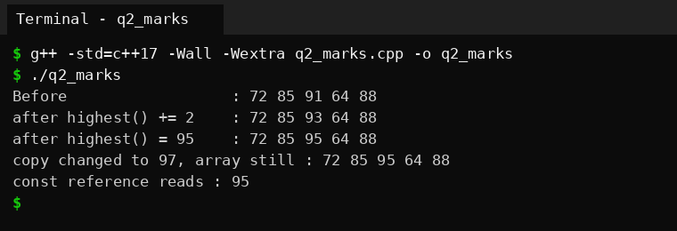
Output screenshot: q2_marks
Because highest() returns int&, the call expression is an lvalue, which is the same thing as the array element. That is why highest(marks, 5) += 2 changes marks[2] and why the call can stand on the left of =. A function that returns a plain int gives only a temporary value, and writing highestCopy(...) = 95 would not even compile.

Reference, const reference and copy compared
Return type | Can the caller change the array element? | Cost | When I would use it
int& | Yes, f() += 2 changes the element | No copy | Caller must update the element (moderation)
const int& | No, compile error (see below) | No copy | Read-only access to big elements
int | No, the caller only gets a copy | Copies the value | Small values, safest choice

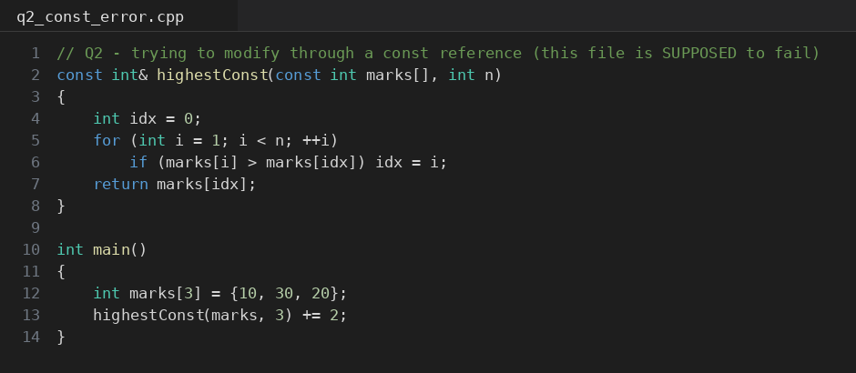
Code screenshot: q2_const_error.cpp
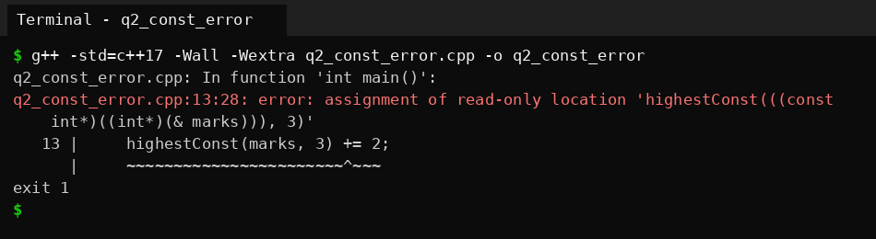
Output screenshot: q2_const_error, trying to modify through a const reference
The compiler rejects highestConst(marks, 3) += 2 with "assignment of read-only location", which is exactly what the const reference is for.

2. Returning a reference to a local variable
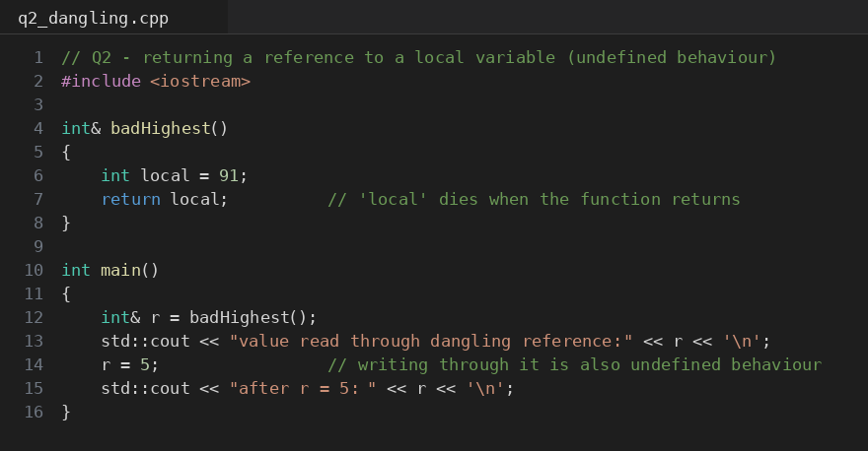
Code screenshot: q2_dangling.cpp
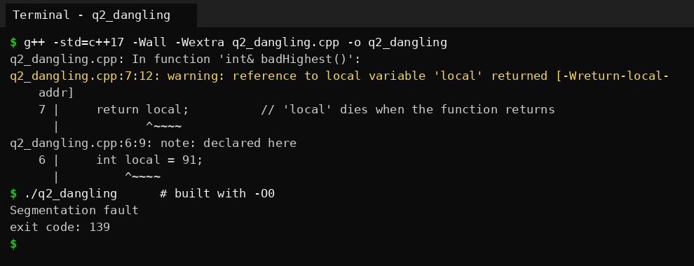
Output screenshot: q2_dangling, compiler warning and the run
What the compiler says. Even without any special flag, g++ warns: reference to local variable 'local' returned [-Wreturn-local-addr]. It is a warning, not an error, so the program still builds. That is dangerous, because a student might ignore it.
Why it is undefined behaviour. local lives in the stack frame of badHighest(). When the function returns, that frame is released and the variable no longer exists, but the reference given back still names it. Reading or writing through it touches memory that is not ours any more. The C++ standard does not say what must happen, so anything is allowed: the old value, garbage, or a crash.
In my run it crashed with a segmentation fault (exit code 139), both at -O0 and at -O2. This is what g++ does here: since the address of a local is certain to be invalid, the compiler replaces it with a null address, so the very first read fails. Another compiler could print 91 or some random number instead. All of those are equally "correct" as far as the language is concerned, which is exactly the problem. A program that happens to print the right number on one day is not correct.

3. Changed condition - the register is a growing std::vector
A std::vector keeps its elements in one block of memory. When push_back is called on a full vector, it allocates a bigger block, moves the elements there and frees the old block. Any reference, pointer or iterator taken earlier still points into the old block and is dangling.
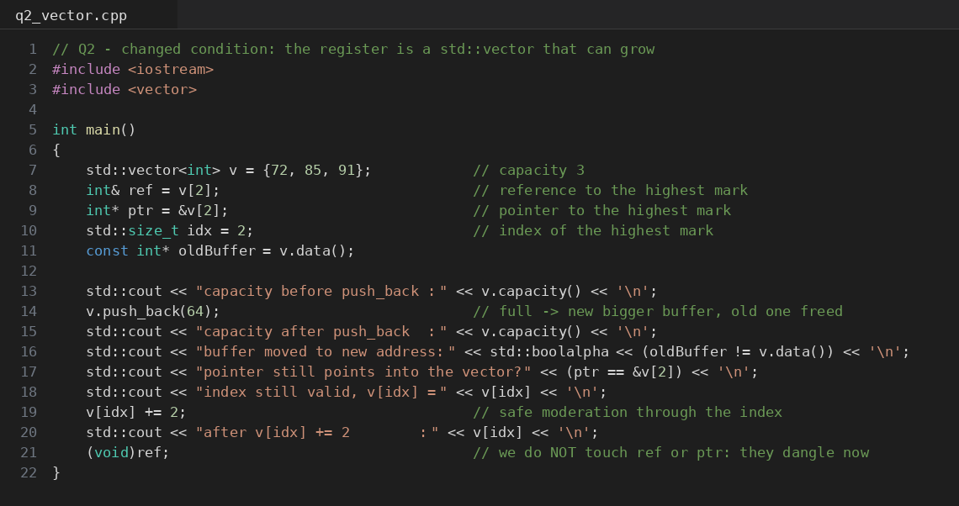
Code screenshot: q2_vector.cpp
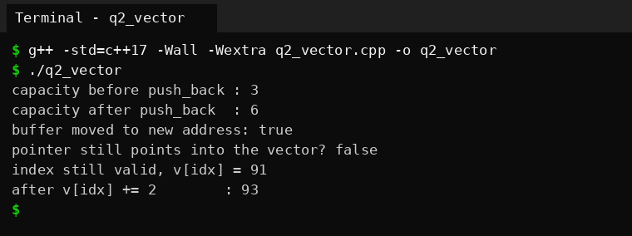
Output screenshot: q2_vector, capacity grows from 3 to 6 and the buffer moves
The capacity went from 3 to 6, the buffer moved, and the saved pointer no longer matches &v[2]. The index still works and v[idx] += 2 gives 93. In this program I deliberately did not read through the stale reference. To see what really happens when it is used, I ran a second program with AddressSanitizer:
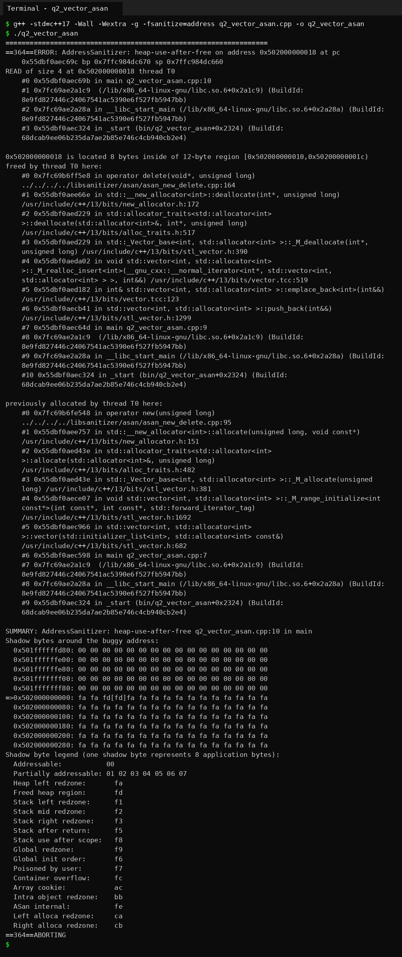

Address Sanitizer reports heap-use-after-free and even shows that the memory was freed inside std::vector's deallocation, called from push_back. So the answer to the changed condition is: a reference obtained before the vector grows may become invalid, because growing can move every element. The ways out are (a) do not keep a reference across any call that can grow the vector (push_back, insert, resize), get it again after, (b) store an index, or (c) call reserve() early so growth never happens, though that is fragile because someone can exceed the reserved size later.

4. Alternative concept and complexity analysis
Returning the highest mark as an index or as a pointer instead of a reference:
Return type | Calling code for the +2 moderation | What can go wrong
int& | highest(v) += 2; | Reference dangles if the vector grows later
int* | int* p = highestPtr(v); *p += 2; | Pointer dangles after growth; can be null (useful for an empty register)
int (index) | int i = highestIndex(v); v[i] += 2; | Stays valid after growth; wrong only if elements before it are erased

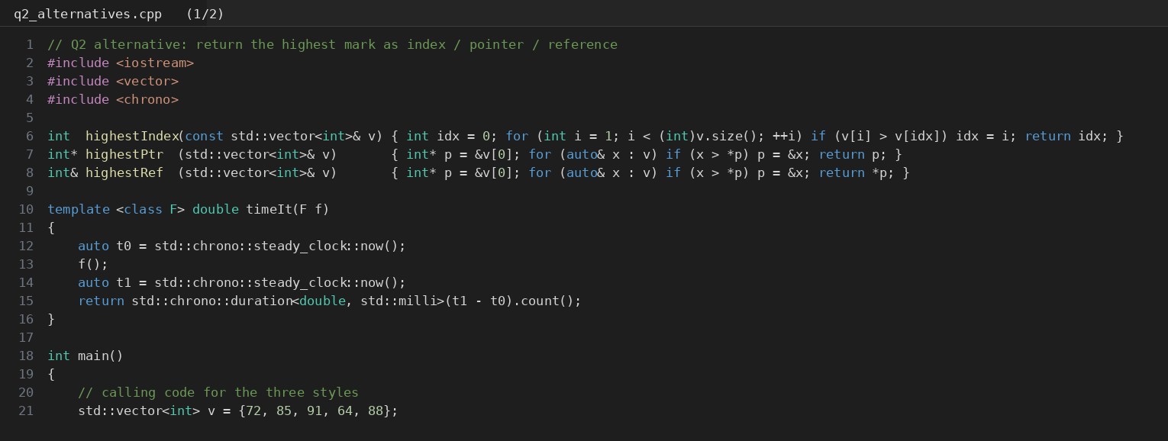
Code screenshot: q2_alternatives.cpp (part 1 of 2)
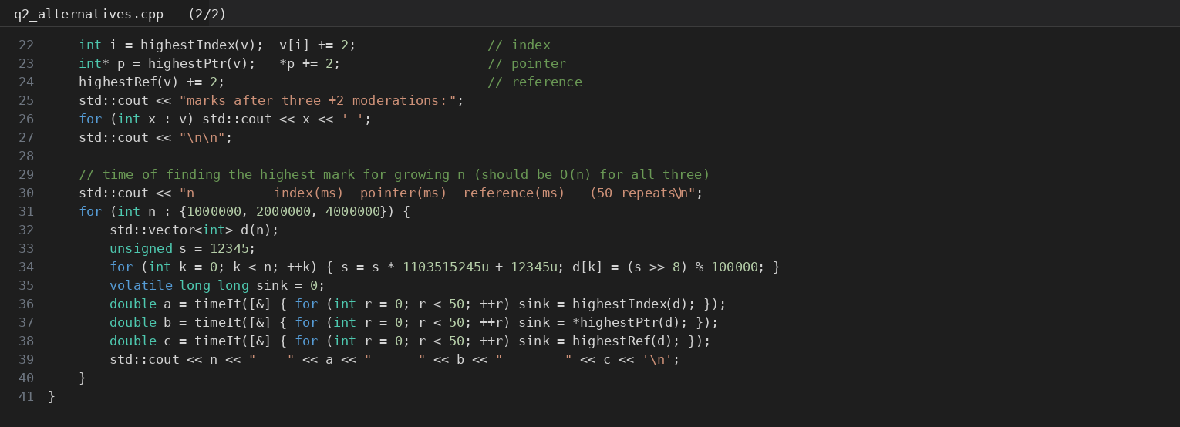
Code screenshot: q2_alternatives.cpp (part 2 of 2)
Time is O(n) for all three because each one has to look at every mark once, and space is O(1) because only a few local variables are needed. I measured it with 50 repeats for n = 1, 2 and 4 million marks, compiled with -O2:
n | Index (ms) | Pointer (ms) | Reference (ms)
1,000,000 | 17.2146 | 37.2461 | 40.6315
2,000,000 | 38.9065 | 75.6395 | 76.0352
4,000,000 | 89.1988 | 155.668 | 155.325

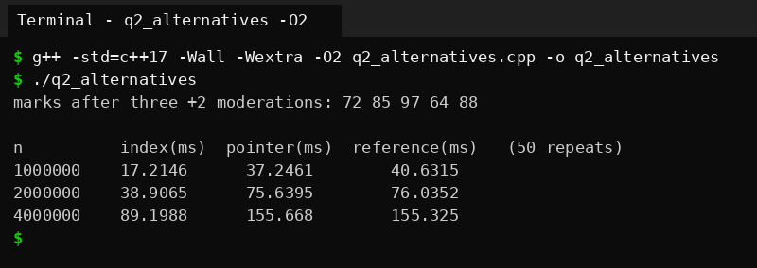
Output screenshot: q2_alternatives compiled with -O2
When n doubles, the time roughly doubles for all three, which is the linear growth O(n) predicts. The index version was faster than the other two in my measurement (the pointer and reference versions walk with a pointer and compare through it). I did not dig further into why, and since the three share the same big-O class I would not choose between them on speed.
Safety when the array is replaced by a growing vector: the index is the safest, since it stays valid however the buffer moves. The pointer and the reference have the same weakness (both dangle), but a pointer can at least be null to say "no element found" for an empty register, while a reference cannot represent that. My highest() functions assume n > 0, and I would add a check or return a pointer if the register can be empty.
Evidence summary: working functions, compiler warning evidence for the dangling reference, AddressSanitizer evidence for the vector, and a response to the changed condition (prefer an index, or re-obtain the reference after any growth).

Q3 - Default Arguments and Function Overloading
Problem in one line. The developer wrote charge(double), charge(double, bool) and charge(double, bool = false, bool = false), and the program does not compile.

1. The compiler error
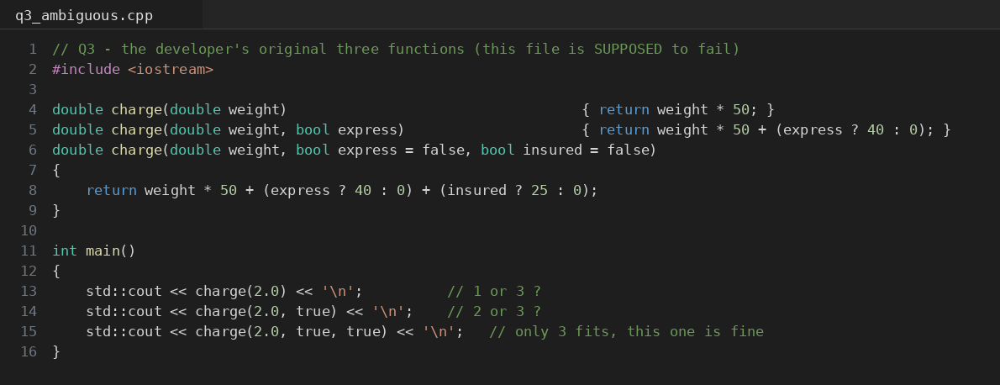
Code screenshot: q3_ambiguous.cpp
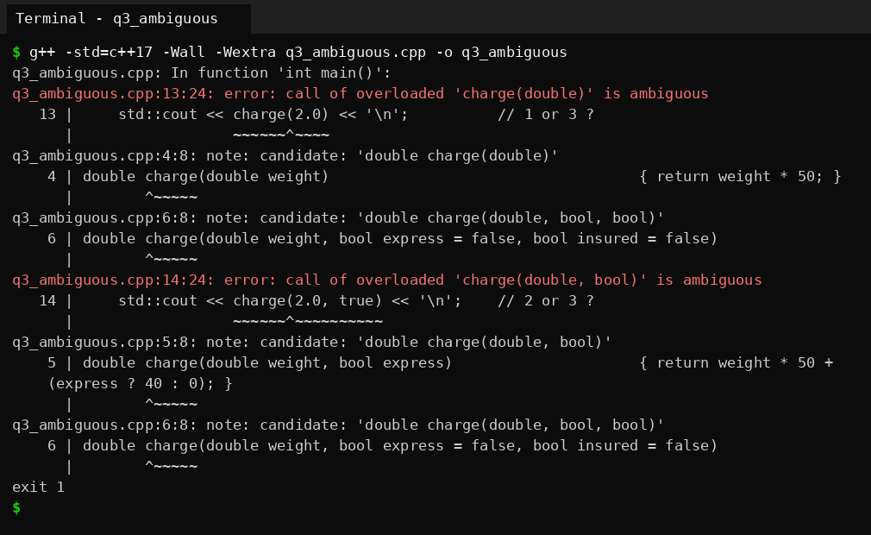
Output screenshot: q3_ambiguous, two ambiguous calls
The program fails at two places. The declarations themselves are legal; the error appears at the calls.
- charge(2.0) is ambiguous between charge(double) and charge(double, bool, bool). For the one argument we pass, both are an exact match. The default arguments of the third function fill the missing two parameters, but they do not count against it when the compiler ranks the candidates. Neither function is better, so the call is ambiguous.
- charge(2.0, true) is ambiguous between charge(double, bool) and charge(double, bool, bool), for the same reason: both match the two arguments exactly.
- charge(2.0, true, true) is fine because only the third function accepts three arguments.
The real mistake is that the first two functions are already covered by the third function with default arguments. They only duplicate it.

2. The redesign
The charge uses Rs 50 per kg, Rs 40 for express and Rs 25 for insurance (these are my own rates for the test). The functions are:
- double charge(double kg, bool express = false, bool insured = false) - weight in kg. Default arguments keep common calls short.
- double charge(int grams, bool express = false, bool insured = false) - weight in grams as an int.
- double charge(const Parcel& p) - a whole Parcel object.
No function is a duplicate of another, so the only difference between overloads is the type of the first argument, and no call is ambiguous. Each function prints a tag so the output shows which one the compiler picked.
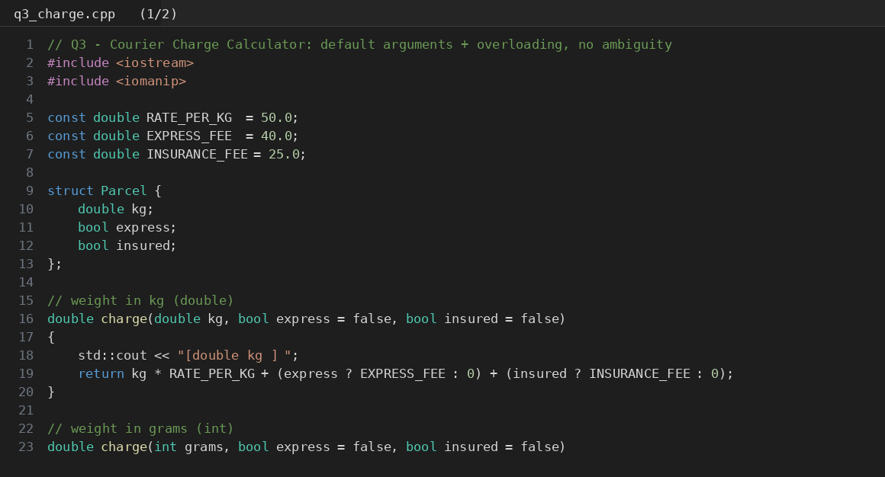
Code screenshot: q3_charge.cpp (part 1 of 2)
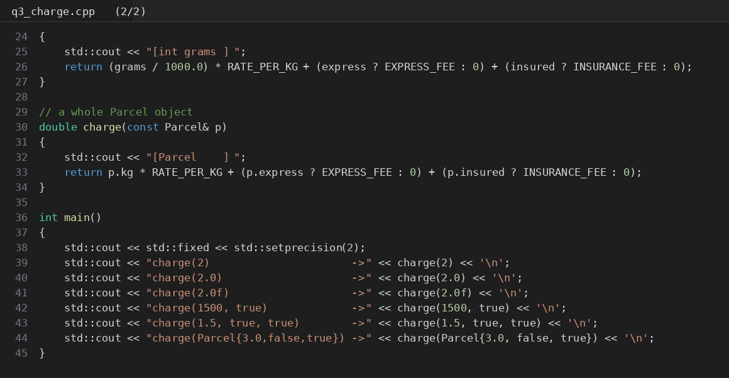
Code screenshot: q3_charge.cpp (part 2 of 2)

Predicted selections (written before running) and observed
Call | Predicted function | Pred. value | Observed function | Observed value | Matches?
charge(2) | int grams | 0.10 | int grams | 0.10 | Yes
charge(2.0) | double kg | 100.00 | double kg | 100.00 | Yes
charge(2.0f) | double kg | 100.00 | double kg | 100.00 | Yes
charge(1500, true) | int grams | 115.00 | int grams | 115.00 | Yes
charge(1.5, true, true) | double kg | 140.00 | double kg | 140.00 | Yes
charge(Parcel{3.0,false,true}) | Parcel | 175.00 | Parcel | 175.00 | Yes

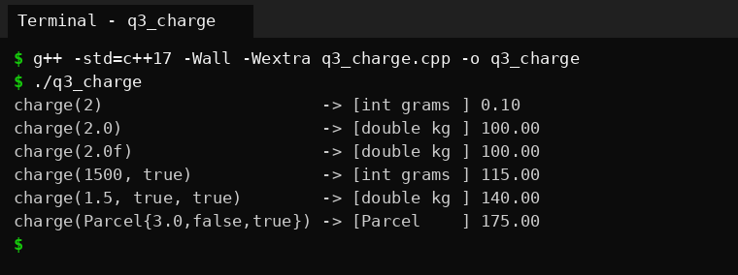
Output screenshot: q3_charge, selected overload for each call
Why charge(2) picks the int version: the argument is an int, so charge(int, ...) is an exact match while charge(double, ...) needs a conversion. So it means 2 grams and costs 0.10 rupees. That looks silly, and it points to a weakness in this design: it is easy to write charge(2) meaning 2 kg. In a real program I would use separate types such as Grams and Kilograms, but the question asks for int and double overloads, so I kept those and documented the trap.
Why charge(2.0f) picks the double version: a float goes to double by a floating-point promotion, but to int only by a conversion (and it would lose the fractional part). A promotion ranks better than a conversion, so the double version wins.
There is one more weak spot. A long argument matches neither overload exactly (long to int and long to double are both conversions of the same rank), so charge(2500L) is ambiguous. I confirmed it with a small test:
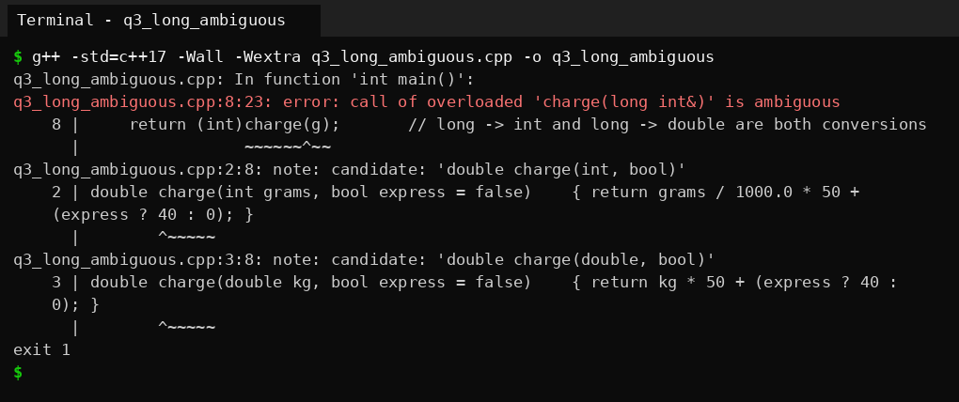
Output screenshot: q3_long_ambiguous

3. Inquiry - how the compiler chooses, and why defaults go from the right
Overload resolution happens at compile time in three steps. First the compiler collects all functions with the called name. Then it keeps the viable ones, meaning the number of arguments fits (default arguments allow fewer) and each argument can be converted to the parameter type. Finally it ranks each argument conversion, and the best function must be at least as good as every other one for all arguments and strictly better for at least one. The ranks, from best to worst:
- Exact match - same type, or trivial changes such as lvalue to rvalue, array to pointer, adding const.
- Promotion - for example float to double, or char, short and bool to int.
- Conversion - for example int to double, double to int, long to int.
- User-defined conversion (a converting constructor or a conversion operator), then the ellipsis ... last.
If two functions tie, the call is ambiguous, which is what happened in the original code and in the long example.
Why default arguments must be given from the right. When the call leaves out arguments, the compiler can only leave out the last ones, because arguments are matched to parameters by position. There is no syntax for skipping a middle argument such as f(1, , 3). So if y had a default while z did not, the default for y could never be used. C++ therefore requires that after the first parameter with a default, every following parameter has a default too.

4. Alternative concept and complexity analysis
The alternative is to take one Parcel structure with optional fields, and write a single function. I tested it with a new field fragile that the overload design does not have:
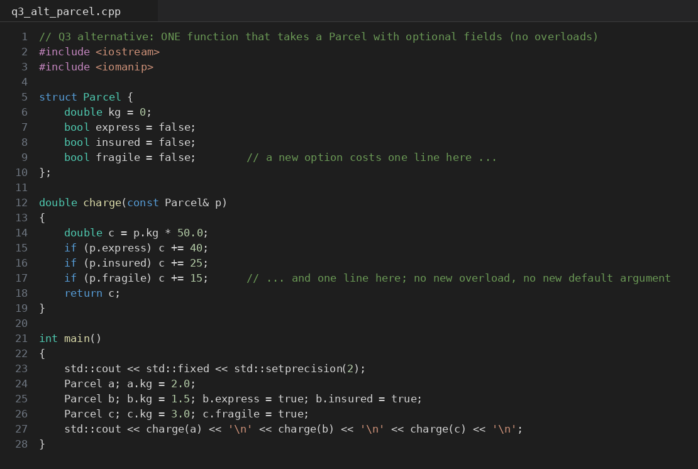
Code screenshot: q3_alt_parcel.cpp
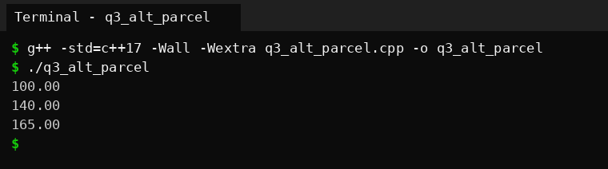
Output screenshot: q3_alt_parcel (100.00, 140.00, 165.00)
 | Overloads with default arguments | Single Parcel parameter
Time of overload resolution | Compile time only, no run-time cost | No overload resolution at all (one function)
Space copied per call | Only the arguments: 8 + 1 + 1 bytes (kg, two bools) | A const Parcel& is an 8-byte address; by value it would be sizeof(Parcel) = 16 bytes
Adding a new option (fragile) | New parameter at the end of every overload, and a new chance of ambiguity | One new field with a default value and one line in the function
Common short call | charge(2.0) is short and readable | Needs a Parcel to be built first, so longer
Call-site readability | charge(1.5, true, true) - which bool is which? | p.express = true; p.insured = true; - self-explanatory

A function template (for example template<class W> double charge(W w)) would also be possible, but then the unit has to be decided from the type, and int versus double meaning grams versus kilograms would be hidden inside if constexpr code. I think the Parcel structure is the better choice once there are more than about three options; for two optional flags the overloads with defaults are shorter to call.
Evidence summary: explained ambiguity with the real compiler message, a redesigned set of functions, predicted and observed selections for six calls, and an explanation of overload resolution.

Q4 - Specifying a Class with an Array Inside It
Problem in one line. Each SavingsAccount must remember its last 10 transactions for the ATM mini statement, and older ones are discarded.

1. Class specification
The class has private data: account number, balance, an array tx[10] of Transaction records, a count of stored records, and totalDone (the running transaction number, so the statement can show which transactions are kept). The public interface is deposit(), withdraw() and miniStatement().
Inside the class: the constructor and getBalance(), which are one-liners. Outside the class with SavingsAccount::: record() (private), deposit(), withdraw() and miniStatement(), which are longer. A withdrawal larger than the balance is rejected and is not recorded in the history.
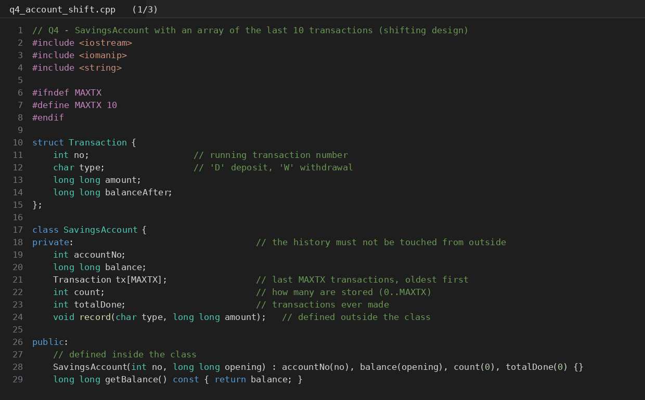
Code screenshot: q4_account_shift.cpp (part 1 of 3)
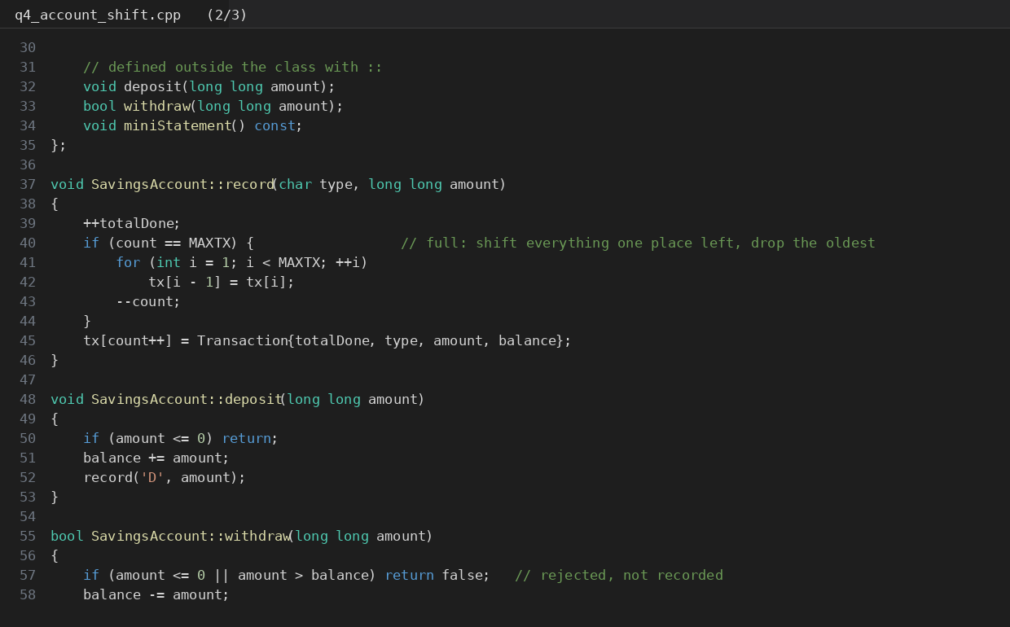
Code screenshot: q4_account_shift.cpp (part 2 of 3)
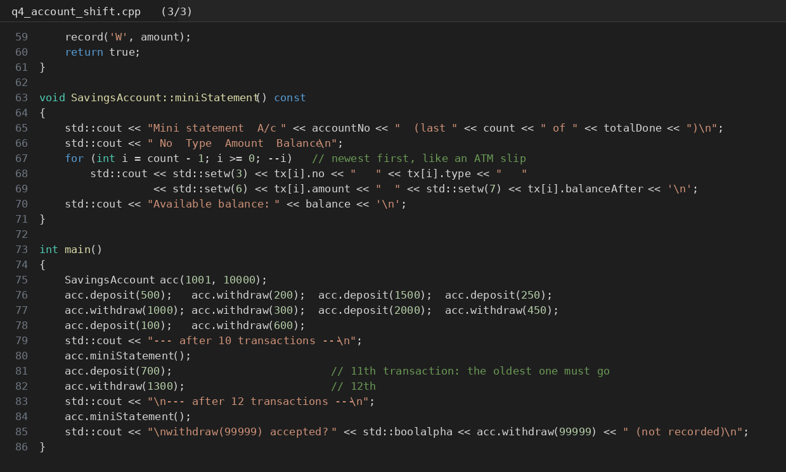
Code screenshot: q4_account_shift.cpp (part 3 of 3)
Predicted (written before running): after 12 transactions the statement shows numbers 12 down to 3, and the final balance is 11200. I worked out the balance by hand from the opening balance 10000: +500, -200, +1500, +250, -1000, -300, +2000, -450, +100, -600 gives 11800 after ten transactions, then +700 and -1300 gives 11200.
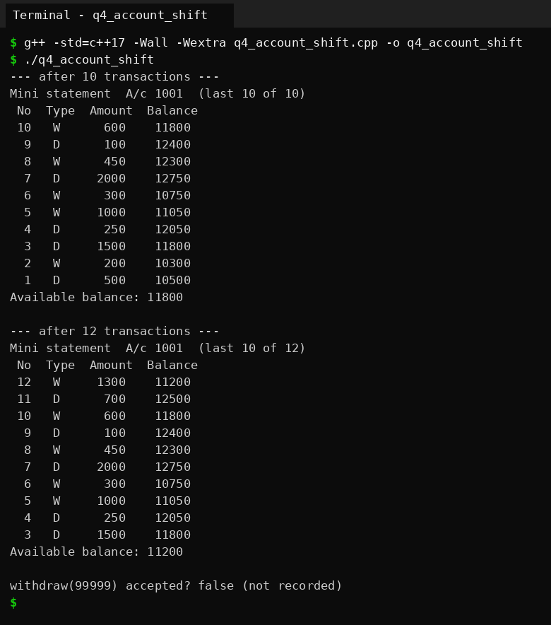
Output screenshot: q4_account_shift, statement after 10 and after 12 transactions
The observed output matches the prediction. After ten transactions the statement holds numbers 10 to 1; after 12 it holds 12 to 3 (transactions 1 and 2 were discarded) and the balance is 11200. The rejected withdraw(99999) returned false and was not recorded.

2. Inquiry
Why the array must be private. The array and count must always agree with each other and with the balance. If the array were public, any code could write a fake transaction, change count to 15 and make the statement read beyond the array, or reorder the history. With it private, only record() can change it, and record() always keeps the rules. It also lets me change the way the history is stored (as I do below with the circular index) without touching any code outside the class.
What happens when the 11th transaction arrives:
 | Shift the array | Circular index
What is done | Copy tx[1..9] to tx[0..8] (9 copies of a 24-byte record), then write the new one at tx[9] | Overwrite the oldest record at index start, then start = (start + 1) % 10
Cost per add once full | O(k), k = capacity - 1 = 9 copies | O(1), one write and one index update
Reading for the statement | Plain loop tx[i] | Loop with tx[(start + i) % 10]
Extra space | None | One int (start)

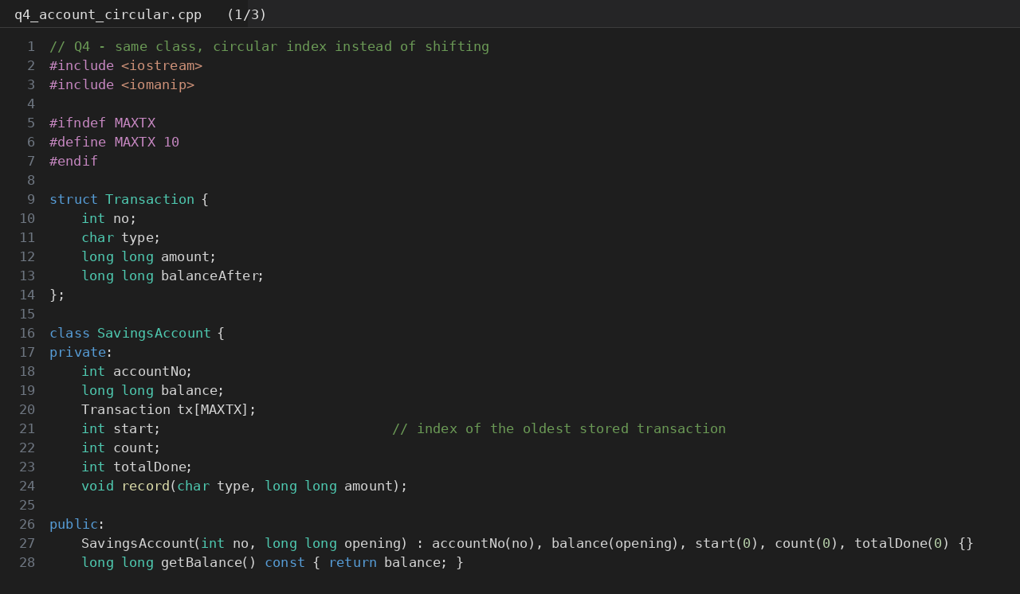
Code screenshot: q4_account_circular.cpp (part 1 of 3)
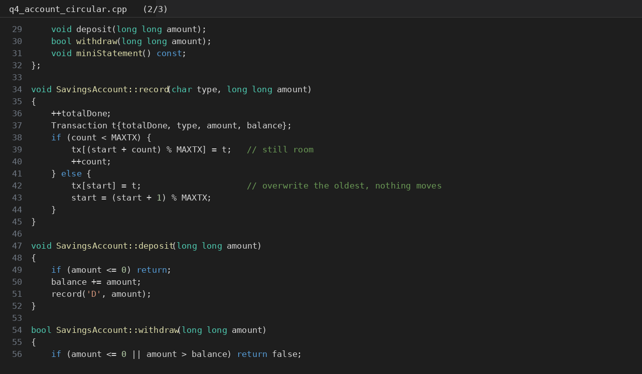
Code screenshot: q4_account_circular.cpp (part 2 of 3)
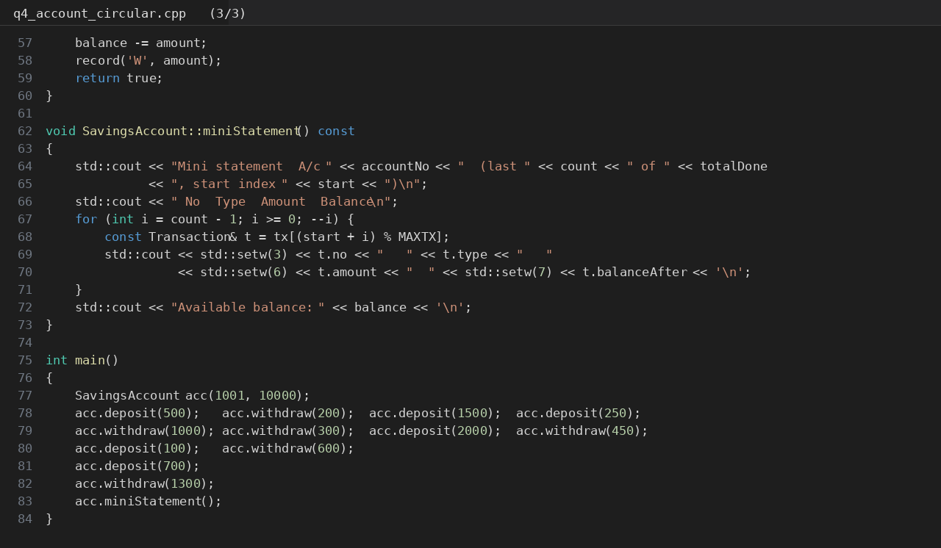
Code screenshot: q4_account_circular.cpp (part 3 of 3)
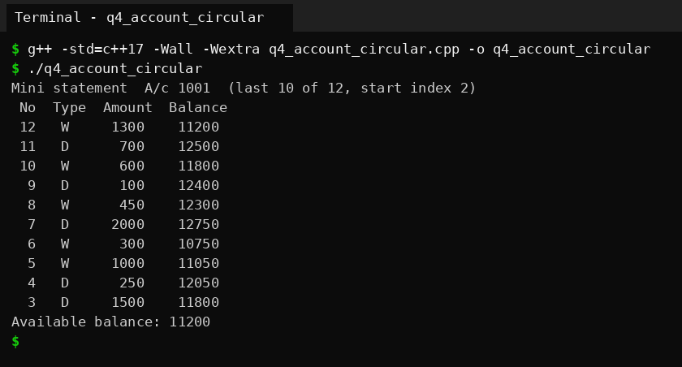
Output screenshot: q4_account_circular, same statement, start index = 2
The circular version prints the same statement. After 12 transactions start is 2, because transactions 1 and 2 were overwritten by 11 and 12, so the oldest record (number 3) sits at index 2.

3. Design decision - the last 50 transactions
In both versions the capacity is one constant (MAXTX), so the program text barely changes: I only compile with -DMAXTX=50. The question is then which design behaves well after the change. I chose the circular index, because it needs only that one constant to change and its cost per transaction stays the same, while the shifting version now copies 49 records per transaction instead of 9, five times more work for each add. miniStatement(), deposit() and withdraw() are not touched in either case.
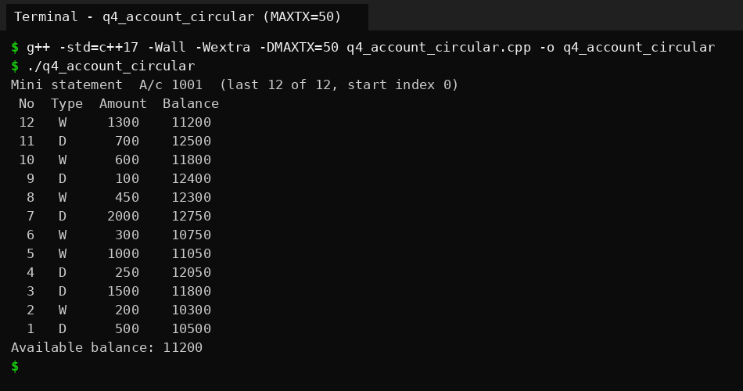
Output screenshot: q4_account_circular compiled with -DMAXTX=50 (all 12 transactions fit, nothing discarded yet)
This output also shows that the design is correct for the new size: 12 of 12 are kept and the start index is still 0 because the buffer has not wrapped yet.

4. Alternative concept and complexity analysis
The same account with std::deque<Transaction>, using push_back for a new transaction and pop_front when there are more than 10:
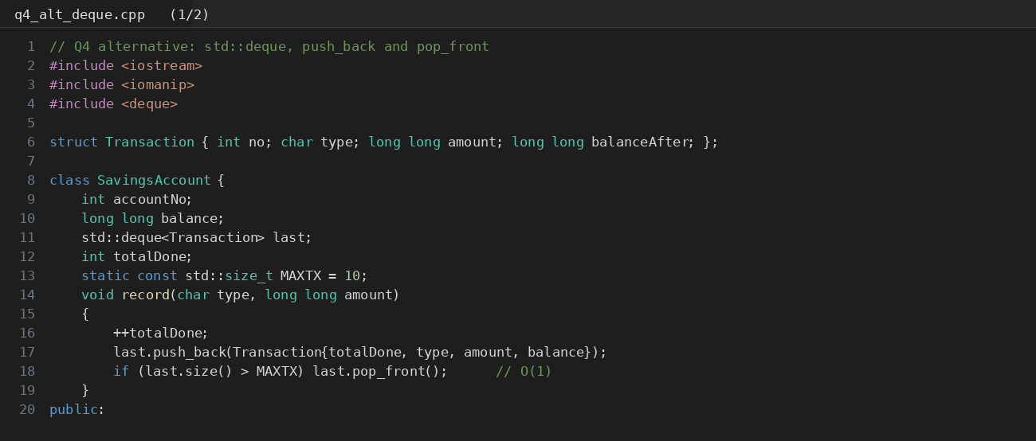
Code screenshot: q4_alt_deque.cpp (part 1 of 2)
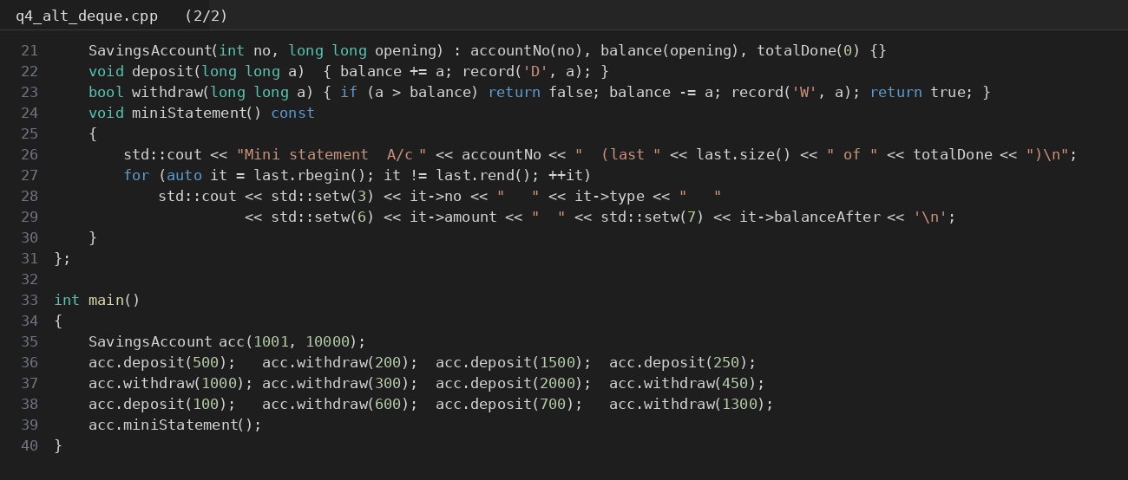
Code screenshot: q4_alt_deque.cpp (part 2 of 2)
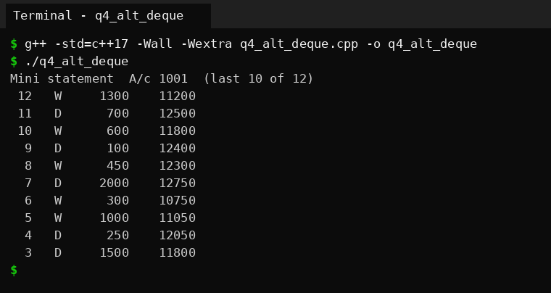
Output screenshot: q4_alt_deque, identical statement
 | Shifting array | std::deque | Circular buffer (start index)
Time to add a transaction | O(k), k = capacity - 1 | O(1) amortised | O(1)
Space | O(capacity), fixed array inside the object | O(capacity) plus the deque's bookkeeping; memory is allocated in chunks on the heap | O(capacity) + one int, fixed array inside the object
Needs dynamic memory? | No | Yes | No
Code to read the history | Simplest | Simple (iterators) | Needs (start + i) % CAP

The deque is the shortest to write, but it allocates memory while the program runs and I did not write the removal logic myself. The circular buffer gets the same O(1) and keeps the data inside the object with no allocation. For 10 transactions all three are fast enough, as the measurements in Q7 show.
Evidence summary: complete class specification with members defined inside and outside the class, a correct handling of the 11th transaction (two versions), and a defended design for 50 transactions.

Q5 - Static Members and Arrays of Objects
Problem in one line. Every BusTicket must get the next seat number, tickets beyond the capacity go to a waiting list, and the transport office must see how many seats were issued without looking at any ticket.

1. From the principle to a class design
The principle says that data belonging to the whole class should exist once, however many objects there are. Going through the data of the problem:
Data | Static? | Reason
issued (seats given out so far) | Static | One number for the whole bus. If each ticket had its own, no ticket could know the next seat.
waiting (tickets on waiting list) | Static | Also a whole-class count
CAPACITY (3) | Static const | Same for every ticket, so one copy is enough and it costs no space in each object
seat, name | Not static | Each ticket has its own seat and passenger name
count(), seatsIssued() | Static member function | The office wants the number without any ticket object

- Where a static data member must be defined. Inside the class, static int issued; is only a declaration. The definition int BusTicket::issued = 0; must be written once outside the class, in exactly one source file. Without it the linker reports an undefined reference. (static const int CAPACITY = 3; is allowed to have its value inside the class because it is an integral constant; I only use its value, so it needs no separate definition.)
- Why a static member function cannot use this or a non-static member. A static member function is not called on an object, so there is no object and no this. BusTicket::count() can run when zero tickets exist. A non-static member such as seat or name belongs to one particular ticket, so the function would not know whose seat to use. It can only touch static members.
- How an array of BusTicket is created. The constructor takes a name and is explicit, so the class has no default constructor and BusTicket trip[4]; would not compile. Each element is initialised in the braces: BusTicket trip[4] = {BusTicket("Asha"), ...}. The constructor runs once for each element in index order, and the elements are destroyed in reverse order at the end.
- Count inside a loop or a function. The static counter lives for the whole program, not for any object. Tickets created in a function are destroyed on return, but issued stays where it was (I show this below). So issued means "seats issued so far", not "tickets alive now". If I wanted the second meaning, a destructor would have to decrement a counter.

2. Predict the output - Token
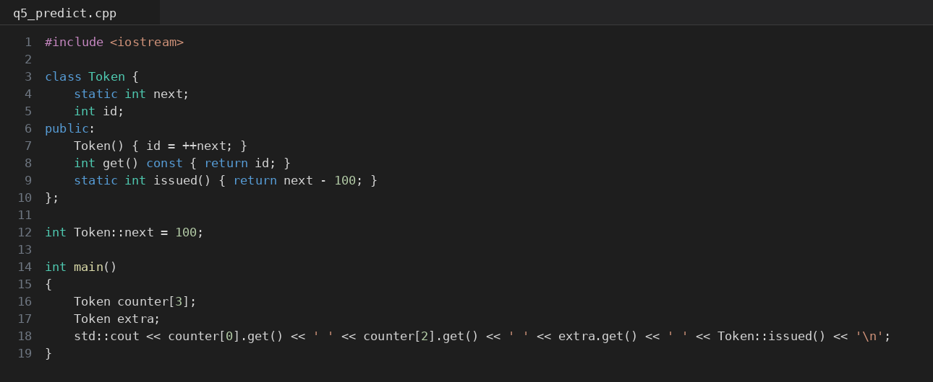
Code screenshot: q5_predict.cpp
 | Predicted (before running) | Observed
Output | 101 103 104 4 | 101 103 104 4

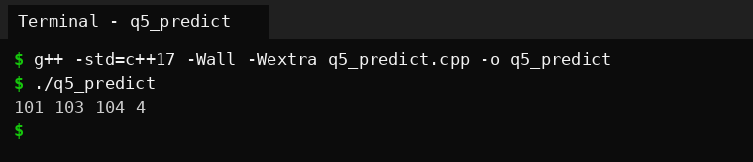
Output screenshot: q5_predict
No difference. The static counter next is defined as int Token::next = 100; outside the class, so it starts at 100. The constructor ran 4 times: three times for the array counter[3] and once for extra. Each run does id = ++next, so the ids are 101, 102, 103 for the array and 104 for extra. The line prints counter[0] (101), counter[2] (103), extra (104), and Token::issued() which is next - 100 = 4.

3. Complete the code - BusTicket
TODO 1 in the constructor: if (issued < CAPACITY) { ++issued; seat = issued; }. TODO 2 in count(): return issued;. Nothing else was changed.
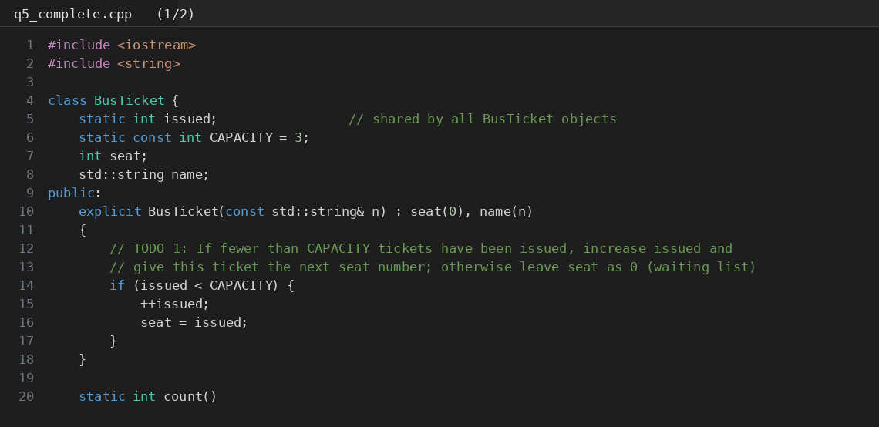
Code screenshot: q5_complete.cpp (part 1 of 2)
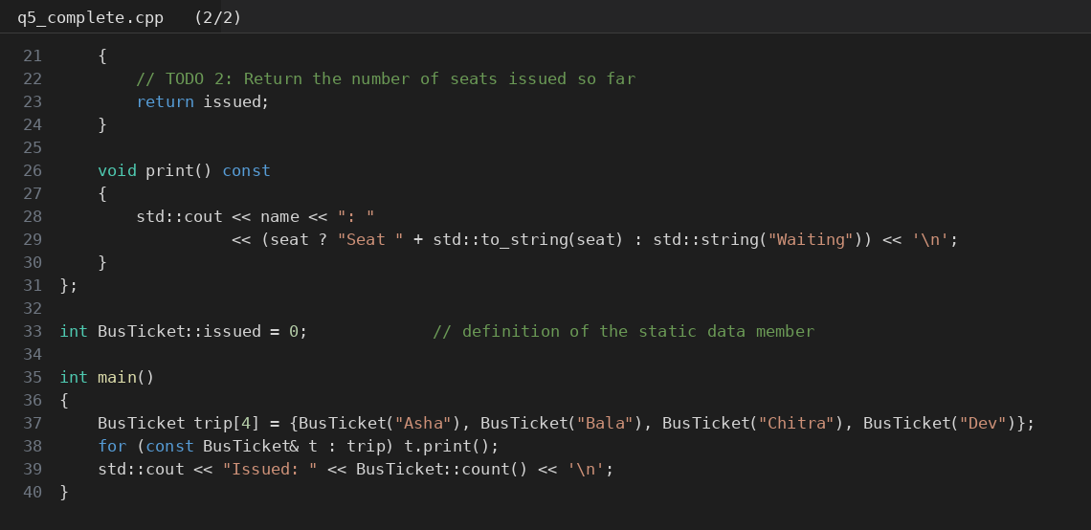
Code screenshot: q5_complete.cpp (part 2 of 2)
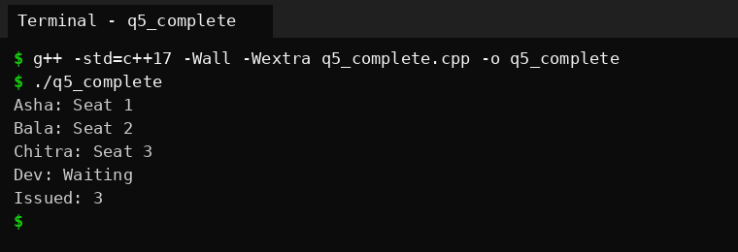
Output screenshot: q5_complete, same as the expected output
The output is exactly the expected one: Asha, Bala and Chitra get seats 1, 2, 3, Dev goes to the waiting list because issued is already 3 (so seat stays 0), and Issued: 3.

4. Test your design

Array larger than the capacity
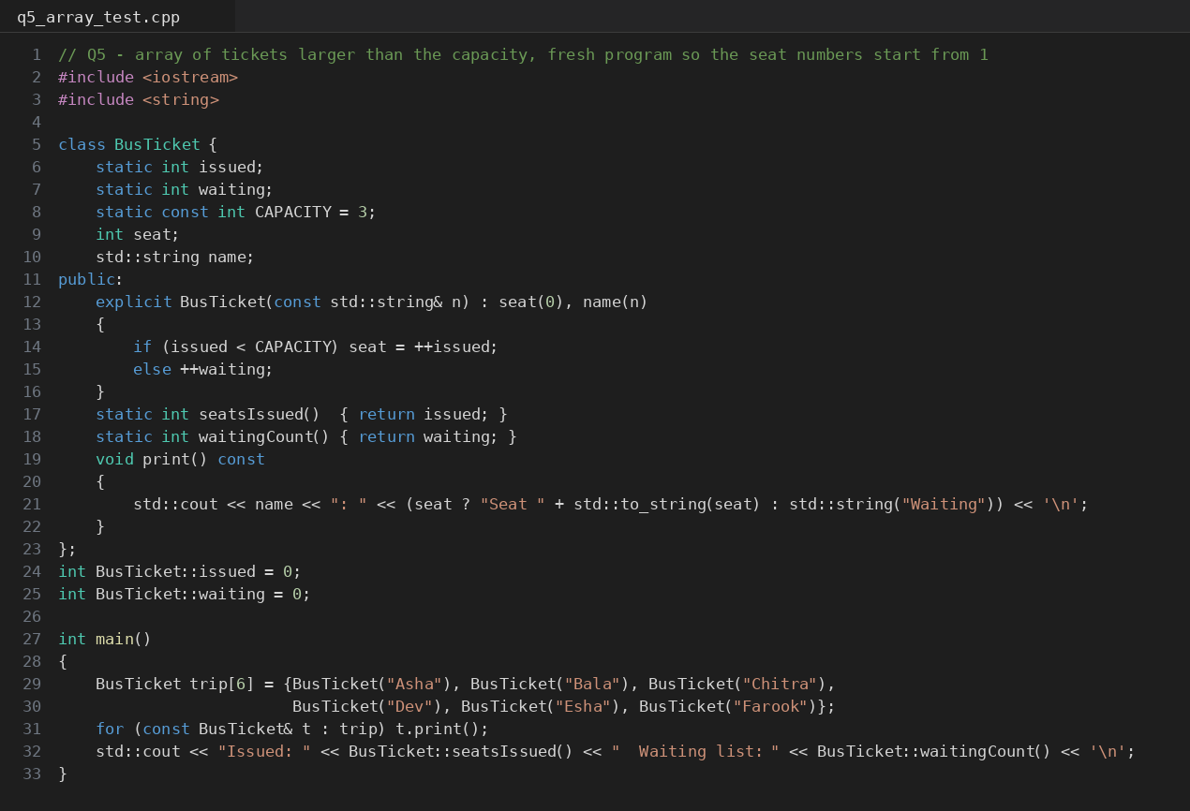
Code screenshot: q5_array_test.cpp
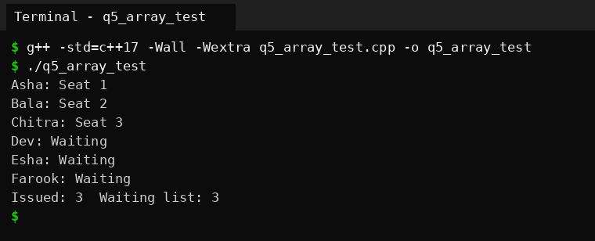
Output screenshot: q5_array_test, six tickets for three seats
Seats 1 to 3 go to the first three tickets in order, and the other three go to the waiting list (waiting = 3, issued = 3), as predicted.

Tickets created inside a function called twice
Predicted before running: after the first call issued = 2, after the second call issued = 3 with one ticket waiting.
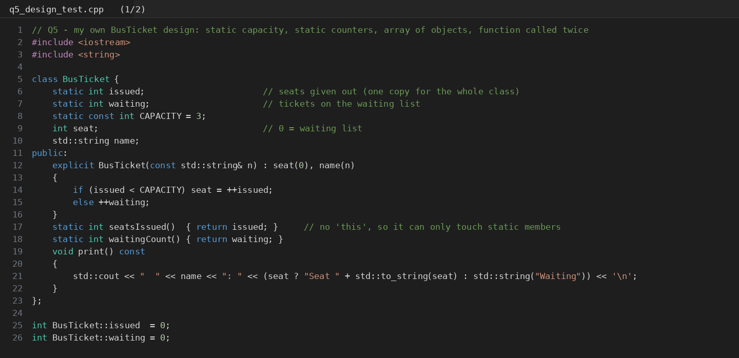
Code screenshot: q5_design_test.cpp (part 1 of 2)
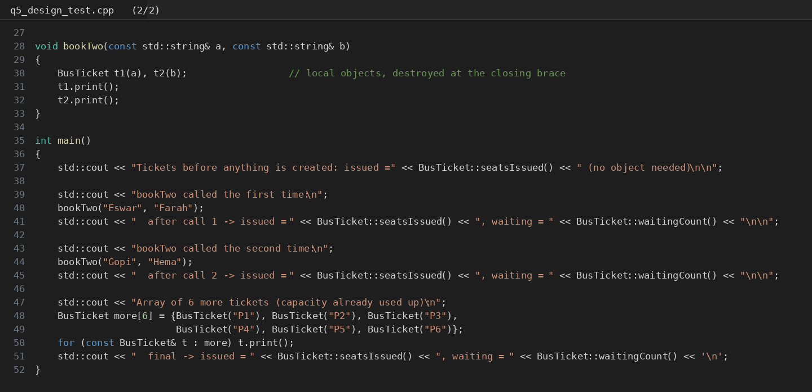
Code screenshot: q5_design_test.cpp (part 2 of 2)
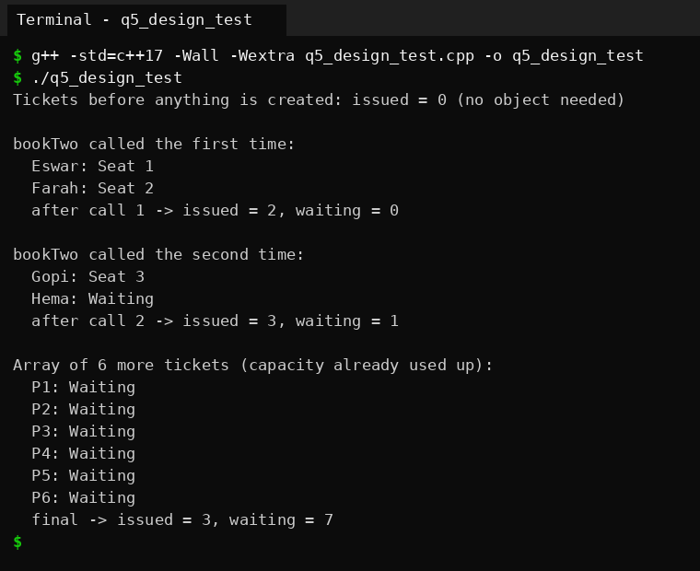
Output screenshot: q5_design_test, count behaviour across function calls
This matches. The four ticket objects of the two calls are gone by the time the counts are printed, but the count kept growing from 2 to 3. The first line also shows BusTicket::seatsIssued() working before a single object exists. Then six more tickets are created in an array and all of them go to the waiting list because the capacity is used up (waiting = 7 in total).

5. Alternative concept and complexity analysis
Here the counter is not a static member. A TicketOffice object holds issued and capacity, and every BusTicket receives the office in its constructor:
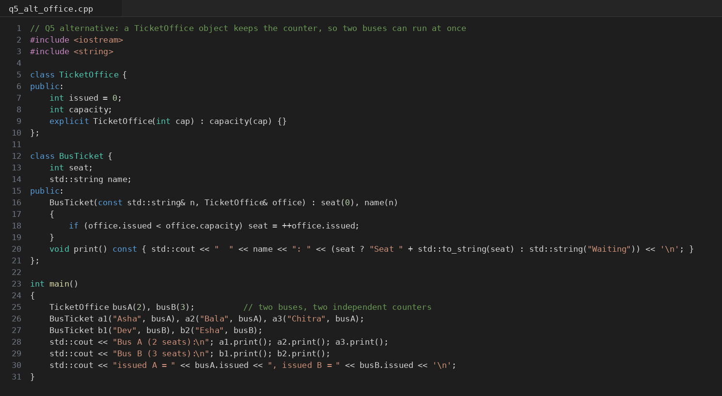
Code screenshot: q5_alt_office.cpp
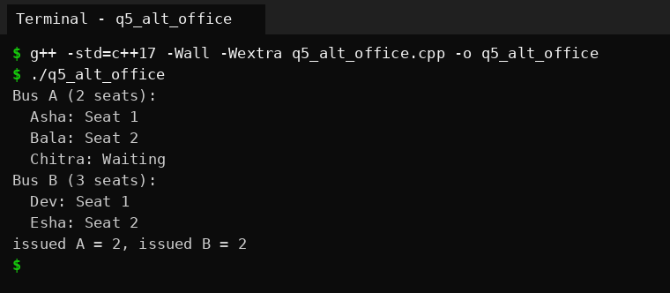
Output screenshot: q5_alt_office, two buses with separate counters
 | Static data member | Global variable | TicketOffice object
Time per ticket | O(1) | O(1) | O(1)
Space for the counter | One int for the whole class | One int | One int per office (one office per bus)
Encapsulation | Can be private, only the class touches it | Anyone in the program can change it | Controlled by the office's interface, but I left its fields public to keep the demo short
Two buses at once | No. There is one counter for the whole class, so every bus shares it | No, same problem | Yes, as the output shows (A: 2 seats, B: 3 seats)
Cost to the caller | Nothing extra | Nothing extra | Must pass the office to every ticket

The time and the space are the same in all of them, so the choice is about design. The static member is the best answer when there is exactly one bus, which is what the problem says. The moment the college needs two buses with different capacities, the static counter becomes a limit, and the office object is the better design. A global variable is the weakest of the three because nothing protects it.
Evidence summary: a class design derived from the principle, an array of objects, tests for capacity and for function calls, and an explanation of how static members work.

Q6 - Friend Functions and Inline Functions
Problem in one line. A Time class keeps h and m private. The planner must find the minutes between two times and decide which is earlier, and these small functions are called millions of times.

1. Design - why friend, and what inline really does
- Why a friend function. minutesBetween(a, b) and earlier(a, b) treat both times equally. A member function a.minutesTo(b) makes a special (it is the object the function is called on) and b just an argument. A non-member function treats the two the same. But a non-member cannot see private h and m, so the class declares the two functions as friends. Only those two named functions get the access.
- How a friend differs from a member. A member is called on an object (a.minutesTo(b)), has this, and is in the class scope. A friend is an ordinary function called as minutesBetween(a, b), has no this, and is not a member, but it can read the private members of the objects passed to it. Friendship is given by the class, and cannot be taken by the function.
- What inline asks. inline is a request that the compiler may replace the call by the body, so the cost of the call (setting up arguments, jumping, returning) disappears. It is only a hint: the compiler can ignore it, and at -O2 it can also inline functions which are not marked. The keyword also lets the same definition appear in many source files without a linker error. For two tiny functions the call overhead is a big part of the cost, so inline is a good idea here.
- What would be lost if h and m were public. Anyone could set h = 25 or m = 99 and the object would hold a time that does not exist. All the checking inside the class would be pointless. Also, if I later decided to store the time as minutes since midnight, I would have to rewrite every place that touched h and m, instead of only the class and its two friends.

2. Complete the code
TODO 1: convert both times to minutes (h * 60 + m) and return the absolute difference. TODO 2: return true when the first time in minutes is smaller than the second.
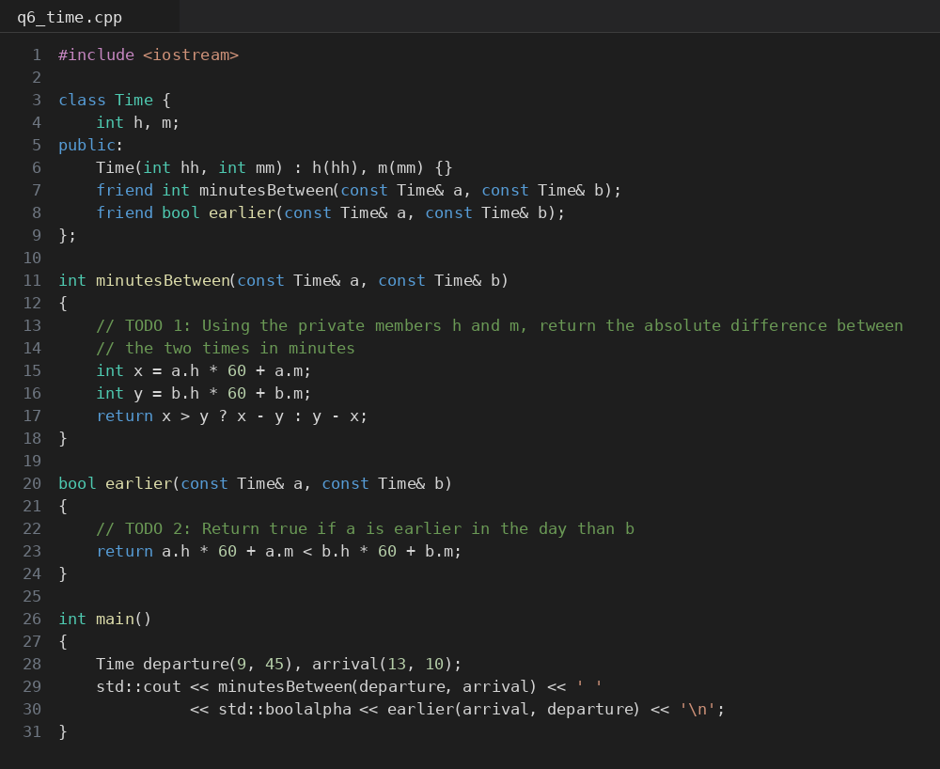
Code screenshot: q6_time.cpp
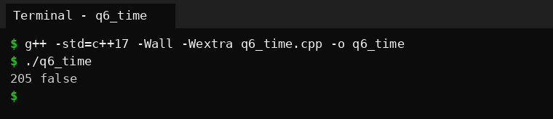
Output screenshot: q6_time, expected output 205 false
Hand check: 9:45 is 9 x 60 + 45 = 585 minutes and 13:10 is 13 x 60 + 10 = 790 minutes, the difference is 205. earlier(arrival, departure) asks whether 790 < 585, which is false. So 205 false, the same as the program printed.

3. Correctness check
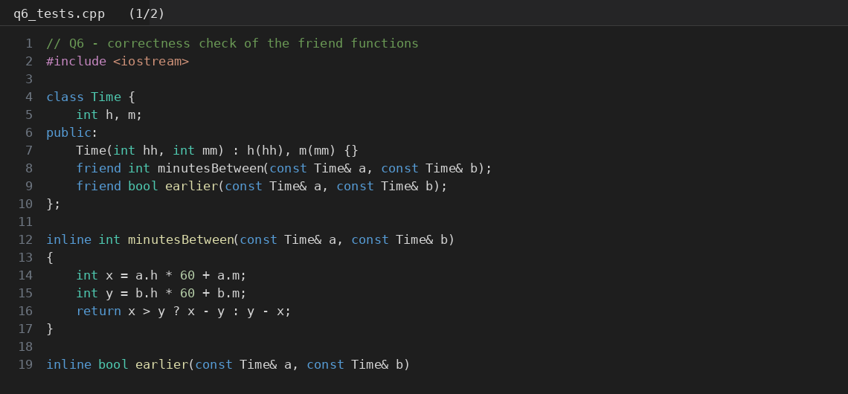
Code screenshot: q6_tests.cpp (part 1 of 2)
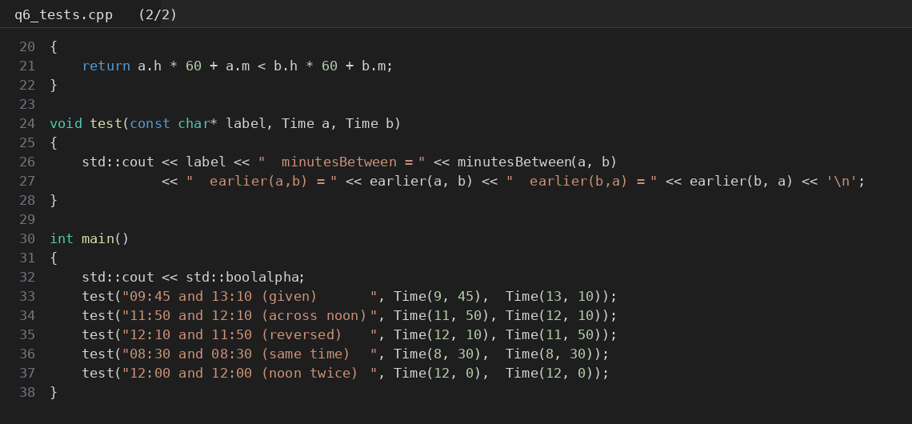
Code screenshot: q6_tests.cpp (part 2 of 2)
Predicted before running, with the hand calculation:
Times | Minutes (hand) | Predicted result | Observed
09:45 and 13:10 | 585 and 790 | 205, earlier true | 205, true / false
11:50 and 12:10 (across noon) | 710 and 730 | 20, earlier true | 20, true / false
12:10 and 11:50 (reversed) | 730 and 710 | 20, earlier false | 20, false / true
08:30 and 08:30 (same time) | 510 and 510 | 0, earlier false both ways | 0, false / false
12:00 and 12:00 | 720 and 720 | 0, false both ways | 0, false / false

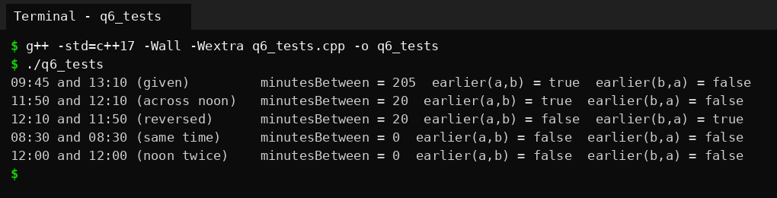
Output screenshot: q6_tests, correctness tests
All results match. The same-time case is the important one: earlier must be false in both directions, which is why I used < and not <=. The test across noon passes because the calculation converts to total minutes first, so it does not matter that the hour goes from 11 to 12.

4. Growth investigation - 10,000,000 calls
The benchmark makes 10,000,000 iterations, each calling minutesBetween and earlier once (so 20 million calls in total), over an array of 1024 different times so the compiler cannot compute the answer in advance. I took the best of 21 repetitions to reduce noise. "noinline" means the same function with __attribute__((noinline)), which stops the compiler from inlining it, so it shows the cost of a real call. I also measured the member-function and getter versions for the alternative question.
Version | -O0 time (ms) | -O2 time (ms)
Friend, inline | 47.6 | 11.9
Friend, noinline | 44.1 | 18.1
Member functions | 48.8 | 14.5
Public getters | 96.5 | 11.8

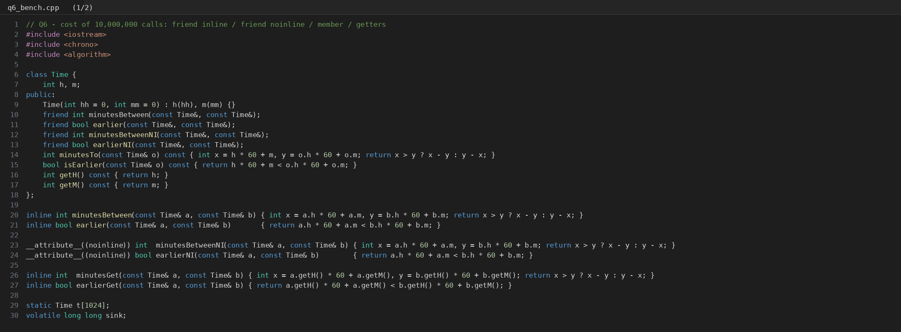
Code screenshot: q6_bench.cpp (part 1 of 2)
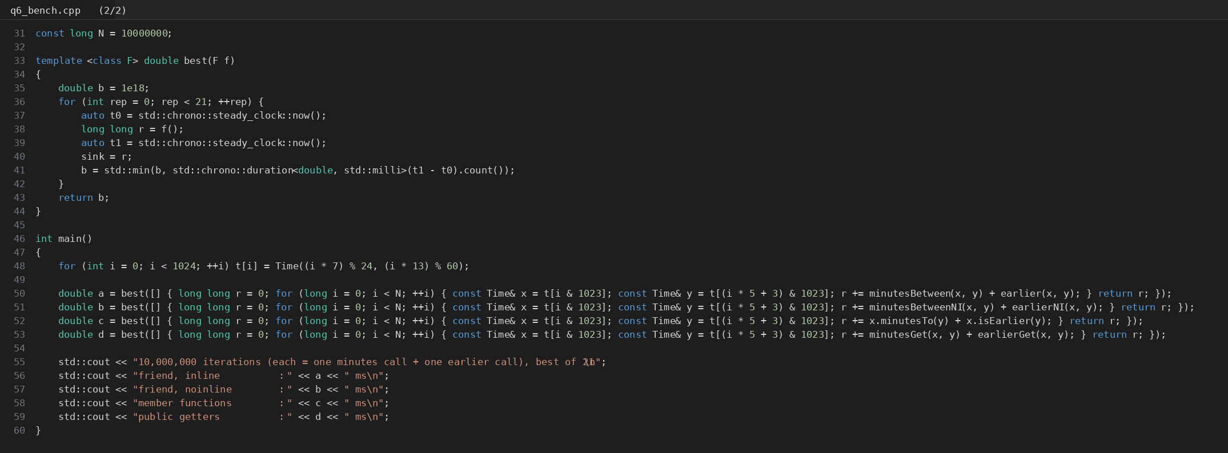
Code screenshot: q6_bench.cpp (part 2 of 2)
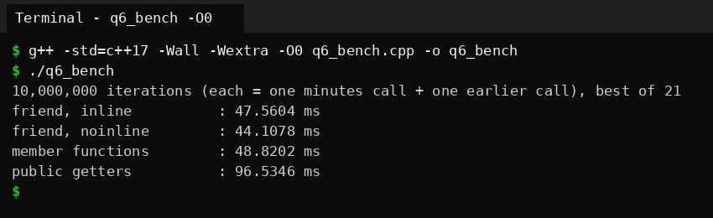
Output screenshot: q6_bench compiled with -O0
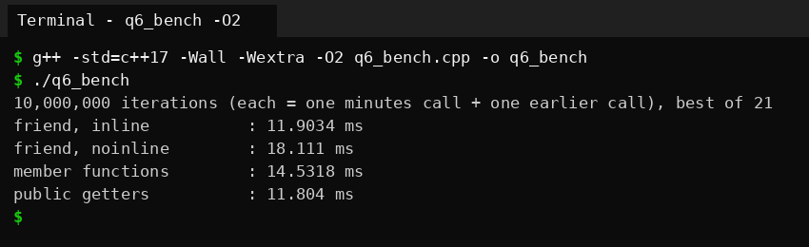
Output screenshot: q6_bench compiled with -O2
Explanation. At -O0 the compiler does no inlining at all, so the inline keyword changes nothing: the inline friend (47.6 ms) and the noinline friend (44.1 ms) are the same function, and the small difference between them is noise. The getters version is about twice as slow at -O0 because each getter is a real call as well, so one iteration makes many more calls. At -O2 the picture changes: the inline friend takes 11.9 ms against 18.1 ms for the noinline one, so inlining made it about 1.5 times faster, because the call is gone and the compiler can also optimise the arithmetic in the loop. The getters take about the same time as the inline friend at -O2 (11.8 ms) because the compiler inlines the tiny getters on its own. So after optimisation the design style does not matter for speed; only the removal of the real call does.
The member versions were a little slower than the inline friend at -O2 in my run (14.5 ms). Members defined inside the class are implicitly inline too, so I expected the same result. I did not investigate further, and the difference is small compared with the noinline case, so I would not read much into it.

5. Deployment decision
I would keep the friend functions. The evidence shows that after optimisation friends, members and getters run at about the same speed, so speed does not decide it. What decides it is encapsulation and the shape of the interface. Friends treat both times equally, expose nothing to the rest of the program, and need no public getters. Getters would let every piece of code read h and m forever, and if the representation changed, those getters would have to stay. The price of friends is that the two functions are tied to the private representation, so if I store minutes since midnight later, I must update them, but that is only two functions beside the class. If other parts of the planner need to display hours and minutes, a read-only getter makes sense for that purpose, and the comparison can still stay as friends.

6. Alternative concept and complexity analysis
Written as members (a.minutesTo(b), a.isEarlier(b)) or with public getters (a.getH(), a.getM()), the solution looks like this:
 | Friend functions | Member functions | Public getters + normal functions
Call syntax | minutesBetween(a, b) | a.minutesTo(b) | minutes(a, b) using a.getH() ...
Access to private data | Only the two named functions | Members only | Everybody can read h and m
Treats both objects equally | Yes | No, a is special | Yes
Time per call | O(1) | O(1) | O(1)
Space per call | Two addresses (16 bytes) with const references | One address plus this | Two addresses
Measured, -O2 (10M iterations) | 11.9 ms | 14.5 ms | 11.8 ms
Measured, -O0 | 47.6 ms | 48.8 ms | 96.5 ms

Time per call is O(1) in all three, since each does one multiplication-add per time and one subtraction or comparison. Space is O(1) too. The measured times above show what inlining does to the constant factor, as explained in section 4.
Evidence summary: a justified friend-function design, correctness tests with hand calculations, measured timings at -O0 and -O2, and a decision based on the measurements and on encapsulation.

Q7 - Day-4 Design Challenge: Diagnose, Redesign and Validate
Program chosen: the transaction history of SavingsAccount from Q4 (the shifting array). Of the six tasks, this is the one whose cost really depends on a size that can change: the capacity. The Q4 requirement already changed once in the task itself (from 10 to 50 transactions), and a bank could easily ask for hundreds when an account statement is exported.

A. Diagnose the limitation (2 marks)
When the history is full, every new transaction triggers a loop that copies all the other records one place to the left (tx[i-1] = tx[i]). The work per transaction is therefore proportional to the capacity: O(CAP). For 10 transactions this is nothing, but the cost grows with the requirement. I measured the time of the original design for several capacities (compiled with -O2, same transactions in both designs):
Capacity | Adds | Total time (ms) | Time per add (ns) | Growth vs CAP = 10
10 | 200,000 | 1.726 | 8.6 | 1x
50 | 200,000 | 3.942 | 19.7 | 2x
500 | 200,000 | 17.389 | 86.9 | 10x
2000 | 100,000 | 34.574 | 346 | 40x
10000 | 50,000 | 195.587 | 3912 | 453x

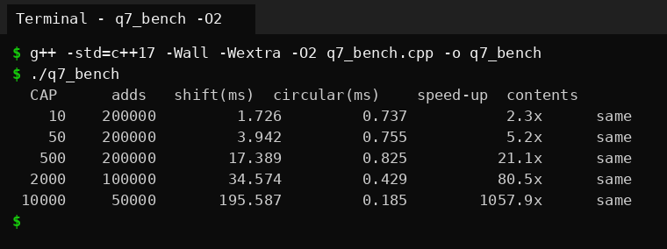
Output screenshot: q7_bench compiled with -O2 (shifting vs circular)
The time per add goes from about 8.6 ns at capacity 10 to about 3912 ns at capacity 10,000. The capacity grew 1,000 times and the cost per add grew roughly the same amount, which is linear growth. The cause is in the design itself: the array is kept in "oldest first" order, and that order is paid for with a physical move of every record on every insertion. Nothing in the mini statement needs the records to be physically in that order.

B. Design objective (2 marks)
A measurable objective derived from the diagnosis:
- The cost of adding a transaction must not depend on the capacity. At capacity 10,000 the redesigned version must be at least 100 times faster per add than the shifting version.
- At capacity 10 it must not be slower than the original.
- It must print exactly the same history. I check this with a checksum of the stored transaction numbers in order, which is compared after every test.
- It may use at most one extra integer of memory.

C. Design of the revised solution (4 marks)
What changes. The records stop moving. Instead the class keeps an extra private integer start that says where the oldest record is. When the array is full, a new record overwrites the slot at start (the oldest one, which is being discarded anyway), and start advances by one with wrap-around. To read the history in order, the position of the i-th oldest record is (start + i) % CAP.
C++ features used. A private data member for the index, member functions that hide the index arithmetic, the modulo operator for the wrap-around, and a class template parameter template<int CAP> in the benchmark so the capacity is a compile-time constant and the array stays inside the object (no dynamic memory).
Extra memory. One int per account (start). The array itself is the same size.
New trade-offs. (1) The array is no longer in time order in memory, so any code that wants the history in order must go through (start + i) % CAP and cannot just loop or memcpy the array. (2) The index arithmetic is easier to get wrong than a simple shift, so it needs testing (I compare the checksum of both designs). (3) The modulo has a small cost of its own, which matters at small capacities (see results).
Pseudocode of the new record():
if count < CAP: tx[(start + count) % CAP] = t; count++
else: tx[start] = t; start = (start + 1) % CAP
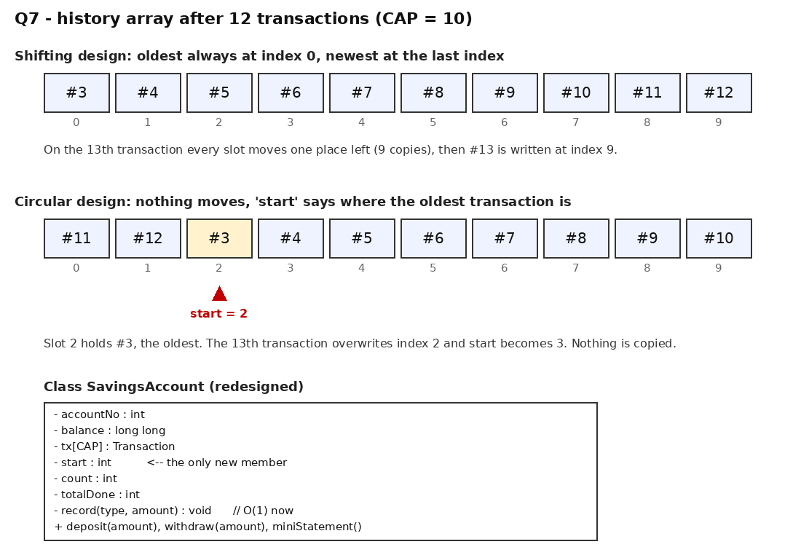
Diagram: the same 12 transactions in the shifting design and in the circular design, and the redesigned class

D. Prediction before implementing (1 mark)
Written in predictions.md before I ran the benchmark: the shifting design costs about the same as capacity grows by a factor k (linear), the circular design stays constant. I expected the circular version to be at least 500 times faster per add at capacity 10,000, and within about 0.3 to 3 times of the original at capacity 10. The measure is the time per add (total milliseconds for a fixed number of adds), compiled with -O2.

E. Implement and validate (2 marks)
Both classes are implemented as templates with the same interface and run the same sequence of transactions. The benchmark was run at -O2 and at -O0:
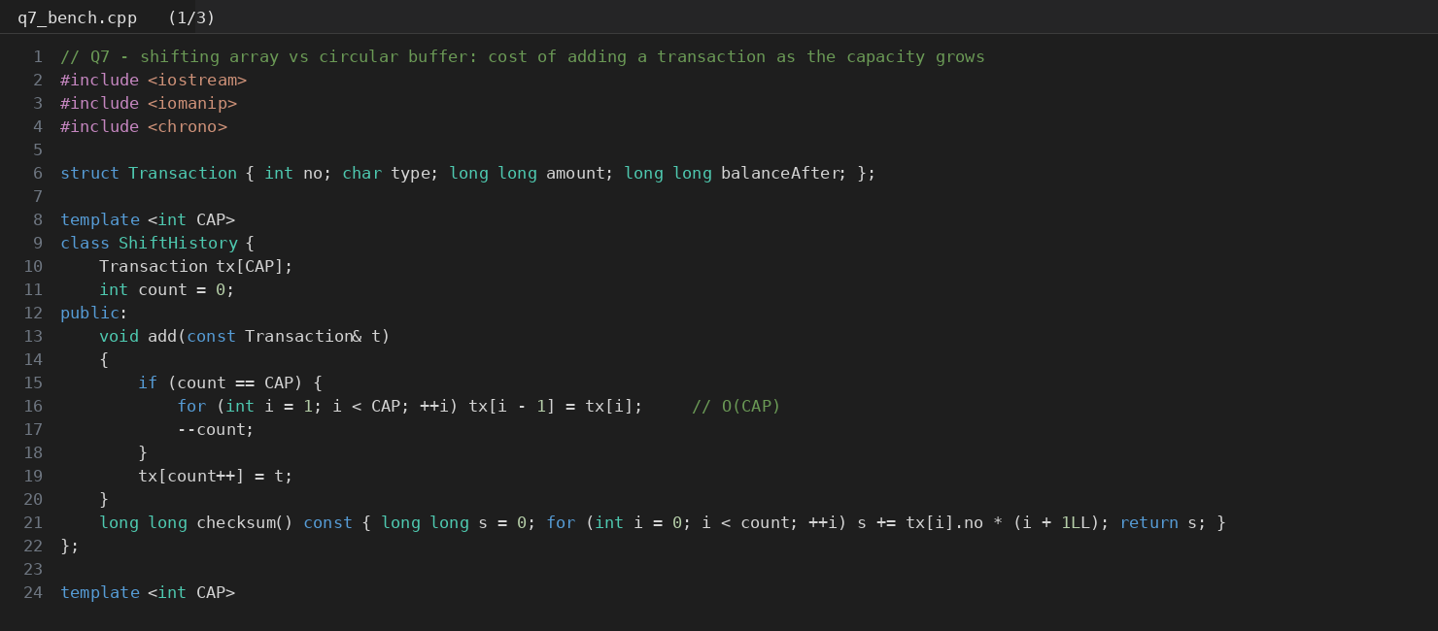
Code screenshot: q7_bench.cpp (part 1 of 3)
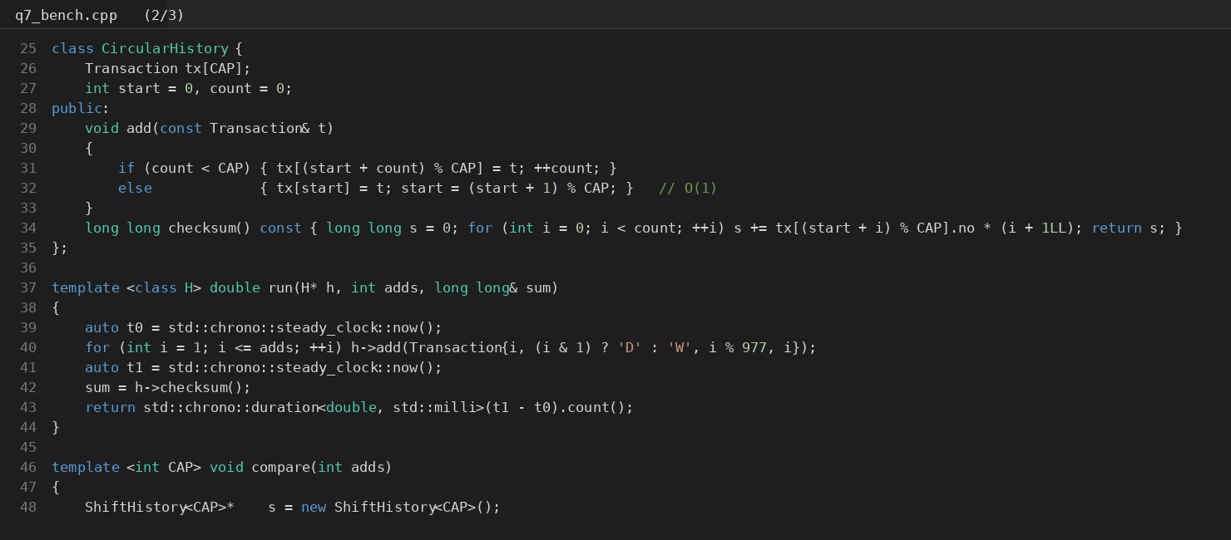
Code screenshot: q7_bench.cpp (part 2 of 3)
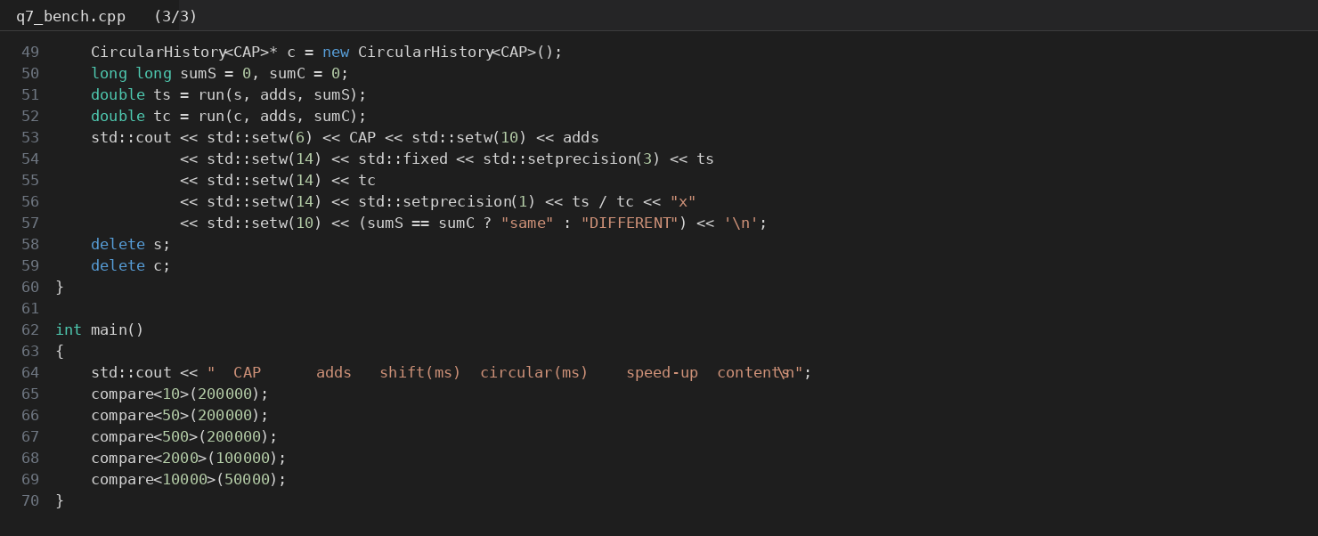
Code screenshot: q7_bench.cpp (part 3 of 3)
Capacity | Adds | Shifting -O2 (ms) | Circular -O2 (ms) | Speed-up -O2 | Speed-up -O0 | Same contents
10 | 200,000 | 1.726 | 0.737 | 2.3x | 3.8x | Yes
50 | 200,000 | 3.942 | 0.755 | 5.2x | 17.4x | Yes
500 | 200,000 | 17.389 | 0.825 | 21.1x | 167.6x | Yes
2000 | 100,000 | 34.574 | 0.429 | 80.5x | 426.4x | Yes
10000 | 50,000 | 195.587 | 0.185 | 1057.9x | 1462.8x | Yes

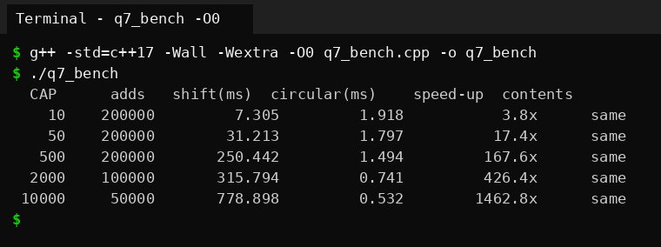
Output screenshot: q7_bench compiled with -O0
Prediction against result. At capacity 10,000 the speed-up is 1057.9x at -O2 (predicted at least 500x, so correct) and 1462.8x at -O0. At capacity 10 the speed-up is 2.3x at -O2, inside the predicted band of 0.3 to 3x, but 3.8x at -O0, which is a little outside my band. The prediction about the shape was right, and the original is not "equal" at capacity 10: the circular version was faster even there. I had expected the modulo to eat the advantage at small sizes, but at this size the shifting loop of 9 copies already costs more than the modulo.
The "Same contents" column confirms that the two designs produce identical histories in every test.

F. Defend the final design (2 marks)
- Objective achieved? Yes. The cost per add of the circular design is nearly constant (about 4 ns at every capacity I tried), so the target of at least 100 times faster at capacity 10,000 was met with a large margin (1057.9x), it was not slower at capacity 10, the histories are identical, and only one extra int was used.
- New costs. The statement code is harder to read because of (start + i) % CAP; the array is not in time order in memory; there is an extra field that must always stay consistent with count; and I had to add a test to be sure about it.
- Where the original is still preferable. For the real ATM requirement (10 records and one transaction at a time), the shifting version costs less than 10 nanoseconds per transaction, which no customer will ever notice, and its code is the simplest to read and to check. If the history needs to be handed to code that expects an ordered array, the shifting version needs no conversion. I would use the circular design when the capacity is large (the 50 asked in Q4 already makes the shift five times longer) or when the history is updated very often.
- Limits of my evidence. These are single runs on one computer, with a synthetic sequence of transactions. The exact numbers will change on another machine, but the linear growth of the original and the flat cost of the redesign come from the algorithm, not from the machine.
This redesign is my own circular buffer. It does not simply replace the code with std::deque: I analysed the deque in Q4 as an alternative and kept the fixed array inside the object, to avoid dynamic allocation.

