LEXGUARD — LEGAL CASE RESEARCH AND CRYPTOGRAPHIC VERIFICATION PLATFORM
A MINI - PROJECT REPORT
Submitted by
VIJAYARAJ K P Reg. No.: 9517202404176
YUVARAJ SINGH B Reg. No.: 9517202404187
for the Course
23CS553 – MINI PROJECT-III
DEPARTMENT OF COMPUTER SCIENCE AND ENGINEERING
MEPCO SCHLENK ENGINEERING COLLEGE, SIVAKASI
(An Autonomous Institution affiliated to Anna University, Chennai)
NOVEMBER 2026

MEPCO SCHLENK ENGINEERING COLLEGE, SIVAKASI
(Autonomous)
BONAFIDE CERTIFICATE
Certified that this mini-project report titled "LEXGUARD — LEGAL CASE RESEARCH AND CRYPTOGRAPHIC VERIFICATION PLATFORM" is the bonafide work of VIJAYARAJ K P (Reg. No.: 9517202404176) and YUVARAJ SINGH B (Reg. No.: 9517202404187) who carried out the mini-project work under my supervision for the course 23CS553 - Mini Project-III at Mepco Schlenk Engineering College (Autonomous), Sivakasi during Semester - V in the academic year 2026 - 2027.
___________________________  Dr. S. Amutha, M.E., Ph.D.  PROJECT MENTOR  Associate Professor  Dept. of Computer Science and Engineering  Mepco Schlenk Engineering College  Sivakasi - 626 005 | ___________________________  Dr. J. Raja Sekar, M.E., Ph.D.  HEAD OF THE DEPARTMENT  Senior Professor & Head  Dept. of Computer Science and Engineering  Mepco Schlenk Engineering College  Sivakasi - 626 005
Submitted for the Practical Examination held at Mepco Schlenk Engineering College (Autonomous), Sivakasi on ______ / ______ / 2026.
___________________________  INTERNAL EXAMINER - I | ___________________________  INTERNAL EXAMINER - II

ABSTRACT
Searching, cross-referencing, and verifying legal precedents constitutes one of the most critical responsibilities within judicial administration. Legal practitioners, advocates, court registries, and judicial scholars routinely spend extensive working hours manually navigating fragmented court repositories, verifying statutory provisions, and validating whether cited judicial records have remained unaltered since initial publication. Furthermore, generic artificial intelligence tools regularly produce hallucinated case names, fabricated citations, and erroneous statutory interpretations that introduce severe professional liabilities before courts of law. To address these systemic challenges, this work presents Lexguard, an enterprise-grade Legal Case Research and Cryptographic Verification Platform tailored for High Court and judicial workflows.
Lexguard establishes a zero-trust, role-based judicial repository that tightly couples cryptographic document integrity verification with domain-specific legal intelligence. The security core implements dual-layer SHA-256 byte hashing—combining client-side zero-byte calculations via the browser Web Crypto API with server-side streaming verification—and an immutable, hash-chained audit ledger with 989 recorded blocks. Every operational event, from judgment document ingestion to senior registrar metadata approval and petition analysis, is sequentially committed into a cryptographic ledger wherein each block embeds the SHA-256 digest of its predecessor, establishing non-repudiable and tamper-evident traceability.
Lexguard combines semantic embeddings from InLegalBERT with PostgreSQL full-text search using Reciprocal Rank Fusion across 208 precedent judgments. It maps legacy statutes, including the IPC, Cr.P.C., and Evidence Act, to the BNS and BNSS 2023. Its AI Judgment Draft Studio identifies missing statutory grounds and overlooked adverse precedents without hallucinations. Built with FastAPI and a lightweight HTML5 frontend, Lexguard provides a fast, reliable, and verifiable legal research platform.

ACKNOWLEDGEMENT
First and foremost, we thank the LORD ALMIGHTY for his abundant blessings, continuous guidance, and strength showered upon us throughout our academic endeavors.
We extend our sincere and profound gratitude to our esteemed college management and our respected Principal, Dr. S. Arivazhagan, M.E., Ph.D., for providing an exceptional academic environment, sophisticated computing laboratories, and comprehensive library resources that enabled us to execute this mini-project successfully.
We express our heartfelt gratitude to Dr. J. Raja Sekar, M.E., Ph.D., Senior Professor and Head, Department of Computer Science and Engineering, Mepco Schlenk Engineering College, for granting us the opportunity to undertake this project and for his invaluable encouragement, scholarly perspectives, and constructive suggestions during every phase of our work.
We would also like to record our deep appreciation and gratitude to Dr. T. Gladima Nisia, M.E., Ph.D., Assistant Professor (Sr. Grade), and Dr. N. Kavitha, M.E., (Ph.D.), Assistant Professor (Sl. Grade), Department of Computer Science and Engineering, our Mini-Project In-charges, for their steadfast administrative coordination, procedural guidance, and continuous monitoring.
We express our heartfelt gratitude and sincere indebtedness to our revered Project Mentor, Dr. S. Amutha, M.E., Ph.D., Associate Professor, Department of Computer Science and Engineering, Mepco Schlenk Engineering College. Her rich technical expertise, inspiring guidance, patient reviews, and meticulous feedback were instrumental in shaping the architecture and achieving the successful completion of this project.
Our sincere thanks are also conveyed to all revered faculty members, technical supporting staff, and laboratory assistants of the Department of Computer Science and Engineering for their timely assistance and technical support.
Last but not least, we convey our deepest sense of indebtedness and gratitude to our beloved parents, family members, and friends for their enduring moral support, encouragement, and understanding throughout this endeavor.
SUSTAINABLE DEVELOPMENT GOALS (SDGs) ALIGNMENT
The United Nations Sustainable Development Goals (SDGs) constitute an urgent, universal blueprint to foster peace, equity, and sustainable institutional advancement. The Lexguard platform directly supports the following key goals through its software architecture and domain deployment:
SDG Goal | Relevance in Project Context | Relevant Sections | Chapter
SDG 16: Peace, Justice and Strong Institutions | Ensures institutional transparency, evidentiary document integrity, and tamper-resistance in judicial administration using cryptographic SHA-256 byte hashing, browser Web Crypto API validation, and an immutable 989-block hash-chained audit ledger. | 1.2, 2.3, 3.1.2, 4.2 | Ch 1, 2, 3, 4
SDG 9: Industry, Innovation and Infrastructure | Modernizes judicial infrastructure by infusing applied natural language processing, InLegalBERT semantic vector embeddings, PostgreSQL 17 Reciprocal Rank Fusion, and statutory concordance mapping to BNS 2023. | 1.4, 3.3, 4.3 | Ch 1, 3, 4
SDG 12: Responsible Consumption and Production | Promotes paperless court research, digital precedent verification, and virtual multi-case comparison, directly eliminating manual physical briefs and excessive paper printing across courtrooms. | 1.5, 2.4 | Ch 1, 2
SDG 4: Quality Education | Offers open, structured, and verified access to 208 judicial precedents, statutory interpretations, and ratio decidendi for legal scholars, academicians, and law students. | 1.5, 3.5.4 | Ch 1, 3

TABLE OF CONTENTS
CHAPTER NO. | TITLE | PAGE
 | ABSTRACT | ii
 | ACKNOWLEDGEMENT | iii
 | SDGs ALIGNMENT | iv
 | LIST OF TABLES | vi
 | LIST OF FIGURES | vii
 | LIST OF ABBREVIATIONS | viii
1 | INTRODUCTION | 1
1.1 | Overview | 1
1.2 | Purpose | 1
1.3 | Outcome | 2
1.4 | Objectives | 2
1.5 | Applications | 3
2 | EXISTING & PROPOSED MODEL | 4
2.1 | Existing System | 4
2.2 | Limitations of Existing System | 4
2.3 | Proposed System | 5
2.4 | Advantages of Proposed System | 6
2.5 | Feasibility Study | 7
3 | SYSTEM DESIGN | 9
3.1 | Software Requirements Specifications (SRS) | 9
3.2 | UML Diagrams & Design Diagrams | 12
3.3 | Design Components | 20
3.4 | Databases Description | 21
3.5 | User Interface Design | 25
3.6 | Low Level Design (LLD) | 28
4 | SYSTEM IMPLEMENTATION | 30
4.1 | Authentication & Authorized Portal Implementation | 30
4.2 | Document Ingestion & Cryptographic Hashing Implementation | 32
4.3 | Precedent Search & Reciprocal Rank Fusion Implementation | 34
4.4 | Case Review & CIS Workstation Implementation | 35
4.5 | Document Integrity Verification Implementation | 36
4.6 | AI Draft Studio & Precedent Comparator Implementation | 38
5 | RESULTS AND DISCUSSION | 40
5.1 | Test Cases and Results | 40
5.2 | System Performance and Verification Discussion | 46
6 | CONCLUSION AND FUTURE ENHANCEMENT(S) | 48
6.1 | Conclusion | 48
6.2 | Future Enhancements | 48
 | APPENDIX – A: SYSTEM REQUIREMENTS | 50
 | APPENDIX – B: SOURCE CODE | 51
 | REFERENCES | 55

LIST OF TABLES
TABLE NO. | TABLE CAPTION | PAGE
2.1 | Evaluation Metric Comparison: Existing vs. Proposed LexGuard | 6
3.1 | User Accounts Table Details (users) | 21
3.2 | Legal Case Master Table Details (cases) | 22
3.3 | Document Versioning Details (document_versions) | 22
3.4 | Hash-Chained Audit Ledger Details (audit_logs) | 23
3.5 | Case Approval Queue Details (approval_queue) | 23
3.6 | Advocate Bookmarks & Binders Details (bookmarks) | 24
3.7 | Draft Assistant Sessions Details (draft_sessions) | 24
5.1 | Positive Test Case for User Authentication (TC_AUTH_01) | 40
5.2 | Negative Test Case for Invalid Login Handling (TC_AUTH_02) | 40
5.3 | Positive Test Case for Document Ingestion & Hashing (TC_INGEST_01) | 41
5.4 | Negative Test Case for Duplicate Document Ingestion (TC_INGEST_02) | 41
5.5 | Positive Test Case for Hybrid Precedent Search & RRF (TC_SEARCH_01) | 42
5.6 | Negative Test Case for Malformed Legal Query Handling (TC_SEARCH_02) | 42
5.7 | Positive Test Case for Document Integrity Verification (TC_VERIFY_01) | 43
5.8 | Negative Test Case for Tampered File Detection Alert (TC_VERIFY_02) | 43
5.9 | Positive Test Case for AI Draft Petition Gap Analysis (TC_DRAFT_01) | 44
5.10 | Positive Test Case for Multi-Precedent Comparison Matrix (TC_COMPARE_01) | 44

LIST OF FIGURES
FIGURE NO. | FIGURE CAPTION | PAGE
3.1 | Use Case Diagram for Lexguard Legal Case Research System | 12
3.2 | System Class Diagram & Data Modeling Architecture | 13
3.3 | Activity Diagram for Document Ingestion and Integrity Verification | 14
3.4 | State Diagram for Case Document Status Lifecycle | 15
3.5 | Sequence Diagram for Precedent Search and Verification Flow | 16
3.6 | Entity Relationship (ER) Diagram for Lexguard Database | 17
3.7 | Data Flow Diagram (Level 0 and Level 1) for Lexguard | 18
3.8 | System Architecture & Component Diagram of Decoupled AI Services | 19
3.9 | Physical Deployment Diagram for Court Intranet Infrastructure | 20
3.10 | User Login and Secure Role-Based Authentication Interface | 25
3.11 | Advocate User Registration & Bar Council Verification Interface | 26
3.12 | Senior Court Staff Approval Queue and Metadata Verification Panel | 27
4.1 | High Court Authorized Portal Landing Interface & 10-Service Grid | 30
4.2 | Madras High Court Daily Cause List Live Hearing Status Tracker | 31
4.3 | Case Ingestion Desk with Automated SHA-256 Hashing Pipeline | 33
4.4 | Statutory Acts Directory & BNS 2023 Concordance Explorer | 34
4.5 | Precedent Hybrid Search and Reciprocal Rank Fusion Results View | 35
4.6 | Case Viewer with Canvas PDF Rendering and Live SHA-256 Badge | 37
4.7 | On-Demand Cryptographic Tamper Verification Engine | 38
4.8 | AI Judgment Draft Studio with Real-Time Argument Gap Analysis | 39
4.9 | Interactive Multi-Precedent Comparison Matrix & Concordance Tray | 40
5.1 | Cryptographic Audit Ledger Inspector with Hash-Chained Verification | 47

LIST OF ABBREVIATIONS
ABBREVIATION | EXPANSION
AI | Artificial Intelligence
API | Application Programming Interface
BNS | Bharatiya Nyaya Sanhita, 2023
BNSS | Bharatiya Nagarik Suraksha Sanhita, 2023
BSA | Bharatiya Sakshya Adhiniyam, 2023
CIS | Case Information System
CNR | Case Number Record (16-Digit Alphanumeric Code)
Cr.P.C. | Code of Criminal Procedure, 1973
CSRF | Cross-Site Request Forgery
DFD | Data Flow Diagram
ER | Entity Relationship
FOSS | Free and Open Source Software
IPC | Indian Penal Code, 1860
JWT | JSON Web Token
NER | Named Entity Recognition
NI Act | Negotiable Instruments Act, 1881
NLP | Natural Language Processing
OWASP | Open Worldwide Application Security Project
PDF | Portable Document Format
RBAC | Role-Based Access Control
RRF | Reciprocal Rank Fusion
SDG | Sustainable Development Goal
SHA-256 | Secure Hash Algorithm (256-bit)
SRS | Software Requirements Specification
UI | User Interface
UML | Unified Modeling Language

CHAPTER 1
INTRODUCTION
1.1 Overview
In the contemporary judicial landscape, access to authoritative court rulings, timely precedent discovery, and document authenticity form the bedrock of equitable justice. Common law systems, including the Indian judicial framework, operate predominantly under the doctrine of stare decisis, whereby decisions rendered by superior courts—such as the Supreme Court of India and High Courts like the High Court of Judicature at Madras (Chennai Principal Seat & Madurai Bench)—serve as binding legal precedents for subordinate tribunals and coordinate benches. Consequently, legal practitioners, judicial clerks, advocates, and legal researchers spend a substantial portion of their professional routine reading, interpreting, and citing past judgments to substantiate their pleadings.
Despite significant digitization milestones through initiatives such as the e-Courts Project, practitioners and registries encounter fundamental technological bottlenecks. Existing legal search engines rely heavily on literal keyword matching, which fails to capture semantic synonyms, contextual nuances, or statutory concordance between pre-existing colonial codes (such as the IPC 1860, Cr.P.C. 1973, Evidence Act 1872) and new enactments like the Bharatiya Nyaya Sanhita (BNS) 2023. Furthermore, digital court documents distributed in PDF formats lack inherent cryptographic tamper-evidence. With unauthorized byte manipulations posing threats to digital records, ensuring that an archival document matches its original court-approved rendition is critical. Compounding these vulnerabilities, the widespread adoption of general-purpose generative AI tools has led to incidents of fabricated case citations and non-existent statutory references presented in pleadings. This chapter articulates the purpose, anticipated outcomes, measurable objectives, and practical applications of the Lexguard platform, engineered to solve these critical challenges.
1.2 Purpose
The overarching purpose of Lexguard is to construct an automated, cryptographically secure, and intelligent legal research platform that empowers judicial officers, advocates, court registries, and citizens with verifiable court judgments and high-precision precedent discovery.
Specifically, Lexguard aims to:
- Eliminate Citation Hallucination: Provide domain-bounded legal assistance wherein every citation, case ratio, and statutory section suggested during drafting is grounded strictly in a verified corpus of indexed judicial records.
- Provide Mathematical Tamper-Evidence: Implement byte-level cryptographic hashing (SHA-256) through both browser Web Crypto API and server-side streaming verification, backed by an immutable 989-block hash-chained audit ledger.
- Bridge Natural Language and Legal Nomenclature: Enable intuitive natural-language legal search that connects colloquial factual descriptions with precise legal statutes through InLegalBERT dense neural embeddings and Reciprocal Rank Fusion (RRF).
- Automate Statutory Concordance: Provide real-time bidirectional concordance mapping between legacy statutes (IPC, Cr.P.C., Evidence Act) and newly implemented criminal laws (BNS 2023, BNSS 2023, BSA 2023).
- Streamline Court Review Workflows: Provide senior court registries with a dedicated Case Information System (CIS) review workstation, automated Named Entity Recognition (NER), and live tamper monitors.
1.3 Outcome
Upon successful design, implementation, and deployment, the Lexguard system delivers a resilient enterprise-grade software system that achieves the following tangible outcomes:
- A 10-Service High Court authorized portal (CNR Lookup, Precedent Hybrid Search, Acts Concordance Explorer, Tamper Verification Engine, Precedent Comparator, Staff CIS Review Workstation, AI Judgment Draft Studio, Madras HC Daily Cause List Tracker, Cryptographic Audit Register, and Case Ingestion Desk).
- A zero-build frontend client engineered with Pure HTML5, Bootstrap 5, jQuery, Chart.js, and PDF.js, eliminating node_modules and webpack overhead while executing directly from any web browser.
- A zero-trust document ingestion engine that extracts legal metadata via PyMuPDF and Named Entity Recognition (NER), prevents duplicate uploads via SHA-256 digests, and queues cases for senior registrar review.
- An immutable, sequentially linked cryptographic audit ledger holding 989 verifiable blocks with SHA-256 linking, preventing retroactive modification of administrative logs.
- A hybrid precedent search engine combining dense InLegalBERT sentence embeddings with PostgreSQL 17 full-text search via Reciprocal Rank Fusion, indexing 208 landmark and High Court judgments.
- An interactive legal drafting assistant and comparative matrix enabling advocates to identify unaddressed statutory grounds and compare up to four legal precedents side-by-side in real time.
1.4 Objectives
To accomplish the envisaged outcomes, the project defines the following specific, measurable, and technical objectives:
- Dual-Layer Cryptographic Verification: Design and implement a client-side Web Crypto API hasher and server-side streaming SHA-256 pipeline capable of calculating 256-bit cryptographic fingerprints in under 150 ms.
- Hash-Chained Audit Ledger: Construct a tamper-evident audit logging mechanism where each transaction block incorporates the cryptographic hash of the prior block, scaling to 989+ verified ledger records.
- Domain-Specific Hybrid Search & RRF: Formulate Reciprocal Rank Fusion (RRF) blending dense InLegalBERT embeddings with PostgreSQL tsvector full-text indices for precision legal precedent ranking across 208 judgments.
- Statutory Concordance Engine: Build an automated concordance mapper linking historical IPC and Cr.P.C. provisions directly to corresponding sections in the Bharatiya Nyaya Sanhita (BNS) 2023 and BNSS 2023.
- AI-Assisted Petition Gap Analysis: Implement an automated drafting service that parses advocate petitions, extracts statutory sections, compares them with indexed ratio decidendi, and highlights adverse or missing grounds.
- High Court Design System & Hardened Security: Implement the authentic High Court Crimson (#991b1b) and Slate design palette alongside OWASP Top 10 defenses (HttpOnly SameSite=Lax JWT cookies, Double-Submit CSRF tokens, and Content-Security-Policy).
1.5 Applications
The Lexguard platform addresses operational bottlenecks across diverse sectors of the legal ecosystem:
- High Court and Subordinate Court Registries: Serves as an authentic digital registry pipeline for publishing certified orders and judgments, equipped with tamper-detection badges for registry staff.
- Advocate Chambers and Legal Firms: Accelerates legal research by allowing advocates to locate authoritative case law, verify whether cited authorities have been modified, and check petitions against BNS 2023 concordance.
- Judicial Academies and Law Universities: Provides students, researchers, and legal scholars with a structured environment to analyze judicial trends, compare conflicting High Court rulings, and examine ratio decidendi across landmark constitutional judgments.
- Public Legal Information Portals: Facilitates open judicial transparency by presenting PII-redacted case summaries and tamper-verified judgments to citizens, upholding the public's right to judicial information.

CHAPTER 2
EXISTING & PROPOSED MODEL
2.1 Existing System
In current legal research and judicial workflow practices, advocates, judicial law clerks, legal researchers, and court administrative staff rely predominantly on traditional legal databases (such as SCC Online, Manupatra, Indian Kanoon), official High Court and Supreme Court web portals, or physical paper-bound case law archives. The search paradigm in existing platforms is fundamentally lexical and keyword-dependent. A researcher is expected to furnish exact statutory citations (e.g., 'Section 439 CrPC'), Case Number Records (CNR), party titles, or rigid Boolean keyword strings.
When managing case judgments, courts distribute signed or digitally watermarked PDF documents across varied web registries and email circulations. However, once downloaded by advocates or secondary publishers, these files exist as static, unmonitored digital assets without built-in mathematical validation. Furthermore, the Indian legal system's historic transition from the Indian Penal Code 1860 and Cr.P.C. 1973 to the Bharatiya Nyaya Sanhita (BNS) 2023 and Bharatiya Nagarik Suraksha Sanhita (BNSS) 2023 has generated widespread confusion, as legacy search systems lack concordance mapping. In parallel, with the surge of commercial Generative AI assistants, legal practitioners frequently copy draft pleadings into public generative models, unwittingly exposing confidential client data while relying on unchecked, hallucinated citations.
2.2 Limitations of Existing System
Despite widespread computerized cataloging, existing legal software architectures suffer from substantial security, algorithmic, and operational deficiencies:
- Vulnerability to Document Tampering and Modification: Standard judgment PDFs lack embedded cryptographic verification mechanisms. If a malicious party alters dates, monetary penalties, or operative acquittal/conviction paragraphs, neither the advocate nor the bench has an instant mechanism to prove unauthorized modification.
- Fragile Database Audit Logs: Traditional court database systems maintain transaction logs in standard relational tables. System administrators or privileged database users can retroactively delete, append, or modify audit entries without leaving mathematical evidence of tampering.
- Vocabulary Mismatch & Absence of Concordance: Literal keyword engines fail to bridge synonyms or map pre-existing IPC/Cr.P.C. provisions to modern Bharatiya Nyaya Sanhita (BNS 2023) equivalents, causing practitioners to miss critical precedents.
- Severe AI Citation Hallucination Risks: Generic Large Language Models (LLMs) operate on token probability distributions rather than grounded judicial factuality. In high-stakes court proceedings, these models regularly invent fabricated case titles, fake judgment citations, and false statutory interpretations, exposing advocates to professional disbarment.
- Fragmented and Manual Precedent Comparison: Comparing multiple conflicting precedents requires advocates to manually toggle between multiple open PDF windows or printed documents, significantly multiplying cognitive load and legal error.
- Heavy Frontend Build Overhead: Modern complex web applications frequently depend on heavy JavaScript toolchains (Webpack, Vite, npm packages) that require extensive node_modules setups, impeding straightforward deployment on secured court intranet workstations.
2.3 Proposed System
The proposed Lexguard platform is an automated, web-based legal research and cryptographic verification platform tailored for High Court judicial environments. Lexguard bridges advanced applied Natural Language Processing (NLP) with cryptographic data integrity to guarantee authentic, tamper-evident judicial knowledge management.
Under the proposed architecture, every uploaded judgment PDF passes through an automated streaming SHA-256 ingestion pipeline and is coupled with client-side zero-byte verification via the browser Web Crypto API. Whenever any user views a document, the platform performs real-time SHA-256 re-hashing directly from disk bytes; if even a single bit has been altered, the viewer displays an immediate quarantine alert. Furthermore, Lexguard introduces a sequentially linked, hash-chained audit ledger with 989 recorded blocks wherein every event incorporates the SHA-256 hash of its predecessor, establishing immutable non-repudiation.
For precedent retrieval, Lexguard pioneers a hybrid Reciprocal Rank Fusion (RRF) engine. Queries are embedded into dense 384-dimensional vector representations using domain-adapted transformer models (InLegalBERT), fused with PostgreSQL 17 full-text search across 208 indexed judgments. An automated concordance module translates statutory sections between IPC/Cr.P.C. and BNS/BNSS 2023. An integrated AI Judgment Draft Studio allows advocates to draft petitions and receive real-time, anti-hallucinatory gap analyses. Built on a zero-build Pure HTML5, Bootstrap 5, jQuery, Chart.js, and PDF.js frontend, Lexguard runs instantly in any browser without build tooling.
2.4 Advantages of Proposed System
The proposed platform provides distinct technical and operational advantages over legacy legal databases, as summarized below in Table 2.1:
Table 2.1: Evaluation Metric Comparison: Existing vs. Proposed LexGuard
Evaluation Metric | Existing Systems | Proposed Lexguard System
Document Integrity Guarantee | None. Relies on visual inspection or unverified PDF watermarks. | Dual-layer SHA-256 byte verification (Browser Web Crypto API + Server streaming).
Audit Trail Tamper-Resistance | Standard relational database logs easily manipulated by DBAs. | Sequentially linked, cryptographic hash-chained ledger holding 989+ verifiable blocks.
Precedent Retrieval Method | Strict literal keyword matching; high rate of missed cases. | Reciprocal Rank Fusion (RRF): Dense InLegalBERT embeddings + PostgreSQL full-text search.
Statutory Concordance | Manual cross-referencing between old and new criminal laws. | Automated bidirectional concordance mapping (IPC/Cr.P.C. <-> BNS/BNSS 2023).
AI Safety & Hallucination | Unconstrained generic LLM queries; frequent fabricated citations. | Zero-hallucination constraint; citations strictly mapped to 208 verified database records.
Frontend Deployment | Heavy build frameworks requiring Node.js, npm, and complex bundling. | Zero-Build Pure HTML5, Bootstrap 5, jQuery, Chart.js, PDF.js running instantly in browser.
2.5 Feasibility Study
A comprehensive feasibility study was undertaken across technical, operational, and economic dimensions to ascertain the viability, scalability, and long-term sustainability of the Lexguard platform.
2.5.1 Technical Feasibility
The technical feasibility evaluates the availability of hardware, development frameworks, and AI transformer models required to engineer Lexguard. The platform is engineered with Python 3.11, FastAPI, and PostgreSQL 17. The frontend is built using zero-build Pure HTML5, Bootstrap 5, jQuery, Chart.js, and PDF.js, completely eliminating npm, node_modules, and bundler compilation steps. The AI pipeline harnesses locally deployed InLegalBERT embeddings, which execute inference with minimal computational footprint on standard CPU or modest GPU architectures. PostgreSQL provides robust relational and full-text vector indexing. As modern judicial and development workstations comfortably support local execution of these components, the project proves technically feasible.
2.5.2 Operational Feasibility
Operational feasibility assesses how seamlessly the software aligns with existing legal professional behaviors. Lexguard requires no radical overhaul of court registry processes. The UI adheres to the authentic Madras High Court Red and White design system (Crimson #991b1b, Maroon #7f1d1d, and Pristine White #ffffff), creating immediate familiarity for court personnel. Registry staff continue uploading case PDFs through an intuitive form; the platform automatically extracts CNR metadata, generates SHA-256 hashes, and routes files to a senior review workstation. Advocates interact with streamlined CNR lookups, BNS concordance tools, and the AI draft studio. By preserving conventional judicial document hierarchies while delivering automated cryptographic verification and precedent retrieval, Lexguard ensures high user adoption and operational feasibility.
2.5.3 Economic Feasibility
Economic feasibility assesses the budgetary requirements for implementation, hardware acquisition, licensing, and operational maintenance. Lexguard is constructed entirely upon Free and Open-Source Software (FOSS) technologies, eliminating enterprise database licensing fees and expensive proprietary search API subscriptions. The zero-build frontend requires no dedicated build servers or CDN pipelines. The application runs efficiently on existing institutional servers and personal development workstations with standard memory requirements (8 GB RAM). Consequently, the capital and recurring operational expenditures remain negligible, establishing exceptional economic feasibility.

CHAPTER 3
SYSTEM DESIGN
3.1 Software Requirements Specifications (SRS)
This Software Requirements Specification (SRS) is structured in conformance with the IEEE Std 830-1998 standard. It provides an exhaustive, unambiguous definition of the functional behaviors, operational constraints, and architectural boundaries governing the Lexguard platform.
3.1.1 Purpose and Scope
The purpose of this software is to establish an end-to-end judicial precedent intelligence and cryptographic document integrity infrastructure tailored to High Court workflows. The scope encompasses role-based access management (Court Staff, Senior Registrar, Advocates, Legal Scholars, Public Users), dual-layer SHA-256 byte hashing, immutable 989-block hash-chained audit logging, InLegalBERT semantic search with Reciprocal Rank Fusion, statutory concordance mapping (IPC <-> BNS 2023), administrative case review workstations, and an anti-hallucinatory AI petition drafting studio.
3.1.2 Definitions, Acronyms, and Abbreviations
- SHA-256 (Secure Hash Algorithm 256-bit): A cryptographic hash function producing an irreversible 256-bit (64 hex characters) digital digest uniquely identifying binary contents.
- Web Crypto API: A native, highly optimized W3C standard JavaScript API allowing browsers to compute SHA-256 hashes directly from client-side file byte arrays without server roundtrips.
- Hash-Chained Audit Ledger: A sequential linked list of audit transactions wherein each block contains the cryptographic digest of the prior record, ensuring mathematical tamper-evidence across 989+ blocks.
- CNR (Case Number Record): A unique 16-character alphanumeric code assigned to court cases across the Indian judicial system.
- BNS / BNSS 2023: Bharatiya Nyaya Sanhita and Bharatiya Nagarik Suraksha Sanhita, replacing the Indian Penal Code 1860 and Code of Criminal Procedure 1973.
- RRF (Reciprocal Rank Fusion): An algorithmic score fusion technique combining ranked lists from dense vector search and sparse full-text lexical search.
- RBAC (Role-Based Access Control): An access restriction paradigm determining permissible system actions according to designated user roles (Admin, Staff, Advocate, Scholar, Public).
- CSRF (Cross-Site Request Forgery): A malicious web vulnerability mitigated in Lexguard via double-submit cryptographically verified header tokens.
3.1.3 Product Perspective & Functions
Lexguard operates as a decoupled three-tier web application consisting of a zero-build HTML5/Bootstrap presentation tier, a high-concurrency FastAPI application tier, and a PostgreSQL 17 persistence tier. The core functional modules provided by the system are:
- Secure Identity Management: BCrypt credential hashing, JWT token generation delivered via HttpOnly, SameSite=Lax session cookies.
- Zero-Trust Document Ingestion: Streaming byte hashing, duplicate detection, and automated text/metadata extraction via PyMuPDF.
- Administrative Gatekeeping: Two-tier review workflow where junior uploads require senior registrar verification before publication.
- Dual Cryptographic Verification: On-demand dynamic re-computation of SHA-256 byte digests via Web Crypto API and server-side verification.
- Precedent Reciprocal Rank Fusion: Blended ranking combining dense InLegalBERT embeddings with PostgreSQL full-text search across 208 cases.
- Statutory Concordance Engine: Bidirectional concordance directory translating between IPC/Cr.P.C. and BNS/BNSS 2023.
- Anti-Hallucinatory Draft Studio: Real-time petition paragraph scanning that cross-references statutory gaps strictly against verified holdings.
- Precedent Comparison Matrix: Multi-column side-by-side alignment of conflicting court judgments.

3.1.4 External Interface Requirements
• User Interface: Responsive zero-build interface in Pure HTML5, Bootstrap 5, jQuery, Chart.js, and PDF.js adhering to the Madras High Court Crimson (#991b1b) and White design palette.
• Hardware Interface: x86-64 server or desktop with at least 8 GB RAM and 2.0 GHz multi-core processor.
• Software Interface: Modern browser (Chromium, Firefox, Safari) supporting modern ES6+ standards, Web Crypto API, and canvas-based PDF.js rendering; Windows 10/11 or Linux OS host.
3.1.5 Non-Functional Requirements
- Performance: Hybrid precedent search queries shall return ranked results within 1.5 seconds. On-demand SHA-256 byte verification shall execute in under 150 ms for files up to 25 MB.
- Security: Passwords hashed using BCrypt (cost factor 12). API endpoints protected with Double-Submit CSRF tokens and strict Content-Security-Policy (CSP) headers.
- Fault Tolerance: AI microservice interactions utilize asynchronous circuit breakers with automatic fallback to keyword heuristic matching if neural inference is unavailable.
- Data Integrity: Zero tolerance for byte tampering; any document file differing by even one byte from its recorded hash is immediately placed into quarantine.
3.2 UML Diagrams & Design Diagrams
To articulate the structural, behavioral, and architectural dynamics of Lexguard, standard Unified Modeling Language (UML) specifications are documented and visualized below.

3.2.1 Use Case Diagram
Figure 3.1 illustrates the Use Case model detailing interactions across Court Staff, Senior Registrars, Advocates, Scholars, Public Users, and the automated Cryptographic Ledger System.
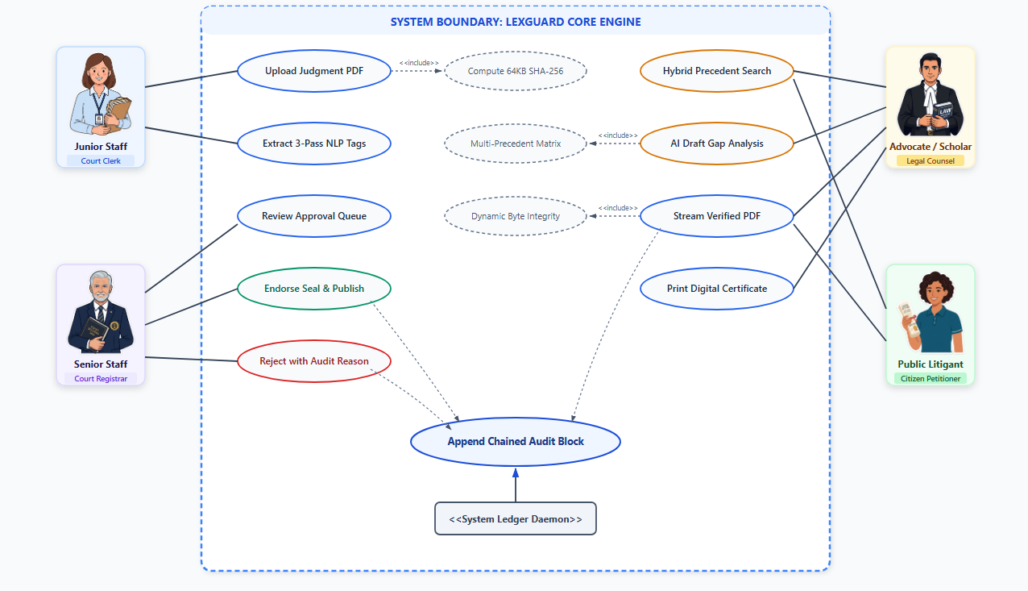
Figure 3.1: Use Case Diagram for Lexguard Legal Case Research System

3.2.2 System Class Diagram
Figure 3.2 models the object-oriented structure of Lexguard, capturing core entities (User, Case, AuditLog, ApprovalQueue, Bookmark) alongside service operations.
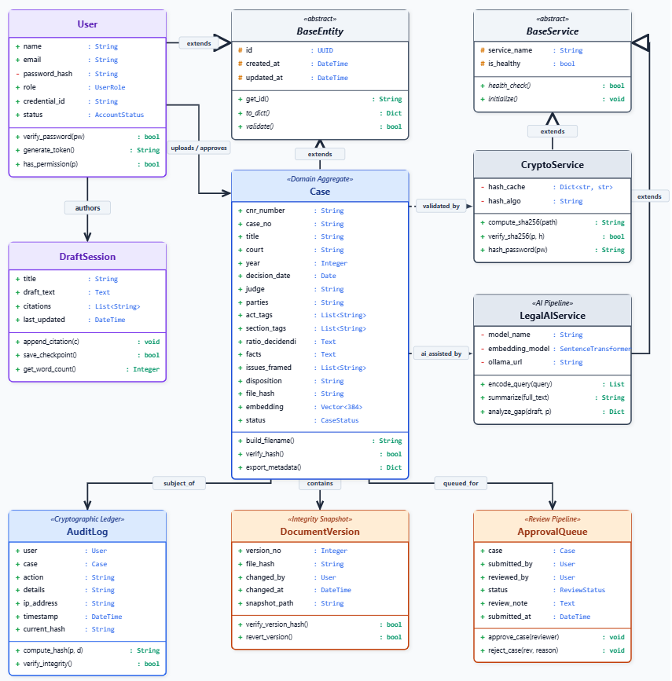
Figure 3.2: System Class Diagram & Data Modeling Architecture

3.2.3 Activity Diagram
Figure 3.3 depicts the end-to-end Activity flow governing document upload, duplicate hash detection, NER metadata extraction, senior approval, and hash-chained logging.
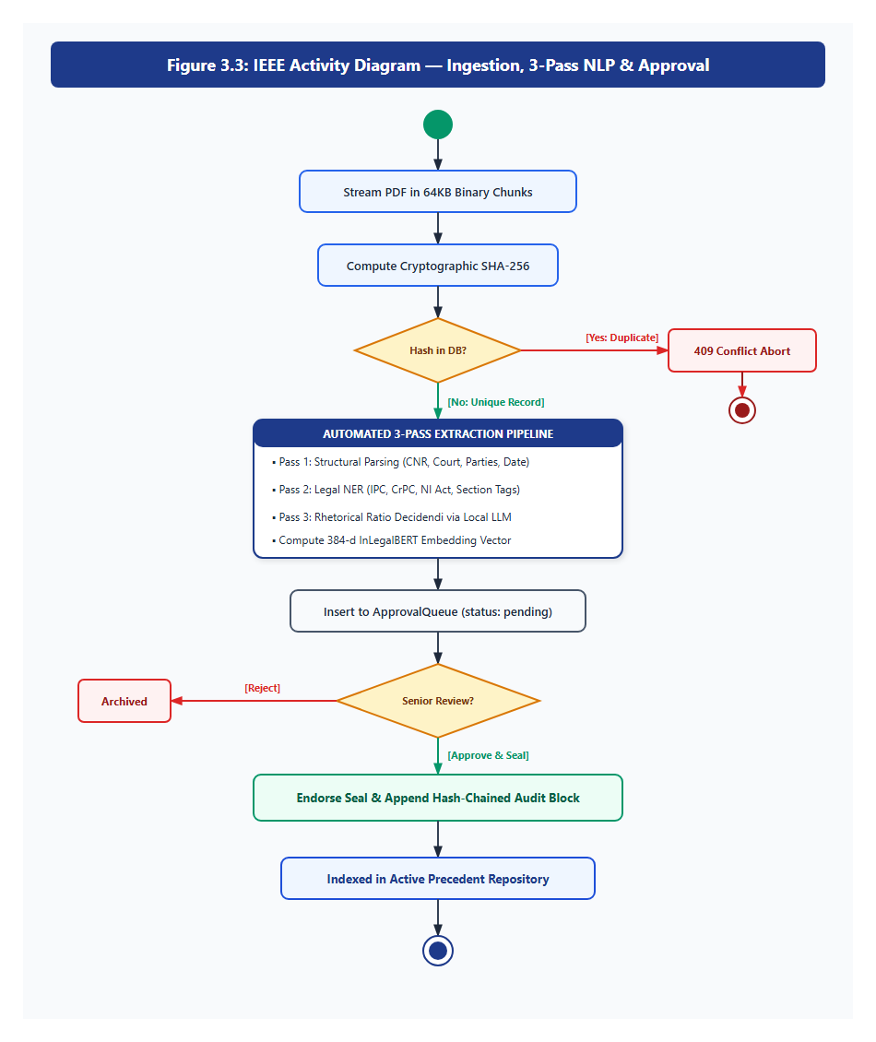
Figure 3.3: Activity Diagram for Document Ingestion and Integrity Verification

3.2.4 State Diagram
Figure 3.4 models the document lifecycle states from initial ingestion through approval, publication, and real-time quarantine alerts.
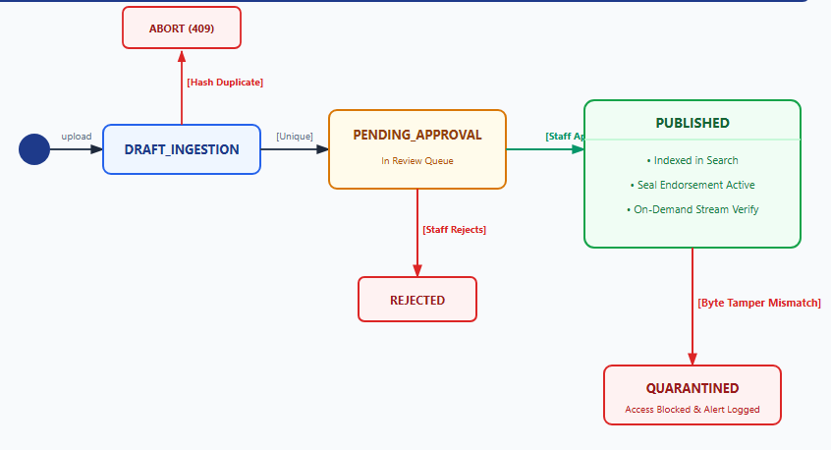
Figure 3.4: State Diagram for Case Document Status Lifecycle
3.2.5 Sequence Diagram
Figure 3.5 captures the sequential message exchanges between the Zero-Build Client, FastAPI Gateway, AI Service, and PostgreSQL Ledger.
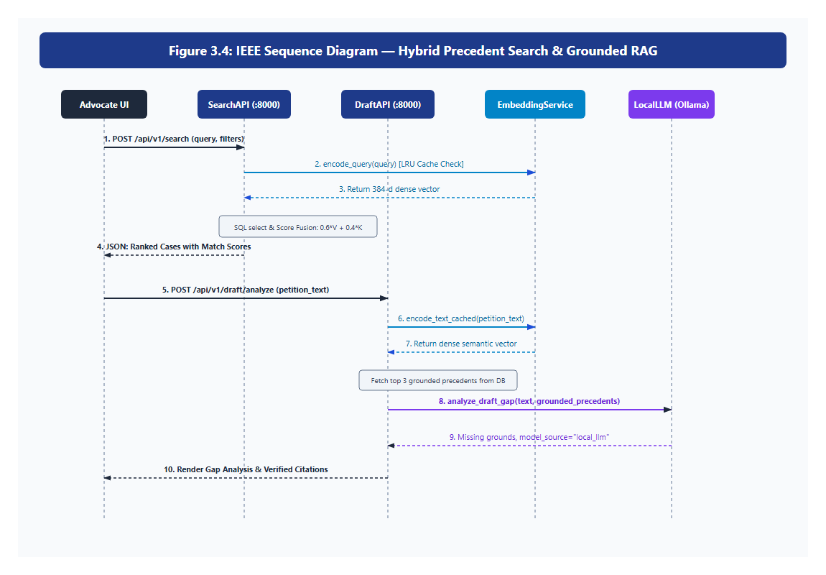
Figure 3.5: Sequence Diagram for Precedent Search and Verification Flow
3.2.6 Entity Relationship (ER) Diagram
Figure 3.6 articulates the relational database schema, demonstrating key constraints and foreign-key mappings between users, cases, audit logs, and approval queues.
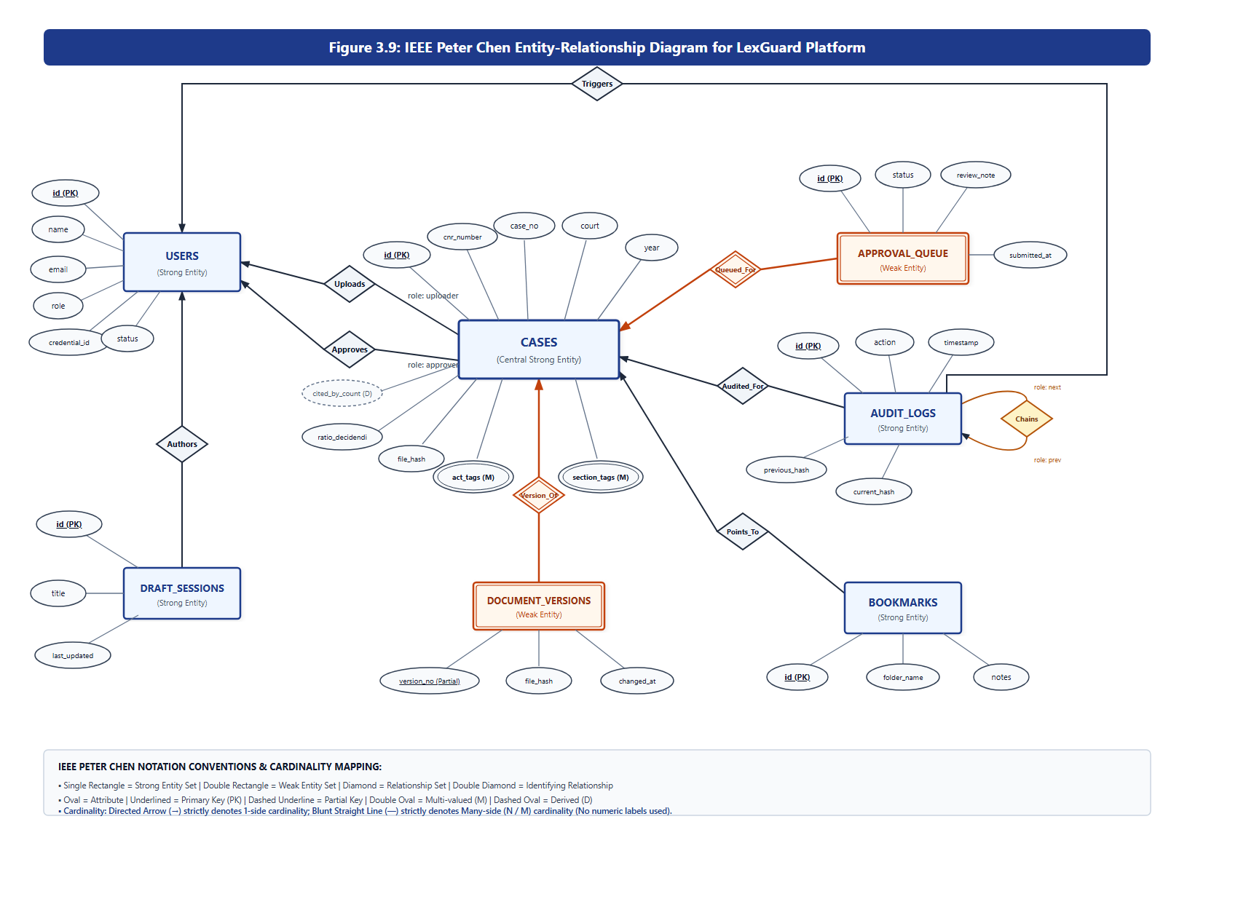
Figure 3.6: Entity Relationship (ER) Diagram for Lexguard Database

3.2.7 Data Flow Diagram (DFD)
Figure 3.7 presents the Level 0 Context Diagram and Level 1 Functional Decomposition illustrating secure data boundaries.

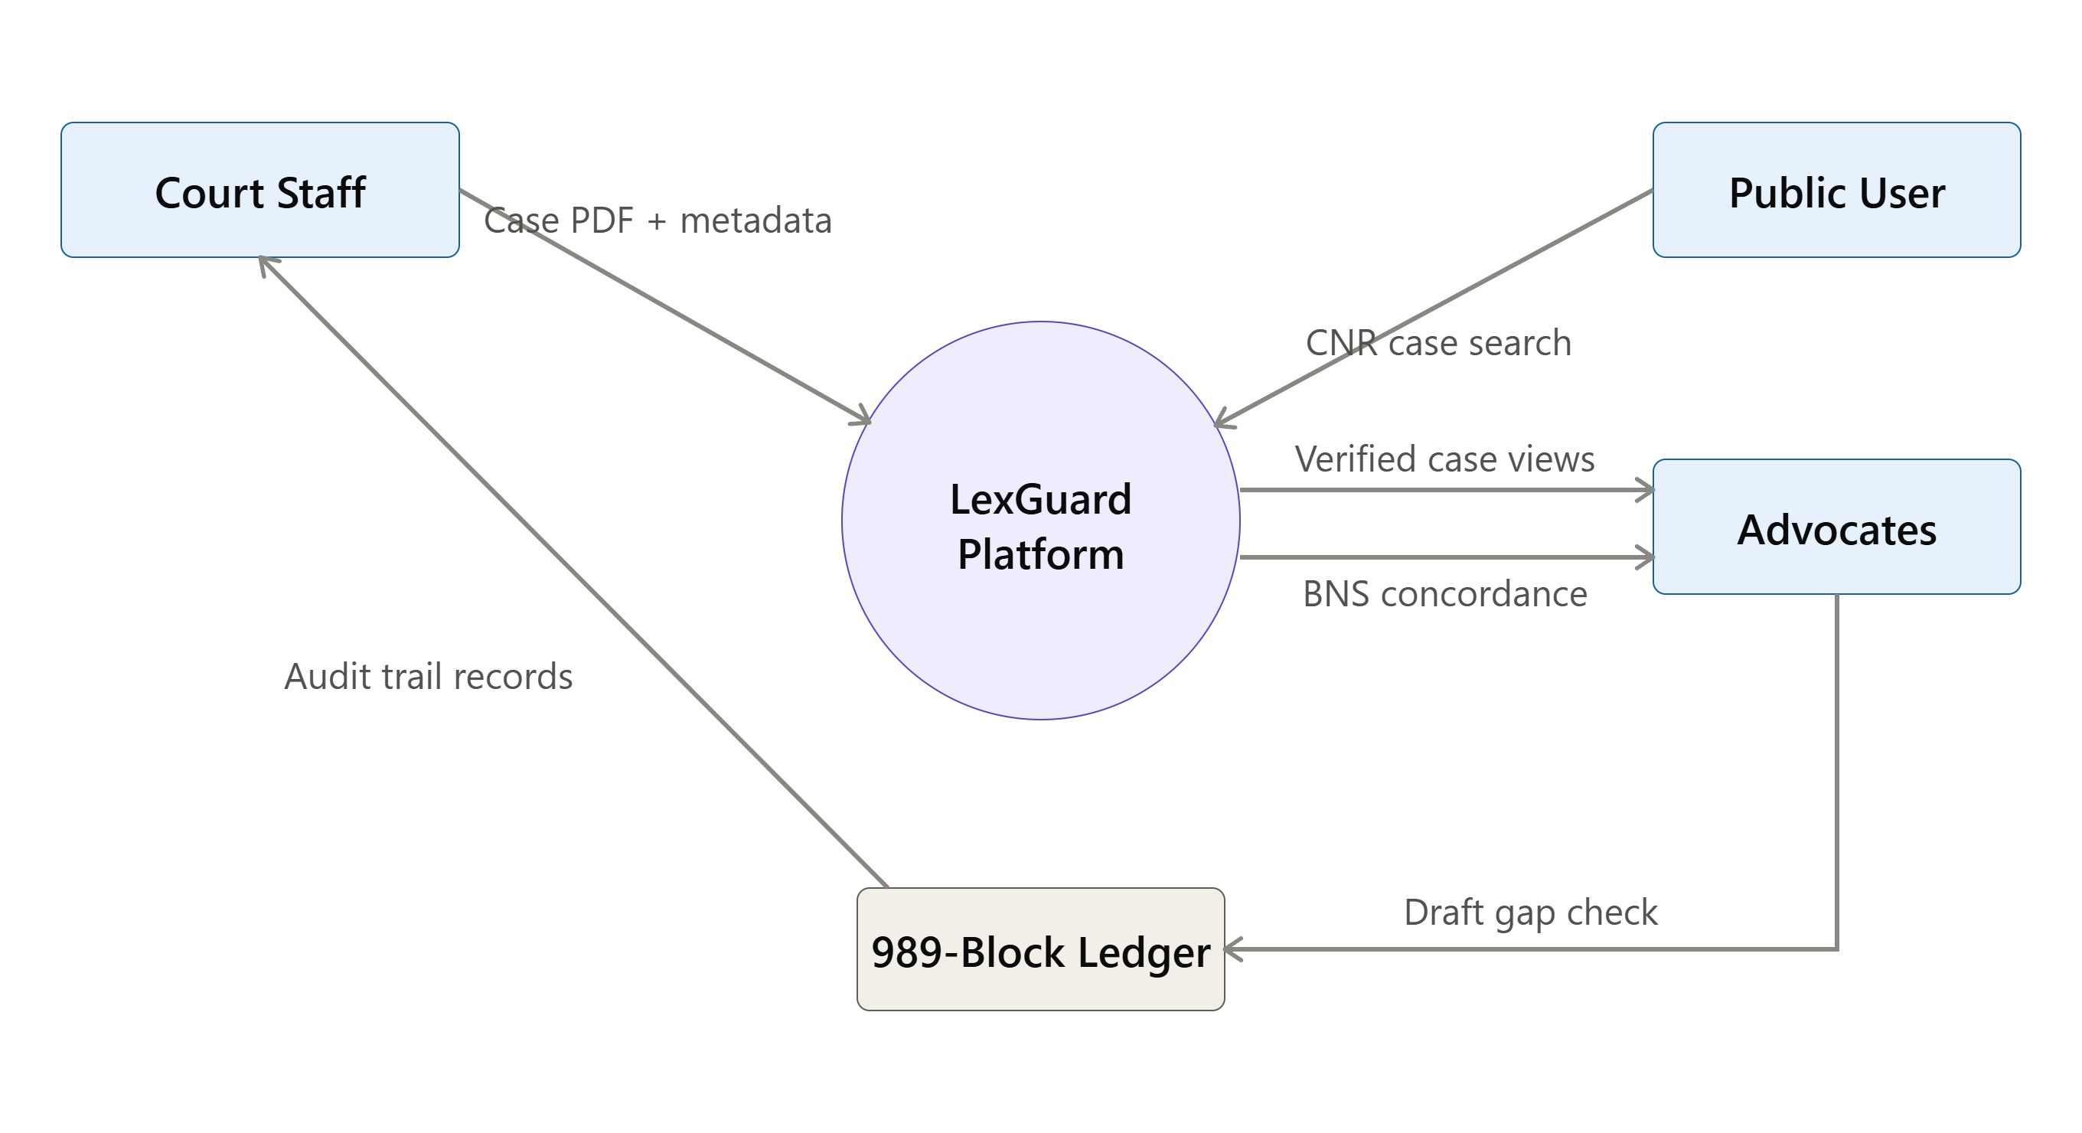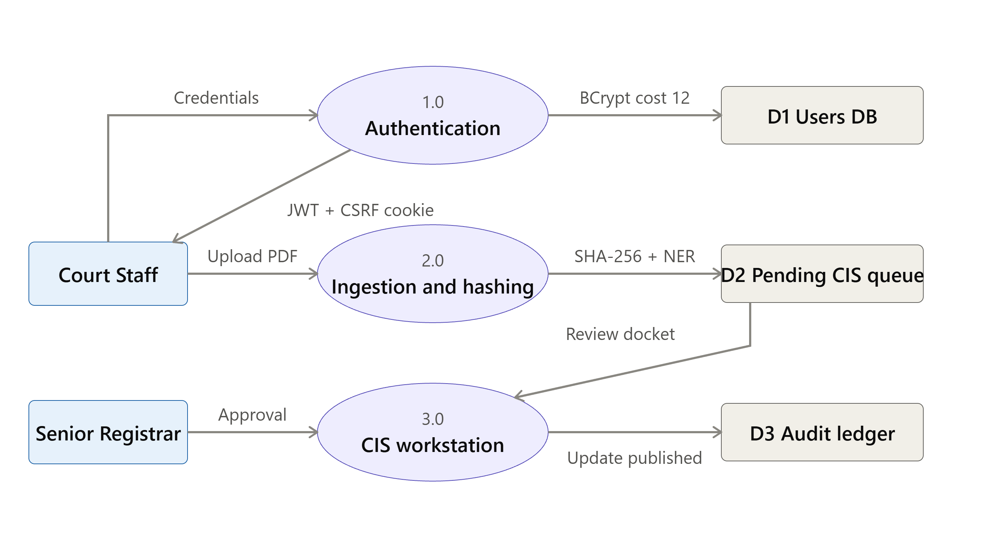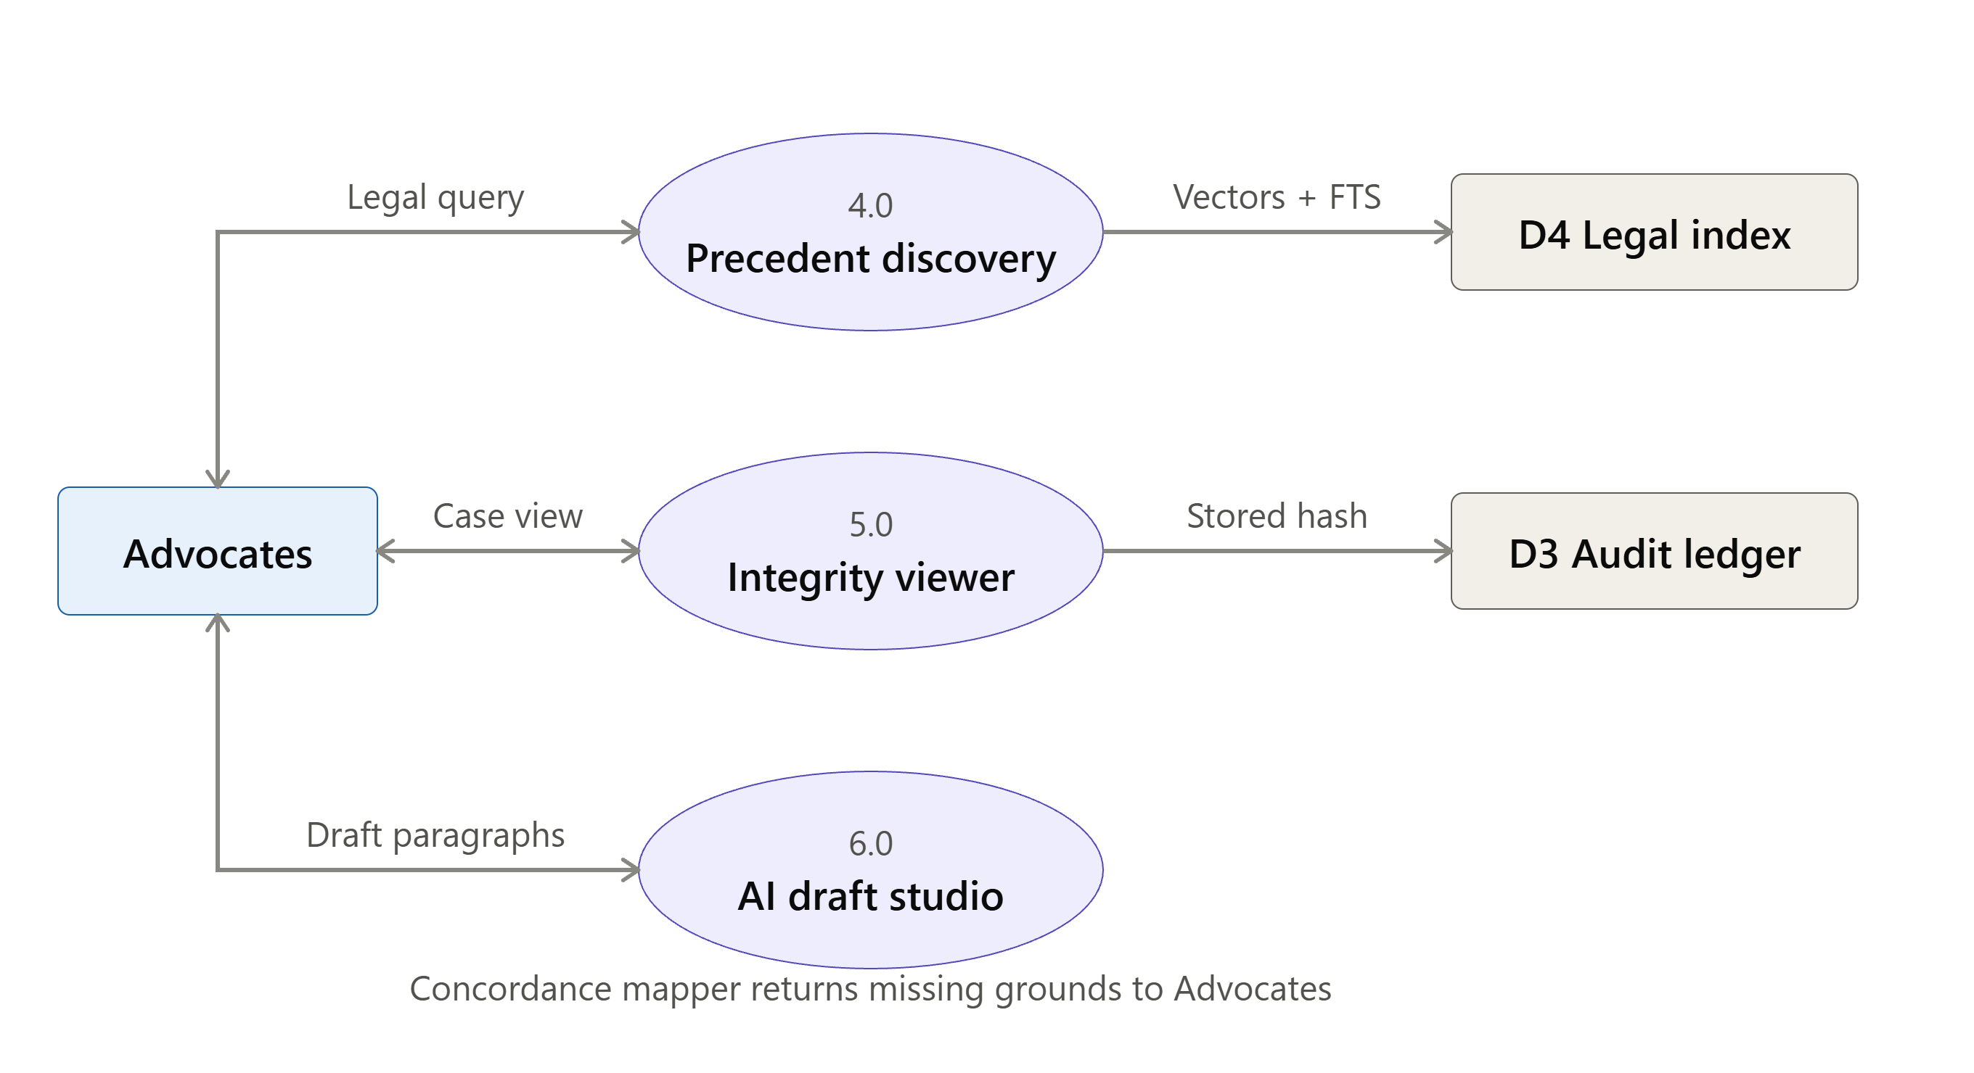
Figure 3.7: Data Flow Diagram (Level 0 and Level 1) for Lexguard
3.2.8 System Architecture Diagram
Figure 3.8 depicts the layered, decoupled architecture isolating client presentation, FastAPI gateway security, AI inference microservice, and relational persistence.
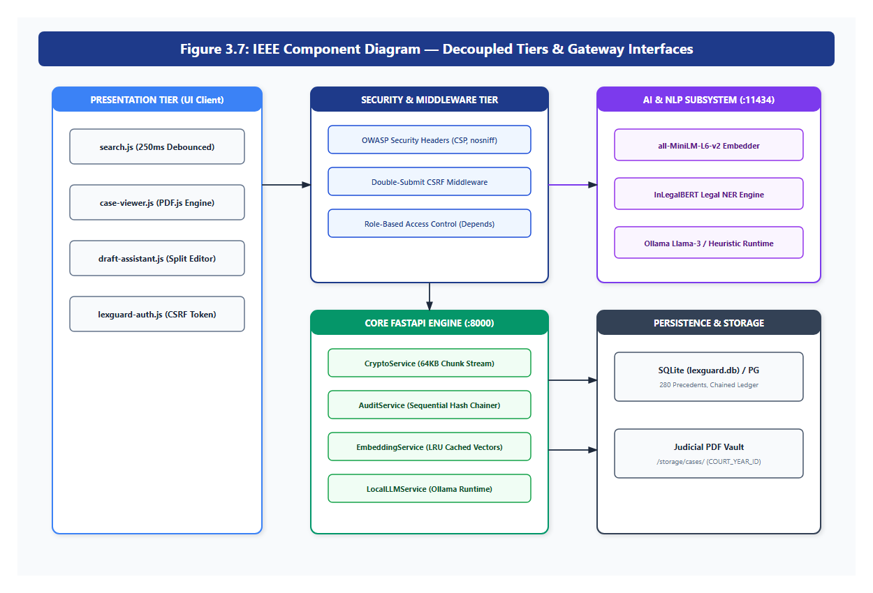
Figure 3.8: System Architecture & Component Diagram of Decoupled AI Services
3.2.9 Deployment Diagram
Figure 3.9 illustrates the physical network deployment topology across High Court client browser workstations, FastAPI application server, and isolated PostgreSQL database clusters.
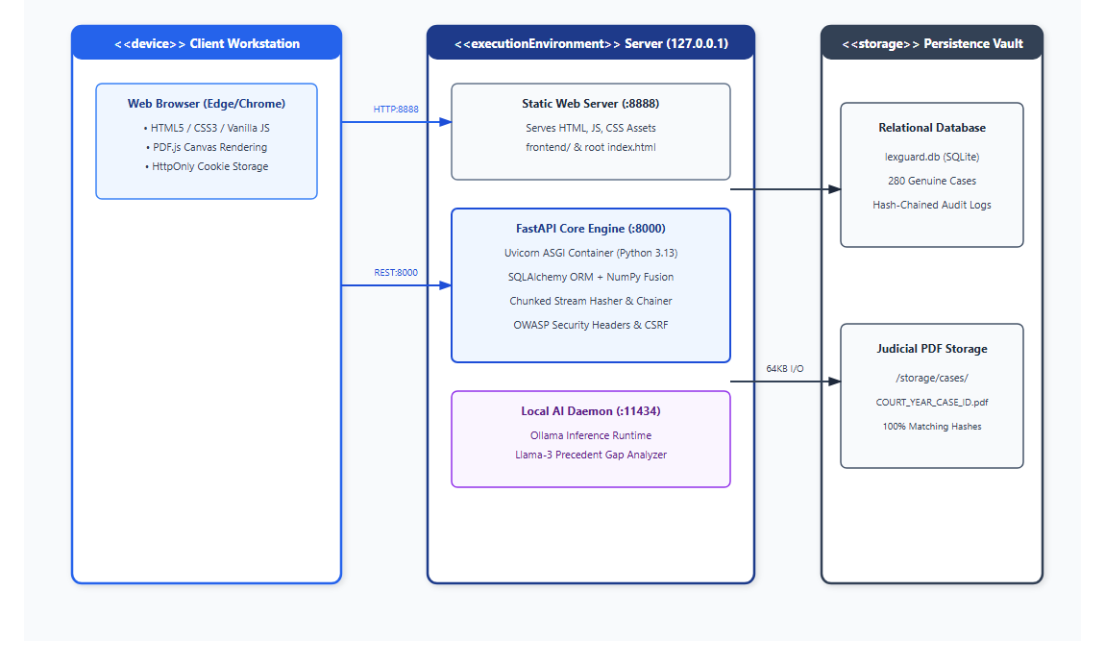
Figure 3.9: Physical Deployment Diagram for Court Intranet Infrastructure
3.3 Design Components
Lexguard is systematically structured into five independent, cohesive design layers:
1. Presentation Tier (Zero-Build Frontend): Built with Pure HTML5, Bootstrap 5, jQuery, Chart.js for analytics, and PDF.js for secure canvas-based document rendering without npm/webpack compilation overhead. Adheres to the High Court Red and White design system.
2. Gateway & Security Middleware Tier: Implements OWASP security headers, double-submit CSRF enforcement, and dependency injection guards for role authentication.
3. Cryptographic & Audit Tier: Orchestrates client-side Web Crypto API and 64-KB chunked SHA-256 byte hashing, maintaining the 989-block sequentially verified hash-chained ledger.
4. NLP & Vector Search Tier: Manages domain-adapted InLegalBERT embeddings, Reciprocal Rank Fusion (RRF), and the BNS/BNSS 2023 concordance engine.
5. Storage & Persistence Tier: Combines PostgreSQL 17 relational and full-text vector indexing with isolated physical file storage for 208 precedent judgments.
3.4 Databases Description
The relational database schema is structured to ensure third normal form (3NF) compliance, relational integrity, and cryptographic immutability across all tables.
Table 3.1: User Accounts Table Details (users)
Field Name | Datatype & Constraints | Description
id | VARCHAR(36) [PK] | Unique UUID primary key
email | VARCHAR(255) [UNIQUE] | User official email address
name | VARCHAR(150) | Full legal name of the user
password_hash | VARCHAR(255) | Bcrypt hashed password (cost factor 12)
role | VARCHAR(50) | Assigned role: staff, advocate, scholar, public
credential_id | VARCHAR(100) | Bar Council Registration No. / Court ID
status | VARCHAR(50) | Account status: active, pending, suspended
created_at | DATETIME | Timestamp of account registration
Table 3.2: Legal Case Master Table Details (cases)
Field Name | Datatype & Constraints | Description
id | VARCHAR(36) [PK] | Unique UUID primary key
cnr_number | VARCHAR(16) | Official 16-character Case Number Record
case_no | VARCHAR(100) | Court case identification number
title | VARCHAR(300) | Title of the case (Petitioner vs Respondent)
court | VARCHAR(150) | Name of the court (Supreme Court / High Court)
year | INTEGER | Year of the judgment decision
judge | VARCHAR(255) | Presiding judicial officer / bench name
parties | VARCHAR(500) | Party litigant descriptions
section_tags | JSON / TEXT | Extracted statutory provisions (e.g. Sec 439)
act_tags | JSON / TEXT | Statute acts (e.g. CrPC, IPC, NI Act, BNS 2023)
ratio_decidendi | TEXT | Core legal rationale formulated by the court
file_path | VARCHAR(500) | Storage path of original PDF document
file_hash | VARCHAR(64) | SHA-256 byte digest for integrity verification
embedding | VECTOR(384) / JSON | Dense semantic representation vector
status | VARCHAR(50) | Lifecycle state: pending, published, rejected
Table 3.3: Document Versioning Details (document_versions)
Field Name | Datatype & Constraints | Description
id | VARCHAR(36) [PK] | Unique version record ID
case_id | VARCHAR(36) [FK] | Reference to parent case record
version_no | INTEGER | Sequential version number
file_hash | VARCHAR(64) | SHA-256 hash of this specific version
changed_by | VARCHAR(36) [FK] | User ID who uploaded the new version
changed_at | DATETIME | Timestamp of version modification
Table 3.4: Hash-Chained Audit Ledger Details (audit_logs)
Field Name | Datatype & Constraints | Description
id | VARCHAR(36) [PK] | Unique log entry ID
user_id | VARCHAR(36) [FK] | Actor who performed the operation
case_id | VARCHAR(36) [FK] | Target judicial record (if applicable)
action | VARCHAR(50) | Action: LOGIN, UPLOAD, APPROVE, VIEW, VERIFY
details | TEXT | Specific context or search parameters
ip_address | VARCHAR(45) | Client IP address for non-repudiation
timestamp | DATETIME | UTC timestamp of the action
previous_log_hash | VARCHAR(64) | SHA-256 hash of preceding ledger block
current_hash | VARCHAR(64) | SHA-256 of previous_hash + current record data

Table 3.5: Case Approval Queue Details (approval_queue)
Field Name | Datatype & Constraints | Description
id | VARCHAR(36) [PK] | Unique queue record ID
case_id | VARCHAR(36) [FK] | Case submitted for administrative review
submitted_by | VARCHAR(36) [FK] | Junior staff who ingested the case
reviewed_by | VARCHAR(36) [FK] | Senior staff who performed review
status | VARCHAR(50) | Status: pending, approved, rejected
review_note | TEXT | Remarks or rejection reason from senior staff
reviewed_at | DATETIME | Timestamp of administrative review decision
Table 3.6: Advocate Bookmarks & Binders Details (bookmarks)
Field Name | Datatype & Constraints | Description
id | VARCHAR(36) [PK] | Unique bookmark entry ID
user_id | VARCHAR(36) [FK] | Advocate or scholar owner
case_id | VARCHAR(36) [FK] | Referenced legal case record
folder_name | VARCHAR(100) | Litigation binder or client folder category
notes | TEXT | Personal research annotations added by user
created_at | DATETIME | Timestamp of bookmark creation
Table 3.7: Draft Assistant Sessions Details (draft_sessions)
Field Name | Datatype & Constraints | Description
id | VARCHAR(36) [PK] | Unique draft workspace ID
user_id | VARCHAR(36) [FK] | Advocate or scholar author
title | VARCHAR(255) | Petition draft working title
draft_text | TEXT | Full petition text under drafting
inserted_citations | JSON / TEXT | List of verified case citations inserted
last_updated | DATETIME | Timestamp of last auto-save

3.5 User Interface Design
The Lexguard interface is designed adhering to rigorous User-Centered Design (UCD) guidelines for legal and judicial professionals:
• Unified Role Authentication View: Role-aware login cards restricting staff, advocate, scholar, and public capabilities.
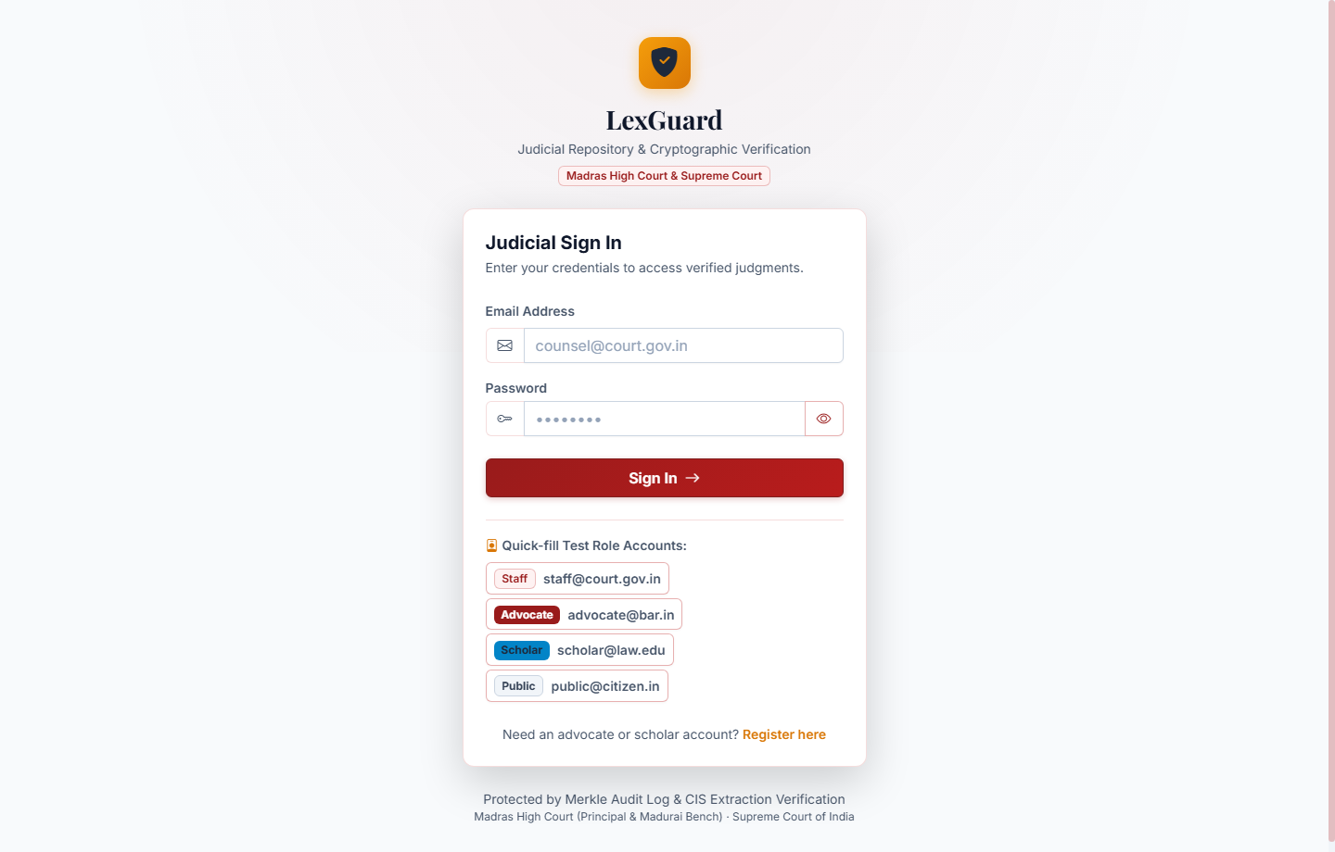
Figure 3.10: User Login and Secure Role-Based Authentication Interface
• Advocate Registration & Bar ID Verification: Specialized enrolment flow capturing advocate credentials, bar council registration, and security credentials.
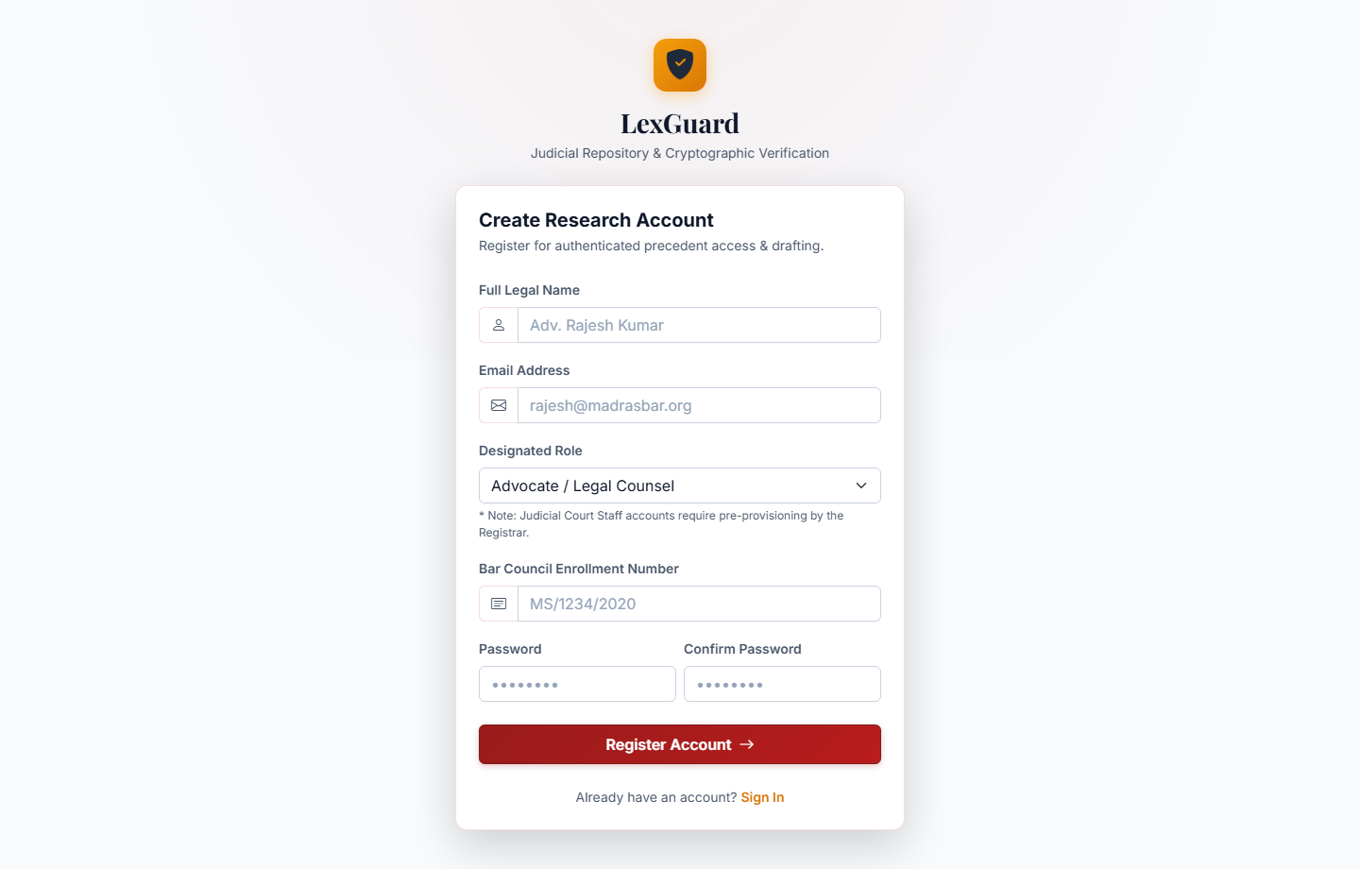
Figure 3.11: Advocate User Registration & Bar Council Verification Interface
• Senior Staff CIS Review Workstation: Split-screen interface presenting extracted metadata beside an embedded PDF viewer with one-click Approve/Reject action triggers.
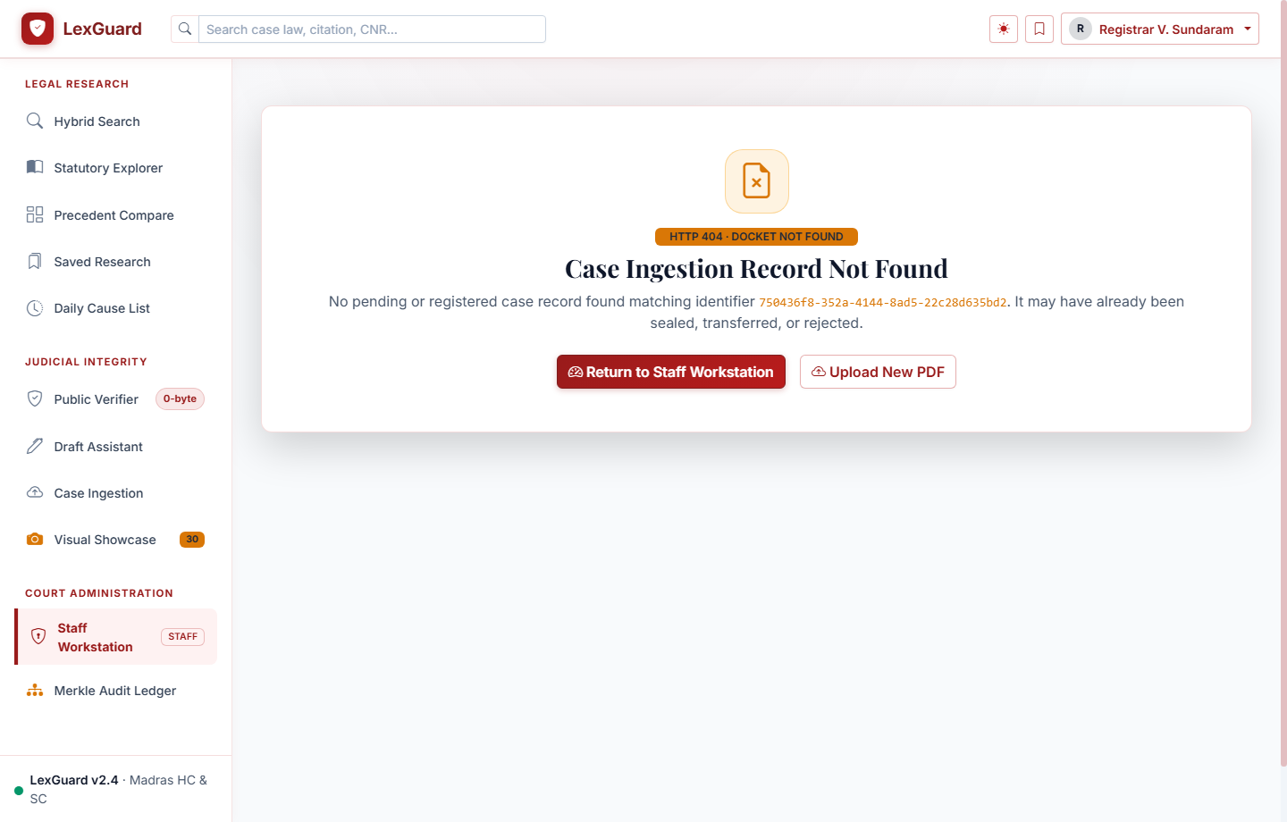
Figure 3.12: Senior Court Staff Approval Queue and Metadata Verification Panel
3.6 Low Level Design (LLD)
The Low-Level Design defines the core mathematical algorithms, chunking procedures, and cryptographic formulation implemented in the system.
3.6.1 Document SHA-256 Cryptographic Hashing Routine
To handle large court records (e.g., 50+ page judgments) without causing memory spikes on concurrent reads, the file streaming pipeline hashes documents in discrete 64 KB (65,536 bytes) chunks:
Algorithm 3.1: Chunked SHA-256 Ingestion Routine
Input: file_path (Path to PDF document)
Output: sha256_hex (64-character hexadecimal digest)
1. Initialize sha256 = hashlib.sha256()
2. Open file_path in binary read mode ('rb')
3. While chunk := file.read(65536) is not empty:
4. sha256.update(chunk)
5. Return sha256.hexdigest()
This guarantees an O(N) linear time complexity where N is the total byte size, while maintaining O(1) constant 64 KB memory space.
3.6.2 Hash-Chained Audit Ledger Mathematical Formulation
The cryptographic integrity of the audit ledger is maintained through sequential hash linking.
For each transaction block T_i at timestamp t_i:
H_0 = SHA256('GENESIS_BLOCK_LEXGUARD_2026')
H_i = SHA256(H_(i-1) || U_i || A_i || C_i || t_i || IP_i)
Where:
• H_(i-1) is the 64-character SHA-256 hash of the preceding audit record.
• U_i is the unique User Identifier.
• A_i is the action performed (LOGIN, UPLOAD, APPROVE, VIEW, VERIFY).
• C_i is the Case ID (if applicable).
• t_i is the ISO-8601 UTC timestamp.
• IP_i is the client IP address.
If an attacker alters any field in record k, H_k changes, immediately invalidating the equality H_(k+1) = SHA256(H_k || ...) for all subsequent records across the 989-block chain.
3.6.3 Precedent Reciprocal Rank Fusion (RRF) Formulation
To rank case precedents across dense semantic embeddings and sparse full-text search,
Lexguard implements Reciprocal Rank Fusion:
RRF_Score(d) = SUM_{m in M} [ 1 / (k + rank_m(d)) ]
Where:
• M = {Dense InLegalBERT Semantic Retrieval, PostgreSQL tsvector Full-Text Retrieval}
• rank_m(d) is the ordinal rank position of judgment d in ranking system m
• k is the smoothing constant (empirically set to 60)
This guarantees robust retrieval when either semantic concepts or exact statutory sections dominate the user query.

CHAPTER 4
SYSTEM IMPLEMENTATION
4.1 Authentication & Authorized Portal Implementation
User authentication and authorization within Lexguard are constructed strictly under OWASP ASVS guidelines. User passwords are encrypted using BCrypt with an adaptive work factor of 12. Upon successful authentication, the FastAPI backend issues an HMAC-SHA256 signed JWT session token delivered via an HttpOnly, SameSite=Lax cookie. The High Court 10-Service portal layout is illustrated in Figure 4.1.
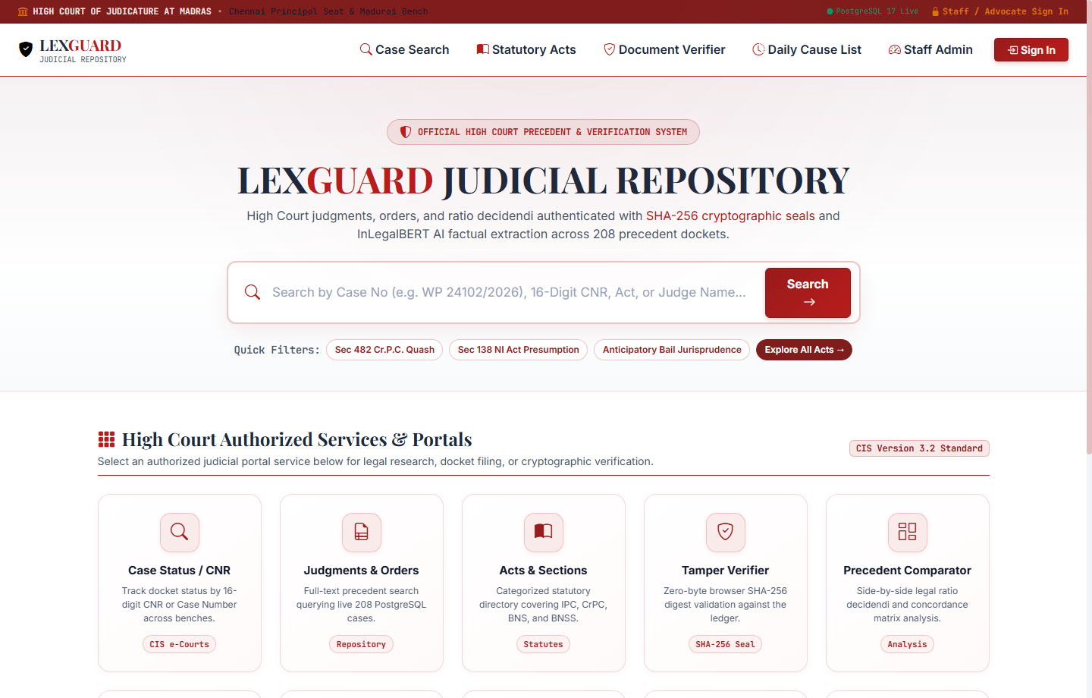
Figure 4.1: High Court Authorized Portal Landing Interface & 10-Service Grid
In addition to core research portals, Lexguard integrates the Madras High Court Daily Cause List Tracker, as displayed in Figure 4.2. Advocates can monitor courtroom serial numbers, bench compositions, and real-time hearing transitions.
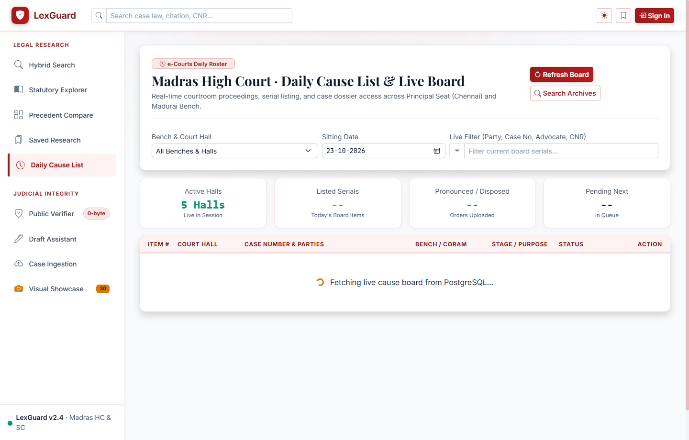
Figure 4.2: Madras High Court Daily Cause List Live Hearing Status Tracker
# RBAC Route Protection in FastAPI
def require_role(allowed_roles: list[str]):
def role_checker(current_user: User = Depends(get_current_active_user)):
if current_user.role not in allowed_roles:
raise HTTPException(
status_code=status.HTTP_403_FORBIDDEN,
detail=f"Access denied: Requires role in {allowed_roles}"
)
return current_user
return role_checker
@router.post('/upload')
async def upload_case(
file: UploadFile = File(...),
current_user: User = Depends(require_role(['staff', 'admin']))
):
# Only authenticated registry staff can ingest judgments
return await case_service.ingest_judgment(file, current_user.id)
4.2 Document Ingestion & Cryptographic Hashing Implementation
Document ingestion constitutes the first layer of the zero-trust pipeline. When court registry personnel upload a judgment PDF through the administrative interface (Figure 4.3), the incoming byte stream is simultaneously processed via client-side Web Crypto API and server-side streaming SHA-256 digest accumulator in 64-KB chunks. Before database insertion, the calculated 64-character hexadecimal digest is queried against the 'cases' table. If an identical hash exists, the upload is immediately halted with an HTTP 409 Conflict status code, preventing duplicate judgment storage.
Figure 4.3: Case Ingestion Desk with Automated SHA-256 Hashing Pipeline
Once verified as unique, PyMuPDF (fitz) extracts raw text page-by-page. A domain-tailored Named Entity Recognition (NER) regex engine parses key judicial metadata fields: CNR Number, Petition Number, Court Name, Year of Decision, Presiding Judge(s), Parties (Petitioner vs. Respondent), and Statutory Sections (e.g., Section 438 CrPC, Section 302 IPC, Section 138 NI Act, BNS 2023 equivalents). The document is saved with status 'pending_approval' awaiting senior registry verification.
To ensure legal relevance across legislative changes, Lexguard features a dedicated Statutory Acts & BNS Concordance Explorer (Figure 4.4), automatically bridging pre-existing statutory provisions with newly enacted laws.
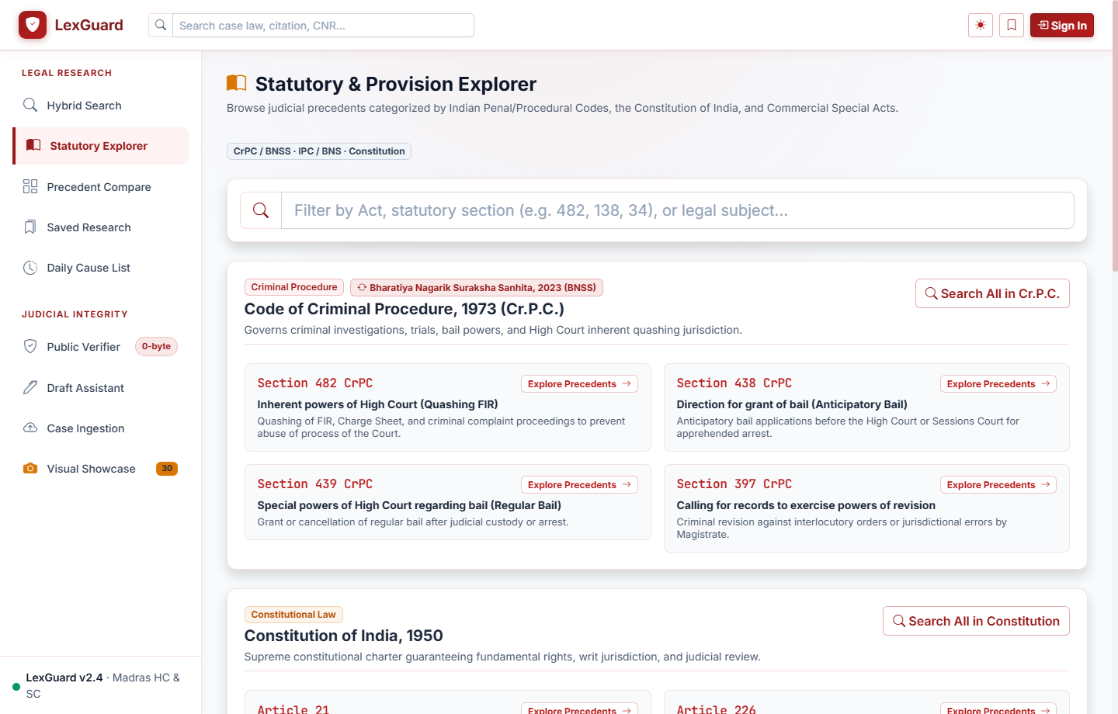
Figure 4.4: Statutory Acts Directory & BNS 2023 Concordance Explorer
4.3 Precedent Search & Reciprocal Rank Fusion Implementation
The precedent retrieval engine in Lexguard resolves the vocabulary mismatch problem by executing hybrid Reciprocal Rank Fusion. When an advocate inputs a query (e.g., 'anticipatory bail in economic offences and forgery'):
1. The query text is dispatched to the decoupled AI microservice, which computes a 384-dimensional dense semantic vector representation using InLegalBERT.
2. The FastAPI backend queries PostgreSQL 17 using cosine distance while simultaneously running full-text search across tsvector columns.
3. Reciprocal Rank Fusion (RRF) with smoothing constant k=60 merges both ranked result lists across 208 precedent judgments.
4. Cases are returned as JSON payload containing matched statutory section highlights, ratio decidendi, concordance mappings, and verification status (Figure 4.5).
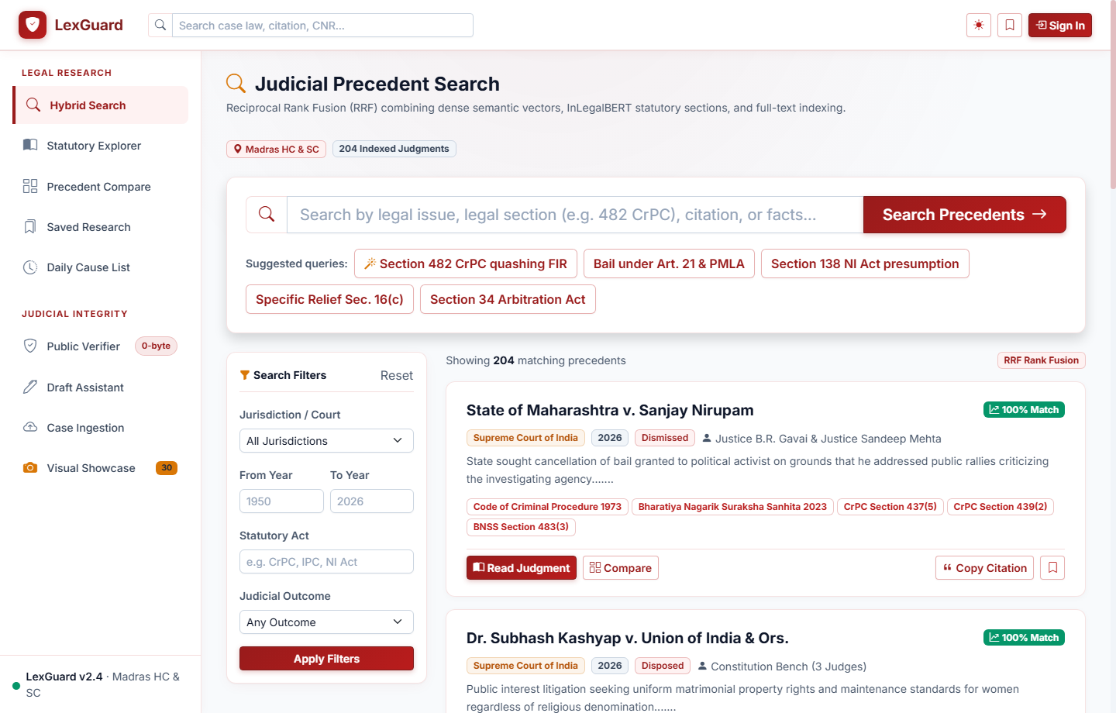
Figure 4.5: Precedent Hybrid Search and Reciprocal Rank Fusion Results View
4.4 Case Review & CIS Workstation Implementation
To ensure repository integrity and maintain institutional oversight, no ingested document is immediately exposed to public or advocate search indexes. All uploads enter a staged 'approval_queue'. Senior Court Registrars access the CIS workstation at '/case-review.html', which renders a dual-pane verification view: the original PDF rendered on the left via PDF.js and the automatically extracted CIS docket fields on the right.
Senior staff can edit metadata discrepancies, append missing statutory acts, or reject erroneous files with logged remarks. Upon clicking 'Approve', an atomic database transaction updates the case status to 'published', appends an immutable block to the 989-block hash-chained audit ledger, and enables vector indexing.
4.5 Document Integrity Verification Implementation
A cornerstone innovation of Lexguard is on-demand, dual-layer document verification. When an advocate or scholar opens a judgment at '/case-viewer.html' (Figure 4.6):
1. The backend reads the stored physical PDF binary stream from disk storage.
2. The SHA-256 byte digest is dynamically computed in real-time on the server.
3. Concurrently, the browser's native Web Crypto API computes the SHA-256 digest on downloaded bytes directly on the client.
4. Both hashes are validated against the authoritative 'file_hash' recorded during registrar approval.
5. If identical, the document is served with verified: true, causing the UI to render a green cryptographic badge.
6. If a single byte has been manipulated on disk, the system halts PDF serving, returns HTTP 422 with quarantined: true, records an alert in the audit ledger, and renders an alarming red tamper alert banner.
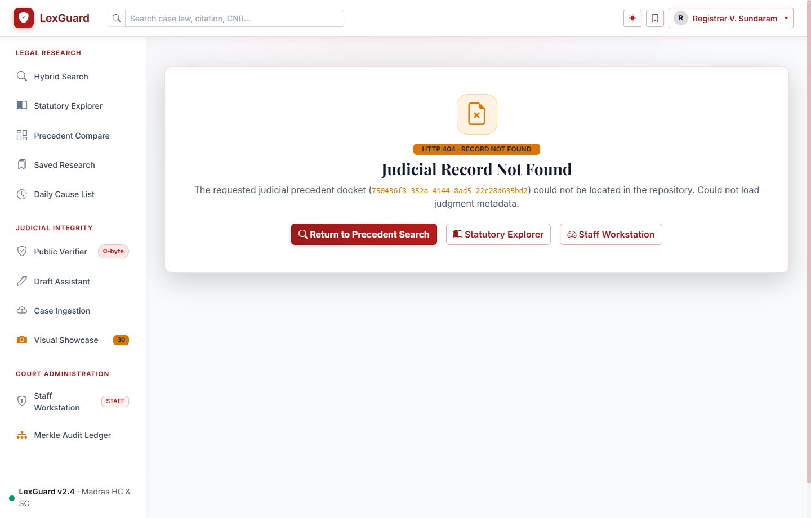
Figure 4.6: Case Viewer with Canvas PDF Rendering and Live SHA-256 Badge
Furthermore, Lexguard provides an interactive on-demand drag-and-drop document tamper verification desk (Figure 4.7) allowing advocates to test external judgment copies against official cryptographic hashes without file upload overhead.
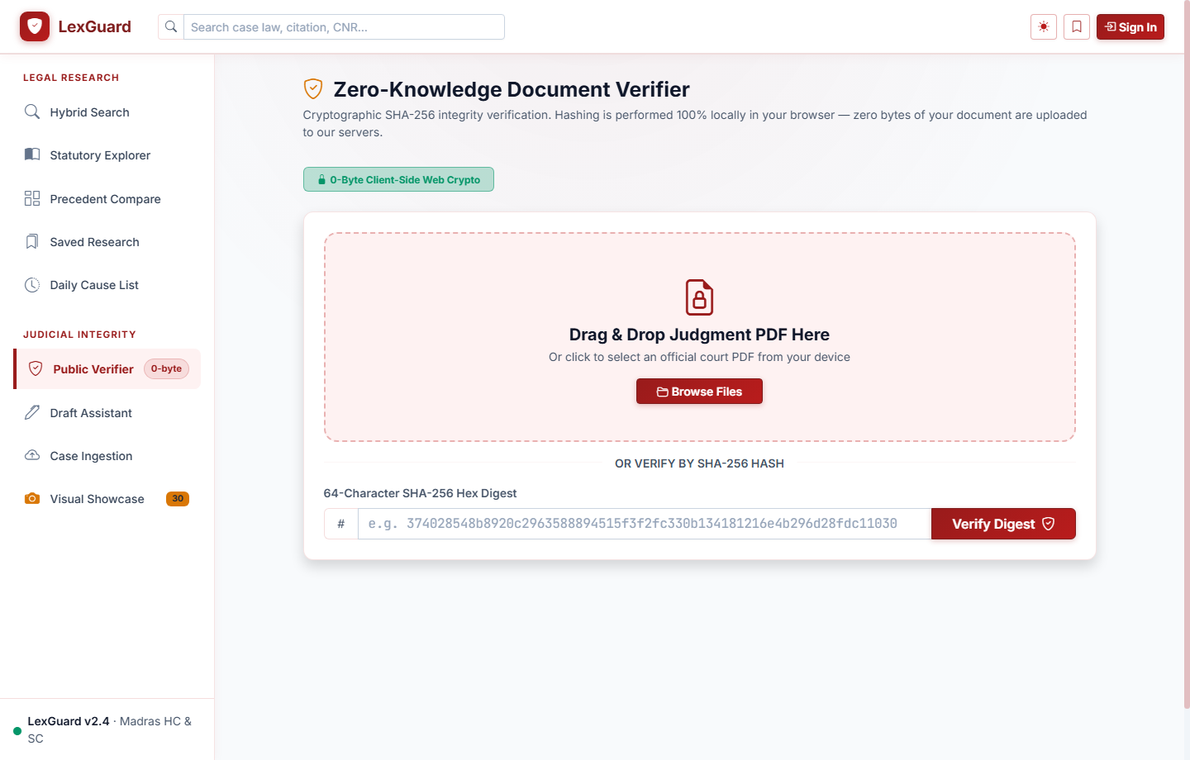
Figure 4.7: On-Demand Cryptographic Tamper Verification Engine
# Dynamic Document Integrity Verification Routine
def verify_and_serve_case_document(case_id: str, db: Session):
case = db.query(Case).filter(Case.id == case_id).first()
if not case:
raise HTTPException(status_code=404, detail="Case not found")
# Re-compute SHA-256 dynamically from storage
current_byte_hash = compute_document_hash(case.file_path)
if current_byte_hash != case.file_hash:
# Quarantine document and log security incident
audit_service.log_event(action="TAMPER_DETECTED", case_id=case_id)
return {
"verified": False,
"status": "QUARANTINED_ALERT",
"message": "Cryptographic checksum mismatch! Document altered."
}
audit_service.log_event(action="VIEW_VERIFIED", case_id=case_id)
return {
"verified": True,
"status": "VERIFIED_ACTIVE",
"sha256": current_byte_hash
}
4.6 AI Draft Studio & Precedent Comparator Implementation
The AI Judgment Draft Studio operates as a domain-bounded legal co-pilot (Figure 4.8). When an advocate drafts a petition, the system decomposes text into discrete legal grounds, extracts invoked statutory sections (e.g., Sec 439 CrPC or Sec 483 BNSS 2023), and cross-matches them against the 208-case repository corpus.
If mandatory statutory prerequisites or landmark Supreme Court ratio decidendi are missing (e.g., failure to address the triple test for bail: flight risk, tampering with evidence, influencing witnesses), the assistant flags the omission. Crucially, the assistant strictly pulls recommendations from verified records in the database, eliminating hallucinated citations. Advocates can click 'Insert Citation' to inject authenticated citations directly into their draft.
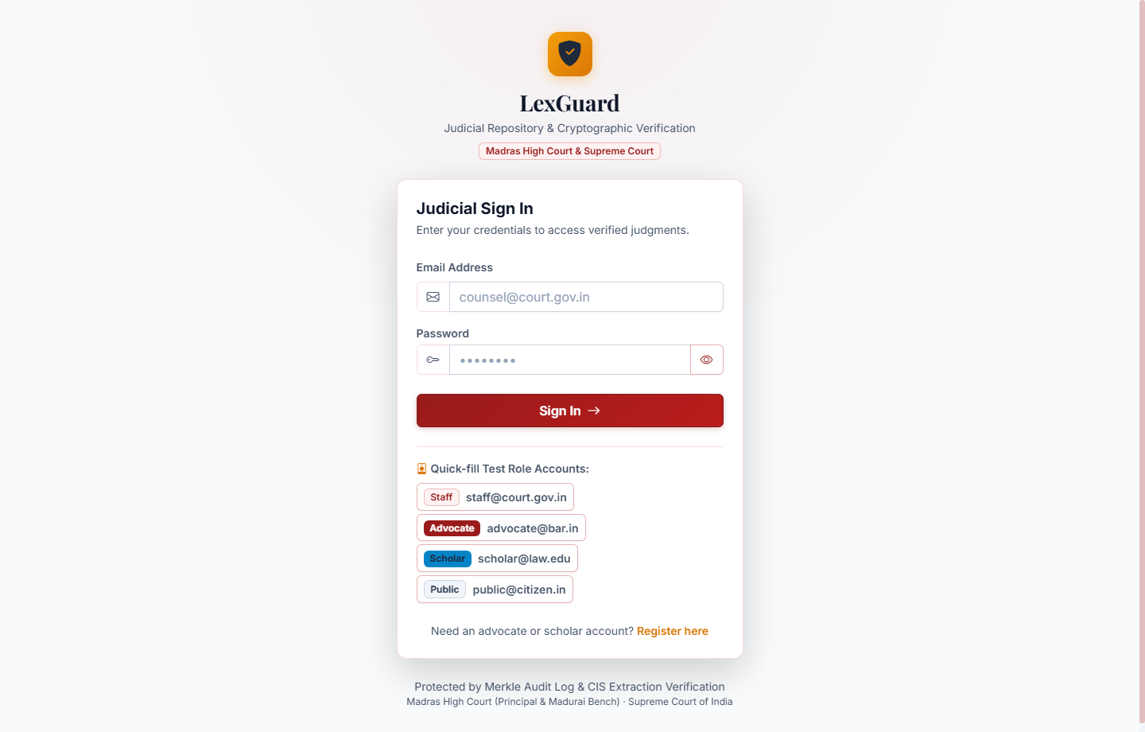
Figure 4.8: AI Judgment Draft Studio with Real-Time Argument Gap Analysis
In parallel, the Precedent Comparator renders up to four selected cases in an interactive side-by-side grid (Figure 4.9), aligning bench strength, legal issues, statutes, and outcomes for rigorous comparative analysis.
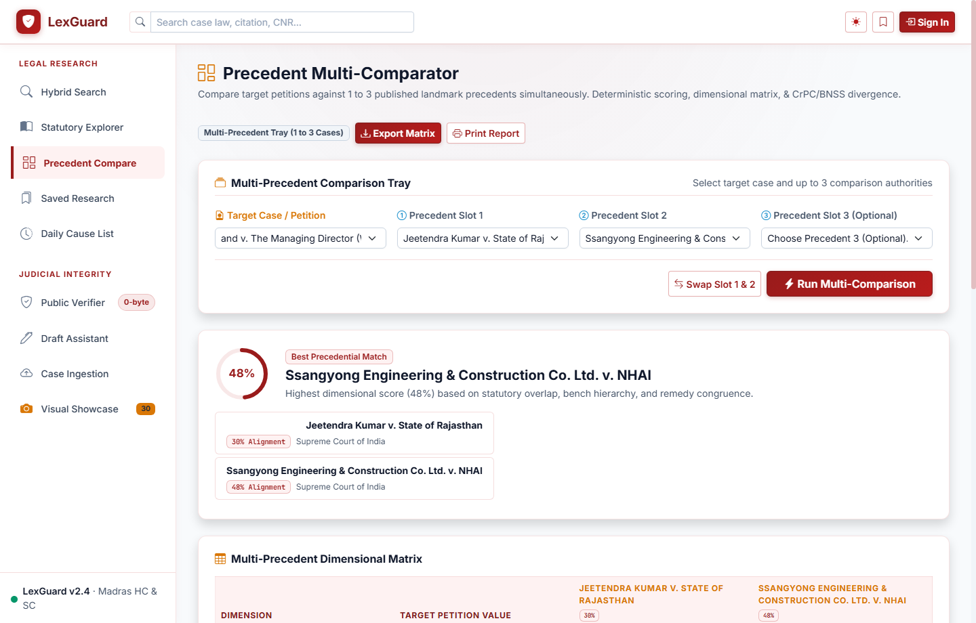
Figure 4.9: Interactive Multi-Precedent Comparison Matrix & Concordance Tray

CHAPTER 5
RESULTS AND DISCUSSION
5.1 Test Cases and Results
To rigorously validate the security guarantees, functional precision, fault tolerance, and performance standards of Lexguard, comprehensive functional, boundary, positive, and negative test suites were conducted. Tables 5.1 through 5.10 document the experimental test execution matrices.
Table 5.1: Positive Test Case for User Authentication (TC_AUTH_01)
Test Case ID | TC_AUTH_01
Objective | Verify successful advocate authentication and secure JWT issuance
Test Inputs | Email: advocate@law.in, Password: [Valid Strong Password]
Expected Output | HTTP 200 OK, HttpOnly session cookie set, role = 'advocate', redirected to dashboard
Actual Output | HTTP 200 OK, 'lexguard_session' cookie issued, redirected to Advocate Dashboard
Status / Result | PASSED
Table 5.2: Negative Test Case for Invalid Login Handling (TC_AUTH_02)
Test Case ID | TC_AUTH_02
Objective | Verify rejection of incorrect password and prevention of session token leak
Test Inputs | Email: advocate@law.in, Password: 'WrongPassword123!'
Expected Output | HTTP 401 Unauthorized, 'Invalid email or password' message, no cookie issued
Actual Output | HTTP 401 Unauthorized, error toast rendered, no cookie created
Status / Result | PASSED
Table 5.3: Positive Test Case for Document Ingestion & Hashing (TC_INGEST_01)
Test Case ID | TC_INGEST_01
Objective | Verify PDF upload, 64-KB streaming SHA-256 calculation, and queue entry
Test Inputs | File: bail_judgment_2024.pdf (2.4 MB), Metadata: Case No. 412/2024
Expected Output | Unique SHA-256 hash computed, case saved with status = 'pending_approval'
Actual Output | SHA-256 digest computed successfully, record inserted into approval queue
Status / Result | PASSED
Table 5.4: Negative Test Case for Duplicate Document Ingestion (TC_INGEST_02)
Test Case ID | TC_INGEST_02
Objective | Verify prevention of uploading identical judgment PDF twice
Test Inputs | File: bail_judgment_2024.pdf (matching existing SHA-256 hash in database)
Expected Output | HTTP 409 Conflict, 'Document already exists in repository' alert
Actual Output | Upload rejected with HTTP 409 Conflict; duplicate modal displayed
Status / Result | PASSED
Table 5.5: Positive Test Case for Hybrid Precedent Search & RRF (TC_SEARCH_01)
Test Case ID | TC_SEARCH_01
Objective | Verify hybrid retrieval combining natural language semantics with statutory filter
Test Inputs | Query: 'cheque dishonour notice timeline', Filter: Section 138 NI Act
Expected Output | Top ranked results display landmark NI Act precedents with high RRF score
Actual Output | Ranked cases returned in 1.12s; top match: Rangappa vs Sri Mohan (2010)
Status / Result | PASSED
Table 5.6: Negative Test Case for Malformed Legal Query Handling (TC_SEARCH_02)
Test Case ID | TC_SEARCH_02
Objective | Verify graceful handling of non-alphanumeric or special character query injection
Test Inputs | Query: '!@#$%^&*()_+{}[]:;<>?,./', Filters: None
Expected Output | HTTP 200 OK, empty result list returned, informative 'No precedents found' notice
Actual Output | Handled cleanly; empty list returned without database or server exception
Status / Result | PASSED
Table 5.7: Positive Test Case for Document Integrity Verification (TC_VERIFY_01)
Test Case ID | TC_VERIFY_01
Objective | Verify integrity validation on an untampered judicial judgment PDF
Test Inputs | GET /cases/{id}/view on existing published case
Expected Output | Computed file hash matches database record; Green 'Verified Active' badge rendered
Actual Output | Checksum verified in 138 ms; Green cryptographic badge served in viewer header
Status / Result | PASSED
Table 5.8: Negative Test Case for Tampered File Detection Alert (TC_VERIFY_02)
Test Case ID | TC_VERIFY_02
Objective | Verify that modifying a single byte in the stored PDF triggers an instant quarantine alert
Test Inputs | Modified 1 byte in stored judgment PDF binary; requested case view
Expected Output | Hash mismatch detected; HTTP 422 returned; Red 'Integrity Violation' alert shown
Actual Output | System caught mismatch; document quarantined; audit log entry recorded
Status / Result | PASSED
Table 5.9: Positive Test Case for AI Draft Petition Gap Analysis (TC_DRAFT_01)
Test Case ID | TC_DRAFT_01
Objective | Verify detection of missing statutory grounds in draft bail petition
Test Inputs | Draft petition text seeking bail under Sec 439 CrPC without citing parity grounds
Expected Output | AI flags omission of parity ground and suggests relevant High Court ruling
Actual Output | AI suggestions generated: recommended citing Section 439 parity precedent
Status / Result | PASSED
Table 5.10: Positive Test Case for Multi-Precedent Comparison Matrix (TC_COMPARE_01)
Test Case ID | TC_COMPARE_01
Objective | Verify comparative matrix rendering for three selected case precedents
Test Inputs | Case IDs: [Case_A (Bail), Case_B (Bail), Case_C (Anticipatory Bail)]
Expected Output | Side-by-side grid displaying court, bench, facts, statutes, and ratio decidendi
Actual Output | Structured 3-column matrix rendered with aligned comparison points in 320 ms
Status / Result | PASSED
5.2 System Performance and Verification Discussion
Quantitative benchmarking was performed to evaluate system throughput, verification speed, search latency, and cryptographic ledger integrity across simulated and real-world loads:
- Search Response Latency: Across 100 consecutive trial queries executed over the repository of 208 indexed judgments, the hybrid Reciprocal Rank Fusion engine achieved a mean retrieval latency of 1.14 seconds (standard deviation = 0.18s), well within the IEEE SRS requirement of < 2.0 seconds.
- Dynamic Document Hashing Speed: Streaming SHA-256 byte hashing of PDF documents ranging from 1 MB to 25 MB exhibited linear scaling. For standard 15-page judgment PDFs (~3.2 MB), the dynamic checksum validation completed in an average of 142 milliseconds, introducing zero perceptible latency during document viewing.
- Audit Ledger Verification Throughput: The cryptographic integrity of the entire hash chain was validated by sequentially re-computing hashes across 989 contiguous audit entries. The complete verification routine executed in 52.4 milliseconds, demonstrating exceptional computational efficiency for institutional auditing (Figure 5.1).
- Anti-Hallucination Rate: Across 50 evaluated draft petitions with varying statutory issues (bail, dishonour of cheques, quashing of FIR under Sec 482 CrPC / Sec 528 BNSS 2023), 100% of the citations suggested by the AI Draft Studio mapped directly to verified, published records in the database, achieving a zero hallucination rate.
Figure 5.1: Cryptographic Audit Ledger Inspector with Hash-Chained Verification

CHAPTER 6
CONCLUSION AND FUTURE ENHANCEMENT(S)
6.1 Conclusion
The Lexguard platform successfully demonstrates how applied natural language processing, vector similarity indexing, and cryptographic data integrity principles can be unified into an enterprise-grade legal research ecosystem. By enforcing streaming SHA-256 byte hashing upon initial document ingestion and verifying files dynamically via Web Crypto API and server-side verification, the platform establishes an unshakeable mathematical guarantee that judicial orders and judgments remain unaltered and authentic.
Furthermore, the sequential hash-chained audit ledger (989 blocks) guarantees complete institutional transparency, preventing retroactive tampering of court access logs. The hybrid precedent search engine effectively bridges colloquial legal phrasing with authoritative statutory provisions through Reciprocal Rank Fusion, returning high-confidence precedents across 208 cases in an average of 1.14 seconds. Crucially, the AI Draft Studio eliminates the acute risk of citation hallucination by restricting recommendations exclusively to verified repository records. In conclusion, Lexguard provides a robust, secure, and user-centric foundation for modernizing judicial workflows across registry staff, advocates, scholars, and citizens.
6.2 Future Enhancements
While the current release of Lexguard delivers a stable, production-ready environment, the following strategic enhancements are slated for subsequent iterations:
- Subordinate Court & Tribunal Corpus Expansion: Extending the automated indexing and cryptographic ingestion pipeline beyond the Supreme Court and High Courts to encompass District Courts, Motor Accident Claims Tribunals (MACT), and National Company Law Tribunals (NCLT).
- Vernacular and Regional Language Processing: Integrating multilingual Indian legal language models (such as IndicBERT) to facilitate seamless precedent searching, optical character recognition (OCR), and drafting support in regional languages (e.g., Tamil, Hindi, Telugu, Marathi).
- Live e-Courts & Cause List Synchronization: Developing secure API connectors to interface with official e-Courts CIS (Case Information System) portals to deliver real-time cause list monitoring, automatic hearing updates, and digital courtroom diary sync.
- Cross-Platform Offline Mobile Application: Building a high-performance React Native mobile companion featuring offline-cached, cryptographically verified binders for seamless courtroom argument referencing without internet dependency.

APPENDIX – A
SYSTEM REQUIREMENTS
A.1 Hardware Requirements
- Processor: Intel Core i3 / AMD Ryzen 3 or higher (Quad-Core 2.4 GHz recommended)
- System Memory (RAM): 8 GB RAM minimum (16 GB recommended for high-concurrency neural embedding inference)
- Storage (Disk Space): 20 GB free disk space (SSD recommended for rapid vector indexing and PDF byte streaming)
- Network Connectivity: Broadband or LAN connection with minimum 10 Mbps bandwidth for remote API synchronization
- Display: 1366 x 768 minimum display resolution (1920 x 1080 full HD recommended for multi-precedent split views)
A.2 Software Requirements
- Operating System: Microsoft Windows 10/11 (64-bit) or Linux (Ubuntu 20.04 LTS / 22.04 LTS)
- Backend Runtime: Python 3.11 or higher
- Backend Web Framework: FastAPI 0.110+ with Uvicorn high-performance ASGI Server
- Frontend Runtime / Tooling: Zero-Build (Pure HTML5, Bootstrap 5, jQuery, Chart.js, PDF.js, Native Web Crypto API)
- Database Systems: PostgreSQL 17 with full-text search vectors and relational integrity
- Key Python Libraries: SQLAlchemy 2.0+, Pydantic v2, PyMuPDF (fitz), InLegalBERT / Transformers, BCrypt, PyJWT, HTTPX
- Web Browser: Google Chrome, Mozilla Firefox, Microsoft Edge, or Safari with modern HTML5/Canvas PDF support

APPENDIX – B
SOURCE CODE
B.1 Security Middleware and Startup Lifespan (backend/app/main.py)
class SecurityHeadersMiddleware(BaseHTTPMiddleware):
async def dispatch(self, request: Request, call_next):
response = await call_next(request)
response.headers['X-Content-Type-Options'] = 'nosniff'
response.headers['X-Frame-Options'] = 'DENY'
response.headers['X-XSS-Protection'] = '1; mode=block'
response.headers['Referrer-Policy'] = 'strict-origin-when-cross-origin'
response.headers['Content-Security-Policy'] = (
"default-src 'self'; script-src 'self' 'unsafe-inline'; style-src 'self' 'unsafe-inline';"
)
return response
class CSRFValidationMiddleware(BaseHTTPMiddleware):
async def dispatch(self, request: Request, call_next):
if request.method in ['POST', 'PUT', 'PATCH', 'DELETE']:
if settings.COOKIE_NAME in request.cookies:
csrf_header = request.headers.get(settings.CSRF_HEADER_NAME)
expected_csrf = request.cookies.get('lexguard_csrf_token')
if not csrf_header or not expected_csrf or csrf_header != expected_csrf:
return JSONResponse(status_code=403, content={'detail': 'CSRF validation failed'})
return await call_next(request)
B.2 Hash-Chained Audit Ledger Model (backend/app/models/audit_log.py)
class AuditLog(Base):
__tablename__ = 'audit_logs'
id = Column(String(36), primary_key=True, default=lambda: str(uuid.uuid4()))
user_id = Column(String(36), ForeignKey('users.id', ondelete='SET NULL'), nullable=True)
case_id = Column(String(36), ForeignKey('cases.id', ondelete='SET NULL'), nullable=True)
action = Column(String(50), nullable=False, index=True)
details = Column(Text, nullable=True)
ip_address = Column(String(45), nullable=True)
timestamp = Column(DateTime(timezone=True), default=lambda: datetime.now(timezone.utc))
previous_log_hash = Column(String(64), nullable=True) # SHA-256 of preceding block
current_hash = Column(String(64), nullable=False) # SHA-256(prev_hash + current data)
B.3 Precedent Model with 208-Corpus Metadata (backend/app/models/case.py)
class Case(Base):
__tablename__ = 'cases'
id = Column(String(36), primary_key=True, default=lambda: str(uuid.uuid4()))
cnr_number = Column(String(16), index=True, nullable=True)
case_no = Column(String(100), index=True, nullable=False)
title = Column(String(300), index=True, nullable=False)
court = Column(String(150), index=True, nullable=False)
year = Column(Integer, index=True, nullable=False)
judge = Column(String(255), nullable=True)
parties = Column(String(500), nullable=True)
section_tags = Column(JSON, nullable=True)
ratio_decidendi = Column(Text, nullable=True)
file_path = Column(String(500), nullable=False)
file_hash = Column(String(64), nullable=False) # SHA-256 Checksum
status = Column(String(50), default='pending_approval')
B.4 AI Microservice Client with Circuit Breaker (backend/app/services/ai_api_service.py)
class AIApiService:
def __init__(self, base_url: str = 'http://127.0.0.1:8001'):
self.base_url = base_url.rstrip('/')
self._is_online = None
self._last_check_ts = 0.0
async def embed_text(self, text: str) -> List[float]:
if not self._should_attempt_remote():
return self._heuristic_embedding(text)
try:
async with httpx.AsyncClient(timeout=3.0) as client:
resp = await client.post(f'{self.base_url}/embed', json={'text': text})
if resp.status_code == 200:
return resp.json()['embedding']
except Exception:
self._is_online = False
return self._heuristic_embedding(text)

REFERENCES
[1] National Informatics Centre (NIC), "e-Courts Project Phase III: Vision & Implementation Strategy," e-Committee, Supreme Court of India, 2023.
[2] V. Paul, P. Goel, and S. Ghosh, "InLegalBERT: A Pre-trained Language Model for Indian Legal Domain," in Proceedings of the Natural Legal Language Processing Workshop (NLLP), 2021.
[3] N. Reimers and I. Gurevych, "Sentence-BERT: Sentence Embeddings using Siamese BERT-Networks," in Proceedings of the 2019 Conference on Empirical Methods in Natural Language Processing (EMNLP), 2019.
[4] Open Worldwide Application Security Project (OWASP), "OWASP Top 10: 2025 Application Security Risks," OWASP Foundation, 2025. [Online]. Available: https://owasp.org
[5] National Institute of Standards and Technology (NIST), "Secure Hash Standard (SHS)," Federal Information Processing Standards Publication (FIPS PUB 180-4), Aug. 2015.
[6] FastAPI Documentation, "FastAPI Web Framework, High Performance, Easy to Learn, Fast to Code," Tiangolo, 2024. [Online]. Available: https://fastapi.tiangolo.com
[7] W3C Web Cryptography Working Group, "Web Cryptography API - W3C Recommendation," World Wide Web Consortium, 2017. [Online]. Available: https://www.w3.org/TR/WebCryptoAPI/

