**Project Proposal**

**Introduction (or) Problem/Issue:**

**Room Hunt** is regarding the availability of rooms in Horizons West Apartment for Northwest Missouri State University Students according to their preferences and for who wish to fill their vacancies.

* **Save Time:** There is no need of searching for rooms in person.
* **Reduce stress:** No worries about the rooms, you get information and vacancies through the app itself.
* **Save Energy:** Manual presence is not required. You can access it from anywhere.
* **Flexibility:** No time limitations, 24/7 access.

**Team Members:**

1. Vijaya Raja Mayuri, Akula
2. Bhavani ,Pathuri
3. Farheen,Mohammad
4. Satish,Hiru Gadge

**Activities**

**Login Activity:** The first page of the Room Hunt Android application consists of a Login activity where the users can login and new users can sign up regarding room information and if the registered user forgets the password he/she can click the “forgot password” redirecting to another activity called “trouble Logging in” where user can reset password by entering recovery “Email ID” or “phone number” and by clicking the “send login link” the link is send to respective email ID or phone number.Then,after resetting the password we can go back to login page

**Owner Login:** In the Homepage by clicking the “Owner Login” the activity gets directed to list of blocks and availabilities activity where can check availabilities and what rooms are available

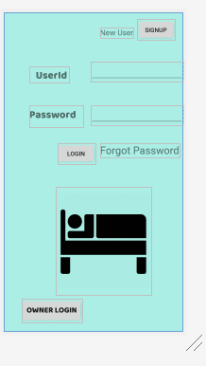 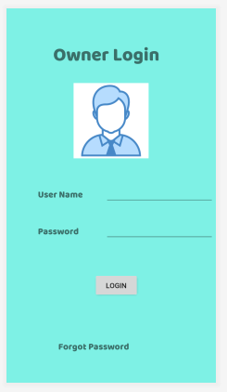

List of blocks and availabilities(Owner activity directs to this page)

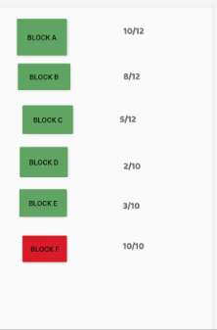 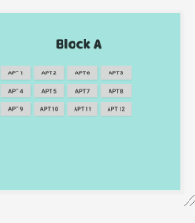

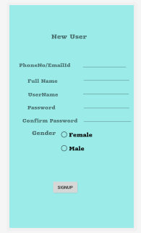 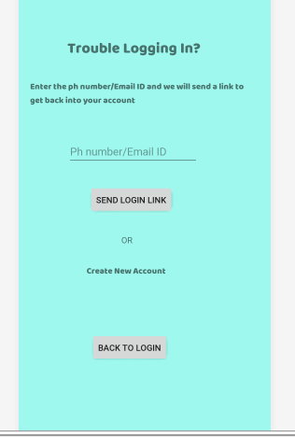

Firstly, When the user signup and login to the page it will be redirected to the Horizons West Apartment page. By selecting “Availability” ,a tabbed activity named “Availability” is opened which specifies total no.of rooms available,no.of shared rooms available and no.of private rooms available.We get all this information which is stored in the database that is uploaded to cloud.

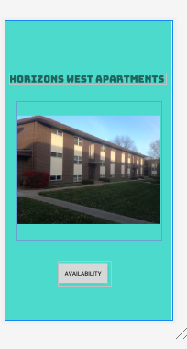

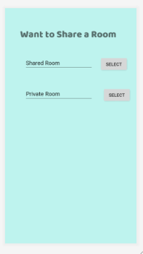 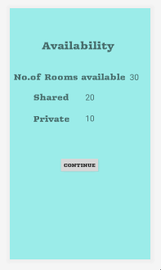

By selecting the shared room in the above tabbed activity another activity called “Shared Room” Is opened as below :

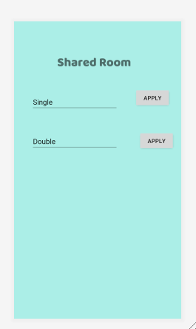

By selecting the Private Room the tabbed activity named “Private Room” is opened which consists of Single, Double and other specification

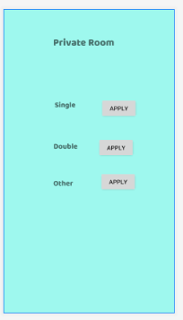

By applying to other another activity named “other” is opened where user can give their preferences and specifications. This data is taken and the suitable rooms are searched accordingly by using the word search mechanism.

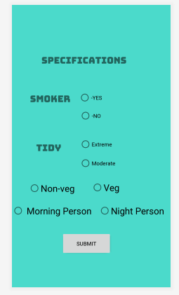

The feedback page is opened after every activity’s final click of “Apply” is clicked. For more queries the user can contact to specified email id.

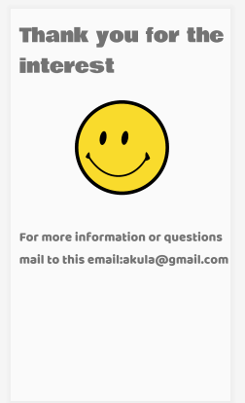

**Database Requirements:**

The data uploaded by the owner like number of vacancies, apartment number, type of room and user responses like selecting room are stored into cloud database.

**Output:**



