Module-5
Module-End Assignment:
“Integrated Tools for Software Development and Project Management”

1.Demonstrate a Sample API Testing using Postman API

- Perform API testing using Postman.
- Create a simple collection to test Restful APIs (GET, POST, PUT, DELETE).
- Validate status codes response body, headers, and response time.
- Use environment variables and assertions for dynamic validation.
- Generate and export test results in JSON or HTML format.

Postman is a leading, AI-native API platform used by millions of developers to design, build, test, and manage application programming interfaces. It simplifies the entire API lifecycle through an intuitive graphical interface.

Key Features

- API Client: Send HTTP, GraphQL, gRPC, and WebSocket requests, inspect response data, headers, and status codes.
- Collections: Organize and group related request folders to reuse and automate workflows.
- Testing & Automation: Write JavaScript-based test scripts and run them via the Collection Runner or CLI.
- Collaboration: Share workspaces, mock servers, and auto-generated documentation across teams.

The primary purpose of Postman in API testing is to serve as an all-in-one graphical client that allows developers and QA engineers to send requests, validate responses, and automate testing workflows without needing to write complex backend code.
Testers can execute HTTP methods like GET, POST, PUT, and DELETE. They can easily customize query parameters, headers, cookies, and request bodies (such as raw JSON or form-data) to test how the API handles different data types.

To set up Postman, you need to download the application, create an account, and send your first test request.

Download and Installation
- Go to the Official Postman Download Page.
- Click download for your operating system (Windows 64-bit, macOS, or Linux).
- Run the installer file (.exe for Windows, drag to applications for Mac, or use snap for Linux)
Account Setup
- Open the Postman app after it finishes installing.
- Sign up for a free account by entering your email, username, and password, or log in with Google.
- Verify your email if prompted and log into the app

Create Workspace and Request
- Create a new workspace or use your default home workspace.
- Click the + icon to open a new tab and create an API request.
- Choose the HTTP method (like GET).
- Enter a test URL (like https://postman-echo.com) and click Send to view the response.

To configure Postman for API testing, you must follow a structured workflow: set up your environment variables, organize requests into collections, write automated validation scripts using JavaScript, and execute them using the Collection Runner.

Organize Requests into Collections
Collections act as folders that group related API endpoints, allowing you to build end-to-end execution sequences.
- New Collection: Click the + or New icon in the sidebar, select Collection, and type a name.
- Add Requests: Click Add request inside your collection.
- Configure Methods: Select the required HTTP verb (GET, POST, PUT, DELETE) from the dropdown menu.
- Set Body and Headers: For POST or PUT, click the Body tab, choose raw, select JSON from the format list, and paste your payload.

Manage Environments and Variables

Instead of hardcoding URLs, use environments to easily switch between local, staging, and production settings.
- Create Environment: Go to Environments on the left menu bar, click Create Environment, and name it (e.g., Staging).
- Add Variables: Define a variable like base url and input your API's root address.
- Apply Variables: Use double curly braces {{base_url}} inside your request URL bar to reference the active environment variable.
- Activate: Select your new environment from the dropdown menu at the top-right corner of the workbench

Write Automated Test Scripts
Postman relies on JavaScript within the Tests tab to perform assertion checking after an API executes.

Execute Automated Test Runs
Once configured, you can execute all tests simultaneously instead of clicking "Send" on individual items.
- Manual Runner: Click the three dots beside your collection folder, select Run collection, specify the request sequence, and hit Start Run.
- CI/CD Automation: Use Newman or the Postman CLI to run these exact same test files automatically inside deployment pipelines (like GitHub Actions or Jenkins).

Screenshots:

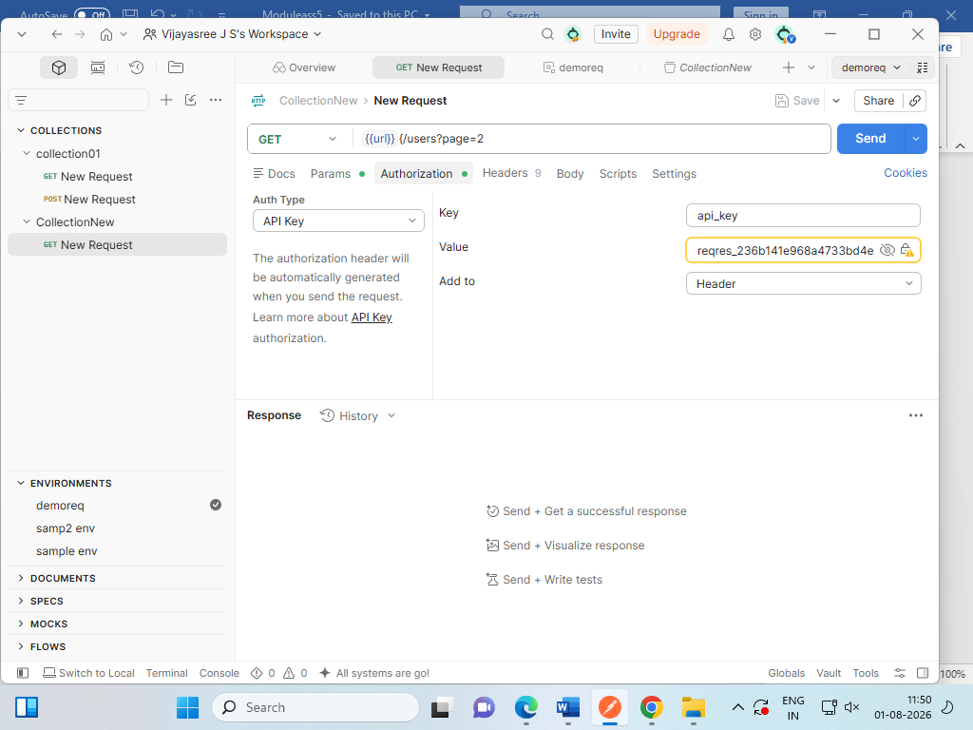

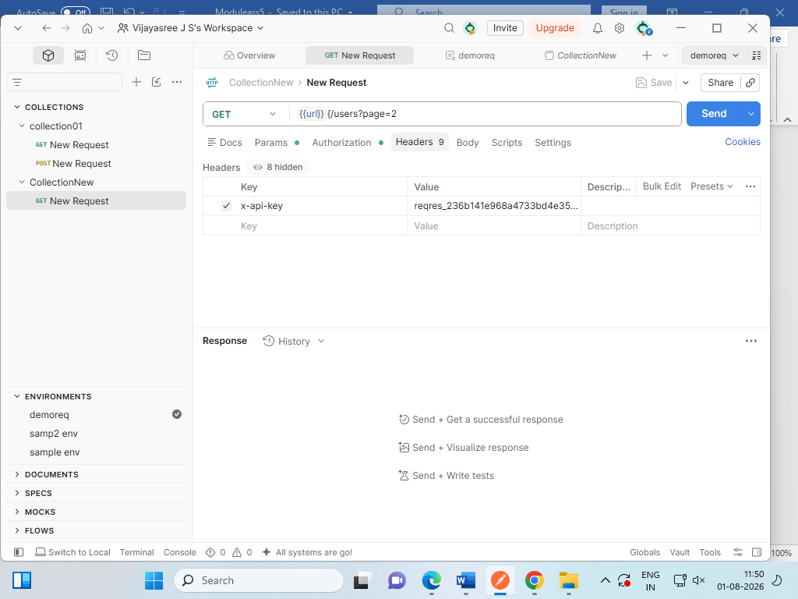

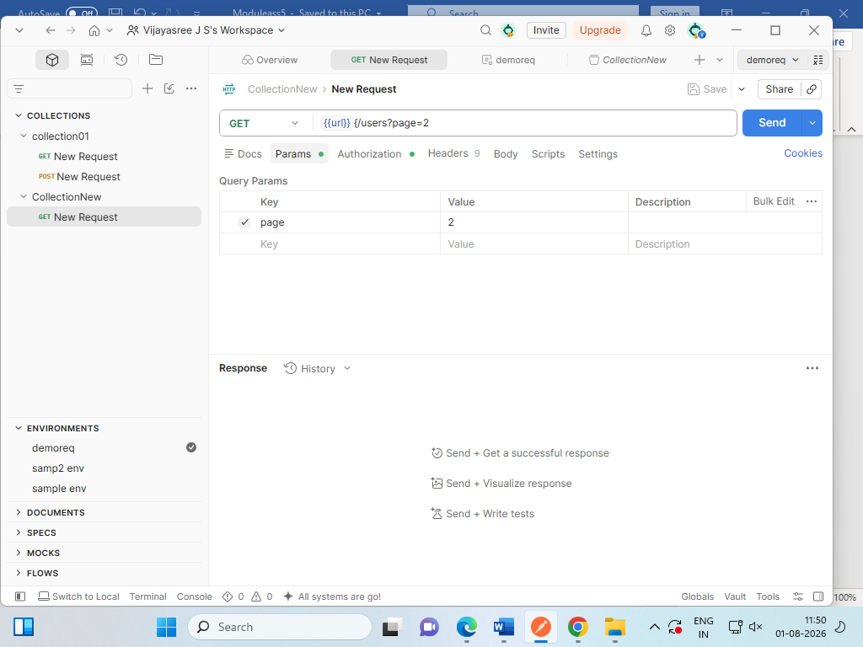

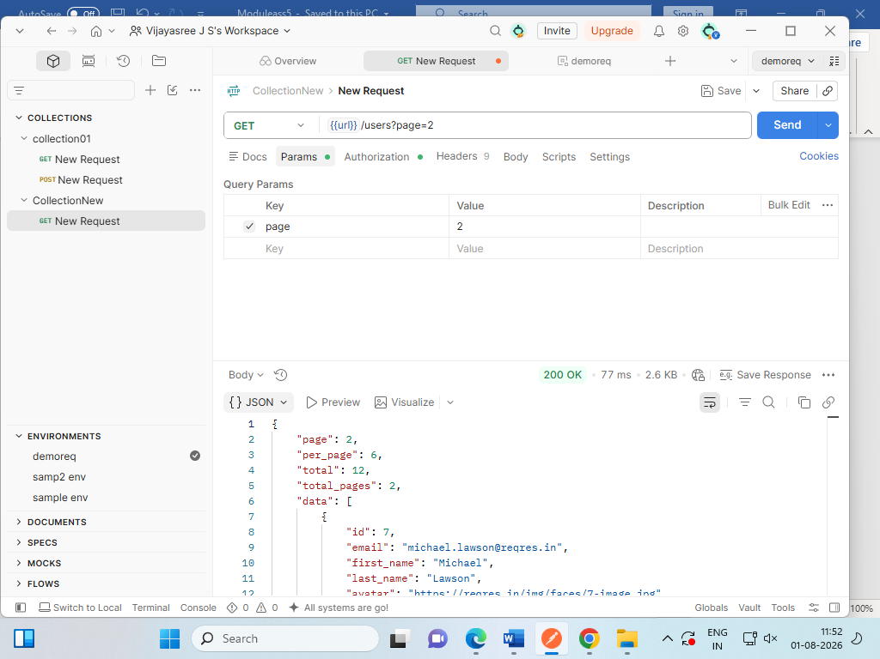

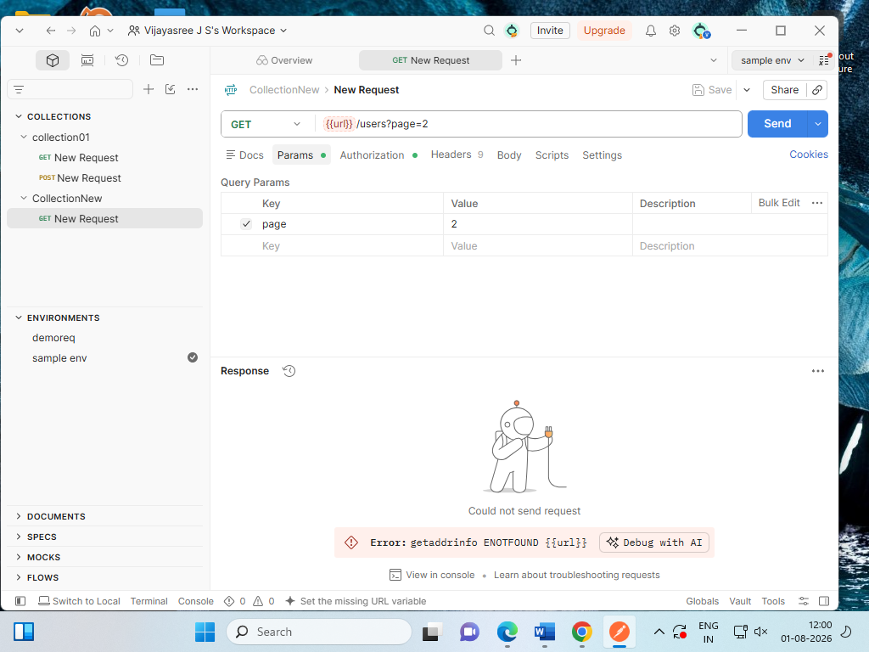

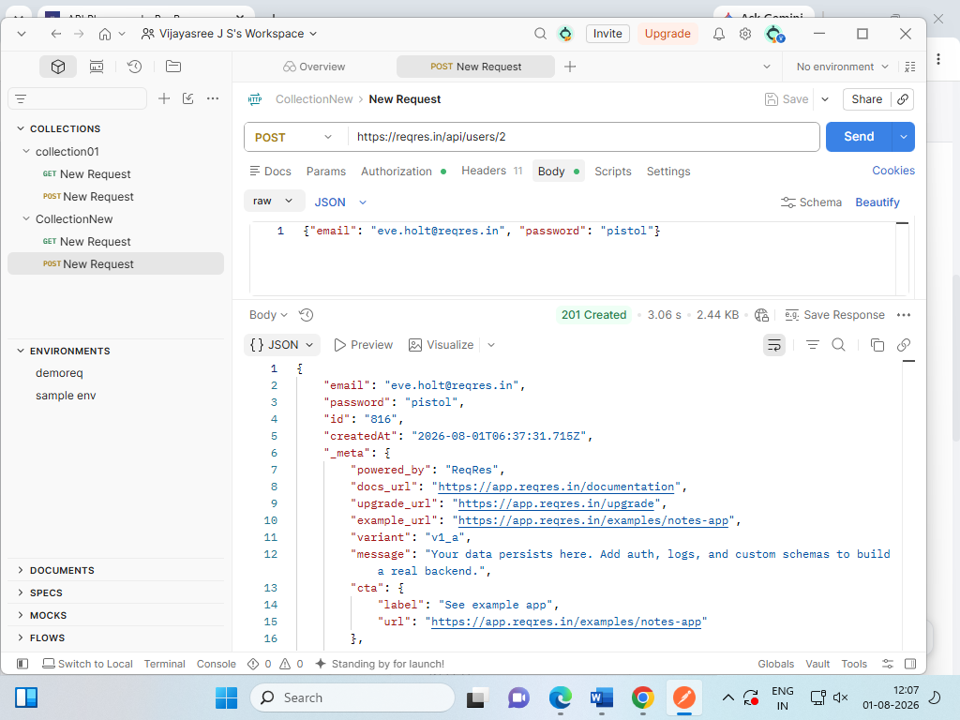

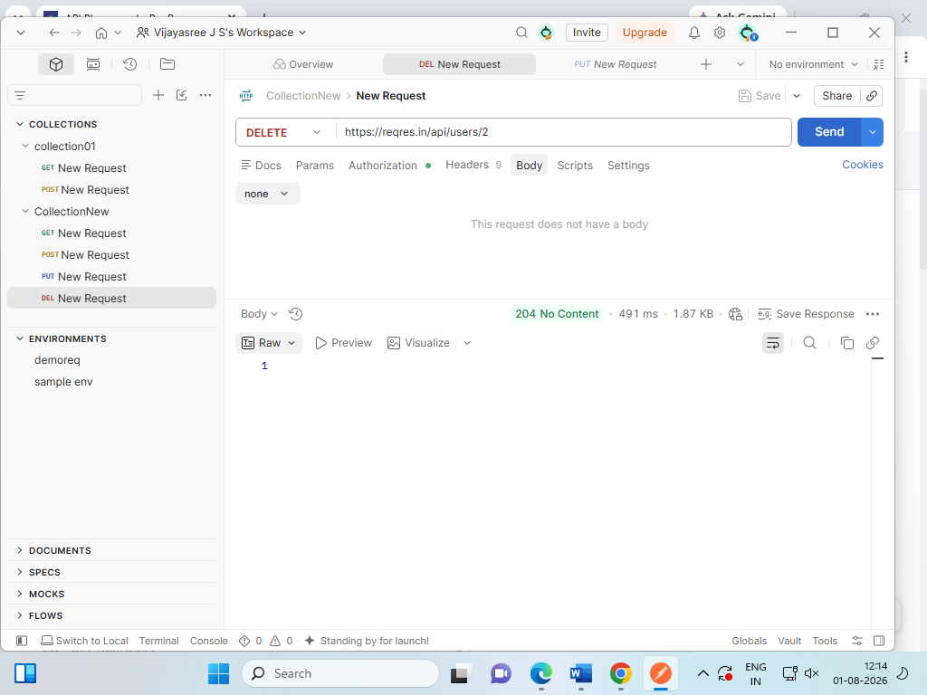

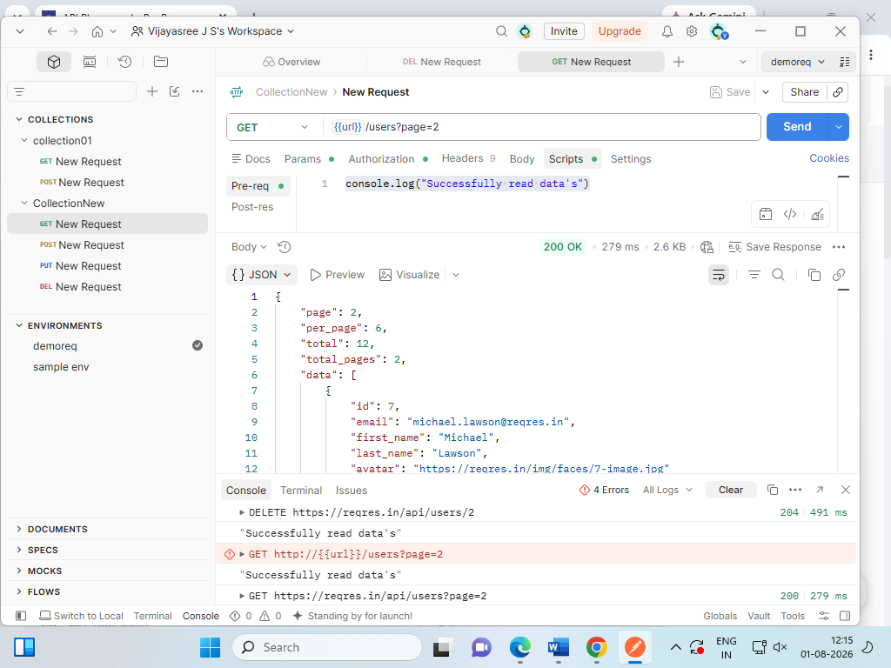

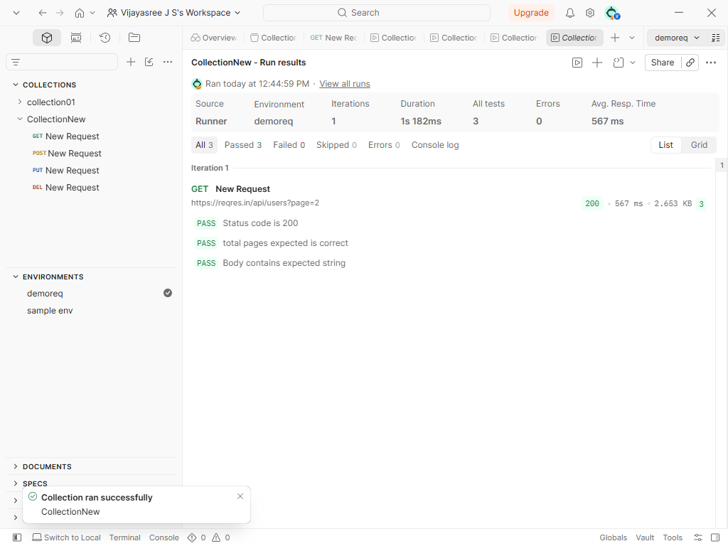

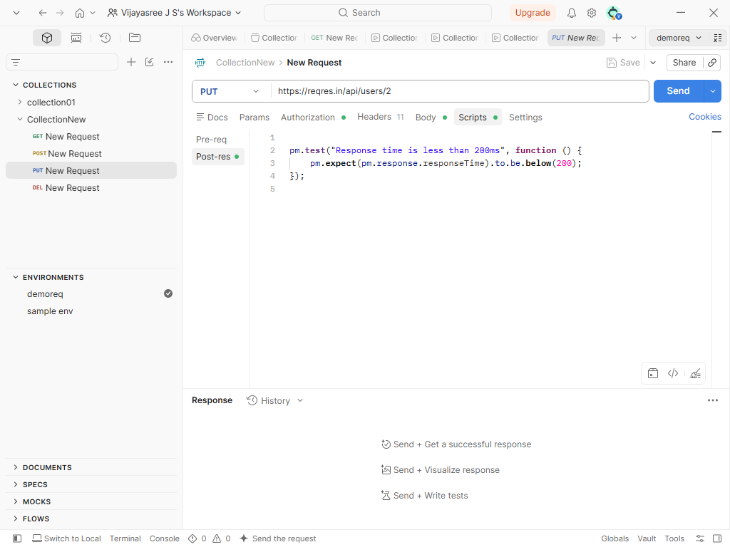

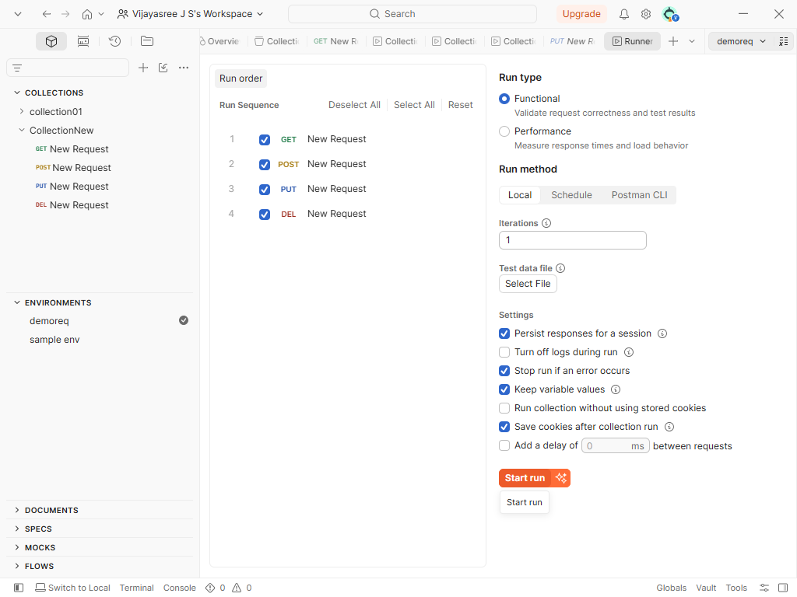

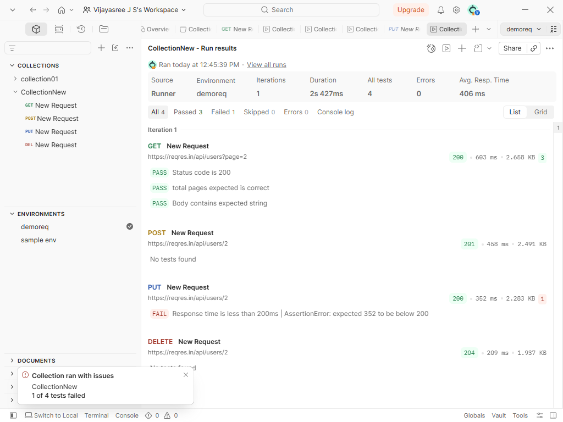

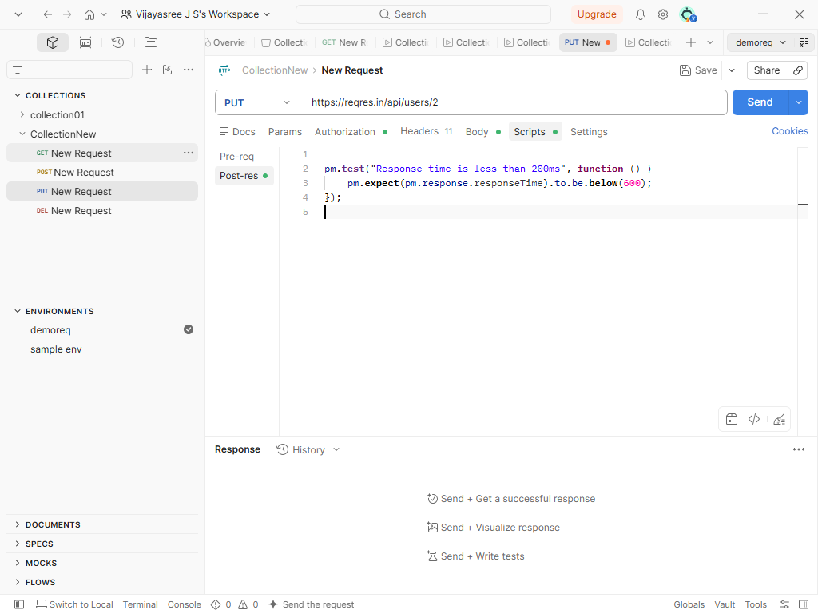

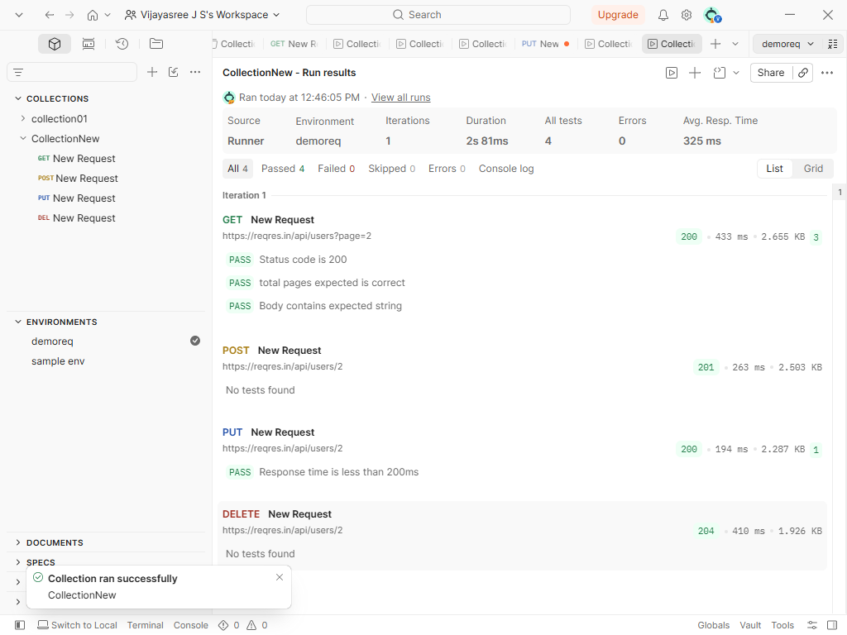

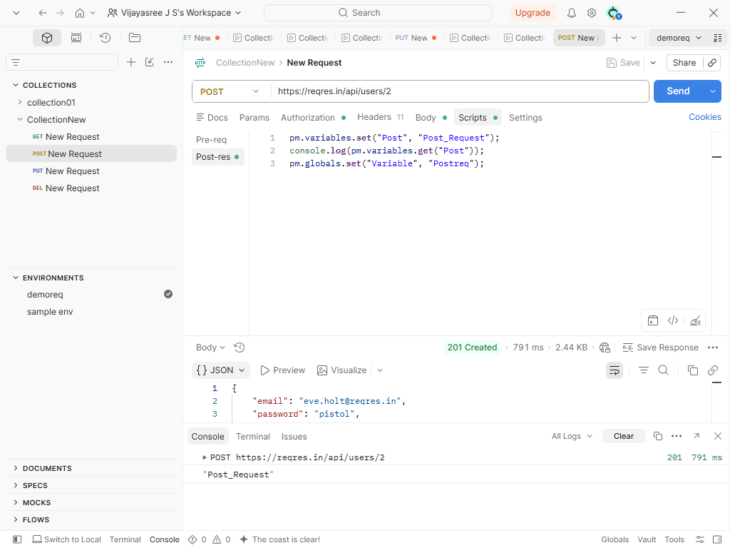

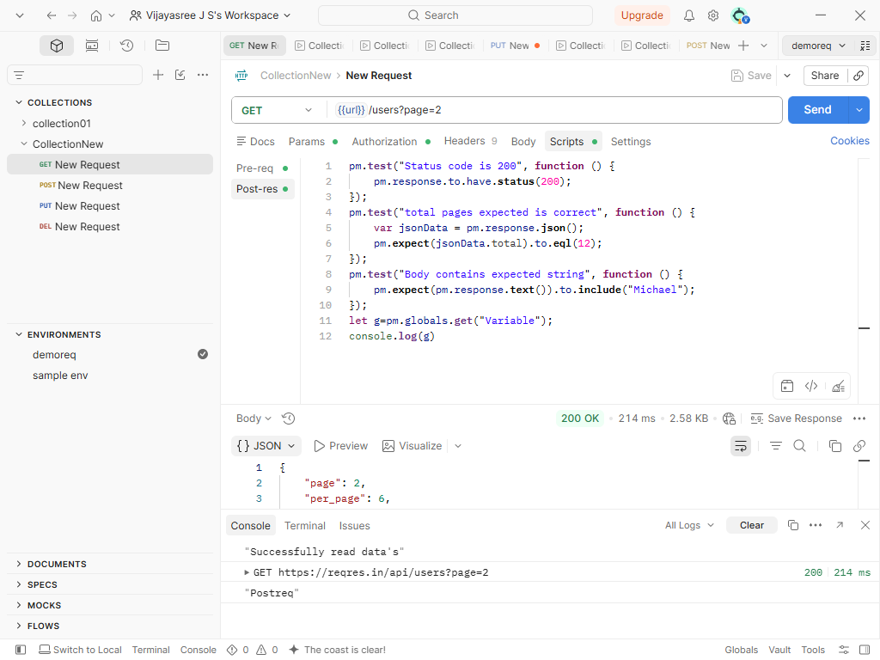

JSON Report :
{
"info": {
"_postman_id": "b8738034-0220-416d-aca3-b0f1f044034c",
"name": "CollectionNew",
"schema": "https://schema.getpostman.com/json/collection/v2.1.0/collection.json",
"_exporter_id": "56868327",
"_collection_link": "https://go.postman.co/collection/56868327-b8738034-0220-416d-aca3-b0f1f044034c?source=collection_link"
},
"item": [
{
"name": "New Request",
"event": [
{
"listen": "prerequest",
"script": {
"exec": [
"console.log(\"Successfully read data's\")"
],
"type": "text/javascript",
"packages": {},
"requests": {}
}
},
{
"listen": "test",
"script": {
"exec": [
"pm.test(\"Status code is 200\", function () {\r",
" pm.response.to.have.status(200);\r",
"});\r",
"pm.test(\"total pages expected is correct\", function () {\r",
" var jsonData = pm.response.json();\r",
" pm.expect(jsonData.total).to.eql(12);\r",
"});\r",
"pm.test(\"Body contains expected string\", function () {\r",
" pm.expect(pm.response.text()).to.include(\"Michael\");\r",
"});\r",
"let g=pm.globals.get(\"Variable\");\r",
"console.log(g)"
],
"type": "text/javascript",
"packages": {},
"requests": {}
}
}
],
"request": {
"auth": {
"type": "apikey",
"apikey": [
{
"key": "value",
"value": "reqres_236b141e968a4733bd4e35ad210b70fc",
"type": "string"
},
{
"key": "key",
"value": "api_key",
"type": "string"
}
]
},
"method": "GET",
"header": [
{
"key": "x-api-key",
"value": "reqres_236b141e968a4733bd4e35ad210b70fc",
"type": "text"
}
],
"url": {
"raw": "{{url}}/users?page=2",
"host": [
"{{url}}"
],
"path": [
"users"
],
"query": [
{
"key": "page",
"value": "2"
}
]
}
},
"response": []
},
{
"name": "New Request",
"event": [
{
"listen": "test",
"script": {
"exec": [
"pm.variables.set(\"Post\", \"Post_Request\");\r",
"console.log(pm.variables.get(\"Post\"));\r",
"pm.globals.set(\"Variable\", \"Postreq\");"
],
"type": "text/javascript",
"packages": {},
"requests": {}
}
}
],
"request": {
"auth": {
"type": "apikey",
"apikey": [
{
"key": "value",
"value": "reqres_236b141e968a4733bd4e35ad210b70fc",
"type": "string"
},
{
"key": "key",
"value": "api_key",
"type": "string"
}
]
},
"method": "POST",
"header": [
{
"key": "x-api-key",
"value": "reqres_236b141e968a4733bd4e35ad210b70fc",
"type": "text"
}
],
"body": {
"mode": "raw",
"raw": "{\"email\": \"eve.holt@reqres.in\", \"password\": \"pistol\"}",
"options": {
"raw": {
"language": "json"
}
}
},
"url": {
"raw": "https://reqres.in/api/users/2",
"protocol": "https",
"host": [
"reqres",
"in"
],
"path": [
"api",
"users",
"2"
]
}
},
"response": []
},
{
"name": "New Request",
"event": [
{
"listen": "test",
"script": {
"exec": [
"\r",
"pm.test(\"Response time is less than 200ms\", function () {\r",
" pm.expect(pm.response.responseTime).to.be.below(600);\r",
"});\r",
""
],
"type": "text/javascript",
"packages": {},
"requests": {}
}
}
],
"request": {
"auth": {
"type": "apikey",
"apikey": [
{
"key": "value",
"value": "reqres_236b141e968a4733bd4e35ad210b70fc",
"type": "string"
},
{
"key": "key",
"value": "api_key",
"type": "string"
}
]
},
"method": "PUT",
"header": [
{
"key": "x-api-key",
"value": "reqres_236b141e968a4733bd4e35ad210b70fc",
"type": "text"
}
],
"body": {
"mode": "raw",
"raw": "{\"name\": \"morpheus\", \"job\": \"zion resident\"}",
"options": {
"raw": {
"language": "json"
}
}
},
"url": {
"raw": "https://reqres.in/api/users/2",
"protocol": "https",
"host": [
"reqres",
"in"
],
"path": [
"api",
"users",
"2"
]
}
},
"response": []
},
{
"name": "New Request",
"request": {
"auth": {
"type": "apikey",
"apikey": [
{
"key": "value",
"value": "reqres_236b141e968a4733bd4e35ad210b70fc",
"type": "string"
},
{
"key": "key",
"value": "api_key",
"type": "string"
}
]
},
"method": "DELETE",
"header": [
{
"key": "x-api-key",
"value": "reqres_236b141e968a4733bd4e35ad210b70fc",
"type": "text"
}
],
"url": {
"raw": "https://reqres.in/api/users/2",
"protocol": "https",
"host": [
"reqres",
"in"
],
"path": [
"api",
"users",
"2"
]
}
},
"response": []
}
]
}

2. Building a Web Test Plan & HTML Report Generation (JMeter)
- Design and configure a Web Test Plan in Apache Jmeter for a sample website.
- Include Thread Group, HTTP Request, and Listener Components.
- Execute the test with defined users and ramp-up settings.
- Analyze test results (Response Time, Throughput, Error%).
- Export performance metrics and generate an HTML Summary Report.

Apache Jmeter is an open-source, 100% pure Java desktop application designed to load test functional behaviour and measure the performance of software applications. It simulates a heavy load on a server, group of servers, network, or object to test its strength and analyse overall performance under different load types. The primary purpose of Apache JMeter in software testing is to measure and analyse the performance, stability, and scalability of applications.

Key Features & Supported Protocols
- Protocol Support: HTTP, HTTPS, REST, SOAP, JDBC (databases), FTP, LDAP, and TCP.
- Test IDE: Full GUI to record, build, and debug test plans.
- CLI Mode: Headless, non-GUI command-line execution for heavy load tests.
- Reporting: Dynamic, ready-to-present HTML performance dashboards.

Core Architecture Elements
- Thread Group: Controls virtual user counts, ramp-up time, and loops.
- Samplers: Sends specific protocol requests to targets.
- Listeners: Collects, visualizes, and graphs result metrics.
- Config/Timers: Manages default settings and user delay intervals.

Screenshots:

