**IBM NAAN MUDHALVAN**

**SKILL UP**

**PROJECT TITLE:**

**SMART WATER MANAGEMENT SYSTEM**

**COLLEGE: PERI INSTITUTE OF TECHNOLOGY**

**DEPT: ELECTRONICS AND COMMUNICATION ENGINEERING**

**DOMAIN: INTERNET OF THINGS (IOT)**

**Submitted By :**

**VIJAYA SRI Y (au411521106060)**

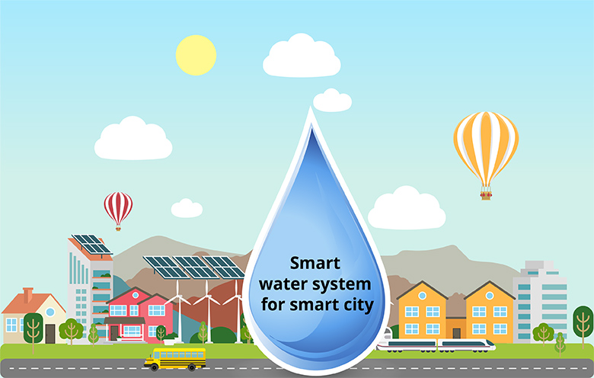

**PHASE-4:**

* 1. **Outline of this project:**
* This project aims to create a smart water management system using IoT technology. It will employ sensors, microcontrollers, and cloud platforms to monitor water resources efficiently. Users will have a user-friendly interface for monitoring and control, ensuring better water management.
  1. **Features of Smart Water Management:**
* A smart water management system using IoT incorporates several key features to enhance efficiency and sustainability. It employs sensors to monitor water parameters like level, quality, and temperature, providing real-time data. Automated controls enable timely response to fluctuations, optimizing water distribution. Leak detection mechanisms swiftly identify and mitigate losses. User interfaces, accessible via mobile apps or web platforms, empower consumers to track usage and set conservation goals. Additionally, data analytics offer insights for proactive decision-making. These features collectively ensure a more intelligent, responsive, and eco-conscious approach to water resource management..
  1. **Real time working:**

The step by step working is given below:

**Step 1 :** Connect all the components according to the step by step procedure mentioned in Phase-3.

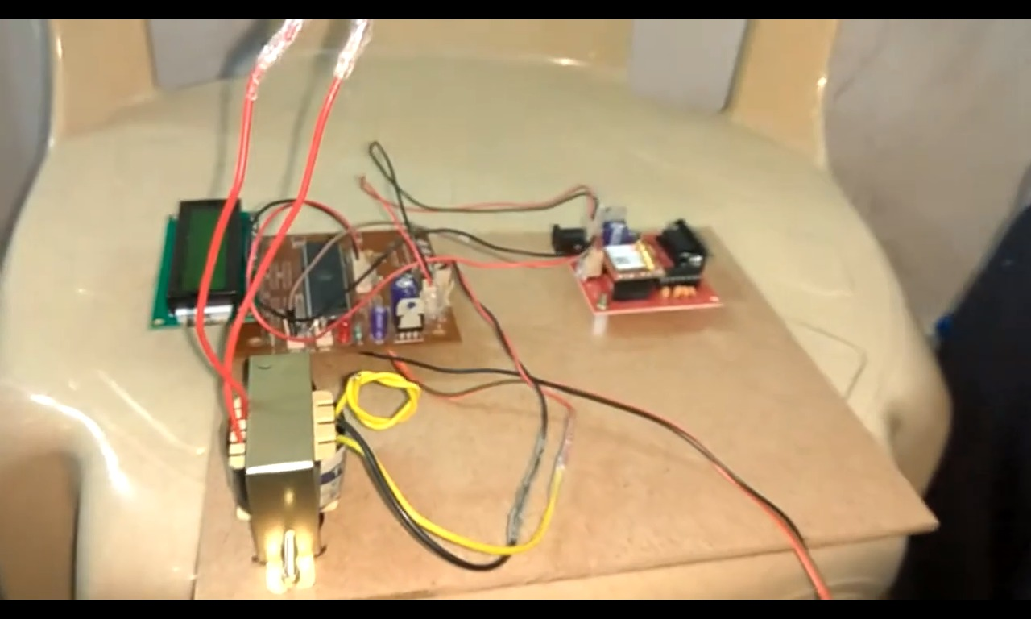

**Step 2 :** Power ON the circuit and it will show like this in the LCD Display.

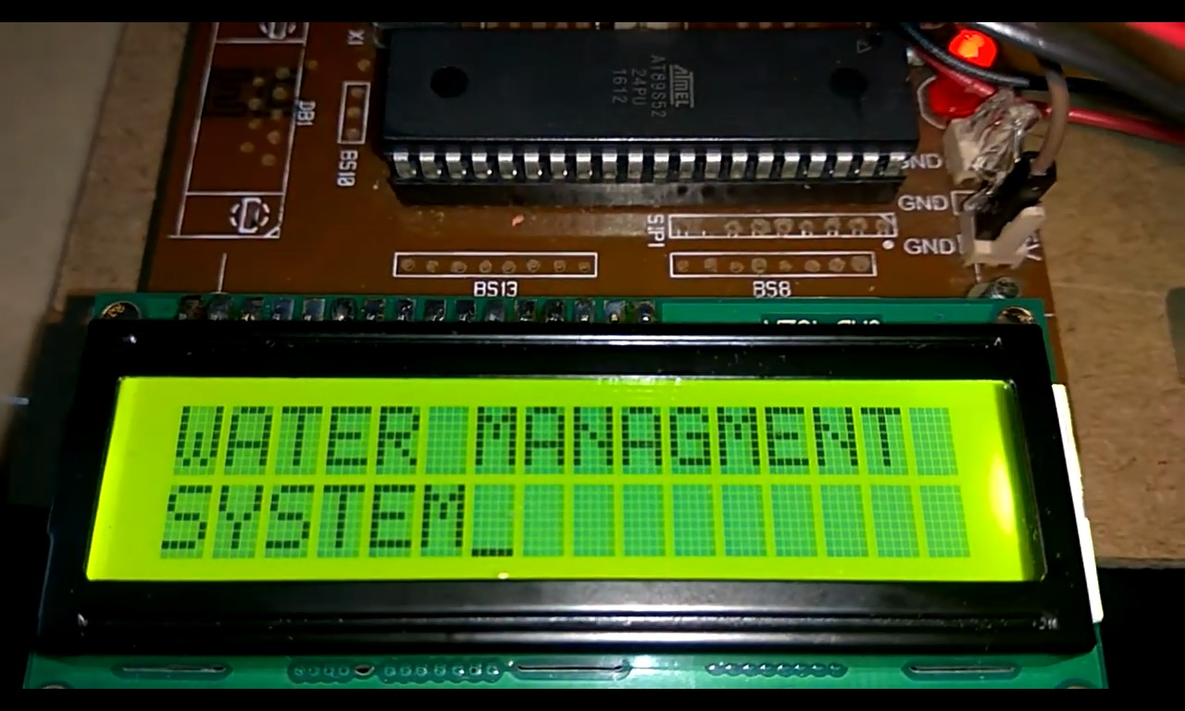

**Step 3 :** First, the water tank (cup) is empty.

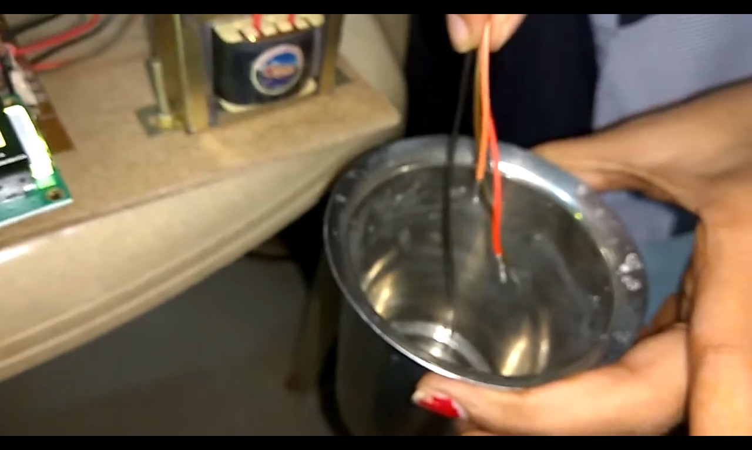

**Step 4 :** When the water tank (cup) is empty, it will display as empty.



**Step 5 :** Then thewater tank (cup) is filled for about 33% of water



**Step 6 :** When the water tank (cup) is 33% filled, it will display like this.

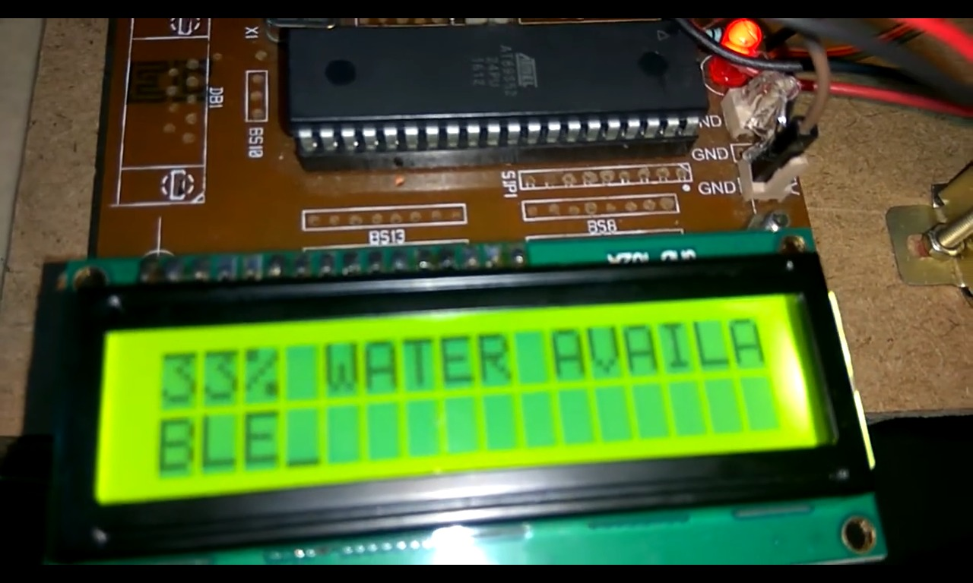

**Step 7 :** The chart is updated for every 50 seconds. For 33% water, the chart is given as,

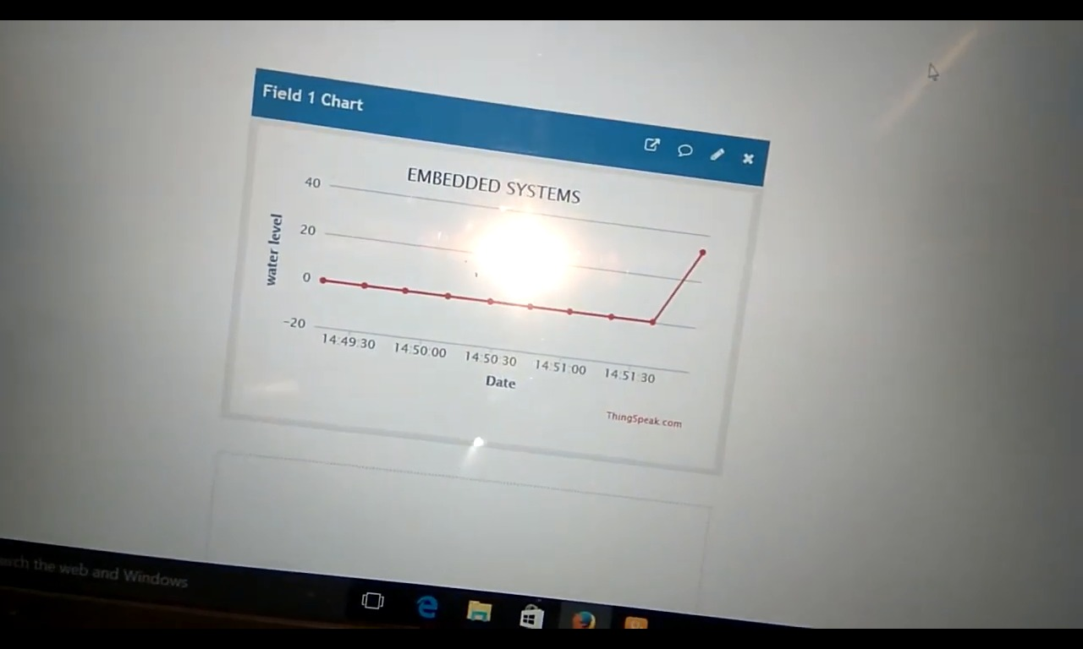

**Step 8 :** Then thewater tank (cup) is filled for about 66% of water

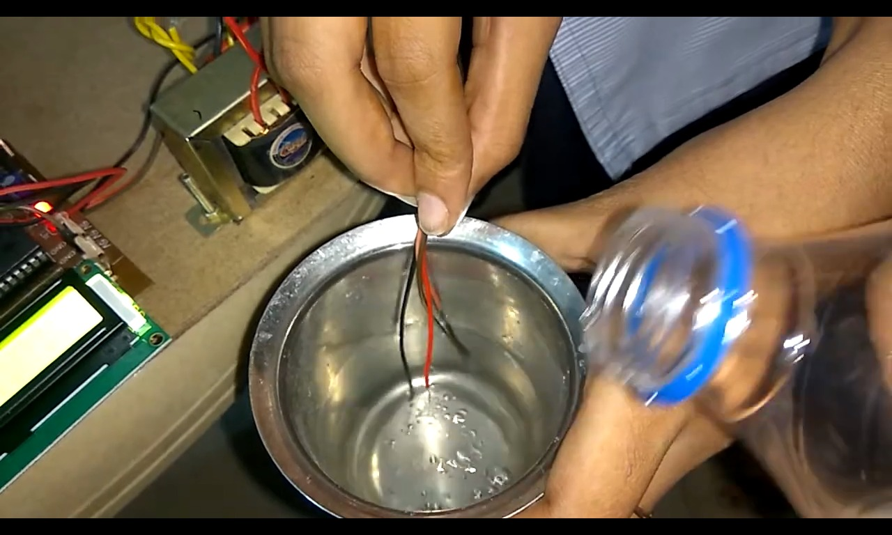

**Step 9 :** When the water tank (cup) is 66% filled, it will display like this,

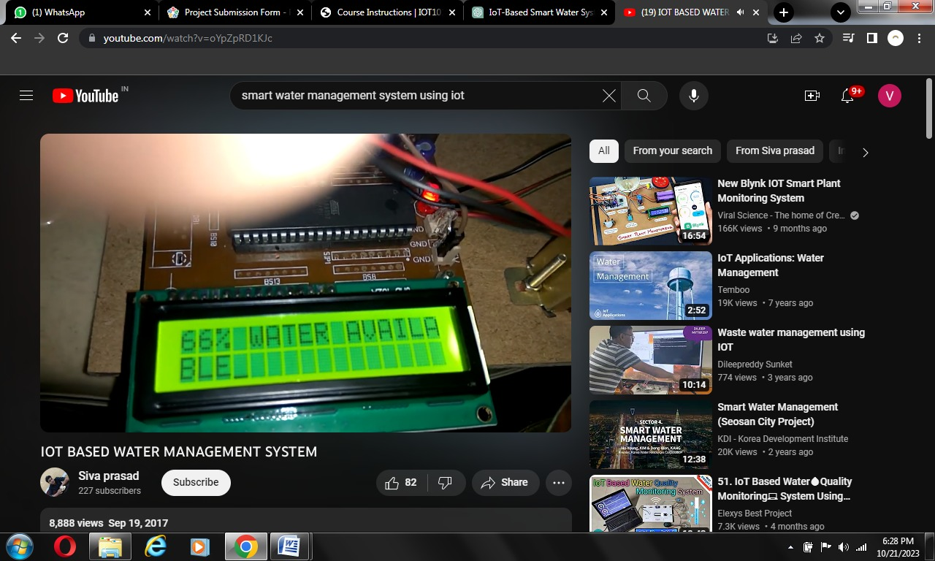

**Step 10 :** For 66% water, the chart is given as,

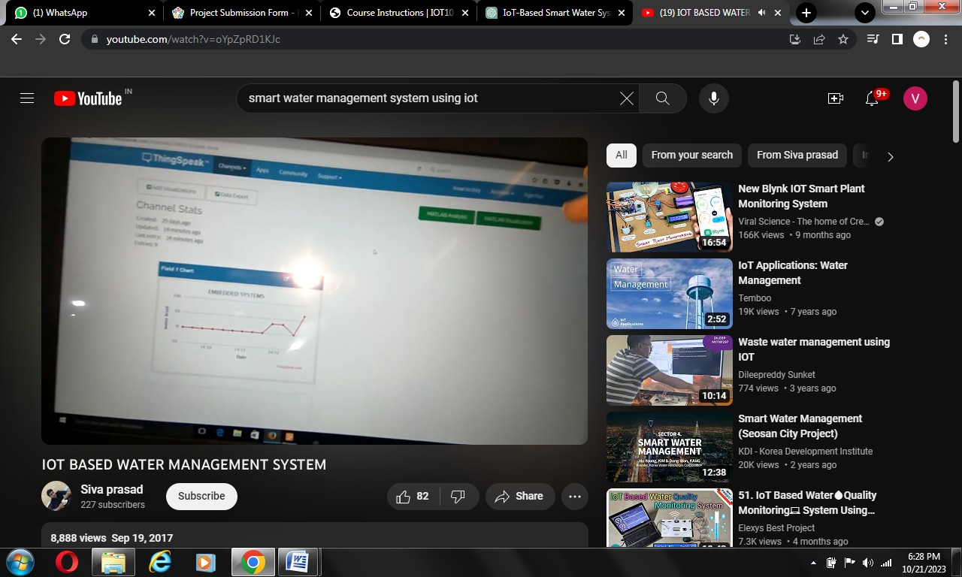

**Step 11 :** Then thewater tank (cup) is filled for about 99% of water

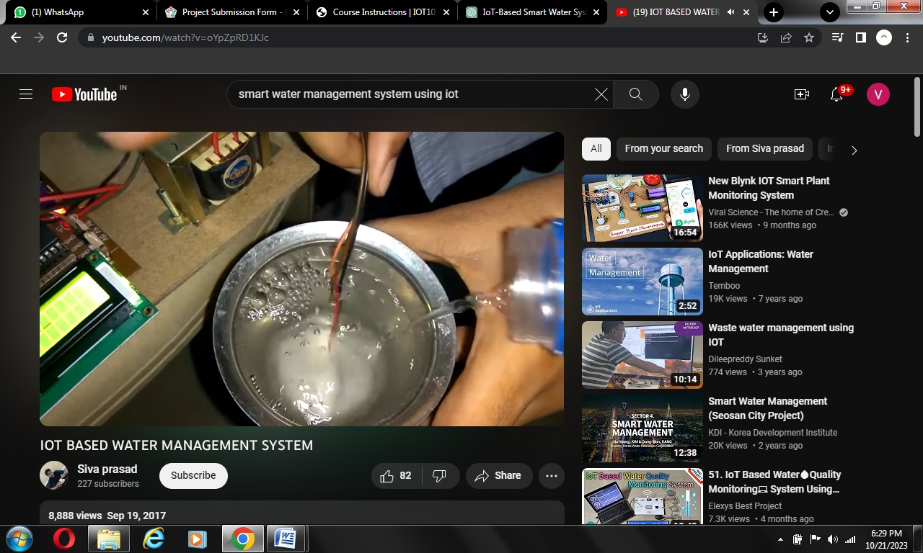

**Step 12 :** When the water tank (cup) is 99% filled, it will display like this.

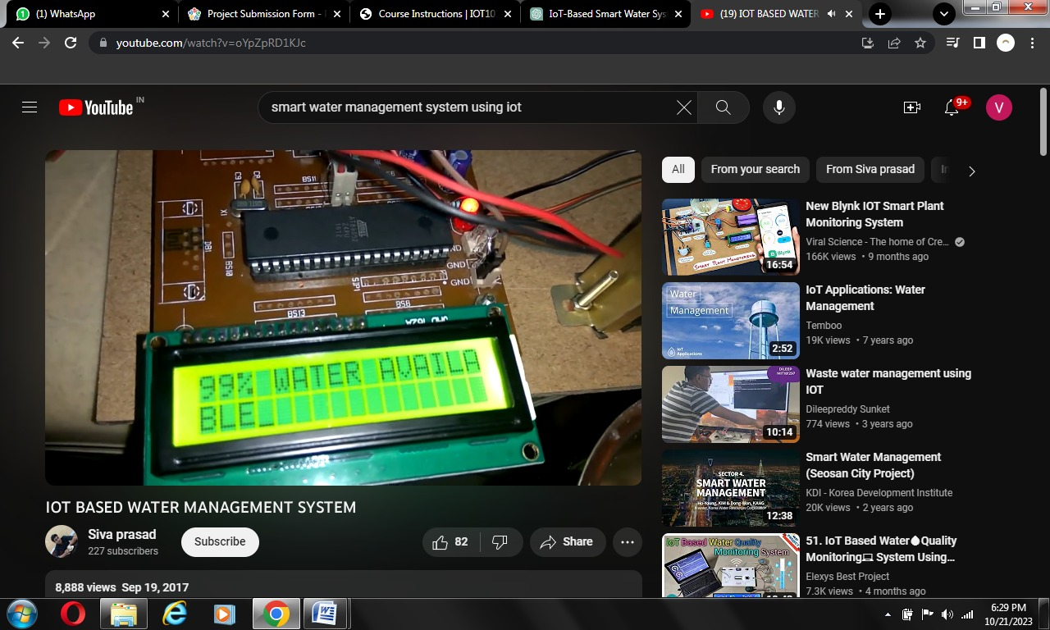

**Step 13 :** For 99% water, the chart is given as

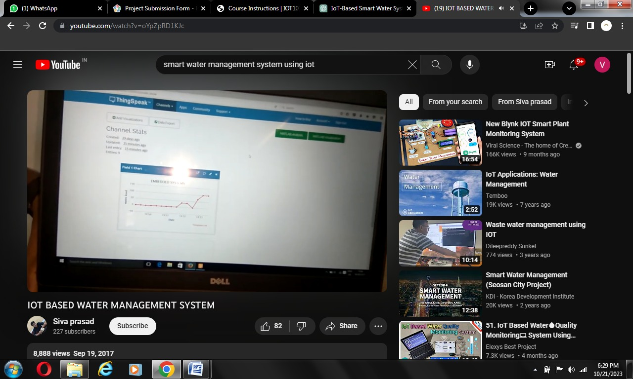

* 1. **Advantages:**
* Real-time Monitoring
* Efficient Resource Allocation
* Leak Detection and Prevention
* Remote control and Automation
* Predictive Maintenance
* Data-Driven Insights
* Enhanced User Awareness
* Environmental Impact
* Early Warning systems
* Cost efficient
  1. **Conclusion :**
* Smart water management, enabled by IoT technology, revolutionizes how we monitor and conserve water. It provides real-time data, improves environmental sustainability, enhances public health, and strengthens communities. Ongoing collaboration, innovation, and investment are essential for a sustainable water future.