**IBM NAAN MUDHALVAN**

**SKILL UP**

**PROJECT TITLE:**

**SMART WATER MANAGEMENT SYSTEM**

**COLLEGE: PERI INSTITUTE OF TECHNOLOGY**

**DEPT: ELECTRONICS AND COMMUNICATION ENGINEERING**

**DOMAIN: INTERNET OF THINGS (IOT)**

**Submitted By :**

**VIJAYA SRI Y (au411521106060)**

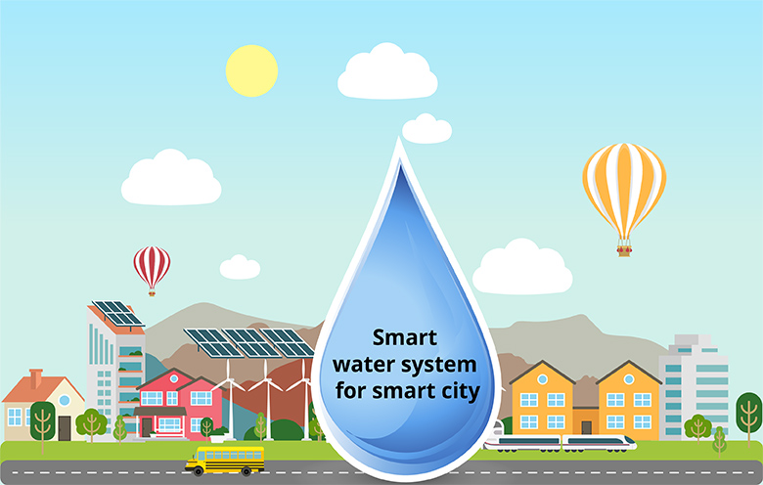

**PHASE-5:**

* 1. **Objectives of this Project:**
* The objective of this project is to promote water conservation by providing real-time water consumption data to the public. This empowers individuals, communities, and industries to make informed decisions and take proactive measures to reduce water wastage and improve overall efficiency in water usage. By leveraging technology and data transparency, the project aims to foster a culture of responsible water management for a more sustainable future.
  1. **IoT Sensor Setup:**
* For the basic sensor setup in a smart water management system project, we would need the following sensors:

1. **Water Level Sensor**: This sensor, typically an ultrasonic or pressure sensor, is placed in the water storage tank or reservoir to measure the water level. It is connected to a microcontroller to collect data.

2. **Water Quality Sensor**: For monitoring water quality, select a sensor that measures parameters like pH, turbidity, or conductivity. Install this sensor in the water source or pipeline, and connect it to the microcontroller for data acquisition.

3. **Flow Rate Sensor**: Choose a flow rate sensor, such as an electromagnetic or ultrasonic sensor, to measure the water flow in the supply line. Connect this sensor to the microcontroller to capture flow data.

* These sensors should be calibrated and interfaced with a microcontroller or IoT device. The collected data can then be transmitted to a cloud platform for further analysis and control. Ensure that security measures are in place to protect the data, and consider a user interface for monitoring and managing the system.
  1. **Mobile App and Web development:**
* A web page is developed for user visualization. A user gets notified with alert messages about water presence in storage tank and overhead tank. User has full control of toggling motor on/off. Motor is automated when tank is empty or overflow. Some of the snapshots of our proposed system are shown.
* This is the screenshot of the data in the page. The Water level in the tank changes according to time. Here, the water level is changed for every minute. It gives the real time data depending on the usage of water. It also shows real time quality and temperature of the water.

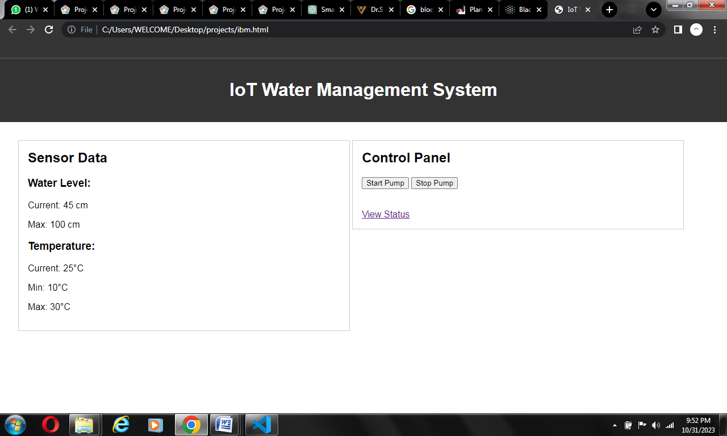

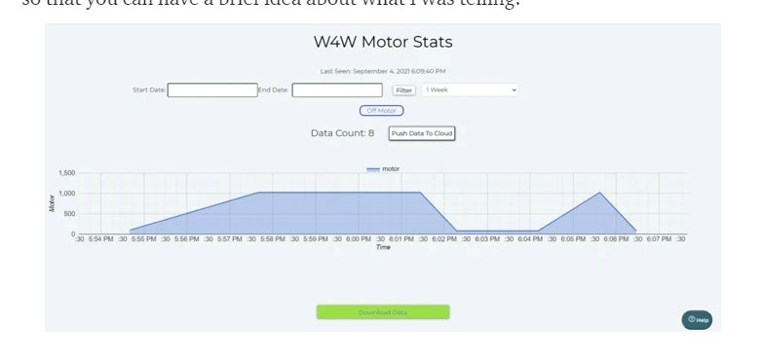

**Code:**

<!DOCTYPE html>

<html lang="en">

<head>

    <meta charset="UTF-8">

    <meta name="viewport" content="width=device-width, initial-scale=1.0">

    <title>IoT Water Management System</title>

    <style>

        body {

    font-family: Arial, sans-serif;

    margin: 0;

    padding: 0;

}

header, footer {

    background-color: #333;

    color: #fff;

    text-align: center;

    padding: 1em 0;

}

main {

    padding: 2em;

}

section {

    border: 1px solid #ccc;

    padding: 1em;

    margin-bottom: 1em;

}

h2 {

    margin-top: 0;

}

.sensor-data, .control-panel {

    width: 48%;

    display: inline-block;

    vertical-align: top;

    box-sizing: border-box;

}

@media (max-width: 768px) {

    .sensor-data, .control-panel {

        width: 100%;

    }

}

    </style>

</head>

<body>

    <header>

        <h1>IoT Water Management System</h1>

    </header>

    <main>

        <section class="sensor-data">

            <h2>Sensor Data</h2>

            <div class="sensor-reading">

                <h3>Water Level:</h3>

                <p>Current: 45 cm</p>

                <p>Max: 100 cm</p>

            </div>

            <div class="sensor-reading">

                <h3>Temperature:</h3>

                <p>Current: 25°C</p>

                <p>Min: 10°C</p>

                <p>Max: 30°C</p>

            </div>

        </section>

        <section class="control-panel">

            <h2>Control Panel</h2>

            <button>Start Pump</button>

            <button>Stop Pump</button><br><br><br>

            <a href="status.html">View Status</a>

        </section>

    </main>

</body>

</html>

* The mobile application for this project is also developed. It gets the data from the user and gives real time results. The Water level in the tank changes according to time. The snapshot of the water level in the tank is given below.

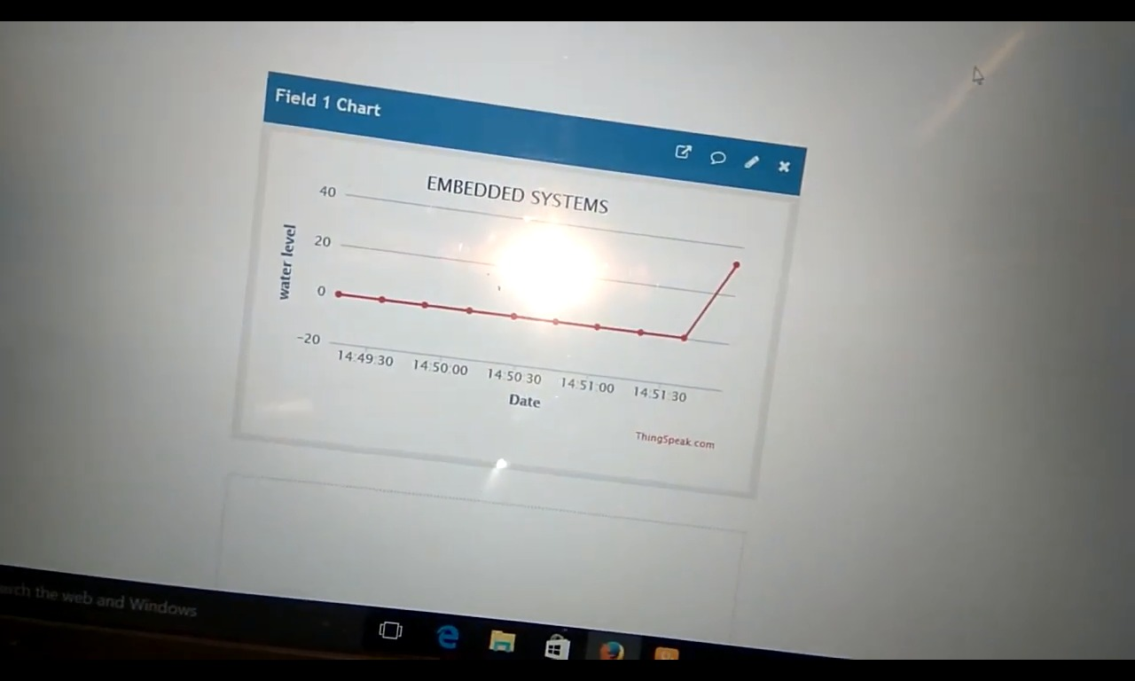

* 1. **Screenshot:**

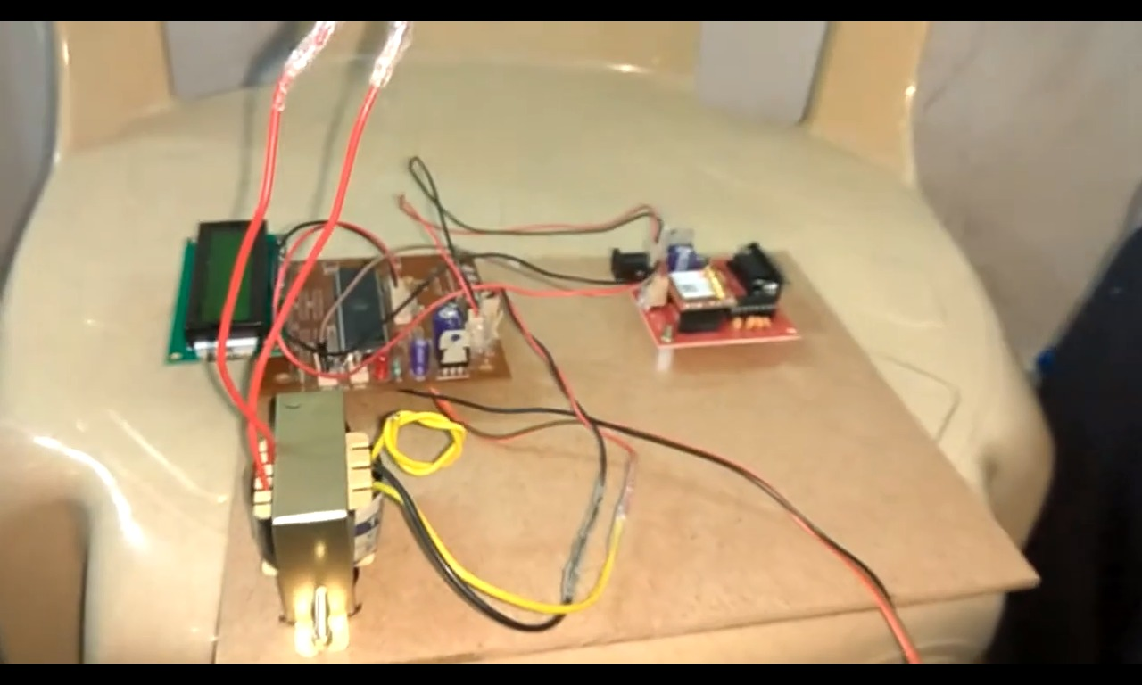

* 1. **How this promotes water conservation?**
* An IoT-based smart water management system promotes water conservation through real-time monitoring, leak detection, and automated optimization of irrigation. By integrating weather data and monitoring water quality, it ensures efficient usage. Users receive alerts and recommendations, empowering them to make informed decisions. Additionally, the system enables remote control and compliance tracking, making it a powerful tool for conserving water resources in various settings, from households to industrial processes.
  1. **Future Implementations:**
* The potential future implementations for an IoT-based smart water management system project:

1. **Predictive Analytics and Machine Learning:**

Implementing advanced analytics and machine learning algorithms can enhance the system's capabilities. By analyzing historical data and real-time inputs, the system can predict water usage patterns, detect anomalies, and optimize operations proactively. This allows for even more precise control and conservation of water resources.

1. **Integration with Smart Grids and Energy Efficiency:**

Future implementations may involve integrating the water management system with smart grids and energy management systems. This would enable synchronized control of water pumps and systems with energy demand patterns, optimizing energy usage and further reducing environmental impact.

1. **Smart Water Recycling and Treatment:**

Expanding the system to include water recycling and treatment capabilities can significantly enhance sustainability. Incorporating sensors and actuators for water treatment processes, as well as integrating with filtration and purification technologies, would allow for efficient reuse of water resources in various applications, from industrial processes to household usage.

* These future implementations would not only advance the capabilities of the system but also contribute to more comprehensive and sustainable water management practices.
  1. **Conclusion:**
* Smart water management, enabled by IoT technology, revolutionizes how we monitor and conserve water. It provides real-time data, improves environmental sustainability, enhances public health, and strengthens communities. Ongoing collaboration, innovation, and investment are essential for a sustainable water future.