What tumour gene expression reveals about the clinical receptor groups of breast cancer: a TCGA analysis checked in protein and an independent cohort
BT3041 Analysis and Interpretation of Biological Data · Term project report · IIT Madras · November 2026
Team: [Name 1, roll no.] · [Name 2, roll no.] · [Name 3, roll no.] · [Name 4, roll no.] · [Name 5, roll no.]
Abstract. Breast cancers are grouped for treatment by three clinical tests: oestrogen receptor (ER), progesterone receptor (PR) and HER2. We asked what tumour RNA-seq reveals about these clinical groups, using the clinical labels (not the expression-derived PAM50 subtypes) to avoid circular reasoning. In 1,088 TCGA tumours (clinical groups: HR+/HER2− 591, HER2+ 160, triple-negative 157), label-free clustering recovered a basal-like group that held 138 of 157 triple-negative tumours (ARI with ER status 0.67). Against HR+/HER2− tumours, triple-negative tumours differed more than 2-fold in 2,741 genes (FDR 5%), with the oestrogen-response programme down and proliferation, MYC and immune programmes up; only the oestrogen-response shift survived a correlation-aware gene-set test. Classifiers trained on the whole transcriptome matched, but did not beat, the receptor gene alone (ER: ESR1 AUC 0.959 vs best model 0.954; HER2: ERBB2 0.845 vs 0.851). The findings held in protein from the same tumours (mRNA–protein effect correlation ρ = 0.80) and in 1,980 METABRIC tumours (frozen-model AUC 0.96 for ER, 0.91 for HER2; 86% of differentially expressed genes replicated).

1. Introduction and research questions
Pathologists test every invasive breast cancer for ER and PR by immunohistochemistry (IHC) and for HER2 by IHC or in-situ hybridisation (FISH) [1, 2]. The result chooses the therapy: endocrine drugs for hormone-receptor-positive (HR+) disease, anti-HER2 antibodies for HER2+ disease and chemotherapy for triple-negative breast cancer (TNBC), which has no targeted option. Expression profiling defined the intrinsic subtypes (luminal A/B, HER2-enriched, basal-like) [3, 4], now assigned with the PAM50 centroids [5]. Many machine-learning studies predict PAM50 from RNA-seq, but PAM50 is itself computed from RNA, so such accuracy partly measures agreement of an algorithm with itself. We therefore used the clinical IHC/FISH labels as the ground truth and PAM50 only as a comparator.
We asked three questions. Q1: Does label-free structure in tumour expression (PCA, UMAP, clustering) recover the clinical receptor groups? Q2: Which genes and pathways differ between TNBC and HR+/HER2− tumours, and how robust are they? Q3: Can whole-transcriptome classifiers predict clinical ER and HER2 status better than the receptor gene alone? Every answer was checked in a second assay (protein, RPPA) on the same tumours, in an independent cohort (METABRIC) with labels from other assays, and against published numbers.

2. Data acquisition and preprocessing
Sources. TCGA-BRCA RNA-seq (HiSeqV2, log2(RSEM+1)), STAR gene counts (GDC, GENCODE v36), clinical IHC/FISH fields, reverse-phase protein arrays (RPPA) and PAM50 calls were downloaded from UCSC Xena [6]; survival end points came from the TCGA Clinical Data Resource [7]. METABRIC Illumina HT-12 expression and clinical tables [8, 9] came from the cBioPortal datahub. Gene symbols in every data set (and the Hallmark gene sets [10]) were mapped to current HGNC symbols. Raw files were checksummed at a data freeze.
Cleaning and labels. We kept one primary tumour per patient (1,097) and excluded 9: five whose HiSeqV2 and STAR profiles did not match each other (Spearman ρ below the 99th percentile of between-patient correlations) and five whose clinical record is redacted in the Clinical Data Resource (one tumour failed both), leaving 1,088 tumours for all label-free work. HER2 was called from FISH first, then the IHC score (3+ positive, 0/1+ negative, 2+ without FISH missing), using the status text only when no score was recorded; conflicting records were set to missing. This rule agrees with the TCGA 2012 HER2 calls at κ = 0.88. The supervised set holds the 1,076 female patients (12 male patients were kept only for label-free work). Groups were HR+/HER2− (ER or PR positive, HER2 negative), HER2+ (any ER/PR) and TNBC (all three negative); 168 tumours lacked one of the three results. For differential expression we kept STAR genes with ≥ 10 counts in at least 157 tumours (the smallest group), 24,660 genes. Matrices were left unscaled so that every scaling step could run inside cross-validation folds. Table 1 lists the data sets.
Table 1. Data sets and group sizes under the current labels (HER2 rule v1). *METABRIC groups use IHC ER and SNP6 copy-number HER2 (gain vs no gain); PR is not available, so the ER−/HER2-not-gained group is not called TNBC.
Data set | Used for | n | HR+/HER2− | HER2+ | TNBC
TCGA HiSeqV2 (analysed) | PCA, UMAP, clustering | 1,088 | 596 | 166 | 157
TCGA supervised set | classifiers | 1,076 | 591 | 160 | 157
TCGA STAR counts | differential expression | 1,075 | 591 | 160 | 157
TCGA RPPA (131 antibodies) | protein validation | 730 | 395 | 114 | 109
METABRIC (HT-12 arrays) | external validation | 1,980 | 1,220* | 426* | 286*

3. Methods
All analyses used Python 3.12 (scikit-learn, PyDESeq2, GSEApy, lifelines) with seed 42; every parameter and package version is written to a params.json next to each result, and the code is in the supplementary material. Multiple tests were corrected by Benjamini–Hochberg (BH) FDR [11].
Exploration and clustering (Q1). PCA and UMAP [12] (15 neighbours) used the 2,000 most variable genes after removing sex-chromosome-specific genes. We tested marker genes between groups with Mann–Whitney U tests (rank-biserial r as effect size) and the share of PC variance explained by group and by tissue-source site (η², with a permutation chance level). k-means (k = 2–8, PAM50 genes left out) was run with consensus clustering [13] (100 resamples of 80% of tumours); k was chosen before looking at the labels as the lowest proportion of ambiguous clustering (PAC) [14]. Agreement with labels was measured by the adjusted Rand index (ARI) with bootstrap 95% CIs and compared with the best ARI reachable by two clusters.
Differential expression and pathways (Q2). PyDESeq2 [15, 16] on raw STAR counts with design ~ histology + group tested |log2FC| > 1 directly (lfc_null = 1) rather than filtering by fold change after a test of zero change. Fold changes were shrunk for ranking and plotting. Sensitivity runs added age, kept invasive ductal tumours only, dropped every low-confidence HER2 call, or used the ER−/HER2− vs ER+/HER2− contrast that matches METABRIC. Hallmark enrichment used GSEA prerank on the Wald statistic [17, 18] (1,000 permutations), Fisher over-representation of the DEG lists, and two tests that account for inter-gene correlation: CAMERA [19] and phenotype-permutation GSEA.
Classification (Q3). Targets were clinical ER (n = 1,024, 789 positive) and HER2 (n = 913, 161 positive). L1-penalised logistic regression, a linear SVM, a Random Forest and PLS-DA were trained in nested cross-validation (outer 5 folds × 3 repeats, inner 5 folds, class-balanced weights). A variance filter (top 5,000 genes), scaling, univariate selection of k genes (k ∈ {50, 200, 1000}) and the hyper-parameters were all fitted inside the training folds. The baseline was the receptor gene alone (ESR1 or ERBB2), with a cut-off chosen inside the folds. Models were compared on pooled out-of-fold ROC-AUC with the Nadeau–Bengio corrected t-test [20] and a paired bootstrap. An ablation removed ESR1, PGR, ERBB2, every gene within 1.5 Mb (and 2 Mb) of ERBB2 and the 50 PAM50 genes (135 genes). Shuffled labels gave a negative control.
Validation. (i) Protein: Mann–Whitney tests on RPPA, and the Spearman correlation between DE fold changes and protein differences for the 85 genes with a total-protein antibody, with a gene-label permutation null; the out-of-fold ER errors were compared with ERα protein. (ii) METABRIC: the ER, HER2 and ER−/HER2− models were refit on all TCGA tumours and frozen (with checksums logged) before any METABRIC label was read, then applied to METABRIC z-scored within cohort on the 18,936 shared genes. DE was replicated by OLS with age (ER-IHC−/HER2-not-gained 286 vs ER-IHC+/HER2-not-gained 1,220). (iii) Survival: Kaplan–Meier, log-rank and Cox models with Schoenfeld checks; TCGA progression-free interval (PFI) with group, age and stage (100 events, so 5 parameters), and METABRIC breast-cancer death within 10 years with group, age, grade and size. (iv) Literature: our numbers were placed next to published ones, each checked against PubMed.

4. Results and interpretation

4.1 Label-free structure follows ER, and recovers TNBC as a basal-like group (Q1)
PC1 (14% of variance) was the ER axis: it separated IHC ER-positive from ER-negative tumours with AUC 0.95 and the clinical group explained η² = 0.59 of it, while tissue-source site explained ≤ 0.08 of PC1–4. In the UMAP (Fig. 1a) a separate island of 189 tumours held 129 of 157 TNBC (82%); HER2+ tumours did not form their own island but sat at one edge of the HR+ mass. Marker genes behaved as expected: ESR1 was the strongest single difference between TNBC and HR+/HER2− (rank-biserial r = −0.95), the basal transcription factor FOXC1 was higher in TNBC (r = +0.83) and ERBB2 was higher in HER2+ (r = +0.65; all q < 10⁻³⁰).
Consensus clustering was most stable at k = 2 (PAC 0.02; k = 5: 0.14). The smaller cluster of 217 tumours held 138 of 157 TNBC (Fig. 1b) and agreed with IHC ER at ARI 0.67 (0.61–0.73) and with the three clinical groups at 0.42, against a ceiling of 0.88 for two clusters (Fig. 1c). k-means, consensus, Ward and average-linkage clusterings agreed at k = 2 (ARI 0.82–1.00). At k = 5 a HER2-enriched cluster appeared, but it was the least reproducible across methods, and the luminal tumours split differently from PAM50 LumA/LumB (ARI 0.35), in line with the luminal continuum described by Netanely et al. [21]. Answer to Q1: expression recovers the ER-negative, basal-like axis strongly and the HER2+ group only weakly.
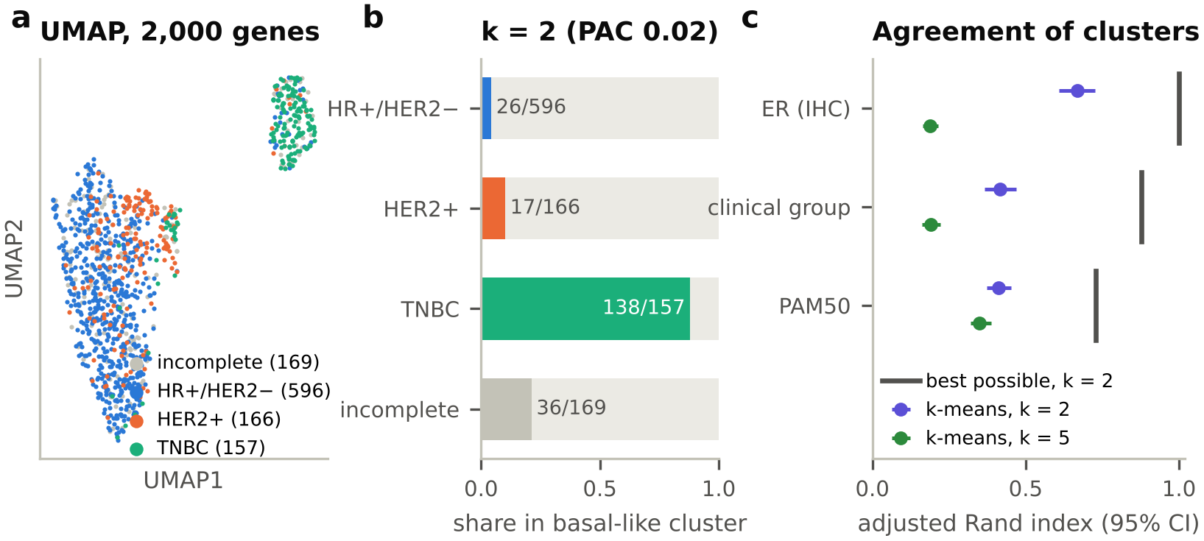
Figure 1. Label-free structure. (a) UMAP of 1,088 tumours coloured by clinical group. (b) Share of each clinical group in the smaller k-means cluster (k = 2). (c) Adjusted Rand index of k-means clusters with ER, the clinical groups and PAM50 (95% bootstrap CI); bars mark the best ARI reachable with two clusters.

4.2 TNBC is a distinct transcriptional state (Q2)
Of 23,439 genes, 2,741 differed more than 2-fold between TNBC and HR+/HER2− at FDR 5% (1,484 higher, 1,257 lower in TNBC; Fig. 2a). A plain Wald test of zero change called 18,604 genes (79%), which shows why the threshold was tested rather than applied afterwards. ESR1 (log2FC −5.1) and PGR (−4.4) acted as positive controls. Beyond them, the ER-driven luminal programme was lower in TNBC (GATA3 −3.3, AGR3 −4.8, FOXA1 −2.9, XBP1 −2.4) and basal transcription factors and keratins were higher (FOXC1 +3.1, as reported by Ray et al. [22]; KRT5 +2.4). The list was robust: 94% of the DEGs stayed significant with the same sign after adding age, 91% in ductal tumours only (so lobular biology is not being reported as HR+ biology), 87% with strict labels and 96% in the ER−/HER2− contrast. HER2+ vs HR+/HER2− tumours differed in only 148 genes, 33 of them within 2 Mb of ERBB2 on the 17q12 amplicon.
GSEA found 28 Hallmark sets at FDR < 0.05 (Fig. 2b): proliferation (E2F targets, NES +3.11; G2M checkpoint +2.88), MYC targets (+2.74), interferon-γ (+2.18) and mTORC1 (+2.16) were higher in TNBC, and the early and late oestrogen responses lower (−3.08, −2.40), as in the TCGA and CPTAC proteogenomic studies [4, 23]. Gene-permutation q-values are optimistic when genes in a set are co-expressed (median inter-gene correlation 0.06, up to 0.25 for E2F targets). Both correlation-aware tests agreed with the prerank direction for all 28 sets (NES ρ = 0.92), but only the early oestrogen response stayed significant (CAMERA q < 0.05). We therefore report the proliferation, MYC and immune programmes as consistent shifts with large effect sizes, not as proven to be more shifted than the average gene. Answer to Q2: TNBC switches off the oestrogen-response programme and switches on basal and proliferative genes; HER2+ tumours differ far less, mainly at the amplicon.
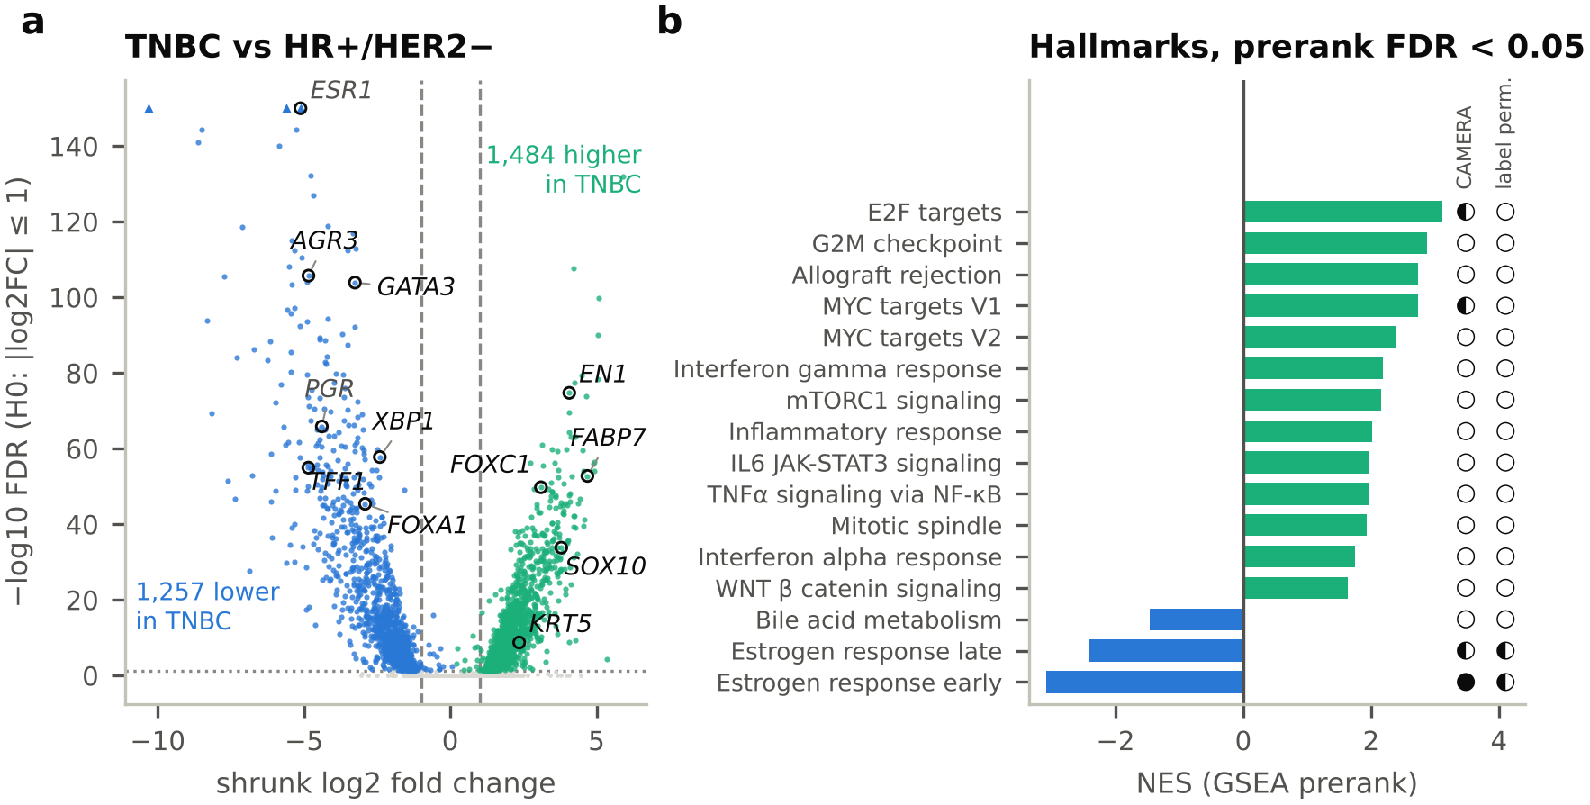
Figure 2. TNBC vs HR+/HER2− (157 vs 591). (a) Volcano plot: shrunk log2 fold change against FDR of the |log2FC| > 1 test (y capped at 150). (b) Hallmark sets at prerank FDR < 0.05 (the 13 strongest positive and all 3 negative of 28); symbols give the correlation-aware checks (● q < 0.05, ◐ nominal p < 0.05, ○ neither).

4.3 Whole-transcriptome models match, but do not beat, the receptor gene (Q3)
For ER, ESR1 alone reached AUC 0.959 and the best model (Random Forest) 0.954 (corrected t-test p = 0.69); for HER2, ERBB2 alone 0.845 and the best model 0.851 (p = 0.66) (Fig. 3a–b). All four model types gave similar AUCs (Fig. 3c), shuffled labels gave MCC −0.01 (ER) and +0.04 (HER2), and accuracy of the single gene (94% for ESR1, 89% for ERBB2) matched the 88–96% reported for arrays by Gong et al. [24]. The ablation separates the two receptors. Without the receptor genes, the amplicon and the PAM50 genes, ER was predicted as well as before (AUC 0.948–0.953): ER status is written across a whole regulon, not one gene. HER2 fell to 0.784–0.820, the same at 2 Mb, so most HER2 signal sits in the amplicon and the remainder largely reflects the lower-ER, proliferative character of HER2+ tumours. Label quality limits HER2: dropping the 30 HER2+ calls based on status text alone raised ERBB2 alone to 0.894 and the best model to 0.884. Only for the combined ER−/HER2− target did a model beat one gene (0.964 vs 0.948 for ESR1; p = 0.005), because no single gene encodes both receptors. As a secondary, circular benchmark, the same pipeline reproduced 5-class PAM50 calls with 88% accuracy (87% without the PAM50 genes). Answer to Q3: no; the receptor gene already carries almost all the information about clinical status.
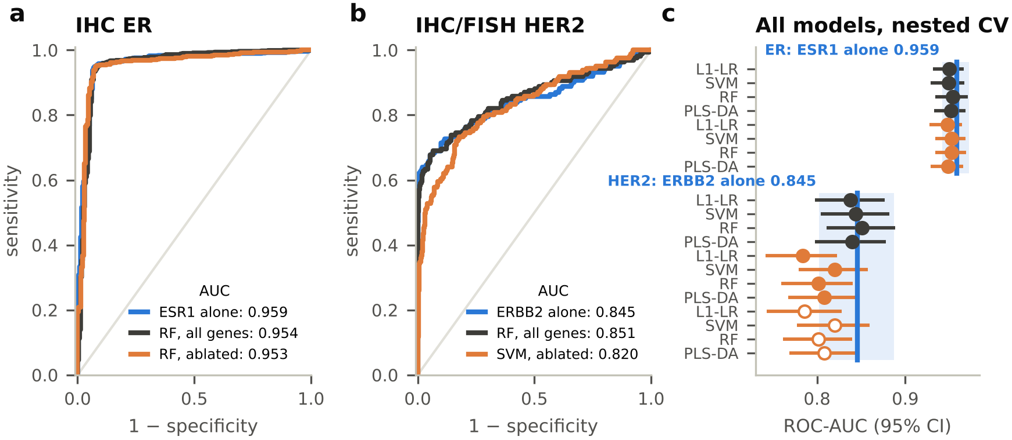
Figure 3. Classification of clinical status (nested CV, pooled out-of-fold). (a, b) ROC curves for the receptor gene alone, the best model with all genes and the best ablated model. (c) AUC (95% CI) of every model: dark, all genes; orange, ablated (±1.5 Mb); open, ablated (±2 Mb). Blue line and band: receptor gene alone.

4.4 Validation in protein, in METABRIC and against published studies
Protein. 92 of 131 RPPA antibodies differed between TNBC and HR+/HER2− (q < 0.05). Across the 85 genes with a total-protein antibody, the mRNA fold change predicted the protein difference with ρ = 0.80 (permutation p = 0.001; 95th percentile of the null 0.49; Fig. 4a), and all 15 DEGs with an antibody agreed in sign. The ER errors are informative (Fig. 4b): of the 15 IHC ER-negative tumours called ER-positive, 8 of 10 with RPPA had ERα protein above the 95th percentile of correctly called ER-negative tumours, which suggests IHC false negatives rather than model errors. Of the 68 IHC ER-positive tumours called negative, 40 were PAM50 Basal or HER2-enriched and 26 of 43 with RPPA had ERα below the 5th percentile of correctly called ER-positive tumours, consistent with ER-low tumours or IHC false positives.
METABRIC. The frozen TCGA models transferred without loss (Fig. 4c): ER AUC 0.959 (0.947–0.970) against 0.950 in TCGA cross-validation, HER2 (copy-number gain) 0.906 against 0.838, and ER−/HER2− vs rest 0.935. HER2 transferred better than it cross-validated because METABRIC's copy-number label tracks mRNA more closely than clinical IHC/FISH. As in TCGA, the models did not beat the gene alone (ESR1 0.960, ERBB2 0.900). Of the 1,857 TCGA DEGs measured on the array, 1,599 (86%) replicated with the same sign at q < 0.05 (effect-size ρ = 0.79), and Hallmark NES agreed with ρ = 0.94.
Table 2. Our numbers next to published ones (each checked against PubMed). TCGA 2012 analysed a subset of the same tumours (a consistency check); the other studies used different cohorts or assays.
Quantity | This study | Published
TNBC called PAM50 Basal | 83% (130/157) | 86% (65/76) [4]
PAM50 Basal that are TNBC | 81% (130/160) | 80% (65/81) [4]
Clinical HER2+ called HER2-enriched | 33% | ~50% [4]
ER+ called Basal or HER2-enriched | 6.3% | 8.7% [25]
Single-gene accuracy, ER / HER2 | 94% / 89% | 88–96% / 89–93% [24]
AUC change across cohorts, ER / HER2 | 0.95→0.96 / 0.84→0.91 | 13–22% drop [26]
5-y BC death HR vs LumA (ER+, endocrine-treated): LumB / HER2E / Basal | 2.6 / 3.4 / 8.2 | 2.0 / 3.6 / 17.7 [25]

Published studies. Table 2 shows that the clinical–PAM50 concordance, the single-gene accuracy and the subtype order of risk agree with the literature. Clinical HER2+ tumours were called HER2-enriched less often than in TCGA 2012; with the 2012 HER2 labels and PAM50 calls the same tumours give 52%, so the gap comes from the larger cohort, the newer PAM50 calls and the HER2 rule, not from an error. Unlike the 13–22% loss reported for a multimodal model moved from TCGA to CPTAC [26], our simpler mRNA models lost nothing in METABRIC.
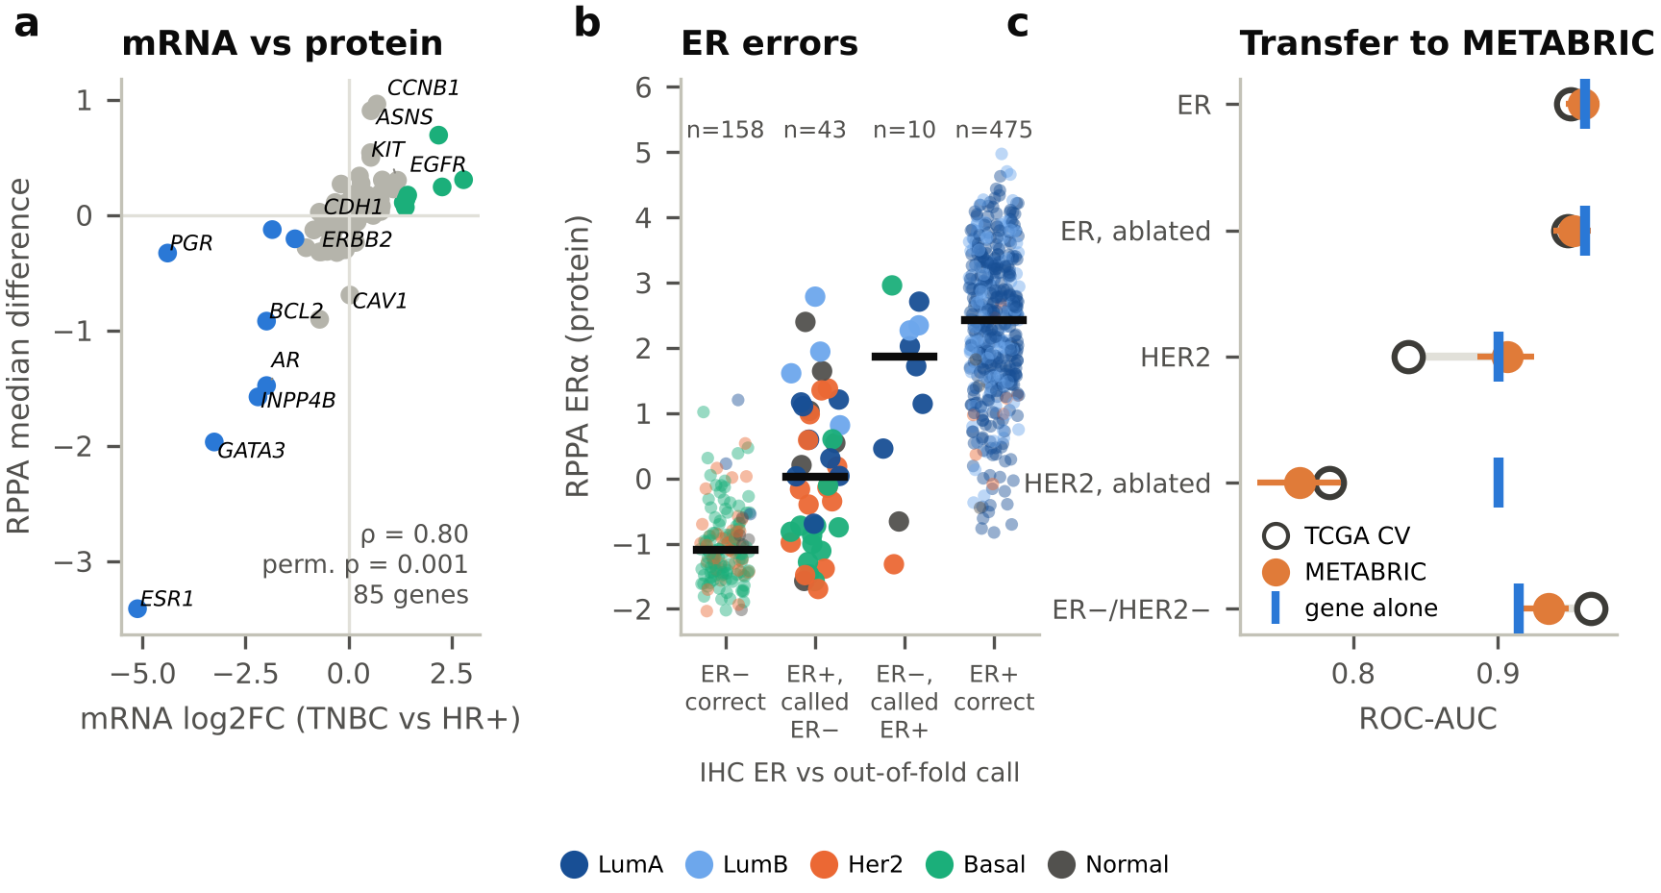
Figure 4. Validation. (a) DE log2FC vs RPPA median difference (TNBC vs HR+/HER2−); coloured, DEGs. (b) RPPA ERα by IHC ER status and out-of-fold call, coloured by PAM50. (c) AUC in TCGA cross-validation and in METABRIC for the frozen models, with the receptor gene alone in METABRIC.

4.5 Survival (beyond the talk)
In TCGA (median follow-up 2.4 years) PFI differed by group (log-rank p = 0.0072; Fig. 5a). Adjusted for age and stage, TNBC had a hazard ratio (HR) of 2.69 (95% CI 1.70–4.26) against HR+/HER2−, while HER2+ did not differ (HR 0.98, 95% CI 0.56–1.71; Fig. 5c); the group effect met the proportional-hazards assumption (p = 0.49), age did not (p = 0.03). In METABRIC (1,846 tumours, 492 breast-cancer deaths within 10 years; Fig. 5b) HER2 gain carried HR 1.90 (95% CI 1.54–2.35). The ER−/HER2− effect violated proportional hazards; split at 5 years it was 2.46 in years 0–5 and 0.51 in years 5–10 (interaction p = 6 × 10⁻⁷), the known early-relapse pattern of ER-negative disease. The frozen TCGA classifier's predicted ER−/HER2− group also separated METABRIC survival (log-rank p = 3 × 10⁻⁸), and METABRIC's PAM50 subtypes reproduced the risk order reported by Nielsen et al. [25] (Table 2).
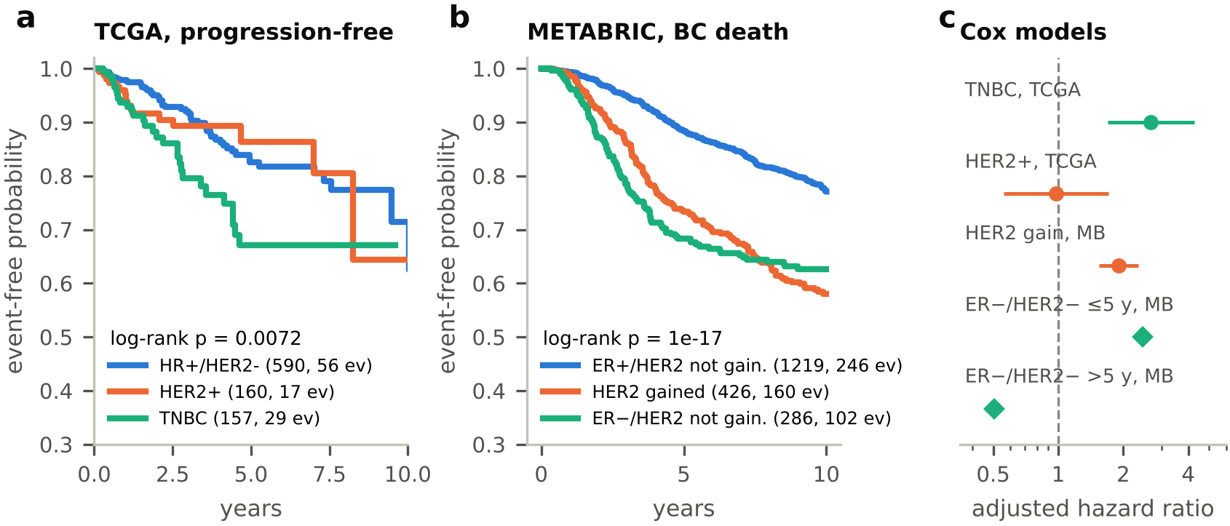
Figure 5. Outcome by group. Kaplan–Meier curves for (a) TCGA progression-free interval and (b) METABRIC breast-cancer death within 10 years (n, events). (c) Adjusted Cox hazard ratios (95% CI) against HR+/HER2−; diamonds, METABRIC ER−/HER2− effect split at 5 years. MB, METABRIC.

5. Conclusion and discussion
Summary. (1) The dominant structure in breast tumour expression is the ER axis; label-free methods recover TNBC as a basal-like group but not HER2+ tumours as a group. (2) TNBC is a distinct transcriptional state, with 2,741 genes more than 2-fold different from HR+/HER2− tumours, robust to covariates, histology and label noise. (3) Whole-transcriptome classifiers match but do not beat ESR1 and ERBB2 alone. (4) The results hold in protein, in an independent cohort with labels from other assays, and against published numbers.
Biological interpretation. ER status is a regulon-wide state: removing ESR1 and every PAM50 gene leaves the prediction intact, because GATA3, FOXA1, AGR3 and XBP1 move together with it. TNBC tumours replace this programme with basal transcription factors (FOXC1, EN1, SOX10) and high proliferation and MYC activity, and they relapse early, as the time-dependent METABRIC hazard shows. HER2 positivity, in contrast, is mostly a local genomic event: the amplicon dominates both the DE list and the classifier, and the rest of the transcriptome resembles HR+ disease. Practically, an expression assay adds little to IHC for ER and HER2 calls, but tumours where mRNA and IHC disagree are worth a second look: our ER error analysis suggests that some IHC calls, not the model, are wrong.
Limitations. (i) TNBC and HR+ tumours differ in tumour purity and immune infiltration, which contribute to the proliferation and immune signals; DE was not adjusted for purity. (ii) Pathway significance shrinks once inter-gene correlation is counted, so pathway findings are effect sizes, not tests. (iii) HER2 labels are noisy (some rest on status text alone) and the TCGA HER2 rule is our own. (iv) METABRIC lacks PR and uses copy-number HER2, so its groups are not identical to the clinical ones. (v) TCGA survival is short (median 2.4 years) and treatment was not modelled. (vi) Classifier comparisons rest on overlapping folds, which the corrected test handles conservatively.
Future directions. Adjust DE for purity (e.g. ESTIMATE scores) or deconvolve the immune signal; test whether ERBB2 mRNA can resolve IHC 2+ equivocal cases; extend the protein check to the CPTAC mass-spectrometry proteome; split the HR+/HER2− group into proliferative and immune subgroups and test their outcome in METABRIC.
Data and code availability. TCGA data from UCSC Xena (GDC and TCGA hubs); METABRIC data from the cBioPortal datahub, used under the Open Database License (ODbL). Code, parameters, logs, AI prompts and AI chat histories are in the supplementary material: [GitHub or Drive link]. Use of AI: an AI assistant helped plan the analysis, write and run the code, review the results and draft this report; the team checked every number against the result files and every reference against PubMed. Prompts and chat histories are in the supplement.

References
1. Allison KH, et al. J Clin Oncol 2020;38:1346–1366. doi:10.1200/JCO.19.02309
2. Wolff AC, et al. J Clin Oncol 2018;36:2105–2122. doi:10.1200/JCO.2018.77.8738
3. Sørlie T, et al. PNAS 2001;98:10869–10874. doi:10.1073/pnas.191367098
4. Cancer Genome Atlas Network. Nature 2012;490:61–70. doi:10.1038/nature11412
5. Parker JS, et al. J Clin Oncol 2009;27:1160–1167. doi:10.1200/JCO.2008.18.1370
6. Goldman MJ, et al. Nat Biotechnol 2020;38:675–678. doi:10.1038/s41587-020-0546-8
7. Liu J, et al. Cell 2018;173:400–416. doi:10.1016/j.cell.2018.02.052
8. Curtis C, et al. Nature 2012;486:346–352. doi:10.1038/nature10983
9. Pereira B, et al. Nat Commun 2016;7:11479. doi:10.1038/ncomms11479
10. Liberzon A, et al. Cell Syst 2015;1:417–425. doi:10.1016/j.cels.2015.12.004
11. Benjamini Y, Hochberg Y. J R Stat Soc B 1995;57:289–300. doi:10.1111/j.2517-6161.1995.tb02031.x
12. McInnes L, Healy J, Melville J. arXiv 2018;1802.03426. doi:10.48550/arXiv.1802.03426
13. Monti S, et al. Mach Learn 2003;52:91–118. doi:10.1023/A:1023949509487
14. Şenbabaoğlu Y, Michailidis G, Li JZ. Sci Rep 2014;4:6207. doi:10.1038/srep06207
15. Love MI, Huber W, Anders S. Genome Biol 2014;15:550. doi:10.1186/s13059-014-0550-8
16. Muzellec B, et al. Bioinformatics 2023;39:btad547. doi:10.1093/bioinformatics/btad547
17. Subramanian A, et al. PNAS 2005;102:15545–15550. doi:10.1073/pnas.0506580102
18. Fang Z, Liu X, Peltz G. Bioinformatics 2023;39:btac757. doi:10.1093/bioinformatics/btac757
19. Wu D, Smyth GK. Nucleic Acids Res 2012;40:e133. doi:10.1093/nar/gks461
20. Nadeau C, Bengio Y. Mach Learn 2003;52:239–281. doi:10.1023/A:1024068626366
21. Netanely D, et al. Breast Cancer Res 2016;18:74. doi:10.1186/s13058-016-0724-2
22. Ray PS, et al. Cancer Res 2010;70:3870–3876. doi:10.1158/0008-5472.CAN-09-4120
23. Krug K, et al. Cell 2020;183:1436–1456. doi:10.1016/j.cell.2020.10.036
24. Gong Y, et al. Lancet Oncol 2007;8:203–211. doi:10.1016/S1470-2045(07)70042-6
25. Nielsen TO, et al. Clin Cancer Res 2010;16:5222–5232. doi:10.1158/1078-0432.CCR-10-1282
26. Shah V, Patel M. Comput Biol Chem 2026;124:109228. doi:10.1016/j.compbiolchem.2026.109228

