**Name : Vijaya baskar R,**

**Dept : Compute Science And Engineering,**

**Topic : Employee Management System**

**College : KSR Institute for Engineering**

**and Technology.**

**CRUD OPERATIONS USING HTTP**

**Form Creation:**

Create the fields with the required fields in your project.  
  
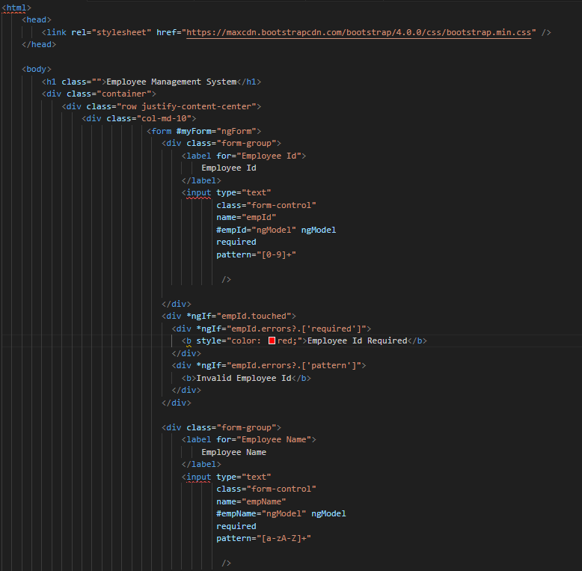 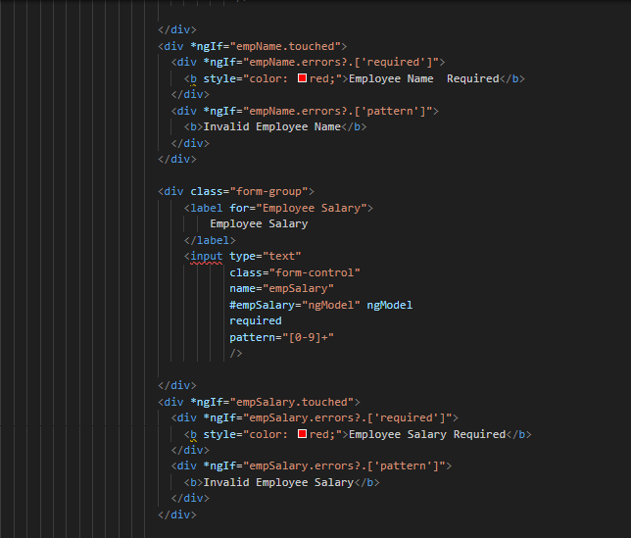

**Output:**

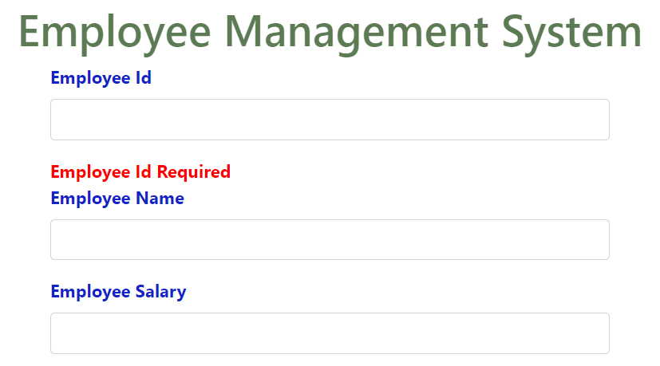

**CREATE:**

Create operation is used to insert the values/save the values in the database.

**App.component.html file:**



**app.component.ts file:**

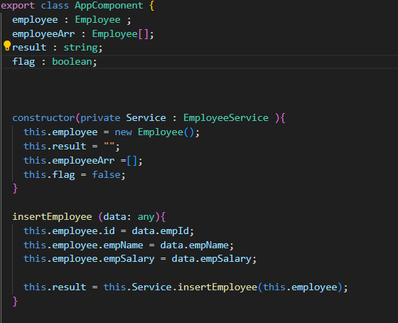

**employee.service.ts file:**

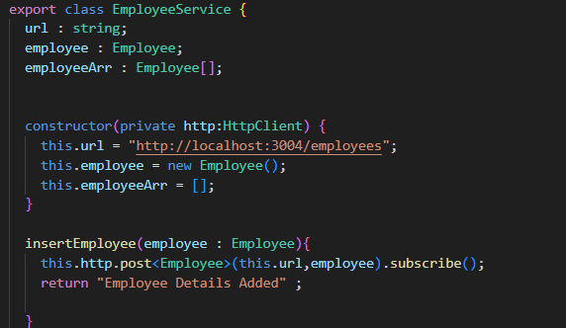

**Output(Create):**

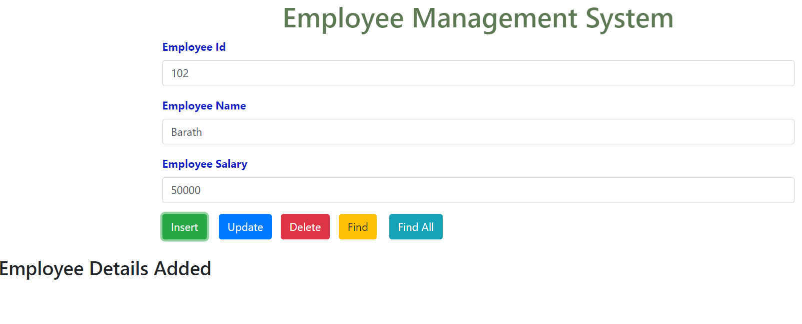

**Database:**

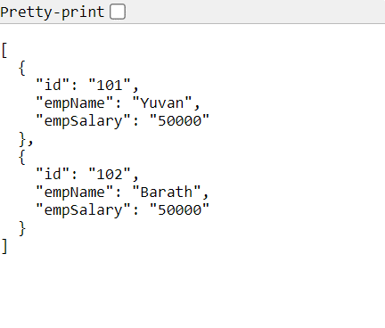

**UPDATE:**

Update operation is used to update the values/edit the values in the database.

**App.component.html file:**



**app.component.ts file:**

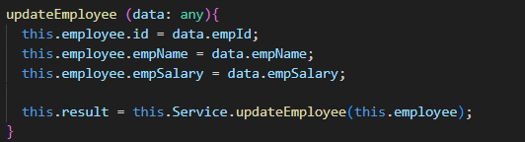

**employee.service.ts file:**

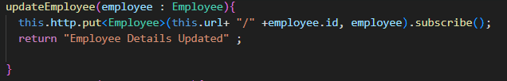

**Output(Create):**

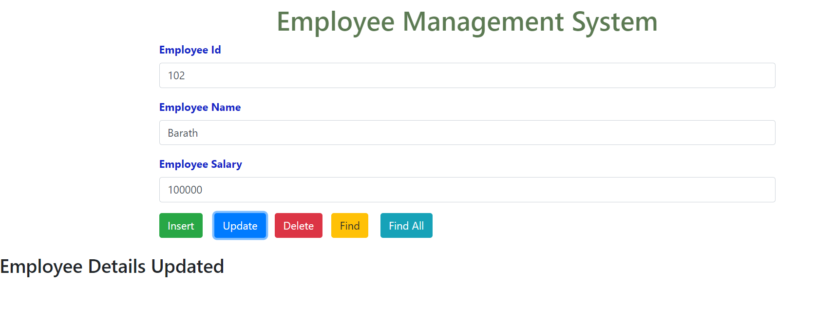

**Database:**

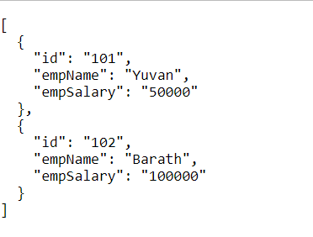

**Delete:**

Delete operation is used to delete the values/erase the values in the database.

**App.component.html file:**

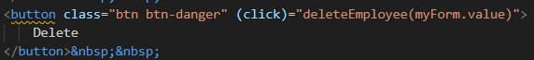

**app.component.ts file:**

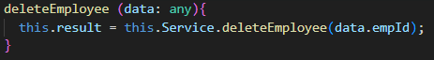

**employee.service.ts file:**

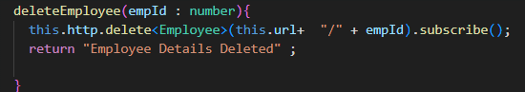

**Output(Create):**

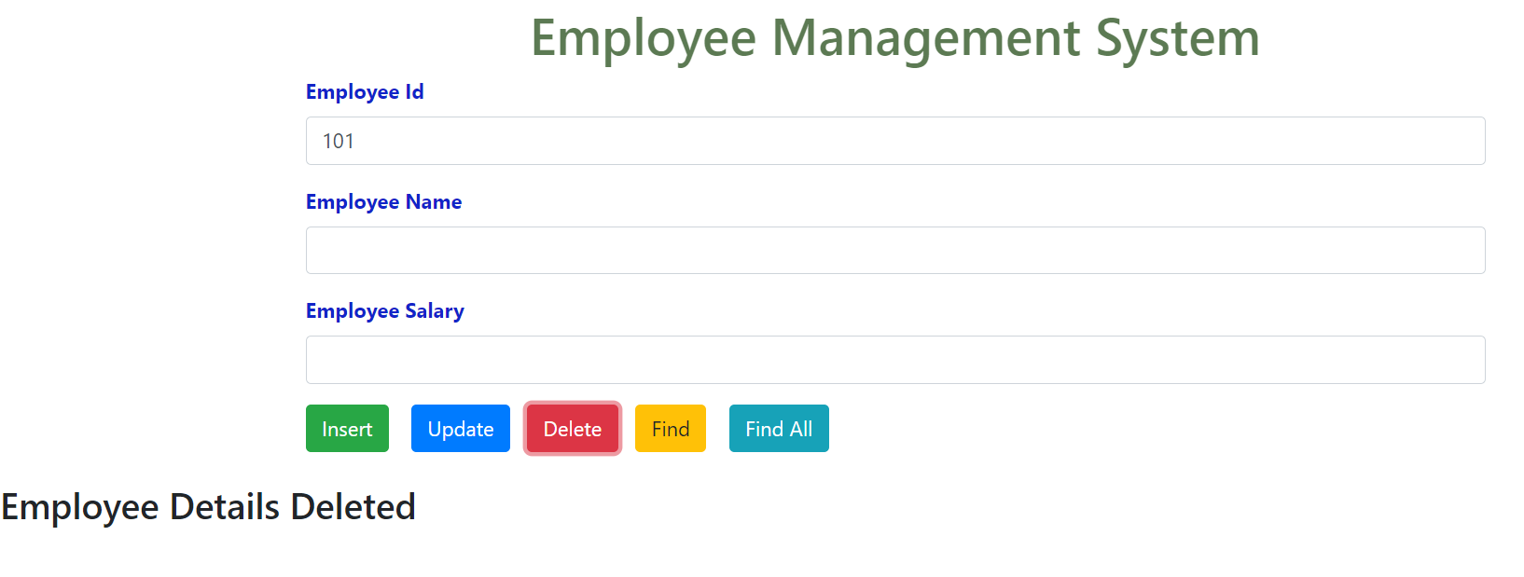

**Database:**

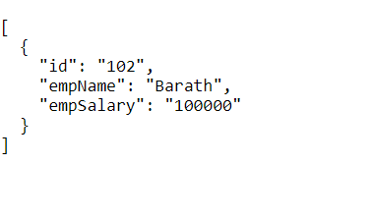

**READ:**

Read operation is used to read the data/view the data in the database.

**App.component.html file:**

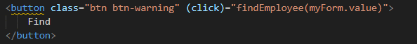

**app.component.ts file:**

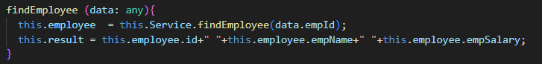

**employee.service.ts file:**

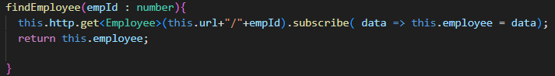

**Output(Create):**

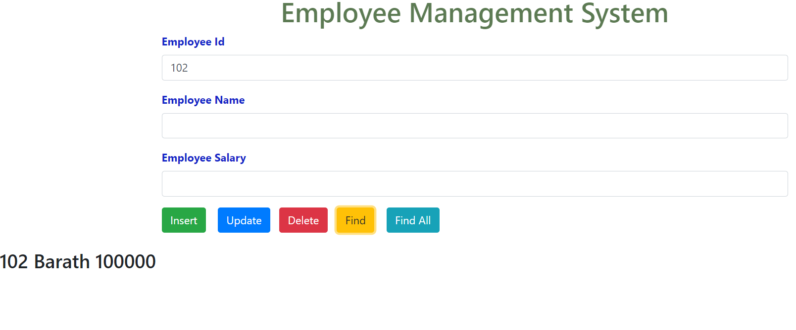

**Database:**



**FIND ALL:**

Find all operation is used to find all the data/view all the data in the database.

**App.component.html file:**

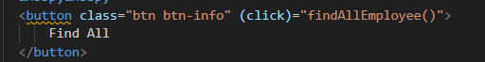

**app.component.ts file:**

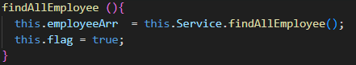

**employee.service.ts file:**

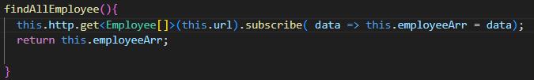

**Output(Create):**

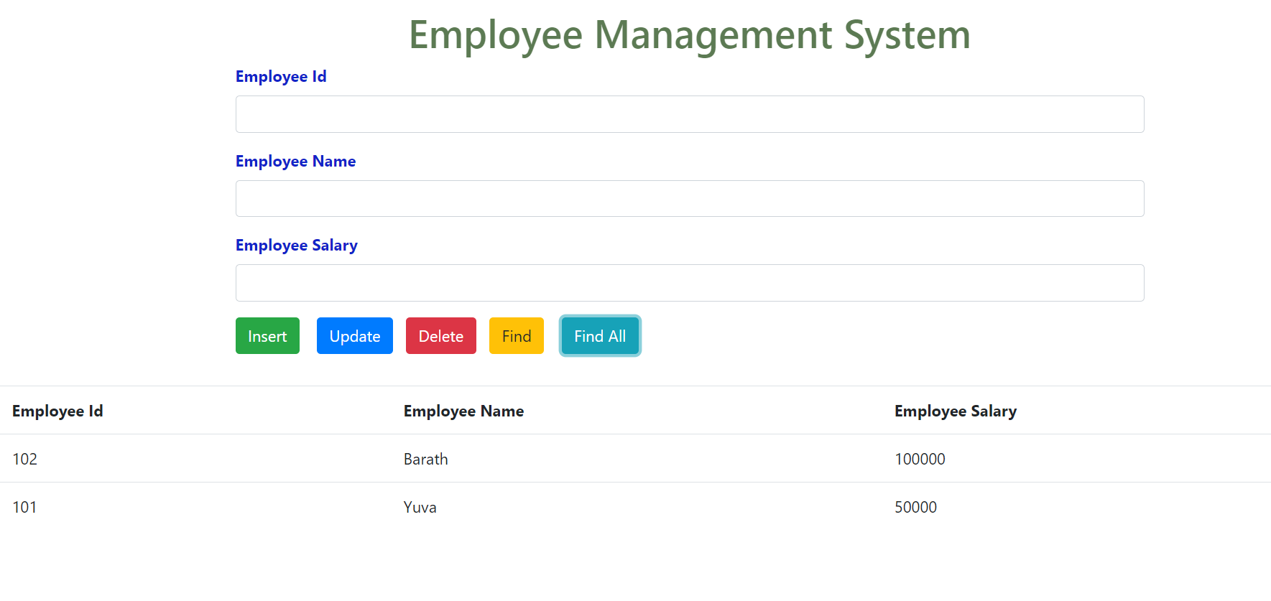

**Database:**

