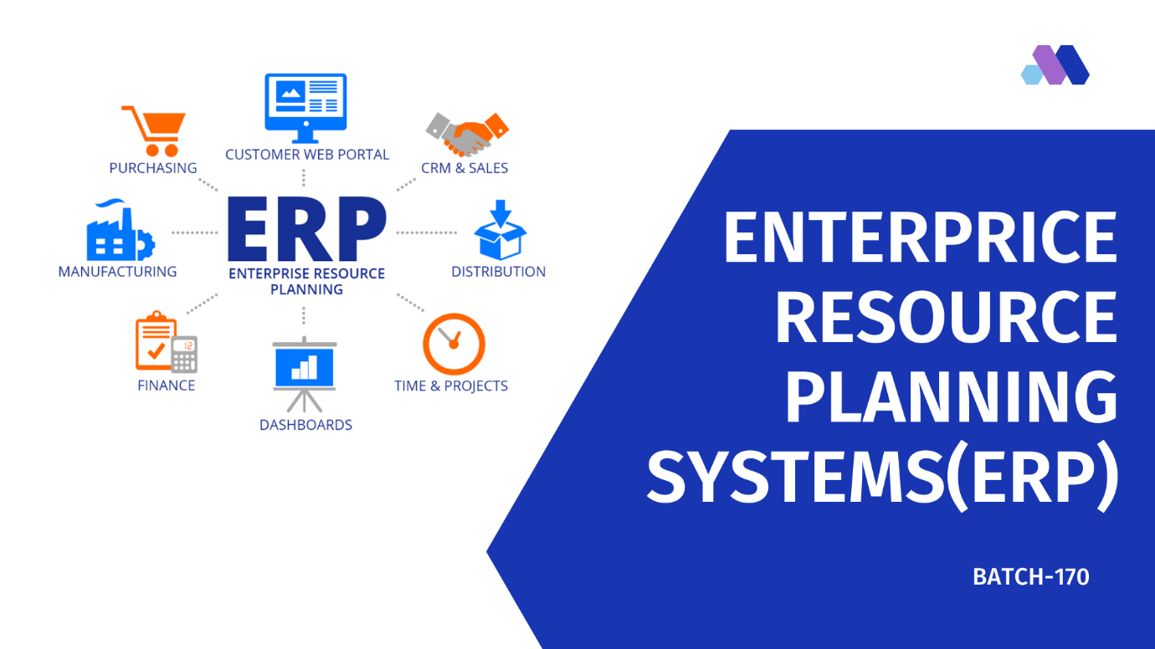

**WHAT'S SDP?**

SKILL DEVELOPMENT PROJECT.

There were a couple of projects assigned to us this semester

but we chose the topic called Is Enterprise Resource Planning (ERP) because we as

individuals are connected to it and we share equal

responsibility and efforts to help It and promote it.

To doing the this project we both follow the Agile methodology

because Agile methodology is a collection of principles that value

adaptability and flexibility. Agile aims to provide better

responsiveness to changing business needs and therefore focuses on

enabling teams to deliver in workable increments.

It’s always handy to know how to do things best. Here are seven things

we both doing when implementing any type of Agile methodology: 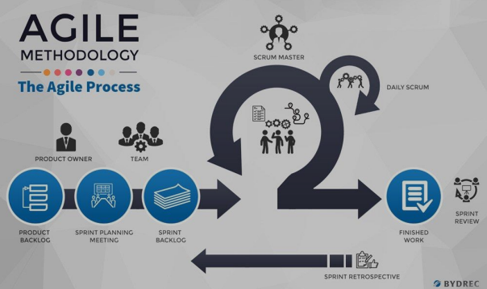

What Is Enterprise Resource Planning (ERP)?

Enterprise resource planning (ERP) is a process used by companies to manage and integrate the important parts of their businesses. Many ERP software applications are important to companies because they help them implement resource planning by integrating all of the processes needed to run their companies with a single system. An ERP software system can also integrate planning, purchasing inventory, sales, finance, human resources, and more.

**SURVEY:**

We have gone to different types of shops in Vijayawada market and asked them questions personally about their problems in business and what they lack to develop their business to high level. We have taken note of every one queries and answers and we also passed an online form to survey other people who do business other than Vijayawada since we can’t go much far. The results of the online form will be displayed below. Some offline questions which we asked were

Do you use computer/laptop to store the bills or transactions?

How do you pay shop income tax and income reports? (Self or accountant)

could you operate computer or laptop?

Do you have customers around the state or country?

If we provide solution to Enterprise resource planning, what type of features do you expect in that?

Can you explain how do you run your daily business?

**Photos during the interaction, interviews and conducting surveys:**

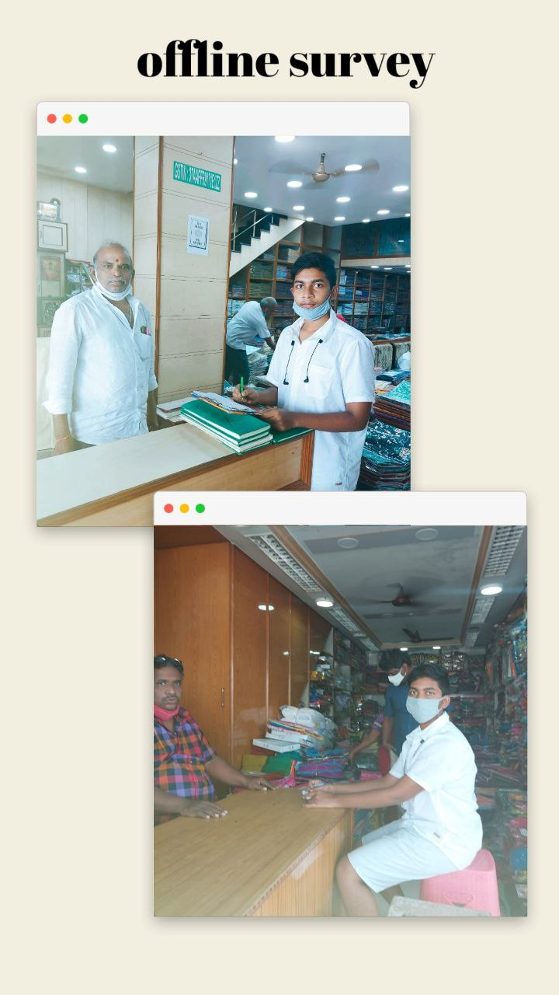

**Online survey through forms:**

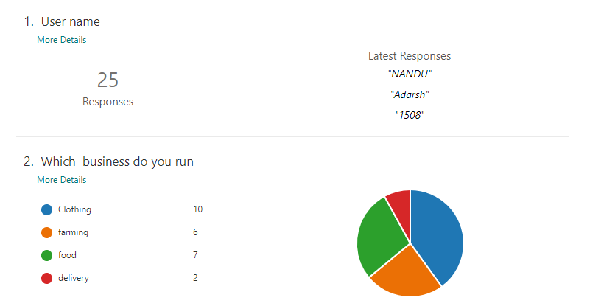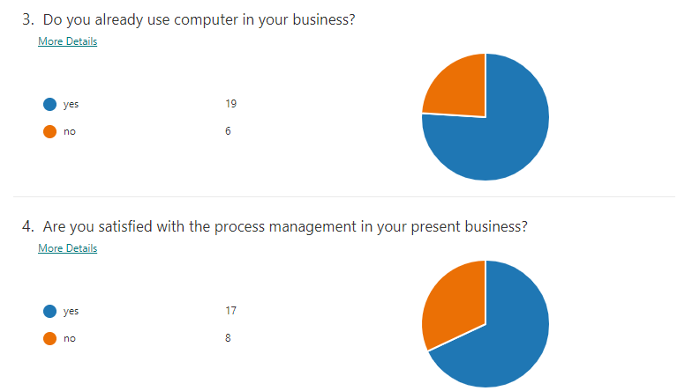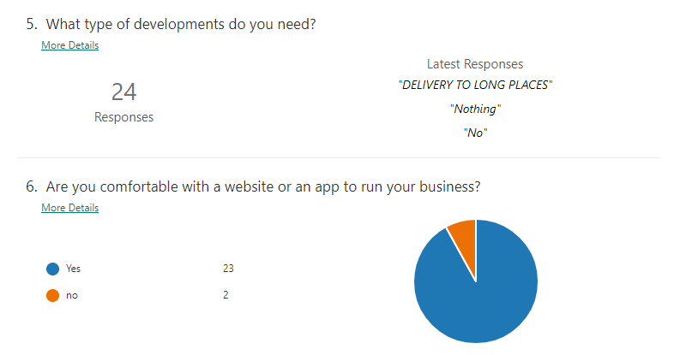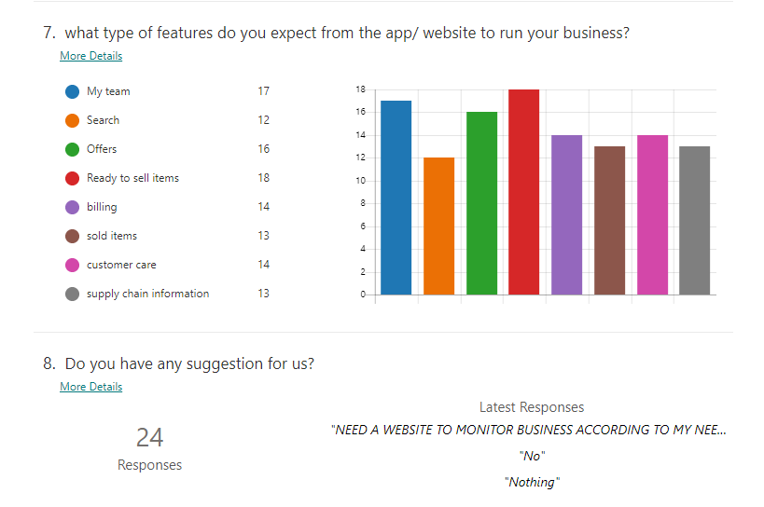

**Online Research Links:**

we have spent some time doing our research online knowing about working and building of ERP. We came to know about many new points.

ERP software system can also integrate planning, purchasing inventory, sales, marketing, finance, human resources, and more. ERP applications also allow the different departments to communicate and share information more easily with the rest of the company.

<https://www.investopedia.com/terms/e/erp.asp#what-is-enterprise-resource-planning-erp>

<https://www.oracle.com/in/erp/what-is-erp/>

<https://insights.sap.com/what-is-erp/>

**User Personas:**

We have made user personas of different customers and we have mentioned about them below.

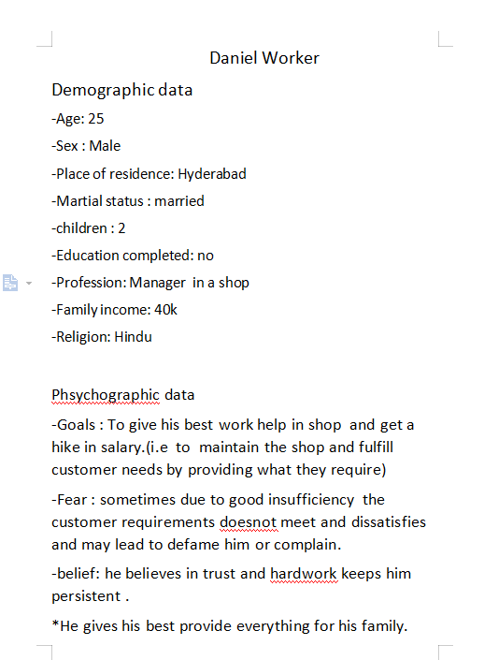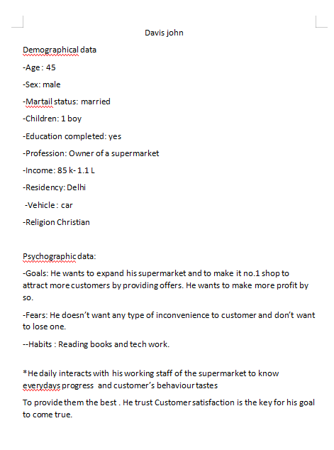

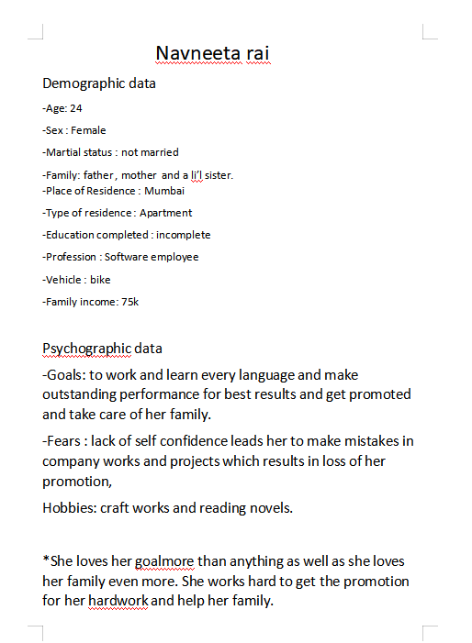

INTERFACE : 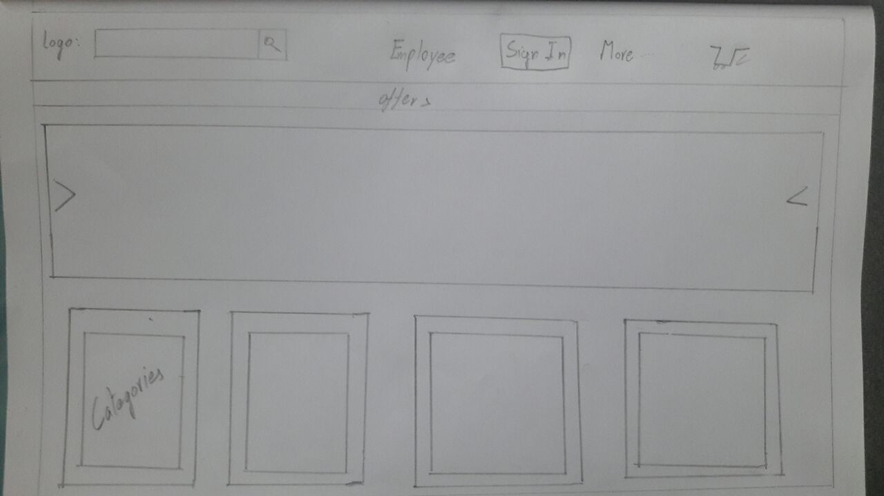

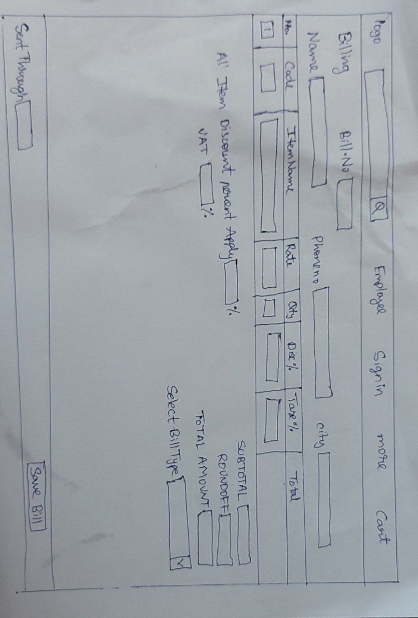

**Customer Journey map:**

A customer journey map is a research-based tool. It examines the

story of how a customer relates to the business, brand or product over

time. As we might expect no two customer journeys are identical. So

from the Quantitative research data we prepared some customer

journey maps

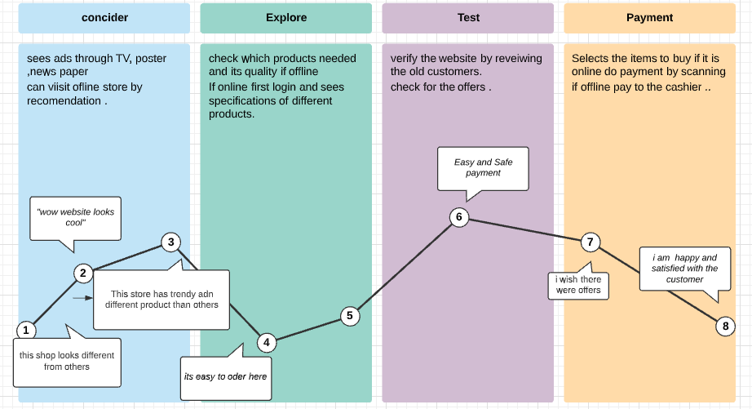

Empathy map:

An empathy map is a visualization tool which helps you sum up what

we learned from design research to help better understand business

and articulate what we know to colleagues and stakeholders.

By using the five steps of empathy map

Define the scope and purpose

Conduct relevant research

Fill out empathy map

Analise the quadrant data

Identify businessman’s need

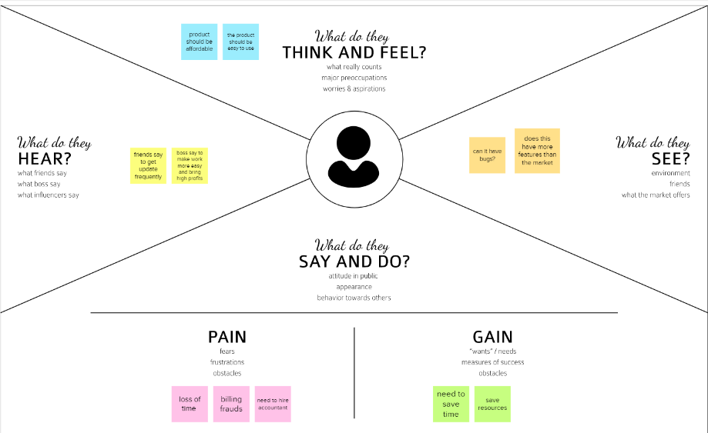

Conclusion:

From the survey conducted through online and offline we came to know about the common problems faced by shop owners and what type of solutions they are interested in. Our group came to a conclusion about the solution which we can make and its features and discussed with the shopkeepers and asked to rate them for 10 points and we ranked our ideas from top to bottom. Listening and summarizing the problems that we were given we thought of developing an app that could easily make the businessman self-sufficient with the help of it since many of the problems mentioned we got know had just some basic fixes we decided to develop a web page with our computer knowledge which we had.

We created an interface that uses the technological data to the use of

a basic customer which is a businessman. we made sure the interface was

well designed and simpler to use so that the people who have less knowledge about internet and working

professionals in that field have eased on.

In our project we are going to create a website for the shopkeepers to plan their finance, employee, billing, online ordering system with online payment facility for users. The shopkeepers have separate id so that they can see all the cargo items which should be shipped and which are on their way. we also add a customer care page which will give the details such as mail id and phone number to connect them in case of any payment failure, bugs, query related to products. We will use react js and through visual studio code and mongo dB to store database. We would like to share the application of the use of technical

knowledge and the power of coding to solve real-world problems that

could be solved and would benefit a huge mass of people.

Benefits:

This will save both customers and shopkeepers’ time. This saves lot of money by online selling so number of workers can be decreased and the customers can be increased since delivery through cargo can be done to far places. The customers get delivered in remote area also. since all the transactions are done in website, we also provide billing which provide bills at offline store so all the transaction are visible in the database and the accounting can be made very easy and the cost to pay to the accountant will decrease. In the shops we surveyed they were paying for cashier since they don’t have proper and basic service for billing and the present software’s were too complicated for them.The two share documents from one section to another section will decrease since all are stored in one database and easy to. It was just our honour to select this topic and work for it, we know that our solution may not be the best possible solution for this problem but with proper time and effort given this project and this way of thinking would just be a huge help in the Is Enterprise Resource Planning system